Instructor Patrick Shepherd

Giorgi Lomia

Computing & Sustainable Systems CSC 486

**Make-Up Assignment Matrix Operations**

This assignment will count towards your multiple regression and gradient descent score for the first homework. If you get 100% on this it will be equivalent to 50 point for the Programming Assignment 1. In this assignment you will be tasked with finishing the provided code and completing a Matrix class, with all the major operations. Matrices should be represented as list of lists data structure.

1. Matrix addition
2. Matrix subtraction
3. Extract individual rows and columns
4. Matrix transpose
5. Scalar multiplication
6. Dot product between two individual vectors
7. Matrix multiplication

You may not use any libraries what so ever. You must make sure that matrix dimensions are appropriate before carrying out any operations; if matrices are given which have incompatible dimensions, your class should print an error message and return None. There should be one check during class initialization that the input is a list of lists, but type checks are not necessary in the matrix operation functions; you may assume that inputs to your functions will be lists-of-lists. The code has to follow proper class structure you learned about in CSC 226 and CSC 236. Each function must return a Matrix object with the correct values after each operation.

The required functions and some resources are provided below:

1. Matrix addition

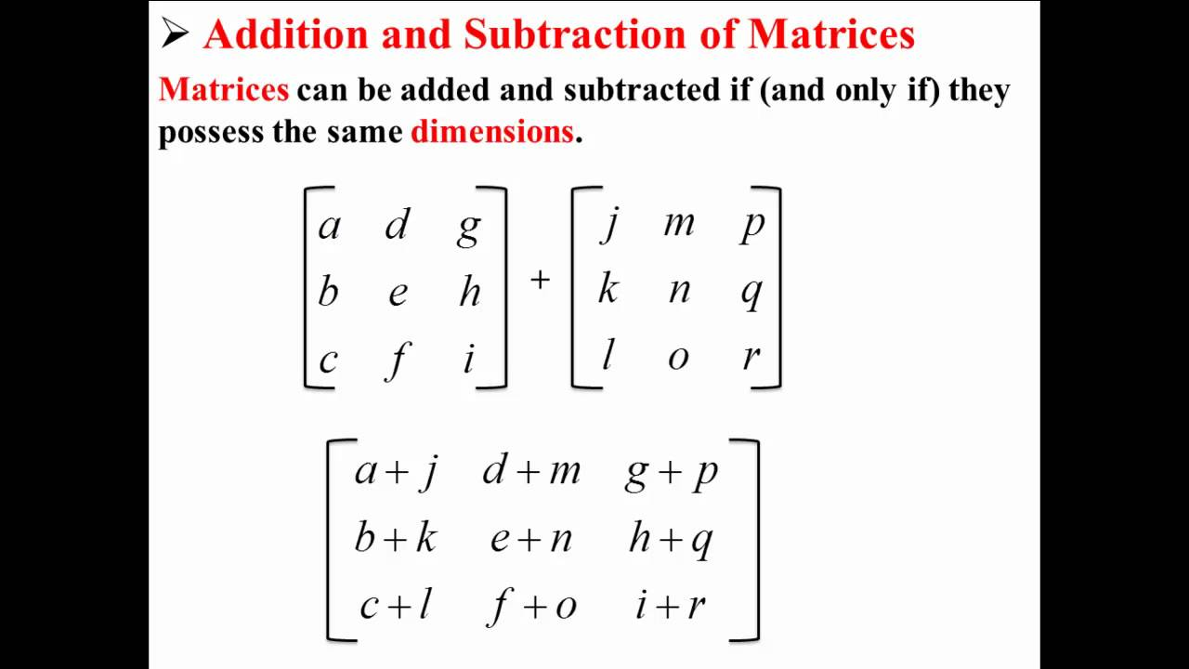

For additional understanding of matrix addition: <https://www.khanacademy.org/math/precalculus/x9e81a4f98389efdf:matrices/x9e81a4f98389efdf:adding-and-subtracting-matrices/v/matrix-addition-and-subtraction-1>

1. Matrix subtraction is done in the same way as addition, only instead of adding elements you subtract them.
2. Scalar multiplication

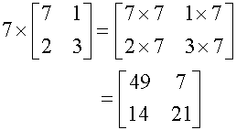

For additional understanding of scalar multiplication:

<https://www.khanacademy.org/math/precalculus/x9e81a4f98389efdf:matrices/x9e81a4f98389efdf:multiplying-matrices-by-scalars/v/scalar-multiplication>

1. Matrix Multiplication. In order to multiple 2 matrices the number of columns of the first one has to equal the number of the rows of the second one and it is calculated in the following fashion.

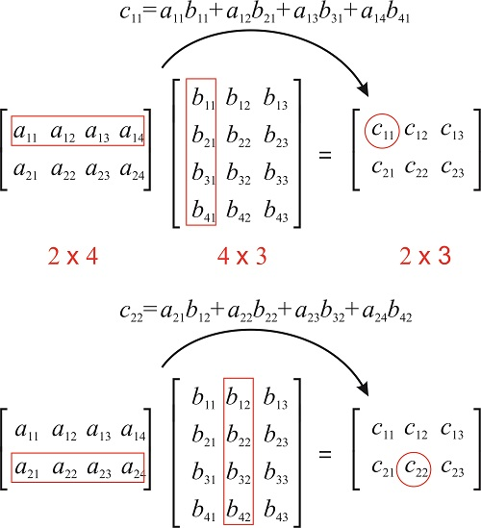

For additional understanding: <https://www.khanacademy.org/math/precalculus/x9e81a4f98389efdf:matrices/x9e81a4f98389efdf:multiplying-matrices-by-matrices/v/matrix-multiplication-intro>

1. Dot product between two individual vectors

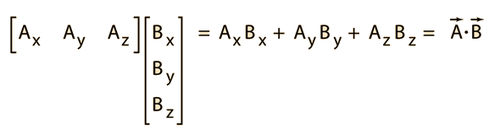

For additional understanding: <https://www.khanacademy.org/math/linear-algebra/vectors-and-spaces/dot-cross-products/v/vector-dot-product-and-vector-length>

1. Extract individual rows and columns

Create function that if prompted return the row and column they have been asked for.

1. Matrix transpose

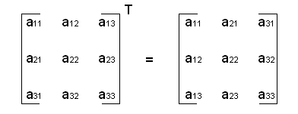

For additional understanding: <https://www.khanacademy.org/math/linear-algebra/matrix-transformations/matrix-transpose/v/linear-algebra-transpose-of-a-matrix>

Please submit a link to the Github repo that you completed the assignment in. **NO OTHER FORMS OF SUBMISSION!!!**