

JAX-CMS MySQL Release

Design Specifications Document

Prepared by: Abigail Ames and Dave Springer
Scientific Software Engineer
Computational Biology Department
The Jackson Laboratory

Document modification history

Revision number | Date | Who | Comments
0 | 5/30/2007 | AMA | Began first draft
1.01 | 2/18/2009 | DSJ | Updating as Design Doc.

About this document

Document Purpose

This document lists the user requirements for the release of the JAX-CMS software compatible with a MySQL database and all of the necessary associated tasks.

Audience
The audience is the CS management, developers, and the software quality assurance staff.

Table of contents

1. Project Objective 3
2. Discussion 3
3. High Level Requirements 4
3.1. Create a JAX-CMS Database Conversion Tool which migrates the JAX-CMS back end database from MS Access to MySQL 4
3.2. Make necessary modifications and additions to the JAX-CMS web site to support downloading, installing, and running the JAX-CMS Database Conversion Tool 4
4. Use Cases 4
4.1. Existing JAX-CMS user converts database to MySQL 4
4.1.1. Assumptions 4
4.1.2. Description 4
4.2. New install of JAX-CMS using MySQL database 4
4.2.1. Assumptions 4
4.2.2. Description 5
4.3. Existing JAX-CMS/MySQL user upgrades JAX-CMS version 5
5. Functional Specification 5
5.1. Install of MySQL database (if necessary) 5
5.2. Download and install of JAX-CMS Database Conversion Tool 5
5.3. Running the application 5
5.4. General information about functional specification 7
5.5. Exceptions 9
6. Technical Specification 9
6.1. Updates to existing JAX-CMS web site pages 9
6.1.1. The following statement: 9
6.1.2. A new section of text will be added to the Register/Download page, under the existing text under the heading “Upgrade.” It will read: 10
6.1.3. A segment will be added to the Upgrade page, just after the first full paragraph. This segment will read: 10
6.2. Additions to JAX-CMS web site 10
6.2.1. A new page, titled “JAX-CMS Database Conversion Tool” will be added to the web site. This page is accessed via the link referenced in sections 6.1.1 and 6.1.2. Full text for this page is provided in Appendix A. 10
6.3. Setup and deployment 10
6.4. Implementation details-General 10
6.5. Implementation details-Schema Migration 11
6.6. Implementation details-Data Migration 11
Appendix 13
a) Full text for conversion tool’s download page 13
JAX-CMS Database Conversion Tool 13
Troubleshooting problems with database conversion 15
Instructions for downloading and installing MySQL 16
1) Point to http://dev.mysql.com/downloads/ in your web browser. In the section listed "MySQL Community Edition," click the link designated as the current release. 16
2) Select the install package for the platform you own. If you are a Windows owner, simply select the "pick a mirror" link to the right of the text that says "Windows (x86)." 16
3) Follow the instructions and select a mirror near to your geographic location. Click the link to download the file and save it onto your computer. 16
4) Using a zip extraction program such as WinZip, the free 7-Zip, or the program that comes with Windows, extract the files from the zip to another folder. 16
5) Access the folder you created and double click setup.exe. 16
6) Follow the instructions for the installation and when you reach the final prompt that reads "configure mysql server now," check the box next to it. Click Finish. 16
7) Now we have finished the installation and will begin the configuration. Click "Next." 16
8) Click the radio button next to "Standard Configuration" and click "Next." 16
9) Check the "Install As Windows Service" and "Launch the MySQL Server Automatically" checkboxes. Click "Next". 16
10) Now you need to create a root password you will need to access your server. Type in a password that is not easy to guess and make sure the "enable root access from remote machines" is checked. Click "Next." 16
11) On this window, click "Execute" to start MySQL and click "Finish." 16
12) To ensure that MySQL is properly installed, go to your task bar and go to "Start" > "All Programs" > "MySQL" > "MySQL Server 4.1" > "MySQL Command line client." 16
b) Data type conversion from MS Access to MySQL 16

List of Figures and Tables

Figure 1-Setup screen 7
Figure 2-Conversion Tool's start up screen 7
Figure 3-Database exists error 7
Figure 4-Progress window during update 8
Figure 5-Database conversion failure example 8
Figure 6-Database conversion successful 8

Table 1-Input fields on start up screen 6
Table 2-Exceptions 9
Table 3-Global constants 10

List of Acronyms and Abbreviations

Term | Definition
JAX-CMS | Jackson Laboratory Colony Management System
DSN | Data Source Name
DDL | Data Definition Language

Project Objective

This project will be complete when a user has the capability to use JAX-CMS with a MySQL database. This includes any necessary database creation and migration utilities and updated user documentation.

Discussion

JAX-CMS was developed with a Microsoft Access front end and back end database. These two databases are JCMS.mdb and JCMS_db.mdb respectively. Many JAX-CMS users have inquired about compatibility with a MySQL database and have expressed the need to be able to use JAX-CMS with a MySQL back end database. This has resulted in an effort to support the migration of the back end database to MySQL. Because JAX-CMS was developed with separate interface and database layer databases, no modifications to the interface layer code are necessary. The bulk of the effort is creating a tool which converts the Access back end database to a MySQL back end database. After the MySQL database has been created and all data migrated into it, it is simply a matter of pointing the front end database’s table links to the MySQL database.

About this document

This document lists the high-level user requirements in section 3. In section 4 the relevant use cases are described, the functional specifications for requirements are discussed in detail in section 5, and section 6 contains technical specifications for implementing the requirements.

High Level Requirements

Create a JAX-CMS Database Conversion Tool which migrates the JAX-CMS back end database from MS Access to MySQL

Make necessary modifications and additions to the JAX-CMS web site to support downloading, installing, and running the JAX-CMS Database Conversion Tool

Use Cases

Existing JAX-CMS user converts database to MySQL

Assumptions
- User has an existing install of JAX-CMS
- User has administrative rights on the machine on which the utility is being installed
- User has an Administrative account on both JCMS databases
- User has either:
- access to a MySQL server and a root login to create a new schema
- the technical ability and necessary privileges to carry out an install of MySQL database

Description
An existing JAX-CMS user navigates to the JAX-CMS website and clicks on the “Register/Download” link on the left navigation pane. There is a section on this page under the heading “Upgrade” that has a link to the JAX-CMS Database Conversion Tool’s web page. On clicking that link, the user is presented with a web page with a “Download” link and instructions for downloading and installing the tool. The user is instructed to first download and install MySQL if he/she does not already have an available MySQL database. A link to the download section of the MySQL web site and instructions for installing are provided. Upon downloading and installing the conversion tool, the user launches the conversion tool from the JAX-CMS application group in the startup menu. The Conversion Tool launches and prompts the user for database location and logon information for both databases. After entering this information the user clicks the “Convert” button. A new window appears with a progress bar, progress indication label, and output window. As the utility runs, feedback is given for each step. If the conversion was successful, a “Database conversion complete” message is displayed, otherwise a “Database conversion failed” message is displayed. In the case of a failure, the output window will contain detailed information about the cause of the failure. In addition, an external log file records each step and may be used for troubleshooting. A user may resolve the issue that caused the failure and run the tool again at any time. The user has the option of disabling the source database after it has been converted.

New install of JAX-CMS using MySQL database

Assumptions
- User has administrative rights on the machine on which the utility is being installed
- User has an Administrative account on both JCMS databases
- User has either:
- access to a MySQL server and a root login to create a new schema
- the technical ability and necessary privileges to carry out an install of MySQL database

Description
A new JAX-CMS user navigates to the JAX-CMS website and clicks the “Register/Download” link on the left navigation pane. The user reads and selects to agree with the license agreement. The user supplies registration information and clicks “Register.” Upon successful registration, the user is provided a link to download the JAX-CMS software. After downloading and installing JAX-CMS, the user will follow the steps in section 4.1.2 above.

Existing JAX-CMS/MySQL user upgrades JAX-CMS version
At this time, upgrading to a new version of JAX-CMS cannot be done after the conversion to MySQL. Instructions for use of the Database Conversion Tool will advise that the user upgrades to the current version of JAX-CMS prior to running the conversion. A future release of the JAX-CMS Upgrader will include support for upgrading a MySQL back end database.

Functional Specification

Install of MySQL database (if necessary)
If the user does not have access to a MySQL database server, it will be necessary to install MySQL. Instructions for doing so are provided on the JAX-CMS Database Conversion Tool web page. See Appendix (a) for complete text for these instructions.

Download and install of JAX-CMS Database Conversion Tool
After clicking the download link from the Conversion Tool’s web page, the user is prompted with a “Save As/Run” dialog box. They may select either, if they select “Save As” they will need to select a directory on a local drive in which to save the install package, JAX-CMS-Conversion-Tool.msi. Clicking “Run” from the “Save As/Run” dialog box, or double clicking the install package from the local drive will both result in the setup screen shown in Figure 1. The installer installs everything necessary to perform the database conversion, including the MySQL ODBC driver, the Conversion Tool executable and all associated dlls. The installer creates a machine DSN called MyJCMS that may be used for manual table linking if necessary. A shortcut to the conversion tool application is installed in the JAX-CMS start programs group. This program group includes all installed components of the JAX-CMS suite, including JAX-CMS itself, the upgrader, and the conversion tool.

Running the application
The user clicks on the shortcut in the start menu to launch the Conversion Tool. When it launches, the main window appears, as seen in Figure 2. All input values on this screen are required, however a password field may be left blank under the assumption that the password associated with the specified user account may be blank. The “Convert” button, which starts the conversion process, will not be enabled until all required fields are filled in. Required fields are indicated with an asterisk (*) to the left of the field label. The following table explains each input value on this screen:

Input | Explanation
JCMS Database | The Access database representing the interface database (JCMS.mdb.) This value is selected by using the button to the right of the box, which opens a file open dialog box. The file open dialog box filters on files of type .mdb (Access database) and the default path is the JAX-CMS install directory.
Access Username | A user that has administrative rights within the database. At the very least, this user must have privileges to read design and data in the source database, and to modify design for new tables in the interface database.
Access Password | The password corresponding to the user name above.
Disable database after conversion | Check box that indicates whether or not to disable, by renaming the file, the Access source database upon a successful conversion.
MySQL Host | The server name on which the MySQL database is located. This will generally be “localhost” for the server on the local machine, so that is the default value.
MySQL Port | The port on the server assigned to the MySQL database, the default port is 3306.
MySQL Username | A user in the MySQL database that has administrative privileges to create a new schema. This is defaulted to the root user.
MySQL Password | The password corresponding to the user name above
Table 1-Input fields on start up screen

After entering these values, the user clicks the “Convert” button, which initiates the conversion process. The first step in the process creates the MySQL database, called JCMS_db. If an existing MySQL database called JCMS_db already exists, the user is notified that the conversion process cannot continue. The user must either remove or rename the existing database and then start the process again. See Figure 3 for the error message. If the database does not already exist, the conversion progress window appears. This window indicates the overall progress via a progress bar and updates the output window with information as each step is completed. In addition, as each step in the process completes, details about the process are written to an external log file. This log file is located in the JCMS database location directory indicated on the main screen and may be used to obtain further details about the conversion process if necessary. If any step of the database conversion fails, the entire conversion is considered to have failed. The only exception is the final step, wherein the links to the original Access back end database are removed from the front end database and links to the new MySQL database are created. If this step fails, it can be done manually by the user, so the migration is considered to be successful. Instructions for manually recreating the links are provided on the Conversion Tool’s web page. The entire conversion process may fail due to several reasons, including inadequate permissions, non-conformance of user created tables (such as special characters in table names), etc. On failure, the output window indicates the step that failed and the error that caused the failure. Steps for resolving common errors are provided on the Conversion Tool’s web site. Figures 4, 5, and 6 show the progress window in various states: during conversion, conversion failed, and conversion succeeded. A “Cancel” button is enabled during the conversion process, and clicking it will prompt the user to confirm cancelling the conversion. If the user chooses to continue with the cancel action, the MySQL JCMS_db database is removed. The “Exit” button is not enabled during the conversion process, so that the user only has a choice of explicitly cancelling the process while it is occurring. If the user opted to disable the source database, it is renamed after a successful conversion.

General information about functional specification
- The Conversion Tool converts all tables in the Access database, regardless of whether or not they originally shipped with JAX-CMS. Likewise, it links all tables created in the MySQL database to the Access interface database, regardless of the origin of the table.
- The Conversion Tool does not perform any modification to the Access source database, either schema or data. If the database conversion fails, the application is still usable with the original Access database.

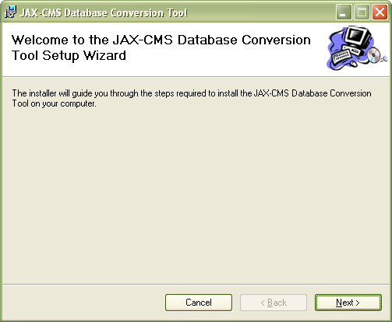
Figure 1-Setup screen

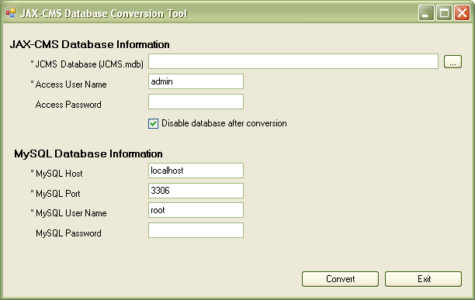
Figure 2-Conversion Tool's start up screen

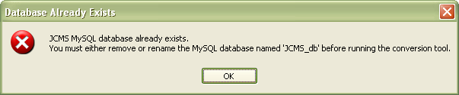
Figure 3-Database exists error
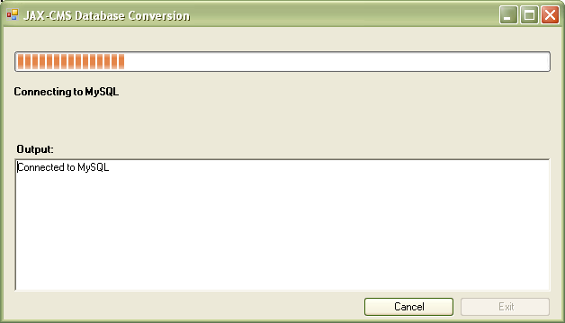
Figure 4-Progress window during update
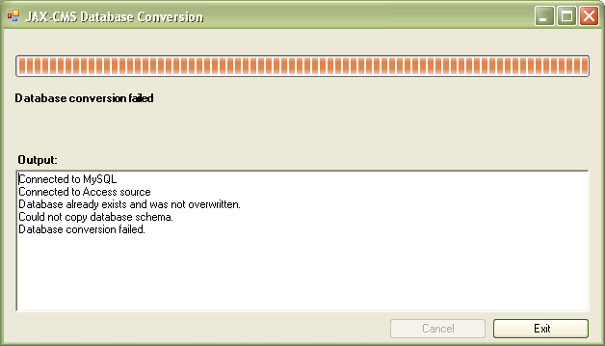
Figure 5-Progress window when database already exists

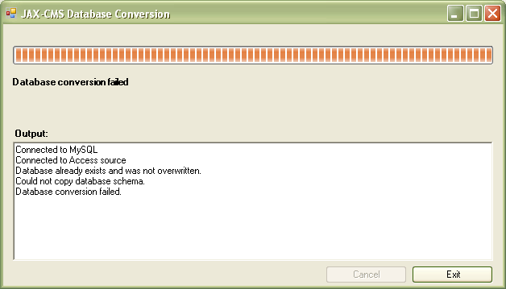
Figure 6-Database conversion failure example
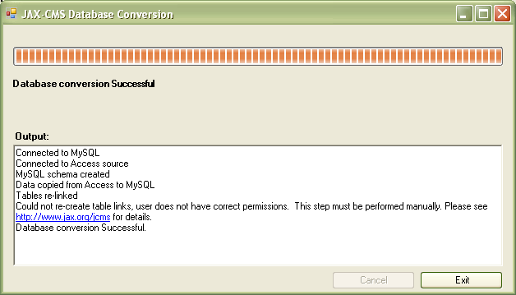
Figure 7-Table linking step failed, conversion still successful

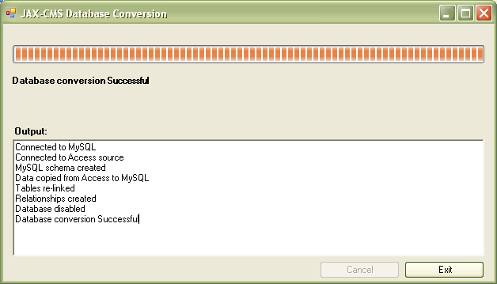
Figure 8-Database conversion successful

Exceptions
Exception | Result
Invalid log on information for Access database | Message in output window indicates invalid permissions. Conversion fails.
Invalid log on information for MySQL database | Message in output window indicates invalid permissions. Conversion fails.
Invalid database privileges for specified MySQL user name | Message in output window indicates CREATE command denied. Conversion fails.
A JCMS_db MySQL database already exists | Message prompting user to continue is displayed. Clicking No aborts the process, clicking Yes continues.
Special characters in table or field name | Output window indicates that table could not be created and lists table name. Conversion fails
Table 2-Exceptions

Technical Specification

Updates to existing JAX-CMS web site pages

The following statement:
“In its current form, JAX-CMS runs as a Microsoft Access® application. It can be executed remotely from UNIX or Macintosh® environments using technologies such as Citrix Server.”

Will be changed to:

“In its current form, JAX-CMS runs as a Microsoft Access® application. By default, it installs with a Microsoft Access back end database. This database may be converted any time to a MySQL database using the database conversion utility available here for download. JAX-CMS can be executed remotely from UNIX or Macintosh® environments using technologies such as Citrix Server.”

A new section of text will be added to the Register/Download page, under the existing text under the heading “Upgrade.” It will read:
“If you have an existing version of JAX-CMS and wish to convert your database to MySQL, you may download the database conversion tool by clicking here.” Please note that it is advised that you upgrade to the latest version of JAX-CMS prior to converting your database.”

A segment will be added to the Upgrade page, just after the first full paragraph. This segment will read:
“Note: Currently the upgrader cannot upgrade a MySQL database. If you are planning to convert your database to MySQL, please run the upgrader first. If you have already converted your database to MySQL, you cannot upgrade at this time. This functionality will be available in a future release.”

Additions to JAX-CMS web site

A new page, titled “JAX-CMS Database Conversion Tool” will be added to the web site. This page is accessed via the link referenced in sections 6.1.1 and 6.1.2. Full text for this page is provided in Appendix A.

Setup and deployment
The installation of the Database Conversion Tool and the MySQL ODBC driver, along with the automated creation of the MyJCMS DSN, are packaged into JAX-CMS-Conversion-Tool.msi. This is a Windows installer file that is downloaded from the JAX-CMS web site. The default location for installing the Database Conversion Tool is:
C:\Program Files\The Jackson Laboratory\JAX-CMS Database Conversion\
A new program group, titled “JAX-CMS” is created during the setup process and a shortcut to the Database Conversion Tool is placed there. If a previous installation of JAX-CMS and/or the upgrader utility are detected, these shortcuts will be moved into the JAX-CMS program group.

Implementation details-General
- For creating the MySQL schema and migrating the data, the Conversion Tool generates SQL statements on the fly and executes them using a global connection object which is opened on the MySQL database.
- MySQL object names are wrapped in backticks, this prevents errors generated by the use of reserved words as object names in the Access database. For example, the JCMS_db.mdb has a table containing a column called “where.” Without enclosing the object name in backticks, the generated DDL statement used to create the table would fail because WHERE is a reserved word.
- Upon successful conversion, if the user has kept the default checkbox “Disable database after conversion” checked, the Access source database is renamed by appending “_disabled” to its name.
- Key values for auto-incremented columns are preserved.
- Several global constants are used, as specified in the table below:

Constant | Description
INITIAL_PATH | Used for defaulting file open dialog boxes (for specifying database location) and for location of text file generated for data loads. It is initialized to the location of the JAX-CMS application directory.
MYSQL_DB_NAME | Name of new MySQL database. Defaulted to “JCMS_db”
MY_ODBC_VERSION | Name of the installed version of the MySQL ODBC driver. Defaulted to “MySQL ODBC 3.51 Driver.”
Table 3-Global constants

Implementation details-Schema Migration
Schema migration is accomplished with the following series of procedures:
- Create connection to MySQL database
A global ADO connection object is used to open a connection to the MySQL database. This connection object is held open and used throughout the conversion.
- Create connection to Access database
A global ADO connection object is used to open a connection to the Access JCMS_db.mdb database. The location of this database is derived from the properties of the table links in the interface database indicated on the main screen. This connection object is held open and used throughout the conversion.
- Drop MySQL database if it exists
If a database called “JCMS_db” already exists on the MySQL server and the user responds when prompted to overwrite it, a DROP DATABASE statement is generated and executed.
- Create MySQL database
- Create tables
Loop through tables in Access database and generate a “CREATE TABLE” script based on table and column properties. This process will convert each column’s data type from Access data types to corresponding MySQL data types, per the table in Appendix B. Indexes (including primay key and unique), Nullable property, and default values are also copied from the Access columns. If a table has an “Autoincrement” column, the DDL for that column specifies NOT NULL AUTO_INCREMENT. Default values from Booleans are converted from Access values (Yes/No) to MySQL values (1/0.)
- Create table relationships
The MSysRelationships table in the Access JCMS_db.mdb is queried and for each record, an ALTER TABLE ADD FOREIGN KEY SQL statement is built. The optional <constraint symbol> is omitted, so that MySQL creates its own global ID for the constraint.
- Re-create table links in Access interface database
The interface database is opened and an ADO catalog is created for the open connection. The table objects are looped through and if the table is a linked table, the link is removed. A loop is then set up for all tables in the MySQL database and these are in turn added as new table links.

Implementation details-Data Migration
Data migration is accomplished with the following series of procedures for each table in the Access Database:
- Create a disconnected recordset of the table
All rows are selected from the table and read into a standalone recordset. This allows data modification necessary for loading into MySQL without changing any data in the Access source database. The select statement generated to read the data into the recordset calls the FORMAT function on any date column to convert it to MySQL date format (YYYY-MM-DD HH:MM:SS.)
- Prepare data for export
With each record, any non-null text fields are updated to escape commas and replace newline values with spaces, since commas are the field delimiters and newline is the row terminator for the infile. Commas are escaped with a backslash, as this is the escape character specified in the LOAD DATA INFILE statement.
- Export the recordset to a comma delimited text file
The ADO method “GetString” method is called on the recordset to format it for output, using comma as field delimiter, newline as row delimiter and “\N” for null values (this is the default sequence recognized as null by MySQL when it is reading the infile.) The results are then saved to a text file to be used as the source for the LOAD DATA INFILE statement.
- Assemble the “LOAD DATA INFILE” statement
The statement is assembled from the standard load statement, the name of the table, the name of the text file generated in the previous step, the specifications for field and row terminators, the specifications for escape character, and column specification. The columns are specified in the order that they were selected in the select statement that generated the recordset above. This way it is assured that the right data go into the right columns.
- Execute the “LOAD DATA INFILE” statement on the MySQL server
- Verify record counts
The number of records in the MySQL database is compared to the number of records in the original Access table. If the counts do not match, the conversion is considered to have failed.
- Delete the text file
Once it has been loaded, it is no longer needed

Remove need for DbReleationship Table
There is not a need to create a copy of MSysRelationships table, if you utilize ADOX to find all the foreign keys. This will remove the need for the Upgrade Utility to maintain the content of the DbReleationship Table.

New Code:

try
{
// Loop through every table in the database.
foreach (ADOX.Table tblLoop in catAccess.Tables)
{
// Do not consider MSys tables.
if ((tblLoop.Type == "TABLE" | tblLoop.Type == "VIEW") &&
("MSys" != tblLoop.Name.Substring(0, 4)))
{
// For each table get a list of Keys.
foreach (ADOX.Key tblKey in tblLoop.Keys)
{
// If this is a Foreign Key then we need to create a relationship.
if (tblKey.Type == ADOX.KeyTypeEnum.adKeyForeign)
{
// Get the Column in the Key.
foreach (ADOX.Column tblColumn in tblKey.Columns)
{
// If GUID is found, do not utilize the Access Reference Name.
if ( 0 <= tblKey.Name.ToString().IndexOf('{') )
{
strSQL = "ALTER TABLE "
+ MySQLName(tblLoop.Name)
+ " ADD FOREIGN KEY ("
+ MySQLName(tblColumn.Name) + ") REFERENCES "
+ MySQLName(tblKey.RelatedTable) + "("
+ MySQLName(tblColumn.RelatedColumn)
+ ") ON DELETE RESTRICT ON UPDATE RESTRICT";
}
else
{
// If GUID is not found, then use specifice Relationship name.
strSQL = "ALTER TABLE "
+ MySQLName(tblLoop.Name)
+ " ADD CONSTRAINT " + MySQLName(tblKey.Name)
+ " FOREIGN KEY ("
+ MySQLName(tblColumn.Name) + ") REFERENCES "
+ MySQLName(tblKey.RelatedTable) + "("
+ MySQLName(tblColumn.RelatedColumn)
+ ") ON DELETE RESTRICT ON UPDATE RESTRICT";
}
// Execute SQL Statement for a Foreign Key.
ExecuteSQL(strSQL);
}
}
}
}
}

Remove the reference to Scripting Dll.
Removing the refinance and fix the code!

Remove Reference
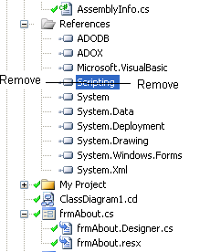

Fix the code

The followig diffs can be read as follows. Lines that are red have been removed, and lines that are all in blue have been added.

frmProgress.cs

public bool CopyData()
{

Scripting.FileSystemObject objFSO = new Scripting.FileSystemObject();

ExecuteSQL("USE " + MYSQL_DB_NAME);
foreach (ADOX.Table tblLoop in catAccess.Tables)
{
if (bwkr.CancellationPending == true)
return false;
if (tblLoop.Type == "TABLE" | tblLoop.Type == "VIEW")
{
CopyTable(tblLoop);
//check again for cancel, don't output if the cancel happened during this table copy
if (bwkr.CancellationPending == false)
bwkr.ReportProgress(1, "Copied table " + tblLoop.Name);
else
//if process exited due to cancel or error, clean up the data file
{

if (objFSO.FileExists(strSourceDbPath.Replace("\\", "\\\\") + "\\" + tblLoop.Name + ".txt"))
objFSO.DeleteFile(strSourceDbPath.Replace("\\", "\\\\") + "\\" + tblLoop.Name + ".txt", false);

FileInfo fI = new FileInfo(strSourceDbPath.Replace("\\", "\\\\") + "\\" + tblLoop.Name + ".txt");
if (fI.Exists )
{
fI.Delete();
}
}
}
} // For loop
return true;
}

public void CopyTable(ADOX.Table tblAccess)
{
ADODB.Recordset recMaster = new ADODB.Recordset();
ADODB.Recordset recLoop = new ADODB.Recordset();
int intLoop = 0;

Scripting.FileSystemObject objFSO = new Scripting.FileSystemObject();
Scripting.TextStream objTextStream = null;
.
.
.
}

frmMain.cs

public void Create_DSN()
{
Scripting.FileSystemObject objFSO = new Scripting.FileSystemObject();
Scripting.TextStream objTextStream = null;

try
{
objTextStream = objFSO.OpenTextFile("C:\\Program Files\\Common Files\\ODBC\\Data Sources\\myJCMS.dsn", Scripting.IOMode.ForWriting, true, Scripting.Tristate.TristateUseDefault);

objTextStream.WriteLine("[ODBC]");
objTextStream.WriteLine("DRIVER={MySQL ODBC 3.51 Driver}");
objTextStream.WriteLine("SERVER=" + txtMySQLHost.Text);
objTextStream.WriteLine("PORT=" + txtMySQLPort.Text);
objTextStream.WriteLine("DATABASE=jcms_db");
objTextStream.WriteLine("UID=" + txtMySQLUserName.Text);
objTextStream.WriteLine("PWD=" + txtMySQLPwd.Text);
objTextStream.Close();

FileStream fs;
StreamWriter sw;

fs = File.Create("C:\\Program Files\\Common Files\\ODBC\\Data Sources\\myJCMS.dsn");
sw = new StreamWriter(fs);
sw.WriteLine("[ODBC]");
sw.WriteLine("DRIVER={MySQL ODBC 3.51 Driver}");
sw.WriteLine("SERVER=" + txtMySQLHost.Text);
sw.WriteLine("PORT=" + txtMySQLPort.Text);
sw.WriteLine("DATABASE=jcms_db");
sw.WriteLine("UID=" + txtMySQLUserName.Text);
sw.WriteLine("PWD=" + txtMySQLPwd.Text);
sw.Close();
fs.Close();

return true;
}
catch
{
return false;
}
}

Update install package.
Rebuild without project referencing the Interop.Scripting.dll

Appendix

Full text for conversion tool’s download page

JAX-CMS Database Conversion Tool

Installing the Conversion Tool
If you wish to use JAX-CMS with a MySQL version of the JAX-CMS database, you must first install JAX-CMS. It is recommended that you install the latest version of JAX-CMS prior to converting your database. You must also have access to a MySQL database. If you do not, you may follow the instructions below to install MySQL. The next step is to download the conversion tool by clicking here. You may either save the file to your local machine and then run it, or select “Run” directly from the link. You will be prompted to specify the location where you would like it to install. After clicking “Next,” the software will be installed onto your machine

Preparing your Access database
Prior to running the Conversion Tool, you need to prepare your Access database by setting the correct permissions. To do this, open your JCMS_db.mdb database and take the following steps:
- Go to the “Tools” menu and select “Options”
- Locate the “System Objects” check box in the window that comes up and make sure it is checked as shown below. Click “OK.”

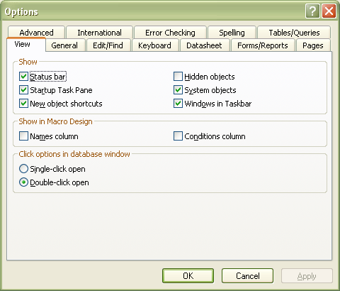

- Go to the “Tools” menu and select “Security” and then “User and Group Permissions.”
- Highlight the table called “MSysRelationships”
- Make sure the user account you are using for the Conversion Tool is highlighted, then make sure the “Read Data” and “Read Design” check boxes are checked, as shown below:

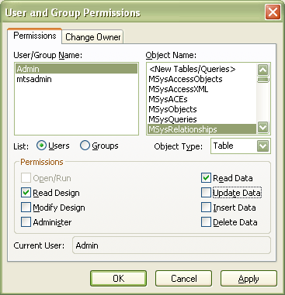

- Click “OK.”

Running the Conversion Tool
After installing it, you may start the conversion tool at any time by clicking Start -> Program Files -> JAX-CMS -> JAX-CMS Database Conversion. You will see the following screen:

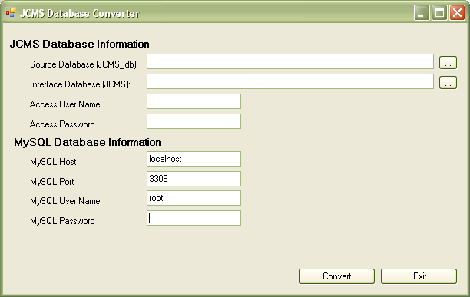

This is where you enter the location and log in information for your JAX-CMS and MySQL databases. After you have entered this information, click “Convert.” You will then see a screen indicating each step performed and the overall progress of the conversion, for example:

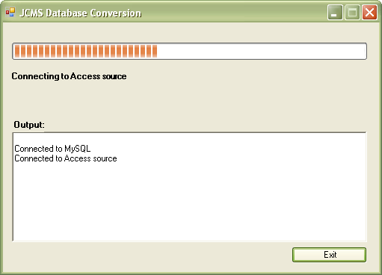

If for some reason your database conversion fails, a message will be provided, indicating the cause of the failure. If this happens, you may still use your JAX-CMS Access database, as this process DOES NOT affect your existing database.

Troubleshooting problems with database conversion
- Message “Error creating table <table name>”
  - This means that the table could not be created in MySQL and could be due to special characters in the table name. Check for and remove any special characters (such as question marks) and then attempt the conversion again.
- Message “Could not re-create table links. This step must be performed manually.”
  - This message indicates that the MySQL database was created and is ready for use, but you must manually recreate the links from your JAX-CMS.mdb by performing the following steps
    - Bring up JAX-CMS
    - Hit F11
    - On the “Tables” tab, highlight each table and click the “X” icon in the toolbar to delete (these are the links to your old database, you are just deleting the link, not the table.)
    - Right click on the “ Tables” icon in the “ Objects” dialog
    - Select “Link Tables ..”
    - Select “ODBC databases” in the “Files of type” drop down list
    - Click on the “Machine Data Sources” tab
    - Select “MyJAX-CMS” from the list and click “OK”
    - Click “Select All” to highlight all of the tables. Unselect any tables that begin with “mysl.” and “ OK”
    - Restart JAX-CMS
- Message “Could not create relationships, account does not have correct permissions.”
  - You need to set read permissions on the Access relationships table. To do this, please follow the steps for “Prepare your Access database” above

Instructions for downloading and installing MySQL

Point to http://dev.mysql.com/downloads/ in your web browser. In the section listed "MySQL Community Edition," click the link designated as the current release.

Select the install package for the platform you own. If you are a Windows owner, simply select the "pick a mirror" link to the right of the text that says "Windows (x86)."

Follow the instructions and select a mirror near to your geographic location. Click the link to download the file and save it onto your computer.

Using a zip extraction program such as WinZip, the free 7-Zip, or the program that comes with Windows, extract the files from the zip to another folder.

Access the folder you created and double click setup.exe.

Follow the instructions for the installation and when you reach the final prompt that reads "configure mysql server now," check the box next to it. Click Finish.

Now we have finished the installation and will begin the configuration. Click "Next."

Click the radio button next to "Standard Configuration" and click "Next."

Check the "Install As Windows Service" and "Launch the MySQL Server Automatically" checkboxes. Click "Next".

Now you need to create a root password you will need to access your server. Type in a password that is not easy to guess and make sure the "enable root access from remote machines" is checked. Click "Next."

On this window, click "Execute" to start MySQL and click "Finish."

To ensure that MySQL is properly installed, go to your task bar and go to "Start" > "All Programs" > "MySQL" > "MySQL Server 5.0" > "MySQL Command line client."

Data type conversion from MS Access to MySQL

MS Access Data Type | ADOX DataTypeEnum | MySQL Data Type
Text | adVarWChar | VARCHAR
Memo | adLongVarWChar | LONGTEXT
Long Integer | adInteger | INTEGER
Byte | adUnsignedTinyInt | TINYINT
Integer | adSmallInt | SMALLINT
Single | adSingle | REAL
Double | adDouble | FLOAT
Decimal | adNumeric | NUMERIC
Date/Time | adDate | DATETIME
Currency | adCurrency | FLOAT
Autonumber | adInteger | INTEGER
Yes/No | adBoolean | TINYINT(1)

