


Computational Sciences Department
The Jackson Laboratory

Requirements Specification
Project 1575
JCMS-PedTracker
Document number: | 1575.002
Revision: | 1.0
Saved date: | December 12, 2008
Printed date: | August 26, 2008
Status: | Technical Spec
Approvals
Title/role | Name | Signature |  | Date
Associate Director, Computational Sciences | Chuck
Manager, Applications Software Engineering | Mike
Software QA Engineer | Kirk
Software Engineer | Mike Relac
Software Engineer | Abigail Ames
Revision history
SR# | Revision | Author | Comments | Date
 | 0.1 | Dave Springer | Created | May 29, 2008
 | 1.0 | Dave Springer | Added in comments from Harry Chapmen meeting. | May 29, 2008

Contents
.
Purpose: 7
1 System View 9
1.1 Context 11
1.2 Requirements Summary 12
1.2.1 Functional Requirements Summary 13
1.2.2 Performance Requirements Summary 13
1.2.3 Usability Requirements Summary 13
1.2.4 Reliability, Availability, Serviceability Requirements Summary 13
1.2.5 Portability Requirements Summary 13
1.2.6 Localization Requirements Summary 13
1.2.7 Testability Requirements Summary 13
1.2.8 Maintainability Requirements Summary 13
1.2.9 Security Requirements Summary 13
1.2.10 Extendibility Requirements Summary 13
1.2.11 Alternatives Considered and Rejected 13
1.3 Process Model 13
1.3.1 Process Hierarchy Chart 13
1.3.2 Functional Cross Reference 14
1.3.3 Use-Case List 14
1.3.4 Use-Case Cross Reference 14
1.4 Data Inventory 14
1.4.1 Data Classes/Entities 14
1.4.2 Data Class/Entity Relationships 14
1.4.3 Data Element List 14
1.4.4 Data Element Cross Reference 14
1.5 External Entity Descriptions 14
2 Data Access Subsystem 15
2.1 Data Access Requirements Summary 15
2.1.1 Functional Requirements Summary 15
2.1.2 Performance Requirements Summary 15
2.1.3 Usability Requirements Summary 15
2.1.4 Reliability, Availability, Serviceability Requirements Summary 15
2.1.5 Portability Requirements Summary 16
2.1.6 Localization Requirements Summary 16
2.1.7 Testability Requirements Summary 16
2.1.8 Maintainability Requirements Summary 16
2.1.9 Security Requirements Summary 16
2.1.10 Extendibility Requirements Summary 16
2.2 Process Model 16
2.3 Data Flow Diagrams 16
2.4 Function Descriptions 16
2.5 Use-Case Descriptions 16
2.6 Data Structures Descriptions 16
2.7 External Entity Descriptions 16
3 GUI Subsystem 17
3.1 GUI Requirements Summary 17
3.1.1 Functional Requirements Summary 17
3.1.2 Performance Requirements Summary 17
3.1.3 Usability Requirements Summary 17
3.1.4 Reliability, Availability, Serviceability Requirements Summary 17
3.1.5 Portability Requirements Summary 17
3.1.6 Localization Requirements Summary 17
3.1.7 Testability Requirements Summary 18
3.1.8 Maintainability Requirements Summary 18
3.1.9 Security Requirements Summary 18
3.1.10 Extendibility Requirements Summary 18
3.2 Process Model 18
3.3 Data Flow Diagrams 18
3.4 Function Descriptions 18
3.5 Use-Case Descriptions 18
3.6 Data Structures Descriptions 18
3.7 External Entity Descriptions 18
4 Configuration Subsystem 19
4.1 Configuration Subsystem Requirements Summary 19
4.1.1 Functional Requirements Summary 19
4.1.2 Performance Requirements Summary 19
4.1.3 Usability Requirements Summary 19
4.1.4 Reliability, Availability, Serviceability Requirements Summary 19
4.1.5 Portability Requirements Summary 19
4.1.6 Localization Requirements Summary 19
4.1.7 Testability Requirements Summary 19
4.1.8 Maintainability Requirements Summary 19
4.1.9 Security Requirements Summary 19
4.1.10 Extendibility Requirements Summary 19
4.2 Process Model 19
4.3 Data Flow Diagrams 19
4.4 Function Descriptions 19
4.5 Use-Case Descriptions 20
4.6 Data Structures Descriptions 20
4.7 External Entity Descriptions 20
5 JPT Application Requirements 21
5.1 Mouse Data 21
5.1.1 Requirement stated 21
5.1.2 Data Map 22
5.2 Deviant Search 22
5.2.1 Requirement stated 22
5.2.2 UseCase 23
5.2.3 Data map 23
5.3 Progeny Search 24
5.3.1 Requirement stated 24
5.3.2 Use Case 24
5.3.3 Data map 25
5.4 Progeny Report 25
5.4.1 Requirement stated 25
5.4.2 Use Case 26
5.4.3 Data flow 26
5.5 Install Package 27
5.5.1 Requirement stated 28
5.5.2 Use Case 28
5.6 Progeny Report Performance 28
5.6.1 Requirement stated 29
5.7 JPT Portability 29
5.7.1 Requirement stated 29
5.8 Localization and Globalization 30
5.8.1 Requirement stated 30
5.9 JCMS No Version Checking 30
5.9.1 Requirement stated 31
5.10 JCMS Version Checking 31
5.10.1 Requirement stated 31
5.11 JPT Extensibility 31
5.11.1 Requirement stated 32
5.12 Parent Report 32
5.12.1 Requirement stated 32
5.12.2 Use Case 33
5.12.3 Data flow 33
5.13 Progeny Report Performance a Second Option 33
5.13.1 Requirement stated 33
5.14 No user security 34
5.14.1 Requirement stated 34
5.15 User security credentials 34
5.15.1 Requirement stated 34
6 Data Access Subsystem Requirements 36
6.1 Connect to MySQL 36
6.1.1 Requirement stated 36
6.2 Connect to MsAccess 36
6.2.1 Requirement stated 36
6.3 Data Access Abstraction 37
6.3.1 Requirement stated 37
6.4 Data Access Unit Test 38
6.4.1 Requirement stated 38
7 GUI View Requirements 40
7.1 Interface with Configuration Subsystem 40
7.1.1 Requirement stated 40
7.2 Interface with the Data Access Subsystem 40
7.2.1 Requirement stated 40
7.3 Localization Testing 41
7.3.1 Requirement stated 41
7.4 Select Mouse 41
7.4.1 Requirement stated 41
7.5 Select Population Algorithm 42
7.5.1 Requirement stated 43
7.6 Select MouseID in tree. 44
7.6.1 Requirement stated 44
7.7 Mouse Tree Navigation 45
7.7.1 Requirement stated 46
7.8 Open Report Dialog 46
7.8.1 Requirement stated 47
7.9 Generate Report 47
7.9.1 Requirement stated 48
7.10 Cancel Report 49
7.10.1 Requirement stated 49
7.11 Go Button 49
7.11.1 Requirement stated 50
7.12 Alternate Mouse Tree Text 51
7.12.1 Requirement stated 51
7.13 Mouse Tree Filters 52
7.13.1 Requirement stated 53
8 Configuration View Requirements 55
8.1 Application Configuration 55
8.1.1 Requirement stated 55
8.2 User Configuration 56
8.2.1 Requirement stated 56
8.3 Configuration Usability 57
8.3.1 Requirement stated 57
8.4 Configuration Portability 58
8.4.1 Requirement stated 58
8.5 Configuration Unit tests 58
8.5.1 Requirement stated 59
8.6 Configuration Maintenance 59
8.6.1 Requirement stated 59
8.7 Hash Passwords 59
8.7.1 Requirement stated 60
9 Update History 61
10 References 62

Purpose:

This application is to assist in the investigation of possible mutant mice found the JCMS database. The idea would be to simply automate the search for a Mouse’s parents and/or their offspring.
Some time ago the Research Lab Manager for the Serreze Lab, Mr. Harold Chapman was tasked to do this very thing. With the complication of the suspected mutant could be several generations back because the phenotype was not easily discoverable. Armed with knowledge of the Mouse, Mating and Litter tables he reconstructed the parent matings back to the mutant, and then traced litters to show what mice have been effected. This was done by successive queries of the mouse query form and utilizing a notebook. This one instance of work took more than two weeks to perform.
This application will automate the query for several generations of Parents and or Children for a given mouse ID. The interface will be somewhat simple consisting of a Mouse ID list, combobox or listbox, a selection for showing parents or children via radio buttons, and a tree control that will display several generation of parents of children based on the what radio buttons are selected. With any node in the tree control selected a set of information about the mouse will be displayed.
The user will then have an opportunity to make the selected mouse ID the root of the tree, by repeatedly doing this the user can navigate up the database hierarchy for parents and down the database hierarchy for children.
The final desire-ment being the ability to print our all children from a giving mouse ID. This may take some time and will imply several architectural design choices.
In conclusion, with an application such as this Mr. Chapman will be able to do a deviant search in hours of work rather than weeks.

Description:

JCMS is a database that has been used to organize the information of animal husbandry in the Laboratory. Since its inception, about ten years ago, it has added features to organize genotyping information, experimental data and samples. Since the product is mature with a large user base, time does not allow for a rewrite of the animal husband section to allow for specific mating/crosses to be enforced and or reported such that elaborate graphs can be drawn. Instead this application will look at the current data in JCMS and navigate the husbandry data to find parents, siblings and children. For any particular mouse, data will be displayed to help the user to navigate up or down the hierarchy.

The JCMS application consists of two basic parts the user interface and a database backend. The user interface is Microsoft Access database and the backend is either a Microsoft Access database or a MySQL database.

The architecture of the JCMS-PedTracker, or JPT for short, is intended to be a move away from the Microsoft Access user interface and utilize Java Swing for the application. The intent is to migrate functionality and features to a platform independent model that does not require licensing. Even thought this is the intent this application will have some platform dependencies. If the application is configured to query a MySQL database the client should be able to run on any computer that supports JRE1.6. On the other hand if the application is configured to utilize the MsAccess database backend it will be limited to running on Microsoft Windows computer.

The data flow will primarily be repeated select queries; these repeated queries will often be created by the recursive calls to the database. In an effort to minimize the amount of data the user has to view at any one time and the possibly unresponsiveness of the application the displayed hierarchy will be limited to 3 generations. To navigate further then 3 generations the users will need to select mouse IDs down the tree select that as the tree root. In doing so there isn’t any real depth or generation limitation for the user.

Lastly, the application being a desktop application used by people all over the world, the application is developed utilize localization framework. This will be done utilizing the build in features of the prospective IDE.

System View

The JCMS Pedigree Tracker, hence forth JPT, is constructed to be a platform independent application what will interface with either a JCMS database utilizing MsAccess or a connecting to a MySQL database. JPT will query the database for husbandry information and mouse information and display it to the user. The queries will be done via one or more of these possible technologies.
- Web Services
- JCMS Application Framework
- JDBC
- JPA

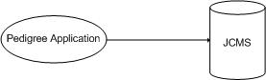
Figure 1 JMCS Pedigree overview

High Level Processes
- Find Parents
- Find Children
- Find Siblings
- List all Children
- Find Mouse Information
- Install Application
- Remove Application

Data
- Mouse Table
- Mating Table
- Litter Table
- Genotype Table
- Strain Table

Subsytems
Below we discuss the necessary systems to develop this application fully. Consider the follow map of the subsystems.

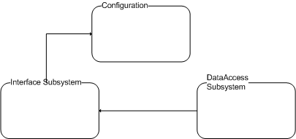
Figure 2 Subsystem Map

Data Access Subsystem
The data access class will be an abstraction of the following technologies giving the JPT application the ability to refractor the underlying query system with out rewriting the entire application.

JDBC { JDBC to ODBC bridge/ MySQL Connect}
The tried and true method may be the most practical choice.

GUI Subsystem
The gui layer should be a data independent layer of code that once started has no interaction with the Configuration Subsystem and relies on the Data Access layer to retrieve data to populate the user interface.

The gui layer will be implemented with Java Swing or similar Technology. The technology must be able to represent a hierarchal tree in order to provide the work flow described in this document

Configuration
The main function of the program will need to do some very simple configuration, weather this is done by the a configuration file or command line parameters certain information about the system is necessary to be defined for application execution.

Configuration options
- What type of computer are we on (Derived by Code)
- If not Window, then MySQL only.
- What type of database do we want to talk to
- MySQL
- MsAccess
- Where is the database we want to talk to
- Computer name
- Port
- File

- Database Credentials
- User name
- Password.

Configuration update
Once installed the user will need to be able manipulate and modify configuration options. This may be done via a gui app or hand editing a text file.

Context

The JPT application is a user application that interacts with the JMCS database system to provide the user with ability to navigate the Parent Child hierarchy that is inherent in the JCMS database. Being a standalone application it does not have the constraints of being tied directly to a single technology or architecture. However the integration point to JCMS is, that would be the mechanisms to retrieve data from either MsAccess or MySQL databases.

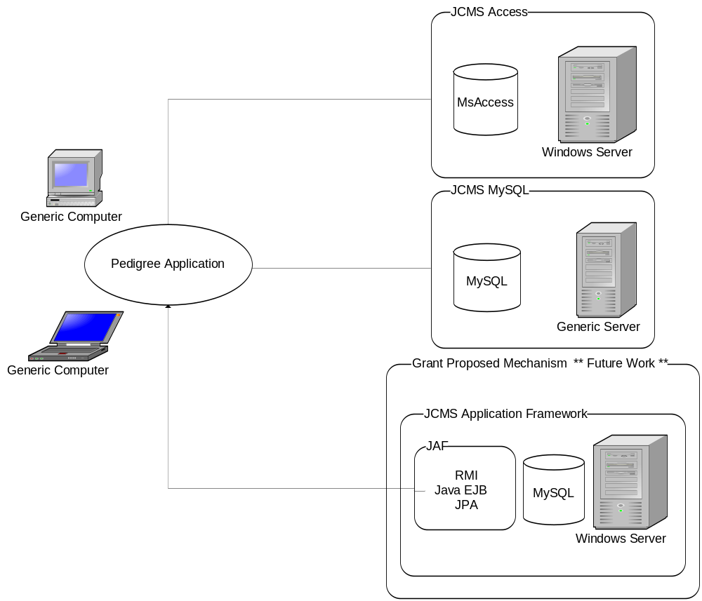
Figure 3 Context View

The JPT needs to have the extendibility to meet current needs and the flexibility to be upgraded to take advantage of future initiatives. One such initiative would be to connect to the proposed JCMS Application Framework..

Requirements Summary
For the JPT to be a successful application it will need to integrate with current JCMS database regardless if it is MySQL or MSAccess hosting the data. In addition it will need to be able to navigate up the hierarchy by listing parents and down the hierarchy by listing children of any given mouse. For any specific mouse ID the application will need to display specific information about the mouse to Aid the user in navigation. Listed below are links to all the requirements that area application specific. In other words the general requirements for the application that define the application!

Functional Requirements Summary
5.1 Mouse Data
5.2 Deviant Search
5.3 Progeny Search
5.4 Progeny Report
5.12 Parent Report
5.5 Install Package

Performance Requirements Summary
5.6 Progeny Report Performance
5.13 Progeny Report Performance a Second Option

Usability Requirements Summary

Reliability, Availability, Serviceability Requirements Summary

Portability Requirements Summary
5.7 JPT Portability

Localization Requirements Summary

Testability Requirements Summary

Maintainability Requirements Summary
5.9 JCMS No Version
5.10 JCMS Version Checking

Security Requirements Summary
5.14 No user security

Extendibility Requirements Summary

Alternatives Considered and Rejected
5.11 JPT Extensibility
5.15 User security credentials
5.8 Localization and Globalization

Process Model

Process Hierarchy Chart

Functional Cross Reference

Use-Case List
5.2.2 Deviant Search
5.3.2 Progeny Search
5.4.2 Progeny Report
5.5.2 Install Package
5.12.2 Parent Report

Use-Case Cross Reference

Data Inventory

Data Classes/Entities

Data Class/Entity Relationships

Data Element List

Data Element Cross Reference

External Entity Descriptions

Data Access Subsystem

The Data Access Layer is basically an abstract class that exposes the necessary interactions between the GUI subsystem and the underlying databases. The GUI will ask the Data Access system or layer for data and will get the data requested. All the detail of Connecting, Querying the database are abstracted away from the GUI subsystem

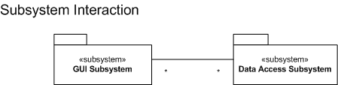
Figure 4 GUI / DataAccess Subsystems

Once the Data Access system is instantiated the GUI execute functions on the instance of this Data Access object and will not need to know anything about MsAccess or MySQL.

Data Access Requirements Summary
The data access subsystem must retrieve data form JCMS database hosted either in Microsoft Access or MySQL.

Functional Requirements Summary
6.1 Connect to MySQL
6.2 Connect to MsAccess

Performance Requirements Summary

Usability Requirements Summary

Reliability, Availability, Serviceability Requirements Summary

Portability Requirements Summary

Localization Requirements Summary

Testability Requirements Summary
6.4 Data Access Unit Test

Maintainability Requirements Summary

Security Requirements Summary

Extendibility Requirements Summary

Alternatives Considered and Rejected
6.3 Data Access Abstraction

Process Model

Data Flow Diagrams

Function Descriptions

Use-Case Descriptions

Data Structures Descriptions

External Entity Descriptions

GUI Subsystem
The Graphical User Interface subsystem will be the interaction between the JPT application and the end user. It will be not directly read/write data to the configuration subsystem and it will not directly read data from the database. By abstracting these functions will allow a high degree of maintainability and flexibly. The interface will localize all visual text on the form, this includes labels button captions it does not include the text derived from the database. The corresponding resource files per supported language. The only supported language for this release will be US English.

GUI Requirements Summary
The graphical interface must allow for the selection of a MouseID, retrieve pertinent information for that mouse ID, and display the Ancestors or Dependences of that MouseID. In addition a report can be created for a specific mouse ID with similar information in the report.

Functional Requirements Summary
7.1 Interfaces with Configuration Subsystem
7.2 Interfaces with the Data Access Subsystem
7.4 Select Mouse
7.5 Select Population Algorithm
7.6 Select MouseID in tree
7.7 Mouse Tree Navigation
7.8 Open Report Dialog
7.9 Generate Report
7.10 Cancel Report
7.11 G Button
7.12 Alternate Mouse Tree Text
7.14 Make Mouse Tree Node information optional.
7.15 Add Mouse Tree Node information.

Performance Requirements Summary

Usability Requirements Summary

Reliability, Availability, Serviceability Requirements Summary

Portability Requirements Summary

Localization Requirements Summary

Testability Requirements Summary

Maintainability Requirements Summary

Security Requirements Summary

Extendibility Requirements Summary

Alternatives Considered and Rejected
7.3 Localization Testing
7.13 Mouse Tree Filters

Process Model

Data Flow Diagrams

Function Descriptions

Use-Case Descriptions

Data Structures Descriptions

External Entity Descriptions

Configuration Subsystem
The configuration subsystem is simply the repository of application parameters and the code necessary to retrieve this information at run time. Information like database location and type needs to be configurable due to the requirement of supporting multiple databases.

Configuration Subsystem Requirements Summary
The configuration sub system needs to be able to configure the location, credentials and type of the database. In addition application parameters for Report type, Report Depth and Mouse Tree Depth.

Functional Requirements Summary
8.1 Application Configuration
8.2 User Configuration

Performance Requirements Summary

Usability Requirements Summary
8.3 Configuration Usability

Reliability, Availability, Serviceability Requirements Summary

Portability Requirements Summary
8.4 Configuration Portability

Localization Requirements Summary

Testability Requirements Summary
8.5 Configuration Unit tests

Maintainability Requirements Summary
8.6 Configuration Maintenance

Security Requirements Summary

Extendibility Requirements Summary

Alternatives Considered and Rejected
8.7 Hash Passwords

Process Model

Data Flow Diagrams

Function Descriptions

Use-Case Descriptions

Data Structures Descriptions

External Entity Descriptions

Application Requirements

Mouse Data

Requirement Number | 001
Requirement Type | Functional Requirement
Requirement Grade | A
Requirement Dependency
Requirement Status | Accepted

The JPT application will assist in the discovery of Deviants, by displaying information about a single mouseID.

Requirement stated
Given a mouse ID, the following information will be displayed.

Information to be displayed for each individual mouse:
- ID
- birthDate
- exitDate
- cod
- codNotes
- generation
- sex
- owner
- origin
- protocol
- comment
- Litter Mates
- Strain
- Genotype Information
- Mating ID
- Litter ID

Data Map

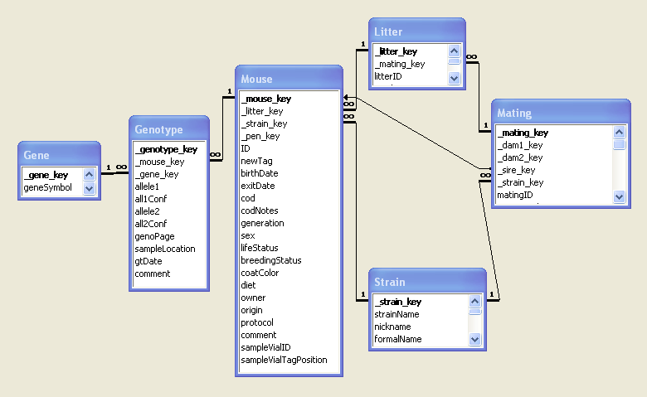
Figure 5 JPT Data Map

Deviant Search

Requirement Number | 002
Requirement Type | Functional Requirement
Requirement Grade | A
Requirement Dependency
Requirement Status | Accepted
The purpose of this application is search for the origin of mouse found to have a mutation. The mouse which is the origin of the mutation is the called the deviant. A deviant search is the process of looking the parents of a given mouse to determine whether they have the same characterizes.

Requirement stated

Giving any mouse ID the application will query the JCMS database and construct a tree representing the parents.

Note: a NULL set is possible and valid.

UseCase

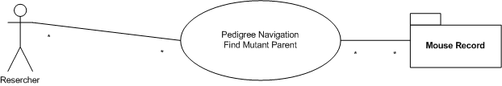
The researcher actor needs to navigate the JCMS Mouse Mating Hierarchy to find candidates for the cause of the deviant phenotype. The resulting information the JPT application yields is a Mouse Record and information associated with that information.

Data map
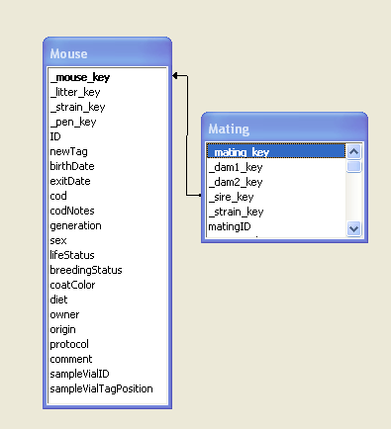
Figure 6 Parents Map

Progeny Search

Given a deviant mouse find all progeny, or children, for that mouse. These mice need to be identified to have them suitably classified.
Requirement Number | 003
Requirement Type | Functional Requirement
Requirement Grade | A
Requirement Dependency
Requirement Status | Accepted

Requirement stated
Giving any mouse.ID the application will query the JCMS database and construct a tree representing the progeny.

Note: a NULL set is possible and valid.

Use Case

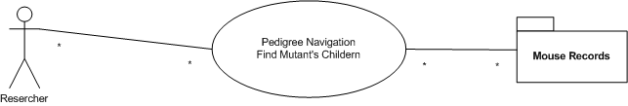

The researcher actor needs to navigate the JCMS Mouse Litter Hierarchy to find possible influence mice from the mutant. The resulting information the JPT application yields are a Mouse Records and information associated with that information.

Data map
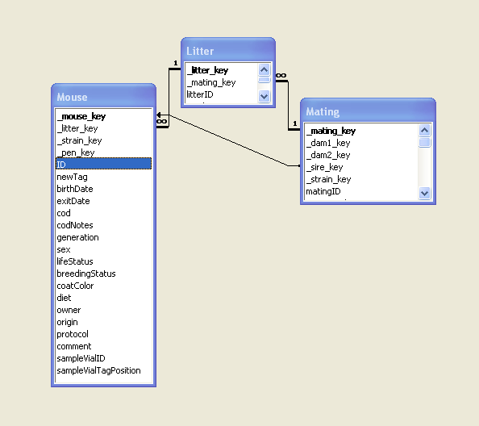
Figure 7 Children Data Map

Progeny Report

Requirement Number | 004
Requirement Type | Functional Requirement
Requirement Grade | B
Requirement Dependency | 5.6, 5.13
Requirement Status | Accepted

The Progeny Report is a simple report for all the children of a single mouse. The Report will be either Text or HTML and user selectable. The users choose will be stored in the configuration subsystem. The default will be Text
.

Requirement stated
The Progeny report will print out all generation (See Performance Requirements) for a given mouse. The empty or NULL set is possible and valid.

Use Case

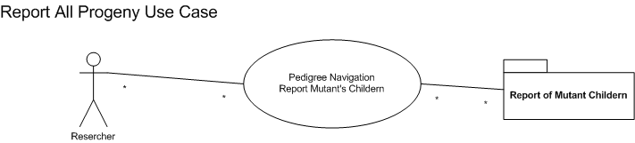

In some cases the Research may want a printed report of all the mice that are in the blood line for a given mouseID. In this situation the application will print a simple text file listing all the progeny for a give mouse.
Note: The NULL set is possible and valid.
Note: This could take a large amount of time depending on the database.

Data flow

Diagram example of the report

Should Mouse ID reflect the ID, Mating ID and Litter ID.

Text Report

MouseID [GenoType : Strain ]
| MouseID [GenoType : Strain ]
| | MouseID [GenoType : Strain ]
| | MouseID [GenoType : Strain ]
| | | MouseID [GenoType : Strain ]
| | | MouseID [GenoType : Strain ]
| | | | MouseID [GenoType : Strain ]
| | | | MouseID [GenoType : Strain ]
| | | MouseID [GenoType : Strain ]
| | MouseID [GenoType : Strain ]
Figure 8 JPT Text Report

HTML Report
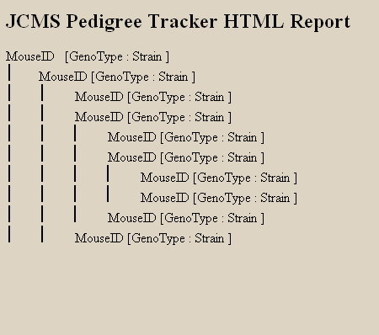
Figure 9 HTML Report

Install Package

Requirement Number | 005
Requirement Type | Functional Requirement
Requirement Grade | A
Requirement Dependency | 8.3 Configuration Usability
Requirement Status | Accepted

The application needs some initial configuration and system validation. The best way to do this will be to create an Installer that recognizes the system, determines Java configuration and as the capability to prompt user for configuration options.

Requirement stated
The JPT application will be installed to the local computer and short cuts created.

Details
In the Java environment it is important to define installed as the downloading of the application, short cut create to start the application utilizing local machine JVM.

Points of interest:
- If possible have installer determine JVM installed or not and point to sun to download jre.
- If possible have the installer start the JPT for configuration.

Use Case

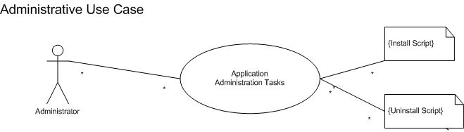

The application needs to run on a computer that has a JAVA virtual machine and access to a JCMS database. Configuration Information needs to be collected and saved so the application can launch and run.

The configuration details are described by section 8 Configuration View Requirements.

Progeny Report Performance

Requirement Number | 006
Requirement Type | Performance Requirement
Requirement Grade | B
Requirement Dependency | Progeny Report, 5.004
Requirement Status | Accepted

The Progeny Report requirement has the possibility to consume the application and all the resources the Java JVM is allowed to consume. Thus the Progeny Report will be implemented by a background worker thread.
A window will be popped non model window will be popped up to give the user feedback.
This window will also have the ability to cancel the operation.
The application will immediately stop and close open file when a memory exception is encountered.

Exception:
Memory Exception may occur depending on the combination of tree depth and memory of a given computer.

The number of levels allowed to report on is defined in the configuration subsystem Section 8, in particular section 8.2 report tree depths!

Requirement stated
The Progeny Report will be cancelable.

Details
This implies a work thread be spun off to do the report work.

JPT Portability

Requirement Number | 007
Requirement Type | Portability Requirement
Requirement Grade | B
Requirement Dependency
Requirement Status | Accepted

Funding organizations are given preference to systems that are open source and provide functionality to a wide range of users. To do this we are using javaSE with connectivity options to the JCMS database.

Requirement stated
The JPT application will install and run on Mac OS/X and windows XP

Details
There will be no special limitation made to prevent this use of this application from Linux, BSD or other e operation systems. They will most likely not be tested. This will be accomplished utilizing tools that accomplish this; however this requirement does not signify the necessity to fully test all Operating systems.

Localization and Globalization

Requirement Number | 008
Requirement Type | Localization Requirement
Requirement Grade | B
Requirement Dependency
Requirement Status | Not Accepted

The JCMS user base is World Wide and we have had multiple requests to convert existing application to Language specific versions.

Requirement stated
The JPT application will support localization mechanism inherent in the JavaSE architecture {Not exactly sure what that is.} At least two Languages will be support for test of functionality.

Details
This requirement only speaks to the mechanism to support multiple languages. In order to test this there will be at least two sets of strings.
The English language and strings will be developed.
A second language will be configured, German, the strings will be the English strings with ** at the beginning of the string.

The justification for taking this approach is the relative little effort need to add it at the beginning of the project versus the large expense associated with refactoring an existing application with out localization support.

JCMS No Version Checking

Requirement Number | 009
Requirement Type | Maintenance Requirement
Requirement Grade | C
Requirement Dependency | Conflicting Req with 5.10
Requirement Status | Accepted

Requirement stated
The JPT will not query the dbSetup table for specific version of JCMS to run against.

Details
Since the application is a stand along application that will work on many of the version of the schema, enforcing versioning compliance will generate more User Support for a very busy JCMS team. Instead the application should validate it can find the Mating, Mouse, and Litter tables and the necessary information with them.

JCMS Version Checking

Requirement Number | 010
Requirement Type | Maintenance Requirement
Requirement Grade | C
Requirement Dependency | Conflicting Req with 5.09
Requirement Status | Not Accepted

Per Chuck’s request, consider the requirements 5.10 and 5.09 and the pros and cons for each.
The JPT application will not work with JCMS systems older then version 2.8.1 and will display the version of the database on the use interface.

Requirement stated
The JPT Application will query the JCMS database and retrieve the version number from the DBInfo table the version must be 2.8.1 or greater.

Exceptions
- Exception { Exception Action; Message}
- JCMS Application is too old {Display Message: “Please consider upgrading to latest version of JCMS.”
- Unable to determine JCMS Version {Display Message; “Please verify database configuration”}

JPT Extensibility
Remove this Requirment ….
Requirement Number | 011
Requirement Type | Extensibility Requirement
Requirement Grade | B
Requirement Dependency | N/A
Requirement Status | Not Accepted

Not to be considered in the course of this project.

This application if the first JCMS feature that is to utilize the JCMS database but to be developed out side of Microsoft Access database. It is important that the code writing for this application will be easily refactored to work with proposed JAF. This means the data mechanisms should be abstracted from the GUI.

Requirement stated
The JPT application will be architected with well defined encapsulation.

Details
This is not a testable requirement, these concepts will be validated via design and code reviews. The issues surround this will be database base encapsulation, application configuration encapsulation, and automated unit testing for these layers. This abstraction allows for Unit tests written and executed against this code.

Parent Report

Requirement Number | 012
Requirement Type | Functional Requirement
Requirement Grade | A
Requirement Dependency | 5.006
Requirement Status | Accepted

The Parent Report is a simple report for all the parents of a single mouse.

Requirement stated
The Parent report will print out all previous generation (See Performance Requirements) for a given mouse.

The empty or NULL set is possible and valid.
This could take a large amount of time depending on the database.

Details
The Report will be either Text or HTML and user configurable. If the user does not configure or removes configuration, a text report will be generated.

Use Case

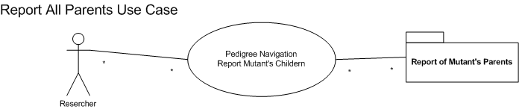

In some cases the Research may want a printed report of the pedigree a given mouseID. In this situation the application will print a simple text file listing all the progeny for a give mouse.

Data flow
Diagram Data query, need to firm up the possible display data. Also not in diagram the output of the file.
See Figure 9 HTML Report for an example output.

Progeny Report Performance a Second Option

Requirement Number | 013
Requirement Type | Performance Requirement
Requirement Grade | B
Requirement Dependency | Competing Requirement, 5.006
Requirement Status | Accepted

The Progeny Report requirement has the possibility to consume the application and all the resources the Java JVM is allowed to consume.

Requirement stated
The Progeny/Parent Report will be implemented to report N number of generations.
The users may need to generate many reports to get the desired set of mice reported.

Details
This implies:

The number of generations the tree has is an option.
It can be configured by the user.
It has a predefined maximum value determined by configuration subsystem that cannot be overridden. In other words the default number of generations will be 3 and can be increase to 10.

No user security

Requirement Number | 014
Requirement Type | Security Requirement
Requirement Grade | C
Requirement Dependency | Conflicting requirement 5.15
Requirement Status | Accepted

The JCMS application allows for all of its users to view any data in the database. With that in mind JPT will be a read only application it will not consider users name and password credentials.

Requirement stated
The JPT application will not query user for database credentials.

User security credentials

Requirement Number | 015
Requirement Type | Security Requirement
Requirement Grade | C
Requirement Dependency | Conflicting requirement 5.14
Requirement Status | Not Accepted

The JPT application will query the JCMS.mdw file for user security. All user information regardless of database is stored in the Microsoft Access mdw file.

Requirement stated
The JPT will collect the username and password from the user and query the JCMS .mdw file.

Issues
This one requirement will force windows only. The only way to configure what .mdw file to utilize is to configure the proper file in the “ODBC Datasource Administrator”. This would remove the ability to utilize the JPT on Mac or Linux regardless of what database backend is used.

Data Access Subsystem Requirements

Connect to MySQL

Requirement Number | 001
Requirement Type | Functional Requirement
Requirement Grade | A
Requirement Dependency
Requirement Status | Accepted

In order for the application to connect to current JCMS database it will need to connect to a MySQL database.

Requirement stated
The JPT application connects MySQL database.

Details
Necessary Options
MySQL Host Name [remote computer name] [Default localhost]
MySQL Port [xxxx] [Default 3306]
MySQL User Name [username]
MySQL Password password

Connect to MsAccess

Requirement Number | 002
Requirement Type | Functional Requirement
Requirement Grade | A
Requirement Dependency
Requirement Status | Accepted

In order for the application to connect to current JCMS database it will need to connect to a MsAccess.

Requirement stated
The JPT application connects MsAccess database.

Details
Necessary Options

ODBC
DSN Name ->
FileName,
User,
Password
Data Source configuration. ( Give Examples )

Data Access Abstraction

Requirement Number | 003
Requirement Type | Extensibility Requirement
Requirement Grade | C
Requirement Dependency | 6.001, 6.002, 5.001-5.004,5.006,5.012, 5.013
Requirement Status | Not Accepted

The GUI should not have to deal with any issues of the database configuration or the particular way in which it gets data from the data. Abstracting that away to a common interface or abstract class will allow for the addition and subtracting of data stores without code modifications to the application.

This is a design axiom decision not a requirement!

Requirement stated
The JPT will utilize the concept of an abstract class (implemented by an abstract class or interface).

Implementation Classes

Currently an implantation class will be created for MySQL Communication and MsAccess Communication.

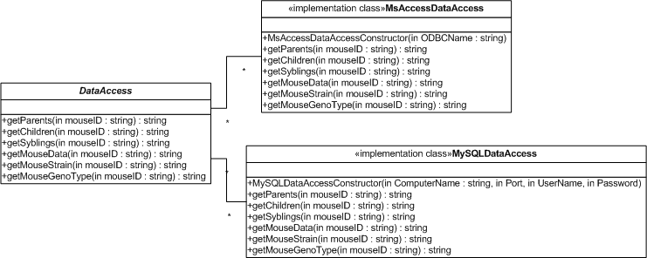
Figure 10 Data Access Class Diagram

Data Access Unit Test

Requirement Number | 004
Requirement Type | Testable Requirement
Requirement Grade | C
Requirement Dependency | 003
Requirement Status | Accepted

By abstracting the data access into one interface, the developer can effectively utilize UnitTesting as a means to insure stability, availability, and quality of the data access code.

Requirement stated
The data access layer will include unit test for the following configurations and functions.

Details
By virtue of working with JCMS, the JPT application will need to work with the following configurations.

Configurations:
MsAccess
MySQL local host
MySQL remote host.

The above configurations test the implantation class’s constructors. In addition the unit tests should implement/test the following functions.

Functions:
getParents( strMouseID)
getChildren ( strMouseID)
getSyblings( strMouseID )
getMouseData(strMouseID)
getMouseStrain(strMouseID)
getMouseGenoType(strMouseID)

GUI View Requirements

Interface with Configuration Subsystem

Requirement Number | 7.1.001
Requirement Type | Functional Requirement
Requirement Grade | C
Requirement Dependency
Requirement Status | Accepted

Application parameters need to be read from Configuration subsystem.

Requirement stated
The following application parameters will be read from the configuration subsystem.

ApplicationTreeDepthDefault
ReportTreeDepthDefault
ReportTypeDefault

Details
This does not imply the GUI must interact with the configuration layer at all. It simply states that values in the configuration/properties file will be represented in the GUI when the application starts up.

Interface with the Data Access Subsystem

Requirement Number | 002
Requirement Type | Functional Requirement
Requirement Grade | A
Requirement Dependency | 5.001-5.004
Requirement Status | Accepted

Requirement stated
The GUI retrieves all data from JCMS through the Data Access Subsystem.

Localization Testing

Requirement Number | 003
Requirement Type | Testing Requirement
Requirement Grade | B
Requirement Dependency | 5.008
Requirement Status | Not Accepted

If we use the infrastructure for localization, we need a way to determine that it is operating properly.

Requirement stated
The JPT application will implement two language strings, English and German.

The German set of strings will be English strings that begin with **

Select Mouse

Requirement Number | {004}
Requirement Type | Functional Requirement
Requirement Grade | A
Requirement Dependency
Requirement Status | {Accepted /

Describes the Work flow of the application interface, the application is loaded and no mouse data is visible.

Requirement stated
Selecting a Mouse ID from combo list, fills combo box and populates the tree controls with mice that represent progeny or ancestors of the selected mouse Id based on radio buttons.

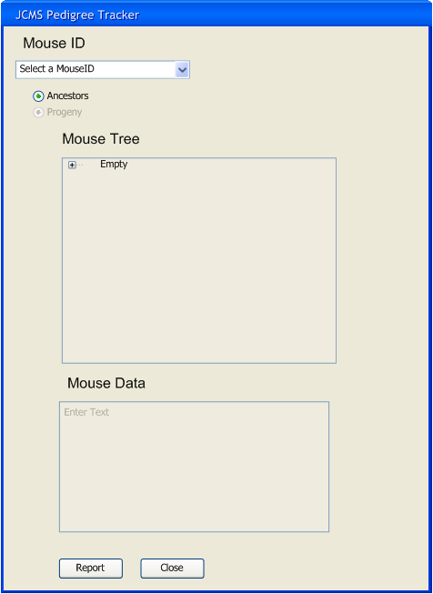
Figure 11 Initial Startup

Implementation detail look into hashing algorithm …

Select Population Algorithm

Requirement Number | 005
Requirement Type | Functional Requirement
Requirement Grade | A
Requirement Dependency | 5.002,5.003
Requirement Status | Accepted

The main application window is open and a mouse is selected, with the tree control populated.

Requirement stated
User Selects Progeny/Parents algorithm radio button, the tree control is emptied and redrawn based on new algorithm base on the mouse ID in the list box.

The default Radio button will be ancestor

Details
The NULL or empty set if valid.

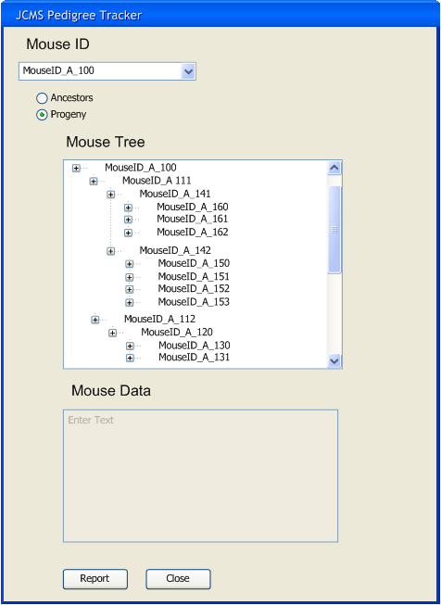
Figure 12 Select Algorithm

Select MouseID in tree.

Requirement Number | 006
Requirement Type | Functional Requirement
Requirement Grade | A
Requirement Dependency | 5.001
Requirement Status | Accepted

Mouse ID selected in list box, the tree control has been populated based on the algorithm determined by radio buttons.

Requirement stated
Select a mouseID in the tree control, the Mouse Data Text Box is populated.

Details

The data will be acquired from the data access layer and contain the information detail in Requirement 5.001

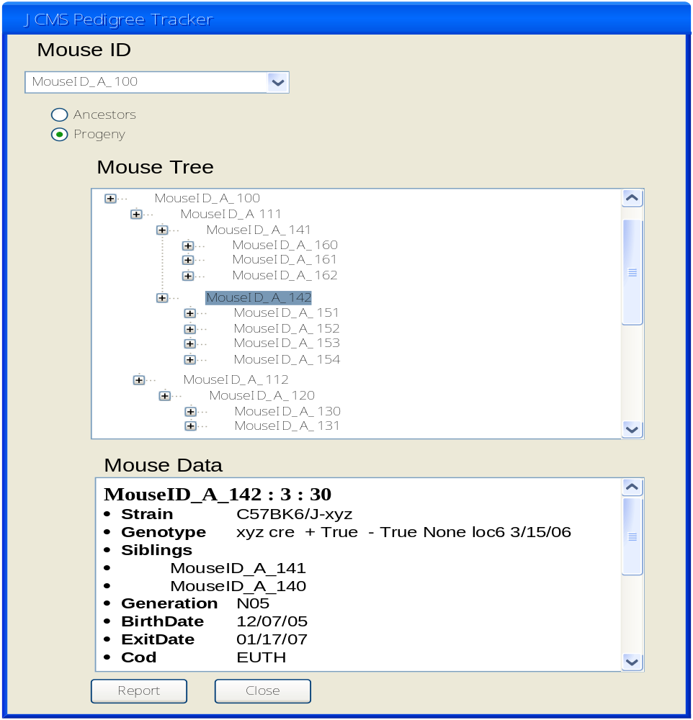
hFigure 13 Display Mouse Data

Mouse Tree Navigation

Requirement Number | 007
Requirement Type | Functional Requirement
Requirement Grade | A
Requirement Dependency
Requirement Status | Accepted

The mouseID Combo box is selected and application tree is populated.

Requirement stated
The user double clicks on a mouse ID in the tree control the mouse detail list is emptied, the tree controls is empted, the mouseID combox is populated with selected MouseID and tree control is redrawn.

NULL set is valid.

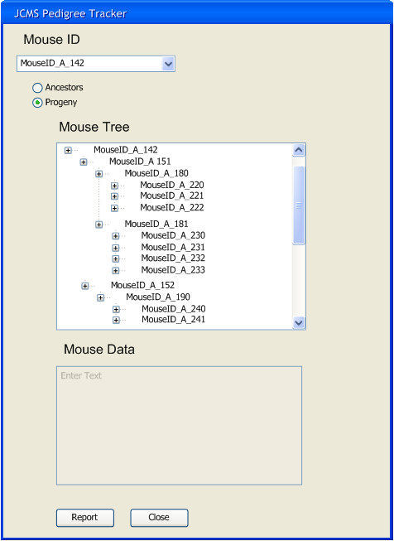
Figure 14 Hierarchy Navigation

Open Report Dialog

Requirement Number | 008
Requirement Type | Functional Requirement
Requirement Grade | B
Requirement Dependency | 5.006, 5.012
Requirement Status | Accepted

With MouseID selected and population algorithm selected, the user clicks the report button.

Requirement stated
When report button pressed the Report Dialog pops up.

Details
The dialog will be pre-populated with
- MouseID
- Report algorithm
- Report type
- Number of generation.

Exceptions

- Exception { Exception Action; Message}
- MouseID not selected. {Display Message, Dialog not opened; “Select a Mouse ID}
- Report algorithm not selected. {Display Message, Dialog not opened; “Select a Ancestor or Progeny”}
- If Mouse tree is a NULL set. {Display Message, Dialog not opened; “Report will empty Select another Mouse ID”}

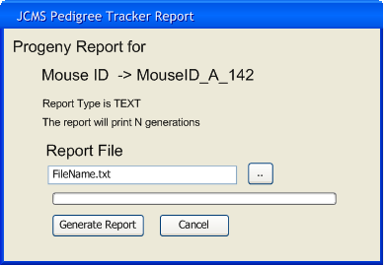
Figure 15 Report Dialog

Ancestor Generate Report

Requirement Number | 009
Requirement Type | Functional Requirement
Requirement Grade | B
Requirement Dependency | 5.006, 5.012
Requirement Status | Accepted

Report Window is open, the mouse ID is displayed the algorithm type is displayed, report type displayed.

Requirement stated
The User selects file for report, then clicks generate report.

Details
User selected file opened for writing.

Exceptions
- Exception { Exception Action; Exception Message}
- File Found {Display Message, Report does not start; “Please Select Another File” }
- Path not found {Display Message, Report does not start; “Path is invalid, please verify path and file name.”}
- Read only permission {Display Message, Report does not start; “Access denied, please verify path, file name and permissions” }
- Memory Allocation error {Display Message, Report stops and closes files; “Application running out of memory.”}

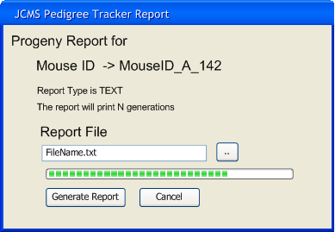
Figure 16 Generate Report

Cancel Report

Requirement Number | 001
Requirement Type | Functional Requirement
Requirement Grade | A
Requirement Dependency | 5.004,5.011,5.013
Requirement Status | Accepted

Due to user configuration or computer speed and memory the application can take a long time to generate report.

Requirement stated
The user has the ability to stop the report while it is executing.

Details
The user has the ability to stop the report anytime they see fit.
Figure 17 Cancel Report

Cancel button should have a “confirmation”

Also, prompt user that action has been canceld.

And put a warning in the gui to give them feedback. { put red text in ..}

Go Button

Requirement Number | 011
Requirement Type | Functional Requirement
Requirement Grade | B
Requirement Dependency | Conflicts 7.004
Requirement Status | {Accepted / Not Accepted}

Chuck requested a Go Button. The thought is the users will not know what to do if a mouse is selected and it takes time for the tree to load.

Requirement stated
The User will select a Mouse ID in combobox and click the “Go” button to populate the Mouse Tree.

Details
NULL set is possible and a valid set for the Mouse Tree.

Revisit this with Chuck @ later date!

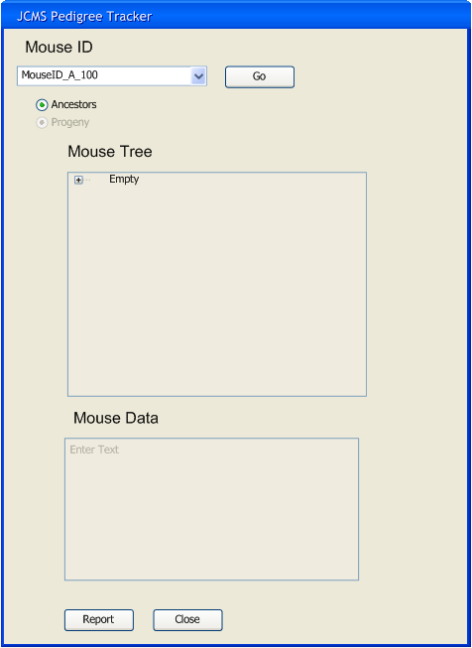
Figure 18 Go Button

Alternate Mouse Tree Text

Requirement Number | 012
Requirement Type | Functional Requirement
Requirement Grade | B
Requirement Dependency | 7.005
Requirement Status | Accepted
Chuck feels that the Mating ID or Mating ID and Litter ID should be displayed in the tree control. This pretty much a Chuck directive, a desirement would be to allow for matting ID and Litter ID to be optionally added or removed from the user interface.

Requirement stated
Each node in Mouse tree will display the MouseID, MatingID and if a progeny tree the LitterID also.

Details
The Ancestors are derived from the mouse and Mating records only. Thus the Ancestor tree would display the MouseID : Mating ID.

The Progenies are derived from the mouse, mating and litter records. As a result they display Mouse ID : Mating ID : Litter ID
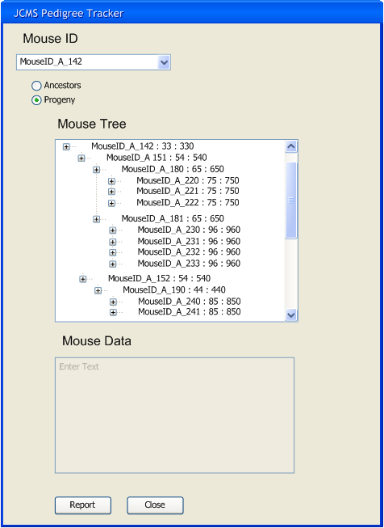
Figure 19 Alternate Tree Node Text

Mouse Tree Filters

Requirement Number | 013
Requirement Type | Functional Requirement
Requirement Grade | C
Requirement Dependency
Requirement Status | Not Accepted

Michael McFarland proposes to filter the mouse tree by Sex, genotype or strain.

Requirement stated
The JPT will interpret filters when populating the MouseID listbox, and The JPT will interpret filters when populating the Mouse Tree.

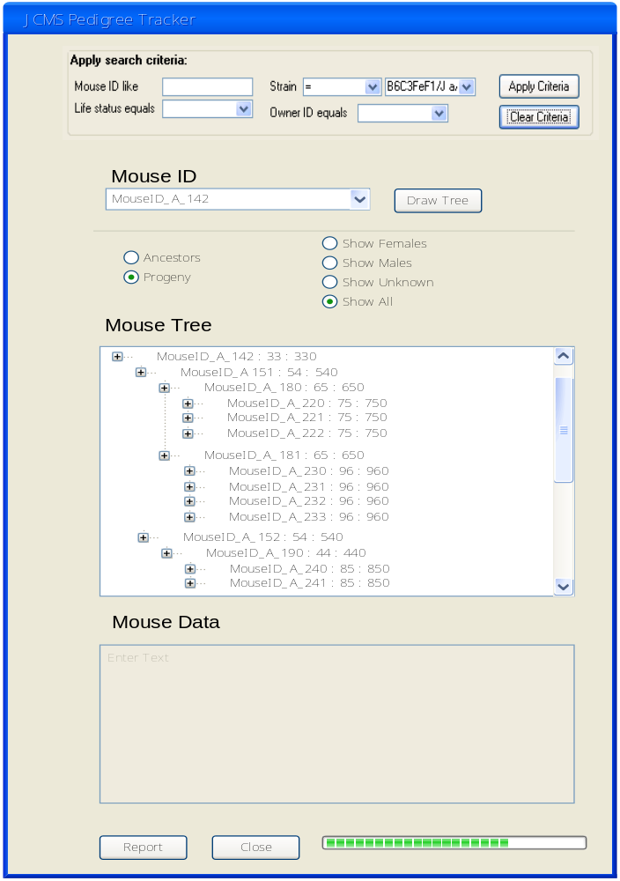
Figure 20

Details:
Need to filter the list of Mice.
Also filter out the Sex

Make Mouse Tree Node information optional.

Requirement Number | 014
Requirement Type | Functional Requirement
Requirement Grade | A
Requirement Dependency | N/A
Requirement Status | Accepted

The JPT Application will allow optional information to be added to the Mouse ID in the Mouse Tree control.

Utilizing check boxes the user will be able to select and unselect information they wish to add or remove from each sub-node in the mouse tree.

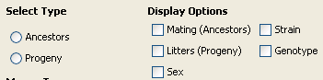
Figure 21 -- Display Options

When the application first opens the default selections will be that is observed in Figure 1.

Testing Considerations:

First verify the defaults are set when applications opens, the defaults will draw the mouse tree as it does in version 1.0.0.

Next Verify each check box and be selected and deselected.

Add Mouse Tree Node information.

Requirement Number | 02
Requirement Type | Functional Requirement
Requirement Grade | A
Requirement Dependency | {N/A}
Requirement Status | Accepted

When the mouse tree is drawn display the corresponding information listed in the checkboxes. The displayed data will be separated by colons.

Displayed Data
- Mating – “ M MatingID”
- Litter – “ L LitterID”
- Strain – “ S StrainName”
- Genotype – “ Gt gene allele1/allele2“
  - Null Genotype, “ Gt / “
  - Multiple Genotype, “ Gt gene allele1/allele2 ...“
- Sex -- “ Sex SexChar”

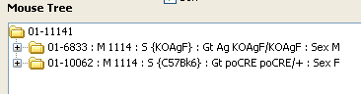
Figure 22 -- Ancestor Results

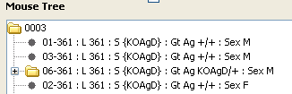
Figure 23 -- Progeny Results

Technically:
The Draw event evaluates the check boxes producing a bit mask which is set on the Data Subsystem by the setDisplayOptions method which passes a byte variable representing the bitmask for the display options. The values for the Bit Mask are imported from the Abstract Class DataAccess via the import static mechanism. This way the bit value math is done with these constants rather than the actually bit values.

Testing Notes:
- Verify if nothing selected a tree of mouse IDs is generated.
- Verify Mating ID is only displayed with an Ancestor tree.
- Verify Litter ID is only displayed with a Progeny tree.
- Verify tree can be displayed with all check boxes selected.

Configuration View Requirements

Application Configuration

Requirement Number | 001
Requirement Type | Functional Requirement
Requirement Grade | A
Requirement Dependency | 6.1, 6.2
Requirement Status | Accepted

Due to the fact that JCMS runs on multiple databases and the JPT application is a separate application from the JCMS, the application needs to be able to change the configuration. This includes the location, type of database and or permissions to the database.

Requirement stated
The user must have the ability to configure the connection information for the particular JCMS database they wish to use.

Details
Data Require:
DataBaseType [MySQL] [ODBC]
If not [MySQL] or [ODBC] then exception on startup!

MySQL Information:
MySQL Host Name [remote computer name] [Default localhost]
MySQL Database Name [jcms_db]
MySQL Port [xxxx] [Default 3306]
MySQL User Name [username] [Default root]
MySQL Password password
If DataBaseType = “MySQL” then this collection of information is used to connect to database.
If unable to connect to database exception is thrown.
If success no errors thrown.

MsAccess Information:
OLEDB
File Name, User, Password

Or

ODBC
DSN Name -> FileName, User, Password configured in the Data Source configuration.
If DataBaseType = “MsAccss” then this collection of information is used to connect to database.
If unable to connect to database exception is thrown.
If success no errors thrown.

Exceptions
- Exception { Exception Action; Exception Message}
- Database Type Invalid {Display Message, Close App; “Database Type Invalid, please configure in jpt.properties file”}
- Database Type Invalid for this computer{Display Message, Close App; “Database Type Invalid, please configure in jpt.properties file”}

User Configuration

Requirement Number | 002
Requirement Type | Functional Requirement
Requirement Grade | B
Requirement Dependency
Requirement Status | Accepted

The user needs to be able to configure applications settings. These setting are the default behavior the application will take when doing specific tasks.

Requirement stated
The user will have the ability to configuration application parameters.

Details

ApplicationTreeDepth = Number of generations the mouse tree control will display.
If not integer exception will occur on startup.
If integer is 0 or less exception will occur.
If integer larger then 10 warning will be displayed.

ReportTreeDepth = Number of generations the mice the report will display.
If not integer exception will occur on startup.
If integer is 0 or less exception will occur.
If integer larger then 20 warning will be displayed.

ReportType = [HTML] [TEXT]
If not HTML or TEXT exception will occur on startup.

Exceptions
- Exception { Exception Action; Exception Message}
- ApplicationTreeDepth Invalid {Display Message, Close App; “Application Tree Depth is Invalid, please configure in jpt.properties file”}
- Report Tree Depth Invalid {Display Message, Close App; “Report Tree Depth is Invalid, please configure in jpt.properties file”}
- Report Type Invalid {Display Message, Close App; “Report Type is Invalid, please configure in jpt.properties file”}

Configuration Usability

Requirement Number | 003
Requirement Type | Usability Requirement
Requirement Grade | B
Requirement Dependency | 001, 002
Requirement Status | Accepted

Typically usability requirement refer to the issues surrounding special needs individuals. This could easily be a functional requirement.

Requirement stated
The user has a graphical user interface to manipulate configuration data.

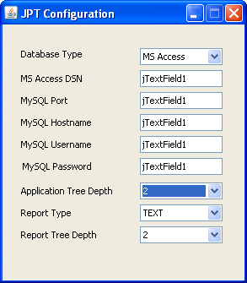
Figure 24 Configuration UI

Configuration Portability

Requirement Number | 004
Requirement Type | Portability Requirement
Requirement Grade | B
Requirement Dependency | 5.007
Requirement Status | Accepted

The JPT application is required to operate on multiple environments. The configurations for the application need to be in highly portable data store.

Requirement stated
The JTP configuration must be stored on a text file.

Options:
INI configuration file
Conf configuration file
XML configuration file

Configuration Unit tests

Requirement Number | 005
Requirement Type | Testability Requirement
Requirement Grade | C
Requirement Dependency | 004
Requirement Status | Accepted

The abstraction of the configuration data will allow for automated uniting.

Requirement stated
The configuration layer will include unit test that will confer the following functions.

Read Configuration data store.
Write Configuration data store.
Validate Configuration data.

Configuration Maintenance

Requirement Number | 006
Requirement Type | Maintenance Requirement
Requirement Grade | A
Requirement Dependency
Requirement Status | {Accepted / Not Accepted}

Encapsulating the configuration subsystem it allows for re-factoring the subsystem to another data store without maintenance in other parts of the application.

Requirement stated
The Configuration subsystem will be implemented in a class that will encapsulate the Read, Write and some validation functions.

Hash Passwords

Requirement Number | 006
Requirement Type | Security Requirement
Requirement Grade | C
Requirement Dependency
Requirement Status | Not Accepted

For security purposes we should not store passwords. In the case of Access the password is stored in the ODBC DSN and is obscured there. In the Case of MySQL we store the password in a file.

Requirement stated
The JPT configuration layer will hash the MySQL password, before storing it.

Design Issues.

This may not be possible, it will depend if MySQL publishes their HASH algorithm and supports password validation with the hashed value.

The fall back position will be to have the user/administrator to create a read only user for the JCMS database.

Update History
The list of revisions as the documents lives through the life of the product.
- Original Draft 5/8/08
- Version 1.0 5/30/08
- Version 1.1 12/12/08

References

