📋 AI WhatsApp Chatbot Onboarding Kit
E-Commerce & Retail Brands
Industry Vertical: ecommerce | Premium homemade-style chikki — jaggery, peanuts, sesame & dry fruits
💡 INSTRUCTIONS FOR TENANT:
1. Fill in the fields and tables below with your company's actual data.
2. Do not modify the section header titles (e.g. [SECTION: BRAND & PROFILE]) as our AI parser uses them to bifurcate your data.
3. Once filled, save this document and upload it via the Admin Console. The AI engine will parse your menu, catalog, and FAQs into your live bot!

[SECTION: BRAND & PROFILE]
Parameter | Description & Constraints | Your Company Input (Fill Here)
Company Legal Name | Official registered company or entity name | TrooGood
Brand / Display Name | Public name displayed to WhatsApp users | TrooGood
Tenant ID / Code | Short unique identifier (lowercase, e.g. dlf, skyline) | troogood
AI Bot Name | Friendly name of your AI assistant | TrooGood
Brand Tagline | 1-2 sentence core value proposition | Premium homemade-style chikki — jaggery, peanuts, sesame & dry fruits
Official Website URL | Company website link | https://www.troogood.com
Customer Support Email | Official support or sales contact email | support@troogood.com
Support Phone Number | Official contact telephone with country code | +91 1234567891
WhatsApp Bot Number | Dedicated phone number to connect to WhatsApp bot | +91 XXXXXXXXXX
Business Working Hours | Daily operational hours (e.g. 09:30 AM - 06:30 PM) | 24/7 Automated Support

[SECTION: WHATSAPP MENU]
CRITICAL WHATSAPP INTERACTIVE BUTTON CONSTRAINTS:
• Title: Max 24 characters (e.g., 'Explore Properties', 'Track Order')
• Description: Max 72 characters (e.g., '2, 3 & 4 BHK apartments in Prime Whitefield')
• Section: Max 24 characters (e.g., 'Properties', 'Support')
Button Title (<=24 chars) | Description (<=72 chars) | Category Section | Action Mapping
Browse Catalog | Explore latest collections, deals & new arrivals | 🛍️ Shop | offerings
Track My Order | Real-time delivery status & courier tracking | 📦 Orders | track_order
Returns & Refunds | Initiate return or replacement within 7 days | 📦 Orders | returns
Exclusive Offers | Discount coupons & seasonal festival promos | 🏷️ Deals | faq
Customer Support | Chat with a support agent regarding order queries | 🆘 Help | raise_ticket

[SECTION: CATALOG & OFFERINGS]
Image URL column: paste a public https link to the product/property photo (JPG/PNG/WebP). Leave blank if none. On publish, images are stored on the offering and shown in chat/catalog.
Product Name | SKU | Category | Price (₹) | Discount Price | Key Specifications / Size | Stock Status | Warranty / Returns | Image URL
Classic Peanut Chikki | TG-CHK-001 | Chikki | ₹149 | ₹129 | Jaggery + roasted peanuts, 200g pack | In Stock | 7-Day Easy Return | https://images.unsplash.com/photo-1599599810769-bcde5a160d32?auto=format&fit=crop&w=800&q=80
Sesame Jaggery Chikki | TG-CHK-014 | Chikki | ₹159 | ₹139 | Til + jaggery bars, 200g pack | In Stock | 7-Day Easy Return | https://images.unsplash.com/photo-1606313564200-e75d5e30476c?auto=format&fit=crop&w=800&q=80
Dry Fruit Energy Chikki | TG-CHK-022 | Chikki | ₹249 | ₹219 | Almonds, cashew, dates & jaggery, 180g | In Stock | 7-Day Easy Return | https://images.unsplash.com/photo-1504674900247-0877df9cc836?auto=format&fit=crop&w=800&q=80
Millet Multigrain Chikki | TG-CHK-031 | Healthy Snacks | ₹199 | ₹179 | Ragi + jowar + jaggery, 200g | In Stock | 7-Day Easy Return | https://images.unsplash.com/photo-1498837167922-ddd27525d352?auto=format&fit=crop&w=800&q=80
[Enter Item] |  |  |  |  |  |  |  | [Paste https image URL]
[Enter Item] |  |  |  |  |  |  |  | [Paste https image URL]

Catalog images (embedded preview)
Classic Peanut Chikki — https://images.unsplash.com/photo-1599599810769-bcde5a160d32?auto=format&fit=crop&w=800&q=80

Sesame Jaggery Chikki — https://images.unsplash.com/photo-1606313564200-e75d5e30476c?auto=format&fit=crop&w=800&q=80

Dry Fruit Energy Chikki — https://images.unsplash.com/photo-1504674900247-0877df9cc836?auto=format&fit=crop&w=800&q=80
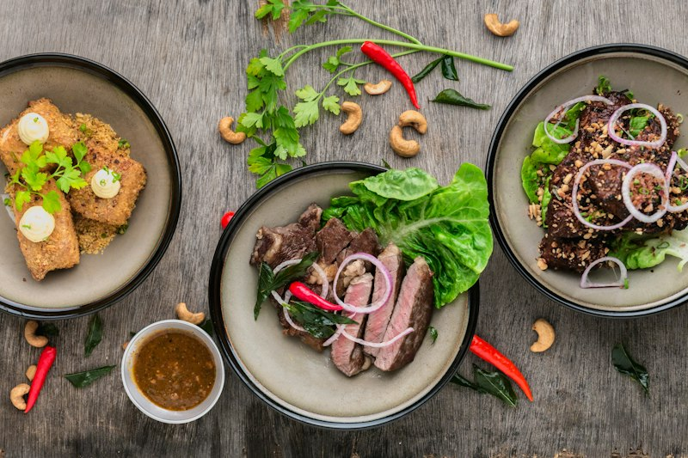
Millet Multigrain Chikki — https://images.unsplash.com/photo-1498837167922-ddd27525d352?auto=format&fit=crop&w=800&q=80


[SECTION: FAQS & POLICIES]
Frequently Asked Customer Question | Verified Official Answer | Topic / Category
What is your standard delivery timeline? | Metro cities: 2–3 business days. Tier-2/3 cities: 4–6 business days. Remote pin codes may take up to 8 days. Live courier tracking is shared on dispatch. | Shipping
How do I return a product? | Initiate return within 7 days of delivery via Returns & Refunds or by sharing your Order ID. We arrange free pickup within 48 hours for eligible SKUs. | Returns
What payment methods do you accept? | UPI (GPay, PhonePe, Paytm), credit/debit cards, net banking, wallets, and Cash on Delivery on eligible pin codes (COD fee may apply). | Payments
How do I track my active order? | Type Track Order with your 6-digit Order ID or registered mobile number. You will receive the courier AWB link and status. | Tracking
When will I receive my refund? | Refunds are processed within 5–7 business days after the returned item passes QC. UPI/card refunds go to the original payment method; COD refunds use UPI/bank transfer. | Refunds
Do you ship internationally? | Currently we ship within India only. International expansion is planned; join the waitlist via Customer Support. | Shipping
What is your exchange policy? | Size/color exchanges are allowed once within 7 days if the item is unused with tags. Stock availability determines exchange vs store credit. | Exchanges
Are products covered under warranty? | Warranty terms are listed per SKU (typically 1–2 years for electronics/accessories). Warranty covers manufacturing defects, not misuse or water damage unless stated. | Warranty
How do coupon codes work? | Enter the code at checkout. Coupons cannot usually stack with other promos unless marked Stackable. One coupon per order. | Offers
What if my package arrives damaged? | Refuse delivery if visibly damaged, or share unboxing photos within 24 hours. We arrange free replacement or full refund. | Damages
Can I cancel an order after placing it? | Orders can be cancelled free of charge until packed. After dispatch, convert to return after delivery. | Cancellations
Do you offer gift wrapping? | Gift wrap is available on select SKUs for a small fee. Add Gift Wrap in order notes or ask Support before dispatch. | Gifting
How is GST shown on invoices? | All prices are inclusive of GST unless marked otherwise. Tax invoices are emailed and available under Track Order. | Invoices
What pin codes support Cash on Delivery? | COD is enabled for most serviceable pin codes. Checkout will show COD availability; prepaid may be required for high-value or remote orders. | Payments
[Add Question]
[Add Question]
Knowledge Base Articles — longer policy / how-to pages indexed for chatbot retrieval (keep the Title / Category / Article Content columns).
Knowledge Article Title | Category | Article Content
Shipping, Delivery & Order Tracking Policy | Shipping | # Shipping & Tracking  Orders are processed within 24 hours on business days. Metro deliveries average 2–3 days; other regions 4–6 days. An AWB tracking link is sent on dispatch.  If a package shows Delivered but is missing, contact Support within 48 hours with photos of the delivery location. We coordinate with the courier for traces and resolution.
Returns, Exchanges, Refunds & Warranty | Returns | # Returns & Warranty  Most SKUs allow returns within 7 days if unused with original tags and packaging. Personal-care items may be non-returnable for hygiene once unsealed — check the product page.  Refunds complete in 5–7 business days after QC. Warranty covers manufacturing defects only; keep the invoice and serial number for claims.
Payments, COD, Coupons & Invoicing | Payments | # Payments & Offers  Accepted modes: UPI, cards, net banking, wallets, and COD where enabled. Coupon codes apply at checkout and usually do not stack.  GST-inclusive invoices are emailed automatically. For GSTIN business invoices, share your GST details in order notes before dispatch.

[SECTION: BOT PERSONA & GUARDRAILS]
Configuration Parameter | Bot Behavior / Value
Tone & Persona | Polite, consultative, crisp, and brand-aligned
Welcome Message | Welcome to TrooGood! How can I assist you today?
Strict Guardrails (Never-Do List) | 1. Never offer unauthorized discounts or unlisted pricing.  2. Never promise dates or legal commitments outside official brochure.  3. Never request passwords, OTPs, or credit card details.
Human Escalation Trigger | Escalate to live sales agent when user asks for 'human', 'agent', 'manager', or expresses grievance.

