📋 AI WhatsApp Chatbot Onboarding Kit
Tours & Travel Agency
Industry Vertical: tours_travel | Recognized by Gujarat Tourism (TCGL) | Customized Domestic & International Holidays
💡 INSTRUCTIONS FOR TENANT:
1. Fill in the fields and tables below with your company's actual data.
2. Do not modify the section header titles (e.g. [SECTION: BRAND & PROFILE]) as our AI parser uses them to bifurcate your data.
3. Once filled, save this document and upload it via the Admin Console. The AI engine will parse your menu, catalog, and FAQs into your live bot!

[SECTION: BRAND & PROFILE]
Parameter | Description & Constraints | Your Company Input (Fill Here)
Company Legal Name | Official registered company or entity name | 99 Destinations Holidays Pvt. Ltd.
Brand / Display Name | Public name displayed to WhatsApp users | 99 Destinations Holidays Pvt. Ltd.
Tenant ID / Code | Short unique identifier (lowercase, e.g. dlf, skyline) | 99destinations
AI Bot Name | Friendly name of your AI assistant | 99 Destinations Assistant
Brand Tagline | 1-2 sentence core value proposition | Recognized by Gujarat Tourism (TCGL) | Customized Domestic & International Holidays
Official Website URL | Company website link | https://www.99destinations.in
Customer Support Email | Official support or sales contact email | info@99destinations.in
Support Phone Number | Official contact telephone with country code | +91 7874833999
WhatsApp Bot Number | Dedicated phone number to connect to WhatsApp bot | +91 XXXXXXXXXX
Business Working Hours | Daily operational hours (e.g. 09:30 AM - 06:30 PM) | 10:30 AM - 07:30 PM (Mon-Sat)

[SECTION: WHATSAPP MENU]
CRITICAL WHATSAPP INTERACTIVE BUTTON CONSTRAINTS:
• Title: Max 24 characters (e.g., 'Explore Properties', 'Track Order')
• Description: Max 72 characters (e.g., '2, 3 & 4 BHK apartments in Prime Whitefield')
• Section: Max 24 characters (e.g., 'Properties', 'Support')
Button Title (<=24 chars) | Description (<=72 chars) | Category Section | Action Mapping
Holiday Packages | Domestic & international curated holiday packages | ✈️ Packages | offerings
Custom Itinerary | Build a personalized honeymoon, family or group trip | ✈️ Packages | quote
Visa & Documents | Tourist visa requirements, passport & travel insurance | 📋 Travel Info | faq
Speak to Travel Expert | Call our destination specialist for flight & hotel advice | 📞 Contact | book_callback
Cancellation Policy | Refund terms, reschedule rules & trip insurance | ℹ️ Policies | faq

[SECTION: CATALOG & OFFERINGS]
Image URL column: paste a public https link to the product/property photo (JPG/PNG/WebP). Leave blank if none. On publish, images are stored on the offering and shown in chat/catalog.
Package Name | Destination | Duration | Price per Person | Key Inclusions | Highlights | Best Travel Months | Image URL
Best of Gujarat | Gujarat Circuit | 8N / 7D | On request | Hotels, transfers, sightseeing, breakfast | Dwarka, Somnath, Gir, Diu | Oct - Mar | https://images.unsplash.com/photo-1524492412937-b28074a5d7da?auto=format&fit=crop&w=800&q=80
Rann Utsav Special | Kutch / Dhordo | 3N / 2D | On request | Tent city, transfers, cultural evening | White Rann sunset, camel safari | Nov - Feb | https://images.unsplash.com/photo-1477587458883-47145ed94245?auto=format&fit=crop&w=800&q=80
Lions Calling — Gir Safari | Sasan Gir | 3N / 2D | On request | Resort, safari permit assist, meals | Asiatic lion jungle safari | Dec - May | https://images.unsplash.com/photo-1546182990-dffeafbe841d?auto=format&fit=crop&w=800&q=80
Statue of Unity Escape | Kevadia | 3N / 2D | On request | Hotel, viewing gallery assist, transfers | 182m statue, Valley of Flowers, dam | All year | https://images.unsplash.com/photo-1524492412937-b28074a5d7da?auto=format&fit=crop&w=800&q=80
[Enter Item] |  |  |  |  |  |  | [Paste https image URL]
[Enter Item] |  |  |  |  |  |  | [Paste https image URL]

Catalog images (embedded preview)
Best of Gujarat — https://images.unsplash.com/photo-1524492412937-b28074a5d7da?auto=format&fit=crop&w=800&q=80
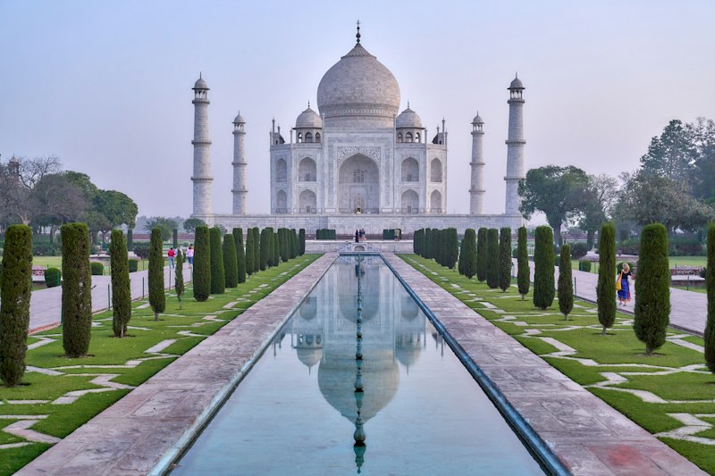
Rann Utsav Special — https://images.unsplash.com/photo-1477587458883-47145ed94245?auto=format&fit=crop&w=800&q=80
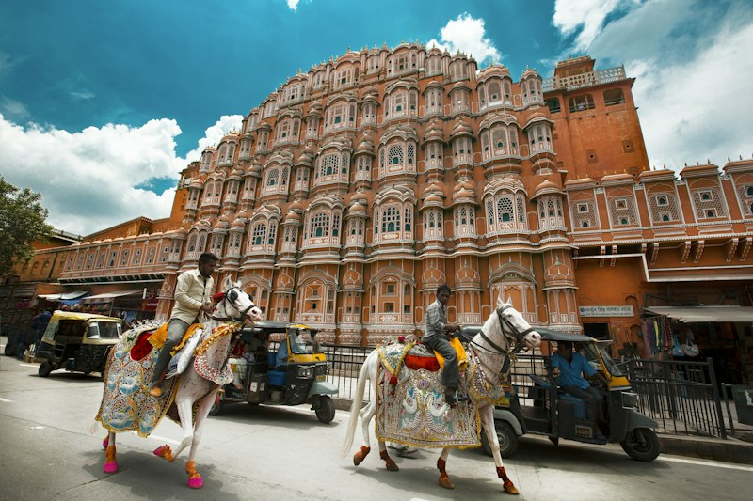
Lions Calling — Gir Safari — https://images.unsplash.com/photo-1546182990-dffeafbe841d?auto=format&fit=crop&w=800&q=80

Statue of Unity Escape — https://images.unsplash.com/photo-1524492412937-b28074a5d7da?auto=format&fit=crop&w=800&q=80

[SECTION: FAQS & POLICIES]
Frequently Asked Customer Question | Verified Official Answer | Topic / Category
Are flights included in the package cost? | Packages are offered with or without flights. Flight-inclusive quotes depend on departure city, dates, and airline class. | Flights
What is your cancellation and refund policy? | Cancel 21+ days before departure: typically 90% refund of land package. 7–20 days: partial refund per supplier rules. Inside 7 days: largely non-refundable unless travel insurance covers it. | Refunds
Do you assist with tourist visas? | Yes. Our visa desk reviews documents, books appointments where needed, and tracks application status. Visa approval is always at the consulate’s discretion. | Visa
Can packages be customized for families? | Yes — rooming, kid meals, accessibility needs, extra nights, and activity swaps can be tailored before booking confirmation. | Customization
What documents do travellers need? | Valid passport (6+ months validity for international), tickets, hotel vouchers, travel insurance, and destination-specific forms. Domestic trips need government photo ID. | Documents
Is travel insurance mandatory? | Strongly recommended for international trips; some packages bundle basic cover. Medical evacuation and trip cancellation add-ons are available. | Insurance
How do I pay for a booking? | Booking amount secures seats; balance is due as per invoice schedule. We accept UPI, cards, net banking, and bank transfer. EMI options on select cards. | Payments
What if a flight is delayed or cancelled? | We coordinate rebooking with airlines/hotels. Compensation follows airline policy; land arrangements are adjusted where possible. | Disruptions
Do prices include tourist taxes and resort fees? | Inclusions are listed per package. City taxes, resort fees, and personal expenses are usually extra unless marked inclusive. | Pricing
Can you arrange honeymoon or group departures? | Yes — honeymoon upgrades, private transfers, and group blocks with tour managers are available on request. | Customization
How early should I book peak-season travel? | For Dec–Jan and school holidays, book 6–10 weeks ahead for better airfares and hotel inventory. | Planning
Are meals included every day? | Meal plans vary (BB, MAP, AP). Daily inclusions are listed in the itinerary; special diets should be declared at booking. | Meals
Do you provide 24x7 emergency support on trip? | Yes. Guests receive a destination duty phone for medical, lost passport, or logistics emergencies. | Support
What is the child / infant policy? | Child rates depend on age and bed sharing. Infants usually travel free on land packages excluding flights and entrance fees. | Family
[Add Question]
[Add Question]
Knowledge Base Articles — longer policy / how-to pages indexed for chatbot retrieval (keep the Title / Category / Article Content columns).
Knowledge Article Title | Category | Article Content
Booking, Payments & Travel Documents Checklist | Planning | # Booking Checklist  Confirm destination dates, traveler names as per passport, rooming, and meal plan. Pay the booking amount to hold space; clear the balance per invoice timeline.  Carry passport (6+ months validity for international), tickets, vouchers, insurance, and any destination forms. Domestic travelers need government photo ID.
Cancellation, Reschedule & Travel Insurance | Refunds | # Cancellations & Insurance  Land-package refunds generally: 90% if cancelled 21+ days prior; reduced thereafter; limited inside 7 days. Airline tickets follow airline fare rules.  Travel insurance is strongly recommended for medical emergencies, baggage loss, and trip interruption.
Visa Assistance & On-Trip Emergency Support | Visa | # Visas & Support  Our visa desk helps with document checklists and appointments. Final approval is always the consulate’s decision — never guarantee outcomes.  On trip, guests receive a 24x7 duty number for hotel, medical, or document emergencies.

[SECTION: BOT PERSONA & GUARDRAILS]
Configuration Parameter | Bot Behavior / Value
Tone & Persona | Polite, consultative, crisp, and brand-aligned
Welcome Message | Welcome to 99 Destinations Holidays Pvt. Ltd.! How can I assist you today?
Strict Guardrails (Never-Do List) | 1. Never offer unauthorized discounts or unlisted pricing.  2. Never promise dates or legal commitments outside official brochure.  3. Never request passwords, OTPs, or credit card details.
Human Escalation Trigger | Escalate to live sales agent when user asks for 'human', 'agent', 'manager', or expresses grievance.

