📋 AI WhatsApp Chatbot Onboarding Kit
Software & IT Services
Industry Vertical: it_software | Software Development & AI Solutions — Engineering Future-Ready Digital Products
💡 INSTRUCTIONS FOR TENANT:
1. Fill in the fields and tables below with your company's actual data.
2. Do not modify the section header titles (e.g. [SECTION: BRAND & PROFILE]) as our AI parser uses them to bifurcate your data.
3. Once filled, save this document and upload it via the Admin Console. The AI engine will parse your menu, catalog, and FAQs into your live bot!

[SECTION: BRAND & PROFILE]
Parameter | Description & Constraints | Your Company Input (Fill Here)
Company Legal Name | Official registered company or entity name | Leeway Softech Private Limited
Brand / Display Name | Public name displayed to WhatsApp users | Leeway Softech Private Limited
Tenant ID / Code | Short unique identifier (lowercase, e.g. dlf, skyline) | leewaysoftech
AI Bot Name | Friendly name of your AI assistant | Leeway Tech Advisor
Brand Tagline | 1-2 sentence core value proposition | Software Development & AI Solutions — Engineering Future-Ready Digital Products
Official Website URL | Company website link | https://leewaysoftech.com
Customer Support Email | Official support or sales contact email | sales@leewaysoftech.com
Support Phone Number | Official contact telephone with country code | +91 8690783030
WhatsApp Bot Number | Dedicated phone number to connect to WhatsApp bot | +91 XXXXXXXXXX
Business Working Hours | Daily operational hours (e.g. 09:30 AM - 06:30 PM) | 09:30 AM - 07:00 PM (Mon-Sat)

[SECTION: WHATSAPP MENU]
CRITICAL WHATSAPP INTERACTIVE BUTTON CONSTRAINTS:
• Title: Max 24 characters (e.g., 'Explore Properties', 'Track Order')
• Description: Max 72 characters (e.g., '2, 3 & 4 BHK apartments in Prime Whitefield')
• Section: Max 24 characters (e.g., 'Properties', 'Support')
Button Title (<=24 chars) | Description (<=72 chars) | Category Section | Action Mapping
Our Services | Web, mobile, AI & enterprise engineering | 💻 Services | offerings
Technologies | React, Python, Flutter, AWS & AI stack | 💻 Services | technologies
Projects | Portfolio, case studies & industries | 🏢 Company | projects
Get a Quote | Share requirements for a written estimate | 📋 Sales | quote
Careers | Open roles, internships & how to apply | 🏢 Company | careers
Benefits | Why teams choose Leeway Softech | 🏢 Company | benefits

[SECTION: CATALOG & OFFERINGS]
Image URL column: paste a public https link to the product/property photo (JPG/PNG/WebP). Leave blank if none. On publish, images are stored on the offering and shown in chat/catalog.
Service / Offering | Category | Starting Price / Model | Tech Stack & Tools | Typical Timeline | Scope & Deliverables | Image URL
Full-Stack Web App Development | Custom Software | Starting ₹4,00,000 / Fixed or T&M | Next.js, FastAPI, PostgreSQL, AWS, Docker | 6 - 12 Weeks | Architecture, responsive UI, APIs, CI/CD | https://images.unsplash.com/photo-1498050108023-c5249f4df085?auto=format&fit=crop&w=800&q=80
Cross-Platform Mobile App | Mobile Engineering | Starting ₹5,50,000 / Project | Flutter / React Native, Firebase | 8 - 14 Weeks | iOS & Android, push, offline, store publishing | https://images.unsplash.com/photo-1512941937669-90a1b58e7e9c?auto=format&fit=crop&w=800&q=80
WhatsApp Business API + AI Chatbot | AI Engineering | Starting ₹2,50,000 / Project | Meta Cloud API, RAG, FAISS, Ollama/OpenAI | 4 - 8 Weeks | Bot flows, catalog, FAQ/KB, human handoff | https://images.unsplash.com/photo-1677442136019-21780ecad995?auto=format&fit=crop&w=800&q=80
Cloud & Dedicated Engineering Pods | Cloud / Teams | Starting ₹1,80,000 / Month | AWS, GCP, Terraform, Kubernetes | Ongoing retainer | IaC, deployments, dedicated squad | https://images.unsplash.com/photo-1451187580459-43490279c0fa?auto=format&fit=crop&w=800&q=80
[Enter Item] |  |  |  |  |  | [Paste https image URL]
[Enter Item] |  |  |  |  |  | [Paste https image URL]

Catalog images (embedded preview)
Full-Stack Web App Development — https://images.unsplash.com/photo-1498050108023-c5249f4df085?auto=format&fit=crop&w=800&q=80

Cross-Platform Mobile App — https://images.unsplash.com/photo-1512941937669-90a1b58e7e9c?auto=format&fit=crop&w=800&q=80
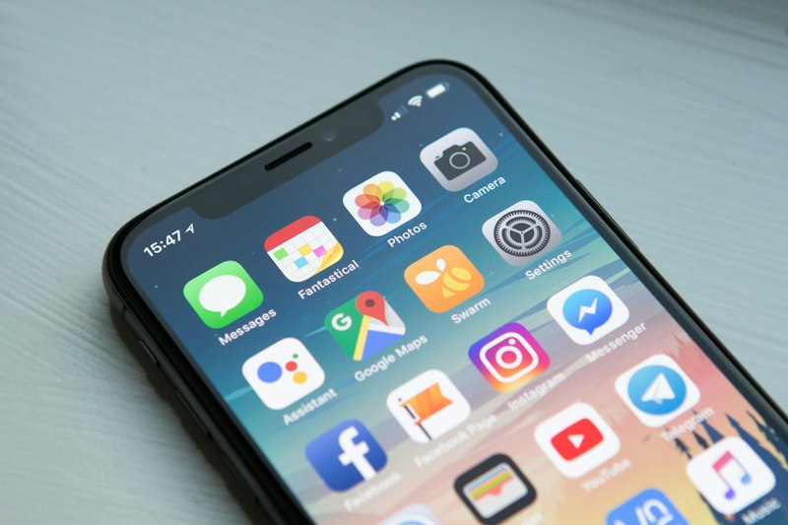
WhatsApp Business API + AI Chatbot — https://images.unsplash.com/photo-1677442136019-21780ecad995?auto=format&fit=crop&w=800&q=80

Cloud & Dedicated Engineering Pods — https://images.unsplash.com/photo-1451187580459-43490279c0fa?auto=format&fit=crop&w=800&q=80


[SECTION: FAQS & POLICIES]
Frequently Asked Customer Question | Verified Official Answer | Topic / Category
How do you estimate project costs? | We scope features, integrations, user roles, non-functionals, and timeline, then propose fixed-bid, T&M, or dedicated squad pricing with a written SOW. | Pricing
Do you sign an NDA before discussions? | Yes. Mutual NDAs are executed before reviewing architecture diagrams, codebases, or confidential product roadmaps. | Security & IP
Who owns the intellectual property (IP)? | Clients own 100% of custom source code, designs, and project data upon settlement of agreed milestones, unless open-source components apply under their licenses. | IP Ownership
What post-launch maintenance do you provide? | Every build includes 60 days complimentary warranty for defects introduced by us. Optional SLA retainers cover monitoring, patches, and feature velocity. | Support
Which engagement models do you offer? | Fixed-price projects, time & materials, monthly dedicated teams, and outcome-based retainers for product pods. | Engagement
Do you work with existing internal teams? | Yes. We embed with client engineering via shared repos, CI, and standups, or run as a parallel delivery stream with clear interface contracts. | Delivery
What is your typical discovery timeline? | Paid discovery usually runs 1–2 weeks and produces UX flows, architecture options, backlog, and a budget-confidence estimate. | Discovery
Can you take over a legacy codebase? | Yes. We run a structured audit (tests, deps, infra, security), then propose stabilization vs rewrite recommendations. | Legacy
How do you handle security and compliance? | Secure SDLC practices, dependency scanning, secrets management, and optional SOC2/ISO-aligned controls depending on the engagement. | Security & IP
Do you deploy to our cloud accounts? | Preferred model is deploy into the client’s AWS/GCP/Azure org with IaC (Terraform) and least-privilege access. | Cloud
What communication cadence should we expect? | Weekly demos, shared Slack/Teams channel, written status notes, and a single accountable delivery lead. | Delivery
Do you provide UI/UX design? | Yes — product design is available as a standalone track or bundled with engineering (wireframes, design system, handoff). | Design
How are change requests priced? | Out-of-scope items are estimated in writing and approved before work starts; velocity trackers keep the backlog transparent. | Pricing
Can you help hire or train our team? | We offer enablement workshops, pairing, and hiring scorecards as an optional professional-services add-on. | Enablement
[Add Question]
[Add Question]
Knowledge Base Articles — longer policy / how-to pages indexed for chatbot retrieval (keep the Title / Category / Article Content columns).
Knowledge Article Title | Category | Article Content
Engagement Models, SOW & Change Control | Delivery | # How We Engage  We deliver via fixed-price, time & materials, or dedicated squads. Every engagement starts with a written SOW covering scope, milestones, acceptance criteria, and commercial terms.  Change requests are estimated and approved in writing before implementation so budgets stay predictable.
Security, NDA & Intellectual Property | Security & IP | # Security & IP  Mutual NDAs precede deep technical discussions. Custom code and designs transfer to the client after milestone payments, excluding third-party/open-source components which keep their licenses.  Access is least-privilege; secrets stay in vaults; production access is logged.
Support Warranty & SLA Retainers | Support | # After Go-Live  Projects include 60 days warranty for defects attributable to our delivery. Ongoing SLAs can cover uptime monitoring, dependency patches, and a monthly feature capacity.  Severity-1 production incidents get priority response under active retainer terms.

[SECTION: INFO PAGES]
These answers populate the Technologies / Projects / Careers / Benefits console pages (and matching WhatsApp intents). Keep Page Name exactly as shown.
Page Name (intent) | Bot Answer Content
technologies | • Here's the stack we build with:  • *Frontend:* React.js, Next.js, Vue.js, Angular, TypeScript, Tailwind CSS  • *Backend:* Node.js, Python (FastAPI/Django), Golang, Laravel, .NET Core  • *AI & ML:* OpenAI, LangChain, PyTorch, TensorFlow, Hugging Face, Vertex AI, Azure OpenAI  • *Mobile:* iOS (Swift), Android (Kotlin), React Native, Flutter  • *Data & Cloud:* PostgreSQL, MySQL, MongoDB, Redis, AWS, Azure, GCP, Docker, CI/CD  • Tell us what you're building and we'll match the right stack.
projects | • A snapshot of the work we deliver:  • *Web platforms:* e-commerce stores, customer portals and internal systems  • *Mobile apps:* customer and field-force apps for iOS and Android  • *Enterprise:* CRM/ERP integrations, workflow automation and analytics dashboards  • *Industries:* retail, healthcare, finance, logistics and education  • Client names and detailed case studies are shared only with written permission — ask for a walkthrough on a call.
careers | 💼 *Open roles at Leeway Softech:*  *Development*  • Python Developer — 1–3 yrs · Ahmedabad  • UI/UX Developer — 0–1 yrs  *Sales*  • Sales Executive — 2–4 yrs  Forward your CV to hr@leewaysoftech.com with the role in the subject. Shortlisted candidates hear from us shortly.
benefits | • Why teams choose Leeway Softech:  • *Dedicated point of contact* for every engagement  • *Agile delivery* with transparent sprints and demos  • *Learning culture* — mentorship and exposure across web, mobile, AI and cloud  • *Your IP stays yours* — code and assets handed over  • Post-launch support / AMC options and clear contracts + NDA on request

[SECTION: BOT PERSONA & GUARDRAILS]
Configuration Parameter | Bot Behavior / Value
Tone & Persona | Polite, consultative, crisp, and brand-aligned
Welcome Message | Welcome to Leeway Softech Private Limited! How can I assist you today?
Strict Guardrails (Never-Do List) | 1. Never offer unauthorized discounts or unlisted pricing.  2. Never promise dates or legal commitments outside official brochure.  3. Never request passwords, OTPs, or credit card details.
Human Escalation Trigger | Escalate to live sales agent when user asks for 'human', 'agent', 'manager', or expresses grievance.

