📋 AI WhatsApp Chatbot Onboarding Kit
Banking & Insurance Services
Industry Vertical: banking | Meridian Bank — Bank of All Banks
💡 INSTRUCTIONS FOR TENANT:
1. Fill in the fields and tables below with your company's actual data.
2. Do not modify the section header titles (e.g. [SECTION: BRAND & PROFILE]) as our AI parser uses them to bifurcate your data.
3. Once filled, save this document and upload it via the Admin Console. The AI engine will parse your menu, catalog, and FAQs into your live bot!

[SECTION: BRAND & PROFILE]
Parameter | Description & Constraints | Your Company Input (Fill Here)
Company Legal Name | Registered entity name | Meridian Premier Bank Limited
Brand / Display Name | Public WhatsApp-facing name | Meridian Bank
Tenant ID / Code | Lowercase slug (unique) | meridianbank
Industry Vertical | Must match kit vertical | banking
AI Bot Name | Assistant persona name | Meridian Assistant
Brand Tagline | 1–2 sentence positioning | Meridian Bank — Bank of All Banks
Official Website URL | https homepage | https://www.meridianbanker.com/
Logo URL | Public PNG/JPG (min ~512px) | https://www.meridianbanker.com/logo.png
Closing Signature | Sign-off on bot messages | Meridian Bank — Bank of All Banks. (Information only — never share OTP/PIN.)
Welcome / Greeting Message | First reply after Hi | Welcome to Meridian Bank. Ask about accounts, cards, deposits & claims. We never ask for OTP, PIN or passwords here.
Support Email | Customer care inbox | care@meridianbank.com
Support Phone | Helpline with country code (+91…) | +91 7418527567
Sales / Enquiries Email | Lead & quote destination | sales@meridianbank.com
Notifications Support Email | Optional second inbox | care@meridianbank.com
Brochure URL | Downloadable PDF link | https://www.meridianbanker.com/product-guide.pdf
Brochure Label | Button / menu wording | Product Brochure
WhatsApp Bot Number | Send2Digital / WABA MSISDN | +91 7418527567
Timezone | IANA timezone | Asia/Kolkata
Always Open? | true = ignore open/close window | No
Opens | HH:MM 24h | 09:30
Closes | HH:MM 24h | 17:00
Open Days | Weekday pattern | Mon–Fri + 1st/3rd/5th Sat · Phone banking 24×7
Business Hours (display) | Human-readable schedule | 09:00 AM - 06:00 PM (Mon-Fri) | Phone banking 24x7
Out-of-hours Message | Fallback when closed | Branch hours ended. For card block / fraud use Block Lost Card anytime. Other queries: leave details for next working day.
Tone / Persona | Bot voice | formal and compliant
Vocabulary — plural item | e.g. products / services / packages | schemes
Vocabulary — singular item | e.g. product / service | scheme
Vocabulary — browse label | Menu browse title | Our Products
Vocabulary — brochure label | Brochure CTA | Product Brochure
Vocabulary — lead noun | enquiry / booking / consultation | enquiry
Vocabulary — enquire button | Lead CTA label | Enquire
Vocabulary — support label | Support CTA | Customer Care
Features ENABLED | Capabilities turned on | offerings, offering_details, products_schemes, brochure_pdf, lead_capture, callback, faq, kb, complaints, handoff, human_handover
Features DISABLED | Must stay off for this vertical | cart, buy_now, orders, payments, track_order, returns, distributors, services, products, quote, book_appointment, campaigns

[SECTION: OPERATIONS & DOMAIN]
Vertical-specific answers from the registration wizard / profile. Fill every row — these become classifier keywords, policies and lead context.
Domain Field | Why we need it | Your Answer
Products on offer | Catalogue focus | Savings, Current, Fixed Deposit, Credit Cards, Home Loans, Personal Loans, Insurance
Regulatory note | How bot must speak | Information & service requests only. Never execute transfers. Never request OTP/PIN/password. Rates indicative until sanction.
KYC for savings | Docs | Aadhaar, PAN, photograph — Video KYC where eligible
Lost card | Action | Block via menu/chat with last 4 digits — SMS ack in seconds
Branch / IFSC | Locator | Ask city or PIN; IFSC also on cheque book / statements
Claims | Insurance path | Policy number + hospital bills; TPA checklist via Insurance & Claims

[SECTION: WHATSAPP MENU]
CRITICAL WHATSAPP INTERACTIVE BUTTON CONSTRAINTS:
• Title: Max 24 characters (e.g., 'Explore Properties', 'Track Order')
• Description: Max 72 characters (e.g., '2, 3 & 4 BHK apartments in Prime Whitefield')
• Section: Max 24 characters (e.g., 'Properties', 'Support')
Button Title (<=24 chars) | Description (<=72 chars) | Category Section | Action Mapping
Savings & Deposits | Zero-balance savings, high-interest fixed deposits & recurring | 💳 Accounts | offerings
Credit Cards & Loans | Lifestyle cashback cards, personal & vehicle loans | 💳 Accounts | offering_details
Insurance & Claims | Life, health & motor insurance claim settlement guidelines | 🛡️ Insurance | faq
Locate Branch & ATM | Find nearby branch locations, working hours & IFSC codes | ℹ️ Info | faq
Block Lost Card | Instantly block stolen or misplaced debit/credit card | 🆘 Security | raise_ticket

[SECTION: CATALOG & OFFERINGS]
Image URL column: paste a public https link to the product/property photo (JPG/PNG/WebP). Leave blank if none. On publish, images are stored on the offering and shown in chat/catalog.
Product / Scheme | Category | Interest Rate / Annual Fee | Key Features & Benefits | Eligibility Criteria | Minimum Balance | Image URL
Meridian Savings Account | Savings | As published (quarterly credit) | Digital KYC, debit card, net/mobile banking | Resident Indian, 18+ | ₹5,000 AMB / zero-balance salary | https://images.unsplash.com/photo-1554224155-6726b3ff858f?auto=format&fit=crop&w=800&q=80
Meridian Fixed Deposit | Deposits | Competitive FD rates + senior upside | Flexible tenure, loan against FD | Individual / Joint | Min ₹5,000 | https://images.unsplash.com/photo-1579621970563-ebec7560ff3e?auto=format&fit=crop&w=800&q=80
CashBack / Travel Credit Card | Credit Card | Annual fee as per variant | Contactless, rewards, secured-against-FD option | Income ₹20,000+/mo or FD secure | N/A | https://images.unsplash.com/photo-1556742049-0cfed4f6a45d?auto=format&fit=crop&w=800&q=80
Home Loan | Loans | From 8.50% p.a.* | Up to 80% LTV, tenure up to 30 years | Age 21–65, income norms apply | N/A | https://images.unsplash.com/photo-1560518883-ce09059eeffa?auto=format&fit=crop&w=800&q=80
[Enter Item] |  |  |  |  |  | [Paste https image URL]
[Enter Item] |  |  |  |  |  | [Paste https image URL]

Catalog images (embedded preview)
Meridian Savings Account — https://images.unsplash.com/photo-1554224155-6726b3ff858f?auto=format&fit=crop&w=800&q=80
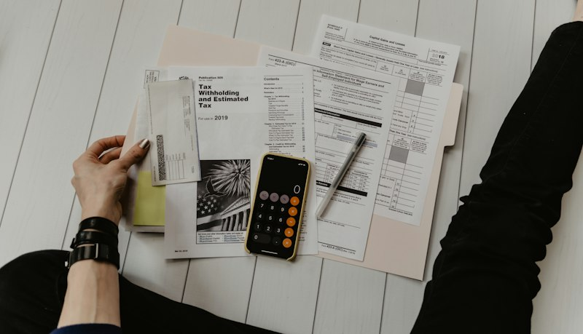
Meridian Fixed Deposit — https://images.unsplash.com/photo-1579621970563-ebec7560ff3e?auto=format&fit=crop&w=800&q=80

CashBack / Travel Credit Card — https://images.unsplash.com/photo-1556742049-0cfed4f6a45d?auto=format&fit=crop&w=800&q=80
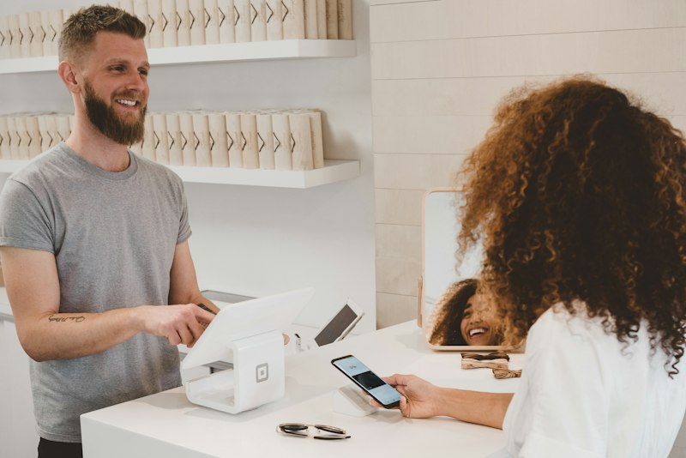
Home Loan — https://images.unsplash.com/photo-1560518883-ce09059eeffa?auto=format&fit=crop&w=800&q=80


[SECTION: FAQS & POLICIES]
Frequently Asked Customer Question | Verified Official Answer | Topic / Category
How do I immediately block a lost or stolen card? | Type Block Card or tap Block Lost Card and confirm the last 4 digits. Blocking is acknowledged by SMS usually within seconds. | Card Security
Can financial transactions be made through WhatsApp? | No. This assistant helps with information, eligibility, and service requests only. Never share OTPs, PINs, or passwords here. | Security Guardrail
What documents are required to open a savings account? | Aadhaar, PAN, and a photograph. Video KYC can often be completed online in minutes for eligible customers. | Account Opening
How do I submit an insurance claim? | Use Insurance & Claims for the checklist, TPA contacts, and document upload guidance. Keep policy number and hospital bills ready. | Claims
How can I find my IFSC and branch details? | Ask for your city or PIN, or use Locate Branch & ATM. IFSC is also printed on cheque books and account statements. | Branch Info
What is the minimum balance for Elite Savings? | Average Monthly Balance of ₹10,000. Non-maintenance charges apply as per the schedule of charges. | Accounts
How do I activate net banking or mobile banking? | Use the official bank app or net-banking portal after debit-card based activation. The chatbot will never ask for your password. | Digital Banking
What should I do if I see an unauthorized transaction? | Block the card immediately, then raise a dispute ticket with date, amount, and merchant. Keep SMS alerts as evidence. | Fraud
Are senior citizens eligible for higher FD rates? | Yes — senior citizen rates are published on the Smart Fixed Deposit scheme and may be ~0.50% higher. | Deposits
How long does home loan sanction take? | Express Home Loan targets sanction in about 48 hours after complete documents and satisfactory verification. | Loans
Can I update my registered mobile number? | Visit a branch with KYC or use authenticated channels in the official app. WhatsApp cannot change registered numbers alone. | Profile
What are branch working hours? | Typically 09:30 AM – 05:00 PM on weekdays and 1st/3rd/5th Saturdays. Confirm for your branch as timings can vary. | Branch Info
Do you offer nomination facilities? | Yes. Nomination can be registered for savings, deposits, and lockers as per bank policy. | Accounts
How do I download account statements? | Use official net banking/app for PDF statements. The assistant can explain steps but cannot email statements without authenticated channels. | Statements
[Add Question]
[Add Question]
Knowledge Base Articles — longer policy / how-to pages indexed for chatbot retrieval (keep the Title / Category / Article Content columns).
Knowledge Article Title | Category | Article Content
Card Safety, Fraud Response & Digital Banking Guardrails | Security | # Stay Safe  Block lost cards immediately via the menu. Never share OTP, PIN, CVV, or passwords in chat.  This WhatsApp assistant does not move money. Use official apps/net banking for payments. Report unauthorized transactions at once with amount, time, and merchant details.
Accounts, Deposits, Cards & Loans Overview | Products | # Product Guide  Elite Savings offers higher interest with AMB requirements and lifestyle benefits. Fixed deposits support flexible tenures and senior-citizen rate upsides.  CashBack cards and Express Home Loans have published eligibility — ask for the latest rate sheet and document checklist before applying.
Claims, Branch Locator & Service Requests | Service | # Everyday Banking Help  Insurance claims follow the checklist under Insurance & Claims. Branch/ATM locator helps with IFSC and timings (typically weekdays + alternate Saturdays).  Service requests (statements, nomination, mobile update) may require authenticated banking channels or a branch visit for regulatory compliance.

[SECTION: BOT PERSONA & GUARDRAILS]
Configuration Parameter | Bot Behavior / Value
Tone & Persona | formal and compliant
Welcome Message | Welcome to Meridian Bank. Ask about accounts, cards, deposits & claims. We never ask for OTP, PIN or passwords here.
Never State (one per line) | - loan approval / sanction  - guaranteed investment returns  - account balance without authenticated channel  - ability to transfer money on WhatsApp  - interest rates as final without underwriting
Forbidden Terms | OTP, PIN, MPIN, CVV, password, net banking password
Escalate Keywords | fraud, unauthorized transaction, legal, ombudsman, RBI, urgent, phishing
Handoff Keywords | human, agent, branch manager, relationship manager
Escalation Message | For your safety I'm connecting you with Meridian customer care. Never share OTP or PIN on chat.
Human Escalation Rule | Pause bot and alert humans when handoff/escalate keywords appear or confidence is low.

