📋 AI WhatsApp Chatbot Onboarding Kit
E-Commerce & Retail Brands
Industry Vertical: ecommerce | Premium homemade-style chikki — jaggery, peanuts, sesame & dry fruits
💡 INSTRUCTIONS FOR TENANT:
1. Fill in the fields and tables below with your company's actual data.
2. Do not modify the section header titles (e.g. [SECTION: BRAND & PROFILE]) as our AI parser uses them to bifurcate your data.
3. Once filled, save this document and upload it via the Admin Console. The AI engine will parse your menu, catalog, and FAQs into your live bot!

[SECTION: BRAND & PROFILE]
Parameter | Description & Constraints | Your Company Input (Fill Here)
Company Legal Name | Registered entity name | TrooGood Foods Private Limited
Brand / Display Name | Public WhatsApp-facing name | TrooGood
Tenant ID / Code | Lowercase slug (unique) | troogood
Industry Vertical | Must match kit vertical | ecommerce
AI Bot Name | Assistant persona name | TrooGood
Brand Tagline | 1–2 sentence positioning | Premium homemade-style chikki — jaggery, peanuts, sesame & dry fruits
Official Website URL | https homepage | https://www.troogood.com
Logo URL | Public PNG/JPG (min ~512px) | https://www.troogood.com/logo.png
Closing Signature | Sign-off on bot messages | TrooGood — Homemade-style chikki, delivered fresh.
Welcome / Greeting Message | First reply after Hi | Hi! Browse TrooGood chikki & snacks, track an order, or ask about delivery & returns.
Support Email | Customer care inbox | support@troogood.com
Support Phone | Helpline with country code (+91…) | +91 1234567891
Sales / Enquiries Email | Lead & quote destination | orders@troogood.com
Notifications Support Email | Optional second inbox | support@troogood.com
Brochure URL | Downloadable PDF link | https://www.troogood.com/catalogue.pdf
Brochure Label | Button / menu wording | Product Catalogue
WhatsApp Bot Number | Send2Digital / WABA MSISDN | +91 1234567891
Timezone | IANA timezone | Asia/Kolkata
Always Open? | true = ignore open/close window | Yes
Opens | HH:MM 24h | 09:00
Closes | HH:MM 24h | 21:00
Open Days | Weekday pattern | All days (bot 24/7; warehouse Mon–Sat)
Business Hours (display) | Human-readable schedule | 24/7 Automated Support
Out-of-hours Message | Fallback when closed | Our warehouse team is offline. Leave Order ID + issue — we reply next working morning.
Tone / Persona | Bot voice | friendly and helpful
Vocabulary — plural item | e.g. products / services / packages | products
Vocabulary — singular item | e.g. product / service | product
Vocabulary — browse label | Menu browse title | Browse Products
Vocabulary — brochure label | Brochure CTA | View Brochure
Vocabulary — lead noun | enquiry / booking / consultation | enquiry
Vocabulary — enquire button | Lead CTA label | Enquire
Vocabulary — support label | Support CTA | Support
Features ENABLED | Capabilities turned on | cart, buy_now, orders, track_order, returns, payments, offerings, offering_details, products, brochure_pdf, faq, kb, complaints, handoff, human_handover
Features DISABLED | Must stay off for this vertical | distributors, services, products_schemes, lead_capture, quote, callback, book_appointment, campaigns

[SECTION: OPERATIONS & DOMAIN]
Vertical-specific answers from the registration wizard / profile. Fill every row — these become classifier keywords, policies and lead context.
Domain Field | Why we need it | Your Answer
Product categories | Menu sections / classifier | Chikki, Healthy Snacks, Dry Fruit Bars, Gift Packs, Grocery
Payment methods | Checkout options | UPI, Card, Net banking, Cash on delivery (eligible PIN codes)
Delivery & returns (one line) | Policy summary | Metro 2–3 days · Free delivery above ₹499 · 7-day easy returns
Order reference prefix | Order IDs look like | TG
Courier partners | Tracking partners | BlueDart, Xpressbees, Delhivery
Refund timeline | After QC | 5–7 business days to original payment method (COD → UPI/bank)
Warranty / quality | Per SKU defaults | Manufacturing defects covered; sealed food items non-returnable once opened

[SECTION: WHATSAPP MENU]
CRITICAL WHATSAPP INTERACTIVE BUTTON CONSTRAINTS:
• Title: Max 24 characters (e.g., 'Explore Properties', 'Track Order')
• Description: Max 72 characters (e.g., '2, 3 & 4 BHK apartments in Prime Whitefield')
• Section: Max 24 characters (e.g., 'Properties', 'Support')
Button Title (<=24 chars) | Description (<=72 chars) | Category Section | Action Mapping
Browse Catalog | Explore latest collections, deals & new arrivals | 🛍️ Shop | offerings
Track My Order | Real-time delivery status & courier tracking | 📦 Orders | track_order
Returns & Refunds | Initiate return or replacement within 7 days | 📦 Orders | returns
Exclusive Offers | Discount coupons & seasonal festival promos | 🏷️ Deals | faq
Customer Support | Chat with a support agent regarding order queries | 🆘 Help | raise_ticket

[SECTION: CATALOG & OFFERINGS]
Image URL column: paste a public https link to the product/property photo (JPG/PNG/WebP). Leave blank if none. On publish, images are stored on the offering and shown in chat/catalog.
Product Name | SKU | Category | Price (₹) | Discount Price | Key Specifications / Size | Stock Status | Warranty / Returns | Image URL
Classic Peanut Chikki | TG-CHK-001 | Chikki | ₹149 | ₹129 | Jaggery + roasted peanuts, 200g pack | In Stock | 7-Day Easy Return | https://images.unsplash.com/photo-1599599810769-bcde5a160d32?auto=format&fit=crop&w=800&q=80
Sesame Jaggery Chikki | TG-CHK-014 | Chikki | ₹159 | ₹139 | Til + jaggery bars, 200g pack | In Stock | 7-Day Easy Return | https://images.unsplash.com/photo-1606313564200-e75d5e30476c?auto=format&fit=crop&w=800&q=80
Dry Fruit Energy Chikki | TG-CHK-022 | Chikki | ₹249 | ₹219 | Almonds, cashew, dates & jaggery, 180g | In Stock | 7-Day Easy Return | https://images.unsplash.com/photo-1504674900247-0877df9cc836?auto=format&fit=crop&w=800&q=80
Millet Multigrain Chikki | TG-CHK-031 | Healthy Snacks | ₹199 | ₹179 | Ragi + jowar + jaggery, 200g | In Stock | 7-Day Easy Return | https://images.unsplash.com/photo-1498837167922-ddd27525d352?auto=format&fit=crop&w=800&q=80
[Enter Item] |  |  |  |  |  |  |  | [Paste https image URL]
[Enter Item] |  |  |  |  |  |  |  | [Paste https image URL]

Catalog images (embedded preview)
Classic Peanut Chikki — https://images.unsplash.com/photo-1599599810769-bcde5a160d32?auto=format&fit=crop&w=800&q=80
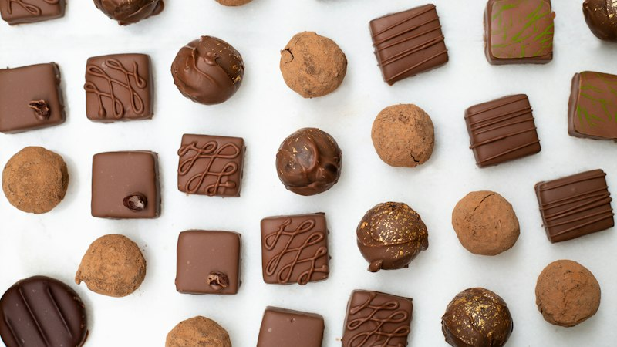
Sesame Jaggery Chikki — https://images.unsplash.com/photo-1606313564200-e75d5e30476c?auto=format&fit=crop&w=800&q=80

Dry Fruit Energy Chikki — https://images.unsplash.com/photo-1504674900247-0877df9cc836?auto=format&fit=crop&w=800&q=80
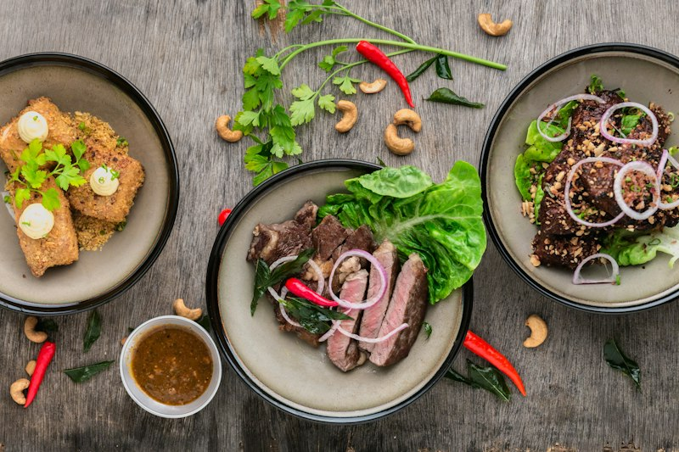
Millet Multigrain Chikki — https://images.unsplash.com/photo-1498837167922-ddd27525d352?auto=format&fit=crop&w=800&q=80
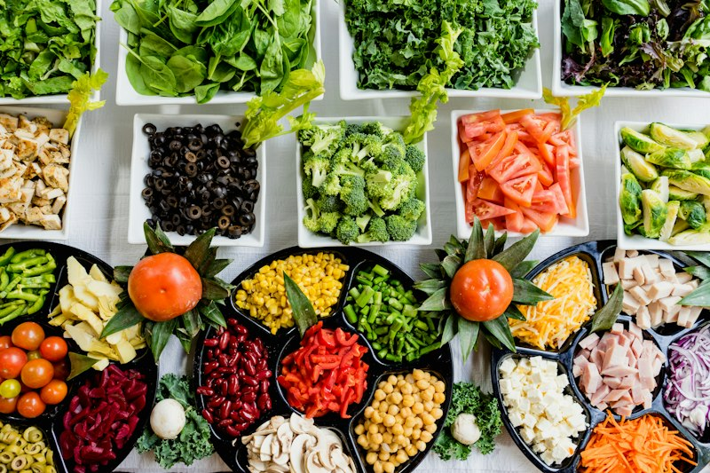

[SECTION: FAQS & POLICIES]
Frequently Asked Customer Question | Verified Official Answer | Topic / Category
What is your standard delivery timeline? | Metro cities: 2–3 business days. Tier-2/3 cities: 4–6 business days. Remote pin codes may take up to 8 days. Live courier tracking is shared on dispatch. | Shipping
How do I return a product? | Initiate return within 7 days of delivery via Returns & Refunds or by sharing your Order ID. We arrange free pickup within 48 hours for eligible SKUs. | Returns
What payment methods do you accept? | UPI (GPay, PhonePe, Paytm), credit/debit cards, net banking, wallets, and Cash on Delivery on eligible pin codes (COD fee may apply). | Payments
How do I track my active order? | Type Track Order with your 6-digit Order ID or registered mobile number. You will receive the courier AWB link and status. | Tracking
When will I receive my refund? | Refunds are processed within 5–7 business days after the returned item passes QC. UPI/card refunds go to the original payment method; COD refunds use UPI/bank transfer. | Refunds
Do you ship internationally? | Currently we ship within India only. International expansion is planned; join the waitlist via Customer Support. | Shipping
What is your exchange policy? | Size/color exchanges are allowed once within 7 days if the item is unused with tags. Stock availability determines exchange vs store credit. | Exchanges
Are products covered under warranty? | Warranty terms are listed per SKU (typically 1–2 years for electronics/accessories). Warranty covers manufacturing defects, not misuse or water damage unless stated. | Warranty
How do coupon codes work? | Enter the code at checkout. Coupons cannot usually stack with other promos unless marked Stackable. One coupon per order. | Offers
What if my package arrives damaged? | Refuse delivery if visibly damaged, or share unboxing photos within 24 hours. We arrange free replacement or full refund. | Damages
Can I cancel an order after placing it? | Orders can be cancelled free of charge until packed. After dispatch, convert to return after delivery. | Cancellations
Do you offer gift wrapping? | Gift wrap is available on select SKUs for a small fee. Add Gift Wrap in order notes or ask Support before dispatch. | Gifting
How is GST shown on invoices? | All prices are inclusive of GST unless marked otherwise. Tax invoices are emailed and available under Track Order. | Invoices
What pin codes support Cash on Delivery? | COD is enabled for most serviceable pin codes. Checkout will show COD availability; prepaid may be required for high-value or remote orders. | Payments
[Add Question]
[Add Question]
Knowledge Base Articles — longer policy / how-to pages indexed for chatbot retrieval (keep the Title / Category / Article Content columns).
Knowledge Article Title | Category | Article Content
Shipping, Delivery & Order Tracking Policy | Shipping | # Shipping & Tracking  Orders are processed within 24 hours on business days. Metro deliveries average 2–3 days; other regions 4–6 days. An AWB tracking link is sent on dispatch.  If a package shows Delivered but is missing, contact Support within 48 hours with photos of the delivery location. We coordinate with the courier for traces and resolution.
Returns, Exchanges, Refunds & Warranty | Returns | # Returns & Warranty  Most SKUs allow returns within 7 days if unused with original tags and packaging. Personal-care items may be non-returnable for hygiene once unsealed — check the product page.  Refunds complete in 5–7 business days after QC. Warranty covers manufacturing defects only; keep the invoice and serial number for claims.
Payments, COD, Coupons & Invoicing | Payments | # Payments & Offers  Accepted modes: UPI, cards, net banking, wallets, and COD where enabled. Coupon codes apply at checkout and usually do not stack.  GST-inclusive invoices are emailed automatically. For GSTIN business invoices, share your GST details in order notes before dispatch.

[SECTION: BOT PERSONA & GUARDRAILS]
Configuration Parameter | Bot Behavior / Value
Tone & Persona | friendly and helpful
Welcome Message | Hi! Browse TrooGood chikki & snacks, track an order, or ask about delivery & returns.
Never State (one per line) | - out-of-stock items as available  - delivery dates for remote PIN without check  - unauthorized discount codes  - COD on restricted high-value SKUs
Forbidden Terms | OTP, CVV, full card number, UPI PIN
Escalate Keywords | fraud, chargeback, legal, food poisoning, allergen, urgent
Handoff Keywords | human, agent, person, manager, complaint
Escalation Message | Connecting you with TrooGood support. Keep your Order ID ready.
Human Escalation Rule | Pause bot and alert humans when handoff/escalate keywords appear or confidence is low.

