📋 AI WhatsApp Chatbot Onboarding Kit
General Business & Enterprise Services
Industry Vertical: generic | Your trusted partner for seamless global logistics
💡 INSTRUCTIONS FOR TENANT:
1. Fill in the fields and tables below with your company's actual data.
2. Do not modify the section header titles (e.g. [SECTION: BRAND & PROFILE]) as our AI parser uses them to bifurcate your data.
3. Once filled, save this document and upload it via the Admin Console. The AI engine will parse your menu, catalog, and FAQs into your live bot!

[SECTION: BRAND & PROFILE]
Parameter | Description & Constraints | Your Company Input (Fill Here)
Company Legal Name | Registered entity name | Apex Global Logistics & Freight Services Private Limited
Brand / Display Name | Public WhatsApp-facing name | Apex Global Logistics & Freight Services
Tenant ID / Code | Lowercase slug (unique) | apexlogistics
Industry Vertical | Must match kit vertical | generic
AI Bot Name | Assistant persona name | Apex Assistant
Brand Tagline | 1–2 sentence positioning | Your trusted partner for seamless global logistics
Official Website URL | https homepage | https://www.apexlogistics.com
Logo URL | Public PNG/JPG (min ~512px) | https://www.apexlogistics.com/logo.png
Closing Signature | Sign-off on bot messages | Apex Logistics — Seamless freight, clear milestones.
Welcome / Greeting Message | First reply after Hi | Welcome to Apex Logistics. Explore freight services, request a quote, or ask how to share an AWB for status guidance.
Support Email | Customer care inbox | care@apexlogistics.com
Support Phone | Helpline with country code (+91…) | +91 98765 43210
Sales / Enquiries Email | Lead & quote destination | sales@apexlogistics.com
Notifications Support Email | Optional second inbox | care@apexlogistics.com
Brochure URL | Downloadable PDF link | https://www.apexlogistics.com/services.pdf
Brochure Label | Button / menu wording | Service Brochure
WhatsApp Bot Number | Send2Digital / WABA MSISDN | +91 98765 43210
Timezone | IANA timezone | Asia/Kolkata
Always Open? | true = ignore open/close window | No
Opens | HH:MM 24h | 09:00
Closes | HH:MM 24h | 18:00
Open Days | Weekday pattern | Mon–Fri (ops desk extended for active shipments)
Business Hours (display) | Human-readable schedule | 09:00 AM - 06:00 PM (Mon-Fri)
Out-of-hours Message | Fallback when closed | Sales desk is closed. For active shipments share AWB + issue. New quotes: leave origin, destination, weight — we reply next working day.
Tone / Persona | Bot voice | helpful
Vocabulary — plural item | e.g. products / services / packages | services
Vocabulary — singular item | e.g. product / service | service
Vocabulary — browse label | Menu browse title | Explore Services
Vocabulary — brochure label | Brochure CTA | Brochure
Vocabulary — lead noun | enquiry / booking / consultation | enquiry
Vocabulary — enquire button | Lead CTA label | Enquire
Vocabulary — support label | Support CTA | Support
Features ENABLED | Capabilities turned on | offerings, offering_details, lead_capture, quote, callback, faq, kb, handoff, human_handover, brochure_pdf
Features DISABLED | Must stay off for this vertical | cart, buy_now, orders, payments, track_order, returns, distributors, services, products, products_schemes, book_appointment, complaints, campaigns

[SECTION: OPERATIONS & DOMAIN]
Vertical-specific answers from the registration wizard / profile. Fill every row — these become classifier keywords, policies and lead context.
Domain Field | Why we need it | Your Answer
What you offer | Catalogue types | Domestic Express, Air Freight, Ocean FCL/LCL, Warehousing & Fulfilment, Customs coordination
Availability | Coverage | Pan-India + major international lanes (port-to-port / door-to-door on request)
Lead time | Typical turnaround | Domestic express 24–48h · Air 2–5 days · Ocean lane-dependent
Consignment / AWB format | Lookup hint | AWB / consignment ID as issued on booking confirmation (share full ID in chat)
Quote inputs needed | Lead capture | Origin, destination, weight/CBM, Incoterms, ready date, commodity type
Customs | Scope | Coordination available; duties/taxes billed as actuals unless DDP quoted

[SECTION: WHATSAPP MENU]
CRITICAL WHATSAPP INTERACTIVE BUTTON CONSTRAINTS:
• Title: Max 24 characters (e.g., 'Explore Properties', 'Track Order')
• Description: Max 72 characters (e.g., '2, 3 & 4 BHK apartments in Prime Whitefield')
• Section: Max 24 characters (e.g., 'Properties', 'Support')
Button Title (<=24 chars) | Description (<=72 chars) | Category Section | Action Mapping
Our Offerings | Browse all products, packages and specialized services | 📦 Offerings | offerings
Pricing & Quote | Request pricing estimates tailored to your needs | 💼 Pricing | quote
Schedule a Callback | Connect directly with our representative | 📞 Contact | book_callback
Knowledge & FAQs | Common questions, delivery terms and company policies | ℹ️ FAQs | faq
Customer Support | Raise a ticket or speak with a live support executive | 🆘 Support | raise_ticket

[SECTION: CATALOG & OFFERINGS]
Image URL column: paste a public https link to the product/property photo (JPG/PNG/WebP). Leave blank if none. On publish, images are stored on the offering and shown in chat/catalog.
Item / Service Name | Category | Price / Rate | Unit | Key Features & Inclusions | Detailed Description | Image URL
Domestic Express Freight | Freight | On request | per shipment | Door-to-door, tracking, insurance assist | Pan-India surface & air express | https://images.unsplash.com/photo-1586528116311-ad8dd3c8310d?auto=format&fit=crop&w=800&q=80
International Air Cargo | Freight | On request | per kg | Airport-to-airport / DDU options | Export documentation support | https://images.unsplash.com/photo-1436491865332-7a61a109cc05?auto=format&fit=crop&w=800&q=80
Ocean FCL / LCL | Ocean | On request | per container / CBM | Port handling, customs coordination | Scheduled sailings major lanes | https://images.unsplash.com/photo-1494412574643-ff11b0a5c1c3?auto=format&fit=crop&w=800&q=80
Warehousing & Fulfilment | 3PL | Starting retainer | per month | Storage, pick-pack, last-mile handoff | SKU inventory visibility | https://images.unsplash.com/photo-1553413077-190dd305871c?auto=format&fit=crop&w=800&q=80
[Enter Item] |  |  |  |  |  | [Paste https image URL]
[Enter Item] |  |  |  |  |  | [Paste https image URL]

Catalog images (embedded preview)
Domestic Express Freight — https://images.unsplash.com/photo-1586528116311-ad8dd3c8310d?auto=format&fit=crop&w=800&q=80
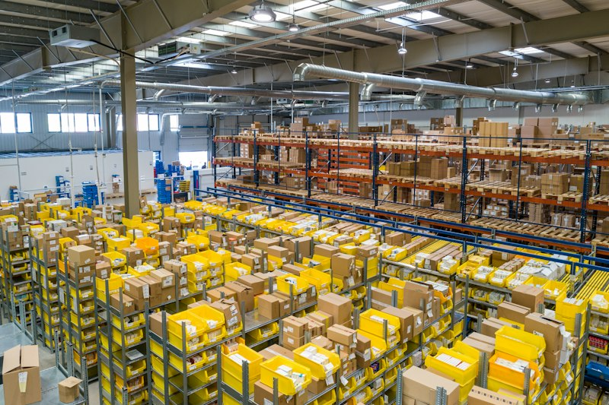
International Air Cargo — https://images.unsplash.com/photo-1436491865332-7a61a109cc05?auto=format&fit=crop&w=800&q=80

Ocean FCL / LCL — https://images.unsplash.com/photo-1494412574643-ff11b0a5c1c3?auto=format&fit=crop&w=800&q=80
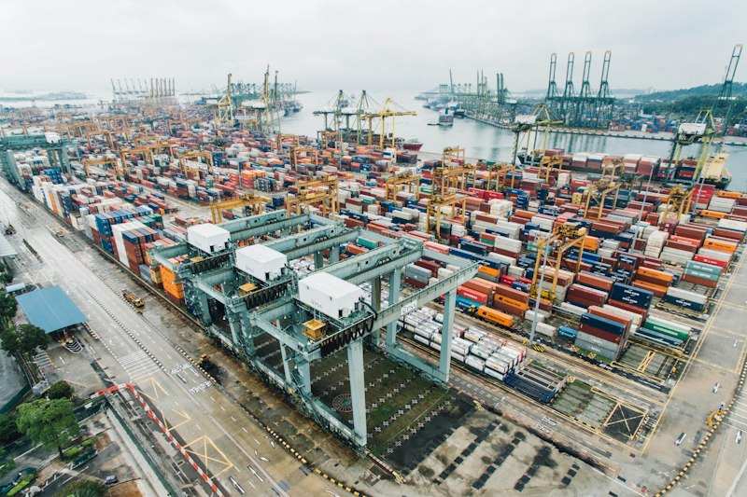
Warehousing & Fulfilment — https://images.unsplash.com/photo-1553413077-190dd305871c?auto=format&fit=crop&w=800&q=80
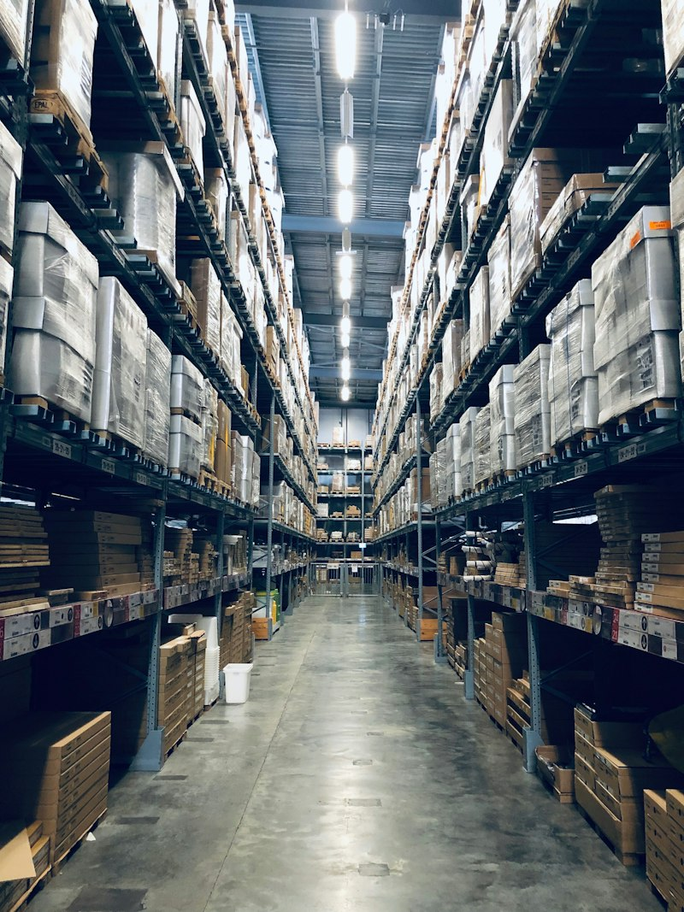

[SECTION: FAQS & POLICIES]
Frequently Asked Customer Question | Verified Official Answer | Topic / Category
What are your business operating hours? | The digital assistant is available 24/7. Human support operates Monday–Friday, 9:00 AM–6:00 PM local time unless a holiday calendar says otherwise. | Hours
How can I request a customized quotation? | Use Pricing & Quote or describe your requirements in chat. A specialist follows up with a written estimate. | Quotes
What is your refund or cancellation policy? | New subscriptions may cancel within 14 days for a full refund if onboarding deliverables are unused. After that, billing follows the contract notice period. | Refunds
How do I contact a senior representative? | Use Schedule a Callback and pick a slot, or ask for a human agent — we escalate with your ticket summary. | Contact
Where can I see product feature comparisons? | Ask for a comparison of Standard vs Professional tiers, or open Our Offerings for the catalog summary. | Products
Do you offer onboarding and training? | Yes. Custom Consultation & Setup includes configuration and a team training session; extra workshops can be quoted. | Onboarding
How is customer data protected? | We apply role-based access, encryption in transit, and tenant isolation. Detailed security summaries are available on request. | Security
Can I integrate with my existing tools? | Professional tier includes standard integrations; custom APIs are scoped as professional services. | Integrations
What SLAs do you provide? | Professional plans include priority support SLAs (response targets in the order form). Standard plans use business-hours email/chat support. | Support
How do license seats work? | Standard includes up to 5 seats; Professional is unlimited seats under fair-use. Extra admin seats can be added on Standard. | Licensing
Do you support multi-location businesses? | Yes — multi-branch profiles and localized menus can be configured during onboarding. | Setup
How do I report a bug or outage? | Raise a ticket via Customer Support with screenshots and time of issue. Critical outages are escalated immediately. | Support
Is there a long-term contract requirement? | Month-to-month and annual plans are both available; annual plans usually include a discount. | Pricing
Can I white-label the experience? | White-label options are available on enterprise agreements — ask Sales for branding guidelines and feasibility. | Branding
[Add Question]
[Add Question]
Knowledge Base Articles — longer policy / how-to pages indexed for chatbot retrieval (keep the Title / Category / Article Content columns).
Knowledge Article Title | Category | Article Content
Getting Started, Plans & Onboarding | Onboarding | # Getting Started  Choose Standard or Professional based on seats and support needs. Onboarding includes configuration help; Custom Consultation adds training and architecture review.  Share your success metrics early so we tailor menus, FAQs, and automations to your workflows.
Support SLAs, Escalations & Refund Policy | Support | # Support & Refunds  Human support runs business hours; the bot is 24/7. Ask for a human agent anytime for grievances.  New subscriptions may cancel within 14 days for a full refund if deliverables are unused. Afterwards, cancellations follow the contractual notice period.
Security, Integrations & Data Isolation | Security | # Platform Trust  Tenant data is isolated with role-based access and encryption in transit. Professional plans unlock standard integrations; custom APIs are quoted separately.  Request our security summary for enterprise questionnaires and DPIA support.

[SECTION: BOT PERSONA & GUARDRAILS]
Configuration Parameter | Bot Behavior / Value
Tone & Persona | helpful
Welcome Message | Welcome to Apex Logistics. Explore freight services, request a quote, or ask how to share an AWB for status guidance.
Never State (one per line) | - guaranteed customs clearance times  - fixed ocean rates without validity window  - delivery without address verification  - hazardous goods acceptance without DG check
Forbidden Terms | OTP, pay to personal UPI, undeclared cargo
Escalate Keywords | lost shipment, damage, fraud, legal, urgent, customs hold
Handoff Keywords | human, agent, ops manager, person
Escalation Message | Connecting you with Apex operations. Keep your AWB ready.
Human Escalation Rule | Pause bot and alert humans when handoff/escalate keywords appear or confidence is low.

