📋 AI WhatsApp Chatbot Onboarding Kit
Healthcare & Specialist Clinics
Industry Vertical: healthcare | Specialties, doctor consultation timings, health packages & appointments
💡 INSTRUCTIONS FOR TENANT:
1. Fill in the fields and tables below with your company's actual data.
2. Do not modify the section header titles (e.g. [SECTION: BRAND & PROFILE]) as our AI parser uses them to bifurcate your data.
3. Once filled, save this document and upload it via the Admin Console. The AI engine will parse your menu, catalog, and FAQs into your live bot!

[SECTION: BRAND & PROFILE]
Parameter | Description & Constraints | Your Company Input (Fill Here)
Company Legal Name | Registered entity name | CareWell Multi-Specialty Clinic Private Limited
Brand / Display Name | Public WhatsApp-facing name | CareWell Multi-Specialty Clinic
Tenant ID / Code | Lowercase slug (unique) | carewellclinic
Industry Vertical | Must match kit vertical | healthcare
AI Bot Name | Assistant persona name | CareWell Care Assistant
Brand Tagline | 1–2 sentence positioning | Specialties, doctor consultation timings, health packages & appointments
Official Website URL | https homepage | https://www.carewellclinic.example
Logo URL | Public PNG/JPG (min ~512px) | https://www.carewellclinic.example/logo.png
Closing Signature | Sign-off on bot messages | CareWell — Compassionate care, clear guidance.
Welcome / Greeting Message | First reply after Hi | Welcome to CareWell. Book appointments, check departments & timings — for emergencies call our 24×7 helpline.
Support Email | Customer care inbox | care@carewellclinic.example
Support Phone | Helpline with country code (+91…) | +91 9988776655
Sales / Enquiries Email | Lead & quote destination | appointments@carewellclinic.example
Notifications Support Email | Optional second inbox | care@carewellclinic.example
Brochure URL | Downloadable PDF link | https://www.carewellclinic.example/services.pdf
Brochure Label | Button / menu wording | Services List
WhatsApp Bot Number | Send2Digital / WABA MSISDN | +91 9988776655
Timezone | IANA timezone | Asia/Kolkata
Always Open? | true = ignore open/close window | No
Opens | HH:MM 24h | 08:00
Closes | HH:MM 24h | 20:30
Open Days | Weekday pattern | Mon–Sat · Emergency desk 24/7
Business Hours (display) | Human-readable schedule | 08:00 AM - 08:30 PM (Mon-Sat), Emergency 24/7
Out-of-hours Message | Fallback when closed | OPD is closed. For emergencies call +91 9988776655. For appointments, leave name, phone, department — reception books next day.
Tone / Persona | Bot voice | calm and empathetic
Vocabulary — plural item | e.g. products / services / packages | departments
Vocabulary — singular item | e.g. product / service | department
Vocabulary — browse label | Menu browse title | Our Departments
Vocabulary — brochure label | Brochure CTA | Services List
Vocabulary — lead noun | enquiry / booking / consultation | appointment request
Vocabulary — enquire button | Lead CTA label | Book Appointment
Vocabulary — support label | Support CTA | Patient Support
Features ENABLED | Capabilities turned on | offerings, offering_details, brochure_pdf, lead_capture, book_appointment, callback, faq, kb, complaints, handoff, human_handover
Features DISABLED | Must stay off for this vertical | cart, buy_now, orders, payments, track_order, returns, distributors, services, products, products_schemes, campaigns, quote

[SECTION: OPERATIONS & DOMAIN]
Vertical-specific answers from the registration wizard / profile. Fill every row — these become classifier keywords, policies and lead context.
Domain Field | Why we need it | Your Answer
Departments | OPD list | Cardiology, Orthopaedics, Paediatrics, Dermatology, General Medicine, Diagnostics, Dental
Triage / escalation rule (REQUIRED) | Bot must never diagnose | Never diagnose or prescribe. Emergencies → show helpline +91 9988776655 and escalate to reception immediately.
Emergency / ambulance | 24×7 | +91 9988776655 — share location & patient condition
Insurance / cashless | TPA | Listed TPAs & corporates; planned procedures need pre-auth
Lab reports | Delivery | Routine PDF on WhatsApp/email within ~12 hours; specialised 24–48 hours
Languages | Preference matching | English, Hindi, Gujarati — subject to doctor availability

[SECTION: WHATSAPP MENU]
CRITICAL WHATSAPP INTERACTIVE BUTTON CONSTRAINTS:
• Title: Max 24 characters (e.g., 'Explore Properties', 'Track Order')
• Description: Max 72 characters (e.g., '2, 3 & 4 BHK apartments in Prime Whitefield')
• Section: Max 24 characters (e.g., 'Properties', 'Support')
Button Title (<=24 chars) | Description (<=72 chars) | Category Section | Action Mapping
Our Specialties | Cardiology, Orthopedics, Pediatrics, Dermatology & Dental | 🩺 Medical | offerings
Book Appointment | Schedule in-person clinic or video consultation | 🩺 Medical | book_callback
Health Checkup Packages | Comprehensive annual, senior & executive wellness packages | 💊 Wellness | offering_details
Lab Tests & Reports | Blood tests, radiology timings & digital test report access | 🔬 Diagnostics | faq
Emergency & Ambulance | 24x7 emergency helpline & fast ambulance dispatch | 🆘 Emergency | faq

[SECTION: CATALOG & OFFERINGS]
Image URL column: paste a public https link to the product/property photo (JPG/PNG/WebP). Leave blank if none. On publish, images are stored on the offering and shown in chat/catalog.
Specialty / Department | Senior Specialist Doctor | Consultation Fee | Available Timings | Services & Treatments | Room / Clinic wing | Image URL
Cardiology & Heart Care | Dr. Rajesh Sharma, MD, DM | ₹900 | Mon, Wed, Fri 10:00-14:00 | ECG, 2D Echo, TMT, Hypertension | Wing A, Room 104 | https://images.unsplash.com/photo-1576091160399-112ba8d25d1d?auto=format&fit=crop&w=800&q=80
Orthopedics & Joint Surgery | Dr. Sunita Rao, MS (Ortho) | ₹800 | Tue, Thu, Sat 14:00-18:00 | Arthritis, fracture care, sports rehab | Wing B, Room 201 | https://images.unsplash.com/photo-1559757175-0eb30cd8c063?auto=format&fit=crop&w=800&q=80
Pediatrics & Child Health | Dr. Amit Verma, DCH, DNB | ₹700 | Mon-Sat 09:00-13:00 | Vaccination, growth, allergy care | Wing A, Room 108 | https://images.unsplash.com/photo-1631217868264-e5b90bb7e133?auto=format&fit=crop&w=800&q=80
Dermatology & Cosmetology | Dr. Neha Kulkarni, MD | ₹850 | Mon, Wed, Sat 16:00-20:00 | Acne, laser, PRP, skin allergy | Wing C, Room 302 | https://images.unsplash.com/photo-1515377905703-c4788e51af15?auto=format&fit=crop&w=800&q=80
[Enter Item] |  |  |  |  |  | [Paste https image URL]
[Enter Item] |  |  |  |  |  | [Paste https image URL]

Catalog images (embedded preview)
Cardiology & Heart Care — https://images.unsplash.com/photo-1576091160399-112ba8d25d1d?auto=format&fit=crop&w=800&q=80
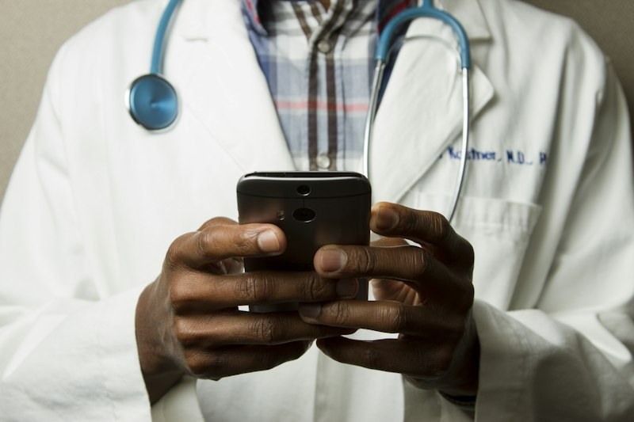
Orthopedics & Joint Surgery — https://images.unsplash.com/photo-1559757175-0eb30cd8c063?auto=format&fit=crop&w=800&q=80
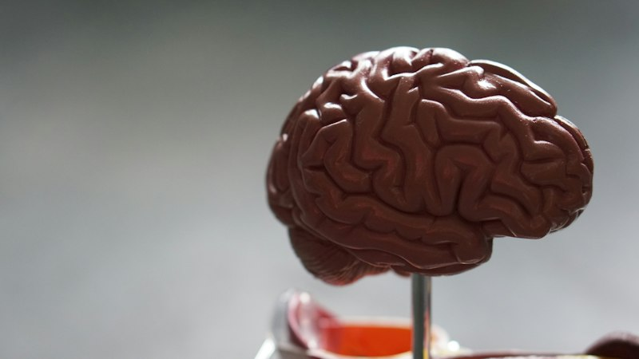
Pediatrics & Child Health — https://images.unsplash.com/photo-1631217868264-e5b90bb7e133?auto=format&fit=crop&w=800&q=80
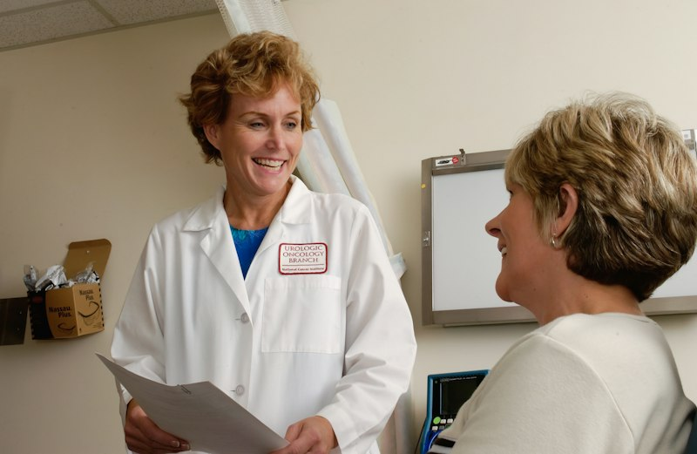
Dermatology & Cosmetology — https://images.unsplash.com/photo-1515377905703-c4788e51af15?auto=format&fit=crop&w=800&q=80
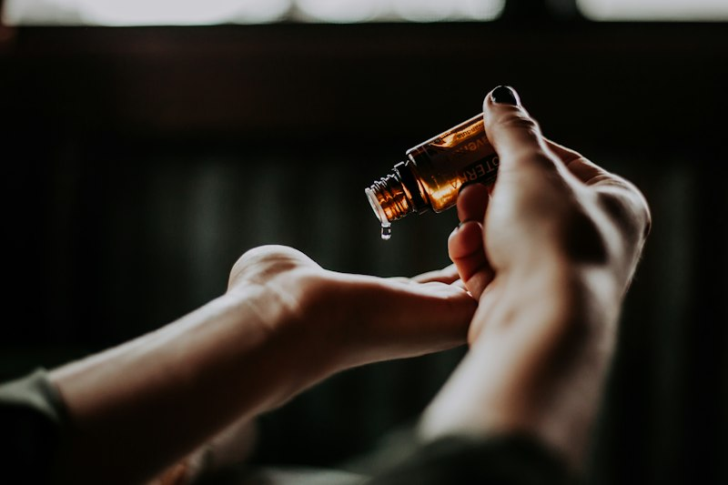

[SECTION: FAQS & POLICIES]
Frequently Asked Customer Question | Verified Official Answer | Topic / Category
How do I book an appointment with a doctor? | Use Book Appointment or message the doctor/department name. You will get available slots; confirmation SMS/WhatsApp follows. | Appointments
How do I receive my diagnostic lab test reports? | Reports are shared as PDF on WhatsApp/email typically within 12 hours for routine tests; specialized panels may take 24–48 hours. | Lab Reports
Do you accept insurance and cashless claims? | Yes for listed TPAs and corporate tie-ups. Carry your e-card and photo ID. Planned procedures need pre-authorization. | Insurance
What should I do in case of a medical emergency? | Call our 24/7 emergency hotline immediately for triage and ambulance dispatch. Share location and patient condition clearly. | Emergency
How early should I arrive for a consultation? | Arrive 15 minutes early for registration and vitals. First-time patients should carry prior reports and medication list. | Appointments
Can I get a video consultation? | Video consults are available for eligible specialties. Prescriptions are shared digitally; some cases still need in-person exam. | Telehealth
What payment modes are accepted at the clinic? | UPI, cards, net banking, and cash. Insurance co-pay is collected as applicable. | Payments
How do I reschedule or cancel an appointment? | Message at least 2 hours before the slot. Repeated no-shows may require advance payment for future bookings. | Appointments
Are health checkup packages customizable? | Yes — packages can add/remove tests with price adjustment. Fasting instructions are sent with the booking confirmation. | Packages
Do you provide home sample collection? | Home collection is available in selected pin codes for routine blood tests. Book via Lab Tests & Reports. | Lab Reports
Is parking available at the clinic? | On-site visitor parking is available; wheelchair access is provided at the main entrance and lifts. | Facilities
How is patient data kept private? | Records are access-controlled and shared only with treating clinicians or as authorized by the patient/guardian. | Privacy
Can I request a particular language-speaking doctor? | We try to match language preference (English, Hindi, and regional languages) subject to doctor availability. | Appointments
What is the pharmacy / medicine policy? | In-house pharmacy stocks commonly prescribed medicines. Bring outside prescriptions only if your clinician advises continuity. | Pharmacy
[Add Question]
[Add Question]
Knowledge Base Articles — longer policy / how-to pages indexed for chatbot retrieval (keep the Title / Category / Article Content columns).
Knowledge Article Title | Category | Article Content
Appointments, Telehealth & Clinic Visit Guide | Appointments | # Visiting CareWell  Book via WhatsApp menu or by naming the specialty. Arrive 15 minutes early with prior reports and a medication list. First-time patients complete a short registration form.  Video consultations are available for eligible cases; some conditions still require physical examination.
Lab Tests, Reports & Health Packages | Diagnostics | # Labs & Packages  Routine reports are typically shared within 12 hours as PDF. Specialized tests may take longer. Home sample collection is available in selected pin codes.  Health packages can be customized; fasting instructions are sent with confirmation messages.
Insurance Cashless, Emergency & Privacy | Insurance | # Insurance & Emergency  Cashless care is available with listed TPAs — carry e-card and ID; planned procedures need pre-auth.  For emergencies dial the 24/7 hotline for triage and ambulance. Patient records are confidential and shared only with care teams or authorized persons.

[SECTION: BOT PERSONA & GUARDRAILS]
Configuration Parameter | Bot Behavior / Value
Tone & Persona | calm and empathetic
Welcome Message | Welcome to CareWell. Book appointments, check departments & timings — for emergencies call our 24×7 helpline.
Never State (one per line) | - diagnosis  - prescription / medicine dosage  - guaranteed cure  - lab interpretation as clinical advice  - surgery recommendation without clinician
Forbidden Terms | self-medicate, ignore chest pain, stop your medicines
Escalate Keywords | chest pain, breathing, unconscious, bleeding, suicide, emergency, ambulance
Handoff Keywords | human, doctor, nurse, reception, agent
Escalation Message | For clinical matters I must connect you with our care team. If this is an emergency, call +91 9988776655 now.
Human Escalation Rule | Pause bot and alert humans when handoff/escalate keywords appear or confidence is low.

