📋 AI WhatsApp Chatbot Onboarding Kit
Tours & Travel Agency
Industry Vertical: tours_travel | Recognized by Gujarat Tourism (TCGL) | Customized Domestic & International Holidays
💡 INSTRUCTIONS FOR TENANT:
1. Fill in the fields and tables below with your company's actual data.
2. Do not modify the section header titles (e.g. [SECTION: BRAND & PROFILE]) as our AI parser uses them to bifurcate your data.
3. Once filled, save this document and upload it via the Admin Console. The AI engine will parse your menu, catalog, and FAQs into your live bot!

[SECTION: BRAND & PROFILE]
Parameter | Description & Constraints | Your Company Input (Fill Here)
Company Legal Name | Registered entity name | 99 Destinations Holidays Private Limited
Brand / Display Name | Public WhatsApp-facing name | 99 Destinations
Tenant ID / Code | Lowercase slug (unique) | 99destinations
Industry Vertical | Must match kit vertical | tours_travel
AI Bot Name | Assistant persona name | 99 Destinations Assistant
Brand Tagline | 1–2 sentence positioning | Recognized by Gujarat Tourism (TCGL) | Customized Domestic & International Holidays
Official Website URL | https homepage | https://www.99destinations.in
Logo URL | Public PNG/JPG (min ~512px) | https://www.99destinations.in/logo.png
Closing Signature | Sign-off on bot messages | 99 Destinations — Recognised by Gujarat Tourism (TCGL).
Welcome / Greeting Message | First reply after Hi | Namaste! Explore holiday packages, visas & custom itineraries — or speak to a travel expert.
Support Email | Customer care inbox | info@99destinations.in
Support Phone | Helpline with country code (+91…) | +91 7874833999
Sales / Enquiries Email | Lead & quote destination | bookings@99destinations.in
Notifications Support Email | Optional second inbox | info@99destinations.in
Brochure URL | Downloadable PDF link | https://www.99destinations.in/packages.pdf
Brochure Label | Button / menu wording | Trip Brochure
WhatsApp Bot Number | Send2Digital / WABA MSISDN | +91 7874833999
Timezone | IANA timezone | Asia/Kolkata
Always Open? | true = ignore open/close window | No
Opens | HH:MM 24h | 10:30
Closes | HH:MM 24h | 19:30
Open Days | Weekday pattern | Mon–Sat
Business Hours (display) | Human-readable schedule | 10:30 AM - 07:30 PM (Mon-Sat)
Out-of-hours Message | Fallback when closed | Travel desk is closed. Share destination, dates, travellers & budget — we reply next working day with options.
Tone / Persona | Bot voice | warm and helpful
Vocabulary — plural item | e.g. products / services / packages | packages
Vocabulary — singular item | e.g. product / service | package
Vocabulary — browse label | Menu browse title | Explore Packages
Vocabulary — brochure label | Brochure CTA | Trip Brochure
Vocabulary — lead noun | enquiry / booking / consultation | booking enquiry
Vocabulary — enquire button | Lead CTA label | Enquire
Vocabulary — support label | Support CTA | Travel Support
Features ENABLED | Capabilities turned on | offerings, offering_details, brochure_pdf, lead_capture, book_appointment, callback, quote, faq, kb, complaints, handoff, human_handover
Features DISABLED | Must stay off for this vertical | cart, buy_now, orders, payments, track_order, returns, distributors, services, products, products_schemes, campaigns

[SECTION: OPERATIONS & DOMAIN]
Vertical-specific answers from the registration wizard / profile. Fill every row — these become classifier keywords, policies and lead context.
Domain Field | Why we need it | Your Answer
Destinations | Where you sell | Gujarat, Kutch, Gir, Statue of Unity, Kashmir, Goa, Rajasthan, Dubai, Bali, Europe
Trip types | Audience | Honeymoon, Family, Group, Adventure, Corporate, Pilgrimage, Solo
Booking & cancellation | Policy summary | Token to confirm · 21+ days ~90% refund on land package · inside 7 days largely non-refundable (supplier rules)
Seasonality | Peak windows | Oct–Mar peak for Gujarat / Rann; international varies by destination
Flights in package? | Default | Land-only or with flights — choose at quote time
Visa assistance | Service | Document vetting, appointments, tracking — approval is consulate discretion
Emergency on trip | Support | Destination duty phone shared on voucher

[SECTION: WHATSAPP MENU]
CRITICAL WHATSAPP INTERACTIVE BUTTON CONSTRAINTS:
• Title: Max 24 characters (e.g., 'Explore Properties', 'Track Order')
• Description: Max 72 characters (e.g., '2, 3 & 4 BHK apartments in Prime Whitefield')
• Section: Max 24 characters (e.g., 'Properties', 'Support')
Button Title (<=24 chars) | Description (<=72 chars) | Category Section | Action Mapping
Holiday Packages | Domestic & international curated holiday packages | ✈️ Packages | offerings
Custom Itinerary | Build a personalized honeymoon, family or group trip | ✈️ Packages | quote
Visa & Documents | Tourist visa requirements, passport & travel insurance | 📋 Travel Info | faq
Speak to Travel Expert | Call our destination specialist for flight & hotel advice | 📞 Contact | book_callback
Cancellation Policy | Refund terms, reschedule rules & trip insurance | ℹ️ Policies | faq

[SECTION: CATALOG & OFFERINGS]
Image URL column: paste a public https link to the product/property photo (JPG/PNG/WebP). Leave blank if none. On publish, images are stored on the offering and shown in chat/catalog.
Package Name | Destination | Duration | Price per Person | Key Inclusions | Highlights | Best Travel Months | Image URL
Best of Gujarat | Gujarat Circuit | 8N / 7D | On request | Hotels, transfers, sightseeing, breakfast | Dwarka, Somnath, Gir, Diu | Oct - Mar | https://images.unsplash.com/photo-1524492412937-b28074a5d7da?auto=format&fit=crop&w=800&q=80
Rann Utsav Special | Kutch / Dhordo | 3N / 2D | On request | Tent city, transfers, cultural evening | White Rann sunset, camel safari | Nov - Feb | https://images.unsplash.com/photo-1477587458883-47145ed94245?auto=format&fit=crop&w=800&q=80
Lions Calling — Gir Safari | Sasan Gir | 3N / 2D | On request | Resort, safari permit assist, meals | Asiatic lion jungle safari | Dec - May | https://images.unsplash.com/photo-1546182990-dffeafbe841d?auto=format&fit=crop&w=800&q=80
Statue of Unity Escape | Kevadia | 3N / 2D | On request | Hotel, viewing gallery assist, transfers | 182m statue, Valley of Flowers, dam | All year | https://images.unsplash.com/photo-1524492412937-b28074a5d7da?auto=format&fit=crop&w=800&q=80
[Enter Item] |  |  |  |  |  |  | [Paste https image URL]
[Enter Item] |  |  |  |  |  |  | [Paste https image URL]

Catalog images (embedded preview)
Best of Gujarat — https://images.unsplash.com/photo-1524492412937-b28074a5d7da?auto=format&fit=crop&w=800&q=80
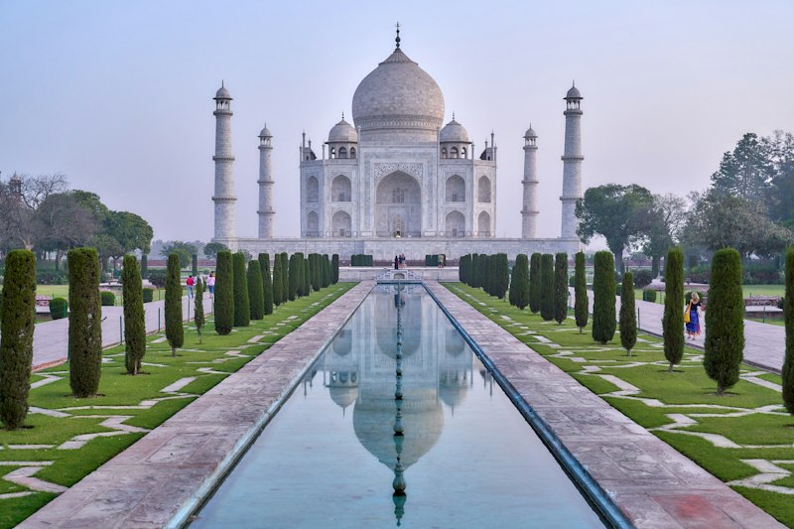
Rann Utsav Special — https://images.unsplash.com/photo-1477587458883-47145ed94245?auto=format&fit=crop&w=800&q=80
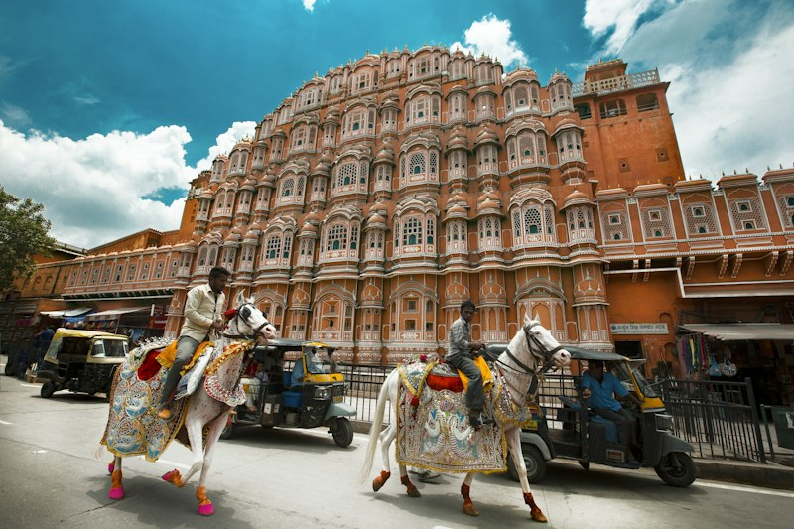
Lions Calling — Gir Safari — https://images.unsplash.com/photo-1546182990-dffeafbe841d?auto=format&fit=crop&w=800&q=80

Statue of Unity Escape — https://images.unsplash.com/photo-1524492412937-b28074a5d7da?auto=format&fit=crop&w=800&q=80

[SECTION: FAQS & POLICIES]
Frequently Asked Customer Question | Verified Official Answer | Topic / Category
Are flights included in the package cost? | Packages are offered with or without flights. Flight-inclusive quotes depend on departure city, dates, and airline class. | Flights
What is your cancellation and refund policy? | Cancel 21+ days before departure: typically 90% refund of land package. 7–20 days: partial refund per supplier rules. Inside 7 days: largely non-refundable unless travel insurance covers it. | Refunds
Do you assist with tourist visas? | Yes. Our visa desk reviews documents, books appointments where needed, and tracks application status. Visa approval is always at the consulate’s discretion. | Visa
Can packages be customized for families? | Yes — rooming, kid meals, accessibility needs, extra nights, and activity swaps can be tailored before booking confirmation. | Customization
What documents do travellers need? | Valid passport (6+ months validity for international), tickets, hotel vouchers, travel insurance, and destination-specific forms. Domestic trips need government photo ID. | Documents
Is travel insurance mandatory? | Strongly recommended for international trips; some packages bundle basic cover. Medical evacuation and trip cancellation add-ons are available. | Insurance
How do I pay for a booking? | Booking amount secures seats; balance is due as per invoice schedule. We accept UPI, cards, net banking, and bank transfer. EMI options on select cards. | Payments
What if a flight is delayed or cancelled? | We coordinate rebooking with airlines/hotels. Compensation follows airline policy; land arrangements are adjusted where possible. | Disruptions
Do prices include tourist taxes and resort fees? | Inclusions are listed per package. City taxes, resort fees, and personal expenses are usually extra unless marked inclusive. | Pricing
Can you arrange honeymoon or group departures? | Yes — honeymoon upgrades, private transfers, and group blocks with tour managers are available on request. | Customization
How early should I book peak-season travel? | For Dec–Jan and school holidays, book 6–10 weeks ahead for better airfares and hotel inventory. | Planning
Are meals included every day? | Meal plans vary (BB, MAP, AP). Daily inclusions are listed in the itinerary; special diets should be declared at booking. | Meals
Do you provide 24x7 emergency support on trip? | Yes. Guests receive a destination duty phone for medical, lost passport, or logistics emergencies. | Support
What is the child / infant policy? | Child rates depend on age and bed sharing. Infants usually travel free on land packages excluding flights and entrance fees. | Family
[Add Question]
[Add Question]
Knowledge Base Articles — longer policy / how-to pages indexed for chatbot retrieval (keep the Title / Category / Article Content columns).
Knowledge Article Title | Category | Article Content
Booking, Payments & Travel Documents Checklist | Planning | # Booking Checklist  Confirm destination dates, traveler names as per passport, rooming, and meal plan. Pay the booking amount to hold space; clear the balance per invoice timeline.  Carry passport (6+ months validity for international), tickets, vouchers, insurance, and any destination forms. Domestic travelers need government photo ID.
Cancellation, Reschedule & Travel Insurance | Refunds | # Cancellations & Insurance  Land-package refunds generally: 90% if cancelled 21+ days prior; reduced thereafter; limited inside 7 days. Airline tickets follow airline fare rules.  Travel insurance is strongly recommended for medical emergencies, baggage loss, and trip interruption.
Visa Assistance & On-Trip Emergency Support | Visa | # Visas & Support  Our visa desk helps with document checklists and appointments. Final approval is always the consulate’s decision — never guarantee outcomes.  On trip, guests receive a 24x7 duty number for hotel, medical, or document emergencies.

[SECTION: BOT PERSONA & GUARDRAILS]
Configuration Parameter | Bot Behavior / Value
Tone & Persona | warm and helpful
Welcome Message | Namaste! Explore holiday packages, visas & custom itineraries — or speak to a travel expert.
Never State (one per line) | - visa approval guarantees  - airline schedule locks without PNR  - prices excluding mandatory taxes when quoted all-in  - weather guarantees
Forbidden Terms | OTP, passport password, pay to personal account
Escalate Keywords | stranded, medical emergency, lost passport, fraud, legal, urgent
Handoff Keywords | human, agent, travel expert, manager
Escalation Message | Connecting you with a 99 Destinations travel expert now.
Human Escalation Rule | Pause bot and alert humans when handoff/escalate keywords appear or confidence is low.

