Client Onboarding Report
WhatsApp AI Chatbot & Tenant Platform
Information and assets to collect from the client

Client / Brand name
Tenant ID (short code)
Industry
Prepared by
Date
Version | 1.0

Purpose: this document lists every piece of information and every file we need from the client to set up, configure and launch their WhatsApp AI chatbot. Each section contains a collection table and a screenshot of the dashboard screen where that information is configured, so the client can see exactly where their answers end up.

Onboarding at a Glance
Onboarding runs through a guided registration wizard in the Admin Console. The client (or our team on their behalf) walks through the steps below once; everything collected in this report maps onto one of them.
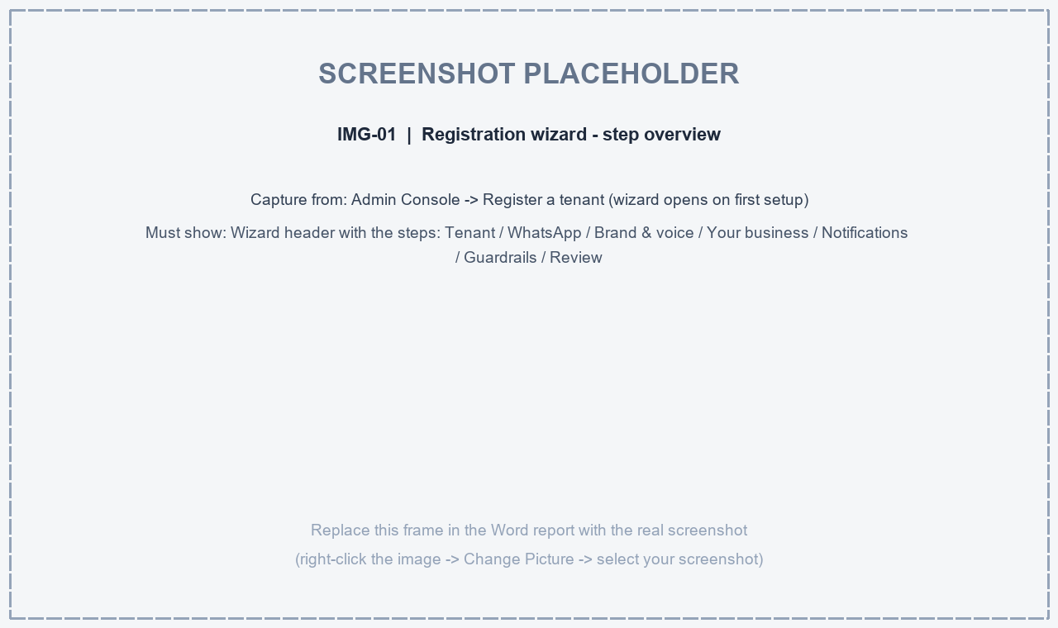
IMG-01 - Registration wizard - step overview (Capture: Admin Console -> Register a tenant (wizard opens on first setup))

1. Business & Brand Details
Information to collect | Description | Client input
Legal company name | Registered company name
Brand / display name | Name shown to customers on WhatsApp
Tagline | One-line brand tagline
Official website | Company website URL
Support email | Customer care email shown by the bot
Support phone | Customer care helpline number
Sales / enquiries email | Where sales enquiries are sent
Timezone | Business timezone (e.g. Asia/Kolkata)
Working hours | Opens / Closes time, or Always open
Out-of-hours message | Message shown outside working hours

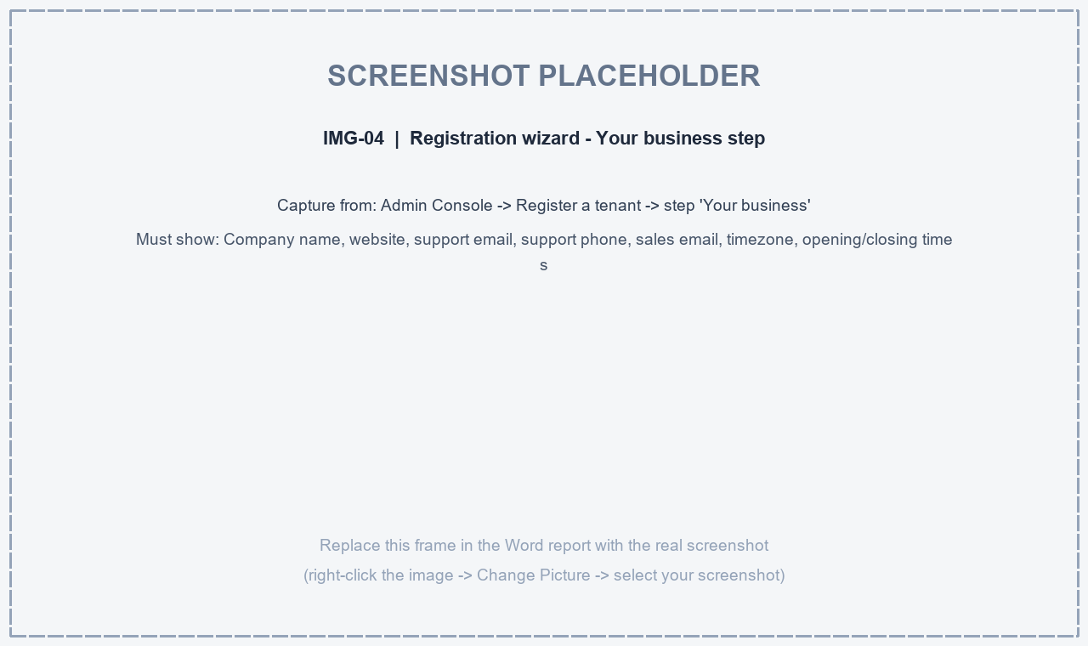
IMG-04 - Registration wizard - Your business step (Capture: Admin Console -> Register a tenant -> step 'Your business')
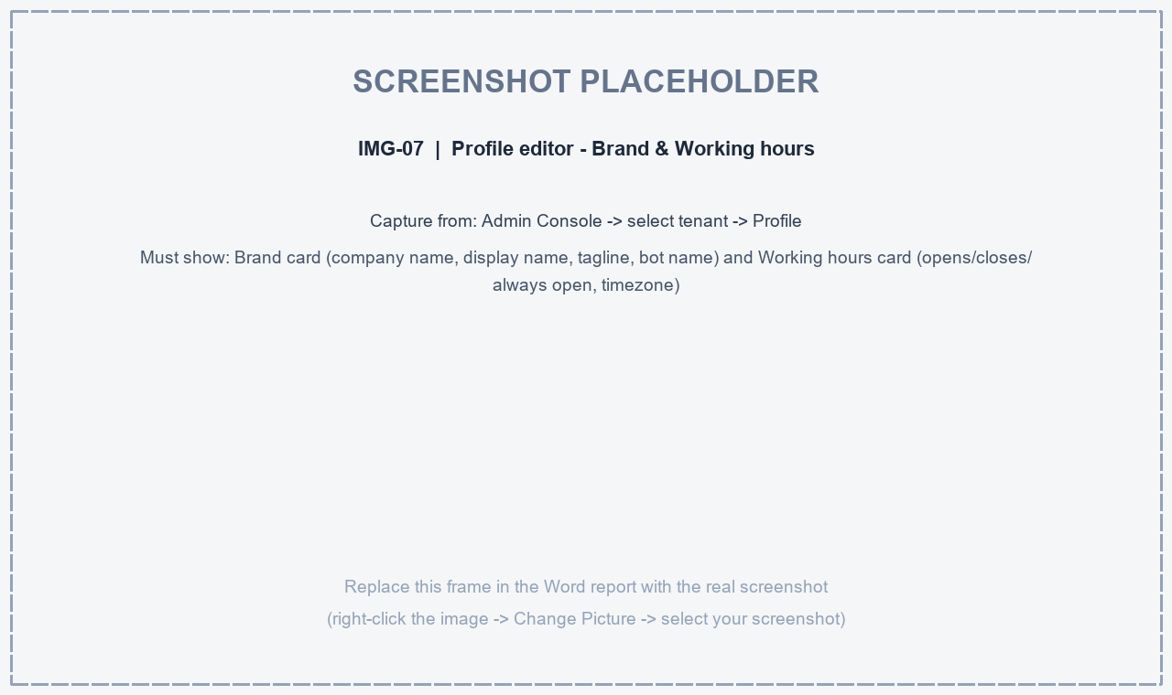
IMG-07 - Profile editor - Brand & Working hours (Capture: Admin Console -> select tenant -> Profile)

2. WhatsApp Business Number
The mobile number the chatbot will be connected to (the number customers chat with). Provide the number with country code.
Information to collect | Description | Client input
WhatsApp phone number | The number to connect the AI chatbot to, with country code (e.g. +91 XXXXXXXXXX)
Number owner confirmation | Confirm the client owns this number / has access to its SMS verification

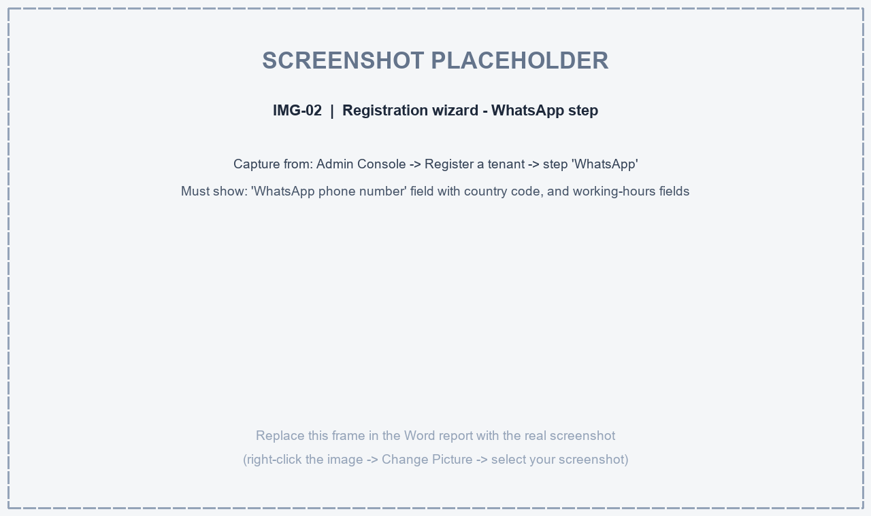
IMG-02 - Registration wizard - WhatsApp step (Capture: Admin Console -> Register a tenant -> step 'WhatsApp')

3. AI Bot Persona & Behaviour
Information to collect | Description | Client input
Bot name | The name the AI assistant introduces itself with
Tone / style | Professional / Friendly / Casual / Luxury / Technical
Menu greeting | Greeting sent when the customer opens the chat
Closing signature | Sign-off line appended to bot messages
Languages | English, Hindi, Hinglish or regional languages
Human handover trigger words | Words that transfer the chat to a human (e.g. human, agent, support)
Escalation message | Message sent when the chat is handed to a human agent

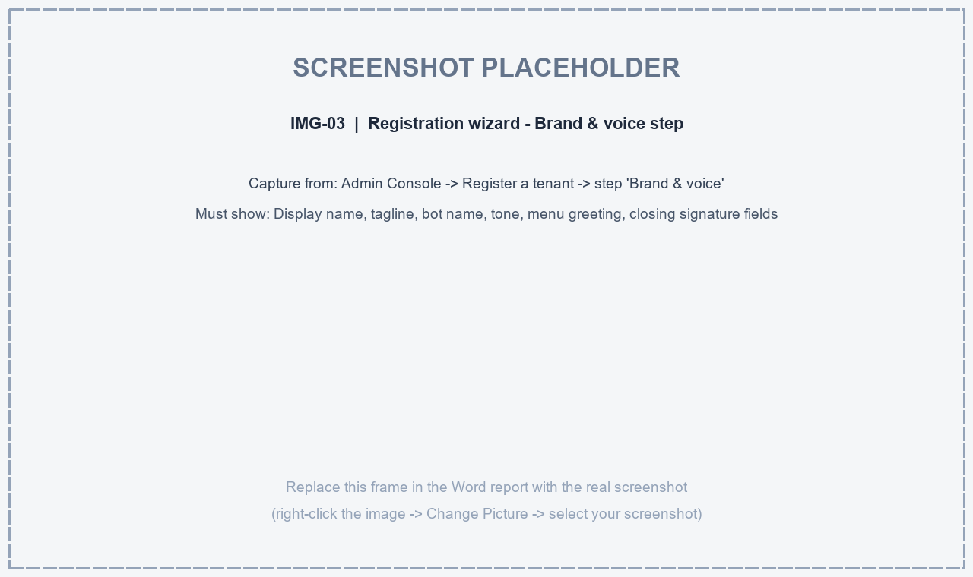
IMG-03 - Registration wizard - Brand & voice step (Capture: Admin Console -> Register a tenant -> step 'Brand & voice')

4. Bot Guardrails (What the Bot Must Never Say)
A list of statements the bot must never make - written carefully, one per line. Examples: promises about guarantees, legal or medical claims, discount commitments.
Information to collect | Description | Client input
Never-state list | Statements the bot must never make, one per line
Compliance notes | Any regulatory wording restrictions for the industry

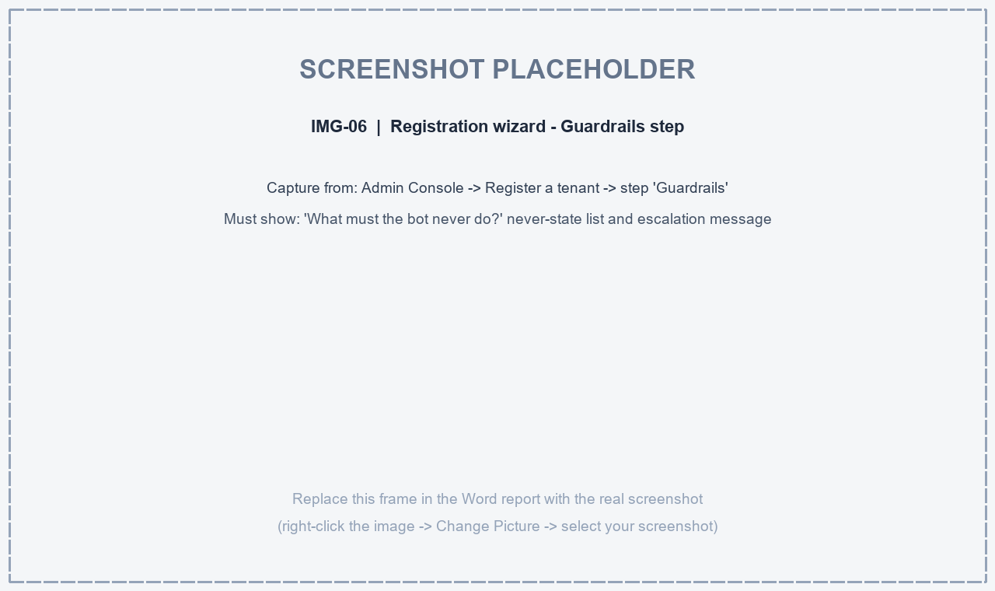
IMG-06 - Registration wizard - Guardrails step (Capture: Admin Console -> Register a tenant -> step 'Guardrails')

5. Notifications & Enquiry Routing
Information to collect | Description | Client input
Notifications email | Email address where new enquiries and alerts are delivered
Urgent enquiry alert | Phone/email to alert the team for urgent inquiries

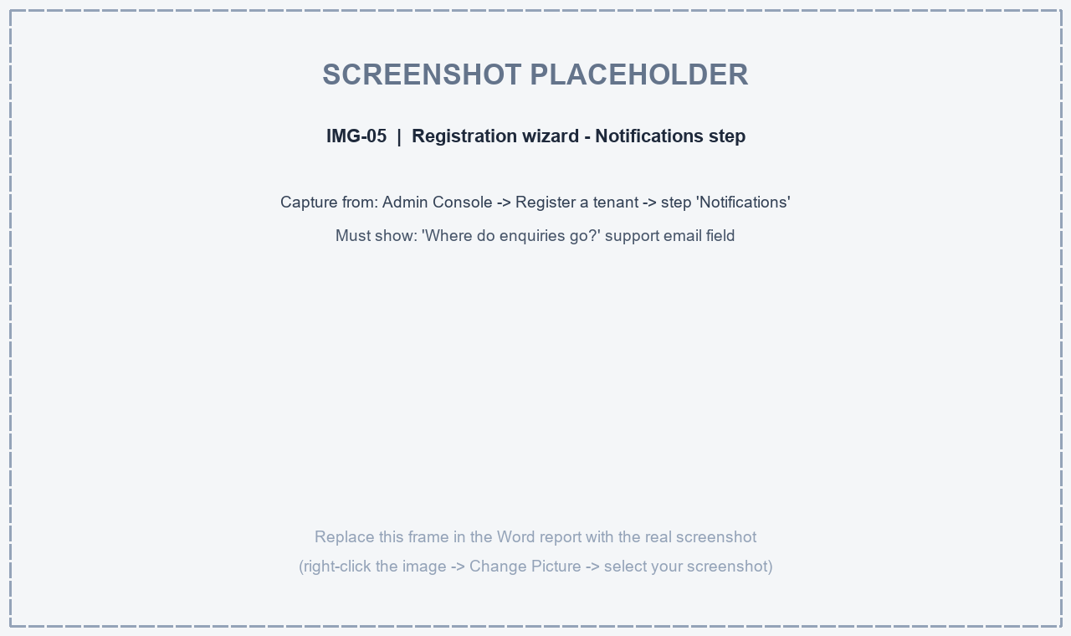
IMG-05 - Registration wizard - Notifications step (Capture: Admin Console -> Register a tenant -> step 'Notifications')

6. Products & Services Catalog
First confirm which optional modules should be enabled, then provide the catalog. The catalog can be supplied as an Excel/CSV sheet using the columns below.
Information to collect | Description | Client input
Modules to enable | Products / Products & Schemes / Services / Distributors / Campaigns
Short label | Product or service name shown in the menu (keep it short)
Short description | One-line summary the bot uses in menus
Full description | Detailed description the bot uses when answering questions
Link | Product page or purchase link (https://...)
Group / category | Grouping used to organise the catalog
Catalog file | Excel/CSV with all products or a ready catalog PDF (optional)

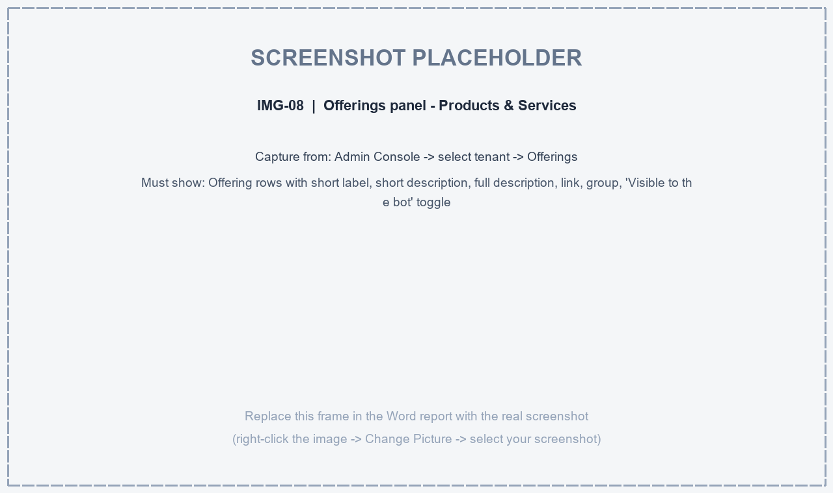
IMG-08 - Offerings panel - Products & Services (Capture: Admin Console -> select tenant -> Offerings)

7. FAQs & Knowledge Base Documents
The AI uses this content to answer customer questions 24x7. Please provide:
- Frequently Asked Questions - question and answer pairs (Excel or document)
- Return / refund / cancellation policy
- Warranty, guarantee and service terms
- Delivery timelines and shipping charges
- Store / office addresses and branch locations
- Accepted payment methods
- Product brochures, user manuals, policy documents (PDF / DOCX / TXT)
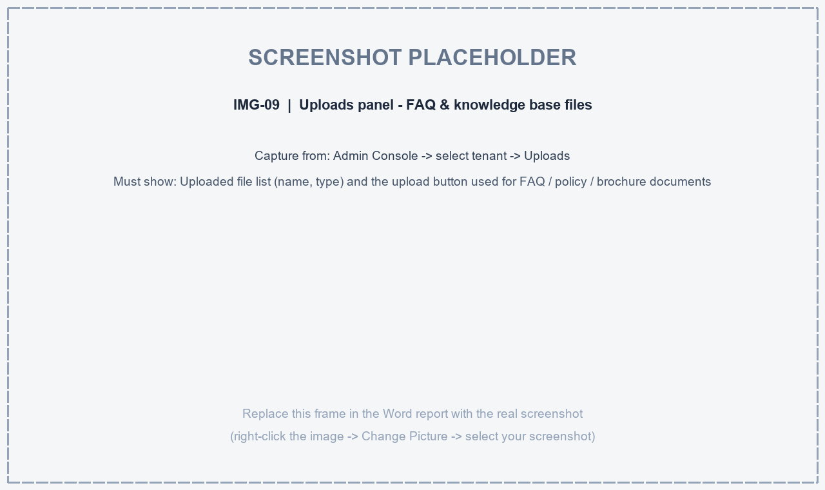
IMG-09 - Uploads panel - FAQ & knowledge base files (Capture: Admin Console -> select tenant -> Uploads)

8. WhatsApp Main Menu Structure
How the main WhatsApp menu should look. If the client already has a preferred structure, capture it here; otherwise our team designs one from the catalog and FAQs.
Information to collect | Description | Client input
Menu header / body / footer | Header text, welcome body text and footer shown on the main menu
Button text | Text on the menu button (e.g. Show Options)
Menu sections | Section names and the options under each section
Option titles, descriptions & icons | Title, one-line description and icon for each menu option

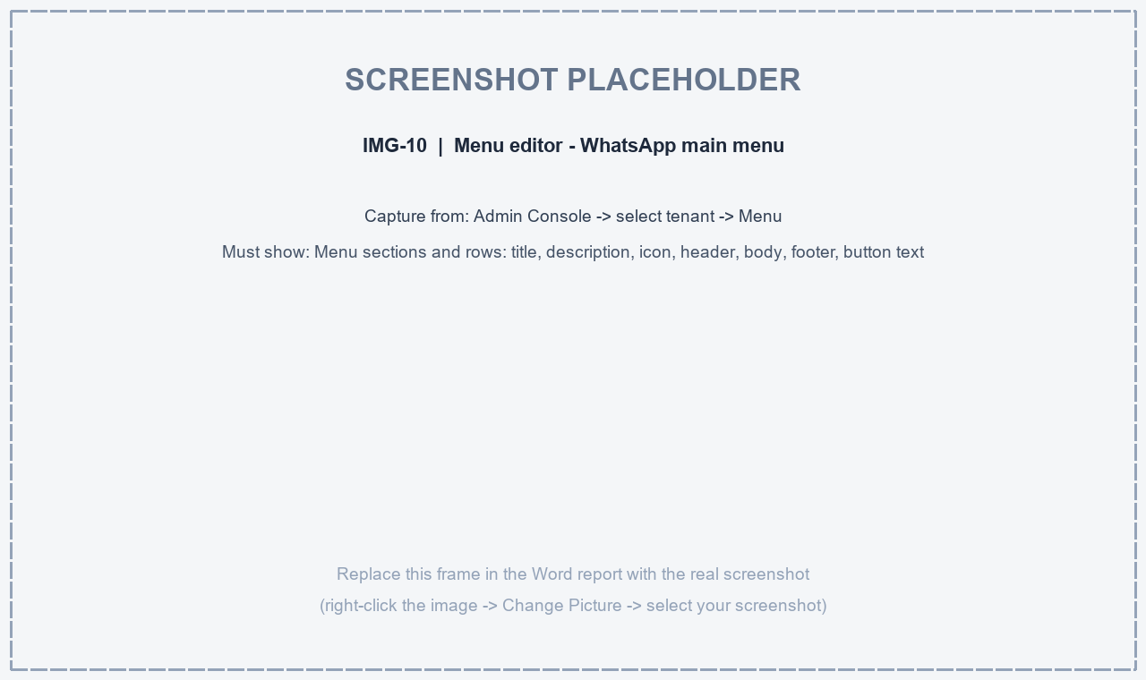
IMG-10 - Menu editor - WhatsApp main menu (Capture: Admin Console -> select tenant -> Menu)

9. Team Accounts & Roles
Team members who need access to the Admin Console and Live Chat Inbox.
Full name | Username | Email | Role | Phone
Roles: Tenant Admin (full control) / Sub Admin / Support Agent (live inbox & orders) / Distributor (stock & orders only)
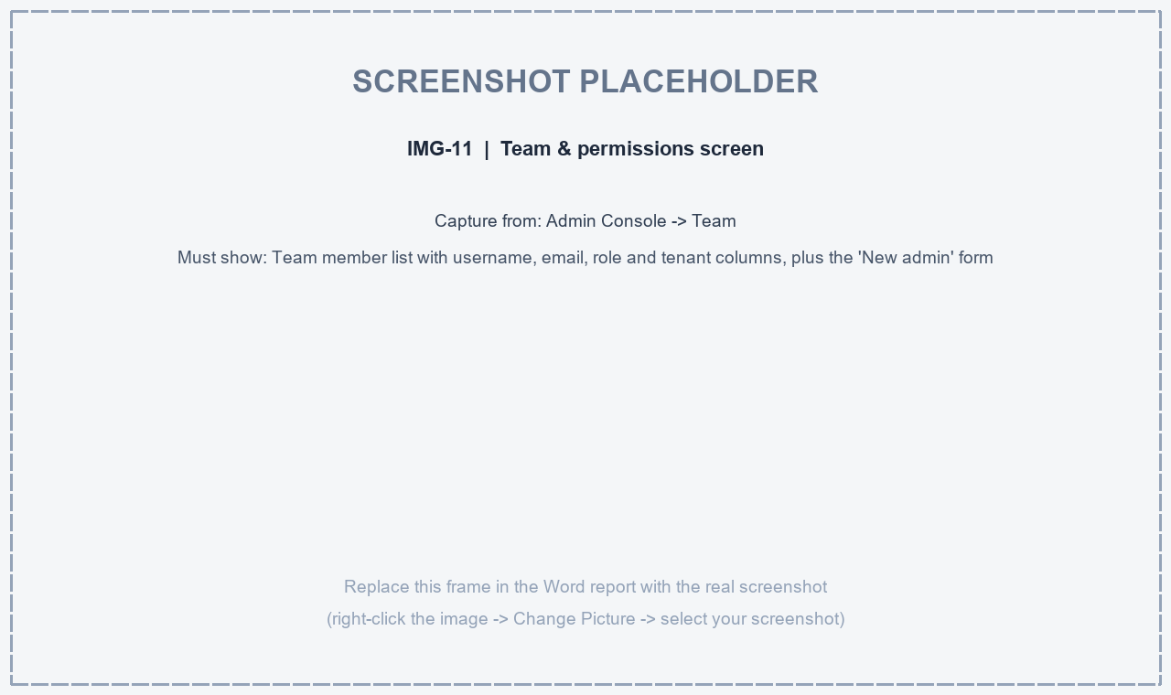
IMG-11 - Team & permissions screen (Capture: Admin Console -> Team)

10. Brand Assets & Files to Attach
Information to collect | Description | Client input
Brand logo | High-resolution logo, PNG or JPG, minimum 512 x 512 px
Product images | Images referenced in the catalog (optional)
Catalog PDF | Ready-made catalog PDF to share with customers (optional)
FAQ / policy documents | Files listed in section 7

11. Submission & Next Steps
1. Fill in the tables above for your brand.
2. Attach your logo, FAQ and product/catalog files.
3. Send this document to your account manager, or upload it through the Admin Console.
4. Our team configures your workspace and connects your WhatsApp line for testing.
5. Go live: after your sign-off on the test conversations, the bot is switched to your live number.

Appendix A - Dashboard Screens to Capture for This Report
Every grey frame in this report is a placeholder for a screenshot of the dashboard. Capture each screen listed below, then replace the matching frame in Word (right-click the frame -> Change Picture -> select the screenshot).
Frame | Dashboard screen | Where to capture it
IMG-01 | Registration wizard - step overview | Admin Console -> Register a tenant (wizard opens on first setup)
IMG-02 | Registration wizard - WhatsApp step | Admin Console -> Register a tenant -> step 'WhatsApp'
IMG-03 | Registration wizard - Brand & voice step | Admin Console -> Register a tenant -> step 'Brand & voice'
IMG-04 | Registration wizard - Your business step | Admin Console -> Register a tenant -> step 'Your business'
IMG-05 | Registration wizard - Notifications step | Admin Console -> Register a tenant -> step 'Notifications'
IMG-06 | Registration wizard - Guardrails step | Admin Console -> Register a tenant -> step 'Guardrails'
IMG-07 | Profile editor - Brand & Working hours | Admin Console -> select tenant -> Profile
IMG-08 | Offerings panel - Products & Services | Admin Console -> select tenant -> Offerings
IMG-09 | Uploads panel - FAQ & knowledge base files | Admin Console -> select tenant -> Uploads
IMG-10 | Menu editor - WhatsApp main menu | Admin Console -> select tenant -> Menu
IMG-11 | Team & permissions screen | Admin Console -> Team

