Feature: Wishlist Management

1.User visits the 'Park Flex' homepage [user action].

2.User clicks on 'Browse Spots' button [user action].

3.System redirects the user to the homepage where a list of parking spots is displayed [system action].

4.User selects a particular parking spot from the list of parking spots [user action].

5.System displays the page for the selected parking spot, detailing availability, location, price, and other relevant information [system action].

6. User clicks on the 'Save' button, located on the top right corner of the page, to add the parking spot to their Wish List [user action].

7. System checks if the user has already saved this parking spot to their Wish List [system action].

7.1. If the parking spot is already in the Wish List system removes the parking spot to the user's Wish List [system action].

7.2. If the parking spot is not in the Wish List system adds the parking spot to the user's Wish List [system action].

8. System displays a confirmation message that the parking spot has been added to the Wish List [system action].

9. User can access their Wish List through their user profile or a designated section within the application [user action].

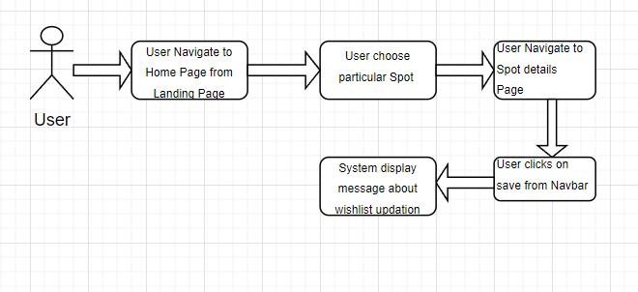

Feature: Help Center

Task 1: FAQs

1. User visits any page of the 'Park Flex' application [user action].
2. User scrolls to the footer [user action].
3. User clicks on the 'FAQs' button [user action].
4. System displays the FAQs section with various categorized questions and answers [system action].
5. User browses through the FAQs to find an answer to their question [user action].

Task 2: Contact us

1. User visits any page of the 'Park Flex' application [user action].
2. User scrolls to the footer [user action].
3. User clicks on the 'Contact Us' button [user action].
4. System displays a contact form requesting the user’s name, email, and message [system action].
5. User fills in the contact form with their information and inquiry [user action].
6. User clicks the 'Submit' button [user action].
7. System displays a confirmation message[system action].



