|  |  |
| --- | --- |
| **Fourier Transform**  Frequency Domain Filtering |  |

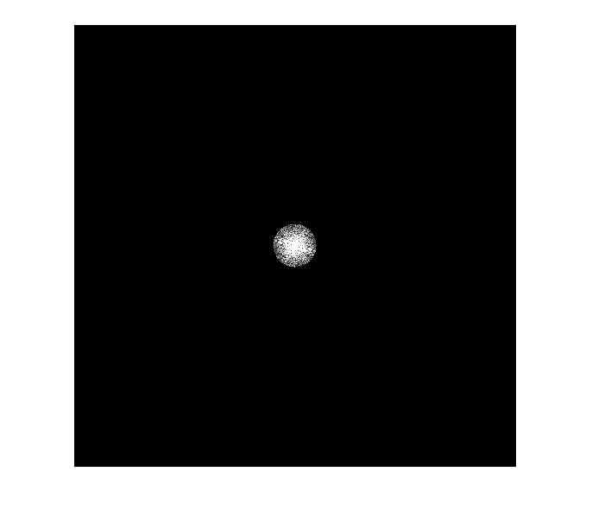

**R E P O R T**

|  |  |
| --- | --- |
| **과목명** | 로봇비전 |
| **담당교수** | 김형석 교수님 |
| **이름** | 이원재 |
| **학과명** | 전자공학부 |
| **학번** | 201314651 |

**차 례**

**01 Matlab Code 01**

SF 01

MLMF 01

MHMF 02

Main Code 03

**02 Result 1 04**

Original Image 04

FDRI 04

LFRIFD 05

LFRITD 05

HFRIFD 06

HFRITD 06

**03 Conclusion 07**