1.)

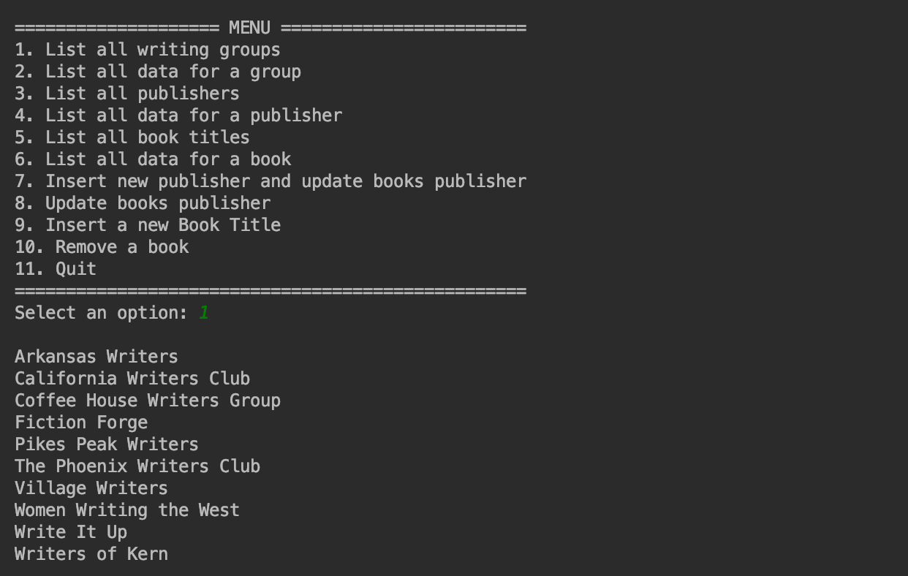

2.)



OTHER PUBLISHER DATA IS INCLUDED TO THE RIGHT OF PUBLISHE ADDRESS, IT JUST GOT CUT OUT IN THE IMAGE

3.)



4.)

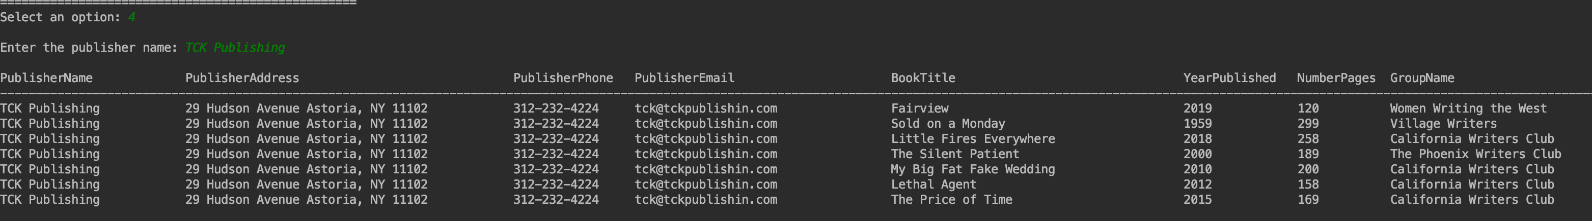

OTHER DATA IS INCLUDED TO THE RIGHT OF GROUPNAME , IT JUST GOT CUT OUT IN THE IMAGE

5.)

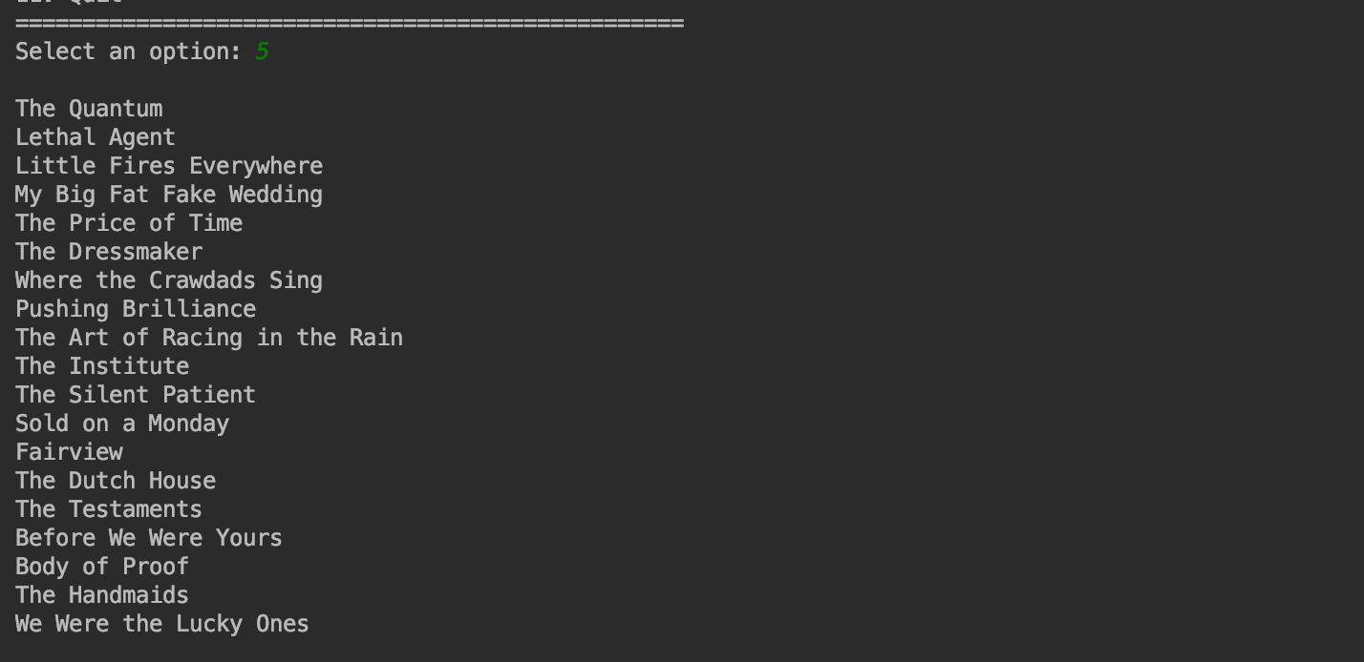

6.)



7.)

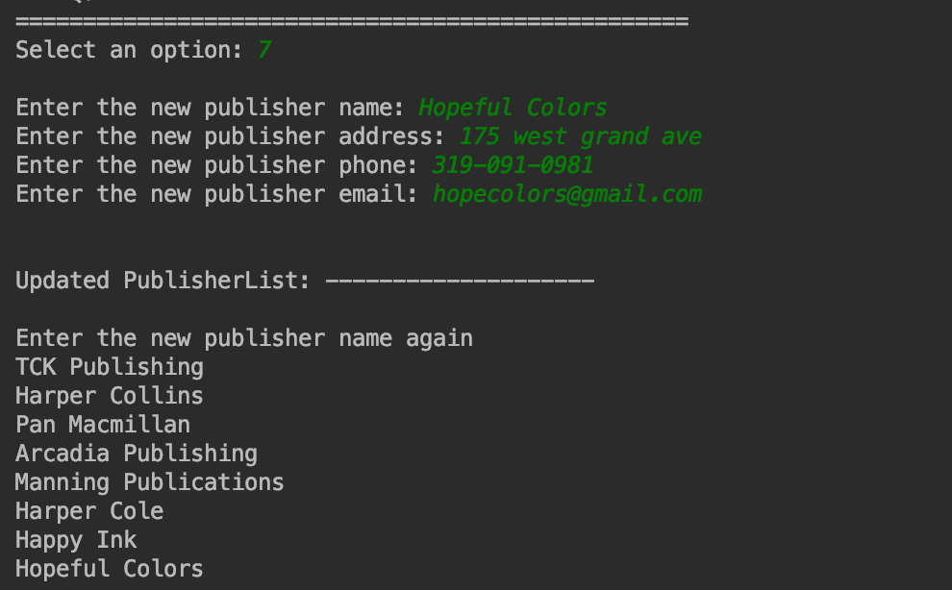

8.)

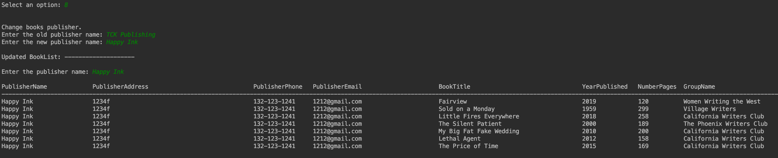

9.)

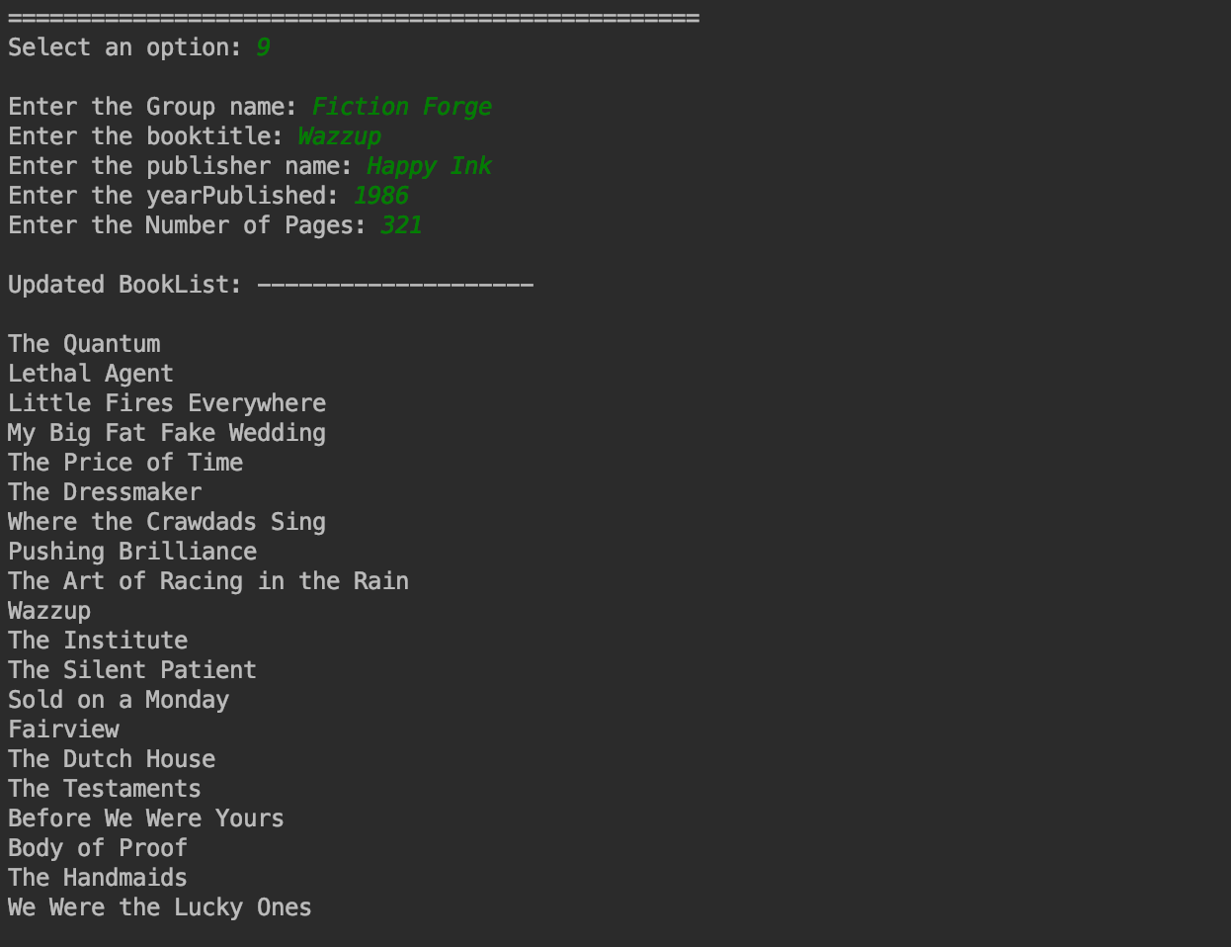

10.)

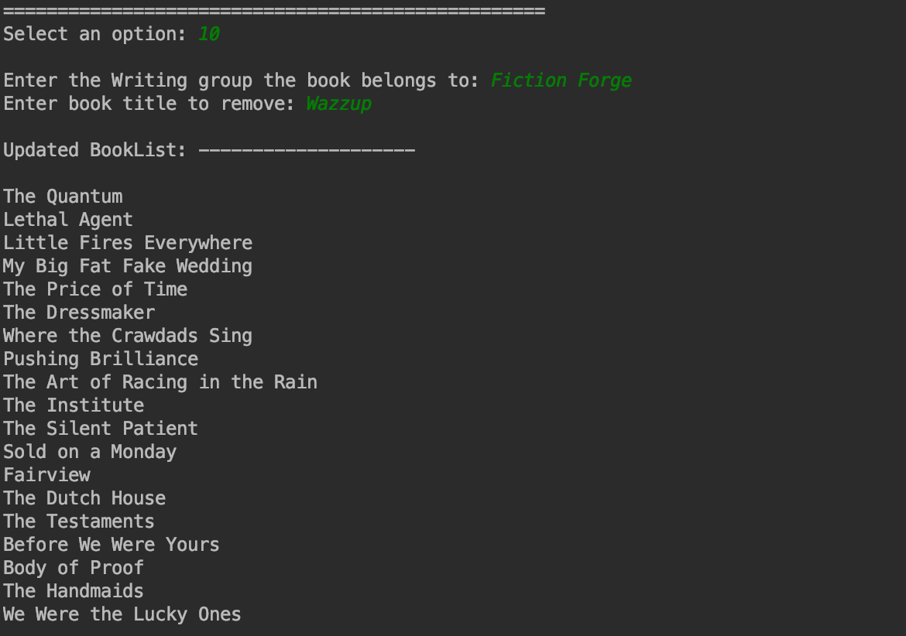

11.)

