URL: <https://justjayapi.000webhostapp.com/allusers>

Method: GET

Params: null

Output:

URL: <https://justjayapi.000webhostapp.com/login_post>

Method: POST

Params: body:form-Data => {username:”value”,password:”value”}

Screenshot : 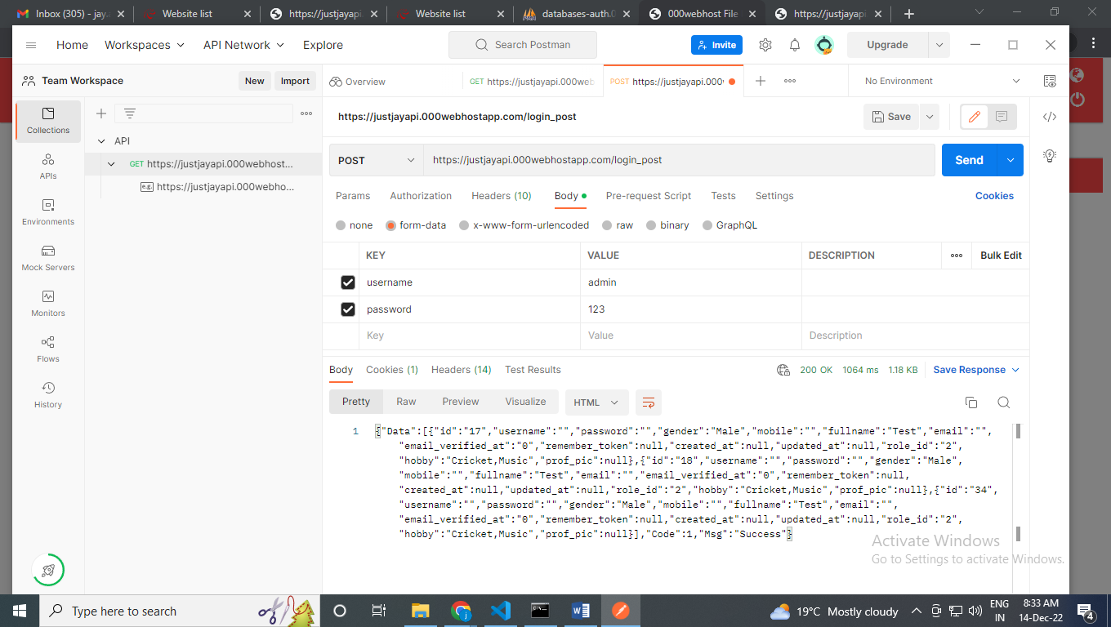

Output:

{"Data":[{"id":"17","username":"","password":"","gender":"Male","mobile":"","fullname":"Test","email":"","email_verified_at":"0","remember_token":null,"created_at":null,"updated_at":null,"role_id":"2","hobby":"Cricket,Music","prof_pic":null},{"id":"18","username":"","password":"","gender":"Male","mobile":"","fullname":"Test","email":"","email_verified_at":"0","remember_token":null,"created_at":null,"updated_at":null,"role_id":"2","hobby":"Cricket,Music","prof_pic":null},{"id":"34","username":"","password":"","gender":"Male","mobile":"","fullname":"Test","email":"","email_verified_at":"0","remember_token":null,"created_at":null,"updated_at":null,"role_id":"2","hobby":"Cricket,Music","prof_pic":null}],"Code":1,"Msg":"Success"}