**Node.js Tutorial**



Node.js tutorial provides basic and advanced concepts of Node.js. Our Node.js tutorial is designed for beginners and professionals both.

Node.js is a cross-platform environment and library for running JavaScript applications which is used to create networking and server-side applications.

## **What is Node.js**

Node.js is a cross-platform runtime environment and library for running JavaScript applications outside the browser. It is used for creating server-side and networking web applications. It is open source and free to use. It can be downloaded from this link <https://nodejs.org/en/>

1. Node.js = Runtime Environment + JavaScript Library

**Different parts of Node.js**

The following diagram specifies some important parts of Node.js:

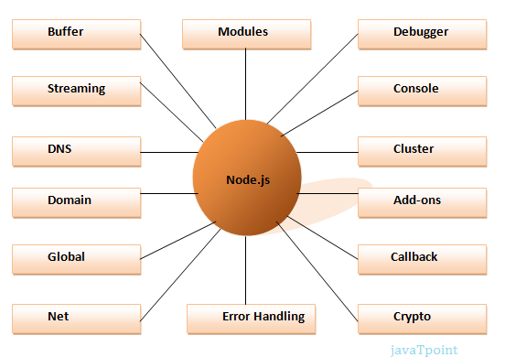

## **Features of Node.js**

Following is a list of some important features of Node.js that makes it the first choice of software architects.

1. **Extremely fast:** Node.js is built on Google Chrome's V8 JavaScript Engine, so its library is very fast in code execution.
2. **I/O is Asynchronous and Event Driven:** All APIs of Node.js library are asynchronous i.e. non-blocking. So a Node.js based server never waits for an API to return data. The server moves to the next API after calling it and a notification mechanism of Events of Node.js helps the server to get a response from the previous API call. It is also a reason that it is very fast.
3. **Single threaded:** Node.js follows a single threaded model with event looping.
4. **Highly Scalable:** Node.js is highly scalable because event mechanism helps the server to respond in a non-blocking way.
5. **No buffering:** Node.js cuts down the overall processing time while uploading audio and video files. Node.js applications never buffer any data. These applications simply output the data in chunks.
6. **Open source:** Node.js has an open source community which has produced many excellent modules to add additional capabilities to Node.js applications.
7. **License:** Node.js is released under the MIT license.