**Node.js First Example**

There can be console-based and web-based node.js applications.

**Node.js console-based Example**

File: console_example1.js

1. console.log('Hello Brijesh');

Open Node.js command prompt and run the following code:

1. node console_example1.js

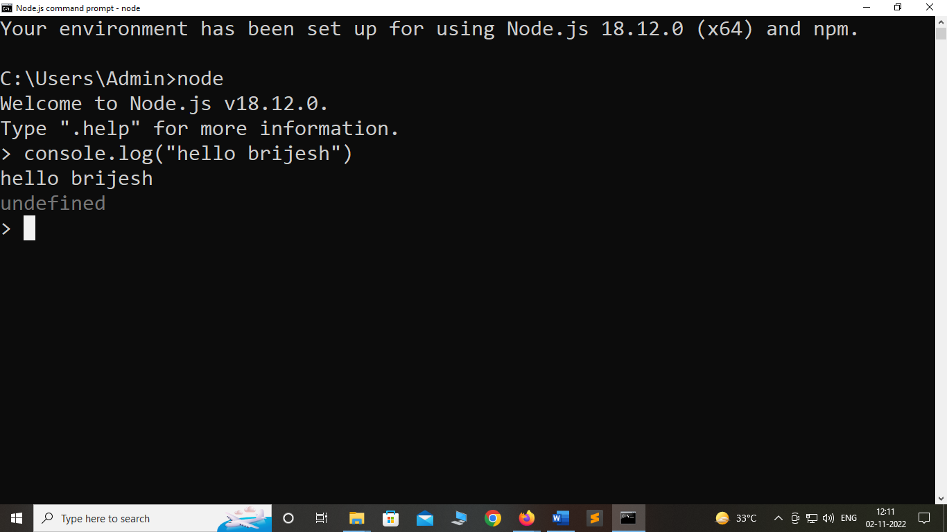

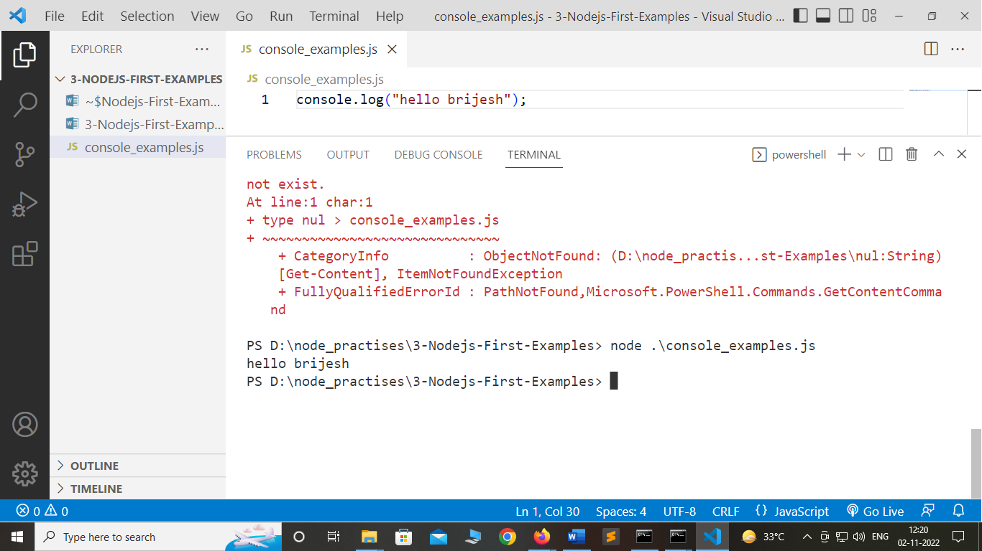

**Node.js web-based Example**

A node.js web application contains the following three parts:

1. **Import required modules:** The "require" directive is used to load a Node.js module.
2. **Create server:** You have to establish a server which will listen to client's request similar to Apache HTTP Server.
3. **Read request and return response:** Server created in the second step will read HTTP request made by client which can be a browser or console and return the response.

**How to create node.js web applications**

Follow these steps:

1. **Import required module:** The first step is to use ?require? directive to load http module and store returned HTTP instance into http variable. For example:
   1. var http = require("http");
2. **Create server:** In the second step, you have to use created http instance and call http.createServer() method to create server instance and then bind it at port 8081 using listen method associated with server instance. Pass it a function with request and response parameters and write the sample implementation to return "Hello World". For example:

File: main.js

* 1. var http = require("http");
  2. http.createServer(function (request, response) {
  3. // Send the HTTP header
  4. // HTTP Status: 200 : OK
  5. // Content Type: text/plain
  6. response.writeHead(200, {'Content-Type': 'text/plain'});
  7. // Send the response body as "Hello World"
  8. response.end('Hello Brijesh\n');
  9. }).listen(8081);
  10. // Console will print the message
  11. console.log('Server running at http://127.0.0.1:8081/');

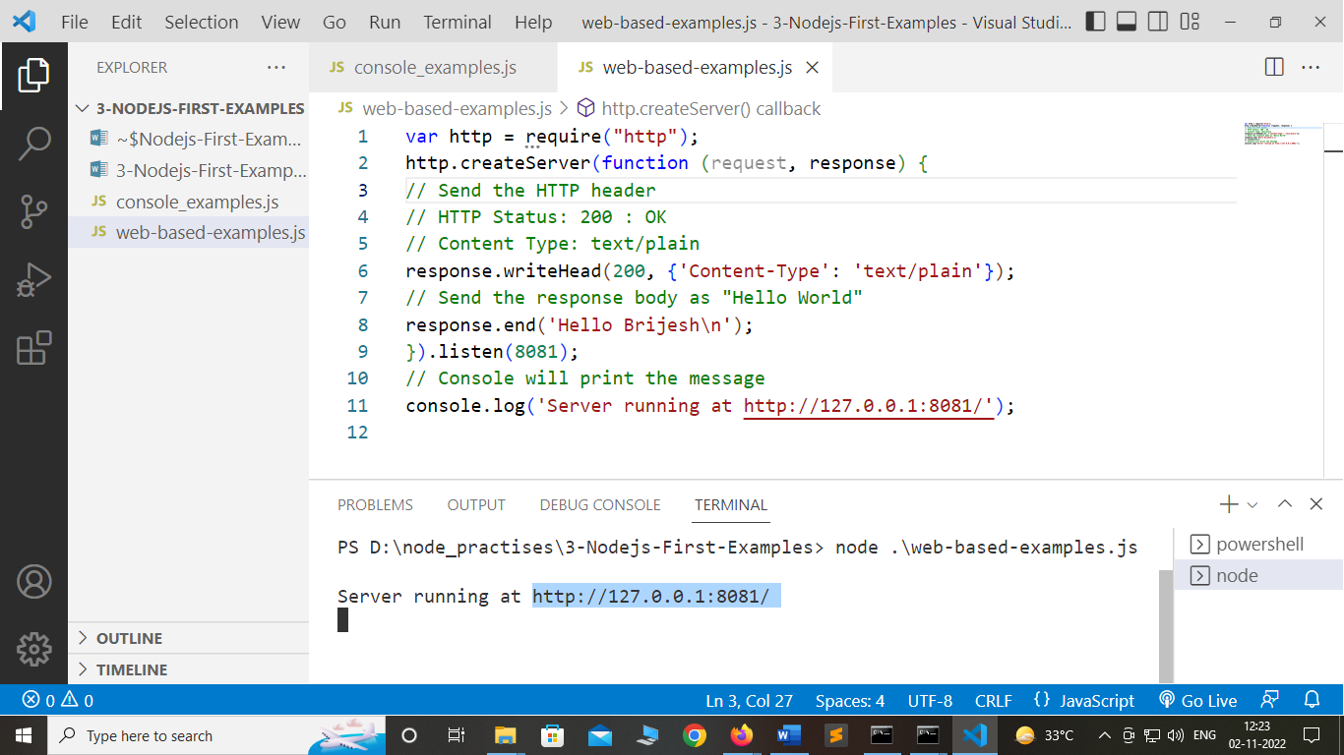

Server running at <http://127.0.0.1:8081/>

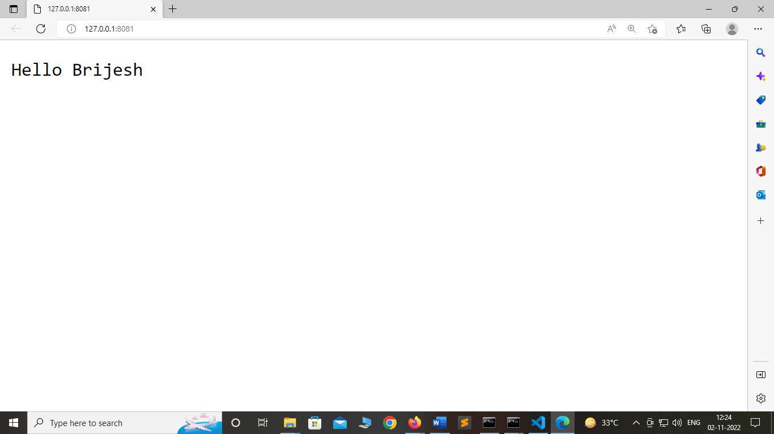

Additions.js

var http = require("http");

http.createServer(function (request, response) {

// Send the HTTP header

// HTTP Status: 200 : OK

// Content Type: text/plain

response.writeHead(200, {'Content-Type': 'text/plain'});

// Send the response body as "additions of numbers"

var a=10;

var b=20;

var c=a+b;

response.end('Additions of numbers is :'+(JSON.stringify(c)));

}).listen(8081);

// Console will print the message

console.log('Server running at http://127.0.0.1:8081/');

