**Class:** Final Year (Computer Science and Engineering)

**Year:** 2024-25 **Semester:** 7

**Course:** High Performance Computing Lab

**Practical No. 4**

**Exam Seat No:21510018**

**Name: Jay Sandeep Chatpalliwar**

**Batch:B1**

**Title of practical:**

Study and Implementation of Synchronization

**Problem Statement 1:**

# Analyse and implement a Parallel code for below programs using OpenMP considering synchronization requirements. (Demonstrate the use of different clauses and constructs wherever applicable)

# Fibonacci Computation:

**Screenshots:**

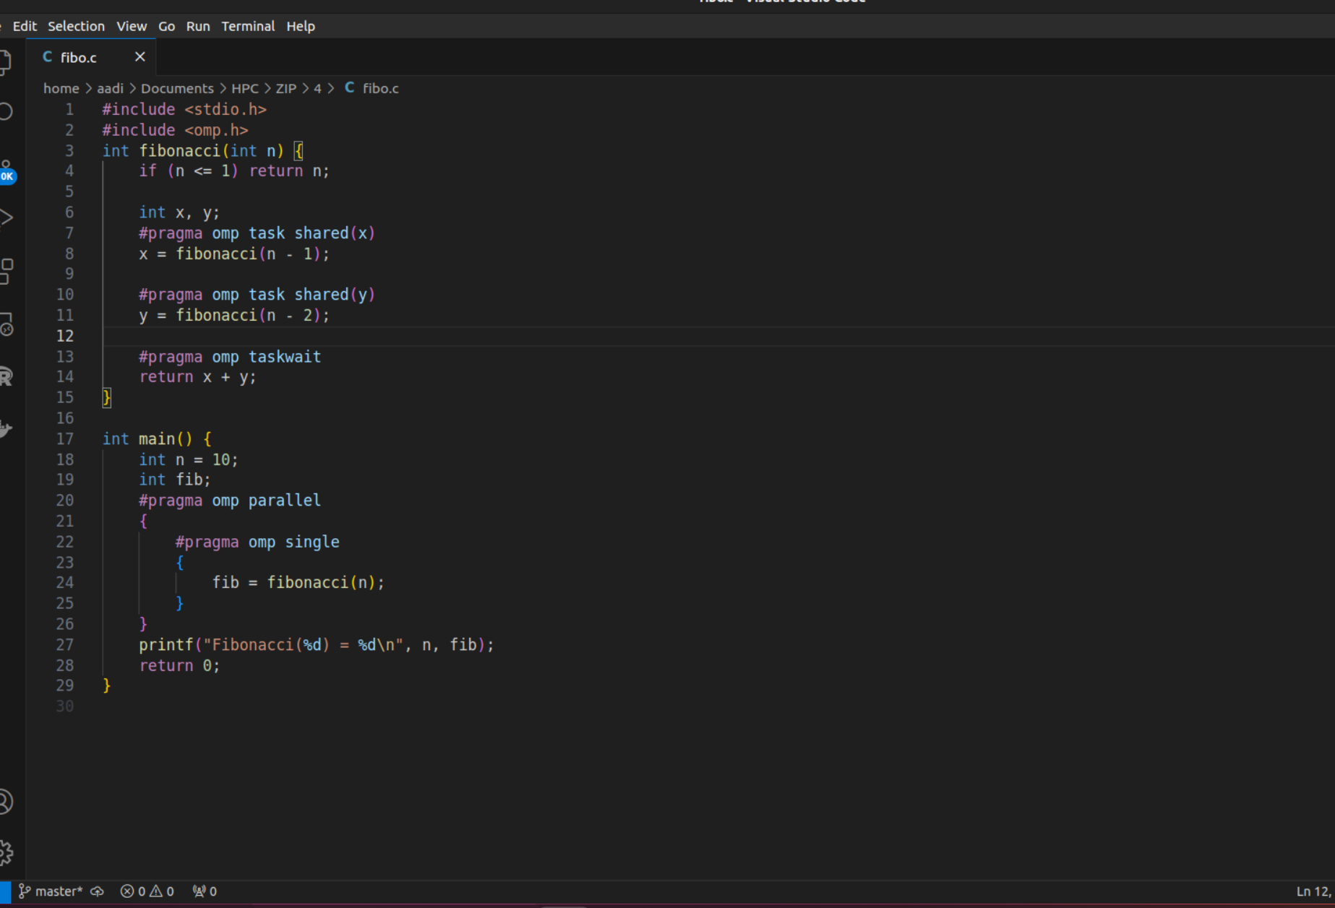

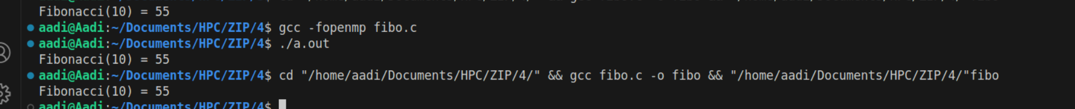

**Information:**

**Problem Statement 2:**

# Analyse and implement a Parallel code for below programs using OpenMP considering synchronization requirements. (Demonstrate the use of different clauses and constructs wherever applicable)

## Producer Consumer Problem

**Screenshots:**

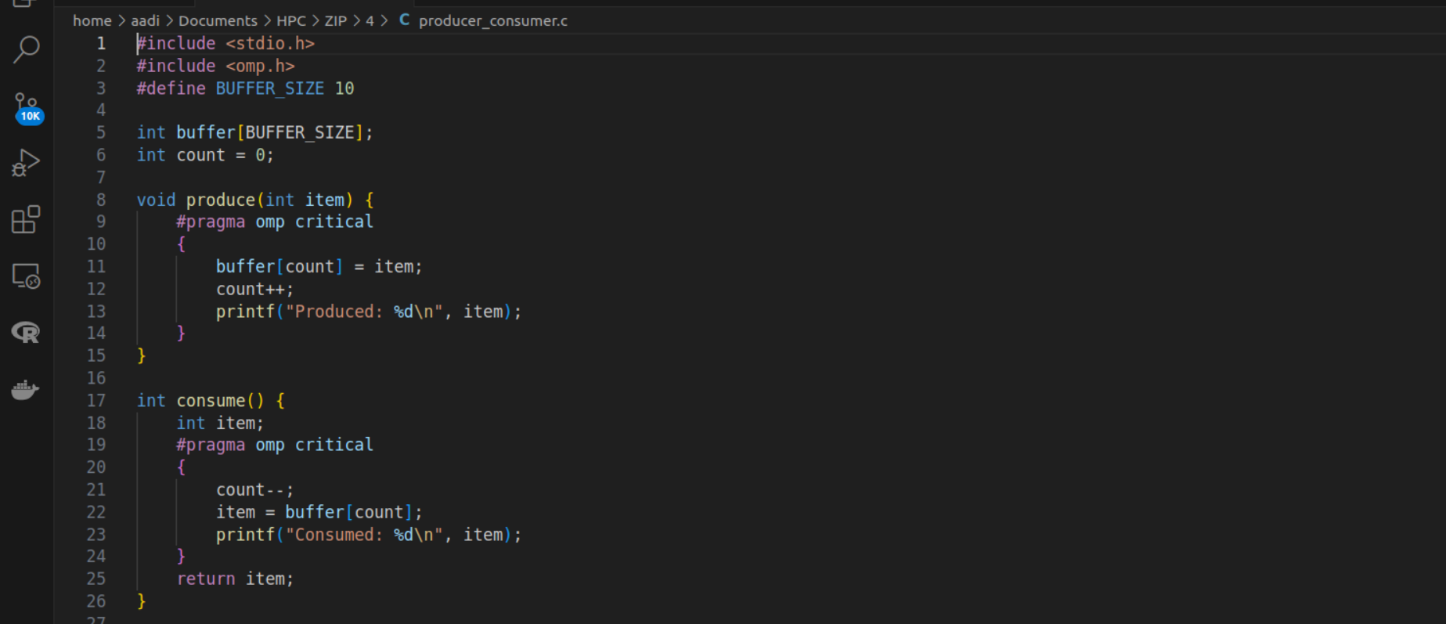

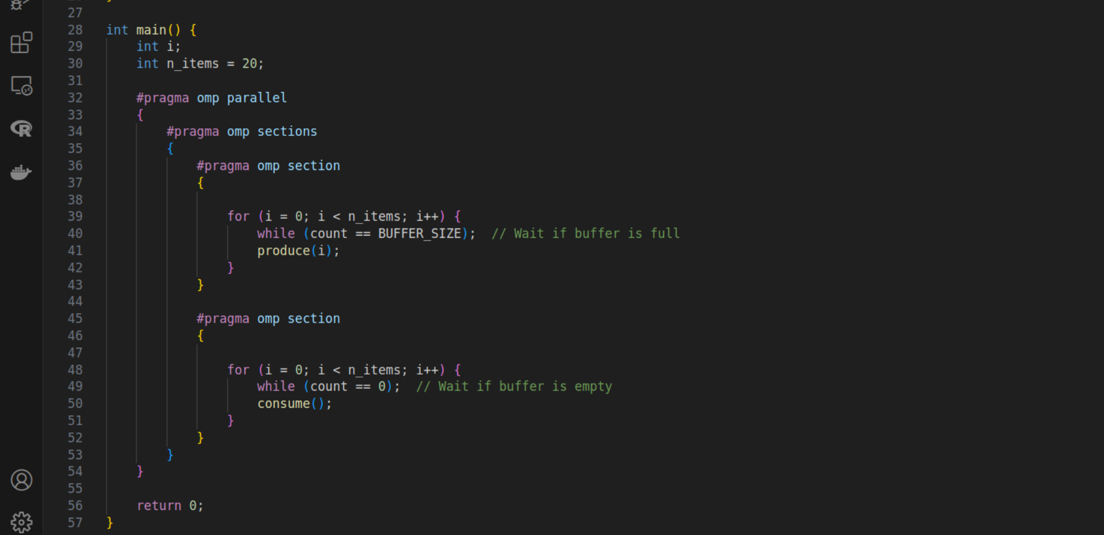

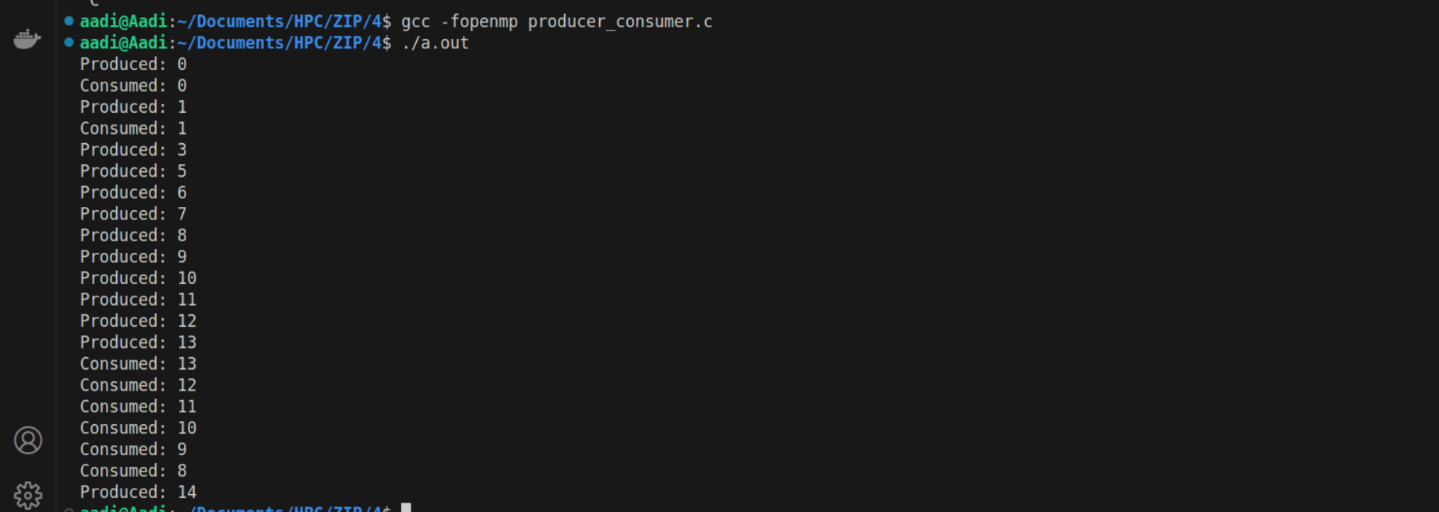**Information:**

**Github Link:** [**Git Repo**](https://github.com/jay-chatpalliwar/HPC-Lab/tree/master/practical4)