**Problem Statement**

Creating a system to monitor temperature and humidity and respond as to how their values must be changed with respect to a specified target. It is described in more detail below.

**Components and Their Use:**

We have created a part of a feedback control mechanism. Here, we have configured two STM32 and two NodeMCU boards to work together. Each STM32 Board is connected to one NodeMCU board they communicate via UART. In the future, we will be calling one STM32 as the sensing board and the other as the display board. The sensing board is also connected to a DHT11 sensor which provides it with temperature and humidity data.

The NodeMCU are responsible for establishing the MQTT connections and the STM32 handle the responsibility of communicating with the other sensors and actuators.

We also created an android app which is primary interaction for the user. It receives sensor data and sets the target temperature and humidity over MQTT.

**Program Flow:**

Once all the boards are initialised, the sensing board gets the temperature and humidity data and passes it on to its NodeMCU via UART which sends the data over MQTT.

The data is then received by the android app and the display board. The android app displays the data to the user. The user can also set the target temperature and humidity values at any given time and the app will broadcast them over MQTT.

The display board receives the data from the sensing board and the android application and turns the appropriate LEDs on. The mapping is given below:

|  |  |
| --- | --- |
| Display Board LED Color | Meaning |
| Blue | Current Temperature > Target Temperature |
| Orange | Current Temperature < Target Temperature |
| Green | Current Humidity > Target Humidity |
| Red | Current Humidity < Target Humidity |

|  |  |
| --- | --- |
| **Sensing Board LED Color** | **Meaning** |
| Orange | Indicates that MQTT is working |
| Blue | Toggles when data is being sent |

**Usecase UML Diagram**

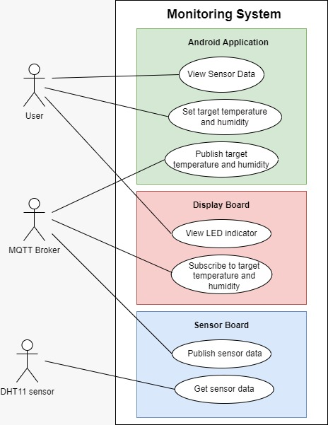

**State UML Diagram**

**Activity UML Diagram**

Since the above State and Activity UML Diagrams are very big, you can find them at this Figma link: <https://www.figma.com/file/9IAr0MD3Oxcyl5AZaLYdL8/SES-UML-Diagram?type=design&node-id=1%3A153&mode=design&t=YOAwQVKWNsuhXzgZ-1>

**Running**

**Wiring:**

The sensor board must be wired as follows:

1. Connect STM32 and NodeMCU to the computer using USB cables.
2. The D7 pin of NodeMCU to PA2 pin of STM, D8 pin of NodeMCU to PA3 pin of STM.
3. The Vcc pin of DHT11 to 5V pin of STM, GND pin of DHT11 to GND pin of STM, DATA pin of DHT11 to PB0 pin of STM.

The display board must be wired as follows:

1. Connect STM32 and NodeMCU to the computer using USB cables.
2. The D7 pin of NodeMCU to PA2 pin of STM, D8 pin of NodeMCU to PA3 pin of STM.

**Results**

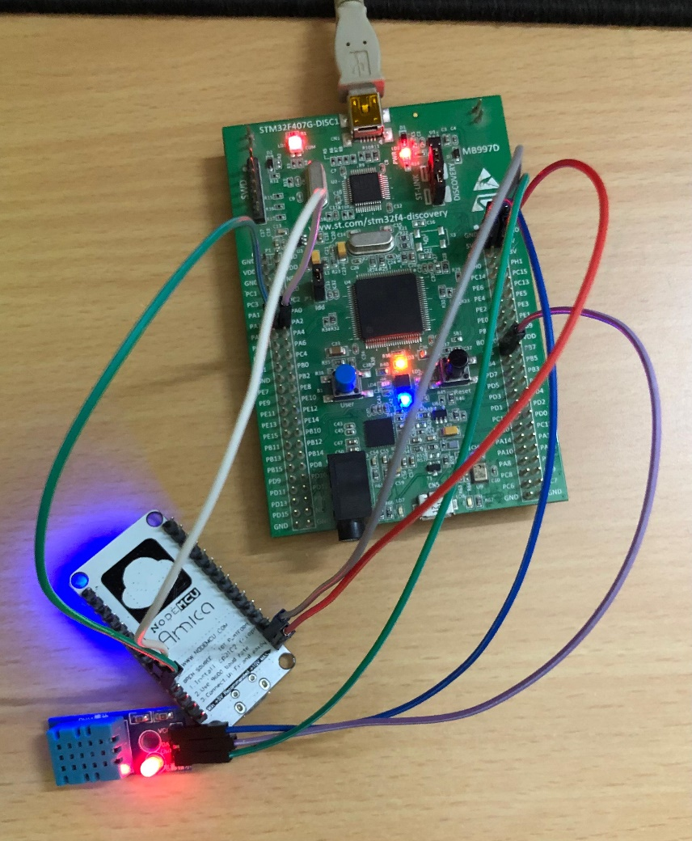

As we can see in the photos, the appropriate LEDs are on for the state described in the Monitor App.

**Efforts by:**

**Jay Goyal (2021A7PS2418P):** MQTT, UART + DMA for NodeMCU and STM32 Communication

**Kunjan Shah(2019HS030072P):** Android Application

**Aditya Shrivastava(2023H1400131P):** DHT11 Programming, MQTT