**🔧 STEP 1: Install Node.js**

1. Go to <https://nodejs.org>
2. Download the **LTS version**
3. Install it (click Next → Next → Install)
4. Open **Command Prompt** (Windows) or **Terminal** (Mac), and type:

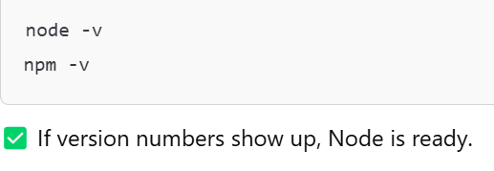

**📥 STEP 2: Download the Project (No Git Needed)**

1. Go to the link submitted of github by the student.
2. Click the green **Code** button → select **Download ZIP**
3. Extract the ZIP file anywhere (e.g., Desktop)

**📦 STEP 3: Install the Project Dependencies**

1. Open **Command Prompt**
2. Navigate into the project folder:

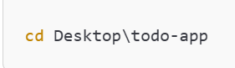

1. Run this Command -:

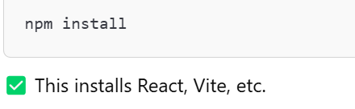

▶️ **STEP 4**: Start the App

* + Run this Command

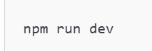

You’ll see something like:

