Lokey

Car Location and Tracking

A mobile application to assist with the struggles of parking.

## User

*Significant locations*, those defined by the user, usually trigger enter and exit events

Frequented locations. Defined locations a user passes through. (helps to fill gaps of sample)

carLocation : Int

viewRefreshRate : Double

locationHistory : [Int]

positionHistory : [[String:Double]]

### Historical Analysis

Similar movement M-F, 7am - 7:35am , 5pm - 6pm

Validates confidence

### Behavior Prediction

Using data from HA, and current behavior.. estimate user action

## Location

An abstract point of interest as defined by the user, an organization, or public listing. In the interest of LoKey, parking garages and lots are representative as locations.

### Indoor Position Approximation

*GPS*

Within a structure, such as a parking garage, approximation of a user’s position is determined by GPS coordinates and the relevant position in a structure’s layout. Any given structure is defined by foundation points and a buffer region. Typically, foundation points are representative of a building’s corners and it’s buffer region serves as a threshold for structure specified events. Each foundation point should be significant, and help to describe the orientation and layout of the building. In the example below, foundation points are the building’s NW, NE, SW, SE corners. By assessing users’ positions based on the following algorithm, a position can be generated with high confidence that a user is at a location, specifically in the N, E, W, S segments of a structure, along with refined positions NE, NW, SE, and SW if thresholds are met.

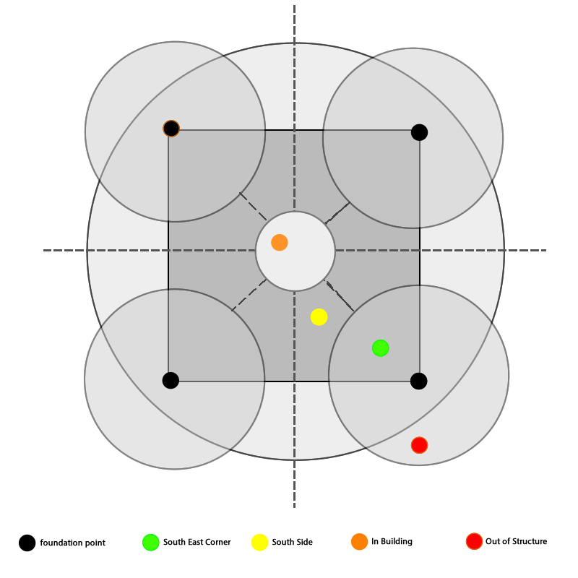

### Building Floor Approximation

Delta H within a sampling of enter/exit events

### Vehicle Detection

Position, connection, behavior combo method

## Device

### Device Manager

The Device Manager serves as a background task delegator. It cycles on a loop, varying speeds based on user behavior and predicted movement. On periodic intervals, various managers are called, adjusting the current location and supplying confidence information.

The figure below illustrates this process, where Position Manager and Behavior manager are only called when a location manager event is triggered or location certainty does not meet a threshold.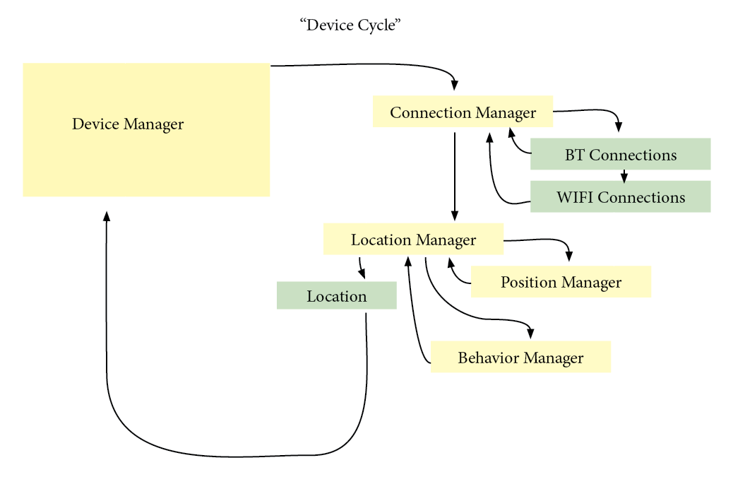

### Connection Manager

knownConnections : [Int:Connection]

currentConnections : [Int]

sessionConnections : [Int]



Connection

id : Int // global ref

localKey : String?

name : String?

type : Int = 0// 0:?, 1:BT, 2:WIFI

AUDIO

ignoredKeys : [String]

currentConnections : [AVAudioSessionPortDescription]

lastSync : Int?

WIFI

currentConnections : [[String : AnyObject]] = [[String : AnyObject]]()

ignoredKeys : [String] = []

### Location Manager

knownLocations : [Int:Location]

unknownLocation : Location

currentLocation : Int

lastLocation : Int

LOCATION

id: Int

name:String

associatedConnections : [Int]

lastCoordinate : [String:Double]

coordinateHistory : [[String:Double]]

foundationPoints : [[String:Double]]

description : String

### Position Manager

posManager = CLLocationManager()

coordinates = [CLLocationCoordinate2D]()

canUpdate = true

isBackground = false

deferringUpdate = false

distance : CLLocationDistance = 320.0 // 320 meters = 0.2 miles

m : Double = 1.0

updateInterval : TimeInterval = 57

### Energy Use

Data handeling, permissions

### Security

Data handeling, permissions

## Development

## Ethics

Tracking only for the UX… but still invasive