Services

Data is the part of model in the MVC structure. Combining the data part with component violates that scenario, as components fulfills view in the services. To decouple data and related functions on the data - services are used.

Component hierarchy diagram in the application: Decoupling services from the components.

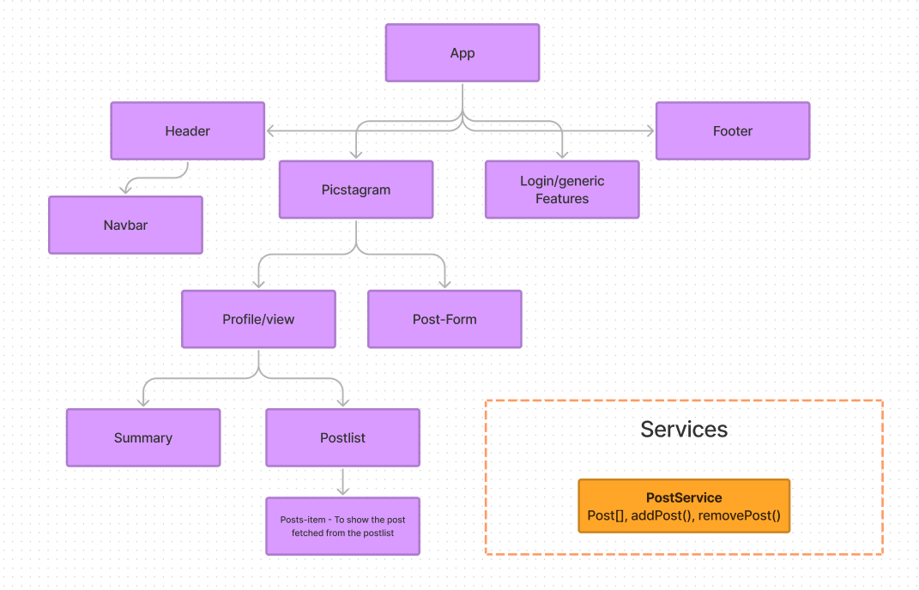

**Data Part:** post[] – post array which contains the list data of posts

To get the data services can call the api to get the data from the server. That data can be passed to the components accordingly. This type of approach - to get the data and share them between more than one component is called as *singleton approach*.

In singleton approach, data is present in the single instance and that can be shared across all the components