1. Write a Python program and calculate the mean of the below dictionary.

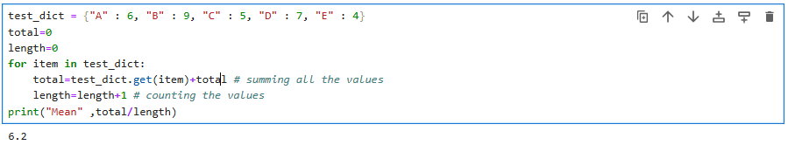

2. Write a Python script to concatenate the following dictionaries to create a new one.

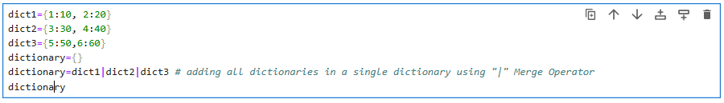

3. Write a Python program to get the key, value and item in a dictionary.

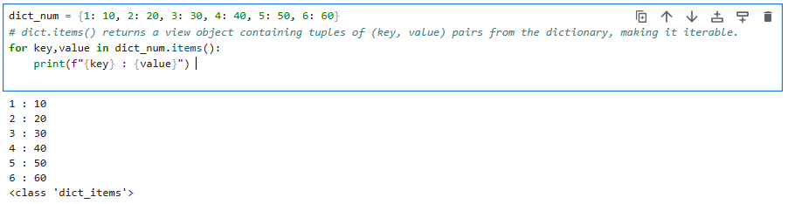

4. Write a Python program to get the key, value and item in a dictionary.

