1. Create a 1D array with elements from 1 to 10.

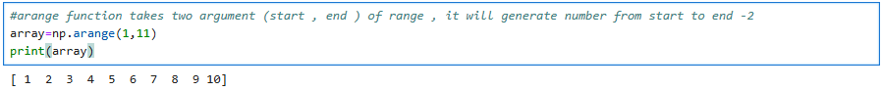

2. Create a 2D array of size 3x3 filled with zeros.

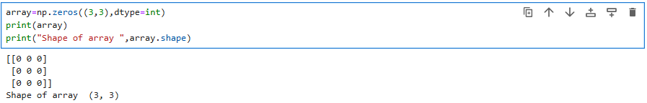

3. Find the maximum and minimum values in an array.

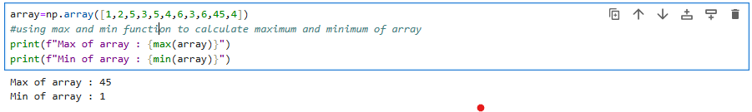

4. Reshape a 1D array into a 2D array of shape 2x5.

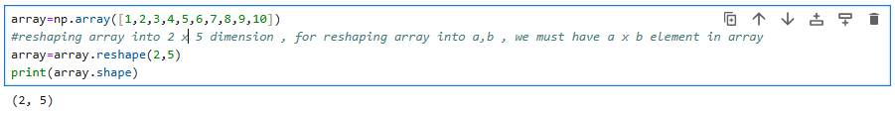

5. Generate a 1D array of 5 random integers between 10 and 50.

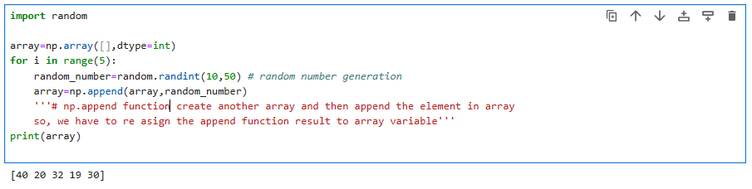

6. Convert the below list into numpy array then display the array

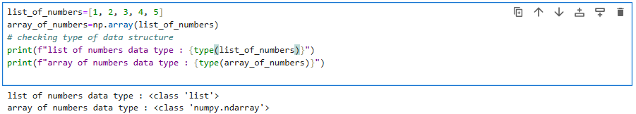

7. Convert the below list into a numpy array then display the array then display the first and last index and then multiply each element by 2 and display the result.

