1. Write a Python program to Get Only unique items from two sets.

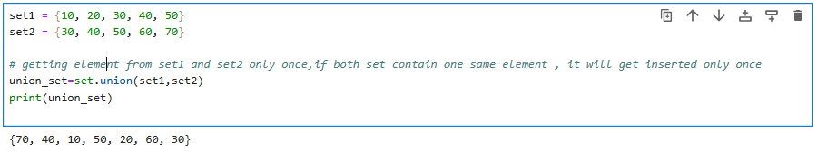

2. Write a Python program to Return a set of elements present in Set A or B, but not both.

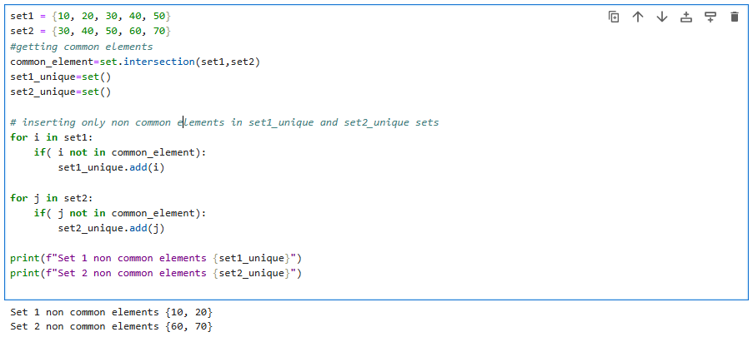

3. Write a Python program to Check if two sets have any elements in common. If yes, display the common elements.

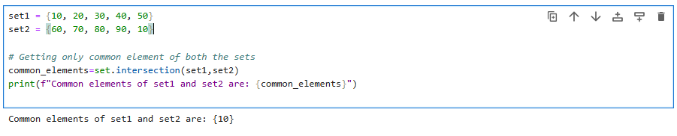

4. Write a Python program to Remove items from set1 that are not common to both set1 and set2.

