1. Write a Python program to count the occurrences of each word in a given sentence

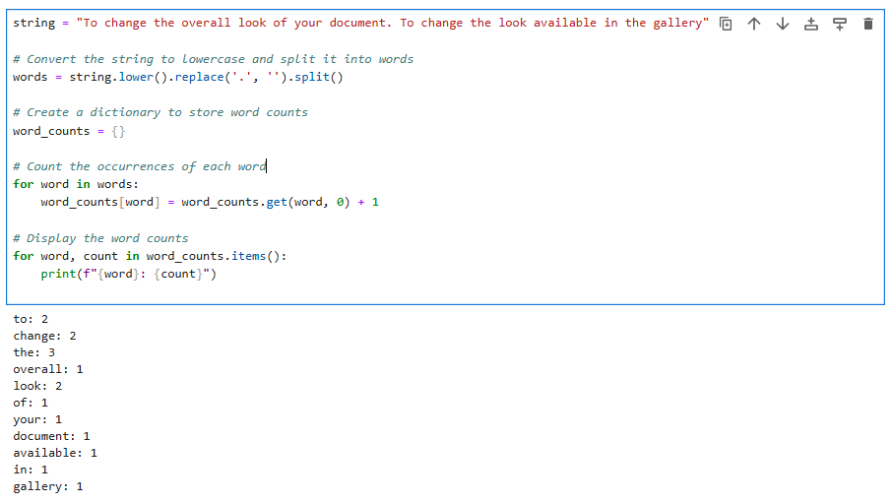

2. Write a Python program to remove a newline in Python

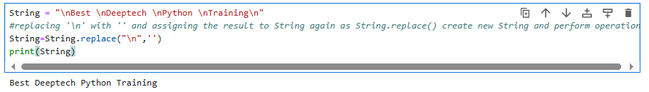

3. Write a Python program to reverse words in a string

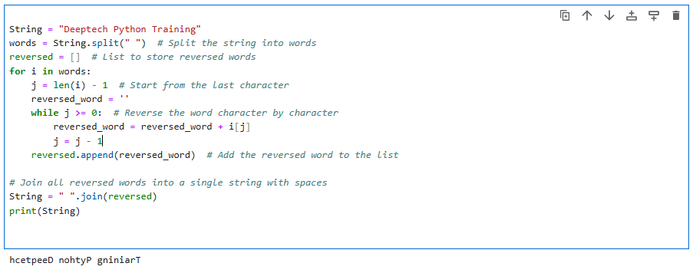

4. Write a Python program to count and display the vowels of a given text

