1. Write a Python program to find the number of times 4 appears in the tuple.

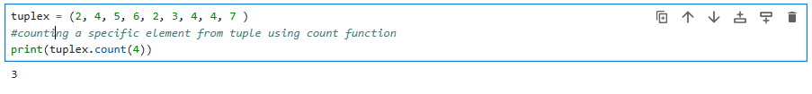

2. Write a Python program to convert a list to a tuple.

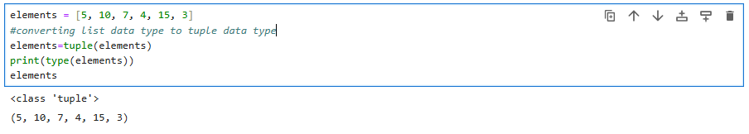

3. Write a Python program to calculate the sum of the numbers in a given tuple.

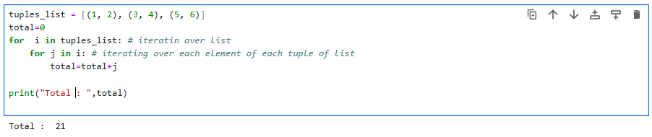

4. Write a python program and iterate the given tuples

