1. Add new Question using Radio button

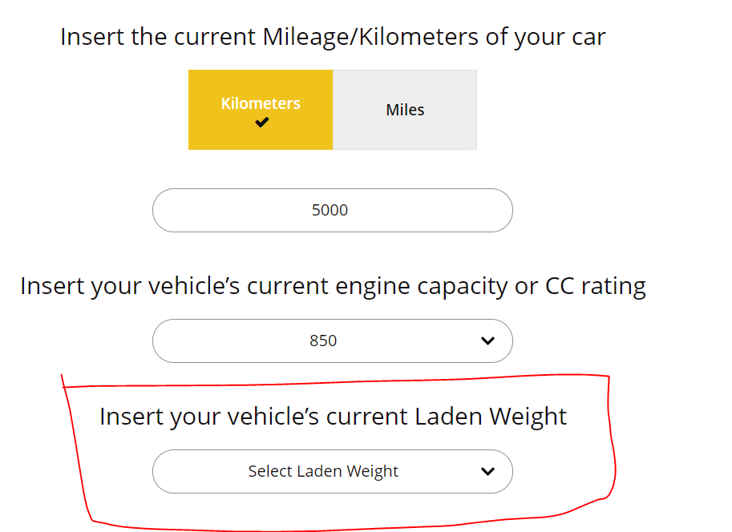

**Step 1)** Identify template in which you want to add the question from “Template” Folder.

For this question we will use

Path: template > new design > vehicle.html

**Step 2)** do manual insert entry in AppObjectTypes table

USE [MarathonInsuranceBroker_local_12_Feb]

GO

INSERT INTO [dbo].[AppObjectTypes]

([AppObjectTypeName]

,[ModifyDate]

,[Active]

,[VariableTitle]

,[ControlName]

,[ShowVariable]

)

VALUES

(

'LadenWeightValues'

,SYSDATETIME()

,1

,'LadenWeightValues'

,'DropDown'

,1)

GO

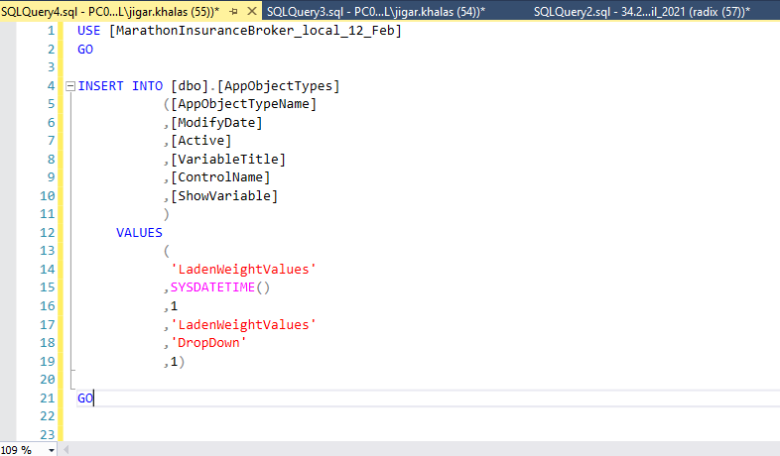

**Step 3)** Go to the admin panel

Route: Master management > benefit app object

Select veribale name = ‘LadenWeightValues’ and add variable values

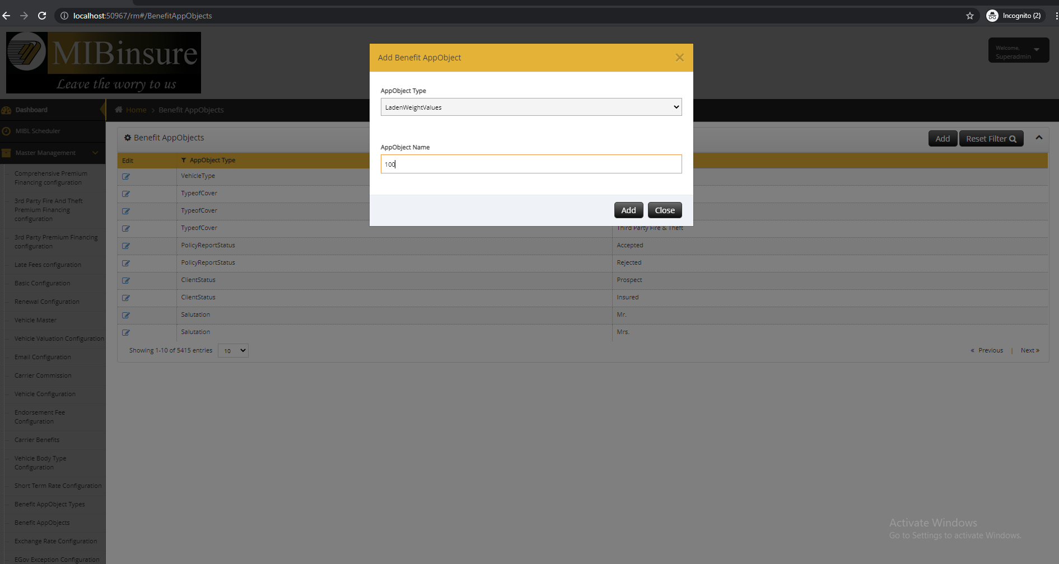

**Step 4)** We need to create pro option like below in propsalformctr.js

Path : script > app > controller > new design > proposalFormctr.js file

//RM#404

$scope.propsladenWeightTypes = {

key: 'ladenWeightType',

value: 'ladenWeightTypeId',//'cchpTypeId',

selectdefultlabel: 'Select Laden Weight',

name: "ladenWeightName",

eventName: 'setladenWeightValue',

eventArgs: ['client.clientVehicleDetails[0].vehicleLadenWeight', 'jsonSource.ladenWeightTypes'],

requiredMsg: "Please select Laden Weight",

divId: "ladenWeightNameDivId",

isManuallyEnteredValue: true

};

//RM#404

**Step 5)** If need we need to create a view according below

CREATE View [dbo].[vLadenWeightValues]

AS

select

AppObjectId As LadenWeightTypeId,

Status,

cast (ColumnFirst AS int) As LadenWeightType

--Cast(Case When ColumnThird ='M' Then 1 Else 0 End AS Bit) As IsMotor

from AppObjects where AppObjectTypeId=7448

**Step 6)**  Create a new model as per generate new views

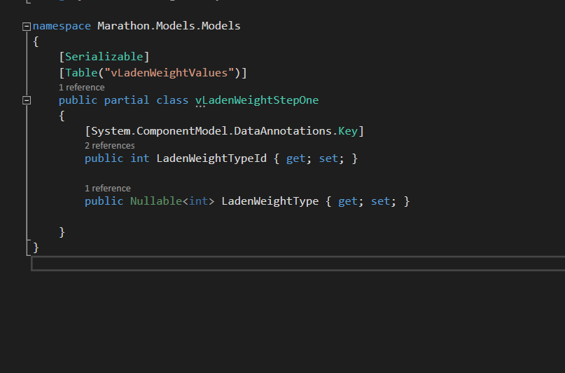

Create a new model map file

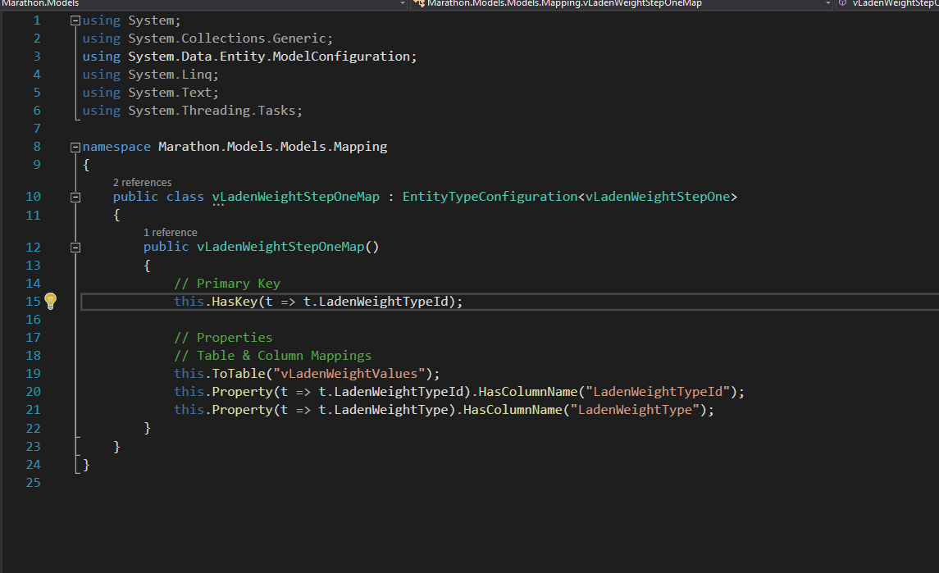

Configure in context file as well

**Step 7)** Get call associated the step currently the step one - ProposalFomOperationsController.cs

Path: Controller > propsalform > ProposalFomOperationsController.cs

Add the get data in proposalfromopertioncontroller.cs file

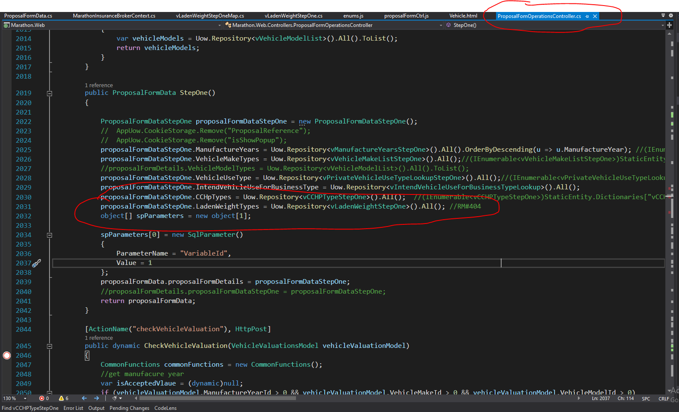

**Step 8)** Add the lookup get call in QuoteLookupController.cs

Path: controller > lookup > QuoteLookupController.cs

Add new get method

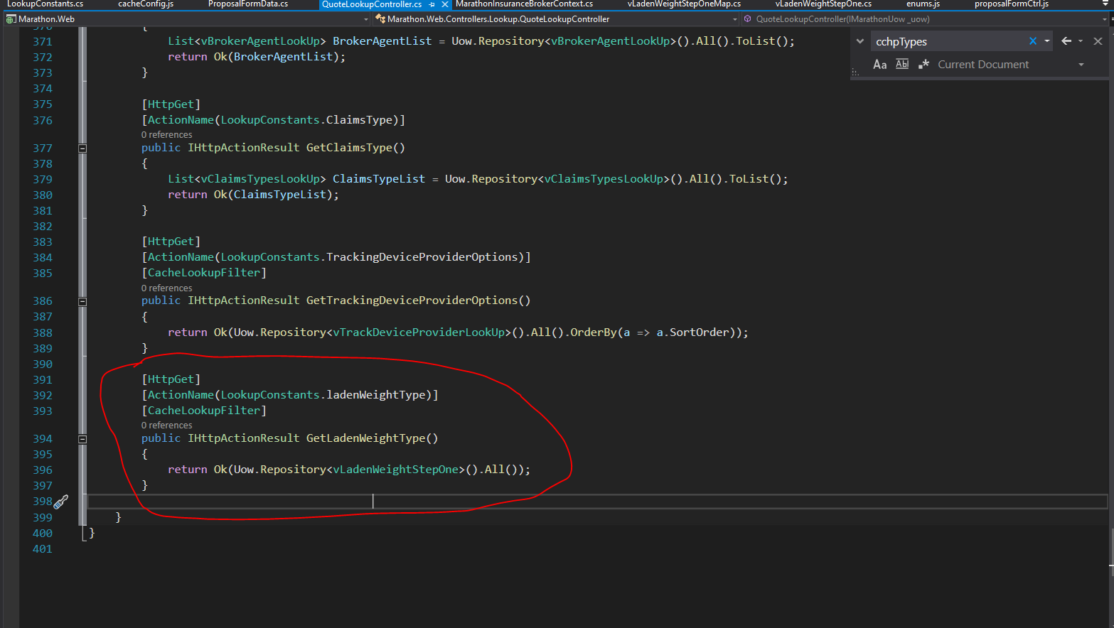

**Step 9)** Add step wise cache object in cacheConfig.js file

Path : scripts > app > logic > cacheConfig.js

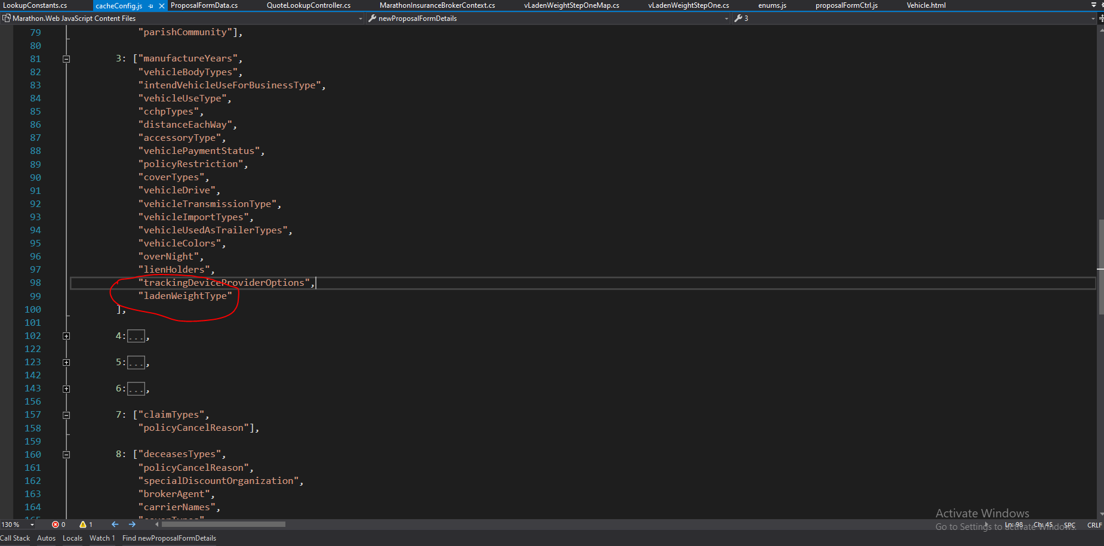

**Step 10)** received the data and store in jsonsource.ladenWeightType objects in proposalFormctr.js

Path: scripts > app > controller > new business > proposalformctr.js

//RM#404

$scope.jsonSource.ladenWeightTypes = rxJson.sortBy(jsonResult.proposalFormDetails.ladenWeightTypes, "ladenWeightType");

//RM#404

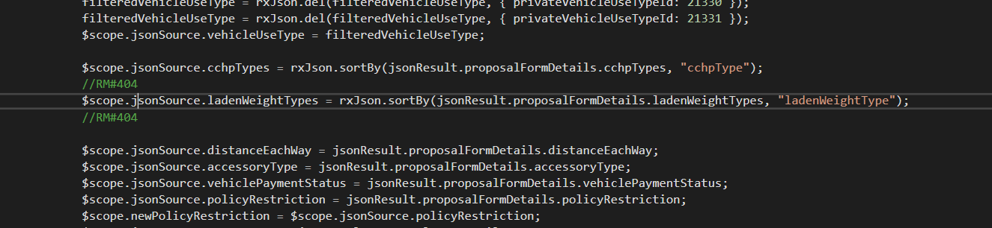

**Step 11)** According the dependency initialized the objects – when we need that object in html or js side

**Step 12)** Add 1 newcolumn in ClientVehicleDetails table and store a value ladenWeightValue.

ALTER TABLE ClientVehicleDetails

ADD ladenWeightValue int null;

**Step 13)** Modify ClientVehicleDetail and ClientVehicleDetailMap model as per update new column

**Step 14)** When user submit the details which is store in this table column

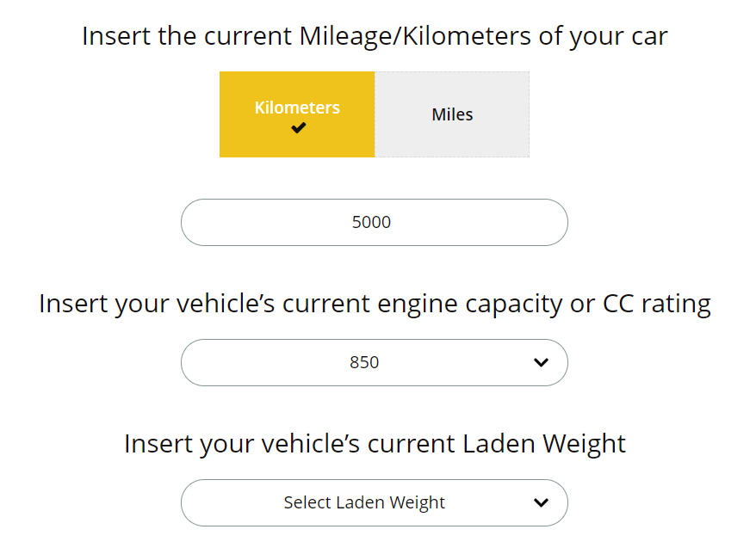

**Follow the general steps for effected areas**

1) Identify template in which you want to add the question from “Template” Folder. **(Front-end code changes)**

2) Go to the template and write down the code by using necessary custom directives and bind the data with ng-model **(front-end code changes)**

3) Create a new props for new question in proposalformctrl.js **(front-end code changes)**

4) Add the field in Model and Map of related table – **(back-end code changes)**

5) Add new column in table of the database – **(database changes)**

Note: Above steps we are including for new business only, that might be change in renew business.