1. Add new question with checkbox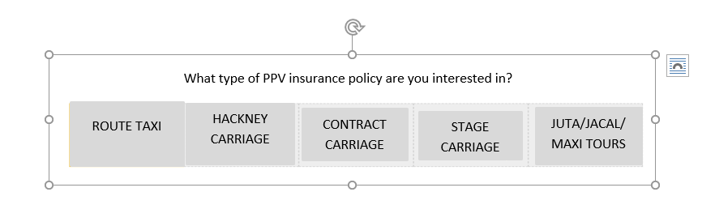

**Step 1)** Check object type from the vehicle.html file and identify the dependant question

Path: template > new design > vehicle.html

Created new div for the new question



**Step 2)** do manual insert entry in AppObjectTypes table and following the other steps as per the docs

Created the propsobject type using radio

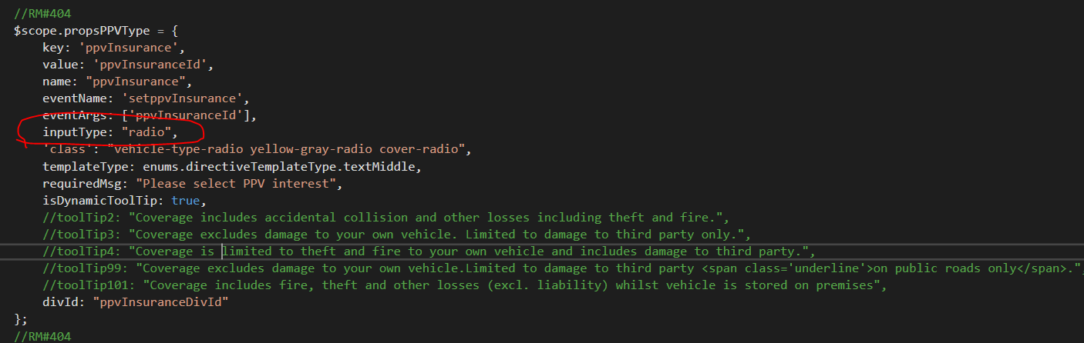

**Step 3)** Get the all data from the database and created models and map according

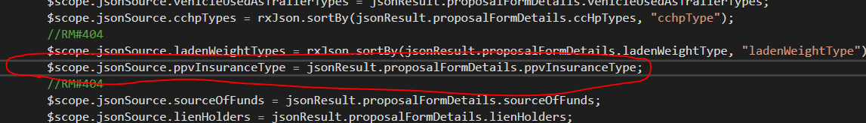

**Step 4)** Generate the events according a selection of current object and store value in object

Generate this event for depending question

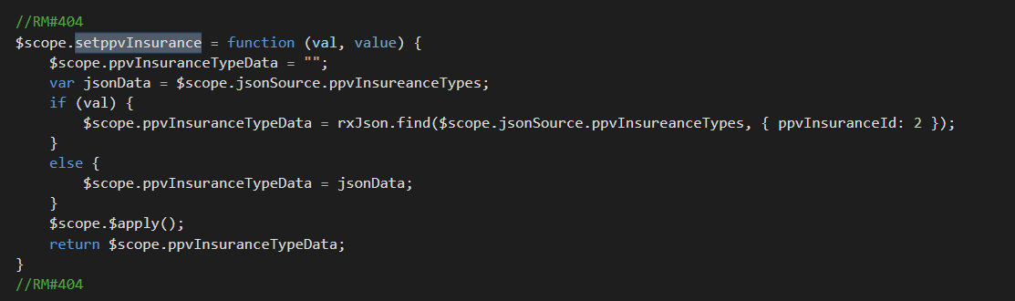

**Follow the general steps for effected areas**

1) Identify template in which you want to add the question from “Template” Folder. **(front-end code changes)**

2) Go to the template and write down the code by using necessary custom directives and bind the data with ng-model **(front-end code changes)**

3) Create a new props for new question in **proposalformctrl.js**  **(front-end code changes)**

4) Add the field in Model and Map of related table – **(back-end code changes)**

5) Add new column in table of the database – **(database changes)**

**6) If need any dependant on this question bind a events with props in proposalformctrl.js (We have cover in this document)**

Note: Above steps we are including for new business only, that might be change in renew business.