## Flow based formulation

## C:\Users\Jay\Desktop\GVRP\results\images\GVRP2_flow_n61_k17_m8_Q15_TL2.png

Figure 1 From Bektas & Kara (2003) TL 2min

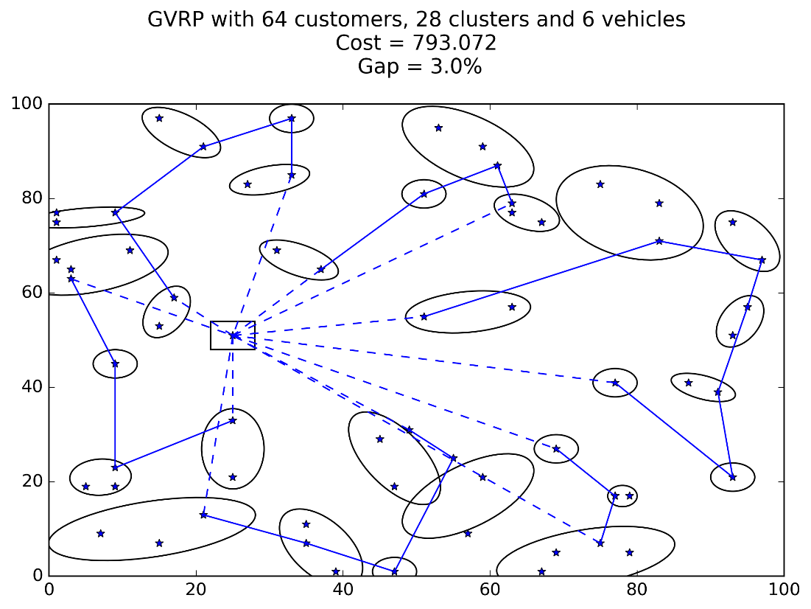

Figure 2 From CVRPLIB A-n65-k9 (timeLim = 6h)

## Node based formulation

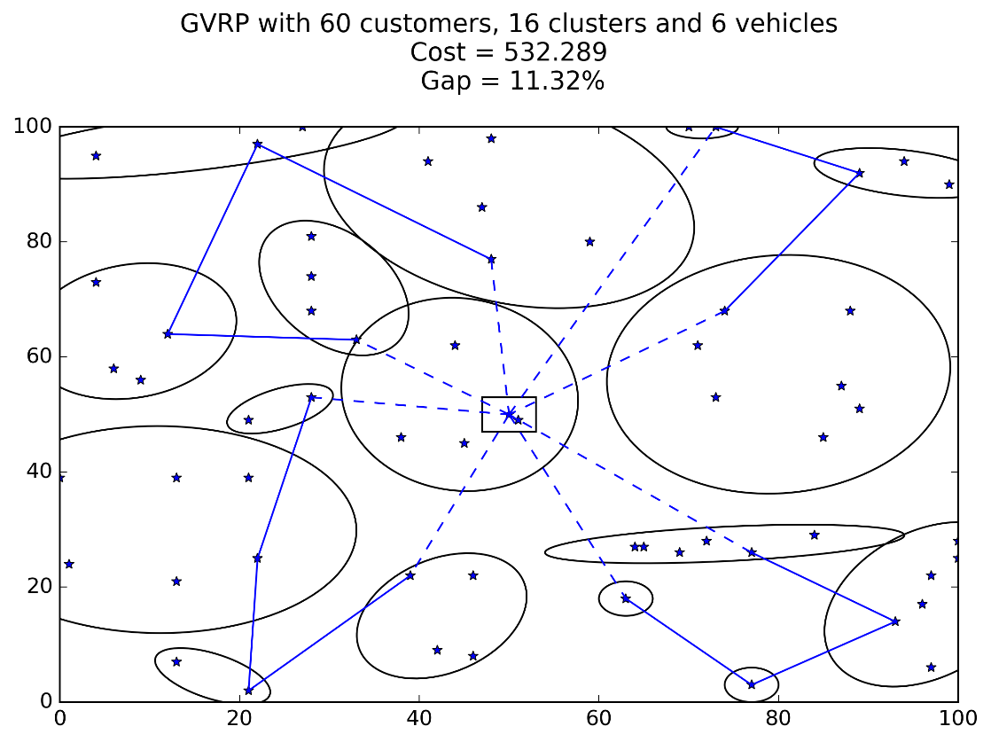

Figure From Bektas & Kara (2003)