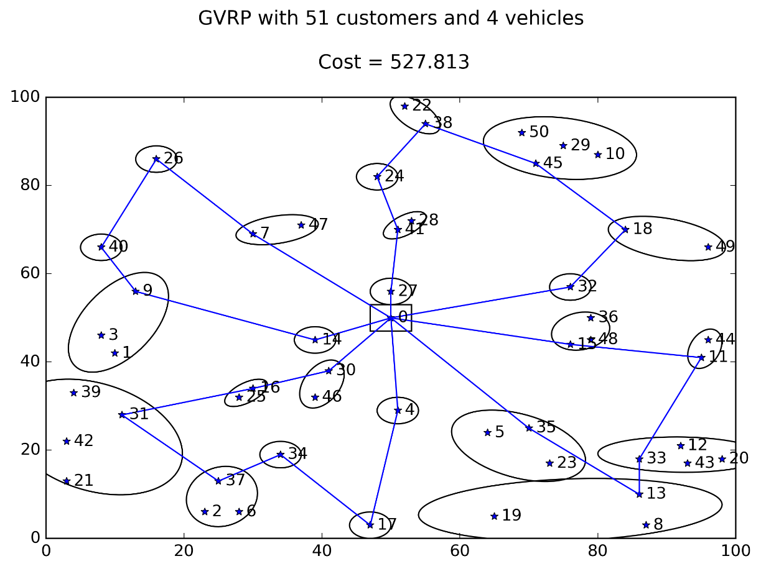

Fig. 1 Flow formulation, time limit 2min, rgap = 1.34%

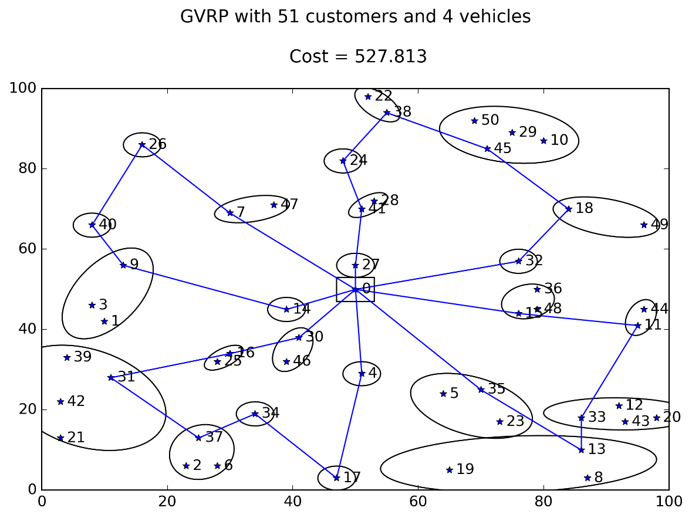

Fig. 2 Flow formulation, time limit 10min, rgap = 0%

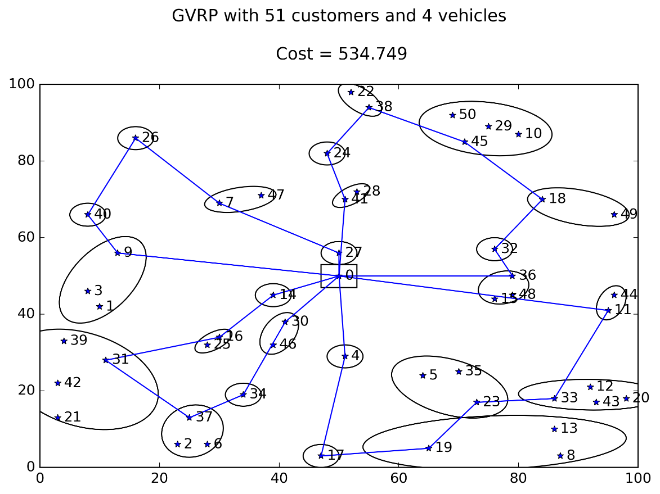

Fig. 3 Node formulation, time limit 2min, rgap = 21.4%

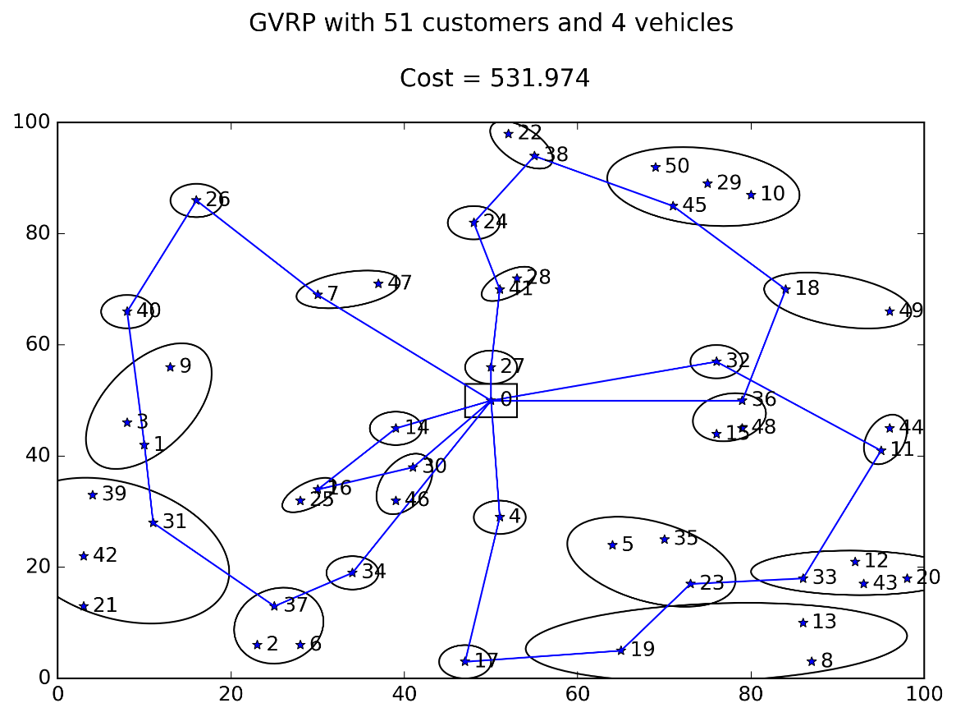

Fig. 4 Node formulation, time limit 10min, rgap = 17.7%

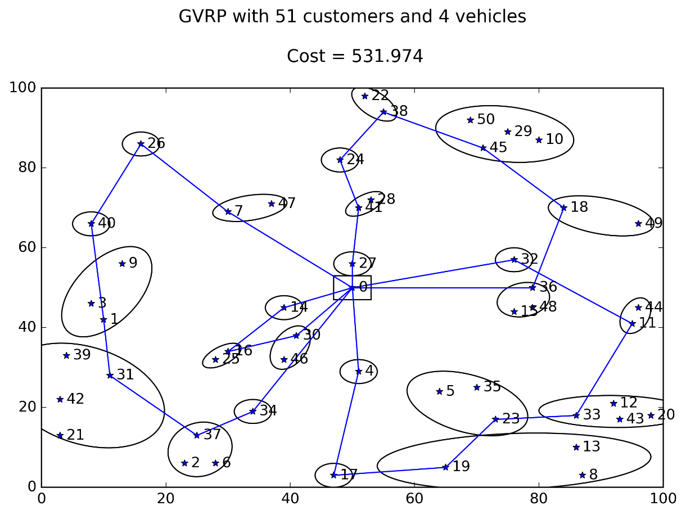

Fig. 5 Node formulation, time limit 30min, rgap = 16.2%

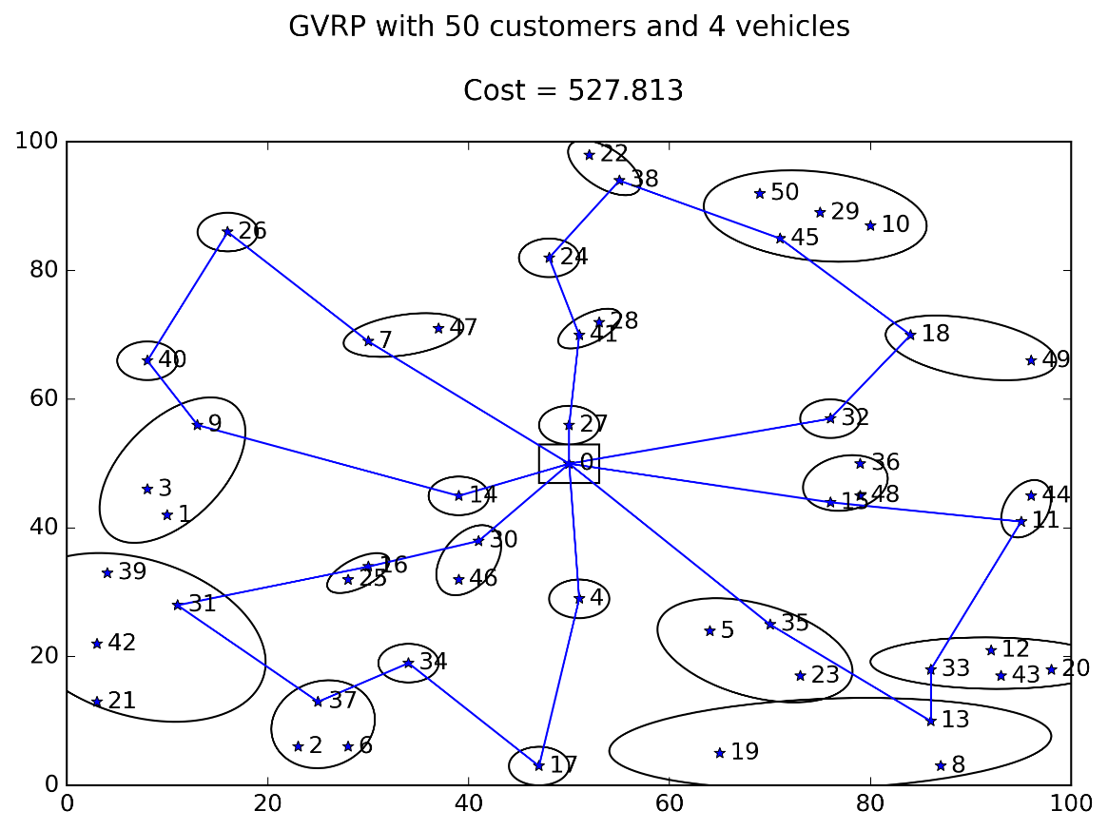

Fig. Node formulation, time limit 2 hours, rgap = 10.7%

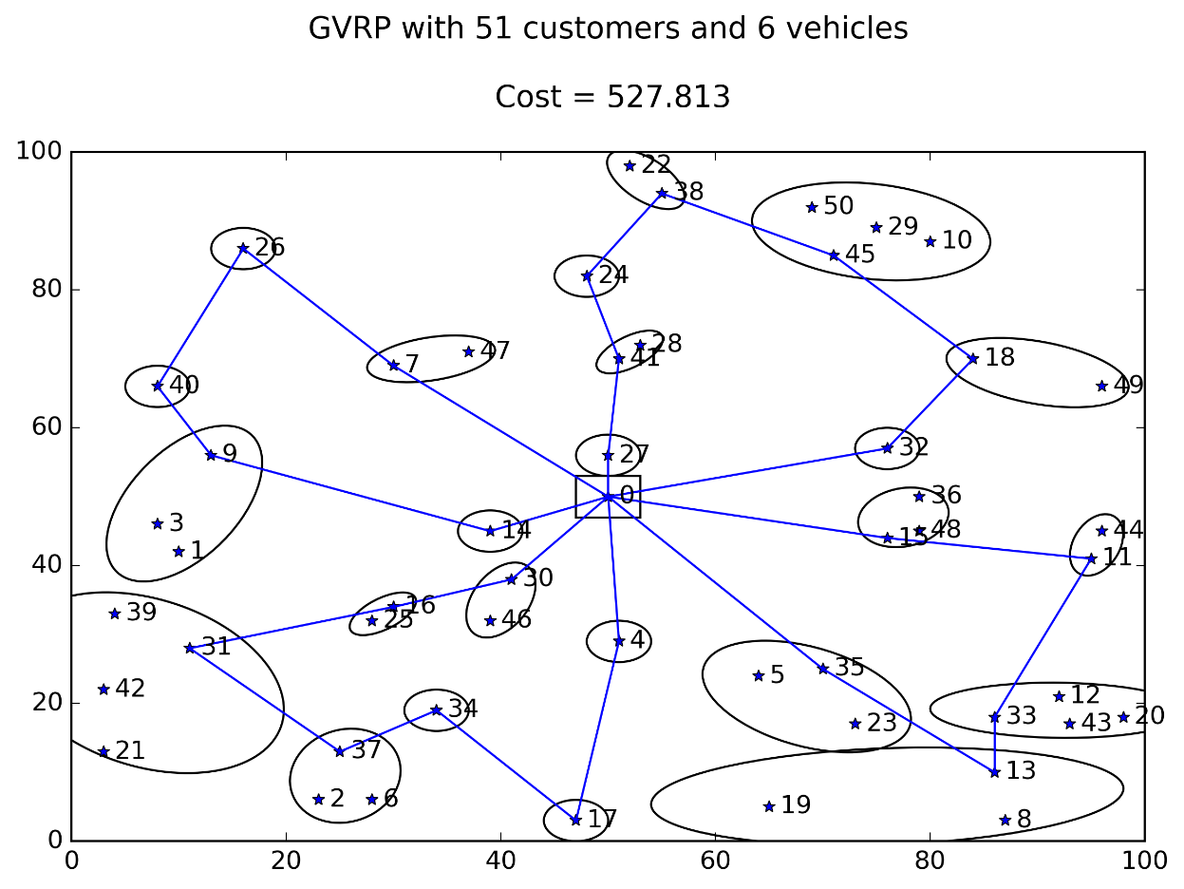

Fig. 7 Node formulation, time limit 2min, rgap = 21.2%

## Without subtour elimination constraints

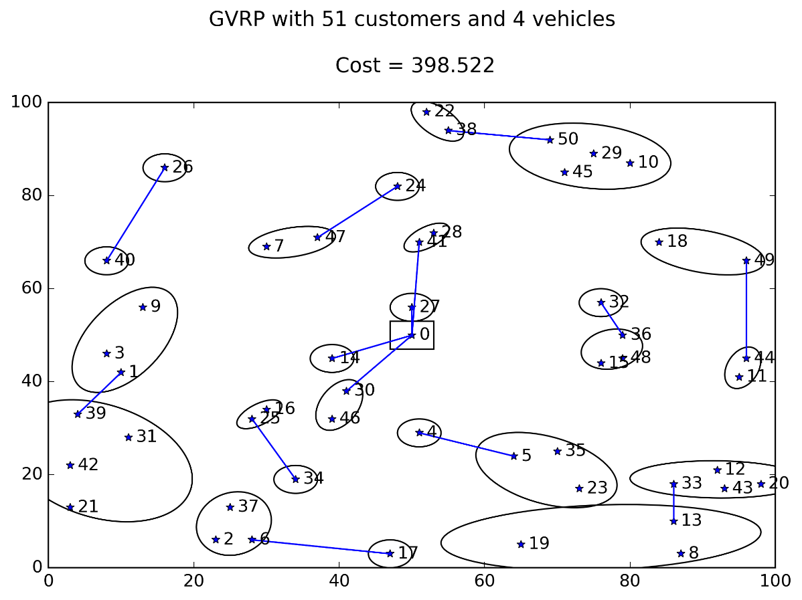

Fig. 8 Flow based formulation

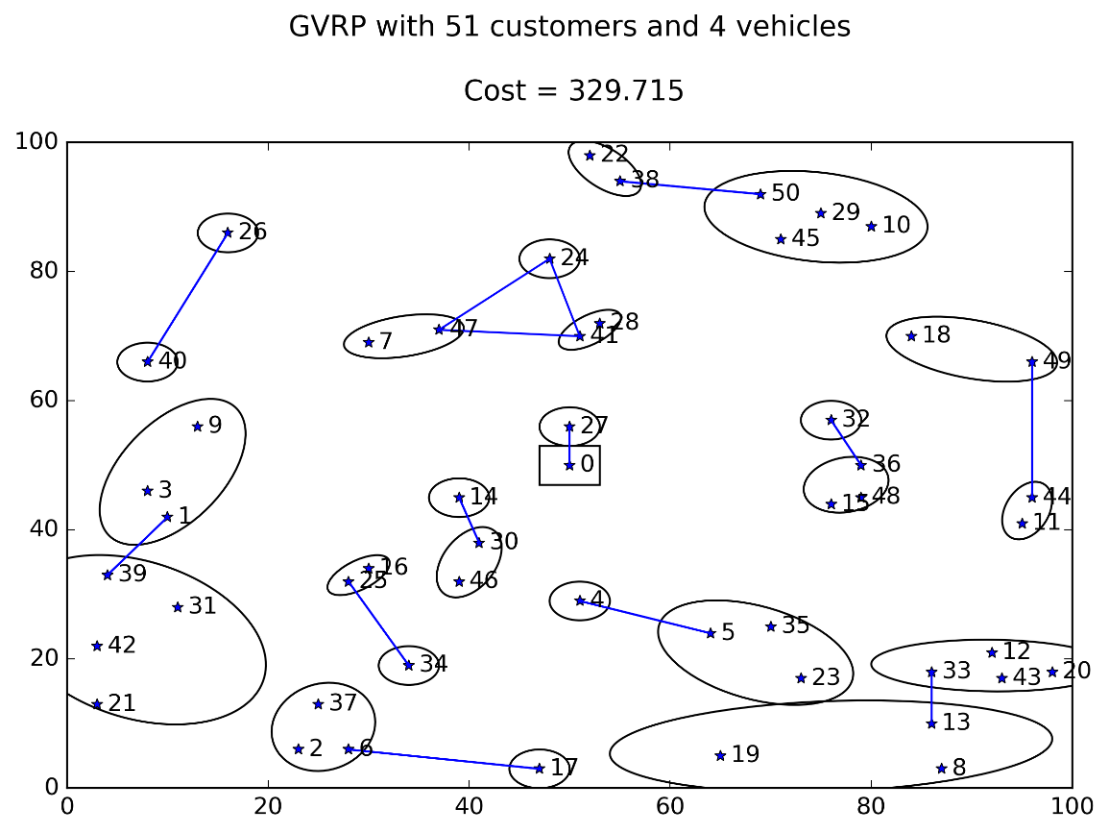

Fig. 9 Node based formulation