**Final Assignment**

**Game Story Summary:**

You are the eldest sibling in the family of 4, comprising of your mom, brother, and sister. The game takes place in your house, and you navigate around as you find things to do. You can explore the kitchen, dining hall, study room, garden, your brother, sister, and mom’s room. You can shop for groceries, visit your friend, go to a café, and a game house too. Additionally, you can go to your class, study in the library, get summoned to the principal office, join the gym and more. You own a brand-new Tesla that you can drive around too. Also, you can enjoy your dog “Happy” company too. You can convince your mom to give you more money or buy games for cheap in a store too. Additionally, some events are randomized, such as watching movies with your sister, telling your brother about people in space, and so on, which is bound to make your experience of the game very entertaining.

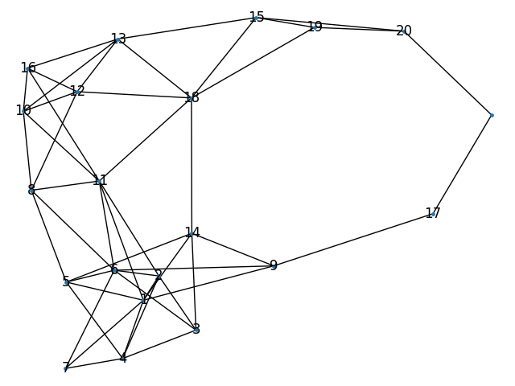

**Fig: Game Map connecting individual room in a game**

**Links:**

**CSV File:** <https://docs.google.com/spreadsheets/d/1GkWdM1DgTqj_kxoFDQZ-E7NkjoQXRYJW6qwmt6JYB_M/edit?usp=sharing>

**GitHub Repo:** <https://github.com/jay-rt/pythonFinal>

**Replit Link:** https://replit.com/join/qouutbov-jayrt