Bharatiya Vidya Bhavan's

Sardar Patel Institute of Technology

(Autonomous Institute Affiliated to University of Mumbai) Bhavan’s Campus, Munshi Nagar, Andheri (West), Mumbai-400058-India

|  |  |
| --- | --- |
| Name | Jay Salunke |
| UID | 2022601007 |
| Batch | A |
| Experiment no | 1 |
| Experiment name | Create basic charts using Tableau / Power BI / R / Python / D3.js to be performed on the dataset of Ecommerce field |

* **AIM:** Complete all plots on practice dataset and reproduce on e-commerce dataset.
* Basic - Bar chart, Pie chart, Histogram, Timeline chart, Scatter plot, Bubble plot
* Calculate Product wise sales, region wise sales
* Write observations from each chart

**1. Dataset**

Typically e-commerce datasets are proprietary and consequently hard to find among publicly available data. However, [The UCI Machine Learning Repository](http://archive.ics.uci.edu/ml/index.php) has made this dataset containing actual transactions from 2010 and 2011. The dataset is maintained on their site, where it can be found by the title "Online Retail".

Dataset Link:

https://www.kaggle.com/datasets/carrie1/ecommerce-data/data

### Metadata:

### Dataset Metadata:

1. **Number of Rows**: The dataset contains 541909 rows.
2. **Number of Columns**: The dataset consists of 8 columns.
3. **Column Names**:
   * InvoiceNo: The invoice number, a unique identifier for each transaction.
   * StockCode: The product (item) code.
   * Description: The product description.
   * Quantity: The quantity of each product per transaction.
   * InvoiceDate: The date and time when the transaction was generated.
   * UnitPrice: The price per product.
   * CustomerID: The unique identifier for each customer.
   * Country: The country where the customer resides.

### Data Description:

The dataset contains retail transaction data from an e-commerce store, with details on invoices, products, quantities, prices, and customer locations. It tracks purchases made by customers over time, useful for analyzing sales patterns, customer behavior, and product performance.This data could be used to analyze the economic growth of different regions within Maharashtra over time by comparing the GDP values across years and districts. ​​

Code:

# 

# Analyzing a sales dataset to visualize the top 10 countries by total quantity of items sold. The code processes the data, handles date conversions, and creates a bar chart showing the quantity of items sold for each country, highlighting the top 10 countries with the highest sales.

# 

Code:

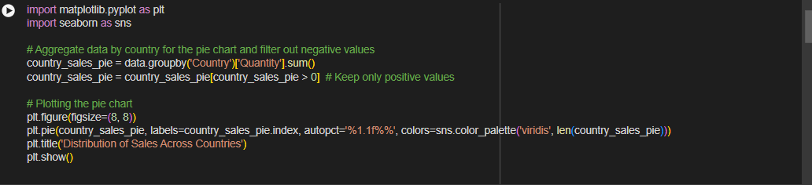

**Creating a pie chart to visualize the distribution of sales across different countries. The data is aggregated by country to sum up the total quantity sold. Negative values are filtered out to ensure only positive sales are considered. The pie chart displays the proportion of sales for each country, with segments colored using a viridis palette, and percentage labels are added to each segment for clarity.**

PieChart   
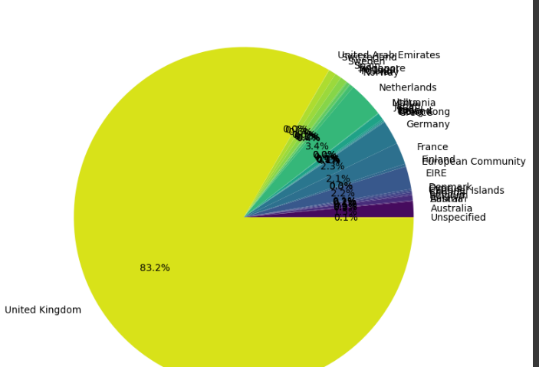

Code:

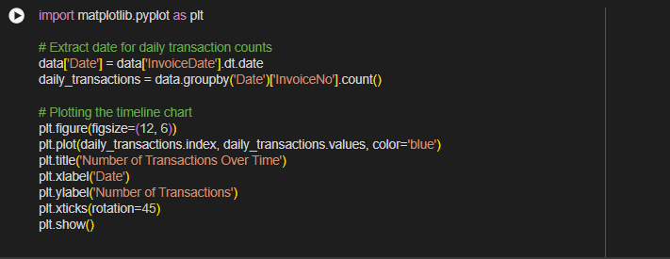

**Creating a timeline chart to visualize the number of transactions over time. The data is aggregated by day to count the total transactions (InvoiceNo) per date. The resulting time series is plotted with dates on the x-axis and the number of transactions on the y-axis. The chart shows how transaction volume varies over time, with date labels rotated for better readability.**

TimeLine Chart

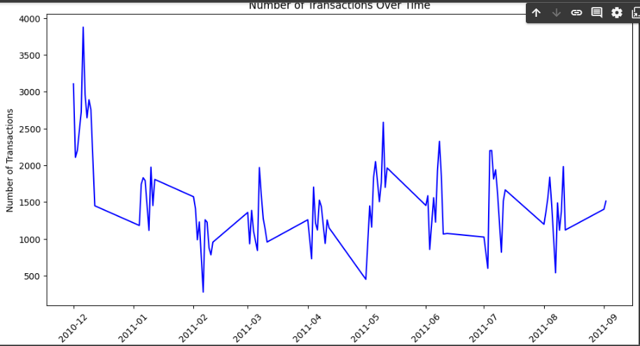

Code:

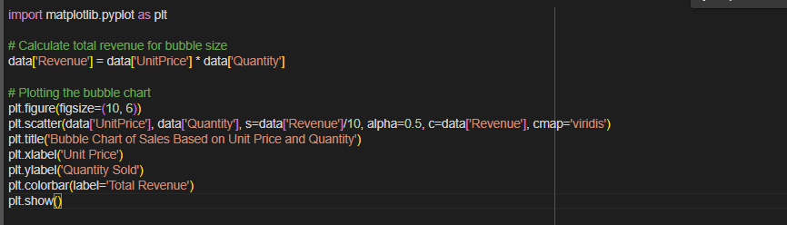

**Creating a bubble chart to analyze sales data based on unit price and quantity. Each bubble represents a transaction, with the x-axis showing the unit price and the y-axis displaying the quantity sold. The size of each bubble corresponds to the total revenue from that transaction, scaled down for visibility. The color of the bubbles indicates the revenue amount, with a color gradient provided by the viridis colormap. The chart helps visualize the relationship between unit price, quantity sold, and revenue.**

Bubble Chart   
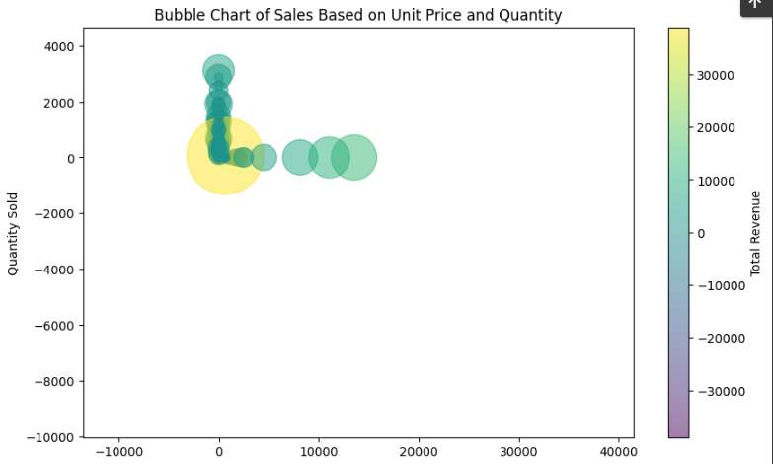

Code:

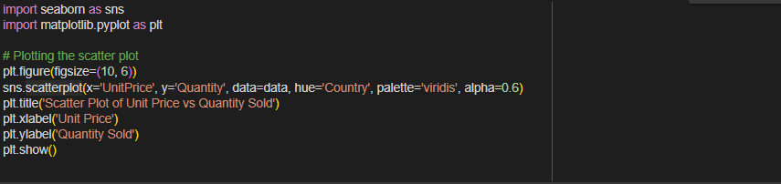

# **creating a scatter plot to explore the relationship between unit price and quantity sold, with data points colored by country. Each point represents a transaction, with the x-axis showing the unit price and the y-axis representing the quantity sold. The color of each point indicates the country, using the viridis color palette to differentiate between them. The plot helps visualize how unit price and quantity sold vary across different countries**.

# Scatter Plot

# Code:

# 

# creating a histogram to visualize the distribution of unit prices, after filtering out extreme outliers. Specifically, you exclude the top 5% of the highest unit prices to focus on more typical values. The histogram is plotted with 50 bins and includes a kernel density estimate (KDE) to show the distribution's shape. The histogram uses a purple color to display the frequency of different unit prices, providing a clearer view of the price distribution without the influence of extreme values.

# Histogram plot

# Questions asked :

1. **Bar Chart of Total Quantity of Items Sold per Country**:
   * **Question Answered**: Which countries have the highest total quantity of items sold?
2. **Pie Chart of Sales Distribution Across Countries**:
   * **Question Answered**: What is the proportion of total sales attributed to each country?
3. **Timeline Chart of Number of Transactions Over Time**:
   * **Question Answered**: How does the number of transactions vary over time?
4. **Bubble Chart of Sales Based on Unit Price and Quantity**:
   * **Question Answered**: What is the relationship between unit price, quantity sold, and total revenue for transactions?
5. **Scatter Plot of Unit Price vs. Quantity Sold**:
   * **Question Answered**: How do unit price and quantity sold relate to each other across different countries?
6. **Histogram of Unit Price Distribution**:
   * **Question Answered**: What is the distribution of unit prices, excluding extreme values?

Top of Form

Bottom of Form

**Conclusion:** The analyses reveal:

1. **Top Countries**: The top 10 countries contribute most to total sales.
2. **Sales Distribution**: Sales are spread unevenly across countries.
3. **Transaction Trends**: Daily transactions show fluctuations over time.
4. **Revenue Insights**: Revenue correlates with unit price and quantity sold.
5. **Pricing Patterns**: Most unit prices are within a typical range, excluding extreme values.

**Submission**

**https://docs.google.com/forms/d/e/1FAIpQLSc9g-c226PEYBN02hiE0vgdLtDYVS nUgtN1RhjBcZfSxz10Bg/viewform?usp=sf_link**