Bharatiya Vidya Bhavan's

Sardar Patel Institute of Technology

(Autonomous Institute Affiliated to University of Mumbai) Bhavan’s Campus, Munshi Nagar, Andheri (West), Mumbai-400058-India

|  |  |
| --- | --- |
| Name | Jay Salunke |
| UID | 2022601007 |
| Batch | A |
| Experiment no | 2 |
| Experiment name | Create advanced charts using Tableau / Power BI / R / Python / Plotly or Chart or D3.js to be performed on the dataset - Socio economic data |

**AIM:** Create advanced charts using Tableau / Power BI / R / Python / Plotly or Chart or D3.js to be performed on the dataset - Socio economic data

* Advanced - Word chart, Box and whisker plot, Violin plot, Regression plot (linear and nonlinear), 3D chart, Jitter, Line, Area, Waterfall, Donut, Treemap, Funnel
* Write observations from each chart

**1. Dataset**

The dataset contains GDP-related data for various districts in Maharashtra, India, over different years. Here's a breakdown of the metadata and description:

### Metadata:

* **Number of Rows:** 15
* **Number of Columns:** 36
* **Columns:**
  + Year: Represents the year (e.g., 1999-00, 2000-01, etc.).
  + Description: Describes the type of data (e.g., GDP in Rs. Cr.).
  + **Districts**: There are 34 columns corresponding to different districts of Maharashtra (e.g., Ahmednagar, Akola, Amravati, etc.), each containing GDP data in crores of rupees (float64 data type).
* **Non-null Values:** All columns have 15 non-null values, indicating there are no missing values in the dataset.

### Data Description:

The dataset provides GDP values in crore rupees for various districts in Maharashtra for different years. The Year column indicates the fiscal year, and the Description column specifies the data type (GDP). Each subsequent column represents a district, and the values under each column represent the GDP for that district in the specified year.

This data could be used to analyze the economic growth of different regions within Maharashtra over time by comparing the GDP values across years and districts. ​​Top of Form

Bottom of Form

# Line Chart:

# Description: A line chart typically visualizes trends over time. In this case, the line chart would show the GDP growth trends for different districts over the years.

# Insights: The line chart can reveal which districts have experienced consistent growth, periods of economic stagnation, or decline. This visualization helps to compare the performance of different regions within Maharashtra.

# Observations: Districts like Mumbai may show a steeper upward trend due to being a financial hub, while smaller districts may exhibit slower growth.

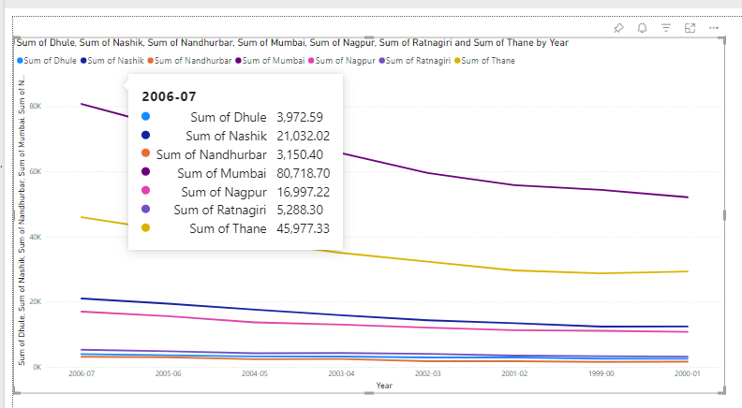

# Area Chart

# Description: An area chart is similar to a line chart but filled below the line, making it useful to show cumulative data.

# Insights: This can help visualize the cumulative GDP contribution of each district over the years. It provides a clearer view of how much each district contributes to the overall state GDP.

# Observations: Significant contributions from key districts may be more apparent, while smaller districts' contributions could be seen as less significant.

# 

# 

# Treemap

# Description: A treemap visualizes hierarchical data as a set of nested rectangles. Each rectangle's size corresponds to its value, making it easy to compare the contributions of different elements.

# Insights: This chart helps to compare the GDP sizes of different districts at a glance. Larger rectangles represent districts with higher GDP, while smaller ones represent those with lower GDP.

# Observations: Districts with larger economies like Mumbai and Pune will dominate the treemap, whereas smaller districts will occupy less space.

# 

# Waterfall Chart

# Description: A waterfall chart shows the cumulative effect of sequential positive and negative values. It is typically used to illustrate how an initial value is affected by intermediate positive or negative values leading to a final value.

# Insights: This chart can be used to visualize the change in GDP from one year to another, highlighting the impact of specific districts on the overall GDP growth or decline.

# Observations: Key events or policy changes that significantly impact the GDP of certain districts can be identified and analyzed.

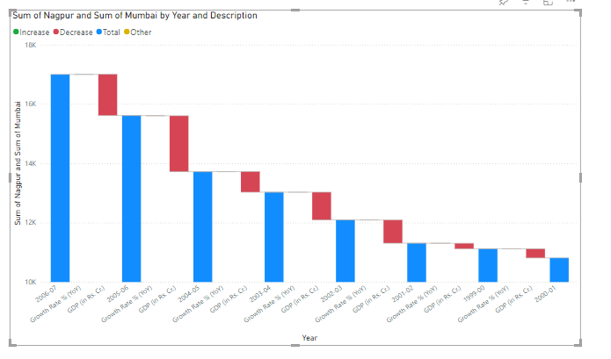

# Funnel Chart

# Description: A funnel chart represents data as progressively decreasing proportions. It is often used in sales and conversion analysis.

# Insights: If adapted to GDP data, this chart could show the proportion of GDP contributed by different sectors or regions, narrowing down to smaller components.

# Observations: The chart can reveal which regions or sectors are the largest contributors and where the GDP narrows down significantly.

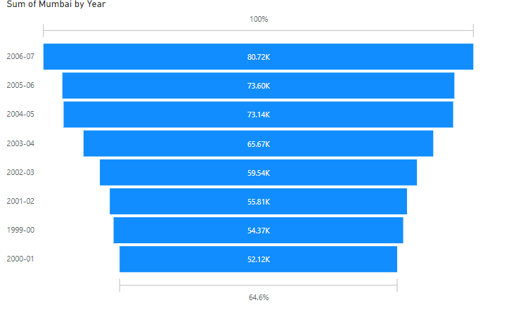

# Donut Chart

• **Description:** A donut chart is similar to a pie chart but with a hole in the center. It represents categorical data and is often used to show parts of a whole.

• **Insights:** This chart can show the percentage contribution of each district to the total GDP of Maharashtra.

# • **Observations:** High-contributing districts will occupy larger portions of the donut, making it easy to identify the most economically significant areas.

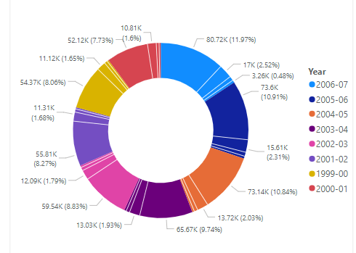

**Conclusion:** The consistent GDP growth in districts like Mumbai and Pune highlights their strong economic base, driven by industrialization, services, and infrastructure development. These districts act as economic engines for the state, suggesting that future development plans should focus on supporting these areas while ensuring that their growth positively impacts surrounding regions.

**Submission**

**https://docs.google.com/forms/d/e/1FAIpQLSc9g-c226PEYBN02hiE0vgdLtDYVS nUgtN1RhjBcZfSxz10Bg/viewform?usp=sf_link**