A PROJECT REPORT ON
SynthGuard: A multi-modal Threat Intelligence and Deepfake Defense System
UNDER THE GUIDANCE OF
MRS. KRUPA KAMDAR
SUBMITTED BY
MR. JAY SHRAVAN KUMAR SHARMA
ROLL NO TYCS47


UNIVERSITY OF MUMBAI
T.Y.B.Sc. C. S. (COMPUTER SCIENCE)
SEMESTER 5
ACADEMIC YEAR: 2026-2027


Department of Computer Science
BHARATIYA VIDYA BHAVAN’S
BHAVAN’S COLLEGE (EMPOWERED AUTONOMOUS),
ANDHERI (W), MUMBAI 400058
BHARATIYA VIDYA BHAVAN’S
BHAVAN’S COLLEGE (EMPOWERED AUTONOMOUS),
ANDHERI (W), MUMBAI 400058
Department of Computer Science

CERTIFICATE

This is to certify that Mr. Jay Shravan Kumar Sharma of T.Y.B.Sc.C.S., SEM 5, Roll No: TYCS47 has satisfactorily completed the Project SynthGuard: A multi-modal Threat Intelligence and Deepfake Defense System to be submitted in the partial fulfilment for the award of Bachelor of Science in Computer Science during the academic year 2026–2027.

Date of Submission: 21/10/2026
Project Guide Name: Mrs. Krupa Kamdar
Project Guide Signature: ______________________________

Head / In charge,
Department of Computer Science, Data Science & AI

College Seal Signature of Examiner: ______________________________

DECLARATION

I, Jay Shravan Kumar Sharma, hereby declare that the project entitled “SynthGuard: A multi-modal Threat Intelligence and Deepfake Defense System” submitted in the partial fulfilment for the award of Bachelor of Science in Computer Science during the academic year 2026–2027 is my original work and the project has not formed the basis for the award of any degree, associateship, fellowship or any other similar titles.

Signature of the Student: __________________________
Place: Mumbai
Date: 21/10/2026

ACKNOWLEDGEMENT

I would like to express my sincere gratitude towards the Computer Science Department of Bhavan’s College.

After months of hard work, finally I am very happy to present my SEM 5 Project. The Project making was full of new experiences and learning and difficult one too. Though a difficult job it was made simpler by the timely guidance received, which helped me greatly in the completion of my project. But it wouldn’t be right to do so without thanking to those who have helped me in converting our thought into reality. So, I would like to take full advantage of this opportunity to thank each and every person who has helped me throughout the completion of our project.

I am obliged to my parents & family members who always support me greatly and encouraged me in each and every step. I give my special thanks and sincere gratitude towards the
Principal Dr. Savita K. Pawar and Head of Department (Computer Science, Data Science & AI)
Prof. Mrs. Krupa Kamdar. I owe my sincere thanks to our Project guide Ms. Krupa Kamdar for her constant support and encouragement without which the successful completion of this project would have been impossible. They have been instrumental for making me concentrate and focus my effort in this project.

I would like to give thanks to my friends for helping me in my project. Finally, I would like to thank each and every individual who was directly or indirectly contributing for the completion of this project.

-Thank You
TABLE OF CONTENTS

Chapter | Title | Page
 | Title page | 1
 | Certificate | 2
 | Declaration | 3
 | Acknowledgement | 4
 | Table of contents | 5
Chapter 1 | ABSTRACT AND KEYWORDS | 6
Chapter 2 | INTRODUCTION | 7
Chapter 3 | LITERATURE REVIEW | 9
Chapter 4 | RESEARCH METHODOLOGY | 11
Chapter 5 | ANALYSIS AND PROPOSED WORK | 14
Chapter 6 | IMPLEMENTATION AND DEVELOPMENT | 17
Chapter 7 | RESULTS AND DISCUSSION | 20
Chapter 8 | RESEARCH PAPER | 22
Chapter 9 | PLAGIARISM AND SIMILARITY REPORT | 25
Chapter 10 | CONCLUSION LIMITATIONS AND FUTURE SCOPE | 26
Chapter 11 | REFERENCES AND BIBLIOGRAPHY | 28
Chapter 12 | APPENDICES AND OPERATIONAL GUIDES | 29
Appendix A | Dataset and Model Artifacts | 45
Appendix B | Operational Thresholds | 46
Appendix C | API and Local Deployment | 46
Appendix D | Evidence Checklist for Final Research Submission | 46
Appendix E | Analyst interface reference | 31
Appendix F | Local API reference | 34
Appendix G | Deployment and operator runbook | 36
Appendix H | Model and evaluation evidence register | 38
Appendix I | Reproducible evaluation protocol | 40
Appendix J | Privacy, security, and limitations | 42
Appendix K | Analyst user guide | 44
Appendix L | Maintenance and acceptance checklist | 45
CHAPTER 1 ABSTRACT AND KEYWORDS

1.1 Abstract
SynthGuard is a locally deployable threat-analysis prototype that examines phishing-related email text, synthetic-speech indicators, and manipulated-face video evidence through three independent model paths. A FastAPI service loads local checkpoints and returns modality scores. A late-fusion function combines available scores using equal nominal weights, with a high-confidence audio or video veto; a React and TypeScript interface supports single-modality and multi-modal analysis. The browser can retain lightweight report metadata in local storage and generate a PDF locally. The project implements a DistilBERT email classifier, an MFCC-based convolutional audio classifier, and an EfficientNet-B0 video classifier preceded by MTCNN face detection. A current-checkpoint email diagnostic re-score covers 3,508 examples and an audio reconstructed split re-score covers 500; their lineage and grouping limitations prevent unqualified held-out claims. No verified video or paired fusion metrics are available. The report documents implementation and evidence status without repeating the historical 99.1% fusion figure as a result.

1.2 Keywords
Phishing detection, Business Email Compromise, DistilBERT, speech spoofing, MFCC, deepfake video, EfficientNet-B0, MTCNN, late fusion, local inference, forensic reporting.
CHAPTER 2 INTRODUCTION

2.1 Background and Context
Digital attacks increasingly combine ordinary messages with impersonation and synthetic media. A fraudulent payment request may arrive as text, be reinforced by a cloned voice message, or be accompanied by manipulated video. Each channel exposes different evidence: language models examine content, audio models examine speech features, and visual models examine facial regions. A single detector cannot directly represent all of these signals. The practical challenge is not only to detect suspicious content, but to interpret evidence that arrives through different channels. A text model may identify urgency or payment language; an acoustic model can score speech artifacts; and a visual model can inspect sampled facial regions. These signals have different input formats, failure modes, and score distributions. A multi-modal interface therefore needs to show which sensors actually ran, what each returned, and how the combined result was produced. Without those details, a single final number can hide missing or failed inputs.
SynthGuard was developed as a student research prototype that connects separate text, audio, and video detectors in one local analysis workflow. It gives analysts an interpretable view of model outputs and is not intended to make autonomous financial or security decisions. The component architecture is described in Chapters 5 and 6.

2.2 Problem Statement
Standalone detectors produce modality-specific outputs and may fail when an attack moves across channels or a model is uncertain. Analysts also need to know which sensors processed successfully and how the final score was formed. SynthGuard addresses this integration problem through separate modality paths, per-sensor status, a rule-based fusion function, and local reporting. Its current evaluation does not establish that fusion improves accuracy on real paired attacks.

2.3 Aim
To design and implement a local multi-modal analysis prototype that accepts email, audio, and video evidence, runs specialized local detectors, combines available scores through a documented late-fusion rule, and presents the output in an analyst-oriented interface.

2.4 Objectives
1. Integrate a locally loaded DistilBERT classifier for phishing-related email text.
2. Implement audio spoof scoring using MFCC features and a convolutional neural network.
3. Implement video face-region scoring using MTCNN and an EfficientNet-B0 classifier.
4. Combine sensor scores with equal-weight dynamic fusion and a high-confidence biometric veto.
5. Expose analysis and health endpoints through a local FastAPI backend.
6. Provide a React interface with modality status, threat indicators, report history, and client-side PDF export.
7. Document the limits of available evaluation evidence and define a reproducible paired-scenario benchmark process.

2.5 Scope of the Study
The project accepts email text, supported audio uploads, and supported video uploads, either individually or in a multi-modal request. The email path tokenizes text; the audio path produces fixed-length MFCC features; and the video path samples frames, detects faces, and averages up to five face-region scores. Responses include an analysis identifier, sensor scores and statuses, and explanatory indicators; the browser can retain lightweight report metadata and generate a PDF. The project does not include a validated enterprise mail gateway, active response, identity verification, financial transaction control, an independent human-review workflow, user authentication, a server-side case-management database, or a verified network air gap.

2.6 Motivation and Contribution
The project contributes an implemented local workflow for three independently trained detectors, a common response structure, an explicit missing-sensor policy, and browser-side reporting. Its research contribution is an evaluation design that distinguishes reproducible re-scoring from held-out evidence and specifies source-linked paired testing across the seven non-empty modality subsets. The project does not claim state-of-the-art accuracy; a properly split, source-linked paired test set remains future work.
CHAPTER 3 LITERATURE REVIEW

3.1 Transformer Models for Email Classification
DistilBERT is a compact transformer language model produced through knowledge distillation. Sanh et al. describe its design as a smaller and faster alternative to BERT for downstream language tasks [1]. SynthGuard uses a DistilBERT sequence-classification checkpoint to assign a phishing probability to email text. This choice provides contextual language representations, but a high score on a single email corpus does not demonstrate robustness to new organizations, current attack campaigns, multilingual messages, or changes in email formatting.
The project notebook loads the Kaggle Phishing Email dataset, removes rows with missing fields and duplicate records, maps safe email to class 0 and phishing email to class 1, and creates an 80/20 stratified split with random state 42. The notebook records 17,538 cleaned examples and a 3,508-example test subset. Corpus quality, duplicate handling, source diversity, and the distinction between phishing and broader spam remain relevant threats to external validity.

3.2 Audio Spoof Detection and MFCC Features
The ASVspoof challenge series provides standardized tasks for detecting spoofed speech and synthetic speech. The 2021 challenge separates logical-access, physical-access, and deepfake tracks and specifies benchmark data and evaluation procedures [3]. SynthGuard represents audio with 40 MFCC coefficients at a 16 kHz sample rate, using a 2,048-sample analysis window and a 512-sample hop, then pads or truncates to 300 frames. MFCCs summarize short-time spectral shape and have a long history in speech processing [8]. They are a feature representation, not by themselves a guarantee of spoof generalization.

3.3 Video Manipulation Detection
FaceForensics++ introduced a benchmark containing manipulated facial videos, including DeepFakes, Face2Face, FaceSwap, and NeuralTextures, with multiple compression conditions [4]. EfficientNet uses compound scaling across network dimensions to balance accuracy and computational cost [5]. MTCNN uses a cascaded convolutional approach to locate and align faces [6]. SynthGuard applies MTCNN to sampled frames and then classifies extracted face crops with EfficientNet-B0. The current inference pipeline is therefore dependent on face visibility, crop quality, compression, and the manipulation types represented in training data.

3.4 Classifier Combination and Late Fusion
Classifier combination research studies how evidence from distinct representations can be combined into a final decision. Kittler et al. provide a theoretical and experimental framework for combining classifier outputs [7]. SynthGuard uses a simple normalized arithmetic mean across the sensor scores that are present and adds a hand-coded veto when audio or video probability is at least 0.85. This rule is an engineering decision that must be assessed empirically; the general literature does not validate SynthGuard’s specific weights or veto threshold.

3.5 Research Gap
The prototype brings text, voice, and face-based outputs into one local workflow. Public datasets are generally organized by modality and do not provide aligned email, voice, and video for one coherent social-engineering scenario. Without authentic pairing and scenario-level labels, fusion metrics may reflect dataset construction choices rather than the value of combined evidence. The benchmark manifest therefore records scenario labels, sensor-specific labels, source groups, and split membership. Shared threat labels alone do not establish that records belong to the same incident; related actors, campaigns, recordings, or source videos must remain together within one partition.

3.6 Literature Review Summary
The model and dataset literature supports the selection of a transformer text sensor, an MFCC-based speech sensor, a face-crop video sensor, and a score-combination layer. It does not support transferring benchmark results from those source works to SynthGuard. Model metrics must be produced from the specific saved checkpoints and evaluation data used by this project.
CHAPTER 4 RESEARCH METHODOLOGY

4.1 Research Approach
This work follows a design-and-implementation approach. The three sensors are treated as independent predictors; the API standardizes their outputs; and a deterministic fusion function combines the available probabilities. The report distinguishes implementation verification from model-performance evaluation. API operation and score routing can be checked with functional tests, while accuracy requires labeled examples that were not used for training or threshold selection. The work separates three kinds of evidence. Code inspection establishes which transformations and decision rules are implemented. A request-level check establishes that the running application accepts an input and returns a response with the expected status fields. A model evaluation estimates predictive behavior only when labels, sample membership, checkpoint identity, preprocessing, and threshold selection are sufficiently documented. These categories are reported separately so that a successful demonstration scan is not mistaken for a benchmark experiment.

4.2 Data Sources and Sample Definition
Modality | Project data source | Label meaning | Evidence currently available
Email | Kaggle Phishing Email dataset; local notebook records 17,538 examples after cleaning [2] | Safe / phishing | Current-checkpoint re-score and per-example CSV exist; checkpoint training provenance remains unverified.
Audio | ASVspoof 2021 logical-access data and exported feature shards [3] | Genuine / spoof | Reconstructed 500-row diagnostic re-score and per-row CSV exist; source groups and exact checkpoint lineage are unresolved.
Video | FaceForensics++ manipulated and original sequences [4] | Original / manipulated | Active checkpoint and inference code exist; source-disjoint held-out metrics and a verified calibration record are absent.
Fusion | Curated scenario manifest specified in project docs | Scenario-level benign / threat | Benchmark runner and manifest contract exist; no authentic paired scenario result bundle is present.
A scenario-level multi-modal sample should contain one investigation story with explicitly paired media, sensor-specific labels, an overall scenario label, and a group identifier for the campaign, actor, or source recording. The scenario label must be written independently of model scores. A benign scenario can contain a spoofed modality, and a threat scenario can contain genuine supporting media. The report does not treat independently sourced audio and video examples as if they belonged to the same event. The manifest should therefore record a scenario identifier, split, group identifier, scenario label, sensor-specific labels, and paths to any available evidence. A missing modality is allowed and must remain missing in the record; it should not be silently replaced with unrelated media merely to fill a row. Before scoring, the curator should verify that the email, audio, and video represent the same actor, event, or deliberately constructed scenario, and document whether each pairing is authentic or synthetic. Group identifiers make it possible to keep correlated source material out of multiple splits.

4.3 Data Preparation
Email text is tokenized with the local DistilBERT tokenizer, truncation enabled, a maximum length of 256 tokens, and fixed-length padding. Audio is loaded at 16 kHz, transformed to MFCCs, and normalized in shape by zero padding or truncation to 300 frames. Video is sampled from the uploaded clip at fixed frame intervals; MTCNN detections above 0.90 confidence are cropped, resized to 224 by 224, and normalized with ImageNet channel statistics before model inference. These steps are implemented in the backend [9].

4.4 Evaluation Design
For a defensible comparison, the validation set is used to select any model threshold or video calibration parameter, after which that choice is frozen. The test set is then evaluated once under the declared protocol. Predictions should retain one row per sample, including its ground-truth label, raw model score, transformed score where applicable, decision threshold, predicted label, source group, and processing status. A run summary should record model and dataset hashes, software revision, split manifest, and metric denominators. These requirements make it possible to distinguish a reproducible score export from a genuinely held-out estimate.

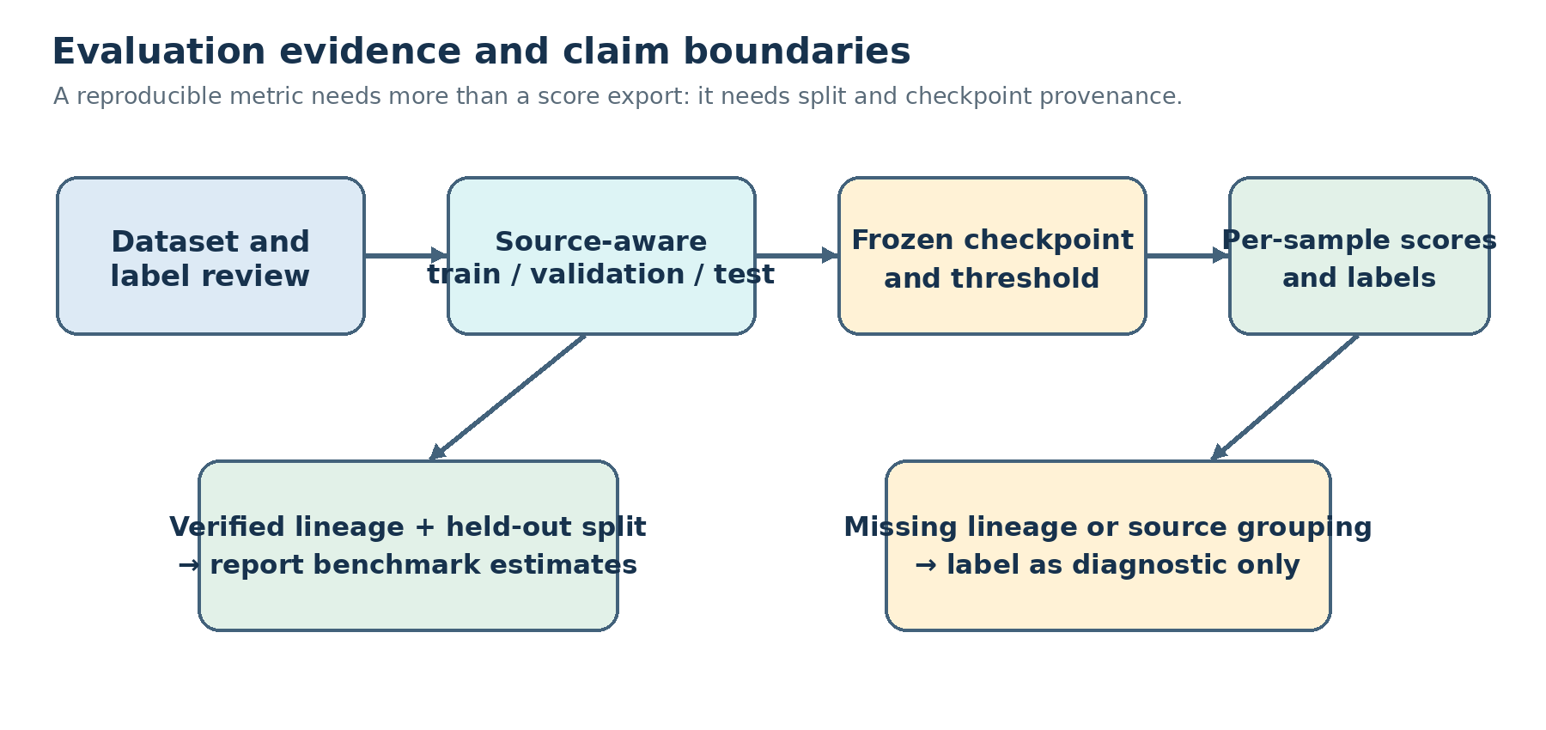
Fig. 4.1. Evaluation evidence gates distinguish diagnostic re-scores from benchmark estimates.

The project contains current-checkpoint email and audio diagnostic re-scores. The email export covers 3,508 saved test rows, with one input clipped at the API character limit; the unclipped check changes the metrics only slightly, so clipping does not explain the difference from the earlier Colab result. Email checkpoint lineage remains unverified, while the audio reconstruction has no speaker/session identifiers and its checkpoint identity is unresolved. No source-disjoint video test output or authentic paired-fusion result is available. These files support qualified diagnostics, not unverified claims of held-out generalization.
The benchmark runner requires separate validation and test splits, selects thresholds on validation rows, scores the test rows, and records scenario-level predictions, modality status, coverage, metrics, and run metadata. Group identifiers are intended to prevent related sources from crossing splits, but the runner cannot verify whether submitted files belong to the same incident; curators must establish and document that relationship. Constructed cases can validate routing and arithmetic, but their results must be reported as logic or stress-test evidence rather than real-world accuracy.

4.5 Metrics
For a binary threat classifier, true positives (TP) are threat cases classified as threat, true negatives (TN) are benign cases classified as benign, false positives (FP) are benign cases classified as threat, and false negatives (FN) are threat cases classified as benign. The report uses the following definitions:
Accuracy = (TP + TN) / (TP + TN + FP + FN)
False positive rate (FPR) = FP / (FP + TN)
False negative rate (FNR) = FN / (FN + TP)
Precision = TP / (TP + FP); Recall = TP / (TP + FN)
For model comparison, confidence intervals should accompany point estimates, and test denominators should be reported separately for benign and threat classes. In a small or constructed scenario set, percentages should not be presented with precision that exceeds the sample size.

4.6 Tools and Techniques
The project uses Python, PyTorch, Hugging Face Transformers, librosa, OpenCV, MTCNN, FastAPI, React, TypeScript, Vite, jsPDF, and Docker Compose. The backend loads models from local project directories and uses an Nginx-served frontend in the containerized configuration. Model inference can operate from local checkpoints after dependencies are installed; the deployment is local and offline-capable, but this wording does not claim a physically air-gapped host. These tools were selected to keep the interface, model inference, and deployment layers understandable within a student project. Python and PyTorch provide the inference path, Transformers supplies the email classifier interface, and librosa supports audio resampling and MFCC extraction. OpenCV and MTCNN handle video frame access and face detection. Docker Compose packages the API and web client as separate services. The exact dependency versions and local weight files should be retained with any future evaluation run because changes in preprocessing or checkpoint loading may affect scores.
CHAPTER 5 ANALYSIS AND PROPOSED WORK

5.1 Existing Workflow
The analyst submits email text, media, or a supported combination through the interface. FastAPI validates each input and invokes its local model; successful scores and sensor statuses are returned to the relevant workspace. The fusion function uses only successfully computed scores. The analyst can inspect the result, export a client-side PDF, and revisit lightweight report metadata in the browser history.

5.2 Proposed System Architecture
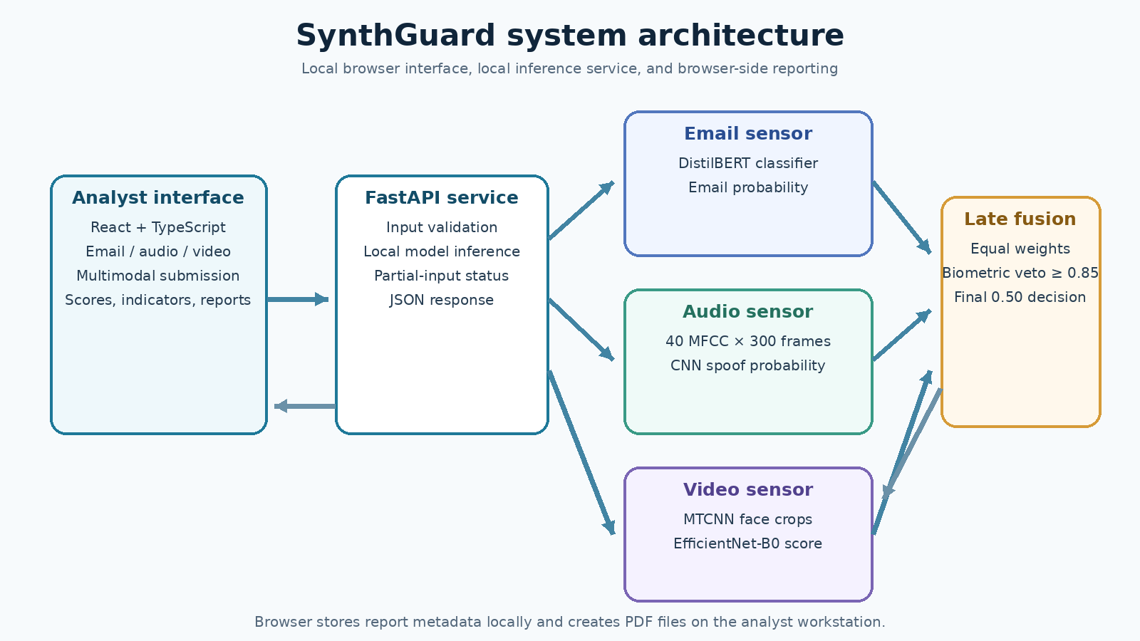
Fig. 5.1. SynthGuard local analysis and reporting flow.

5.3 Sensor Modules
Sensor | Model path | Input and processing | Output
Email | Fine-tuned DistilBERT sequence classifier | Text tokenization; max length 256 | Phishing probability; indicator threshold 0.50
Audio | Three-block CNN over MFCCs | 16 kHz audio; 40 coefficients; 300 frames | Spoof probability; indicator threshold 0.45
Video | MTCNN face detector + EfficientNet-B0 | Sample frames; crop face; resize to 224×224; average up to five scores | Calibrated manipulation probability; decision boundary 0.50

5.4 Fusion Rule
Let E, A, and V denote the email, audio, and video scores that were successfully computed. The implementation assigns nominal weights of 0.3333 to each available sensor and renormalizes by the sum of the available weights. If no modality is available, fusion returns no score. The fused score is classified as a threat when it is at least 0.50.
S_fusion = Σ(w_i S_i) / Σ(w_i), for available sensors i, unless the biometric veto fires
The veto fires when an available audio or video score is at least 0.85. The implementation then returns the highest available sensor score. Therefore, it raises the unified score to the strongest sensor value; it produces exactly 1.00 only when that strongest input is itself 1.00. The veto threshold is a software rule, not a demonstrated false-negative reduction until it is evaluated on independent labeled data [10].
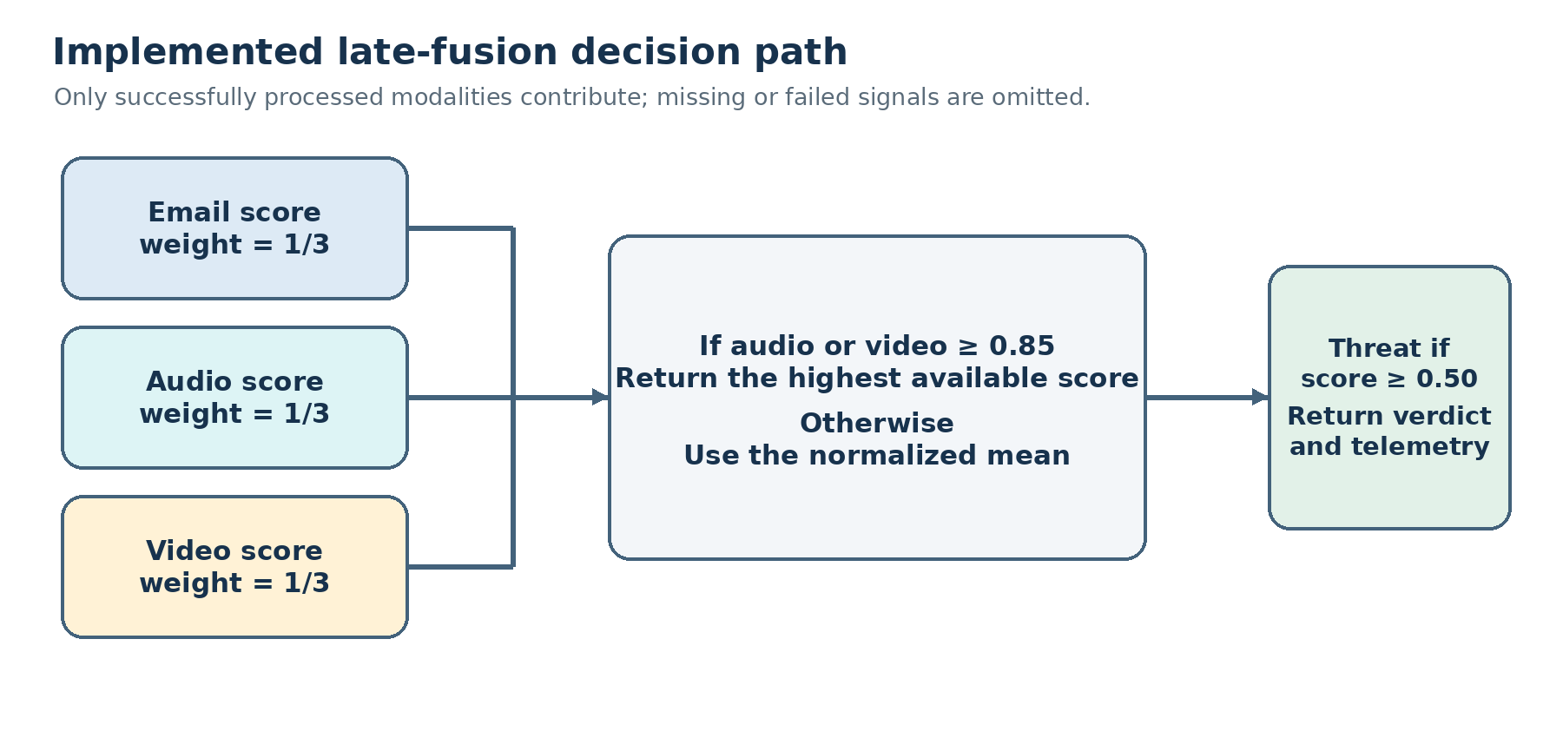
Fig. 5.2. Implemented fusion rule, including dynamic modality coverage and biometric veto behavior.

5.5 Analytical Fusion Examples
Illustrative inputs | Implemented rule | Illustrative output | Interpretation
Email 0.998; audio 0.004; video 0.416 | No biometric score reaches 0.85; equal mean | 0.4727 (47.27%) | Below the 0.50 decision boundary; arithmetic illustration only.
Email 0.0001; audio 1.000; video absent | Audio veto fires; return max available score | 1.0000 (100%) | Threat under the configured boundary; rule illustration only.

These calculations are derived from the current fusion function. They are not measured detector outputs or a benchmark result, and must not be described as experimental cases unless the corresponding inputs are linked to actual labeled test records.

5.6 Workflow Algorithm
1. Receive text, audio, video, or any supported combination.
2. Validate request size, file type, and supported evidence.
3. Run each available local sensor and record processed, failed, unavailable, or omitted status.
4. Calibrate the video probability using the loaded threshold when a face score is available.
5. Apply the audio/video veto or normalized equal-weight score to the successful sensor outputs.
6. Compare the unified score with the 0.50 threat boundary and return the score, label, indicators, and sensor status.
7. Save lightweight report metadata in the browser when a scan succeeds; generate a PDF locally when requested.

5.7 Design Considerations
SynthGuard is a decision-support prototype. The normalized mean uses only the available sensor scores, so its meaning changes with the evidence coverage. A failed or missing sensor is not equivalent to a zero score, and model outputs are not automatically calibrated probabilities of real-world harm. The interface and report should retain each modality score and status so analysts can interpret the result in context.
CHAPTER 6 IMPLEMENTATION AND DEVELOPMENT

6.1 System Components
The project contains a React and TypeScript frontend, a FastAPI backend, local PyTorch checkpoints, and a two-container Docker Compose deployment. During development, Vite proxies relative API requests; in the container deployment, Nginx forwards them to FastAPI over the private Compose network. Model weights are mounted read-only and offline model loading is enabled. These settings support local operation but do not establish that the host lacks external network access or has passed an independent security audit.

6.2 Backend API
Endpoint | Method | Purpose
/api/health | GET | Reports backend and local model availability.
/api/analyze/email | POST | Analyzes email text.
/api/analyze/audio | POST | Analyzes an audio upload.
/api/analyze/video | POST | Analyzes a video upload.
/api/analyze/multimodal | POST | Analyzes any submitted combination of email text, audio, and video.

The API returns an analysis ID, type, status, prediction, summary, indicators, creation time, and modality status; fusion responses also carry per-modality status and errors. File extension, size, and duration limits are enforced. A partial response preserves successful sensor results when another supplied sensor fails, allowing the interface to show the failure without discarding the available evidence. Operators should inspect backend logs for diagnostic detail and avoid exposing stack traces to analysts.

6.3 Email Inference
The backend loads a locally stored DistilBERT sequence-classification model and tokenizer. It tokenizes text to a maximum sequence length of 256, applies a softmax, and uses class index 1 as the phishing score. The single-modality email endpoint and fusion indicator use a 0.50 threshold. The classification checkpoint is stored under models/final/phishing_email.

6.4 Audio Inference
Audio is decoded at 16 kHz and transformed into a 40 by 300 MFCC matrix with 2,048-point FFT and 512-point hop. The CNN contains three convolution, batch-normalization, ReLU, and max-pooling stages with 32, 64, and 128 channels, followed by a 256-unit fully connected layer, dropout, and a single logit. The sigmoid score is treated as spoof confidence; the operational classification boundary is 0.45. The saved checkpoint is models/final/audio_detector/audio_cnn_model.pth.

6.5 Video Inference
The video model is an EfficientNet-B0 with a replaced classifier head. MTCNN detects faces in sampled frames; detections above 0.90 confidence are cropped and normalized, and up to five crop scores are averaged. The backend loads `model.safetensors_2` and applies a logit-space score recentering transform. When no valid calibration file is present, the raw threshold fallback is 0.7920, which maps to a displayed score of 0.50. This mathematical property does not establish statistical calibration or validate the operating point; a validation-derived threshold record is still needed.
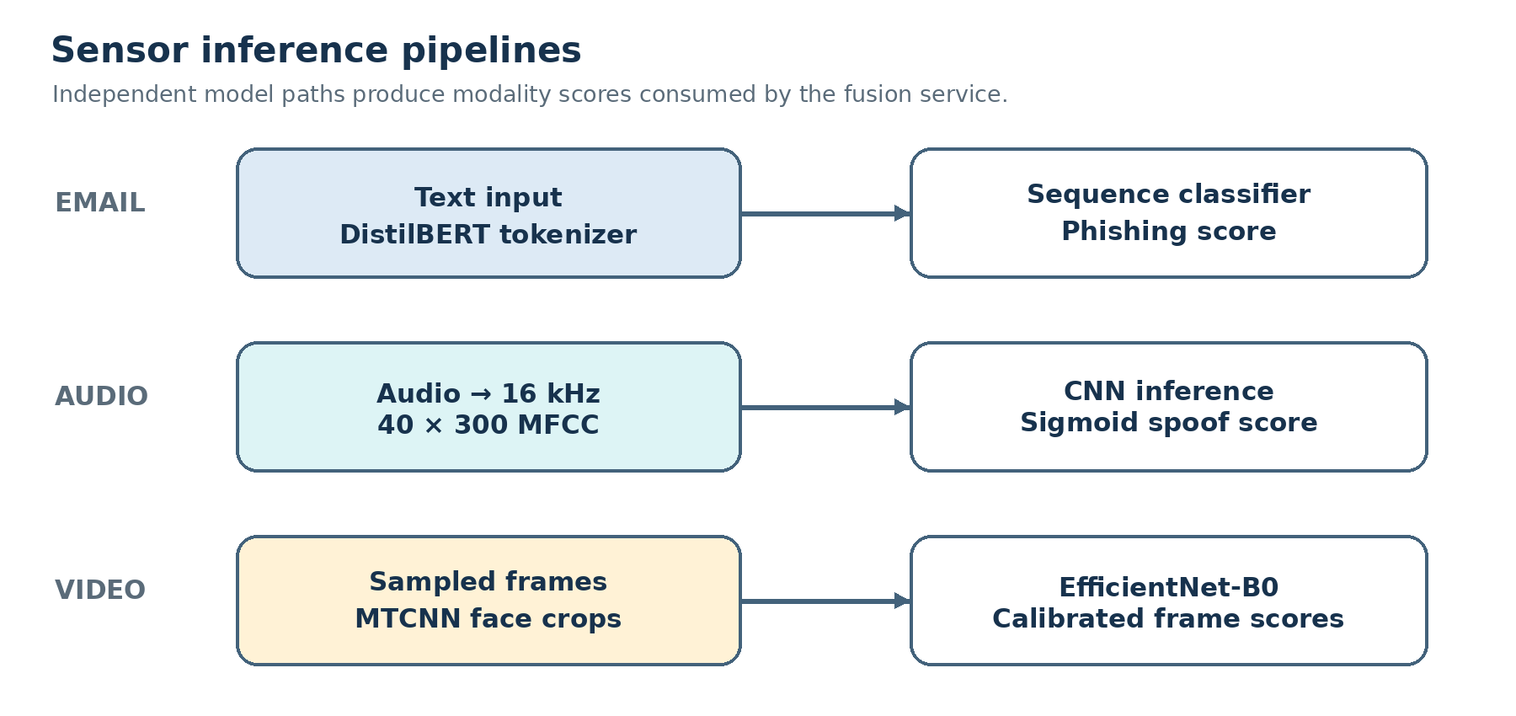
Fig. 6.1. Modality-specific inference pipelines used by the current prototype.

6.6 Fusion and User Interface
The fusion function in src/fusion.py uses equal nominal weights of 0.3333, renormalizes over available sensors, and applies a veto at 0.85 for audio or video. The React interface exposes Dashboard, Email Intelligence, Audio Forensics, Video Forensics, multi-modal Fusion, Threat Reports, and Settings pages. The browser-side report module saves lightweight metadata in localStorage and creates a jsPDF document locally; it does not send PDF content to a server [13].

6.7 Deployment and Privacy
Docker Compose defines separate FastAPI and Nginx/React services, mounts model weights read-only, enables Hugging Face offline mode, and publishes the UI on loopback by default. This supports local inference after dependencies and weights are present, but does not certify an air gap. Host firewall rules, network routes, dependency downloads, and machine configuration remain outside the application-level guarantee.
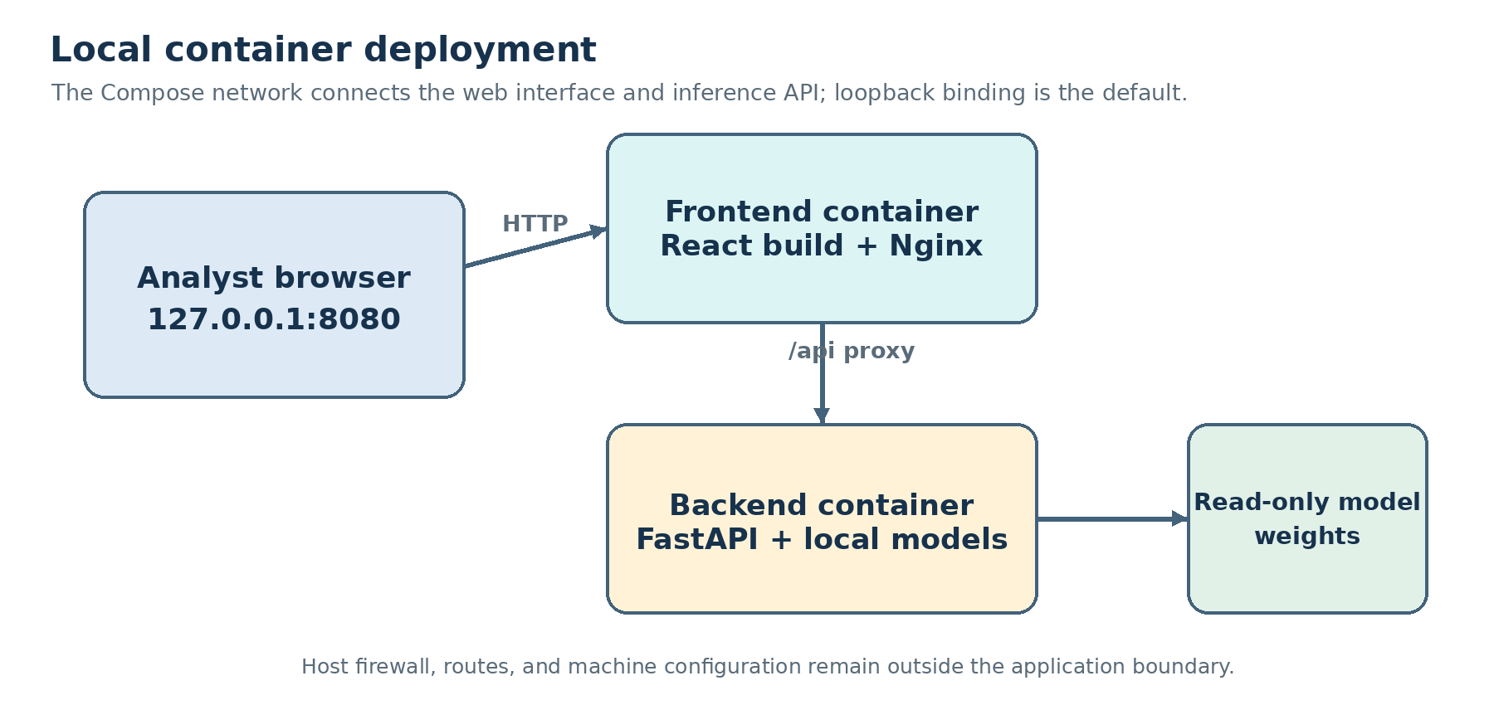
Fig. 6.2. Two-container local deployment and the boundary of the application’s privacy claims.

6.8 Reproducibility and Testing Status
The repository contains model weights, notebooks, backend and frontend code, and prediction exports for email and audio. The email and audio results are reproducible diagnostic re-scores, but checkpoint lineage and source grouping remain incomplete. The video training excerpt concerns a random face-tensor split and a differently named export, not a held-out test of the active checkpoint. No authentic paired-fusion run is present. These limitations constrain performance claims even though the inference workflow is implemented.
CHAPTER 7 RESULTS AND DISCUSSION

7.1 Email Result Available in the Project
The repository now includes outputs/reports/email_test_predictions.csv and email_test_metrics.json, a current-checkpoint re-score of the saved 3,508-row email test split. At threshold 0.50 the counts are TP=1,308, TN=2,023, FP=173, and FN=4, yielding 94.95% accuracy, 88.32% precision, 99.70% recall, 7.88% FPR, and 0.30% FNR. The checkpoint hash and dataset hash are recorded, but the metric file explicitly says the checkpoint’s training and model-selection provenance is unverified. This is therefore a diagnostic re-score, not proven held-out performance. The earlier Colab report states 98.80%, while its archived counts imply 98.69%; the current re-score does not resolve which checkpoint generated that older result.
Evidence source | Recorded value | Interpretation
Email current-checkpoint re-score | N=3,508; TP 1,308; TN 2,023; FP 173; FN 4; accuracy 94.95%. | Prediction CSV and run metadata exist; checkpoint training provenance is unverified, so treat as diagnostic.
Email unclipped subset | N=3,507; FP 172; accuracy 94.98%; FPR 7.84%. | The one clipped input changes the current score minimally; clipping does not explain the historical gap.
Earlier Colab email report | Headline accuracy 98.80%; archived counts imply 98.69%. | Separate historical run; active checkpoint lineage is not established and the two summaries disagree.
Audio reconstructed re-score | N=500; TP 448; TN 46; FP 5; FN 1; accuracy 98.8%; FPR 9.80%. | Random sample split with no source IDs; only 51 genuine test records; diagnostic only.
Video and multi-modal fusion | No active-checkpoint video test report; no authentic paired-fusion run. | Do not report video accuracy or fusion benefit from current evidence.

Excluding the single over-limit email input changes the result only slightly, so clipping does not explain the gap from the earlier Colab summary. The earlier confusion matrix is consistent with its reported 98.80% accuracy, but the older checkpoint and split-generation history are not linked to the active deployment.

7.2 Audio and Video Results
The audio reconstruction was evaluated at both the notebook-comparison threshold of 0.50 and the deployed threshold of 0.45; both thresholds produce the same decisions on this sample. This coincidence does not validate either operating point. Only 51 genuine records are present, the feature batches lack source IDs, and the active checkpoint cannot be matched to the supplied Colab weights, so the result remains diagnostic.

7.3 Multi-modal Fusion Results
The fusion function is implemented, but no completed paired held-out evaluation artifacts were found in outputs/reports. Historical ablation rows in the project are explicitly identified as unverified because their former pipeline combined unrelated modality records and selected a video threshold on the scoring records [15]. The current runner requires curated paired scenarios and creates metrics, prediction, and run-metadata outputs; those outputs are not present. The earlier percentages such as 99.1% accuracy and 0.4% false-negative rate are therefore omitted as measured claims.
The examples in Chapter 8 demonstrate how the code behaves for selected numeric inputs. They validate arithmetic by inspection only. They do not establish sensor detection, fault tolerance on real attacks, or improved accuracy across the seven modality subsets.

7.4 Integrated System Results
The implementation provides separate inference endpoints, a multi-modal endpoint, health reporting, modality-level status, a dashboard, forensic scanners, local report history, and client-side PDF generation. Docker Compose configuration describes a local two-service deployment. No independently audited security test, sustained-load result, or measured latency report is present in this snapshot. Functional availability should therefore be demonstrated separately from detection quality.

7.5 Discussion
The current evidence is stronger than an implementation-only description because sample-level diagnostic re-scores now exist for email and audio. Their exact counts and run metadata are reproducible from the project outputs, but the email checkpoint lineage and audio source grouping remain unresolved. The audio estimate is particularly imprecise for benign speech because only 51 genuine test rows are available. No video test metrics or authentic paired fusion results are available. The appropriate contribution is therefore the functioning architecture and a documented evaluation protocol, not an accuracy advantage. Threshold selection, group separation, coverage, class balance, and training-data overlap must be resolved before stronger research claims are made. The available artifacts support a careful but useful conclusion. The current email output includes a prediction row for each sample, while the audio output provides a reconstructed 500-row diagnostic with a very small benign denominator. The unclipped email check changed little, which rules out the single over-length input as the main source of the difference from the older result. At the same time, checkpoint-to-split lineage remains unresolved for email, and the audio reconstruction lacks source IDs. These limits prevent the point estimates from being generalized to new organizations or recording sources. No video test metrics or authentic paired fusion evaluation are available, so comparative multi-modal benefit remains an open research question.
SynthGuard: A multi-modal Threat Intelligence and Deepfake Defense System
Jay Shravan Kumar Sharma, Roll No. TYCS47, T.Y.B.Sc. Computer Science SEMESTER V
Department of Computer Science, Bhavan's College (Empowered Autonomous), Andheri West
Under the guidance of Mrs. Krupa Kamdar
Abstract— Business email compromise and synthetic media attacks exploit trust across communication channels. SynthGuard is a locally deployed research prototype that routes email, audio, and video evidence to separate classifiers and combines the available scores through an interpretable late-fusion rule. The implementation comprises a DistilBERT email classifier, an MFCC-based convolutional audio model, an MTCNN face-detection stage with an EfficientNet-B0 video classifier, a FastAPI inference service, and a React analyst interface. This paper documents the current implementation and audits the evaluation evidence available for the active checkpoints. A current-checkpoint email re-score produced 94.95% accuracy on the saved 3,508-row test file. A reconstructed 500-row audio sample yielded 98.8% accuracy, but only 51 records were genuine; the resulting 9.80% false-positive rate is based on five errors and is too weakly supported to serve as a reliable operating estimate. Neither result has verified checkpoint-to-split lineage or source-disjoint provenance. The active video checkpoint has no documented held-out test metrics, and no genuinely paired multi-modal test set is available. These are diagnostic observations, not validated generalization estimates. SynthGuard demonstrates an integrated local workflow; comparative effectiveness remains open.
Keywords—business email compromise, phishing detection, speech spoofing, deepfake video, multi-modal late fusion, local inference, evaluation provenance.

I. INTRODUCTION
Business email compromise (BEC) attacks use impersonation, urgency, secrecy, and payment redirection to induce actions that routine spam filters may not identify. Synthetic speech and manipulated video can strengthen the impersonation by supplying apparently familiar biometric cues. These threats are related at the level of an investigation, but each data type exposes different evidence: language conveys intent, audio contains acoustic artifacts, and video contains spatial or temporal manipulation traces.
A practical analyst tool should support independent modality review and combined analysis when evidence is available. Combining scores, however, does not by itself establish that the inputs belong to the same incident, that the scores are calibrated to a common scale, or that an overall accuracy figure is meaningful. The study therefore treats implementation and evaluation as separate questions. The first is whether a local system can route the three evidence types through dedicated inference paths. The second is whether the resulting decisions generalize to unseen data and coherent multi-modal cases.
This work presents SynthGuard, a prototype that integrates local text, audio, and video detectors behind a FastAPI service and an analyst-facing React interface. The paper contributes: (1) a reproducible description of the implemented sensor and fusion paths; (2) an audit of the saved evaluation artifacts and checkpoint identity; and (3) a methodological analysis of why label-matched independent samples cannot establish multi-modal performance. It also specifies a source-disjoint, incident-paired evaluation protocol. The paper does not claim a validated multi-modal accuracy advantage.
The research is organized around three questions. RQ1 asks whether a single local application can process text, audio, and video through distinct inference paths while supporting missing modalities. RQ2 asks what performance evidence can be attributed to the checkpoints currently loaded by the application. RQ3 asks whether the implemented mean-and-veto rule has demonstrated an advantage over individual sensors. The repository establishes an implementation answer for RQ1 and provides qualified diagnostic evidence for RQ2. RQ3 remains unanswered as a performance question; the study’s methodological finding is that fusion claims require incident-level pairing and source-aware partitions, neither of which the available artifacts establish.
The intended use is analyst-assisted triage of uploaded communication evidence. The prototype is not designed to authenticate a sender, establish legal intent, inspect email attachments, verify transaction records, monitor live calls, or automatically block a payment. Its scores are indicators for human review rather than determinations of identity or fraud.

II. RELATED WORK
Transformer encoders have become common for contextual text classification. DistilBERT uses knowledge distillation to reduce model size and inference cost while retaining much of the representational capacity of BERT [1]. SynthGuard uses a fine-tuned DistilBERT sequence classifier for email text. This choice supports contextual analysis, but text classification can still overreact to benign terms or miss a new attack pattern; a score should be interpreted with the email and its organizational context.
Audio spoofing research is represented by the ASVspoof challenges, which provide bonafide and spoofed speech data, attack metadata, evaluation protocols, and baseline systems [2]. Mel-frequency cepstral coefficients (MFCCs) are a compact representation of short-time spectral shape originating in speech-recognition research [3]. SynthGuard extracts MFCC features and classifies them with a convolutional neural network. Results on a random sample split cannot be equated with performance under a speaker-, session-, or attack-disjoint protocol.
For video, FaceForensics++ provides manipulated facial imagery and explicitly studies compression effects [4]. MTCNN jointly detects and aligns faces through a cascaded multi-task network [5]. EfficientNet scales convolutional networks through coordinated depth, width, and resolution choices [6]. These methods motivate the face-crop pipeline used by SynthGuard, but published benchmark results for those methods are not evidence of this project checkpoint’s performance.
Classifier combination has a long history, including rules that aggregate separate classifier outputs [7]. Contemporary audio-visual deepfake work also studies feature-level and cross-modal relationships rather than assuming that independent classifier scores are directly comparable [8]. SynthGuard adopts a simpler score-level rule for transparency and partial-modality support. Its mean-and-veto rule is an engineering choice requiring evaluation against alternatives; it is not presented as a state-of-the-art fusion method.

III. RESEARCH DESIGN AND EVALUATION PROTOCOL

A. Study design and unit of analysis
The implemented prototype is evaluated here through an artifact-based study: model configuration, preprocessing code, checkpoints, saved predictions, evaluation summaries, and analyst-interface outputs are inspected together. A prediction row is the unit of analysis for single-modality re-scores. A multi-modal case must instead be defined as one coherent incident with one or more corresponding evidence items; it cannot be created by matching unrelated records because they share a threat label. The current project artifacts do not contain a verified paired incident set, so the paper separates software integration observations from classifier-performance estimates.

B. Data records and partition provenance
The email evaluation file contains 3,508 labeled records. The available training code loads prebuilt train and test pickle objects, while the active checkpoint was later updated for additional threat patterns. The artifact bundle records hashes for the current test file and checkpoint, but does not provide a complete lineage proving that the current weights were selected without access to this test split. This distinction matters: reproducible scoring of a file is not equivalent to an independent test when model selection may have used the same examples.
The audio feature cache contains 181,566 rows distributed across ten serialized batches. The reconstruction script follows the documented lexicographic file order and recreates a 500-row stratified sample-level test partition using random_state 42. It has no speaker, session, or source identifiers. The video training record describes a random partition of 10,000 face tensors, but the saved log does not preserve an actor, source-video, or clip grouping manifest. A stronger evaluation would assign all samples from each email thread or campaign, speaker/session, and source video to exactly one partition before extracting windows, frames, or derivative features.

C. Scoring procedure and thresholds
For the diagnostic email re-score, every row in the saved test file was sent to the active local API and labeled at a 0.50 score threshold. The evaluation record notes one input clipped at the API limit; both inclusive and unclipped counts are retained. The audio reconstruction was scored at both 0.50, matching the notebook validation decision rule, and 0.45, the backend operating threshold. The two thresholds yield identical decisions on the reconstructed sample, but this coincidence does not validate either threshold for other populations. The active video checkpoint has no test score file. Its configured 0.7920 raw-score recentering value is not re-estimated from the evaluated records in this study.

D. Measures and uncertainty
Threat is treated as the positive class. Accuracy summarizes overall agreement, while precision and recall describe threat alerts and detected threats; FPR measures benign records incorrectly flagged, and FNR measures missed threats. For speech anti-spoof research, equal error rate can provide a threshold-independent operating summary when computed from a complete labeled score set. The local audio notebook records validation EER across epochs, but its test portion is not scored there and its selected checkpoint state is not independently preserved in the excerpt. The present paper therefore reports the reconstructed test confusion counts rather than using that validation EER as a test result.
A confirmatory study should freeze preprocessing, weights, and thresholds before test scoring; report support and uncertainty intervals alongside each metric; and use source-group bootstrap resampling where records share an actor, speaker, thread, or source clip. It should report per-sample prediction files and checkpoint hashes so aggregate values can be independently recomputed. Fusion results should be stratified by each available modality subset, since coverage and error rates can differ substantially between email-only, biometric-only, and genuinely multi-modal cases.

E. Reproducibility criteria
A result is considered traceable when its report identifies the exact test manifest and hash, active checkpoint hash, preprocessing version, threshold, label mapping, sample count, confusion matrix, and code revision. For group-aware testing, it also records the grouping key and demonstrates no group overlap between train, validation, and test. The current email and audio re-score artifacts satisfy several reporting requirements, including per-sample outputs and model/file hashes, but not all lineage and group-separation criteria. The video and fusion results lack the required test artifacts. This protocol guides interpretation of the evidence below and the next reproducible evaluation run.

IV. SYSTEM ARCHITECTURE AND METHODS
The application has three layers. The React client accepts text and media, displays modality-specific outputs, and requests analyses from the local API. FastAPI validates requests, stores uploaded media in temporary files for inference, and dispatches each present modality to its model. The inference layer loads local model weights and returns scores, verdicts, identifiers, timestamps, and forensic indicators. Docker Compose packages the frontend and backend for local operation [9]. The configuration uses local inference services and does not call a hosted model API; this software design alone does not prove that the host is physically air-gapped.
TABLE I
SYNTHGUARD INFERENCE PATH AND OUTPUTS
Evidence input | Processing path | Output used by fusion
Email text | Tokenizer → fine-tuned DistilBERT → class-1 score | Email threat score sₑ
Audio file | 16 kHz resampling → 40 MFCCs → CNN → sigmoid | Spoof score sₐ
Video file | Frame sampling → MTCNN face ROI → EfficientNet-B0 → mean score | Manipulation score sᵥ
Available scores | Equal-weight normalized mean; audio/video veto at 0.85 | Final score and 0.50 decision

A. Email sensor
The email endpoint tokenizes the submitted message and obtains class logits from the saved DistilBERT sequence classifier. The phishing-class probability is returned as a score. The current evaluation script sends each saved test record through the running API; one record exceeded the API character limit of 100,000 characters and was clipped. The reported full-file metrics therefore include one clipped input, while the accompanying unclipped metrics exclude it.

B. Audio sensor
The audio pipeline converts audio to 16 kHz mono, computes 40 MFCC coefficients using an FFT size of 2,048 samples and a 512-sample hop, and pads or truncates the time axis to 300 frames. A three-block convolutional model returns a sigmoid score for spoof audio. The backend uses 0.45 as the operational decision threshold. The available feature batches preserve labels and row order but do not include speaker, session, or source-group identifiers.

C. Video sensor
The video endpoint samples up to five frames, detects facial regions with MTCNN, resizes crops to 224 × 224, runs the active EfficientNet-B0 checkpoint, and averages the frame scores. The current backend loads model.safetensors_2. It transforms a raw score using sᵥ = σ(logit(sᵣₐw) − logit(τ)), after clipping the raw value away from zero and one. With the configured fallback τ = 0.7920, the transform maps that raw threshold to a displayed score of 0.50. No validation manifest or calibration record substantiating 0.7920 was found, so this is described as a configured score recentering, not a newly verified probability calibration.

D. Late fusion and decision rule
Let M be the set of modalities included in an analysis, and let sᵢ be each modality score. The implementation assigns nominally equal weights and renormalizes them over M: Smean = Σᵢ∈M wᵢsᵢ / Σᵢ∈M wᵢ, where wᵢ = 0.3333. If audio or video reaches the veto threshold θ = 0.85, the implementation returns the maximum score among the available modalities; it does not unconditionally set the final score to 1.00. Otherwise it returns Smean. A score of at least 0.50 is labeled a threat. When only one modality is provided, the returned score represents that modality and is not evidence of fusion.
This rule is transparent and tolerant of missing inputs, but it assumes the scores have compatible meanings and ranges [10]. A detector’s sigmoid or softmax output is not automatically a calibrated probability. The veto can increase sensitivity to a high biometric score while also increasing false alarms; both effects must be measured on paired, held-out scenarios.

V. IMPLEMENTATION AND ANALYST WORKFLOW
The backend exposes independent endpoints and a multi-modal endpoint. File size, extension, and duration limits constrain uploads, and missing modalities are skipped. The user interface presents the score and status for each provided sensor, an overall verdict, and forensic indicators. A scan report can be exported as a PDF in the browser. Lightweight report metadata is stored in the browser’s localStorage for the analyst’s report-history view; uploaded frames and full media are not part of that local report-history record. This storage choice persists within the browser profile but is not a server-side audit database or a cross-device archive.
The dashboard presents operational readiness, model availability, and investigation entry points rather than benchmark accuracy. This separation avoids implying that a model-level diagnostic number is a production guarantee. The screenshots below document interface behavior only; the multi-modal example is not treated as an experimentally paired case.
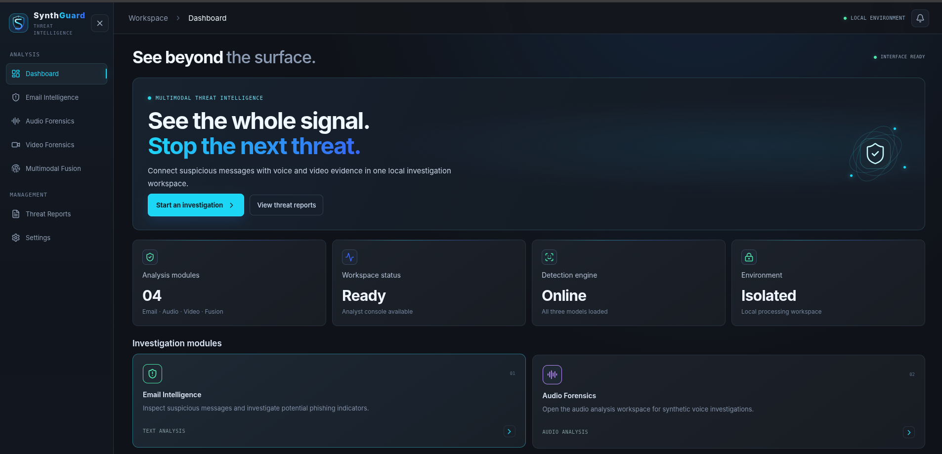
Fig. 1. SynthGuard analyst dashboard. The interface communicates local workspace status and provides access to the modality workspaces.

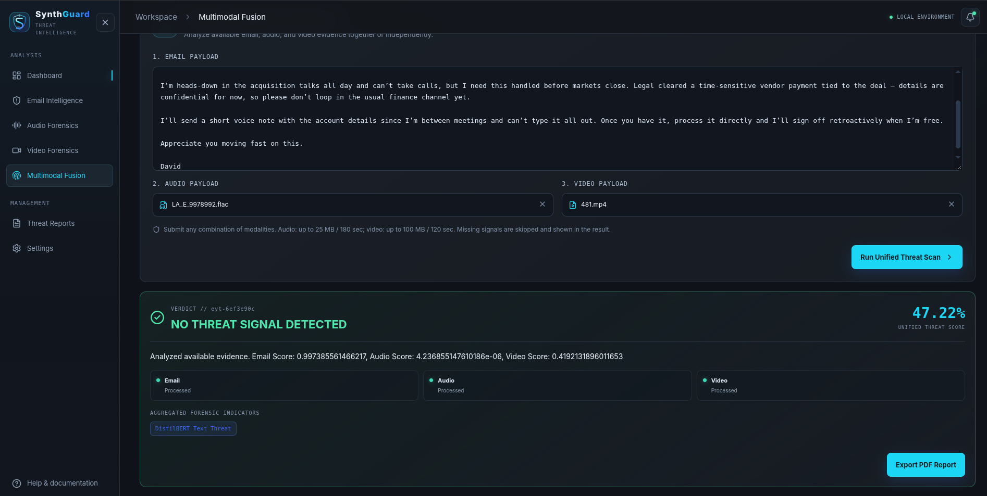
Fig. 2. multi-modal analysis screen. The displayed email, audio, and video scores illustrate UI behavior only; the inputs are not established as a matched research sample.

VI. EXPERIMENTAL EVIDENCE AND RESULTS
The evidence audit distinguishes earlier notebook outputs, current-checkpoint re-scores, and evaluations that have not yet been performed. Sample-level scores are available for the current email re-score and reconstructed audio split. The saved outputs include counts and run metadata. For both modalities, however, evidence tying the active checkpoint to training and model selection without use of the evaluated records is incomplete. These results are therefore diagnostic and should not be interpreted as unbiased estimates of performance on unseen populations.

A. Email evidence
An earlier Colab email experiment reported 98.80% accuracy on 3,508 test rows and showed a confusion matrix with 2,175 true negatives, 21 false positives, 21 false negatives, and 1,291 true positives. That matrix sums to 3,508 and is arithmetically consistent with 98.80%. The notebook excerpt loads prebuilt train and test pickle files but does not provide their creation history or a hash linking its trained weights to the currently deployed checkpoint. This earlier result is not a verified held-out estimate for the active model.
The active checkpoint was separately rescored against the repository’s saved test file at a 0.50 threshold. Including the clipped long input, the 3,508-row confusion counts were TP = 1,308, TN = 2,023, FP = 173, and FN = 4, corresponding to 94.95% accuracy, 7.88% false-positive rate, and 0.30% false-negative rate. Excluding the clipped row gives n = 3,507, TP = 1,308, TN = 2,023, FP = 172, and FN = 4; accuracy is 94.98%. The saved report records the test-file hash and the checkpoint hash, but not training-split lineage. Accordingly, these are reproducible re-score outputs on the saved file, not proven out-of-sample metrics.
B. Audio evidence
The audio training procedure records 181,566 MFCC feature rows and constructs a 500-row stratified test index with random_state = 42. The excerpt creates train and validation loaders but never creates a test loader or reports test-set predictions. A local reconstruction of the 500-row index from the same feature order was scored with the active local audio checkpoint [12]. At the deployed threshold of 0.45, the counts were TP = 448, TN = 46, FP = 5, and FN = 1 (n = 500; 449 spoof and 51 genuine), for 98.8% accuracy. Only 51 genuine samples are present. The observed 9.80% false-positive rate comes from five errors among those 51 records, making it highly sensitive to individual examples and too weakly supported to interpret as a stable operating rate. The 98.8% overall accuracy is similarly misleading in this spoof-heavy sample and should not be treated as a meaningful estimate of balanced detection performance. The batch files have no source IDs, and the Colab checkpoint identity is unavailable for comparison with the active local weights. This reconstruction is diagnostic only, not source-disjoint test evidence.

C. Video evidence
A video training run recorded 95.75% validation accuracy after five epochs on 10,000 face tensors randomly partitioned into 8,000 training and 2,000 validation samples. That run saved model.safetensors; the current application loads model.safetensors_2. The training record contains no source-video groups or held-out test predictions, so its validation metric cannot be attributed to the active checkpoint or treated as test accuracy. No verified held-out metric report exists for the active video model.

D. Fusion evidence
No curated manifest of genuinely corresponding email, audio, and video cases with source-group separation was available. The earlier ablation CSV and LaTeX table are marked in the repository as unverified because independent modality datasets were paired by labels and a video threshold was selected on the same records used for scoring [13]. Their percentages are excluded. This distinction is substantive: sharing a threat/benign label does not make two records evidence from the same investigation, and therefore cannot test whether cross-modal evidence resolves a particular incident. The current multi-modal screenshot illustrates interface behavior only; its media are not verified as one matched scenario. No multi-modal accuracy, false-positive rate, false-negative rate, or fault-tolerance rate is claimed. The resulting contribution is a clear validity requirement for future fusion evaluation, rather than a fusion performance estimate.

E. Metric definitions and evidence summary
For a binary threat label, the reported metrics are computed from TP, TN, FP, and FN as follows: Accuracy = (TP + TN)/(TP + TN + FP + FN); Precision = TP/(TP + FP); Recall = TP/(TP + FN); FPR = FP/(FP + TN); and FNR = FN/(FN + TP). A future benchmark should also report class support, confidence intervals, coverage for each modality subset, and source-group overlap checks.

TABLE II
RESULTS AND EVIDENCE STATUS
Component / evidence | N | Observed result | Interpretation
Email: earlier Colab run | 3,508 | 98.80% accuracy; CM [[2175, 21],[21, 1291]] | Run/checkpoint linkage and split lineage unverified
Email: active-checkpoint re-score | 3,508 | 94.95% accuracy; TP 1308, TN 2023, FP 173, FN 4 | Excluding one clipped row changes accuracy to 94.98%; split lineage unverified
Audio: reconstructed random-row split | 500 | 98.80% accuracy;  TP 448, TN 46, FP 5, FN 1 | No source IDs; checkpoint identity unverified; diagnostic only
Video: active checkpoint | — | No held-out test metrics found | Earlier validation result belongs to a separate checkpoint
multi-modal fusion | — | No paired held-out evaluation | Earlier ablation outputs excluded as unverified

VII. DISCUSSION
The project’s strongest demonstrated result is systems integration: three modality-specific inference paths are available through a shared analyst workflow, including partial-input analysis and browser-generated reports. The methodological contribution is the explicit requirement for incident-level pairing and source-aware partitions before fusion performance can be measured. The available evidence supports a careful description of an integrated prototype; it does not establish that the fusion rule outperforms individual sensors or generalizes to new sources.
The active email re-score has a materially higher false-positive rate than the earlier Colab result. Excluding the single API-clipped record changes the accuracy only from 94.95% to 94.98% and the false-positive count from 173 to 172; clipping therefore does not explain the discrepancy. The remaining difference cannot be attributed using the available artifacts because the earlier run’s checkpoint, split-generation history, and full preprocessing lineage are not linked to the active deployment. The audio figure also requires stronger restraint: 98.8% accuracy on a spoof-heavy sample with only 51 genuine examples is not a reliable operating estimate, and its 9.80% false-positive rate is based on five cases. Both results require source-disjoint evaluation before broader conclusions.
The fusion rule is interpretable but assumes comparable modality scores. Logit recentering at the configured video threshold does not calibrate across models. Future evaluation should lock thresholds on validation data, compare mean and veto against baselines, and report all seven non-empty modality subsets with source-group separation.

VIII. LIMITATIONS AND THREATS TO VALIDITY
First, checkpoint provenance is incomplete. The active email and audio weights cannot be conclusively linked to training histories that exclude the evaluated rows; the active video checkpoint has no corresponding test evaluation. Second, the audio split is sample-level and lacks speaker/session identifiers. The documented video validation partition is sample-level, with no source-video grouping evidence. These designs may allow correlated content to cross partitions and do not establish generalization to unseen sources.
Third, the multi-modal records are not a verified paired BEC corpus. Combining unrelated samples or merely sharing labels does not create a valid multi-modal case. Fourth, the configured video threshold lacks a preserved validation manifest and should not be called a verified calibration. Fifth, the stress examples and screenshots are illustrative; they cannot support population-level accuracy or fault-tolerance claims. Finally, local Docker configuration and local model loading reduce dependence on external inference services. They do not establish air-gapped operation; that claim would require confirmation of host network controls and software supply-chain conditions outside the model code.

IX. CONCLUSION AND FUTURE WORK
SynthGuard integrates email, audio, and video classifiers in a locally deployed analyst workflow and applies an explicit equal-weight score rule with a high-confidence biometric veto. The available audio result is especially weak: 98.8% accuracy on a spoof-heavy sample with only 51 genuine cases is not a dependable operating estimate. The current repository supports detailed architectural reporting and qualified diagnostic re-scores, but not validated performance claims for the active checkpoints as a whole or for paired multi-modal fusion. The study’s fusion contribution is to make the incident-pairing requirement explicit: label-matched records from independent sources do not validate multi-modal performance. Future work should first establish checkpoint and data lineage, then create source-disjoint validation and test partitions, calibrate thresholds on validation data only, and curate paired scenarios whose modalities belong to the same investigation. The final evaluation should publish per-sample scores, confusion counts, source IDs or pseudonymous group IDs, threshold settings, checkpoint hashes, confidence intervals, and reproducible run metadata. Until then, SynthGuard should be presented as an integrated prototype with evaluation in progress, not as a system proven to achieve a particular multi-modal accuracy.

REFERENCES
[1] V. Sanh, L. Debut, J. Chaumond, and T. Wolf, “DistilBERT, a distilled version of BERT: smaller, faster, cheaper and lighter,” arXiv:1910.01108, 2019.
[2] J. Yamagishi et al., “ASVspoof 2021: accelerating progress in spoofed and deepfake speech detection,” in Proc. ASVspoof 2021 Workshop, 2021, pp. 47–54, doi: 10.21437/ASVSPOOF.2021-8.
[3] S. B. Davis and P. Mermelstein, “Comparison of parametric representations for monosyllabic word recognition in continuously spoken sentences,” IEEE Trans. Acoust., Speech, Signal Process., vol. 28, no. 4, pp. 357–366, 1980.
[4] A. Rössler et al., “FaceForensics++: Learning to Detect Manipulated Facial Images,” in Proc. IEEE/CVF Int. Conf. Comput. Vis. (ICCV), 2019, pp. 1–11, doi: 10.1109/ICCV.2019.00009.
[5] K. Zhang, Z. Zhang, Z. Li, and Y. Qiao, “Joint face detection and alignment using multitask cascaded convolutional networks,” IEEE Signal Process. Lett., vol. 23, no. 10, pp. 1499–1503, 2016, doi: 10.1109/LSP.2016.2603342.
[6] M. Tan and Q. Le, “EfficientNet: Rethinking Model Scaling for Convolutional Neural Networks,” in Proc. 36th Int. Conf. Machine Learning, PMLR, vol. 97, 2019, pp. 6105–6114.
[7] J. Kittler, M. Hatef, R. P. W. Duin, and J. Matas, “On combining classifiers,” IEEE Trans. Pattern Anal. Mach. Intell., vol. 20, no. 3, pp. 226–239, 1998, doi: 10.1109/34.667881.
[8] T. Oorloff et al., “AVFF: Audio-Visual Feature Fusion for Video Deepfake Detection,” in Proc. IEEE/CVF Conf. Comput. Vis. Pattern Recognit. (CVPR), 2024.
[9] SynthGuard project, backend/main.py, docker-compose.yml, and frontend report modules, local inference, deployment, and client-side report workflow, project repository, accessed 19 October 2026.
[10] SynthGuard project, src/fusion.py, normalized score aggregation and biometric veto implementation, project repository, accessed 19 October 2026.
[11] SynthGuard project, outputs/reports/email_test_metrics.json and email_test_predictions.csv, current-checkpoint email re-score and qualification metadata, generated 18 October 2026.
[12] SynthGuard project, outputs/reports/audio_reconstructed_test_metrics.json and audio_reconstructed_test_predictions.csv, reconstructed audio split re-score and qualification metadata, generated 18 October 2026.
[13] SynthGuard project, outputs/reports/README.md, status and limitations of historical ablation outputs, project repository, accessed 19 October 2026.
CHAPTER 9 PLAGIARISM AND SIMILARITY REPORT

9.1 Purpose
This section records the similarity result supplied for the SynthGuard research paper. Similarity checkers compare submitted text against the sources and collections available to the service and apply their own settings and exclusions. A percentage is a screening result; it does not by itself establish proper attribution or originality.

9.2 Checker and Result

Similarity report – Paperpal
0% similarity detected
Result shown by the checker: “No similarity detected.”

9.3 Interpretation
The supplied screenshot shows a zero-percent similarity result for the checked paper. This is evidence of the checker output at the time it was produced, not a universal guarantee that no similar wording exists. Results can differ across tools and settings, and matches may not be available for private, offline, paywalled, or unindexed sources. Quotations, common phrases, and paraphrased material should still be reviewed against the paper’s citations.

CHAPTER 10 CONCLUSION LIMITATIONS AND FUTURE SCOPE

10.1 Conclusion
SynthGuard integrates local text, audio, and video analysis in a single threat-investigation workflow. DistilBERT, an MFCC-based CNN, and an MTCNN/EfficientNet-B0 pipeline return separate scores. FastAPI standardizes requests and status; the React interface supports multi-modal submission, report history, and local PDF export. A normalized equal-weight rule and an audio/video veto form the final score. These implementation details are supported by the current source code and the running local deployment checks. The system is best described as a locally deployed prototype; no host-level air-gap audit is claimed.
The repository includes diagnostic re-scores for email and audio. The active email checkpoint produced 94.95% accuracy on 3,508 saved test rows, with 7.88% FPR and 0.30% FNR at the 0.50 threshold. An unclipped diagnostic changed accuracy only to 94.98%, so truncating the single over-limit input does not account for the difference from the earlier Colab summary. The reconstructed audio sample produced 98.8% accuracy on 500 rows, but only 51 were genuine and the resulting 9.80% FPR depends on five false positives. Both outputs have lineage limitations; they are diagnostic observations, not unqualified held-out performance claims. No video test metrics or authentic paired-fusion evaluation are available, so the earlier 99.1% fusion claim remains excluded.

10.2 Limitations
- The email diagnostic re-score is reproducible from saved prediction and metric files, but the active checkpoint’s exposure to training, early stopping, or model selection on the same records has not been ruled out. Its current results should not be called a verified held-out estimate.
- The audio reconstruction covers 500 randomly split rows, with only 51 genuine samples and no speaker/session grouping. The active video checkpoint has no documented source-disjoint test predictions or validation-only calibration record.
- No completed, genuinely paired multi-modal manifest or ablation output exists. The implementation of fusion is documented, but any accuracy gain or fault-tolerance improvement remains unevaluated.
- The email random split does not measure temporal or organization-level generalization; corpus labels and sources may include biases or duplicates after text normalization.
- The three model scores are combined as if they were comparable probabilities, although calibration across sensors has not been documented.
- Video performance depends on face visibility, selected frames, compression, and manipulation types represented by training data.
- The Docker configuration supports local inference after setup but does not alone certify a physically air-gapped environment or an external security audit.
- Browser localStorage is limited to one browser profile and can be cleared or removed by browser settings. It is not a server-backed audit database, and it should not be treated as durable evidence custody for sensitive investigations.

10.3 Future Scope
1. Establish the active email checkpoint’s training and model-selection lineage. If that lineage cannot be verified, create a new held-out split, retrain or select the model without using that split, and publish its prediction-level results and checkpoint hash.
2. Record the ASVspoof and FaceForensics++ split manifests, source groups, training logs, calibration procedure, and held-out predictions for the current audio and video checkpoints.
3. Construct and independently label a sufficiently large scenario-level paired test set. Keep actors, campaigns, source videos, and related records within a single split.
4. Evaluate all seven non-empty sensor subsets with the same scenario labels and report coverage, TP/TN/FP/FN, precision, recall, FPR, FNR, confidence intervals, and runtime.
5. Compare equal-weight fusion and the veto rule against unimodal and alternative fusion baselines without selecting thresholds on test data.
6. Assess sensor-score calibration, missing-modality behavior, and robustness under compression, noise, domain shift, and benign high-risk language.
7. Retain the supplied Paperpal result as evidence for the checked research paper and review its citations and quotations manually. If a similarity result is required for the complete project report, run the institution-approved checker on the final report and retain that separate dated result.
CHAPTER 11 REFERENCES AND BIBLIOGRAPHY
[1] V. Sanh, L. Debut, J. Chaumond, and T. Wolf, “DistilBERT, a distilled version of BERT: smaller, faster, cheaper and lighter,” arXiv:1910.01108, 2019. https://arxiv.org/abs/1910.01108.
[2] Subhajournal, “Phishing Email Dataset,” Kaggle. https://www.kaggle.com/datasets/subhajournal/phishingemails.
[3] H. Delgado, N. Evans, T. Kinnunen, K. A. Lee, X. Liu, A. Nautsch, J. Patino, M. Sahidullah, M. Todisco, X. Wang, and J. Yamagishi, “ASVspoof 2021: accelerating progress in spoofed and deepfake speech detection,” arXiv:2109.00537, 2021. https://arxiv.org/abs/2109.00537.
[4] A. Rössler et al., “FaceForensics++: Learning to Detect Manipulated Facial Images,” in Proc. IEEE/CVF International Conference on Computer Vision (ICCV), 2019. https://openaccess.thecvf.com/content_ICCV_2019/html/Rossler_FaceForensics_Learning_to_Detect_Manipulated_Facial_Images_ICCV_2019_paper.html.
[5] M. Tan and Q. V. Le, “EfficientNet: Rethinking Model Scaling for Convolutional Neural Networks,” in Proc. 36th International Conference on Machine Learning, PMLR, vol. 97, pp. 6105–6114, 2019. https://proceedings.mlr.press/v97/tan19a.html.
[6] K. Zhang, Z. Zhang, Z. Li, and Y. Qiao, “Joint Face Detection and Alignment Using Multitask Cascaded Convolutional Networks,” IEEE Signal Processing Letters, vol. 23, no. 10, pp. 1499–1503, 2016. doi:10.1109/LSP.2016.2603342.
[7] J. Kittler, M. Hatef, R. P. W. Duin, and J. Matas, “On Combining Classifiers,” IEEE Transactions on Pattern Analysis and Machine Intelligence, vol. 20, no. 3, pp. 226–239, 1998.
[8] S. B. Davis and P. Mermelstein, “Comparison of parametric representations for monosyllabic word recognition in continuously spoken sentences,” IEEE Transactions on Acoustics, Speech, and Signal Processing, vol. 28, no. 4, pp. 357–366, 1980. doi:10.1109/TASSP.1980.1163420.
[9] SynthGuard project repository, backend/main.py, local inference and API implementation, accessed 18 October 2026.
[10] SynthGuard project repository, src/fusion.py, equal-weight score fusion and biometric veto, accessed 18 October 2026.
[11] SynthGuard project repository, outputs/reports/classification_report.txt and notebooks/01_phishing_email_classifier.ipynb, historical Colab email report and training artifact, accessed 18 October 2026.
[12] SynthGuard project repository, scripts/run_ablation_study.py and docs/ablation_manifest.md, paired-scenario benchmark design, accessed 18 October 2026.
[13] SynthGuard project repository, frontend-react/src/lib/reports.ts, client-side history and PDF report generation, accessed 18 October 2026.
[14] SynthGuard project repository, docs/docker_deployment.md and docker-compose.yml, local container deployment configuration, accessed 18 October 2026.
[15] SynthGuard project repository, outputs/reports/README.md, status and limitations of historical ablation outputs, accessed 19 October 2026.
CHAPTER 12 APPENDICES

Appendix A Dataset and Model Artifacts
Artifact | Project location | Role
Email checkpoint | models/final/phishing_email/ | DistilBERT model and tokenizer.
Audio checkpoint | models/final/audio_detector/audio_cnn_model.pth | MFCC-based CNN weights.
Video checkpoints | models/final/video_detector/ | EfficientNet-B0 weights and legacy backup/calibration context.
Email dataset split | data/train_dataset.pkl; data/test_dataset.pkl | Email text and labels from the recorded split.
Audio features | data/audio_features_part_*.pkl | Preprocessed audio feature chunks; split lineage requires documentation.
Video training chunks | colab_export/ffpp_chunk_*.pkl | Prepared video face tensors and labels; split lineage requires documentation.
Current email diagnostic | outputs/reports/email_test_metrics.json; outputs/reports/email_test_predictions.csv | Current-checkpoint re-score and per-example predictions; training lineage remains unverified.
Earlier email report | outputs/reports/classification_report.txt | Historical Colab summary; not the current-checkpoint re-score or prediction export.
Benchmark runner | scripts/run_ablation_study.py | Paired-scenario evaluation and result export tool.

Local artifact presence is not proof that a dataset was used only in training or only in testing. The sample manifest, checkpoint and split records should be retained together with hash values for a reproducible evaluation.

Appendix B Operational Thresholds
Sensor / operation | Current implementation setting | Meaning
Email | 0.50 | Class-1 probability at or above this value produces a phishing indicator.
Audio | 0.45 | Sigmoid score at or above this value produces a synthetic-audio indicator.
Video face detection | 0.90 MTCNN confidence | Face region is accepted for downstream crop classification.
Video calibration | 0.7920 fallback raw threshold | Raw score is logit-shifted so this threshold maps to calibrated 0.50; a calibration.json file overrides the fallback.
multi-modal veto | 0.85 audio or video score | Returns the highest available sensor score.
Final threat decision | 0.50 unified score | Scores at or above boundary receive the threat label.

Appendix C API and Local Deployment
The API routes are documented in Chapter 6.2 and Appendix F. The default Compose deployment publishes the user interface on 127.0.0.1:8080 and keeps the backend service on the private Compose network. The project documentation describes building and starting the two services with Docker Compose. Before claiming deployment readiness, confirm both services start, model availability is healthy, API calls complete, and the local host binding is preserved.

Appendix D Evidence Checklist for Final Research Submission
- Current email and audio diagnostics are catalogued in Appendix H; lineage gaps and the remaining video/fusion evidence requirements are listed in Appendix I.

APPENDIX E: ANALYST INTERFACE REFERENCE
The following figures document the interface version supplied during project review. They show the analyst workflow and the kind of response information visible to a user. The displayed scores are individual demonstration scans; they are not benchmark results, ground-truth labels, or estimates of model accuracy. The screenshots are included as interface documentation and should be replaced only if the submitted build changes materially.

E.1 Workspace and module navigation
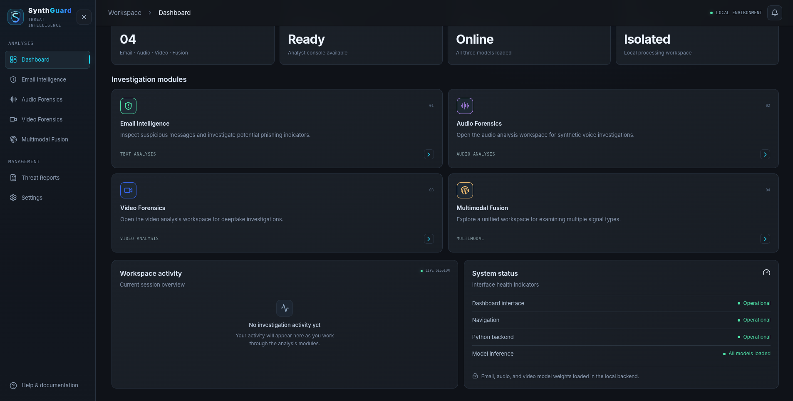
Fig. E.1. Dashboard overview and navigation. The dashboard reports workspace readiness and links to the four analysis modules.

E.2 Email analysis view
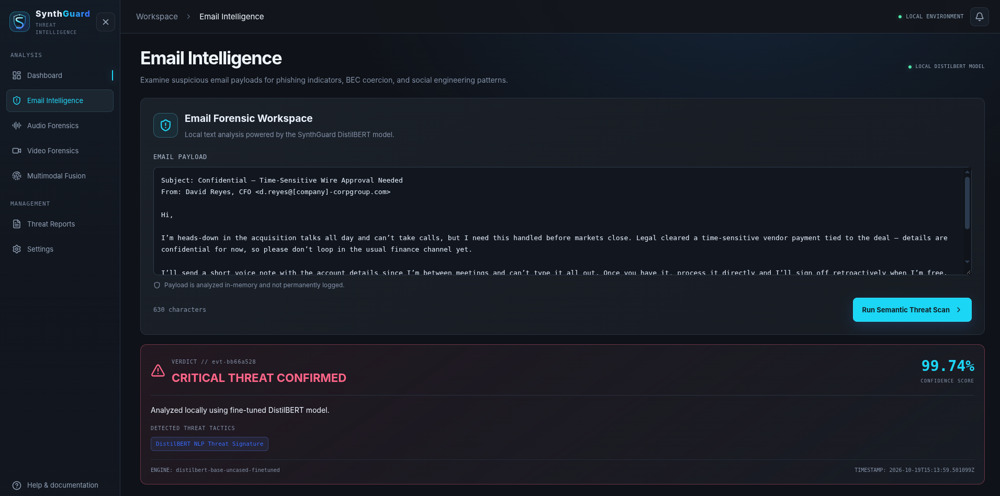
Fig. E.2. Email Intelligence workspace. The result panel presents the email score, verdict, and a textual threat indicator.

E.3 Audio analysis view
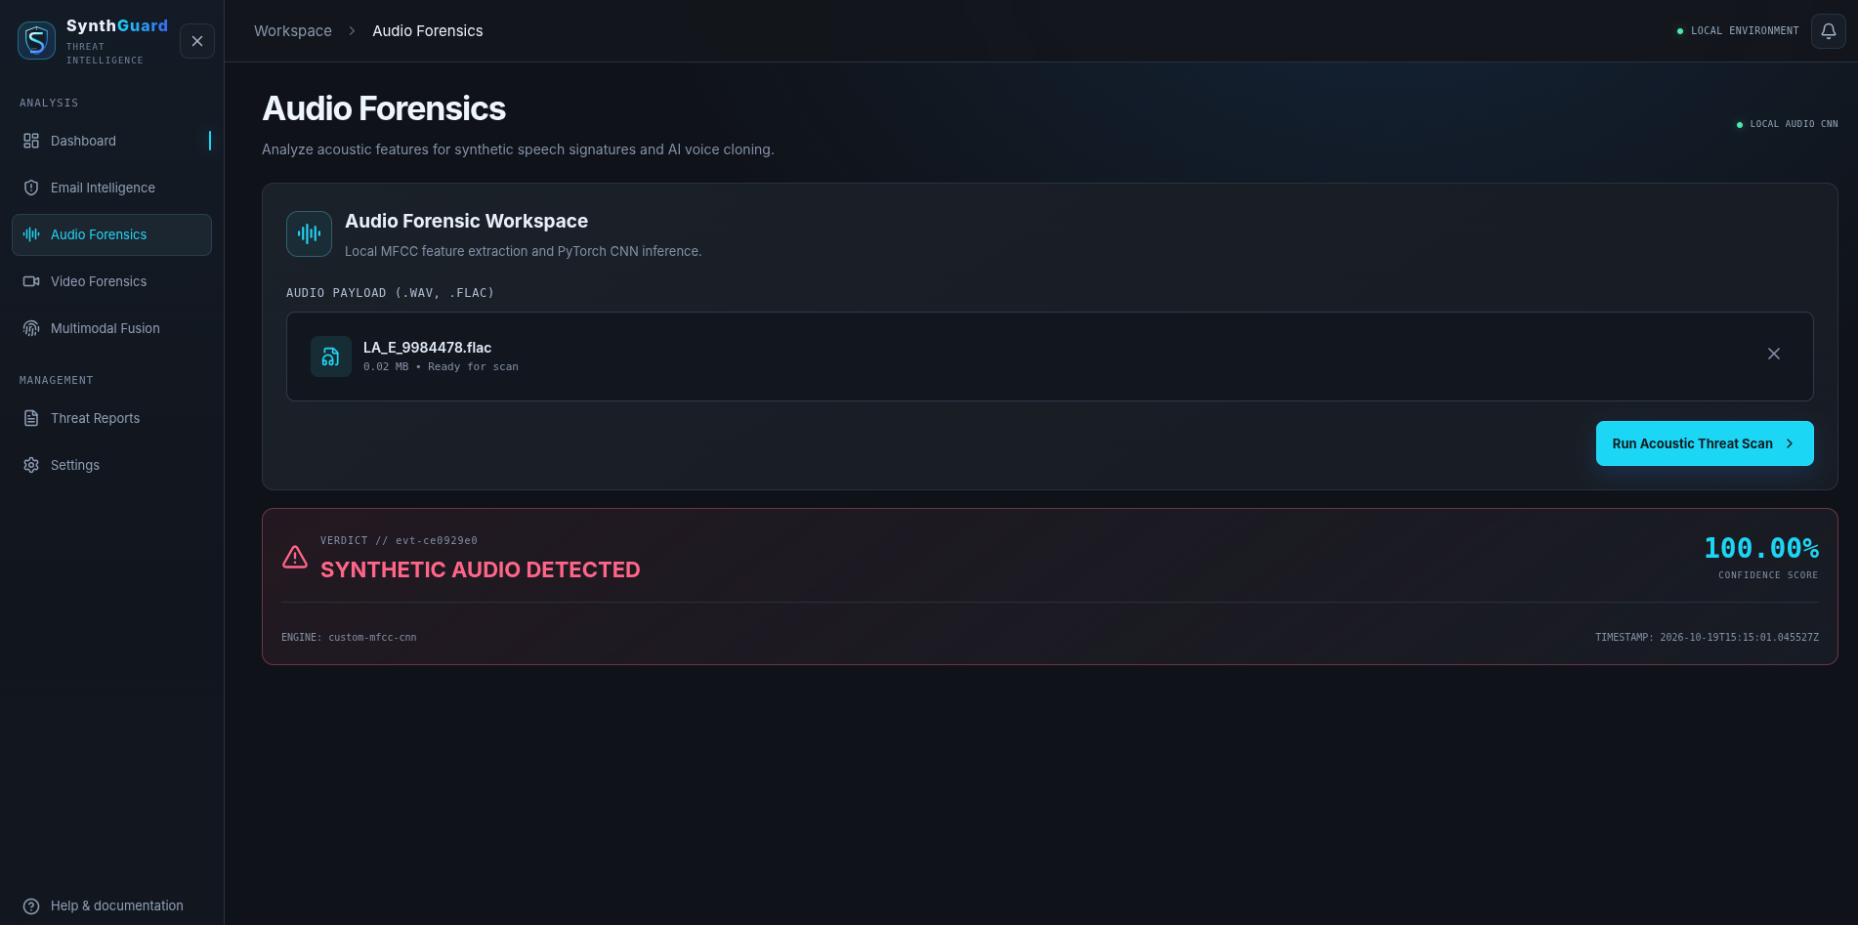
Fig. E.3. Audio Forensics workspace. The upload is analyzed by the local MFCC-CNN path; the shown 100% score is one sample output, not an accuracy metric.

E.4 Video analysis view
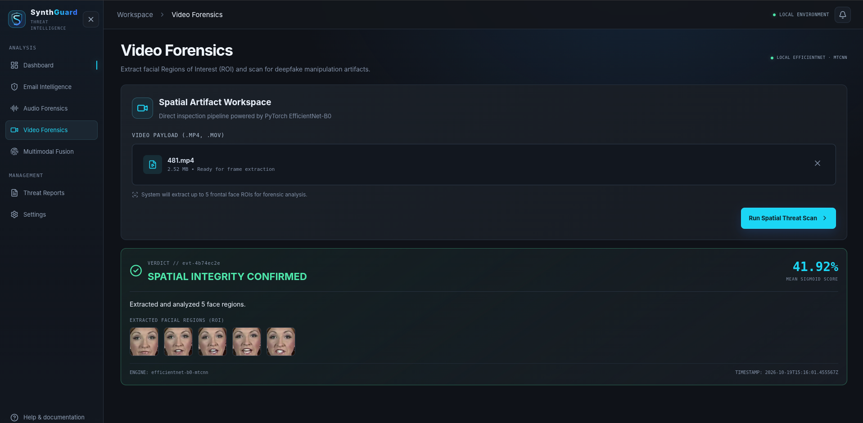
Fig. E.4. Video Forensics workspace. The interface displays extracted face regions and the video score for one sample scan.

E.5 Multi-modal analysis view
Fig. E.5. multi-modal Fusion workspace. The screen shows three modality statuses and the fused score for the submitted inputs; it does not establish paired-test performance.

APPENDIX F LOCAL API REFERENCE
The React client communicates with the FastAPI service through relative `/api` routes. In the Compose deployment, the browser reaches the Nginx frontend and Nginx proxies API requests over the private Compose network. The backend is not directly published as a host port in the supplied Compose file.

F.1 Endpoint summary
Endpoint | Method and input | Successful response | Key validation
/api/health | GET; no body | Service status and availability by model | A model can be unavailable even when the service responds.
/api/analyze/email | POST JSON: {"text":"..."} | Analysis ID, class label, score, model name, summary and indicators | Non-empty text; configured maximum 100,000 characters.
/api/analyze/audio | POST multipart file field | Synthetic/genuine label and CNN score | WAV, FLAC, MP3, OGG or M4A; up to 25 MB and 180 seconds by default.
/api/analyze/video | POST multipart file field | Manipulated/original label, score and up to five face crops | MP4, MOV or M4V; up to 100 MB and 120 seconds by default; a valid face must be found.
/api/analyze/multimodal | POST multipart: optional text/audio/video | Overall prediction plus modality scores, statuses, errors and indicators | At least one modality; each supplied input follows its modality validation rules.

F.2 Common response fields
An AnalysisResponse contains analysis_id, analysis_type, status, prediction, summary, indicators, frames, modality_status, modality_errors, and a creation timestamp. The prediction object includes label, score, score_type, and model_name. A completed response means the request was handled; it does not mean the decision has been independently validated. The UI should preserve the distinction between processed, omitted, failed, and unavailable modalities so a reader can interpret a partial result correctly.
The multi-modal endpoint can return status `partial` when one or more supplied sensors fail while another succeeds. The summary includes each modality score or N/A. A missing modality is excluded from the normalized fusion denominator. A failed modality is also not silently assigned a zero score. The response’s modality_errors field is the place to inspect a concise failure reason; detailed stack traces remain in backend logs.

F.3 Operational thresholds
Sensor / rule | Configured value | Interpretation and limitation
Email indicator | 0.50 | Class-1 softmax score at or above the boundary is labeled phishing.
Audio indicator | 0.45 | CNN sigmoid score at or above the boundary is labeled synthetic.
Video face acceptance | MTCNN confidence > 0.90 | A candidate face region must pass the detector confidence gate.
Video score boundary | 0.50 after score transform | Separates the displayed original/manipulated label.
Video transform fallback | tau = 0.7920 | Legacy logit recentering maps raw tau to 0.50; no validation artifact verifies this as a fitted calibration.
Biometric fusion veto | audio or video >= 0.85 | The branch returns the maximum available score. It does not unconditionally force a 1.00 score.

APPENDIX G DEPLOYMENT AND OPERATOR RUNBOOK
The supported container topology contains two services. The backend loads the local weights and provides inference. The frontend serves the built React application through Nginx and forwards `/api` traffic to the backend over the Compose network. The host publishes only the frontend by default at 127.0.0.1:8080. The project calls this local deployment; host-level network isolation, firewall state, and external connectivity have not been independently audited.

G.1 Prerequisites and startup
- Install Docker Engine and the Docker Compose plugin on the host.
- Confirm models/final contains the email tokenizer and weights, audio checkpoint, and active video checkpoint expected by backend/main.py.
- Review docker-compose.yml and docs/docker_deployment.md; the model directory is mounted read-only and Transformers offline mode is enabled in the backend container.
- Build and start with `docker compose up --build -d` from the project root. The first image build may require package downloads; subsequent inference uses the local checkpoint files.
- Check container state with `docker compose ps`. Review backend and frontend service logs if a container exits or remains unhealthy.
- Open `http://127.0.0.1:8080`. Verify the health response at `/api/health`; the expected response reports `status: ok` and model availability for email, audio, video and multi-modal.

G.2 Readiness and shutdown
The backend health check waits for model initialization and has a start period of 180 seconds. A successful HTTP response is not sufficient if one or more model entries are unavailable. Read each model availability field before using the corresponding scanner. For a graceful stop, run `docker compose down`; this stops the project containers but does not remove local model files or browser history. If the host is restarted, the Compose restart policy is `unless-stopped` and should restart previously enabled services.

G.3 Local address and exposure
The default bind address is 127.0.0.1 to keep the interface reachable from the local machine only. A local `.env` can change SYNTHGUARD_PORT and SYNTHGUARD_BIND. Binding to 0.0.0.0 makes the UI reachable on network interfaces and should only be done with an intentional firewall and access-control plan. The current deployment configuration does not include user authentication, TLS termination, multi-tenant separation, or a server-side audit store.

G.4 Routine operator checks
Check | Expected observation | If it differs
Compose state | Frontend and backend running; backend healthy | Read service logs; verify weight paths, memory and dependency availability.
Health route | Each intended model available | Do not submit that modality until its local model loads.
Single-modality scan | A response includes the matching model name and score | Check supported extensions, payload size/duration, and backend error details.
multi-modal scan | A status for every modality; omitted sensors marked accordingly | Inspect `modality_status` and `modality_errors`; partial responses require review.
Report persistence | History appears in the same browser profile after reload | Local storage may be cleared or unavailable; it is not a central record.
PDF export | Browser downloads one report for the selected analysis | Confirm browser download settings and verify the downloaded report ID.

APPENDIX H MODEL AND EVALUATION EVIDENCE REGISTER
This register identifies the artifacts present in the reviewed project snapshot and the claims that each artifact can support. A model file proves that a checkpoint exists; it does not prove which records were used to train or select it. Dataset names and labels likewise do not establish that a test split is independent from training data.

H.1 Model inventory
Modality | Active path or configuration | Implemented processing | Evidence boundary
Email | models/final/phishing_email/model.safetensors plus tokenizer files | DistilBERT sequence classifier; truncation/padding to 256 tokens; phishing score from class 1. | Checkpoint and tokenizer are present. The current test re-score is reproducible from saved data and checkpoint hash, but training lineage is not verified.
Audio | models/final/audio_detector/audio_cnn_model.pth | 16 kHz decode; 40 MFCC coefficients; 2,048 FFT window; 512 hop; zero-pad/truncate to 300 frames; three-block CNN. | Checkpoint and reconstructed predictions are present. The 500-row split is sample-random and lacks source grouping; checkpoint identity to the training log is unresolved.
Video | models/final/video_detector/model.safetensors_2 | Sample video frames; MTCNN face detection; crop and resize; EfficientNet-B0 score averaging over up to five faces. | Active checkpoint is present. No source-disjoint held-out test export or calibration record was found.
Fusion | src/fusion.py | Equal nominal weights renormalized over available scores; audio/video veto at 0.85 returns maximum score; 0.50 decision boundary. | Software behavior is directly inspectable. No authentic paired scenario evaluation supports an accuracy claim.

H.2 Email diagnostic re-score
The current output in outputs/reports/email_test_metrics.json records an email re-score of the saved test pickle through the active local API. At threshold 0.50 it reports N=3,508; TP=1,308; TN=2,023; FP=173; and FN=4. Derived metrics are accuracy 94.95%, precision 88.32%, recall 99.70%, FPR 7.88%, and FNR 0.30%. The paired row file is outputs/reports/email_test_predictions.csv. The output includes a dataset hash and checkpoint hash. Its qualification states that training provenance is unknown; therefore, it is a checkpoint re-score, not proven held-out performance. One input exceeded the API character limit and was clipped. The 3,507-row unclipped subset yields 94.98% accuracy and 7.84% FPR, showing that this one clipped row does not account for the difference from the older Colab report.

H.3 Audio diagnostic re-score
outputs/reports/audio_reconstructed_test_metrics.json records 500 rows reconstructed from the supplied Colab feature-batch ordering using a stratified random row split with random_state 42. It contains 449 spoof and 51 genuine samples. At both threshold 0.50 and the deployed threshold 0.45, the recorded counts are TP=448, TN=46, FP=5, FN=1; accuracy is 98.8%, precision 98.90%, recall 99.78%, FPR 9.80%, FNR 0.22%, and ROC AUC 99.75%. These estimates are highly uncertain for the genuine class because only 51 benign examples are in the reconstructed test set. The split has no speaker/session/source IDs; the checkpoint hash cannot be matched to the Colab artifact. Present it only as a diagnostic reconstruction, not a source-disjoint benchmark.

H.4 Video and fusion evidence status
The video training excerpt supplied during project review reports validation accuracy during a random split of cached face tensors. The log does not establish source-video grouping and refers to a checkpoint export that is not the same named file as the active `model.safetensors_2` checkpoint. It cannot be used as the active model’s test accuracy. The fallback tau=0.7920 is loaded when no calibration file is present; the transformation shifts logits so that tau maps to 0.50. It is a score recentering rule, not evidence of empirically verified probability calibration.
The old ablation CSV contains percentages from a former pipeline. outputs/reports/README.md records that it paired independent modality datasets by labels and selected a video threshold on the same records used for scoring. The new runner requires scenario-level correspondence, group-separated validation and test records, and separate per-scenario predictions. No completed authentic paired manifest or new result bundle was found, so the old table is omitted from all claims in this report.

APPENDIX I REPRODUCIBLE EVALUATION PROTOCOL
The protocol below turns current diagnostics into a stronger, auditable evaluation. It separates re-scoring from model training, keeps source groups intact, freezes thresholds before the test set is scored, and publishes enough information for another reviewer to reproduce the reported counts.

I.1 Email checkpoint lineage
- Record the SHA-256 of the active checkpoint, tokenizer, training and test datasets, and prediction script version.
- Recover the exact training notebook or run log that created the active checkpoint. Confirm whether any test examples were used for training, early stopping, threshold selection, or model selection.
- Re-score the fixed test pickle with no preprocessing changes. Export one row per example with sample ID, true label, raw score, predicted label, threshold, and whether input truncation or clipping occurred.
- Compute TP, TN, FP, FN directly from that CSV; report class denominators and metrics at the predeclared 0.50 threshold.
- If lineage cannot be established, label the output diagnostic re-score and do not call it a held-out estimate. Create a new source-aware split and retrain only if the study needs defensible generalization metrics.

I.2 Audio and video split design
Audio records must carry a stable speaker, session, recording, or source ID. Related segments from one recording must not be distributed across training, validation, and test. Video records must carry source video, actor, and manipulation-pair identifiers where available; original and manipulated versions derived from the same source must remain in one split. Use group-stratified assignment where feasible, publish the split manifest, and report class counts and excluded/failed samples.
Threshold selection belongs on validation data. For video, record the validation manifest hash, active checkpoint hash, candidate metric and threshold selection rule, then freeze the selected value before the test pass. Do not select tau or the final decision boundary by looking at test outcomes. Store raw scores as well as transformed scores so the effect of the calibration step can be inspected.

I.3 Paired fusion scenario protocol
A fusion row represents one genuine investigation scenario, not merely one threat label. Email, voice, and video must be linked to the same scenario where present. Record the overall scenario label separately from each modality label because a threat scenario can contain genuine audio or video, and a benign scenario may include a spoofed artifact used for a robustness test. Assign group_id to campaigns, actors, or source material and keep each group entirely within validation or test. Keep the written label policy independent of model outputs.
Run the seven sensor subsets (email, audio, video, email+audio, email+video, audio+video, and all three) on rows with full coverage for the corresponding subset. Compare naive weighting, equal weighting, and veto only on equivalent subsets. Report coverage, confusion counts, per-scenario scores, group-bootstrap confidence intervals, checkpoint hashes, thresholds, manifest hash, runtime, and failure reasons. If pair authenticity is synthetic or scripted, report logic/stress-test outcomes rather than real-world accuracy.

I.4 Metric formulas and reporting
Metric | Definition | Interpretation
Accuracy | (TP + TN) / (TP + TN + FP + FN) | Share of evaluated examples classified correctly; depends on class mix.
Precision | TP / (TP + FP) | How often predicted threats are true threats in the evaluation sample.
Recall / TPR | TP / (TP + FN) | Fraction of threat examples detected.
FPR | FP / (FP + TN) | Fraction of benign examples incorrectly escalated.
FNR | FN / (FN + TP) | Fraction of threat examples missed.
ROC AUC | Area under the ROC curve | Ranking discrimination over thresholds; does not identify the operating threshold.
Always provide denominators. A low FNR estimated from a small threat set, or a low FPR estimated from a small benign set, can have a wide uncertainty interval. Confidence intervals do not correct for leakage, label errors, distribution shift, or an unrepresentative source population.

APPENDIX J PRIVACY, SECURITY, AND LIMITATIONS

J.1 Data handling boundaries
The intended deployment keeps inference inside the host running the local containers. Uploaded audio and video are streamed to temporary files for processing, then the endpoint removes those temporary files after inference. Email text is handled in memory by the API. The browser’s PDF report is generated client-side. The local threat-report history stores only metadata such as the analysis identifier, timestamp, verdict, score, modality scores, statuses, summary, and indicators; it does not persist uploaded base64 video frames as the history payload. Browser localStorage is profile-local and can be cleared by the user or browser policies.
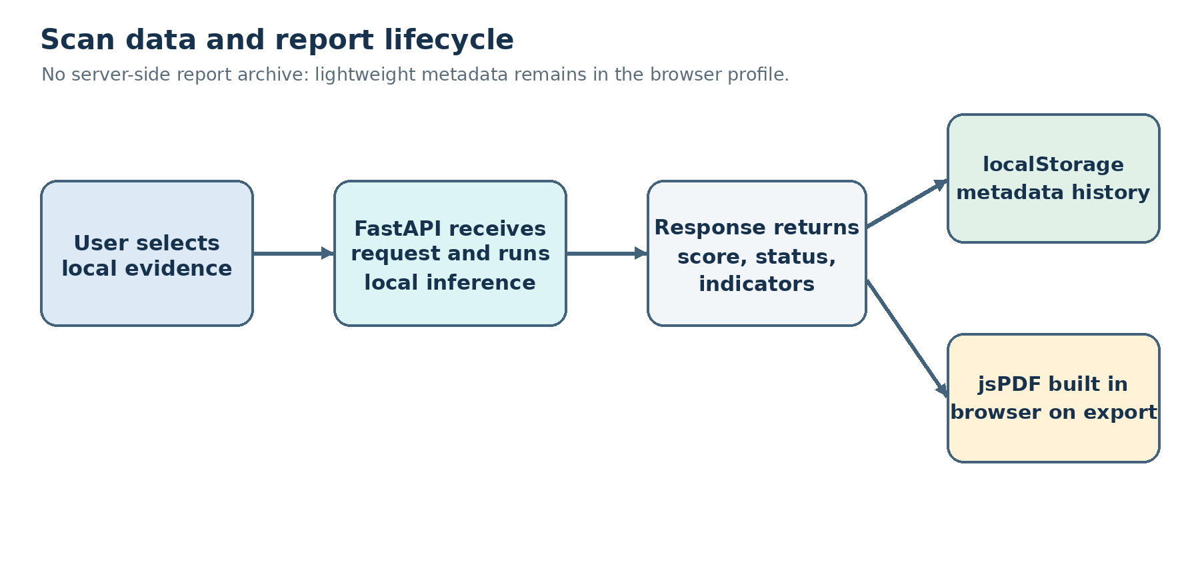
Fig. J.1. Evidence and report lifecycle across the local API and analyst browser.
Local execution is not synonymous with a verified air gap. The software configuration enables offline model loading and does not publish the backend port to the host under the default Compose file, but the host may still have network access, dependency installation may contact package registries, and the application does not provide authentication or encryption for network exposure. Any claim of isolation should be limited to the tested deployment boundary and host configuration.

J.2 Threat model
Concern | Current control or behavior | Residual risk
Oversized uploads | Per-modality size/duration limits and request-body cap. | Resource exhaustion remains possible within limits; host memory/GPU and concurrent load are not benchmarked.
Unsupported file formats | Extension allowlists and empty-file checks. | Extension is not a complete content validation mechanism; decoder behavior depends on installed libraries.
Model unavailable | Health response exposes model availability; endpoint returns service errors. | Users may misinterpret a partial scan unless every modality status is reviewed.
Sensitive evidence | Local processing; temporary upload files removed after inference. | Host/container logs, crash dumps, backups, browser downloads, and disk security remain deployment responsibilities.
Report retention | Browser-only metadata and user-initiated local PDF export. | History is not tamper-resistant or centrally backed up; browser storage can be modified or removed.
False verdict | Scores and sensor status are displayed; result is decision support. | No human escalation workflow, calibrated risk model, or real-world operational performance study is established.

J.3 Responsible use
SynthGuard should be used to prioritize further review, not as the sole basis for financial transfers, employment decisions, identity verification, or allegations of fraud. Analysts should verify requests through a separate trusted channel, especially when a message demands secrecy, urgency, credential changes, or payment redirection. A low model score does not prove an input is safe; a high score does not prove malicious intent. Preserve original evidence and record the model version, score, and investigation context according to the organization’s approved handling procedure.

J.4 Known limitations
- The three scores are not documented as jointly calibrated; their arithmetic mean is an operational heuristic.
- Dynamic fusion uses only available scores. The meaning of the resulting score changes with the set of present modalities.
- The audio veto returns the highest available sensor score and can dominate the mean; false-alarm behavior is not established on a source-disjoint paired test set.
- Video face detection can fail on occlusion, pose, low resolution, no visible face, or severe compression; the system does not assess every frame.
- Dataset and checkpoint lineage are incomplete for some historical training artifacts, and the available diagnostic splits lack source grouping.
- No independent security assessment, deployment penetration test, latency study, or multi-user concurrency study is included.

APPENDIX K ANALYST USER GUIDE

K.1 Start an investigation
- Open the local SynthGuard workspace and confirm the Local Environment indicator is visible.
- Check the dashboard’s model status. If a required model is unavailable, do not rely on that sensor; report the availability issue to the operator.
- Choose Email Intelligence, Audio Forensics, Video Forensics, or multi-modal Fusion based on the evidence available.
- Enter email text or select supported audio/video files. In Fusion, provide any combination of modalities; the application skips missing inputs and reports their status.
- Review the upload name, supported formats, limits and input content before submission. Do not treat the interface as an evidence redaction or sanitization system.
- Run the scan. Review each sensor score, label, forensic indicator, analysis ID and modality status. A partial result requires review of the failed signal before a conclusion is recorded.
- Use Export PDF Report to download a locally generated PDF for the current scan. The PDF contains the analysis ID, generation time, score, verdict, modality telemetry, summary and indicators.
- Open Threat Reports to review prior metadata records in the current browser profile. Download an individual PDF from its record when needed.

K.2 Reading the score and verdict
The score is the detector output transformed by each modality’s implementation. It is not a statistical guarantee that the event has that exact probability of being malicious. The label is produced by a configured threshold. The text interface reports an email-specific verdict; audio and video views report modality-specific synthetic-signal verdicts; Fusion reports an aggregate threat verdict. A missing signal should remain visible as “not provided” or “not processed,” not be interpreted as a benign score.

K.3 Report storage and retention
The report history is stored in localStorage under the browser key `synthguard_threat_reports`. It remains available after reloads in that browser profile until cleared or replaced, but it is not written to the FastAPI database because this project has no server-side report database. Client-side PDF export downloads a file to the user’s configured download location. Users should follow institutional policy before storing sensitive inputs or downloaded reports on a shared device.

K.4 User-facing error handling
Observed condition | Meaning | Recommended action
Model unavailable | That model did not load. | Check /api/health and backend logs; do not use that sensor.
No face detected | No accepted face region was found. | Check format, quality and visible face; this is not a benign verdict.
Upload rejected | The file failed a type, size or duration limit. | Use a supported, authorized input within configured limits.
Partial analysis | One or more supplied sensors failed. | Inspect modality_status and modality_errors before recording a conclusion.

APPENDIX L MAINTENANCE AND ACCEPTANCE CHECKLIST
This checklist is an operational handoff aid. It records the items an administrator or project reviewer should verify at the time of a fresh deployment or before academic demonstration. It is not evidence that those checks have been completed unless a dated record is added.

L.1 Pre-demonstration checks
- Confirm the project commit or source archive and active checkpoint files are recorded with hashes.
- Start the Compose services and save the health response with timestamp and model availability.
- Run one representative input through each available single-modality scanner and one multi-modal combination; record analysis IDs and whether every expected signal processed.
- Verify a PDF can be downloaded and matches the analysis ID, then confirm a report record persists after page reload in the same browser profile.
- Confirm report-history limitations and local-storage behavior are described to the user.
- Use benign and threat-labeled controlled examples only when authorization and dataset licensing permit; do not infer benchmark accuracy from demonstration scans.
- For academic performance claims, attach per-sample predictions, split manifests, model hashes, threshold records, and confusion counts. If a similarity result is included, identify the exact file checked and retain the dated checker output; do not apply a paper-only result to the full project report.

L.2 Evidence custody
For any future evaluation, keep the manifest, predictions, metric summary, run metadata, calibration artifact and model hashes together in a dated output folder. Preserve the exact software revision and dependency versions. Record missing rows and failures instead of dropping them silently. A second person should be able to follow the recorded procedure without access to an untracked Colab session or informal memory of how a split was formed.

L.3 Completion criteria for research claims
Claim category | Minimum evidence before reporting
Email held-out performance | Independent training/test lineage, fixed test split, prediction-level export, metric recomputation and checkpoint hash.
Audio/video performance | Group-separated source manifest, active-checkpoint hash, frozen threshold, per-record scores and class denominators.
Video calibration | Validation-only threshold selection record; calibration method and validation data stated; frozen parameter before test scoring.
Fusion advantage | Authentic scenario-level modality correspondence, split-independent groups, common subset coverage, paired predictions and uncertainty intervals.
Privacy or isolation | Deployment configuration and host/network boundary evidence; avoid “air-gapped” without independently verified isolation.
Similarity result | Institution-approved checker export tied to the final submitted document, with settings/date and reviewed matches.

