A PROJECT REPORT
on
SynthGuard Project Documentation
Multimodal Threat Intelligence and Deepfake Defense System
Submitted by
Jay Shravan Kumar Sharma | TYCS47
in partial fulfilment of the requirements for the degree of
BACHELOR OF SCIENCE
in
COMPUTER SCIENCE

Semester 5
Under the guidance of
Mrs. Krupa Kamdar
Department of Computer Science

BHARATIYA VIDYA BHAVAN’S BHAVAN’S COLLEGE (EMPOWERED AUTONOMOUS)
University of Mumbai
Andheri (West), Mumbai 400058
Academic Year 2026–2027

Submission date: 21 October 2026

BHARATIYA VIDYA BHAVAN’S BHAVAN’S COLLEGE (EMPOWERED AUTONOMOUS)
Department of Computer Science
CERTIFICATE
This is to certify that Jay Shravan Kumar Sharma (TYCS47), a student of Bachelor of Science in Computer Science, has completed the project report titled “SynthGuard Project Documentation: Multimodal Threat Intelligence and Deepfake Defense System” during the academic year 2026–2027 under the guidance of Mrs. Krupa Kamdar.
The report is submitted in partial fulfilment of the requirements for the degree of Bachelor of Science in Computer Science.

Date: ____________________
Project Guide: ______________________________
Head / In-charge: ___________________________
Signature of Examiner: ______________________
College Seal: _______________________________

DECLARATION
I, Jay Shravan Kumar Sharma (TYCS47), declare that this project report, titled “SynthGuard Project Documentation: Multimodal Threat Intelligence and Deepfake Defense System,” is submitted in partial fulfilment of the requirements for the Bachelor of Science in Computer Science. I have described the implementation and evaluation evidence available in the project repository, identified limitations in the provenance of diagnostic results, and cited external material used in the report. I will attach the institution-approved similarity-check output after reviewing the final report version.
Please sign and date this declaration before submission.

Student signature: __________________________
Place: _____________________________________
Date: ______________________________________

ACKNOWLEDGEMENT
I would like to express my sincere gratitude to Mrs. Krupa Kamdar, my project guide, for her direction and feedback throughout the development of SynthGuard. Her guidance helped me refine the project scope, examine the implementation critically, and distinguish software behavior from evidence that still requires controlled evaluation. I am grateful to the Department of Computer Science at Bharatiya Vidya Bhavan’s Bhavan’s College (Empowered Autonomous) for providing the academic environment in which I could complete this work. I also thank my family and friends for their patience and encouragement. Finally, I acknowledge the maintainers of the datasets and software libraries cited in this report; their work made this prototype possible. Any remaining errors in the report are my responsibility.
TABLE OF CONTENTS
Chapter | Title | Page
Front matter | Title page | 1
 | Certificate | 2
 | Declaration | 3
 | Acknowledgement | 4
 | Table of contents | 5
Chapter 1 | ABSTRACT AND KEYWORDS | 6
Chapter 2 | INTRODUCTION | 7
Chapter 3 | LITERATURE REVIEW | 9
Chapter 4 | RESEARCH METHODOLOGY | 11
Chapter 5 | ANALYSIS AND PROPOSED WORK | 14
Chapter 6 | IMPLEMENTATION AND DEVELOPMENT | 17
Chapter 7 | RESULTS AND DISCUSSION | 20
Chapter 8 | RESEARCH PAPER | 22
Chapter 9 | PLAGIARISM AND SIMILARITY REPORT | 25
Chapter 10 | CONCLUSION LIMITATIONS AND FUTURE SCOPE | 26
Chapter 11 | REFERENCES AND BIBLIOGRAPHY | 28
Chapter 12 | APPENDICES AND OPERATIONAL GUIDES | 29
Appendix E | Analyst interface reference | 31
Appendix F | Local API reference | 34
Appendix G | Deployment and operator runbook | 36
Appendix H | Model and evaluation evidence register | 38
Appendix I | Reproducible evaluation protocol | 40
Appendix J | Privacy, security, and limitations | 42
Appendix K | Analyst user guide | 44
Appendix L | Maintenance and acceptance checklist | 45
CHAPTER 1 ABSTRACT AND KEYWORDS

1.1 Abstract
SynthGuard is a locally deployable threat-analysis prototype that examines phishing-related email text, synthetic-speech indicators, and manipulated-face video evidence through three independent model paths. A FastAPI service loads local checkpoints and returns modality scores. A late-fusion function combines available scores using equal nominal weights, with a high-confidence audio or video veto; a React and TypeScript interface supports single-modality and multimodal analysis. The browser can retain lightweight report metadata in local storage and generate a PDF locally. The project implements a DistilBERT email classifier, an MFCC-based convolutional audio classifier, and an EfficientNet-B0 video classifier preceded by MTCNN face detection. A current-checkpoint email diagnostic re-score covers 3,508 examples and an audio reconstructed split re-score covers 500; their lineage and grouping limitations prevent unqualified held-out claims. No verified video or paired fusion metrics are available. The report documents implementation and evidence status without repeating the historical 99.1% fusion figure as a result.

1.2 Keywords
Phishing detection, Business Email Compromise, DistilBERT, speech spoofing, MFCC, deepfake video, EfficientNet-B0, MTCNN, late fusion, local inference, forensic reporting.
CHAPTER 2 INTRODUCTION

2.1 Background and Context
Digital attacks increasingly combine ordinary messages with impersonation and synthetic media. A fraudulent payment request may arrive as text, be reinforced by a cloned voice message, or be accompanied by manipulated video. Each channel exposes different evidence: language models examine content, audio models examine speech features, and visual models examine facial regions. A single detector cannot directly represent all of these signals.
SynthGuard was developed as a student research prototype that connects separate text, audio, and video detectors to a shared analysis workflow. The application is designed to run its inference models locally behind a FastAPI service, with a React interface for submitting evidence and inspecting scores. The system aims to give an analyst a compact, explainable view of model outputs rather than to make an autonomous financial or security decision.

2.2 Problem Statement
Standalone detectors produce modality-specific outputs and may fail when an attack moves across channels or when one model is uncertain. Analysts also need to understand which sensors processed successfully, how the final score was formed, and what evidence contributed to the verdict. SynthGuard addresses the integration problem by providing separate modality paths, a shared score interface, a rule-based fusion function, and a local reporting workflow. Its current evaluation evidence does not yet establish that fusion improves detection accuracy on real paired attacks.

2.3 Aim
To design and implement a local multimodal analysis prototype that accepts email, audio, and video evidence, runs specialized local detectors, combines available scores through a documented late-fusion rule, and presents the output in an analyst-oriented interface.

2.4 Objectives
1. Integrate a locally loaded DistilBERT classifier for phishing-related email text.
2. Implement audio spoof scoring using MFCC features and a convolutional neural network.
3. Implement video face-region scoring using MTCNN and an EfficientNet-B0 classifier.
4. Combine sensor scores with equal-weight dynamic fusion and a high-confidence biometric veto.
5. Expose analysis and health endpoints through a local FastAPI backend.
6. Provide a React interface with modality status, threat indicators, report history, and client-side PDF export.
7. Document the limits of available evaluation evidence and define a reproducible paired-scenario benchmark process.

2.5 Scope of the Study
The implementation scope covers three input modalities and a browser-based analyst interface. The email path accepts text. The audio path accepts supported audio files and extracts fixed-length MFCC features. The video path samples frames, detects faces, and averages up to five face-region model scores. The multimodal endpoint accepts any subset of email text, audio, and video; unavailable or failed modalities are reported in the response. The project does not include a validated enterprise mail gateway, active response, identity verification, financial transaction control, or independent human review workflow.

2.6 Motivation and Contribution
The project brings a small set of independently trained detectors into one local investigation flow and makes the fusion rule visible and inspectable. Its contribution is primarily an implemented prototype and an evaluation design, not a claim of state-of-the-art accuracy. The most important research contribution still to be completed is a properly split, source-linked multimodal test set that allows all seven non-empty sensor subsets to be compared without manufacturing unrelated cross-modal pairs.
CHAPTER 3 LITERATURE REVIEW

3.1 Transformer Models for Email Classification
DistilBERT is a compact transformer language model produced through knowledge distillation. Sanh et al. describe its design as a smaller and faster alternative to BERT for downstream language tasks [1]. SynthGuard uses a DistilBERT sequence-classification checkpoint to assign a phishing probability to email text. This choice provides contextual language representations, but a high score on a single email corpus does not demonstrate robustness to new organizations, current attack campaigns, multilingual messages, or changes in email formatting.
The project notebook loads the Kaggle Phishing Email dataset, removes rows with missing fields and duplicate records, maps safe email to class 0 and phishing email to class 1, and creates an 80/20 stratified split with random state 42. The notebook records 17,538 cleaned examples and a 3,508-example test subset. Corpus quality, duplicate handling, source diversity, and the distinction between phishing and broader spam remain relevant threats to external validity.

3.2 Audio Spoof Detection and MFCC Features
The ASVspoof challenge series provides standardized tasks for detecting spoofed speech and synthetic speech. The 2021 challenge separates logical-access, physical-access, and deepfake tracks and specifies benchmark data and evaluation procedures [3]. SynthGuard represents audio with 40 MFCC coefficients at a 16 kHz sample rate, using a 2,048-sample analysis window and a 512-sample hop, then pads or truncates to 300 frames. MFCCs summarize short-time spectral shape and have a long history in speech processing [8]. They are a feature representation, not by themselves a guarantee of spoof generalization.

3.3 Video Manipulation Detection
FaceForensics++ introduced a benchmark containing manipulated facial videos, including DeepFakes, Face2Face, FaceSwap, and NeuralTextures, with multiple compression conditions [4]. EfficientNet uses compound scaling across network dimensions to balance accuracy and computational cost [5]. MTCNN uses a cascaded convolutional approach to locate and align faces [6]. SynthGuard applies MTCNN to sampled frames and then classifies extracted face crops with EfficientNet-B0. The current inference pipeline is therefore dependent on face visibility, crop quality, compression, and the manipulation types represented in training data.

3.4 Classifier Combination and Late Fusion
Classifier combination research studies how evidence from distinct representations can be combined into a final decision. Kittler et al. provide a theoretical and experimental framework for combining classifier outputs [7]. SynthGuard uses a simple normalized arithmetic mean across the sensor scores that are present and adds a hand-coded veto when audio or video probability is at least 0.85. This rule is an engineering decision that must be assessed empirically; the general literature does not validate SynthGuard’s specific weights or veto threshold.

3.5 Research Gap
The project addresses an integration gap in its prototype by making text, voice, and face-based outputs available through one local workflow. A larger research gap remains: public corpora are organized by modality and often do not contain aligned email, voice, and video from one coherent social-engineering scenario. Without authentic pairing and scenario-level labels, fusion metrics can measure dataset construction choices rather than the benefit of multimodal evidence. The project benchmark documentation accordingly requires a curated manifest with independent validation and test groups.

3.6 Literature Review Summary
The model and dataset literature supports the selection of a transformer text sensor, an MFCC-based speech sensor, a face-crop video sensor, and a score-combination layer. It does not support transferring benchmark results from those source works to SynthGuard. Model metrics must be produced from the specific saved checkpoints and evaluation data used by this project.
CHAPTER 4 RESEARCH METHODOLOGY

4.1 Research Approach
This work follows a design-and-implementation approach. The three sensors are treated as independent predictors; the API standardizes their outputs; and a deterministic fusion function combines the available probabilities. The report distinguishes implementation verification from model-performance evaluation. API operation and score routing can be checked with functional tests, while accuracy requires labeled examples that were not used for training or threshold selection.

4.2 Data Sources and Sample Definition
Modality | Project data source | Label meaning | Evidence currently available
Email | Kaggle Phishing Email dataset; local notebook records 17,538 examples after cleaning [2] | Safe / phishing | Current-checkpoint re-score and per-example CSV exist; checkpoint training provenance remains unverified.
Audio | ASVspoof 2021 logical-access data and exported feature shards [3] | Genuine / spoof | Reconstructed 500-row diagnostic re-score and per-row CSV exist; source groups and exact checkpoint lineage are unresolved.
Video | FaceForensics++ manipulated and original sequences [4] | Original / manipulated | Active checkpoint and inference code exist; source-disjoint held-out metrics and a verified calibration record are absent.
Fusion | Curated scenario manifest specified in project docs | Scenario-level benign / threat | Benchmark runner and manifest contract exist; no authentic paired scenario result bundle is present.

A scenario-level multimodal sample should contain one investigation story with explicitly paired media, sensor-specific labels, an overall scenario label, and a group identifier for the campaign, actor, or source recording. The scenario label must be written independently of model scores. A benign scenario can contain a spoofed modality, and a threat scenario can contain genuine supporting media. The report does not treat independently sourced audio and video examples as if they belonged to the same event.

4.3 Data Preparation
Email text is tokenized with the local DistilBERT tokenizer, truncation enabled, a maximum length of 256 tokens, and fixed-length padding. Audio is loaded at 16 kHz, transformed to MFCCs, and normalized in shape by zero padding or truncation to 300 frames. Video is sampled from the uploaded clip at fixed frame intervals; MTCNN detections above 0.90 confidence are cropped, resized to 224 by 224, and normalized with ImageNet channel statistics before model inference. These steps are implemented in the backend and associated notebooks [P1, P2].

4.4 Evaluation Design
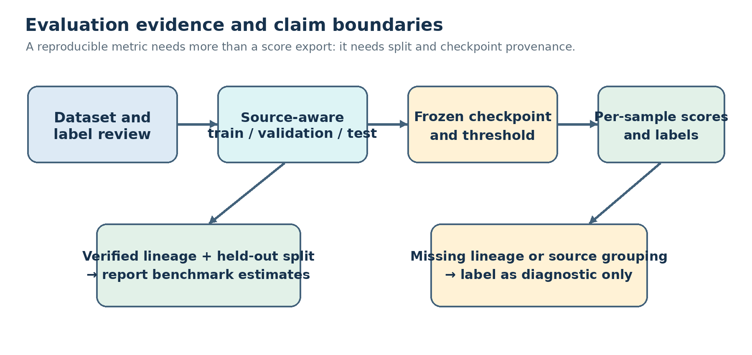
Figure 4.1. Evaluation evidence gates distinguish diagnostic re-scores from benchmark estimates.
A current-checkpoint email re-score is recorded in outputs/reports/email_test_metrics.json and outputs/reports/email_test_predictions.csv. It covers 3,508 rows from the saved test dataset and uses the active email checkpoint, but the checkpoint’s training and model-selection lineage is not established. One input exceeds the API character limit and is clipped; an unclipped diagnostic on the other 3,507 rows is also recorded. The audio artifact outputs/reports/audio_reconstructed_test_metrics.json is a local re-score of a reconstructed random 500-row holdout from the supplied feature ordering; it has no speaker/session identifiers, and its exact checkpoint identity relative to the supplied Colab training run is unverified. No source-disjoint video test output was found. These artifacts support reproducible diagnostics with stated scope, not unqualified claims of held-out generalization.
For future multimodal evaluation, the benchmark script requires separate validation and test splits. It selects video calibration and decision thresholds on validation rows only, computes metrics on test rows, records per-scenario predictions and sensor status, and emits run metadata and model hashes. Group identifiers are intended to prevent related source material from crossing the validation/test boundary. Coverage must be reported because each sensor subset may be evaluated on a different subset of cases [P3].

4.5 Metrics
For a binary threat classifier, true positives (TP) are threat cases classified as threat, true negatives (TN) are benign cases classified as benign, false positives (FP) are benign cases classified as threat, and false negatives (FN) are threat cases classified as benign. The report uses the following definitions:
Accuracy = (TP + TN) / (TP + TN + FP + FN)
False positive rate (FPR) = FP / (FP + TN)
False negative rate (FNR) = FN / (FN + TP)
Precision = TP / (TP + FP); Recall = TP / (TP + FN)
For model comparison, confidence intervals should accompany point estimates, and test denominators should be reported separately for benign and threat classes. In a small or constructed scenario set, percentages should not be presented with precision that exceeds the sample size.

4.6 Tools and Techniques
The project uses Python, PyTorch, Hugging Face Transformers, librosa, OpenCV, MTCNN, FastAPI, React, TypeScript, Vite, jsPDF, and Docker Compose. The backend loads models from local project directories and uses an Nginx-served frontend in the containerized configuration. Model inference can operate from local checkpoints after dependencies are installed; the deployment is local and offline-capable, but this wording does not claim a physically air-gapped host.
CHAPTER 5 ANALYSIS AND PROPOSED WORK

5.1 Existing Workflow
A user supplies one or more evidence types through the analyst interface. The frontend sends email text or media files to FastAPI. Each successful sensor returns a probability-like score and a modality status. The multimodal endpoint passes available scores to the fusion function, classifies the result at a 0.50 boundary, and returns indicators and a summary. The browser can save report metadata in localStorage and construct a client-side PDF. The architecture keeps inference and report generation within the local application workflow.

5.2 Proposed System Architecture
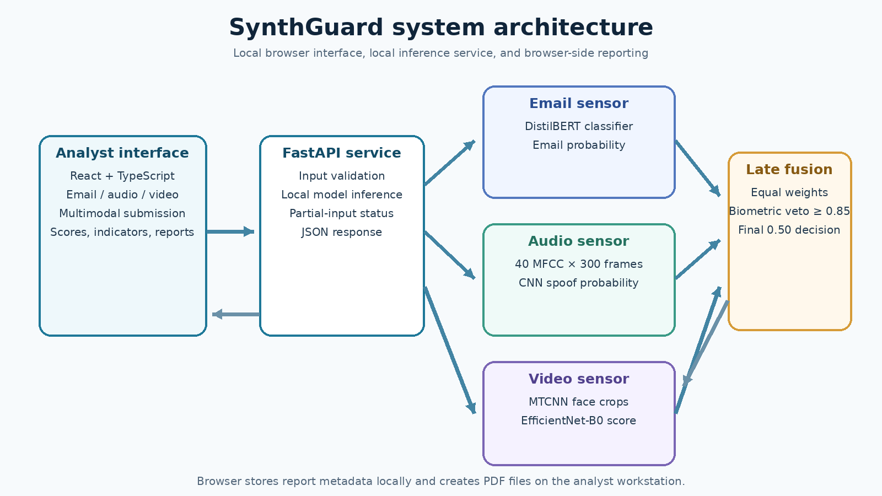
Figure 5.1. SynthGuard local analysis and reporting flow.

5.3 Sensor Modules
Sensor | Model path | Input and processing | Output
Email | Fine-tuned DistilBERT sequence classifier | Text tokenization; max length 256 | Phishing probability; indicator threshold 0.50
Audio | Three-block CNN over MFCCs | 16 kHz audio; 40 coefficients; 300 frames | Spoof probability; indicator threshold 0.45
Video | MTCNN face detector + EfficientNet-B0 | Sample frames; crop face; resize to 224×224; average up to five scores | Calibrated manipulation probability; decision boundary 0.50

5.4 Fusion Rule
Let E, A, and V denote the email, audio, and video scores that were successfully computed. The implementation assigns nominal weights of 0.3333 to each available sensor and renormalizes by the sum of the available weights. If no modality is available, fusion returns no score. The fused score is classified as a threat when it is at least 0.50.
S_fusion = Σ(w_i S_i) / Σ(w_i), for available sensors i, unless the biometric veto fires
The veto fires when an available audio or video score is at least 0.85. The implementation then returns the highest available sensor score. Therefore, it raises the unified score to the strongest sensor value; it produces exactly 1.00 only when that strongest input is itself 1.00. The veto threshold is a software rule, not a demonstrated false-negative reduction until it is evaluated on independent labeled data [P2].
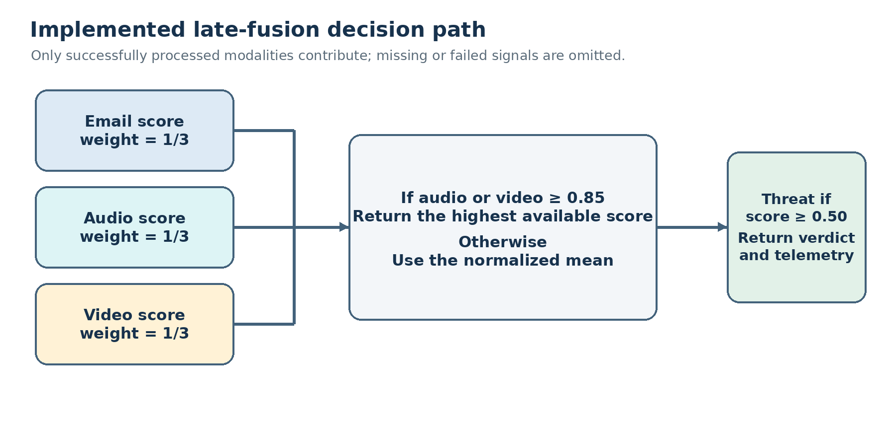
Figure 5.2. Implemented fusion rule, including dynamic modality coverage and biometric veto behavior.

5.5 Analytical Fusion Examples
Illustrative inputs | Implemented rule | Illustrative output | Interpretation
Email 0.998; audio 0.004; video 0.416 | No biometric score reaches 0.85; equal mean | 0.4727 (47.27%) | Below the 0.50 decision boundary; arithmetic illustration only.
Email 0.0001; audio 1.000; video absent | Audio veto fires; return max available score | 1.0000 (100%) | Threat under the configured boundary; rule illustration only.

These calculations are derived from the current fusion function. They are not measured detector outputs or a benchmark result, and must not be described as experimental cases unless the corresponding inputs are linked to actual labeled test records.

5.6 Workflow Algorithm
1. Receive text, audio, video, or any supported combination.
2. Validate request size, file type, and supported evidence.
3. Run each available local sensor and record processed, failed, unavailable, or omitted status.
4. Calibrate the video probability using the loaded threshold when a face score is available.
5. Apply the audio/video veto or normalized equal-weight score to the successful sensor outputs.
6. Compare the unified score with the 0.50 threat boundary and return the score, label, indicators, and sensor status.
7. Save lightweight report metadata in the browser when a scan succeeds; generate a PDF locally when requested.

5.7 Design Considerations
The system is a decision-support prototype. Model confidence values are not automatically calibrated probabilities of real-world harm. Partial-input fusion changes the denominator and therefore the meaning of the aggregate score. A false or unavailable sensor can alter coverage. The UI should expose the sensor statuses and score provenance, and the report should preserve per-sensor scores rather than presenting only the final decision.
CHAPTER 6 IMPLEMENTATION AND DEVELOPMENT

6.1 System Components
The project contains a React and TypeScript frontend, a FastAPI backend, local PyTorch checkpoints, and a Docker Compose configuration for a two-container deployment. The frontend uses a relative API path. During development, Vite proxies requests to the backend; in the container deployment, Nginx forwards API traffic to the backend service over the Compose network [P4].

6.2 Backend API
Endpoint | Method | Purpose
/api/health | GET | Reports backend and local model availability.
/api/analyze/email | POST | Analyzes email text.
/api/analyze/audio | POST | Analyzes an audio upload.
/api/analyze/video | POST | Analyzes a video upload.
/api/analyze/multimodal | POST | Analyzes any submitted combination of email text, audio, and video.

The API response contains an analysis ID, analysis type, status, prediction label and score, score type, model name, summary, indicators, creation time, and modality status. File handling applies extension, size, and duration controls. The API attempts each supplied sensor independently and can return a partial status if one sensor fails while others succeed [P1].

6.3 Email Inference
The backend loads a locally stored DistilBERT sequence-classification model and tokenizer. It tokenizes text to a maximum sequence length of 256, applies a softmax, and uses class index 1 as the phishing score. The single-modality email endpoint and fusion indicator use a 0.50 threshold. The classification checkpoint is stored under models/final/phishing_email.

6.4 Audio Inference
Audio is decoded at 16 kHz and transformed into a 40 by 300 MFCC matrix with 2,048-point FFT and 512-point hop. The CNN contains three convolution, batch-normalization, ReLU, and max-pooling stages with 32, 64, and 128 channels, followed by a 256-unit fully connected layer, dropout, and a single logit. The sigmoid score is treated as spoof confidence; the operational classification boundary is 0.45. The saved checkpoint is models/final/audio_detector/audio_cnn_model.pth.

6.5 Video Inference
The video model is an EfficientNet-B0 with a replaced classifier head. MTCNN detects faces in sampled frames; face detections above 0.90 confidence are cropped and normalized. The backend averages up to five face-crop scores. The raw model score is shifted in logit space by a calibration threshold. The code falls back to 0.7920 if no valid calibration file is available; a raw score equal to the calibration threshold maps to a calibrated score of 0.50. A present calibration file overrides this legacy threshold. The checkpoint is models/final/video_detector/model.safetensors_2.
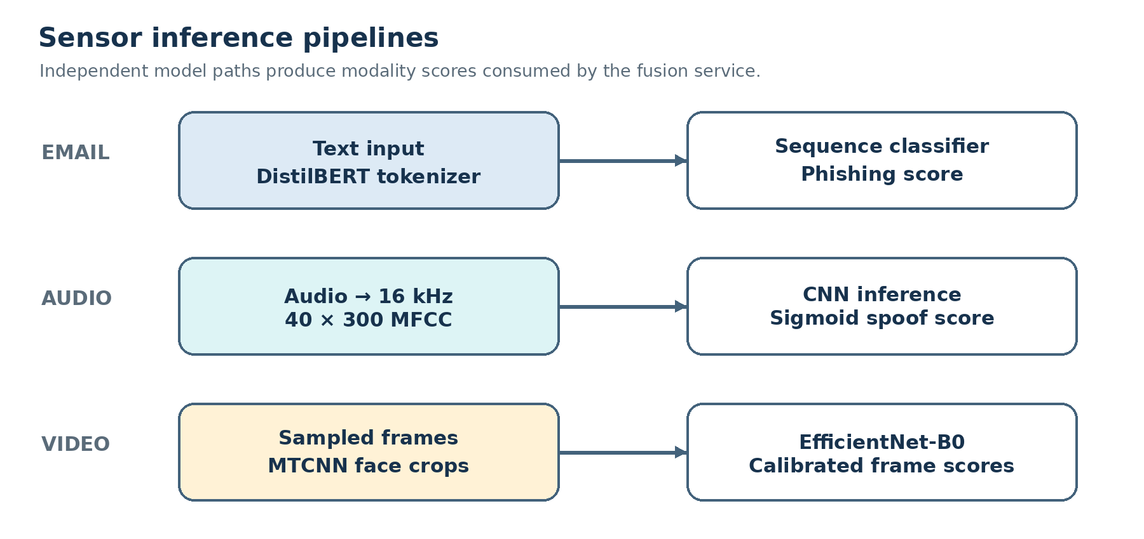
Figure 6.1. Modality-specific inference pipelines used by the current prototype.

6.6 Fusion and User Interface
The fusion function in src/fusion.py uses equal nominal weights of 0.3333, renormalizes over available sensors, and applies a veto at 0.85 for audio or video. The React interface exposes Dashboard, Email Intelligence, Audio Forensics, Video Forensics, Multimodal Fusion, Threat Reports, and Settings pages. The browser-side report module saves lightweight metadata in localStorage and creates a jsPDF document locally; it does not send PDF content to a server [P2, P5].

6.7 Deployment and Privacy
Docker Compose defines separate FastAPI and Nginx/React services, mounts model weights read-only, enables Hugging Face offline mode, and publishes the UI on loopback by default. This supports local operation after image dependencies and weights are present. It is not sufficient by itself to certify an air gap: host firewall, network routes, dependency supply chain, and machine configuration remain outside the application code. The report therefore describes the application as local inference and does not claim externally audited isolation.
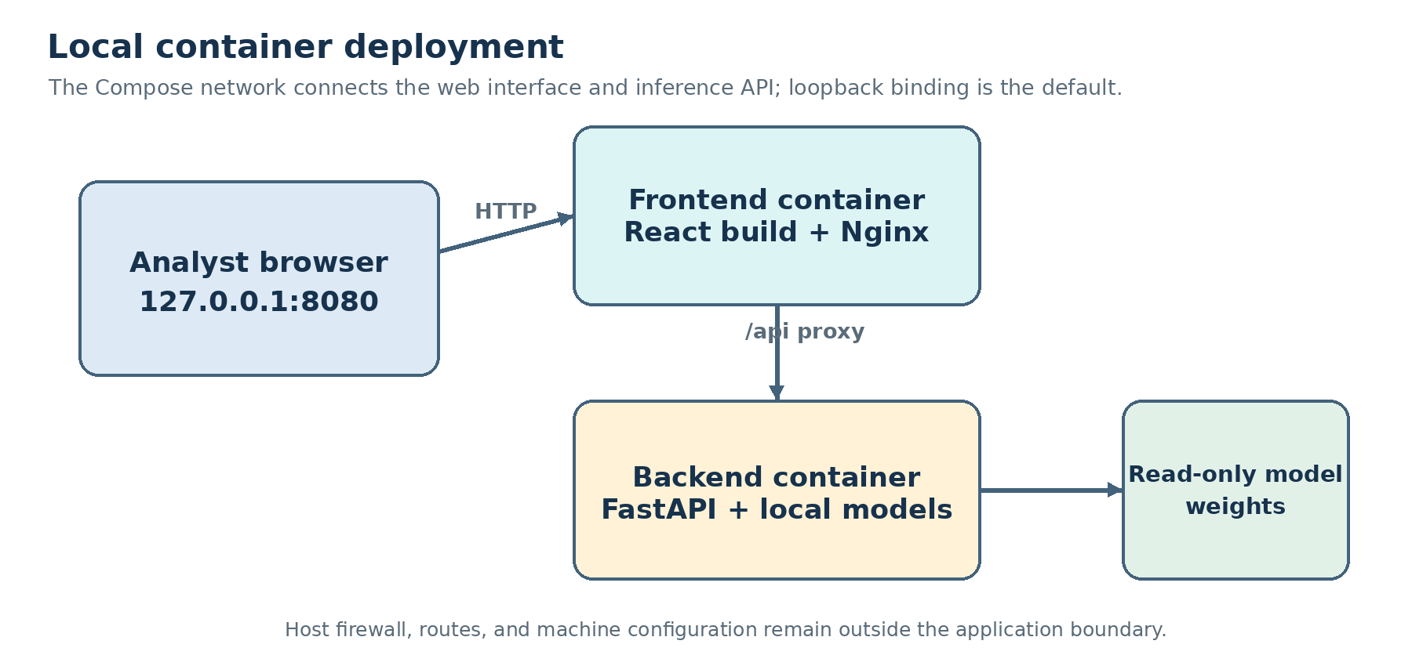
Figure 6.2. Two-container local deployment and the boundary of the application’s privacy claims.

6.8 Reproducibility and Testing Status
The repository contains model weights, source notebooks, backend and frontend code, an email diagnostic prediction export, an audio reconstructed diagnostic export, and a benchmark runner with a paired-manifest contract. The available email and audio exports include run metadata but have unresolved checkpoint or split lineage, so they support diagnostic re-scoring rather than unqualified held-out estimates. The snapshot contains no active-checkpoint video test export and no completed authentic paired-fusion run. These gaps limit performance claims even though the application inference pipeline is implemented.
CHAPTER 7 RESULTS AND DISCUSSION

7.1 Email Result Available in the Project
The repository now includes outputs/reports/email_test_predictions.csv and email_test_metrics.json, a current-checkpoint re-score of the saved 3,508-row email test split. At threshold 0.50 the counts are TP=1,308, TN=2,023, FP=173, and FN=4, yielding 94.95% accuracy, 88.32% precision, 99.70% recall, 7.88% FPR, and 0.30% FNR. The checkpoint hash and dataset hash are recorded, but the metric file explicitly says the checkpoint’s training and model-selection provenance is unverified. This is therefore a diagnostic re-score, not proven held-out performance. The earlier Colab report states 98.80%, while its archived counts imply 98.69%; the current re-score does not resolve which checkpoint generated that older result.
Evidence source | Recorded value | Interpretation
Email current-checkpoint re-score | N=3,508; TP 1,308; TN 2,023; FP 173; FN 4; accuracy 94.95%. | Prediction CSV and run metadata exist; checkpoint training provenance is unverified, so treat as diagnostic.
Email unclipped subset | N=3,507; FP 172; accuracy 94.98%; FPR 7.84%. | The one clipped input changes the current score minimally; clipping does not explain the historical gap.
Earlier Colab email report | Headline accuracy 98.80%; archived counts imply 98.69%. | Separate historical run; active checkpoint lineage is not established and the two summaries disagree.
Audio reconstructed re-score | N=500; TP 448; TN 46; FP 5; FN 1; accuracy 98.8%; FPR 9.80%. | Random sample split with no source IDs; only 51 genuine test records; diagnostic only.
Video and multimodal fusion | No active-checkpoint video test report; no authentic paired-fusion run. | Do not report video accuracy or fusion benefit from current evidence.

An unclipped diagnostic excludes the one input exceeding the configured API character limit (N=3,507; TP=1,308, TN=2,023, FP=172, FN=4) and yields 94.98% accuracy and 7.84% FPR. This small change shows that clipping does not explain the gap from the older Colab headline. The earlier classification report and archived confusion matrix remain inconsistent, and the training lineage behind both historic artifacts is not established.

7.2 Audio and Video Results
The repository includes an audio reconstructed re-score at outputs/reports/audio_reconstructed_test_metrics.json and its per-row output CSV. On N=500 random sample rows (449 spoof, 51 genuine), both the 0.50 notebook-comparison boundary and 0.45 deployed boundary produce TP=448, TN=46, FP=5, FN=1; accuracy is 98.8%, FPR 9.80%, and FNR 0.22%. The small genuine denominator, absence of speaker/session IDs, and unverified mapping between this checkpoint and the supplied Colab run make this diagnostic only. No active-checkpoint video test report is present. Audio 0.45 and video fallback tau 0.7920 (recentered to a 0.50 decision boundary) are implementation settings, not evidence of benchmark performance.

7.3 Multimodal Fusion Results
The fusion function is implemented, but no completed paired held-out evaluation artifacts were found in outputs/reports. Historical ablation rows in the project are explicitly identified as unverified because their former pipeline combined unrelated modality records and selected a video threshold on the scoring records [P8]. The current runner requires curated paired scenarios and creates metrics, prediction, and run-metadata outputs; those outputs are not present. The earlier percentages such as 99.1% accuracy and 0.4% false-negative rate are therefore omitted as measured claims.
The examples in Chapter 8 demonstrate how the code behaves for selected numeric inputs. They validate arithmetic by inspection only. They do not establish sensor detection, fault tolerance on real attacks, or improved accuracy across the seven modality subsets.

7.4 Integrated System Results
The implementation provides separate inference endpoints, a multimodal endpoint, health reporting, modality-level status, a dashboard, forensic scanners, local report history, and client-side PDF generation. Docker Compose configuration describes a local two-service deployment. No independently audited security test, sustained-load result, or measured latency report is present in this snapshot. Functional availability should therefore be demonstrated separately from detection quality.

7.5 Discussion
The current evidence is stronger than an implementation-only description because sample-level diagnostic re-scores now exist for email and audio. Their exact counts and run metadata are reproducible from the project outputs, but the email checkpoint lineage and audio source grouping remain unresolved. The audio estimate is particularly imprecise for benign speech because only 51 genuine test rows are available. No video test metrics or authentic paired fusion results are available. The appropriate contribution is therefore the functioning architecture and a documented evaluation protocol, not an accuracy advantage. Threshold selection, group separation, coverage, class balance, and training-data overlap must be resolved before stronger research claims are made.
CHAPTER 8 RESEARCH PAPER
SynthGuard for Multimodal Threat and Synthetic Media Analysis
Jay Shravan Kumar Sharma | TYCS47 | B.Sc. Computer Science
Department of Computer Science, Bhavan's College, University of Mumbai
Abstract— SynthGuard is a locally deployable multimodal threat-analysis prototype that combines a DistilBERT email classifier, an MFCC-based audio convolutional neural network, and an MTCNN/EfficientNet-B0 video pipeline through a late-fusion rule. The system exposes local FastAPI inference endpoints and a React analyst interface with score and modality-status reporting. Current repository outputs include diagnostic re-scores for email (N=3,508; 94.95% accuracy) and audio (N=500; 98.8% accuracy); both have lineage limitations that prevent unqualified held-out claims. No active-checkpoint video test report or authentic paired-fusion evaluation is available. The earlier 99.1% fusion value is excluded because the historical evaluation pipeline did not use genuinely paired scenarios. The study documents implementation and specifies a group-separated benchmark protocol; it does not establish a general performance advantage.
Index Terms—phishing detection, speech spoofing, deepfake video, multimodal fusion, local inference, forensic analysis.

I. INTRODUCTION
Business email compromise and synthetic media attacks exploit trust across communication channels. Text, voice, and video detectors observe different evidence, but a combined result is meaningful only when inputs correspond to a coherent scenario and labels reflect the intended threat definition. SynthGuard implements a local prototype that routes email, audio, and video evidence to specialized local models and combines available scores. The research question is whether this architecture can be evaluated reproducibly across unimodal and multimodal subsets; the present artifacts establish implementation, not a general performance advantage.
The study makes three limited contributions: a modular inference pipeline; a transparent equal-weight and veto fusion rule; and a validation/test manifest design that preserves scenario and source-group relationships. It does not claim that model outputs are calibrated across modalities or that the veto improves detection rates.
II. RELATED WORK
DistilBERT applies knowledge distillation to produce a compact transformer for language tasks [1]. The project uses it for email sequence classification. ASVspoof 2021 defines challenge tracks and evaluation protocols for spoofed and deepfake speech [3]; MFCCs provide the audio model input representation [8]. FaceForensics++ provides manipulated facial videos and compression conditions for video-forgery research [4]. SynthGuard detects faces with MTCNN [6] and classifies face crops with EfficientNet-B0, an architecture designed around compound scaling [5]. These source works establish model and dataset context, not SynthGuard-specific performance.
Classifier combination offers a framework for aggregating outputs from distinct representations [7]. SynthGuard uses an uncalibrated normalized mean with a biometric override. This simpler rule is chosen for implementation transparency; its effectiveness must be tested against alternative rules on paired data.
III. SYSTEM AND METHODS
The email sensor tokenizes text to 256 tokens and returns the class-1 softmax score. The audio path resamples to 16 kHz, extracts 40 MFCC coefficients with a 2,048-sample FFT and 512-sample hop, and fixes the sequence to 300 frames. A three-stage CNN returns a sigmoid spoof score. The video path samples frames, detects faces with MTCNN, resizes crops to 224×224, scores them with EfficientNet-B0, and averages up to five predictions. A logit shift maps the configured raw calibration threshold to a calibrated score of 0.50.
For the available set M of sensors, the fusion score is F = Σ(i∈M) w_i s_i / Σ(i∈M) w_i, where each nominal weight w_i is 0.3333. If an audio or video score is at least 0.85, the veto branch returns max(s_i). The final label is threat when F ≥ 0.50. Missing sensors are excluded and the remaining weights are renormalized. The implementation is in the project fusion module [P2].
The email notebook records a cleaned dataset and stratified split; the current email re-score and the older Colab result are separate artifacts and should not be conflated. The current output reports N=3,508 with TP=1,308, TN=2,023, FP=173, FN=4 (94.95% accuracy), but the checkpoint’s training lineage is unknown. The older 98.80% headline conflicts with its archived confusion matrix (98.69%). The audio diagnostic covers 500 randomly split rows but lacks speaker/session grouping and confirmed checkpoint identity. No source-disjoint video test metrics or authentic paired fusion result is reported.
IV. RESULTS AND ANALYSIS
The current email diagnostic re-score reports N=3,508 with TP=1,308, TN=2,023, FP=173, and FN=4 at threshold 0.50. These counts imply 94.95% accuracy, 7.88% FPR, and 0.30% FNR. The output includes per-sample predictions and a checkpoint hash, but checkpoint training provenance is unverified. The earlier Colab summary reported 98.80% accuracy while its archived counts imply 98.69%; neither is substituted for the current-checkpoint re-score. On the unclipped 3,507-row subset, FP falls to 172 and accuracy rises to 94.98%, so clipping does not explain the historical gap.
The audio re-score reports N=500 (449 spoof, 51 genuine) with TP=448, TN=46, FP=5, and FN=1 at thresholds 0.50 and 0.45. It yields 98.8% accuracy, 9.80% FPR, and 0.22% FNR. Its random sample split lacks speaker/session grouping and its checkpoint identity is not tied to the Colab log, so this is diagnostic only. No source-disjoint video test predictions or authentic paired fusion results are available. The historical ablation CSV is explicitly marked unverified in outputs/reports/README.md and is excluded from performance claims.
V. DISCUSSION AND LIMITATIONS
The prototype integrates three local inference paths and exposes modality status to the client. It supports partial evidence, but different sensor subsets have different score distributions and denominators. A normalized mean is not necessarily a calibrated posterior probability, so the 0.50 boundary is an operational rule. The biometric veto can dominate the aggregate and should be assessed for false alarms and missed attacks on independent, source-grouped cases.
The email diagnostic uses a saved random stratified split from one public corpus and has unresolved checkpoint lineage; it does not establish temporal or organization-level generalization. The audio reconstruction is random at the row level and lacks source IDs, and the active video checkpoint lacks test metrics. Training split lineage and a common paired BEC scenario set remain incomplete. Results from source datasets cannot be transferred to this system. Deployment is local and offline-capable after dependencies and weights are installed, but the software configuration alone is not proof of a physically isolated or audited environment.
VI. CONCLUSION
SynthGuard demonstrates a locally deployable architecture for combining email, speech, and face-video scores in one analyst workflow. The current checkpoint email re-score and reconstructed audio re-score add useful diagnostic detail, but their lineage limitations prevent generalization claims. No active video test metrics or authentic paired fusion evaluation exist. The project therefore does not support the historical 99.1% fusion accuracy claim. Further evaluation should use source-grouped data, validation-only threshold selection, a genuine scenario manifest, per-sample predictions, coverage, uncertainty intervals, and checkpoint hashes.
REFERENCES
[1] V. Sanh, L. Debut, J. Chaumond, and T. Wolf, “DistilBERT, a distilled version of BERT: smaller, faster, cheaper and lighter,” arXiv:1910.01108, 2019.
[2] Subhajournal, “Phishing Email Dataset,” Kaggle. Available: https://www.kaggle.com/datasets/subhajournal/phishingemails.
[3] H. Delgado et al., “ASVspoof 2021: accelerating progress in spoofed and deepfake speech detection,” arXiv:2109.00537, 2021.
[4] A. Rössler et al., “FaceForensics++: Learning to Detect Manipulated Facial Images,” in Proc. IEEE/CVF ICCV, 2019, pp. 1–11.
[5] M. Tan and Q. Le, “EfficientNet: Rethinking Model Scaling for Convolutional Neural Networks,” in Proc. ICML, PMLR 97, 2019, pp. 6105–6114.
[6] K. Zhang, Z. Zhang, Z. Li, and Y. Qiao, “Joint Face Detection and Alignment Using Multitask Cascaded Convolutional Networks,” IEEE Signal Processing Letters, vol. 23, no. 10, pp. 1499–1503, 2016.
[7] J. Kittler, M. Hatef, R. P. W. Duin, and J. Matas, “On Combining Classifiers,” IEEE Trans. Pattern Analysis and Machine Intelligence, vol. 20, no. 3, pp. 226–239, 1998.
[8] S. B. Davis and P. Mermelstein, “Comparison of parametric representations for monosyllabic word recognition in continuously spoken sentences,” IEEE Trans. Acoustics, Speech, and Signal Processing, vol. 28, no. 4, pp. 357–366, 1980.
[P1] SynthGuard project, backend/main.py, local FastAPI inference pipeline and request handling, project repository, 2026.
[P2] SynthGuard project, src/fusion.py, score aggregation and biometric veto implementation, project repository, 2026.
[P3] SynthGuard project, scripts/run_ablation_study.py and docs/ablation_manifest.md, reproducible paired-scenario benchmark contract, project repository, 2026.
[P4] SynthGuard project, docker-compose.yml, backend/Dockerfile, frontend-react/Dockerfile, and docs/docker_deployment.md, local deployment configuration, project repository, 2026.
[P5] SynthGuard project, frontend-react/src/lib/reports.ts and frontend-react/src/App.tsx, browser-side report generation and history, project repository, 2026.
[P6] SynthGuard project, outputs/reports/classification_report.txt, saved email classification summary, project repository, accessed 18 October 2026.
[P7] SynthGuard project, notebooks/01_phishing_email_classifier.ipynb, email dataset cleaning and stratified split, project repository, 2026.
[P8] SynthGuard project, outputs/reports/README.md, evaluation-output status and warning about historical ablation values, project repository, 2026.

CHAPTER 9 PLAGIARISM AND SIMILARITY REPORT

9.1 Purpose
A similarity review should be run on the final text of this report using the checker required by the college. Similarity scores depend on the tool, indexed sources, exclusions, and report settings. A score alone does not determine whether writing is properly attributed.

9.2 Checker and Result
Required field | Status for this report
Similarity-checking tool | Not provided
Date and time of check | Pending
Report identifier or link | Pending
Overall similarity / matched text | Pending actual checker output
Excluded bibliography, quotations, or repository sources | Pending checker settings
Attached evidence | Insert the exported similarity report after checking the final document

No SynthGuard similarity percentage is asserted in this draft. The chapter must be completed with the actual report generated from the final version. Do not use the sample projects’ checker screenshots, links, dates, or percentages as SynthGuard results.

9.3 Review Procedure
1. Submit the final report using the institution-approved similarity checker.
2. Save the complete report showing the document identity, check date, settings, and matched sources.
3. Review each matched passage and add or correct citations where required.
4. Replace this page with the actual report summary and attach the checker output as an appendix if required by the department.
CHAPTER 10 CONCLUSION LIMITATIONS AND FUTURE SCOPE

10.1 Conclusion
SynthGuard integrates local text, audio, and video analysis in a single threat-investigation workflow. DistilBERT, an MFCC-based CNN, and an MTCNN/EfficientNet-B0 pipeline return separate scores. FastAPI standardizes requests and status; the React interface supports multimodal submission, report history, and local PDF export. A normalized equal-weight rule and an audio/video veto form the final score. These are implementation facts supported by the current codebase.
The saved email report records 98.8% accuracy on 3,508 test samples, but archived confusion counts imply 98.69%, so the exact score remains unresolved. The repository does not include completed held-out metric outputs for audio, video, or multimodal fusion. Consequently, the report does not claim 99.1% fusion accuracy or sub-one-percent false-negative performance. The prototype’s main validated contribution at this stage is a functioning software architecture and a reproducibility plan for further testing.

10.2 Limitations
- The email result lacks a prediction-level export and has a discrepancy between the saved headline accuracy and archived confusion counts.
- Audio and video performance summaries, split lineage, and threshold-selection artifacts are not present in the reviewed repository snapshot.
- No completed paired multimodal manifest or ablation output exists, so fusion gains are not empirically established.
- The email random split does not measure temporal or organization-level generalization; corpus labels and sources may include biases or duplicates after text normalization.
- The three model scores are combined as if they were comparable probabilities, although calibration across sensors has not been documented.
- Video performance depends on face visibility, selected frames, compression, and manipulation types represented by training data.
- The Docker configuration supports local inference after setup but does not alone certify a physically air-gapped environment or an external security audit.
- Browser localStorage is local to a browser profile and can be cleared; it is not a server-backed audit database.

10.3 Future Scope
1. Recompute the email test predictions from the saved checkpoint and publish the per-example labels, confusion matrix, exact metrics, and checkpoint hash.
2. Record the ASVspoof and FaceForensics++ split manifests, source groups, training logs, calibration procedure, and held-out predictions for the current audio and video checkpoints.
3. Construct and independently label a sufficiently large scenario-level paired test set. Keep actors, campaigns, source videos, and related records within a single split.
4. Evaluate all seven non-empty sensor subsets with the same scenario labels and report coverage, TP/TN/FP/FN, precision, recall, FPR, FNR, confidence intervals, and runtime.
5. Compare equal-weight fusion and the veto rule against unimodal and alternative fusion baselines without selecting thresholds on test data.
6. Assess sensor-score calibration, missing-modality behavior, and robustness under compression, noise, domain shift, and benign high-risk language.
7. Complete the approved similarity review and update certificate, guide, and submission details before final academic submission.
CHAPTER 11 REFERENCES AND BIBLIOGRAPHY
[1] V. Sanh, L. Debut, J. Chaumond, and T. Wolf, “DistilBERT, a distilled version of BERT: smaller, faster, cheaper and lighter,” arXiv:1910.01108, 2019. https://arxiv.org/abs/1910.01108.
[2] Subhajournal, “Phishing Email Dataset,” Kaggle. https://www.kaggle.com/datasets/subhajournal/phishingemails.
[3] H. Delgado, N. Evans, T. Kinnunen, K. A. Lee, X. Liu, A. Nautsch, J. Patino, M. Sahidullah, M. Todisco, X. Wang, and J. Yamagishi, “ASVspoof 2021: accelerating progress in spoofed and deepfake speech detection,” arXiv:2109.00537, 2021. https://arxiv.org/abs/2109.00537.
[4] A. Rössler et al., “FaceForensics++: Learning to Detect Manipulated Facial Images,” in Proc. IEEE/CVF International Conference on Computer Vision (ICCV), 2019. https://openaccess.thecvf.com/content_ICCV_2019/html/Rossler_FaceForensics_Learning_to_Detect_Manipulated_Facial_Images_ICCV_2019_paper.html.
[5] M. Tan and Q. V. Le, “EfficientNet: Rethinking Model Scaling for Convolutional Neural Networks,” in Proc. 36th International Conference on Machine Learning, PMLR, vol. 97, pp. 6105–6114, 2019. https://proceedings.mlr.press/v97/tan19a.html.
[6] K. Zhang, Z. Zhang, Z. Li, and Y. Qiao, “Joint Face Detection and Alignment Using Multitask Cascaded Convolutional Networks,” IEEE Signal Processing Letters, vol. 23, no. 10, pp. 1499–1503, 2016. doi:10.1109/LSP.2016.2603342.
[7] J. Kittler, M. Hatef, R. P. W. Duin, and J. Matas, “On Combining Classifiers,” IEEE Transactions on Pattern Analysis and Machine Intelligence, vol. 20, no. 3, pp. 226–239, 1998.
[8] S. B. Davis and P. Mermelstein, “Comparison of parametric representations for monosyllabic word recognition in continuously spoken sentences,” IEEE Transactions on Acoustics, Speech, and Signal Processing, vol. 28, no. 4, pp. 357–366, 1980. doi:10.1109/TASSP.1980.1163420.
[9] SynthGuard project repository, backend/main.py, local inference and API implementation, accessed 18 October 2026.
[10] SynthGuard project repository, src/fusion.py, equal-weight score fusion and biometric veto, accessed 18 October 2026.
[11] SynthGuard project repository, outputs/reports/classification_report.txt and notebooks/01_phishing_email_classifier.ipynb, email evaluation artifacts, accessed 18 October 2026.
[12] SynthGuard project repository, scripts/run_ablation_study.py and docs/ablation_manifest.md, paired-scenario benchmark design, accessed 18 October 2026.
[13] SynthGuard project repository, frontend-react/src/lib/reports.ts, client-side history and PDF report generation, accessed 18 October 2026.
[14] SynthGuard project repository, docs/docker_deployment.md and docker-compose.yml, local container deployment configuration, accessed 18 October 2026.
CHAPTER 12 APPENDICES

Appendix A Dataset and Model Artifacts
Artifact | Project location | Role
Email checkpoint | models/final/phishing_email/ | DistilBERT model and tokenizer.
Audio checkpoint | models/final/audio_detector/audio_cnn_model.pth | MFCC-based CNN weights.
Video checkpoints | models/final/video_detector/ | EfficientNet-B0 weights and legacy backup/calibration context.
Email dataset split | data/train_dataset.pkl; data/test_dataset.pkl | Email text and labels from the recorded split.
Audio features | data/audio_features_part_*.pkl | Preprocessed audio feature chunks; split lineage requires documentation.
Video training chunks | colab_export/ffpp_chunk_*.pkl | Prepared video face tensors and labels; split lineage requires documentation.
Email report | outputs/reports/classification_report.txt | Current-checkpoint diagnostic metrics and per-example predictions; training lineage remains unverified.
Benchmark runner | scripts/run_ablation_study.py | Paired-scenario evaluation and result export tool.

Local artifact presence is not proof that a dataset was used only in training or only in testing. The sample manifest, checkpoint and split records should be retained together with hash values for a reproducible evaluation.

Appendix B Operational Thresholds
Sensor / operation | Current implementation setting | Meaning
Email | 0.50 | Class-1 probability at or above this value produces a phishing indicator.
Audio | 0.45 | Sigmoid score at or above this value produces a synthetic-audio indicator.
Video face detection | 0.90 MTCNN confidence | Face region is accepted for downstream crop classification.
Video calibration | 0.7920 fallback raw threshold | Raw score is logit-shifted so this threshold maps to calibrated 0.50; a calibration.json file overrides the fallback.
Multimodal veto | 0.85 audio or video score | Returns the highest available sensor score.
Final threat decision | 0.50 unified score | Scores at or above boundary receive the threat label.

Appendix C API and Local Deployment
The API routes are documented in Chapter 9. The default Compose deployment publishes the user interface on 127.0.0.1:8080 and keeps the backend service on the private Compose network. The project documentation describes building and starting the two services with Docker Compose. Before claiming deployment readiness, confirm both services start, model availability is healthy, API calls complete, and the local host binding is preserved.

Appendix D Evidence Checklist for Final Research Submission
- Current email and audio diagnostics are catalogued in Appendix H; lineage gaps and the remaining video/fusion evidence requirements are listed in Appendix I.

APPENDIX E ANALYST INTERFACE REFERENCE
The following figures document the interface version supplied during project review. They show the analyst workflow and the kind of response information visible to a user. The displayed scores are individual demonstration scans; they are not benchmark results, ground-truth labels, or estimates of model accuracy. The screenshots are included as interface documentation and should be replaced only if the submitted build changes materially.

E.1 Workspace and module navigation
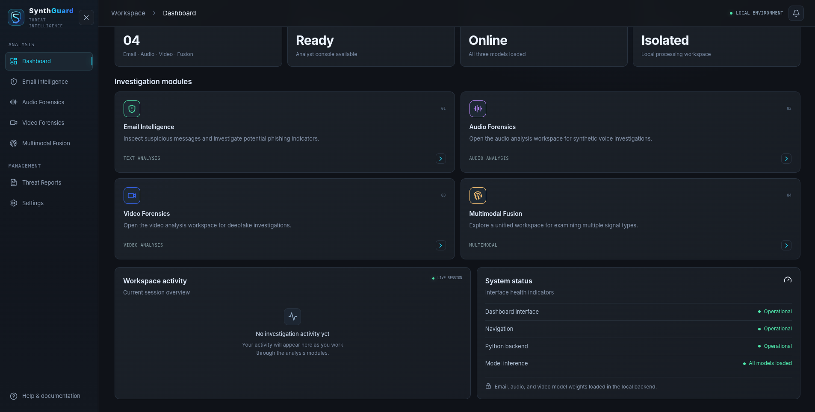
Figure E.1. Dashboard overview and navigation. The dashboard reports workspace readiness and links to the four analysis modules.

E.2 Email analysis view
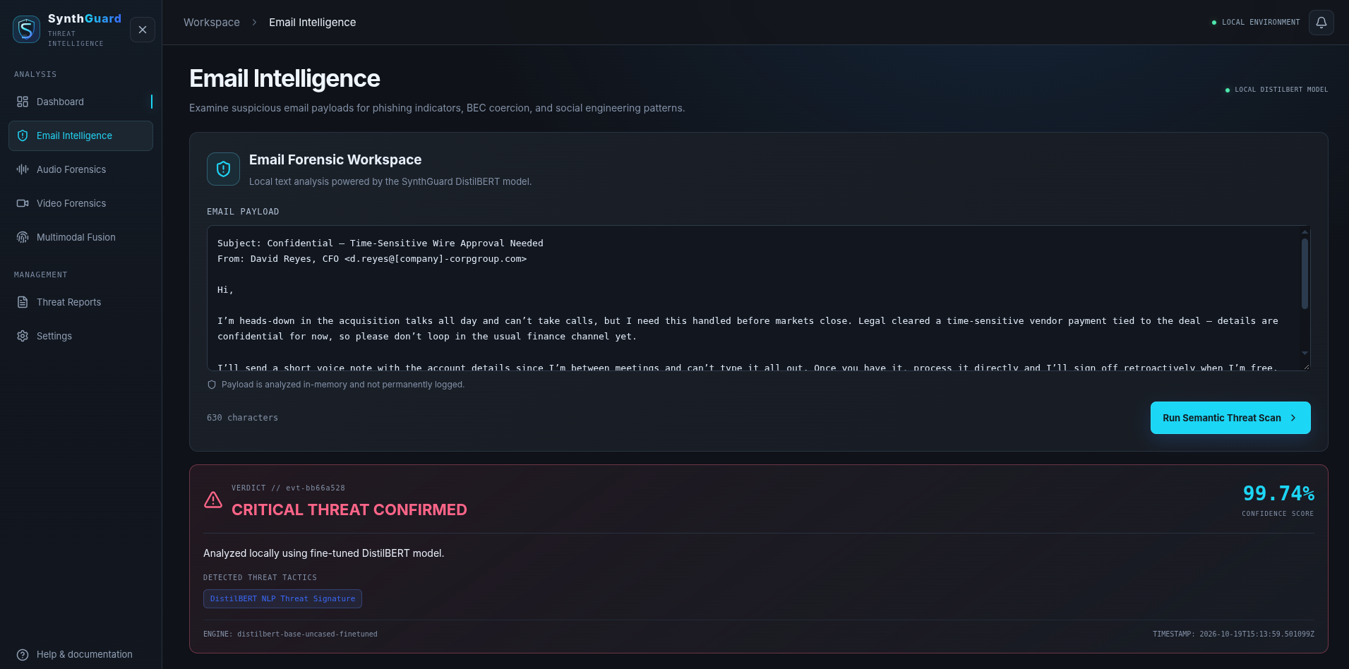
Figure E.2. Email Intelligence workspace. The result panel presents the email score, verdict, and a textual threat indicator.

E.3 Audio analysis view
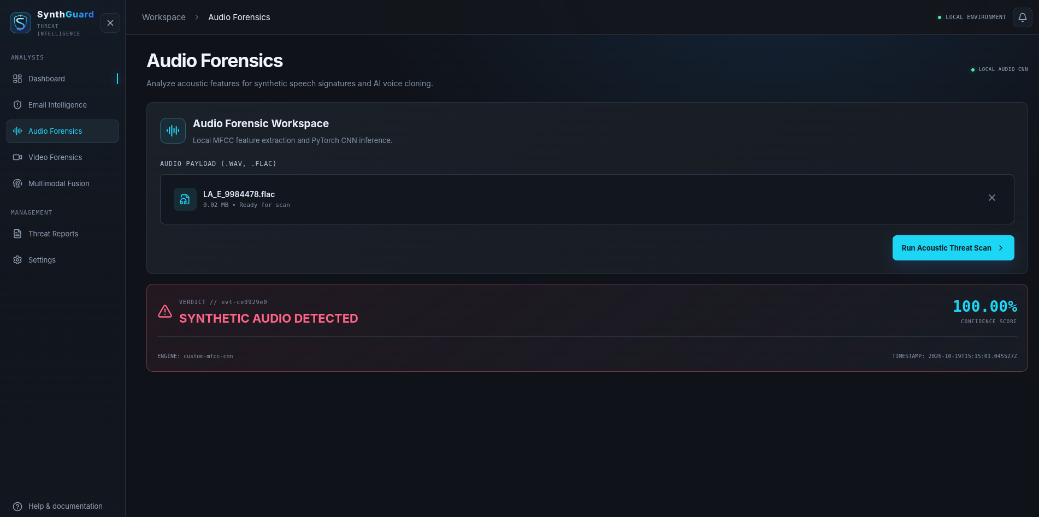
Figure E.3. Audio Forensics workspace. The upload is analyzed by the local MFCC-CNN path; the shown 100% score is one sample output, not an accuracy metric.

E.4 Video analysis view
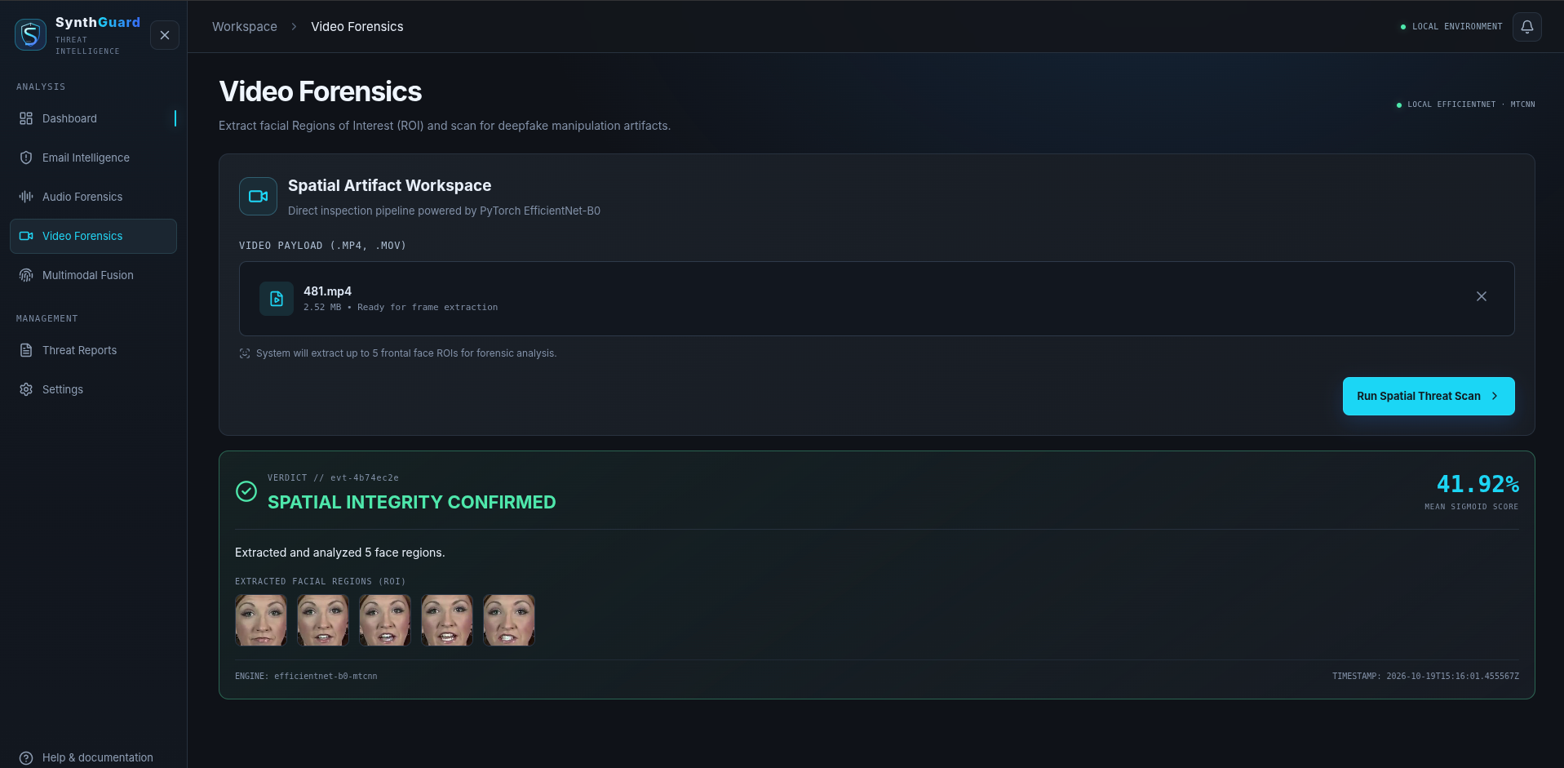
Figure E.4. Video Forensics workspace. The interface displays extracted face regions and the video score for one sample scan.

E.5 Multimodal analysis view
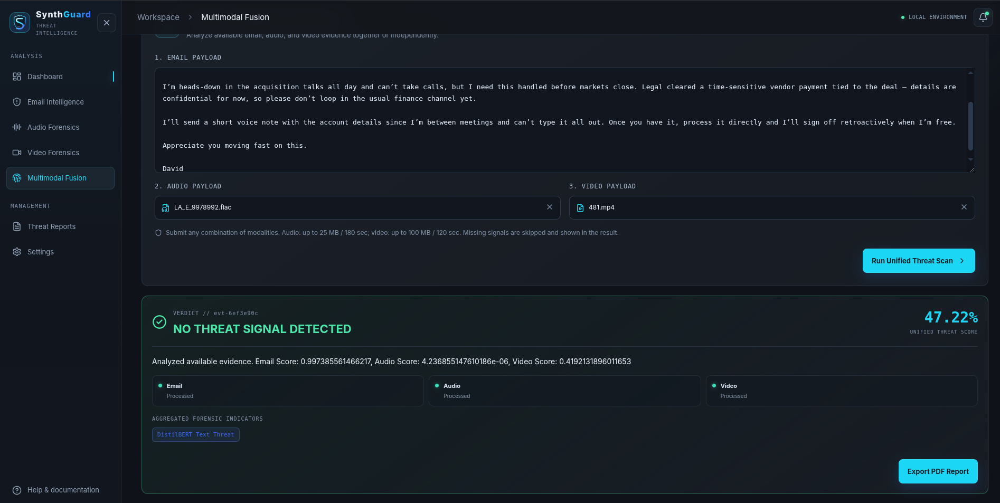
Figure E.5. Multimodal Fusion workspace. The screen shows three modality statuses and the fused score for the submitted inputs; it does not establish paired-test performance.

APPENDIX F LOCAL API REFERENCE
The React client communicates with the FastAPI service through relative `/api` routes. In the Compose deployment, the browser reaches the Nginx frontend and Nginx proxies API requests over the private Compose network. The backend is not directly published as a host port in the supplied Compose file.

F.1 Endpoint summary
Endpoint | Method and input | Successful response | Key validation
/api/health | GET; no body | Service status and availability by model | A model can be unavailable even when the service responds.
/api/analyze/email | POST JSON: {"text":"..."} | Analysis ID, class label, score, model name, summary and indicators | Non-empty text; configured maximum 100,000 characters.
/api/analyze/audio | POST multipart file field | Synthetic/genuine label and CNN score | WAV, FLAC, MP3, OGG or M4A; up to 25 MB and 180 seconds by default.
/api/analyze/video | POST multipart file field | Manipulated/original label, score and up to five face crops | MP4, MOV or M4V; up to 100 MB and 120 seconds by default; a valid face must be found.
/api/analyze/multimodal | POST multipart: optional text/audio/video | Overall prediction plus modality scores, statuses, errors and indicators | At least one modality; each supplied input follows its modality validation rules.

F.2 Common response fields
An AnalysisResponse contains analysis_id, analysis_type, status, prediction, summary, indicators, frames, modality_status, modality_errors, and a creation timestamp. The prediction object includes label, score, score_type, and model_name. A completed response means the request was handled; it does not mean the decision has been independently validated. The UI should preserve the distinction between processed, omitted, failed, and unavailable modalities so a reader can interpret a partial result correctly.
The multimodal endpoint can return status `partial` when one or more supplied sensors fail while another succeeds. The summary includes each modality score or N/A. A missing modality is excluded from the normalized fusion denominator. A failed modality is also not silently assigned a zero score. The response’s modality_errors field is the place to inspect a concise failure reason; detailed stack traces remain in backend logs.

F.3 Operational thresholds
Sensor / rule | Configured value | Interpretation and limitation
Email indicator | 0.50 | Class-1 softmax score at or above the boundary is labeled phishing.
Audio indicator | 0.45 | CNN sigmoid score at or above the boundary is labeled synthetic.
Video face acceptance | MTCNN confidence > 0.90 | A candidate face region must pass the detector confidence gate.
Video score boundary | 0.50 after score transform | Separates the displayed original/manipulated label.
Video transform fallback | tau = 0.7920 | Legacy logit recentering maps raw tau to 0.50; no validation artifact verifies this as a fitted calibration.
Biometric fusion veto | audio or video >= 0.85 | The branch returns the maximum available score. It does not unconditionally force a 1.00 score.

APPENDIX G DEPLOYMENT AND OPERATOR RUNBOOK
The supported container topology contains two services. The backend loads the local weights and provides inference. The frontend serves the built React application through Nginx and forwards `/api` traffic to the backend over the Compose network. The host publishes only the frontend by default at 127.0.0.1:8080. The project calls this local deployment; host-level network isolation, firewall state, and external connectivity have not been independently audited.

G.1 Prerequisites and startup
- Install Docker Engine and the Docker Compose plugin on the host.
- Confirm models/final contains the email tokenizer and weights, audio checkpoint, and active video checkpoint expected by backend/main.py.
- Review docker-compose.yml and docs/docker_deployment.md; the model directory is mounted read-only and Transformers offline mode is enabled in the backend container.
- Build and start with `docker compose up --build -d` from the project root. The first image build may require package downloads; subsequent inference uses the local checkpoint files.
- Check container state with `docker compose ps`. Review backend and frontend service logs if a container exits or remains unhealthy.
- Open `http://127.0.0.1:8080`. Verify the health response at `/api/health`; the expected response reports `status: ok` and model availability for email, audio, video and multimodal.

G.2 Readiness and shutdown
The backend health check waits for model initialization and has a start period of 180 seconds. A successful HTTP response is not sufficient if one or more model entries are unavailable. Read each model availability field before using the corresponding scanner. For a graceful stop, run `docker compose down`; this stops the project containers but does not remove local model files or browser history. If the host is restarted, the Compose restart policy is `unless-stopped` and should restart previously enabled services.

G.3 Local address and exposure
The default bind address is 127.0.0.1 to keep the interface reachable from the local machine only. A local `.env` can change SYNTHGUARD_PORT and SYNTHGUARD_BIND. Binding to 0.0.0.0 makes the UI reachable on network interfaces and should only be done with an intentional firewall and access-control plan. The current deployment configuration does not include user authentication, TLS termination, multi-tenant separation, or a server-side audit store.

G.4 Routine operator checks
Check | Expected observation | If it differs
Compose state | Frontend and backend running; backend healthy | Read service logs; verify weight paths, memory and dependency availability.
Health route | Each intended model available | Do not submit that modality until its local model loads.
Single-modality scan | A response includes the matching model name and score | Check supported extensions, payload size/duration, and backend error details.
Multimodal scan | A status for every modality; omitted sensors marked accordingly | Inspect `modality_status` and `modality_errors`; partial responses require review.
Report persistence | History appears in the same browser profile after reload | Local storage may be cleared or unavailable; it is not a central record.
PDF export | Browser downloads one report for the selected analysis | Confirm browser download settings and verify the downloaded report ID.

APPENDIX H MODEL AND EVALUATION EVIDENCE REGISTER
This register identifies the artifacts present in the reviewed project snapshot and the claims that each artifact can support. A model file proves that a checkpoint exists; it does not prove which records were used to train or select it. Dataset names and labels likewise do not establish that a test split is independent from training data.

H.1 Model inventory
Modality | Active path or configuration | Implemented processing | Evidence boundary
Email | models/final/phishing_email/model.safetensors plus tokenizer files | DistilBERT sequence classifier; truncation/padding to 256 tokens; phishing score from class 1. | Checkpoint and tokenizer are present. The current test re-score is reproducible from saved data and checkpoint hash, but training lineage is not verified.
Audio | models/final/audio_detector/audio_cnn_model.pth | 16 kHz decode; 40 MFCC coefficients; 2,048 FFT window; 512 hop; zero-pad/truncate to 300 frames; three-block CNN. | Checkpoint and reconstructed predictions are present. The 500-row split is sample-random and lacks source grouping; checkpoint identity to the training log is unresolved.
Video | models/final/video_detector/model.safetensors_2 | Sample video frames; MTCNN face detection; crop and resize; EfficientNet-B0 score averaging over up to five faces. | Active checkpoint is present. No source-disjoint held-out test export or calibration record was found.
Fusion | src/fusion.py | Equal nominal weights renormalized over available scores; audio/video veto at 0.85 returns maximum score; 0.50 decision boundary. | Software behavior is directly inspectable. No authentic paired scenario evaluation supports an accuracy claim.

H.2 Email diagnostic re-score
The current output in outputs/reports/email_test_metrics.json records an email re-score of the saved test pickle through the active local API. At threshold 0.50 it reports N=3,508; TP=1,308; TN=2,023; FP=173; and FN=4. Derived metrics are accuracy 94.95%, precision 88.32%, recall 99.70%, FPR 7.88%, and FNR 0.30%. The paired row file is outputs/reports/email_test_predictions.csv. The output includes a dataset hash and checkpoint hash. Its qualification states that training provenance is unknown; therefore, it is a checkpoint re-score, not proven held-out performance. One input exceeded the API character limit and was clipped. The 3,507-row unclipped subset yields 94.98% accuracy and 7.84% FPR, showing that this one clipped row does not account for the difference from the older Colab report.

H.3 Audio diagnostic re-score
outputs/reports/audio_reconstructed_test_metrics.json records 500 rows reconstructed from the supplied Colab feature-batch ordering using a stratified random row split with random_state 42. It contains 449 spoof and 51 genuine samples. At both threshold 0.50 and the deployed threshold 0.45, the recorded counts are TP=448, TN=46, FP=5, FN=1; accuracy is 98.8%, precision 98.90%, recall 99.78%, FPR 9.80%, FNR 0.22%, and ROC AUC 99.75%. These estimates are highly uncertain for the genuine class because only 51 benign examples are in the reconstructed test set. The split has no speaker/session/source IDs; the checkpoint hash cannot be matched to the Colab artifact. Present it only as a diagnostic reconstruction, not a source-disjoint benchmark.

H.4 Video and fusion evidence status
The video training excerpt supplied during project review reports validation accuracy during a random split of cached face tensors. The log does not establish source-video grouping and refers to a checkpoint export that is not the same named file as the active `model.safetensors_2` checkpoint. It cannot be used as the active model’s test accuracy. The fallback tau=0.7920 is loaded when no calibration file is present; the transformation shifts logits so that tau maps to 0.50. It is a score recentering rule, not evidence of empirically verified probability calibration.
The old ablation CSV contains percentages from a former pipeline. outputs/reports/README.md records that it paired independent modality datasets by labels and selected a video threshold on the same records used for scoring. The new runner requires scenario-level correspondence, group-separated validation and test records, and separate per-scenario predictions. No completed authentic paired manifest or new result bundle was found, so the old table is omitted from all claims in this report.

APPENDIX I REPRODUCIBLE EVALUATION PROTOCOL
The protocol below turns current diagnostics into a stronger, auditable evaluation. It separates re-scoring from model training, keeps source groups intact, freezes thresholds before the test set is scored, and publishes enough information for another reviewer to reproduce the reported counts.

I.1 Email checkpoint lineage
- Record the SHA-256 of the active checkpoint, tokenizer, training and test datasets, and prediction script version.
- Recover the exact training notebook or run log that created the active checkpoint. Confirm whether any test examples were used for training, early stopping, threshold selection, or model selection.
- Re-score the fixed test pickle with no preprocessing changes. Export one row per example with sample ID, true label, raw score, predicted label, threshold, and whether input truncation or clipping occurred.
- Compute TP, TN, FP, FN directly from that CSV; report class denominators and metrics at the predeclared 0.50 threshold.
- If lineage cannot be established, label the output diagnostic re-score and do not call it a held-out estimate. Create a new source-aware split and retrain only if the study needs defensible generalization metrics.

I.2 Audio and video split design
Audio records must carry a stable speaker, session, recording, or source ID. Related segments from one recording must not be distributed across training, validation, and test. Video records must carry source video, actor, and manipulation-pair identifiers where available; original and manipulated versions derived from the same source must remain in one split. Use group-stratified assignment where feasible, publish the split manifest, and report class counts and excluded/failed samples.
Threshold selection belongs on validation data. For video, record the validation manifest hash, active checkpoint hash, candidate metric and threshold selection rule, then freeze the selected value before the test pass. Do not select tau or the final decision boundary by looking at test outcomes. Store raw scores as well as transformed scores so the effect of the calibration step can be inspected.

I.3 Paired fusion scenario protocol
A fusion row represents one genuine investigation scenario, not merely one threat label. Email, voice, and video must be linked to the same scenario where present. Record the overall scenario label separately from each modality label because a threat scenario can contain genuine audio or video, and a benign scenario may include a spoofed artifact used for a robustness test. Assign group_id to campaigns, actors, or source material and keep each group entirely within validation or test. Keep the written label policy independent of model outputs.
Run the seven sensor subsets (email, audio, video, email+audio, email+video, audio+video, and all three) on rows with full coverage for the corresponding subset. Compare naive weighting, equal weighting, and veto only on equivalent subsets. Report coverage, confusion counts, per-scenario scores, group-bootstrap confidence intervals, checkpoint hashes, thresholds, manifest hash, runtime, and failure reasons. If pair authenticity is synthetic or scripted, report logic/stress-test outcomes rather than real-world accuracy.

I.4 Metric formulas and reporting
Metric | Definition | Interpretation
Accuracy | (TP + TN) / (TP + TN + FP + FN) | Share of evaluated examples classified correctly; depends on class mix.
Precision | TP / (TP + FP) | How often predicted threats are true threats in the evaluation sample.
Recall / TPR | TP / (TP + FN) | Fraction of threat examples detected.
FPR | FP / (FP + TN) | Fraction of benign examples incorrectly escalated.
FNR | FN / (FN + TP) | Fraction of threat examples missed.
ROC AUC | Area under the ROC curve | Ranking discrimination over thresholds; does not identify the operating threshold.
Always provide denominators. A low FNR estimated from a small threat set, or a low FPR estimated from a small benign set, can have a wide uncertainty interval. Confidence intervals do not correct for leakage, label errors, distribution shift, or an unrepresentative source population.

APPENDIX J PRIVACY, SECURITY, AND LIMITATIONS

J.1 Data handling boundaries
The intended deployment keeps inference inside the host running the local containers. Uploaded audio and video are streamed to temporary files for processing, then the endpoint removes those temporary files after inference. Email text is handled in memory by the API. The browser’s PDF report is generated client-side. The local threat-report history stores only metadata such as the analysis identifier, timestamp, verdict, score, modality scores, statuses, summary, and indicators; it does not persist uploaded base64 video frames as the history payload. Browser localStorage is profile-local and can be cleared by the user or browser policies.
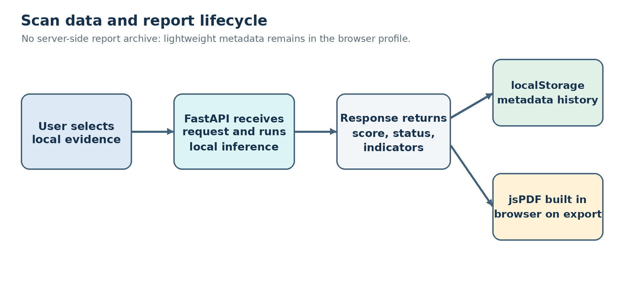
Figure J.1. Evidence and report lifecycle across the local API and analyst browser.
Local execution is not synonymous with a verified air gap. The software configuration enables offline model loading and does not publish the backend port to the host under the default Compose file, but the host may still have network access, dependency installation may contact package registries, and the application does not provide authentication or encryption for network exposure. Any claim of isolation should be limited to the tested deployment boundary and host configuration.

J.2 Threat model
Concern | Current control or behavior | Residual risk
Oversized uploads | Per-modality size/duration limits and request-body cap. | Resource exhaustion remains possible within limits; host memory/GPU and concurrent load are not benchmarked.
Unsupported file formats | Extension allowlists and empty-file checks. | Extension is not a complete content validation mechanism; decoder behavior depends on installed libraries.
Model unavailable | Health response exposes model availability; endpoint returns service errors. | Users may misinterpret a partial scan unless every modality status is reviewed.
Sensitive evidence | Local processing; temporary upload files removed after inference. | Host/container logs, crash dumps, backups, browser downloads, and disk security remain deployment responsibilities.
Report retention | Browser-only metadata and user-initiated local PDF export. | History is not tamper-resistant or centrally backed up; browser storage can be modified or removed.
False verdict | Scores and sensor status are displayed; result is decision support. | No human escalation workflow, calibrated risk model, or real-world operational performance study is established.

J.3 Responsible use
SynthGuard should be used to prioritize further review, not as the sole basis for financial transfers, employment decisions, identity verification, or allegations of fraud. Analysts should verify requests through a separate trusted channel, especially when a message demands secrecy, urgency, credential changes, or payment redirection. A low model score does not prove an input is safe; a high score does not prove malicious intent. Preserve original evidence and record the model version, score, and investigation context according to the organization’s approved handling procedure.

J.4 Known limitations
- The three scores are not documented as jointly calibrated; their arithmetic mean is an operational heuristic.
- Dynamic fusion uses only available scores. The meaning of the resulting score changes with the set of present modalities.
- The audio veto returns the highest available sensor score and can dominate the mean; false-alarm behavior is not established on a source-disjoint paired test set.
- Video face detection can fail on occlusion, pose, low resolution, no visible face, or severe compression; the system does not assess every frame.
- Dataset and checkpoint lineage are incomplete for some historical training artifacts, and the available diagnostic splits lack source grouping.
- No independent security assessment, deployment penetration test, latency study, or multi-user concurrency study is included.

APPENDIX K ANALYST USER GUIDE

K.1 Start an investigation
- Open the local SynthGuard workspace and confirm the Local Environment indicator is visible.
- Check the dashboard’s model status. If a required model is unavailable, do not rely on that sensor; report the availability issue to the operator.
- Choose Email Intelligence, Audio Forensics, Video Forensics, or Multimodal Fusion based on the evidence available.
- Enter email text or select supported audio/video files. In Fusion, provide any combination of modalities; the application skips missing inputs and reports their status.
- Review the upload name, supported formats, limits and input content before submission. Do not treat the interface as an evidence redaction or sanitization system.
- Run the scan. Review each sensor score, label, forensic indicator, analysis ID and modality status. A partial result requires review of the failed signal before a conclusion is recorded.
- Use Export PDF Report to download a locally generated PDF for the current scan. The PDF contains the analysis ID, generation time, score, verdict, modality telemetry, summary and indicators.
- Open Threat Reports to review prior metadata records in the current browser profile. Download an individual PDF from its record when needed.

K.2 Reading the score and verdict
The score is the detector output transformed by each modality’s implementation. It is not a statistical guarantee that the event has that exact probability of being malicious. The label is produced by a configured threshold. The text interface reports an email-specific verdict; audio and video views report modality-specific synthetic-signal verdicts; Fusion reports an aggregate threat verdict. A missing signal should remain visible as “not provided” or “not processed,” not be interpreted as a benign score.

K.3 Report storage and retention
The report history is stored in localStorage under the browser key `synthguard_threat_reports`. It remains available after reloads in that browser profile until cleared or replaced, but it is not written to the FastAPI database because this project has no server-side report database. Client-side PDF export downloads a file to the user’s configured download location. Users should follow institutional policy before storing sensitive inputs or downloaded reports on a shared device.

K.4 User-facing error handling
Observed condition | Meaning | Recommended action
Model unavailable | That model did not load. | Check /api/health and backend logs; do not use that sensor.
No face detected | No accepted face region was found. | Check format, quality and visible face; this is not a benign verdict.
Upload rejected | The file failed a type, size or duration limit. | Use a supported, authorized input within configured limits.
Partial analysis | One or more supplied sensors failed. | Inspect modality_status and modality_errors before recording a conclusion.

APPENDIX L MAINTENANCE AND ACCEPTANCE CHECKLIST
This checklist is an operational handoff aid. It records the items an administrator or project reviewer should verify at the time of a fresh deployment or before academic demonstration. It is not evidence that those checks have been completed unless a dated record is added.

L.1 Pre-demonstration checks
- Confirm the project commit or source archive and active checkpoint files are recorded with hashes.
- Start the Compose services and save the health response with timestamp and model availability.
- Run one representative input through each available single-modality scanner and one multimodal combination; record analysis IDs and whether every expected signal processed.
- Verify a PDF can be downloaded and matches the analysis ID, then confirm a report record persists after page reload in the same browser profile.
- Confirm report-history limitations and local-storage behavior are described to the user.
- Use benign and threat-labeled controlled examples only when authorization and dataset licensing permit; do not infer benchmark accuracy from demonstration scans.
- For academic performance claims, attach per-sample predictions, split manifests, model hashes, threshold records, confusion counts and the actual checker output for the final report version.

L.2 Evidence custody
For any future evaluation, keep the manifest, predictions, metric summary, run metadata, calibration artifact and model hashes together in a dated output folder. Preserve the exact software revision and dependency versions. Record missing rows and failures instead of dropping them silently. A second person should be able to follow the recorded procedure without access to an untracked Colab session or informal memory of how a split was formed.

L.3 Completion criteria for research claims
Claim category | Minimum evidence before reporting
Email held-out performance | Independent training/test lineage, fixed test split, prediction-level export, metric recomputation and checkpoint hash.
Audio/video performance | Group-separated source manifest, active-checkpoint hash, frozen threshold, per-record scores and class denominators.
Video calibration | Validation-only threshold selection record; calibration method and validation data stated; frozen parameter before test scoring.
Fusion advantage | Authentic scenario-level modality correspondence, split-independent groups, common subset coverage, paired predictions and uncertainty intervals.
Privacy or isolation | Deployment configuration and host/network boundary evidence; avoid “air-gapped” without independently verified isolation.
Similarity result | Institution-approved checker export tied to the final submitted document, with settings/date and reviewed matches.

