 | Shree Swami Atmanand Saraswati Institute of Technology  affiliated with  Gujrat Technological University, Ahmedabad | 

A
PROJECT REPORT SUBMITTED
ON

Micro-SIEM: A Lightweight Security Information and Event Management System

Prepared as a part of the requirements for the subject of
Minor Project (BC05001081)

Submitted By
Student Name
(EnrollmentNo)

Under the guidance of
Internal Guide Name

3rd Year, BCA, Semester - V
Bachelor of Computer Application Department

Shree Swami Atmanand Saraswati Institute of Technology
Department of Bachelor of Computer Application
Academic Year 2026-27
Shree Swami Atmanand Saraswati Institute of Technology
affiliated with
Gujrat Technological University, Ahmedabad

CERTIFICATE

This is to certify that the project report submitted along with the project entitled “Micro-SIEM: A Lightweight Security Information and Event Management System” has been carried out by Student Name. bearing enrollment no.:Enrollment no under the guidance of Internal Guide Name as part of Project (BC05001081) 3rd Year (5th Semester) of BCA in the academic year 2026-2027 and their work is satisfactory.

Date: / / 2026
Place: SSASIT, Surat

Internal Guide Name Prof. Sanket Trivedi
Internal Guide Head of BCA Department



SHREE SWAMI ATMANAND SARASWATI INSTITUTE OF TECHNOLOGY

Self-Declaration

I hereby declare that the project report submitted along with the project entitled Micro-SIEM: A Lightweight Security Information and Event Management System submitted as part of Minor Project (BC05001081) 3rd Year (5th Semester) of BCA to Gujarat Technological University, Ahmedabad, is a bonafide record of original project work carried out by me and that no part of this report has been directly copied from any students’ reports or taken from any other source, without providing due reference.

Student Name
(Enrollment no)

Acknowledgments
The success of any task relies on the efforts made by person but it cannot be achieved without cooperation of other persons which are being helpful. So, I would like to thank SHREE SWAMI ATMANAND SARASWATI INSTITUTE OF TECHNOLOGY, SURAT. for giving me the opportunity of doing this Project. I would like to take this opportunity to express our sincere thanks to all those people without whose support and co-operation, it would have been difficult to complete this project.
Primarily, I am very much thankful to my Internal Faculty guide Internal Guide Name for their leading guidance and sincere efforts throughout project work. They took deep interest in simplifying the difficulties. Also, they have been consistent source of inspiration for me.
I also express thanks to Prof.Vaishnavi Bhathawala and Prof. Vipul Chaudhari, class coordinator for her personal involvement, constructive suggestion and thoughtful idea for betterment of the project. I am grateful to our H.O.D. Prof. Sanket Trivedi and our beloved Principal Dr. Jignesh Vaghasiya for providing me deep knowledge and all necessary resources. I am also thankful to our Friends and Non-teaching Staff for their valuable time & help for completion project.
Once again, I am grateful to all those without whom this work would not have been successful.

Student Name
(Enrollment no)

INDEX
 |  | Subject |  | Page No.
1 |  | Project Description |  | 1
 |  | 1.1 | Project Profile | 1
 |  | 1.2 | Project Definition | 1
2 |  | Environment Description |  | 4
 |  | 2.1 | Hardware and Software Specification | 4
 |  | 2.2 | Development Description | 5
3 |  | System Description |  | 7
 |  | 3.1 | Introduction | 7
 |  | 3.2 | Scope of the System | 7
 |  | 3.3 | Objective of the System | 8
 |  | 3.4 | Functionality of System | 8
 |  | 3.5 | Expected Outcome | 10
4 |  | Project Planning and Scheduling |  | 12
 |  | 4.1 | Feasibility Study | 12
 |  | 4.2 | Software Engineering Model | 13
 |  | 4.3 | Requirement Analysis and Data Gathering | 14
 |  | 4.4 | Time Line Chart | 15
5 |  | System Analysis & Design |  | 16
 |  | 5.1 | Use Case Diagram | 16
 |  | 5.2 | Class Diagram | 17
 |  | 5.3 | Activity Diagram | 19
 |  | 5.4 | Deployment Diagram | 22
 |  | 5.5 | Database Design | 23
6 | System Implementation |  |  | 26
 | 6.1 |  | Source Code / Screen Shots | 26
7 | System Testing |  |  | 35
8 | Conclusion and Future Scope |  |  | 38
9 | Bibliography |  |  | 40

1. PROJECT DESCRIPTION
1.1 Project Profile
The table below gives a quick profile of the project — what it is called, what it is built with and the context in which it was developed.
Table 1.1: Project Profile
Particular | Details
Project Title | Micro-SIEM: A Lightweight Security Information and Event Management System
Project Type | Cyber-security monitoring system (web-based, containerized)
Project Category | Minor Project (BC05001081), BCA Semester V
Front End | HTML5, CSS3, JavaScript, Tailwind CSS, Chart.js
Back End / API | Python 3.11, FastAPI, Uvicorn
Data Store | OpenSearch (document store and search engine)
Log Collector | Vector (log shipping and parsing, VRL transforms)
Web Server / Proxy | Nginx (demo portal, reverse proxy, JSON access logs)
Containerization | Docker and Docker Compose (6 services)
Operating System | Linux (developed on Parrot Security OS)
Threat Framework | MITRE ATT&CK, OWASP / CWE
Version Control | Git and GitHub
Developed By | Student Name (Enrollment No)
Internal Guide | Internal Guide Name
Institute | Shree Swami Atmanand Saraswati Institute of Technology, Surat
Academic Year | 2026-27

1.2 Project Definition
Every computer system continuously writes logs — records of who logged in, which web pages were requested, which requests failed and from where they came. These logs contain the first evidence of almost every cyber attack: a password-guessing (brute-force) attack shows up as a burst of failed logins, a successful break-in shows up as a successful login right after many failures, and a web injection attack shows up as a suspicious request string in the web server's access log. The problem is that this evidence is scattered across many different files, in different formats, and nobody reads them in real time.
A Security Information and Event Management (SIEM) system solves this problem. It collects logs from many sources into one place, normalizes them into a common structure, runs detection rules over them to find attacks, and presents the resulting alerts to a security analyst on a dashboard. Commercial SIEMs such as Splunk, IBM QRadar and Microsoft Sentinel are powerful but expensive and far too heavy for a student, a small lab or a small organization to run or to learn from.
Micro-SIEM is a small, fully working SIEM built from scratch for this project. It ingests real logs from live sources, stores them in OpenSearch, runs its own detection engine written in Python, maps every alert to a recognised threat framework (MITRE ATT&CK or OWASP/CWE), and shows the results live on two role-based dashboards — one for an administrator and one for a read-only viewer. To demonstrate the system safely, the project also includes its own deliberately weak demo website (a login page and a search page) that acts as the attack target during a live demonstration.
Problem Statement
Small setups have no simple, understandable way to watch their authentication and web-server logs for attacks in real time. Existing SIEM products are costly, complex, and behave like black boxes, which makes them unsuitable for learning how detection actually works.
Proposed Solution
Build a lightweight, containerized SIEM that can be started with a single command, whose every detection rule is short, readable and explainable, and which demonstrates the complete security-monitoring lifecycle: collect → parse → store → detect → alert → visualise.
Key Highlights
- Real log sources, not simulated data: web login events and Nginx access logs (with SSH auth.log support built into the pipeline).
- Four detection rules: web login brute force (T1110), SSH brute force (T1110), failed-then-successful login correlation (T1078), and signature-based XSS detection (CWE-79).
- Alert history stored permanently in OpenSearch, so alerts remain visible after the attack ends.
- Role-based dashboards with real server-side session authentication (admin and viewer).
- One-command deployment with Docker Compose.
- Response actions (IP and account blocking) designed and implemented, currently disabled and planned for a future version.
2. ENVIRONMENT DESCRIPTION
2.1 Hardware and Software Specification
Micro-SIEM runs as a set of Docker containers on a single Linux machine. OpenSearch is the most resource-hungry component, so memory is the main hardware requirement. The client side only needs a modern web browser.
Table 2.1: Hardware Requirements (Server / Development Machine)
Component | Minimum | Recommended
Processor | Dual-core 64-bit (x86_64) | Quad-core Intel i5 / AMD Ryzen 5 or better
RAM | 4 GB | 8 GB or more
Storage | 10 GB free disk space | 20 GB SSD
Network | Local network (LAN / Wi-Fi) | LAN + Internet (for CDN assets and remote demo)
Display | 1366 × 768 | 1920 × 1080

Table 2.2: Software Requirements (Server)
Software | Version / Detail | Purpose
Operating System | Linux (Parrot Security OS, Debian based) | Host operating system
Docker Engine | 26.x | Runs all project containers
Docker Compose | 2.26 | Starts the 6 services together
OpenSearch | Official image (3.x) | Stores logs, alerts, blocklist
OpenSearch Dashboards | Official image | Raw data exploration (optional)
Vector | latest-alpine image | Reads, parses and ships logs
Python | 3.11 (slim image) | Back-end language
FastAPI | 0.111.0 | REST API framework
Uvicorn | 0.30.1 | ASGI web server for FastAPI
opensearch-py | 2.6.0 | Python client for OpenSearch
Pydantic | 2.7.4 | Request validation
Nginx | alpine image | Demo site, reverse proxy, access logs
Tailwind CSS / Chart.js | CDN | Dashboard styling and charts
Git / GitHub | — | Version control and hosting
Code Editor | Visual Studio Code | Development

Table 2.3: Client Requirements
Item | Requirement
Hardware | Any PC, laptop or smartphone
Software | Modern web browser (Google Chrome, Firefox, Edge)
Network | Same network as the server (or a tunnel such as ngrok)

2.2 Development Description
This section describes each technology used and why it was chosen. The guiding principle was to use industry-standard, open-source tools and to write the security logic itself, so that every part of the detection can be explained line by line.
Docker and Docker Compose
Docker packages each component with everything it needs into an isolated container. Docker Compose describes all six containers — OpenSearch, OpenSearch Dashboards, Vector, the FastAPI back end, the Nginx demo portal and the dashboard web server — in one file (docker-compose.yml), along with their networks and shared volumes. The entire system is started with a single command: docker-compose up -d --build.
OpenSearch
OpenSearch is an open-source search and analytics engine (a community fork of Elasticsearch). It stores every log event and alert as a JSON document and allows fast queries such as "all failed logins in the last two minutes". The project uses three indices: logs-index, alerts-index and blocked-index. OpenSearch Dashboards is included as an optional raw-data explorer.
Vector
Vector is a high-performance log-collection agent. It tails the log files, parses each line using its own transformation language (VRL — Vector Remap Language), adds a log_type tag and a source_ip field, and sends the events in bulk to OpenSearch. The configuration follows three steps for every log: source → transform → sink.
Python, FastAPI and Uvicorn
The back end is written in Python 3.11 using FastAPI, a modern and fast web framework that automatically generates interactive API documentation. Uvicorn is the ASGI server that runs the application. The back end hosts the demo login endpoint, the dashboard authentication, the detection engine and the (currently disabled) response actions.
Nginx
Nginx serves the demo portal (home, login and search pages), forwards /api/ requests to FastAPI, and writes its access log in JSON format so that Vector can read it without complex parsing. A second Nginx container serves the admin and viewer dashboards.
HTML, CSS, JavaScript, Tailwind CSS and Chart.js
The dashboards are plain HTML pages with JavaScript — deliberately without a heavy build toolchain — styled with Tailwind CSS and using Chart.js for the doughnut, line and bar charts. Every three seconds the dashboard fetches fresh data from the API and redraws the charts and tables.
MITRE ATT&CK and OWASP
MITRE ATT&CK is a globally used knowledge base of real attacker techniques. Each alert is tagged with its technique ID (for example T1110 – Brute Force, T1078 – Valid Accounts). XSS is a web-application vulnerability class, not an ATT&CK technique, so it is honestly mapped to OWASP Injection / CWE-79 instead of being forced into ATT&CK.
Table 2.4: Services and Ports
Service (container) | Port | Role
opensearch | 9200 | Data store REST API
opensearch-dashboards | 5601 | Raw data explorer
vector | — | Log collector (no public port)
fastapi-app | 8000 | Back-end API + detection engine
nginx-loginpage | 8080 | Demo attack-target portal
react-console | 8090 | Admin and viewer dashboards

3. SYSTEM DESCRIPTION
3.1 Introduction
Security monitoring starts with logs. Operating systems, web servers and applications record events continuously, but on their own these records are passive — useful only if someone collects, correlates and reads them. A SIEM turns passive logs into active security information: it centralizes the data, applies rules that describe attacker behaviour, and raises alerts that a human analyst can act on.
Micro-SIEM implements this idea at a small, understandable scale. Logs from the demo web application and the Nginx web server flow through Vector into OpenSearch. A detection engine in the FastAPI back end queries recent events, groups them by source IP address, and checks them against threshold, correlation and signature rules. Alerts are written to a permanent alert index and displayed on live dashboards, colour-coded by attack type and tagged with MITRE ATT&CK technique IDs.
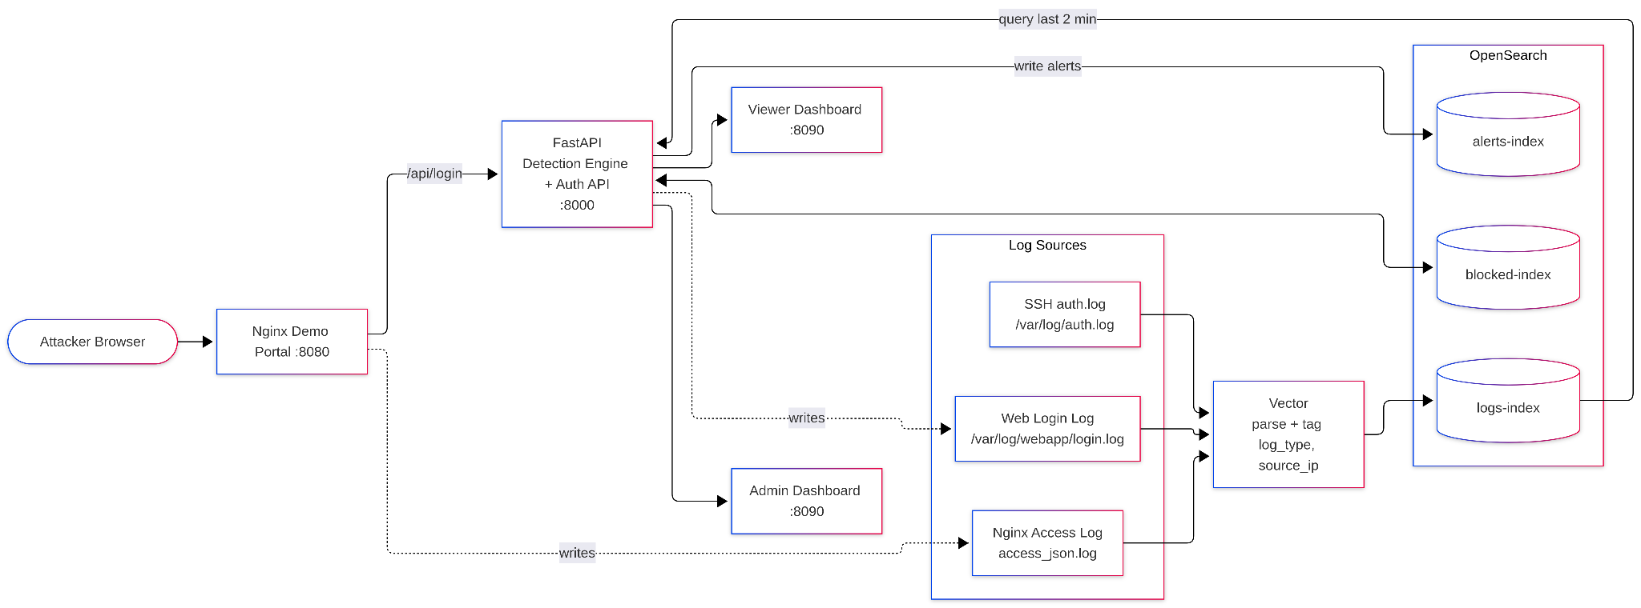
Figure 3.1: System Architecture of Micro-SIEM
3.2 Scope of the System
In Scope
- Collection of logs from multiple real sources (web login log, Nginx access log, SSH auth.log pipeline).
- Parsing and normalization of events into a common JSON structure with log_type and source_ip.
- Central storage and search of logs, alerts and blocklist records in OpenSearch.
- Rule-based detection: threshold (brute force), correlation (fail-then-success) and signature (XSS).
- Mapping of alerts to MITRE ATT&CK techniques or OWASP/CWE classes.
- Live admin and viewer dashboards with charts, logs table and threats table.
- Server-side session authentication with role-based access control.
- A safe, self-contained demo website that acts as the attack target.
Out of Scope
- Machine-learning or anomaly-based detection (all rules are transparent and signature/threshold based).
- Large-scale, multi-node or cloud deployment.
- Automatic (unattended) blocking of attackers — blocking is admin-triggered and currently disabled.
- Monitoring of Windows event logs, firewalls or network packet captures.
3.3 Objective of the System
- To understand and implement the complete SIEM pipeline: collection, parsing, storage, detection, alerting and visualisation.
- To detect common real-world attacks — password brute forcing, credential compromise and cross-site scripting — from real log data.
- To map detections honestly to industry frameworks (MITRE ATT&CK, OWASP, CWE).
- To present security information clearly to analysts with role-based dashboards.
- To keep every rule small and explainable so that the logic can be defended and extended.
- To make the system easy to deploy anywhere with a single Docker Compose command.
3.4 Functionality of System
The system is divided into the following functional modules.
1. Log Collection Module
Vector tails three log files: the web login log written by FastAPI (/var/log/webapp/login.log), the Nginx JSON access log (/var/log/nginx/access_json.log) and the Linux authentication log (/var/log/auth.log). It reads only new lines, so the SIEM reflects live activity.
2. Parsing and Normalization Module
For each source Vector applies a VRL transform. Authentication log lines are tagged linux_auth and the source IP is extracted with a regular expression. Web login and Nginx events are already JSON, so they are parsed and merged directly into the event. Every event ends up with a timestamp, a log_type and a source_ip.
3. Storage Module
Events are bulk-inserted into logs-index. Alerts are written to alerts-index and blocklist records to blocked-index. Keeping alerts in their own index means alert history survives even after the original raw events leave the detection window.
4. Detection Engine
Table 3.1: Detection Rules
Rule | Logic | Mapping
Web Login Brute Force | ≥ 5 failed web logins from the same source IP within 2 minutes | T1110 – Brute Force (Credential Access)
SSH Brute Force | ≥ 5 'Failed password' lines from the same IP within 2 minutes | T1110 – Brute Force (Credential Access)
Suspicious Login (Correlation) | ≥ 2 failed logins followed by a successful login from the same IP within 2 minutes | T1078 – Valid Accounts (Initial Access)
XSS Attempt | Nginx request path contains a known XSS signature (<script, onerror=, javascript:, alert( …) | OWASP Injection / CWE-79

5. Alert Management Module
Each alert records its type, source IP, number of attempts, severity, matched rule and MITRE/CWE mapping. For the XSS rule a de-duplication check prevents the same alert from the same IP being written more than once in five minutes.
6. Dashboard Module
The admin dashboard has three views — Dashboard (statistics and charts), All Logs (live event stream) and Threats & Action (active alerts grouped by IP and the blocked panel). The Attack Vectors chart is colour-coded: XSS and brute-force bars are red, suspicious-login bars are blue. The viewer dashboard shows the same statistics and charts in read-only form. All times are shown in Indian Standard Time.
7. Authentication and Access Control Module
Dashboard users log in through /auth/login and receive a random server-side session token valid for eight hours. Every API call must carry this token. Admin-only actions are refused with HTTP 403 for viewers, so access control is enforced on the server, not just hidden in the browser.
8. Demo Attack Surface
A separate demo portal (home, login and search pages) serves as the target during demonstrations. Its login page accepts three demo accounts and logs every attempt; its search page intentionally reflects the query without escaping so that XSS attempts can be shown and detected safely.
9. Response Module (Planned)
IP-level blocking (host firewall through iptables/ip6tables) and account-level blocking were designed and implemented, but are switched off in the current version through a single configuration flag. The buttons show a "Coming Soon" pop-up; this feature is part of the future scope.
3.5 Expected Outcome
- A working SIEM that can be started with one command and shows live security data within seconds.
- Automatic detection of brute-force, credential-compromise and XSS attempts during a live demonstration.
- Alerts that clearly show what happened, from where, how many times and which technique it represents.
- Separate admin and viewer experiences that demonstrate role-based access control.
- A clear, explainable code base that can be extended with new log sources and rules.
4. PROJECT PLANNING AND SCHEDULING
4.1 Feasibility Study
A feasibility study checks whether the project can realistically be completed and used, before the main development effort begins.
Technical Feasibility
All required tools — Docker, OpenSearch, Vector, Python, FastAPI and Nginx — are mature, open-source and well documented. They run on an ordinary laptop with 8 GB of RAM. The developer has working knowledge of Linux, Python and web technologies, so the project is technically feasible.
Economic Feasibility
Every component is free and open-source, and the system runs on existing hardware. There are no licence fees, cloud costs or paid services. The project is therefore economically feasible — in contrast to commercial SIEMs whose licences are priced by data volume.
Operational Feasibility
The system is started with a single command and used through a web browser. Dashboards are simple, colour-coded and responsive on mobile devices. An administrator and a viewer can use it without special training.
Schedule Feasibility
The work was divided into small increments (ingestion, detection, dashboards, authentication, demo site, testing and documentation) that fit within the semester timeline shown in Section 4.4.
Legal and Ethical Feasibility
All attacks are performed only against the project's own demo website and machine, never against third-party systems. Demo credentials are fictitious and no personal data is collected.
4.2 Software Engineering Model
The project follows the Iterative and Incremental Model. Instead of building everything at once, the system was built in small working increments. Each increment went through requirement analysis, design, coding and testing, and produced a runnable system that was then extended in the next iteration. This model suits the project because each part of a SIEM (ingestion, detection, dashboards) can be built and verified independently, and because real problems discovered in testing (for example log-format or time-zone issues) could be fixed in the next iteration.
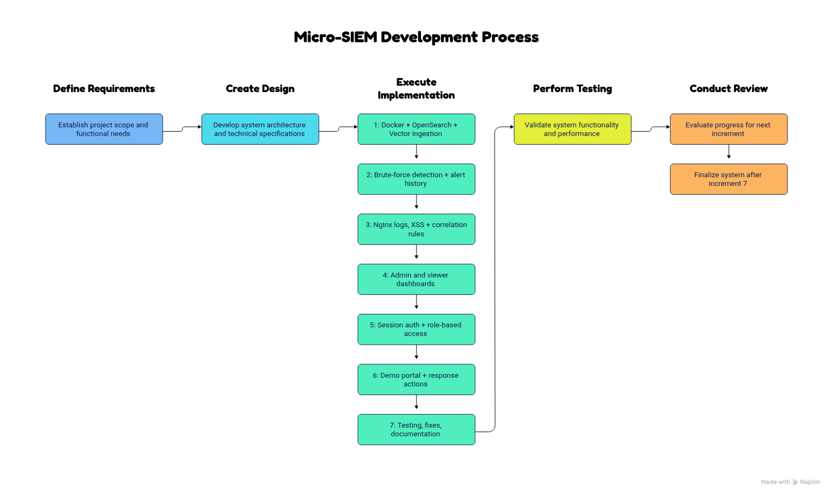
Figure 4.1: Iterative and Incremental Model
Table 4.1: Project Increments
Increment | Work Done
1 | Docker Compose setup; OpenSearch + Vector ingestion of auth.log; FastAPI /logs endpoint
2 | Web login log source; brute-force detection for SSH and web; alert index with history
3 | Nginx JSON access logs; XSS signature detection; fail-then-success correlation rule
4 | Admin and viewer dashboards with Chart.js; IST time; mobile layout
5 | Server-side session authentication and role-based access control
6 | Demo portal (home, login, search); response actions (later disabled for a future version)
7 | Testing, bug fixing, chart colour coding and documentation

4.3 Requirement Analysis and Data Gathering
Data Gathering Methods
- Study of existing SIEM products — Splunk, Elastic Security, Wazuh and Microsoft Sentinel — to understand common features such as ingestion pipelines, correlation rules and alert dashboards.
- Study of log formats — Linux auth.log (sshd messages) and Nginx access log fields — to design parsing rules.
- Threat frameworks — MITRE ATT&CK (T1110, T1078) and OWASP / CWE-79 — to design rules and mappings.
- Official documentation of OpenSearch, Vector, FastAPI and Docker.
- Discussions with the internal guide to fix scope, rules and demonstration flow.
Functional Requirements
Table 4.2: Functional Requirements
ID | Requirement
FR1 | The system shall collect logs from the web login log, the Nginx access log and the Linux auth.log.
FR2 | The system shall parse each log event and tag it with log_type and source_ip.
FR3 | The system shall store all events in OpenSearch and make them searchable.
FR4 | The system shall detect 5 or more failed logins from one IP within 2 minutes (brute force).
FR5 | The system shall detect failed logins followed by a successful login from the same IP (correlation).
FR6 | The system shall detect XSS payload signatures in web requests.
FR7 | The system shall store every alert permanently with severity and MITRE/CWE mapping.
FR8 | The system shall let admin and viewer users log in with separate roles.
FR9 | The system shall display live statistics, charts, logs and alerts, refreshing every 3 seconds.
FR10 | The system shall restrict response actions to the admin role (enforced server-side).

Non-Functional Requirements
Table 4.3: Non-Functional Requirements
Category | Requirement
Performance | New events appear on the dashboard within a few seconds of being logged.
Usability | Clean, colour-coded dashboards usable on desktop and mobile screens.
Security | Token-based sessions, 8-hour expiry, role checks on the server; protected loopback addresses.
Portability | Runs on any Linux machine with Docker using one command.
Maintainability | Small, commented rules; new sources/rules can be added without redesign.
Reliability | Alerts are persisted, so history is not lost when events age out of the window.

4.4 Time Line Chart
The project was carried out over approximately thirteen weeks. The chart below shows the planned activities by week (■ = activity in progress).
Table 4.4: Time Line Chart (Gantt Chart)
Activity | W1 | W2 | W3 | W4 | W5 | W6 | W7 | W8 | W9 | W10 | W11 | W12 | W13
Requirement gathering & study | ■ | ■
Feasibility & planning |  | ■ | ■
Environment setup (Docker, OpenSearch) |  |  | ■ | ■
Log ingestion with Vector |  |  |  | ■ | ■
Detection engine & alert index |  |  |  |  | ■ | ■ | ■
Dashboards (admin / viewer) |  |  |  |  |  |  | ■ | ■ | ■
Authentication & RBAC |  |  |  |  |  |  |  | ■ | ■
Demo portal & response actions |  |  |  |  |  |  |  |  | ■ | ■
Testing & bug fixing |  |  |  |  |  |  |  |  |  | ■ | ■ | ■
Documentation & report |  |  |  |  |  |  |  |  |  |  | ■ | ■ | ■

5. SYSTEM ANALYSIS & DESIGN
5.1 Use Case Diagram
The use case diagram shows the actors that interact with Micro-SIEM and the functions available to each. There are four actors: the Admin (security analyst with full access), the Viewer (read-only observer), the Demo User / Attacker who interacts with the demo portal, and the System itself (Vector and the detection engine), which works automatically.
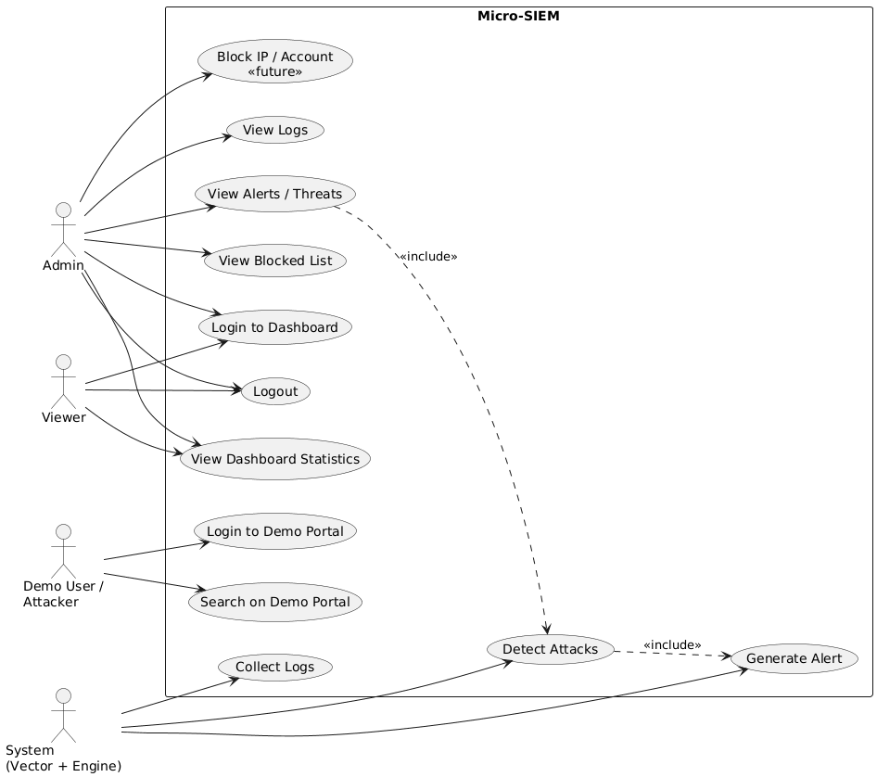
Figure 5.1: Use Case Diagram
Table 5.1: Use Case Description
Use Case | Actor(s) | Description
Login to Dashboard | Admin, Viewer | Enter username and password; receive a session token and role.
View Dashboard | Admin, Viewer | See total logs, alerts, suspicious IPs, success rate and charts.
View Logs | Admin | See the live stream of the latest 100 events.
View Alerts / Threats | Admin | See active alerts grouped by source IP with MITRE ID.
Block IP / Account | Admin | Planned response action — currently shows a 'Coming Soon' pop-up.
Login to Demo Portal | Demo User / Attacker | Attempt login; every attempt is logged.
Search | Demo User / Attacker | Submit a search query; the request is recorded in the Nginx log.
Collect & Detect | System | Vector ships logs; the engine applies rules and writes alerts.

5.2 Class Diagram
Although the back end is written in a functional FastAPI style, its data and responsibilities map naturally onto the classes below. Pydantic models validate incoming requests, and dictionaries stored in OpenSearch represent log events, alerts and blocklist records.
Table 5.2: Classes and Responsibilities
Class | Attributes | Methods / Responsibility
LoginRequest | username: str  password: str | Validates demo portal login input
DashboardLoginRequest | username: str  password: str | Validates dashboard login input
Session | token: str  role: str  expires: datetime | require_session(), require_admin()
LogEvent | timestamp, log_type, source_ip, message, event, username, path, status | Stored in logs-index by Vector
DetectionRule | alert_type, rule_name, match_field, match_value, mitre_id, mitre_tactic | _run_detection(), _run_correlation_rule(), _run_xss_detection()
Alert | timestamp, alert_type, source_ip, attempt_count, severity, matched_rule, mitre_technique, mitre_id, mitre_tactic | Stored in alerts-index; _already_alerted_recently()
BlockRecord | type, ip / username, blocked_at, blocked_by | block_ip(), unblock_ip(), block_account() (disabled)
SIEMApi | client: OpenSearch  sessions, demo_sessions | Exposes /login, /auth/login, /logs, /alerts, /blocked

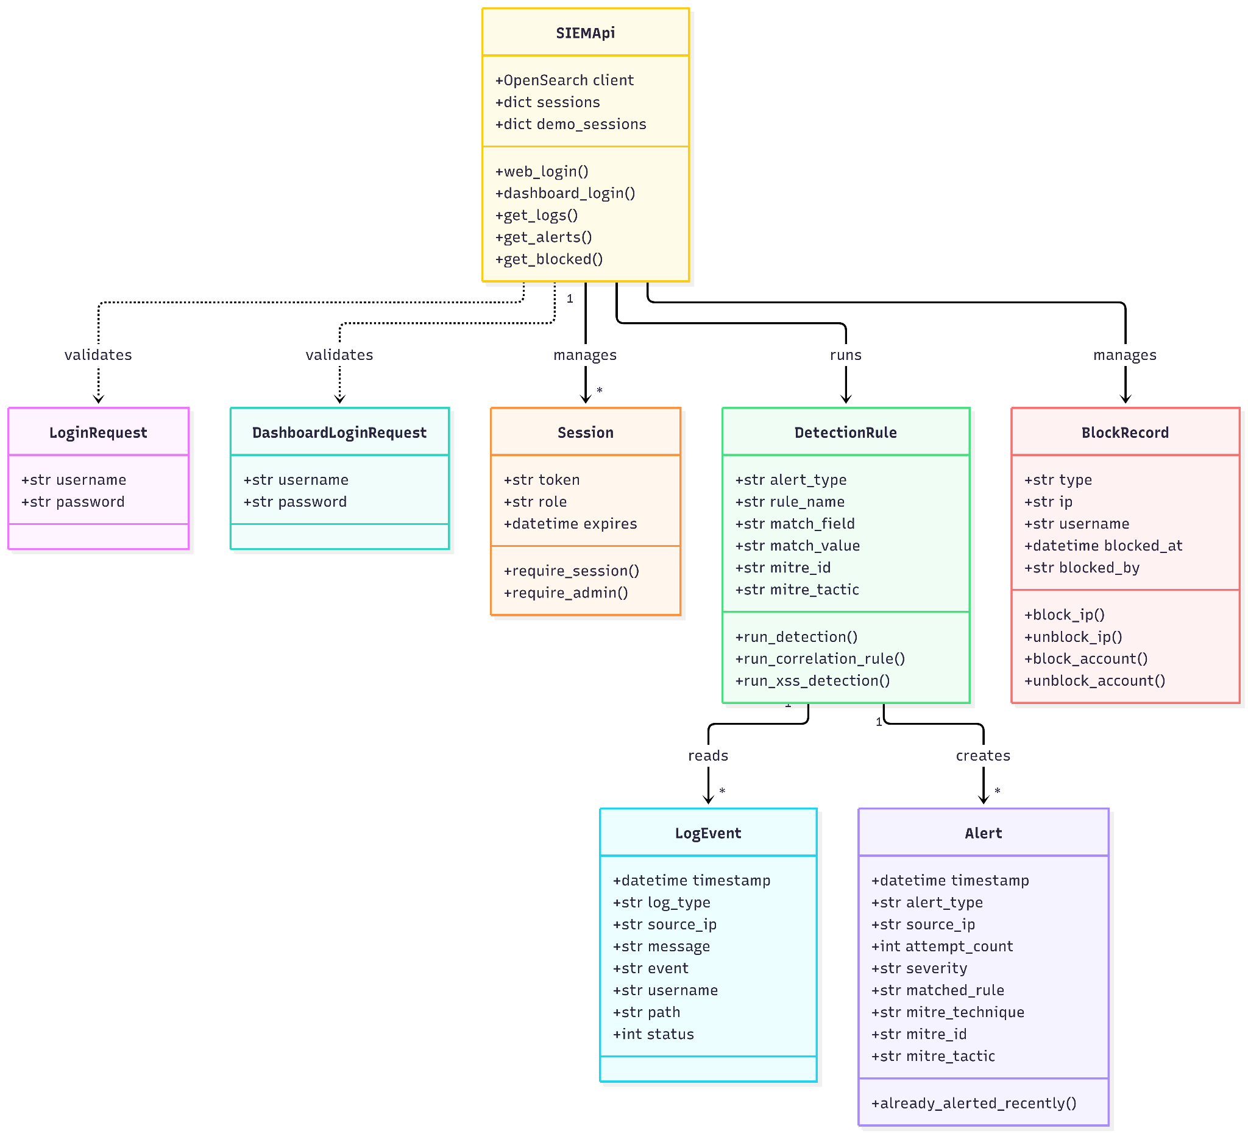
Figure 5.2: Class Diagram
5.3 Activity Diagram
Activity diagrams show the flow of control for the three most important processes in the system.
(a) Demo Login and Logging
The user submits credentials → FastAPI checks whether the account is blocked → checks the password → writes a login_success, login_failed or login_blocked event to the web login log → returns the result. Vector then picks up the new line and ships it to OpenSearch.
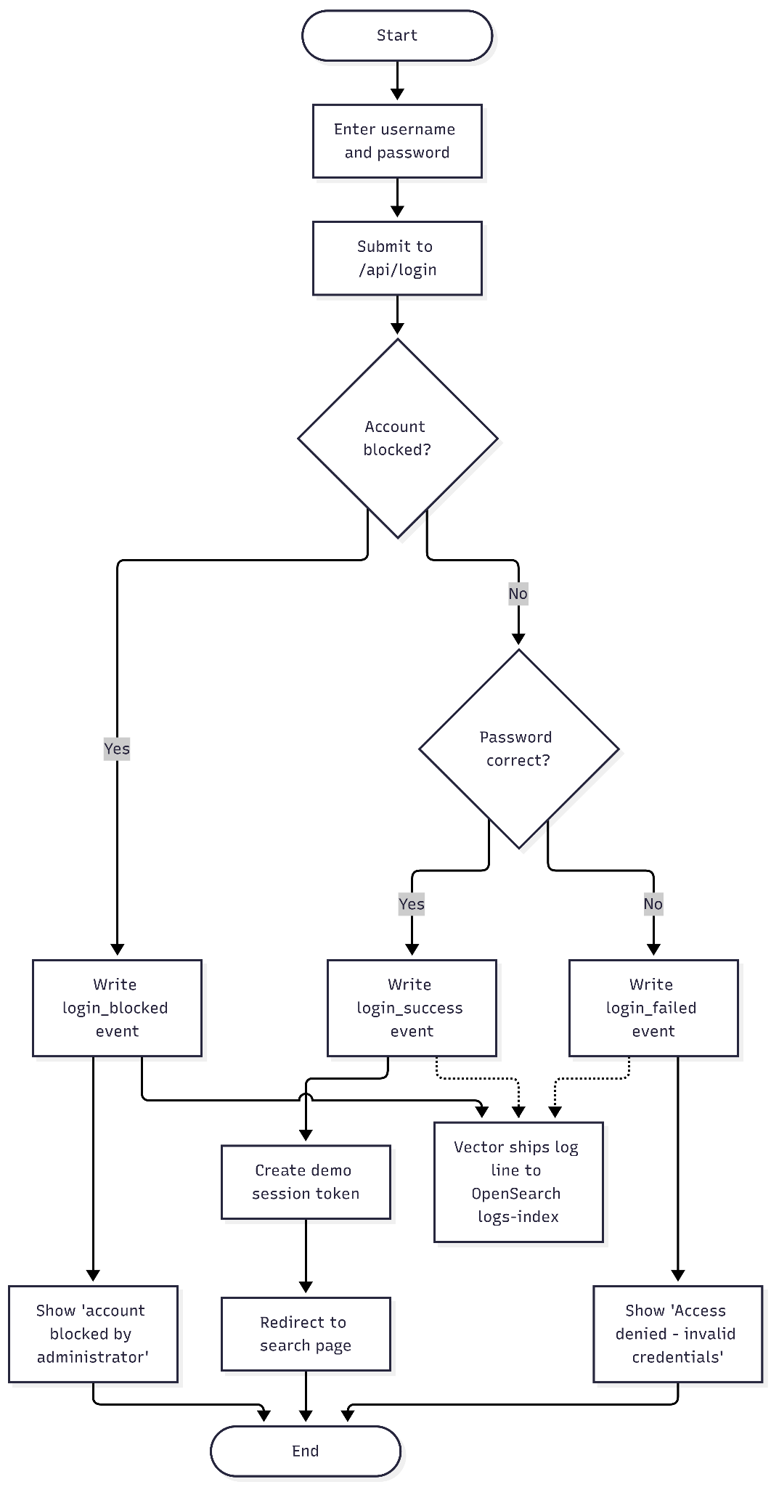
Figure 5.3: Activity Diagram – Demo Login and Logging
(b) Detection Cycle
When the dashboard requests alerts, the engine queries events of the last two minutes for each rule, groups them by source IP, compares the count or sequence against the rule, writes any new alert to alerts-index, and finally returns the alert history.
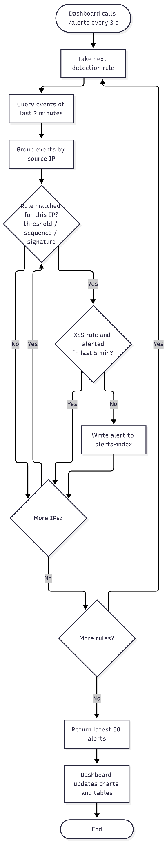
Figure 5.4: Activity Diagram – Detection Cycle
(c) Dashboard Login and Access Control
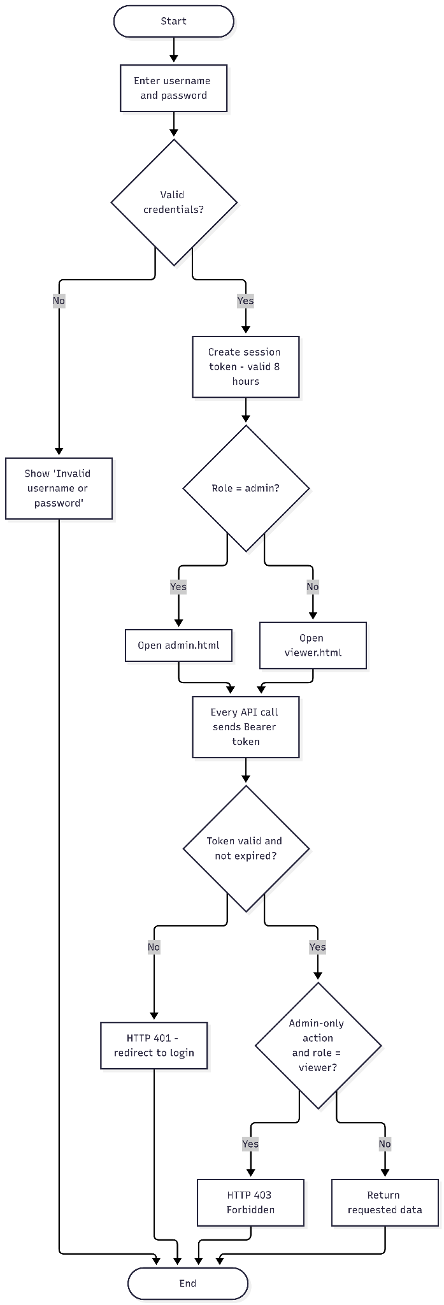
Figure 5.5: Activity Diagram – Dashboard Login and Role Check
5.4 Deployment Diagram
All six components are deployed as Docker containers on one Linux host. OpenSearch, OpenSearch Dashboards, Vector and the two Nginx containers share a Docker bridge network (siem-net). The FastAPI container runs in host network mode with the NET_ADMIN capability, which is required for the planned host-firewall blocking feature. Two named volumes (webapp-logs and nginx-logs) share log files between the containers that write them and Vector, which reads them.
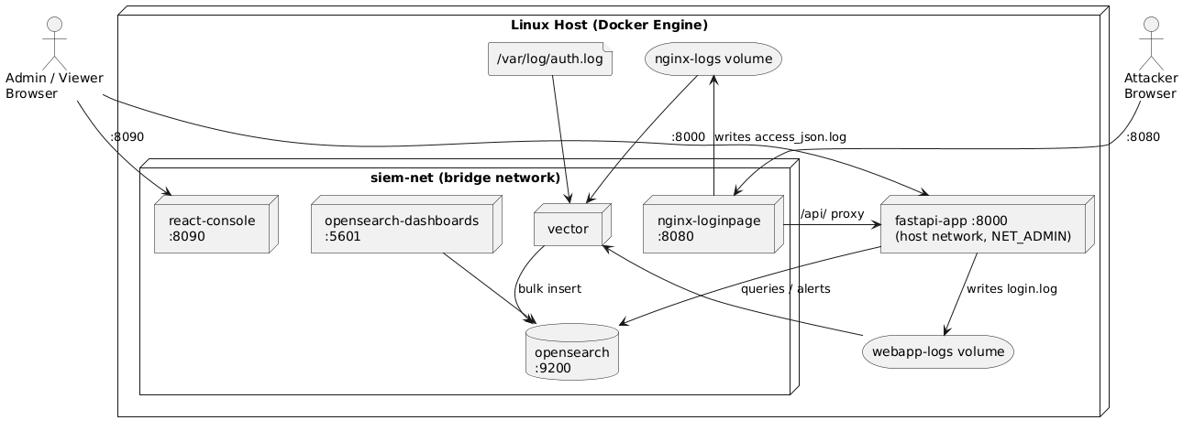
Figure 5.6: Deployment Diagram
Table 5.3: Shared Volumes
Volume / Mount | Written By | Read By
webapp-logs (/var/log/webapp) | fastapi-app (login.log) | vector
nginx-logs (/var/log/nginx) | nginx-loginpage (access_json.log) | vector
/var/log/auth.log (host) | Linux host (rsyslog / sshd) | vector
vector.toml | Developer | vector (read-only)

5.5 Database Design
Micro-SIEM uses OpenSearch, a document-oriented NoSQL store, instead of a relational database. Data is kept as JSON documents in indices (the equivalent of tables). Fields are mapped dynamically; text fields also get a .keyword sub-field used for exact matching. Three indices are used.
Table 5.4: logs-index
Field | Type | Description
timestamp | date | Time of the event (UTC)
log_type | text / keyword | web_login, nginx_access or linux_auth
source_ip | text / keyword | IP address of the client
message | text | Original raw log line
raw_message | text | Copy of the auth.log line (linux_auth only)
event | text / keyword | login_success, login_failed, login_blocked (web_login)
username | text / keyword | Username tried on the demo portal
result | text | success, failed or blocked
method | text | HTTP method (nginx_access)
path | text | Requested URI including query string (nginx_access)
status | long | HTTP status code (nginx_access)
file, host | text | Source file and container added by Vector

Table 5.5: alerts-index
Field | Type | Description
timestamp | date | Time the alert was raised
alert_type | text / keyword | e.g. Web Login Brute Force, XSS Attempt Detected
source_ip | text / keyword | Attacker IP address
attempt_count | long | Number of matching events
severity | text | HIGH
matched_rule | text | e.g. 5_failed_web_logins_2min, xss_signature:<script
mitre_technique | text | Brute Force, Valid Accounts, N/A (OWASP Injection)
mitre_id | text | T1110, T1078 or CWE-79
mitre_tactic | text | Credential Access, Initial Access or N/A

Table 5.6: blocked-index (used by the planned blocking feature)
Field | Type | Description
type | text / keyword | ip or account
ip | text / keyword | Blocked IP address (type = ip)
username | text / keyword | Blocked demo account (type = account)
blocked_at | date | Time of blocking
blocked_by | text | admin

Sample alert document (alerts-index)
{
"timestamp": "2026-09-25T19:26:10.512331",
"alert_type": "Web Login Brute Force",
"source_ip": "192.168.1.25",
"attempt_count": 6,
"severity": "HIGH",
"matched_rule": "5_failed_web_logins_2min",
"mitre_technique": "Brute Force",
"mitre_id": "T1110",
"mitre_tactic": "Credential Access"
}

6. SYSTEM IMPLEMENTATION
6.1 Source Code / Screen Shots
This section presents the most important parts of the source code followed by screenshots of the running system. The complete source code is available in the project repository.
Table 6.1: Project Structure
File / Folder | Purpose
docker-compose.yml | Defines and connects all six services
vector/vector.toml | Log sources, VRL parsing transforms and OpenSearch sink
src/api/main.py | FastAPI back end: logins, sessions, detection engine, blocking
src/api/Dockerfile, requirements.txt | Back-end container image and Python dependencies
nginx/default.conf, nginx/html/ | Demo portal pages, JSON access log format, /api proxy
react-dashboard/ | login.html, admin.html, viewer.html and its Nginx config
docs/PROGRESS.md | Development log, fixed bugs and pending work

Source Code
Code 6.1: docker-compose.yml (excerpt)
services:
opensearch:
image: opensearchproject/opensearch:latest
environment:
- discovery.type=single-node
- DISABLE_SECURITY_PLUGIN=true
- "OPENSEARCH_JAVA_OPTS=-Xms512m -Xmx512m"
ports: ["9200:9200", "9600:9600"]
networks: [siem-net]

vector:
image: timberio/vector:latest-alpine
volumes:
- ./vector/vector.toml:/etc/vector/vector.toml:ro
- /var/log/auth.log:/var/log/auth.log:ro
- webapp-logs:/var/log/webapp:ro
- nginx-logs:/var/log/nginx:ro
depends_on: [opensearch]

api:
build: ./src/api
network_mode: "host"
cap_add: [NET_ADMIN]
environment:
- OPENSEARCH_HOST=localhost
- OPENSEARCH_PORT=9200
volumes:
- webapp-logs:/var/log/webapp

Code 6.2: vector/vector.toml (excerpt)
[sources.webapp_login]
type = "file"
include = ["/var/log/webapp/login.log"]
read_from = "end"

[transforms.parse_webapp]
type = "remap"
inputs = ["webapp_login"]
source = '''
parsed, err = parse_json(.message)
if err == null {
. = merge!(., parsed)
}
'''

[sinks.opensearch_logs]
type = "elasticsearch"
inputs = ["parse_auth", "parse_webapp", "parse_nginx"]
endpoints = ["http://opensearch:9200"]
mode = "bulk"
api_version = "v8"

[sinks.opensearch_logs.bulk]
index = "logs-index"

Code 6.3: Session check and role check (main.py)
def require_session(authorization: str = Header(None)):
if not authorization or not authorization.startswith("Bearer "):
raise HTTPException(status_code=401, detail="Missing or malformed Authorization header")
token = authorization.split(" ", 1)[1]
session = sessions.get(token)
if not session:
raise HTTPException(status_code=401, detail="Invalid session token")
if datetime.utcnow() > session["expires"]:
del sessions[token]
raise HTTPException(status_code=401, detail="Session expired")
return session

def require_admin(session: dict = Depends(require_session)):
if session["role"] != "admin":
raise HTTPException(status_code=403, detail="Admin role required for this action")
return session

Code 6.4: Brute-force detection (main.py, excerpt)
for src in sources:
query = {
"size": 500,
"query": {"bool": {"must": [
{"match": {src["match_field"]: src["match_value"]}},
{"range": {"timestamp": {"gte": since.isoformat()}}},
]}},
}
result = client.search(index=LOGS_INDEX, body=query)
events = [hit["_source"] for hit in result["hits"]["hits"]]

grouped = defaultdict(list)
for event in events:
grouped[event.get("source_ip", "unknown")].append(event)

for source_ip, attempts in grouped.items():
if len(attempts) < FAILED_LOGIN_THRESHOLD:
continue
alert = {
"timestamp": datetime.utcnow().isoformat(),
"alert_type": src["alert_type"],
"source_ip": source_ip,
"attempt_count": len(attempts),
"severity": "HIGH",
"mitre_id": src["mitre_id"],
...
}
client.index(index=ALERTS_INDEX, body=alert)

Code 6.5: Correlation rule — failed attempts then success (main.py)
for source_ip, seq in grouped.items():
fail_count = 0
for event in seq:
if event.get("event") == "login_failed":
fail_count += 1
elif event.get("event") == "login_success" and fail_count >= 2:
alert = {
"alert_type": "Suspicious Login: Failed Attempts Then Success",
"source_ip": source_ip,
"attempt_count": fail_count,
"mitre_technique": "Valid Accounts",
"mitre_id": "T1078",
"mitre_tactic": "Initial Access",
...
}
client.index(index=ALERTS_INDEX, body=alert)
break

Code 6.6: XSS signature detection (main.py)
XSS_SIGNATURES = [
"<script", "onerror=", "onload=", "javascript:", "alert(",
"%3cscript", "document.cookie", "<img", "<svg", "onmouseover=",
]

for hit in events:
path = (hit["_source"].get("path") or "").lower()
matched_sig = next((sig for sig in XSS_SIGNATURES if sig in path), None)
if not matched_sig:
continue
if _already_alerted_recently("XSS Attempt Detected", source_ip):
continue
alert = {"alert_type": "XSS Attempt Detected",
"matched_rule": f"xss_signature:{matched_sig}",
"mitre_id": "CWE-79", ...}
client.index(index=ALERTS_INDEX, body=alert)

Code 6.7: Blocking switched off for a future version (main.py)
BLOCKING_ENABLED = False

def _require_blocking_enabled():
if not BLOCKING_ENABLED:
raise HTTPException(status_code=503,
detail="Blocking is disabled - coming in a future version")

@app.post("/block/{ip}")
def block_ip(ip: str, session: dict = Depends(require_admin)):
_require_blocking_enabled()
...

Code 6.8: Dashboard live refresh and chart colours (admin.html, excerpt)
function alertColor(type) {
if (type.includes('XSS') || type.includes('Brute Force')) return themeColors.rose;
return themeColors.blue;
}

async function refresh() {
const alerts = (await authFetch(`${API_URL}/alerts`)).data.alerts || [];
const logs = (await authFetch(`${API_URL}/logs?limit=200`)).data.logs || [];
...
barChart.data.labels = Object.keys(typeCounts);
barChart.data.datasets[0].data = Object.values(typeCounts);
barChart.data.datasets[0].backgroundColor = barChart.data.labels.map(alertColor);
barChart.update();
}
setInterval(refresh, 3000);

Screen Shots
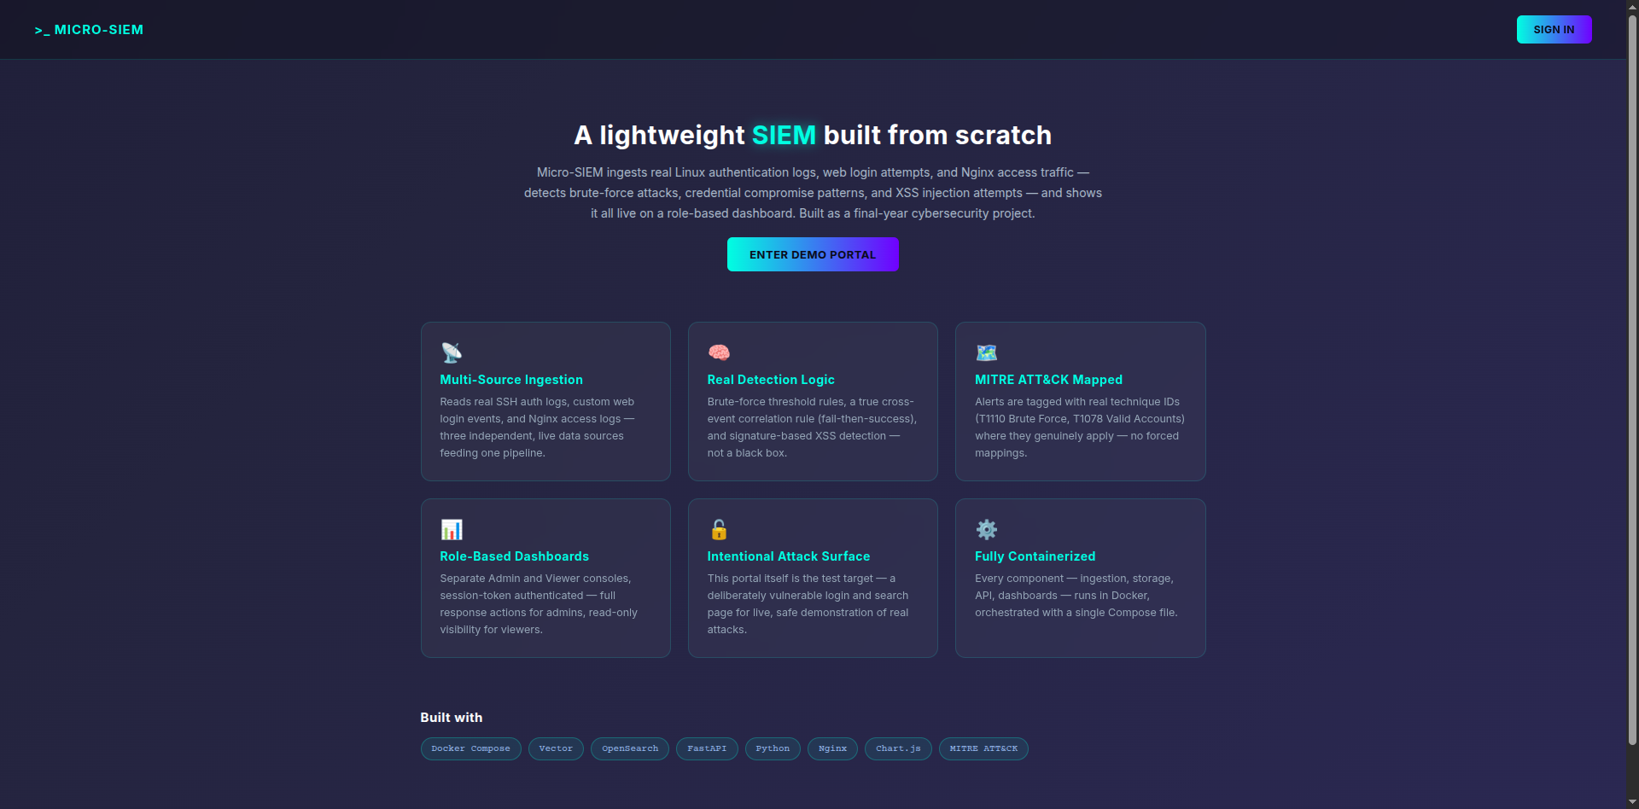
Figure 6.1: Demo Portal – Home Page
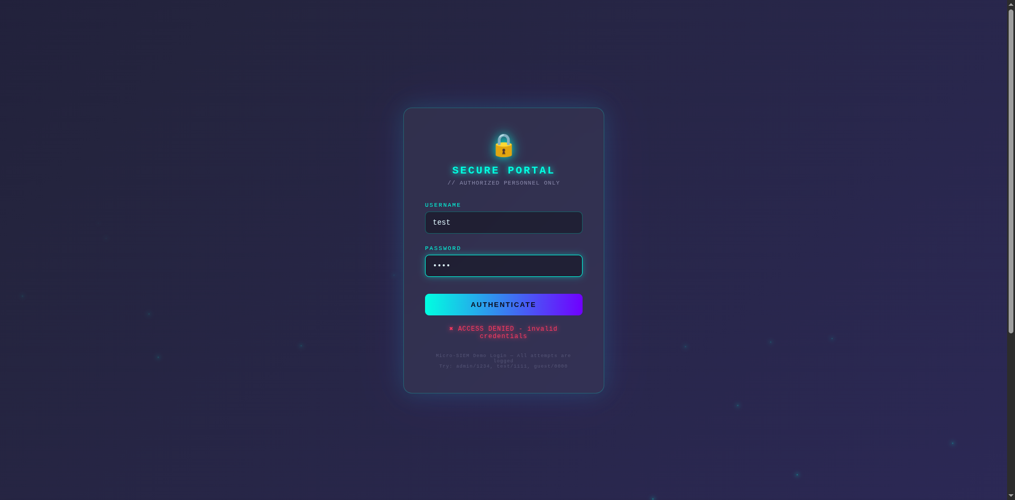
Figure 6.2: Demo Portal – Login Page (Access Denied)
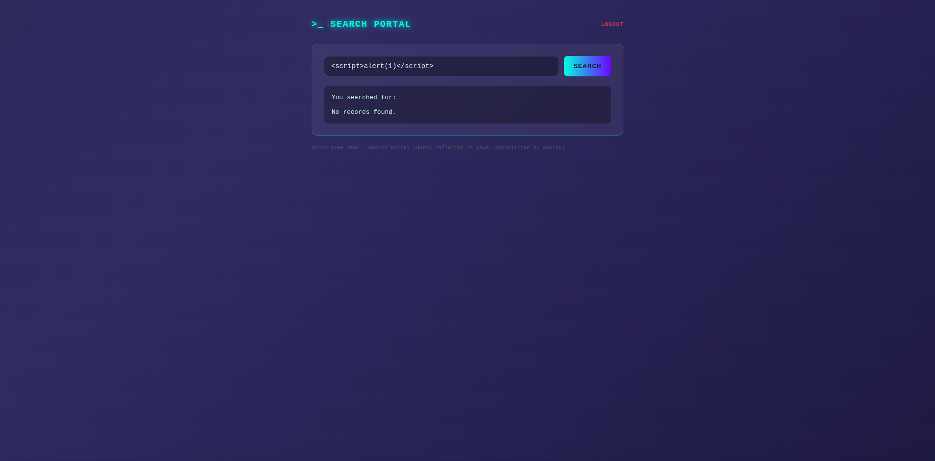
Figure 6.3: Demo Portal – Search Page with XSS Payload
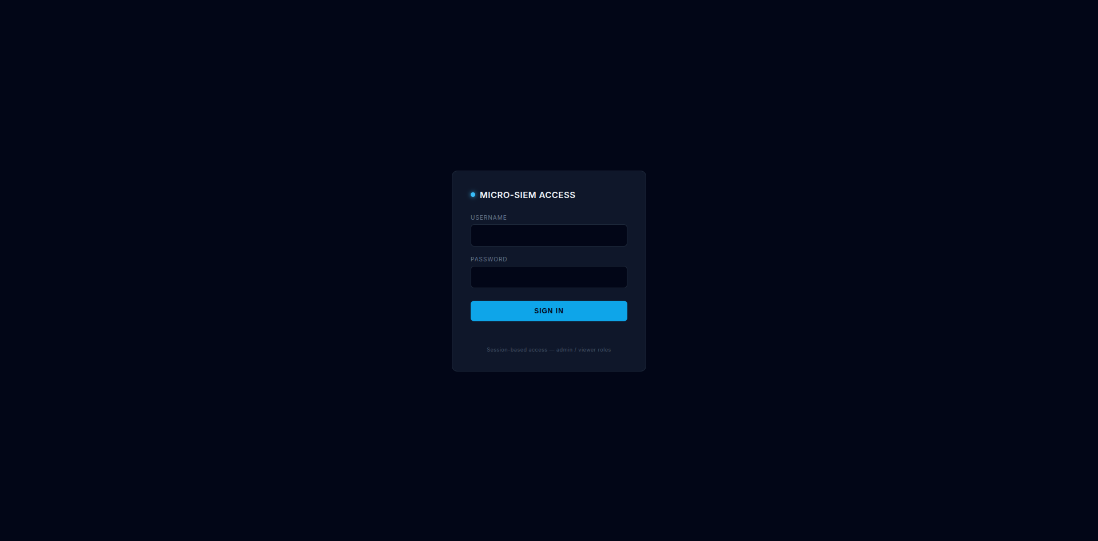
Figure 6.4: Dashboard Sign-In Page
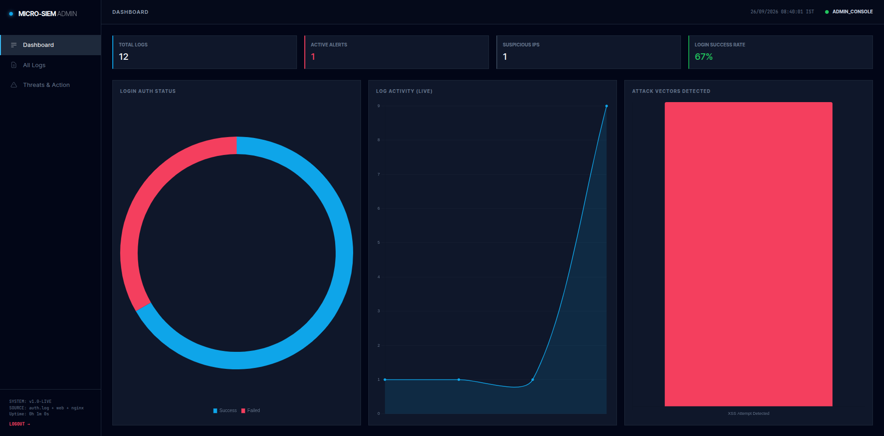
Figure 6.5: Admin Dashboard – Overview
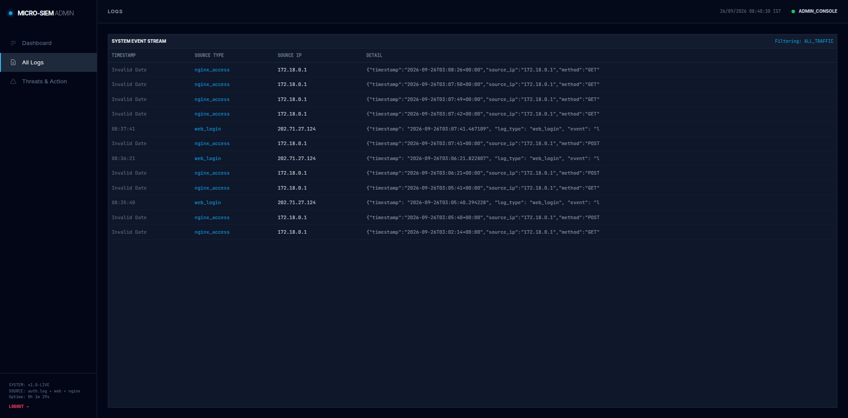
Figure 6.6: Admin Dashboard – All Logs View
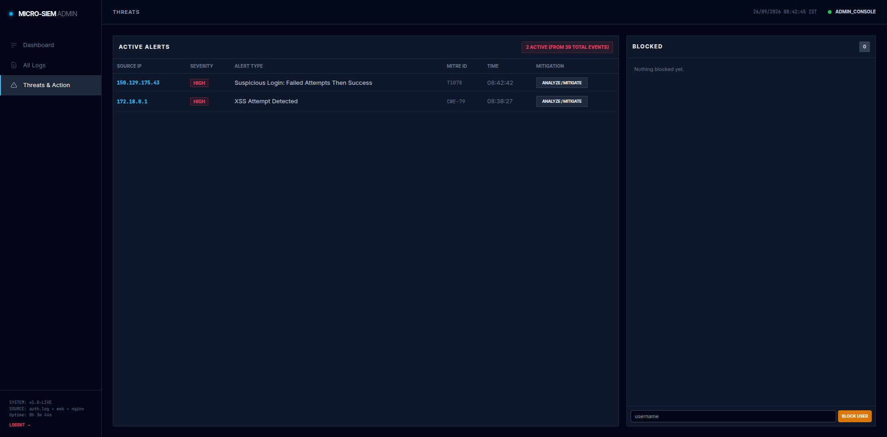
Figure 6.7: Admin Dashboard – Threats & Action View
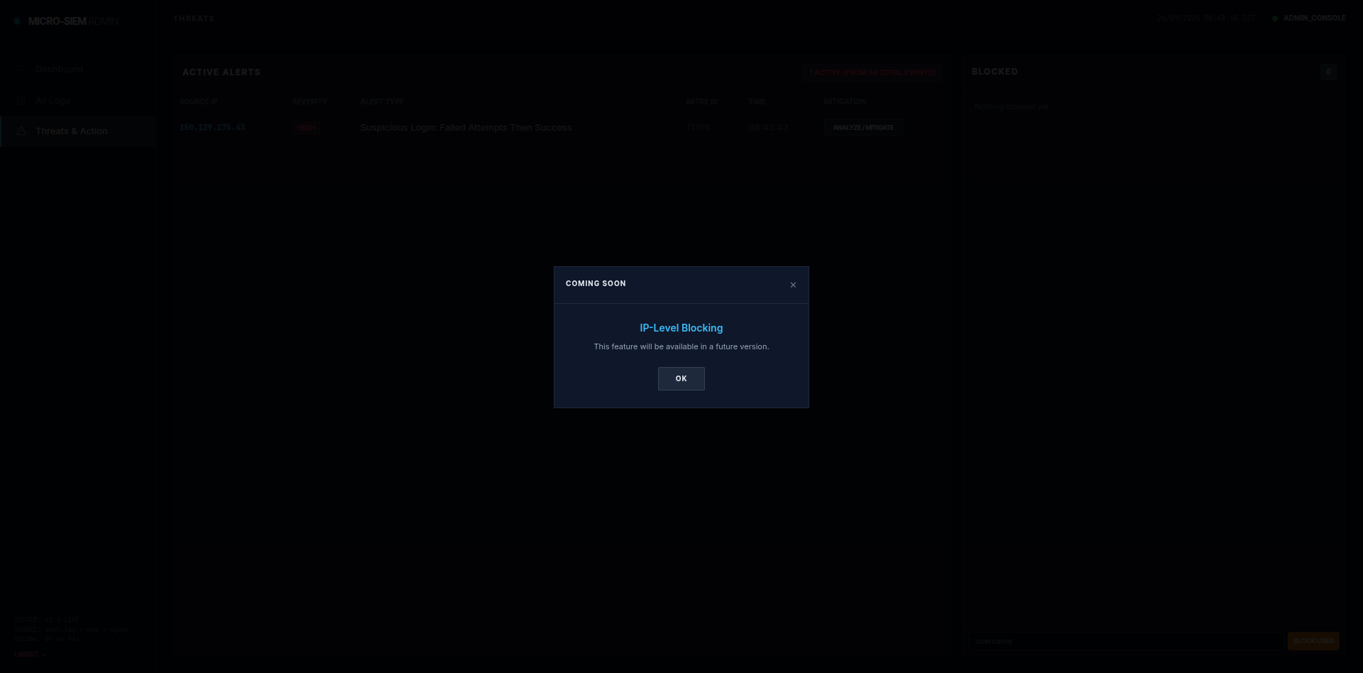
Figure 6.8: Coming Soon Pop-up for Blocking
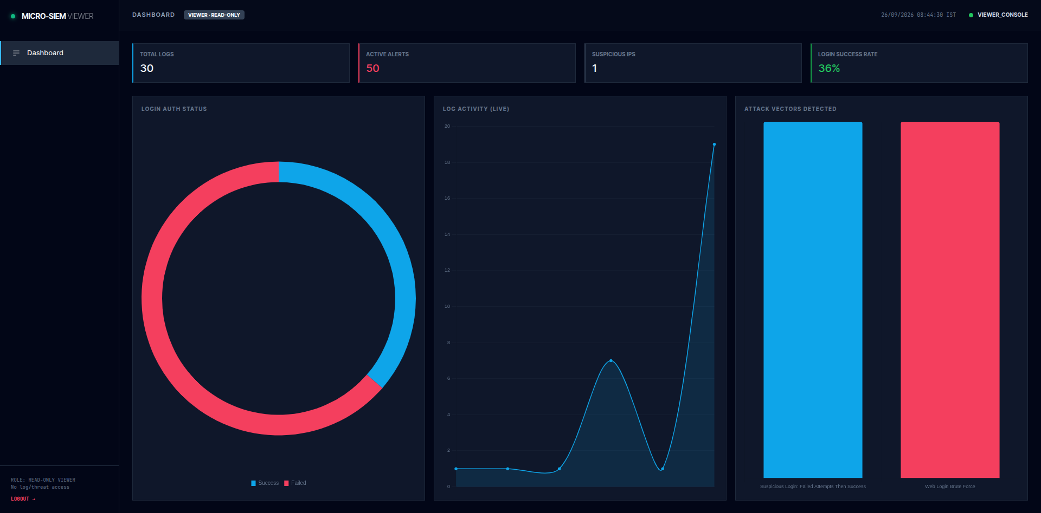
Figure 6.9: Viewer Dashboard (Read-Only)
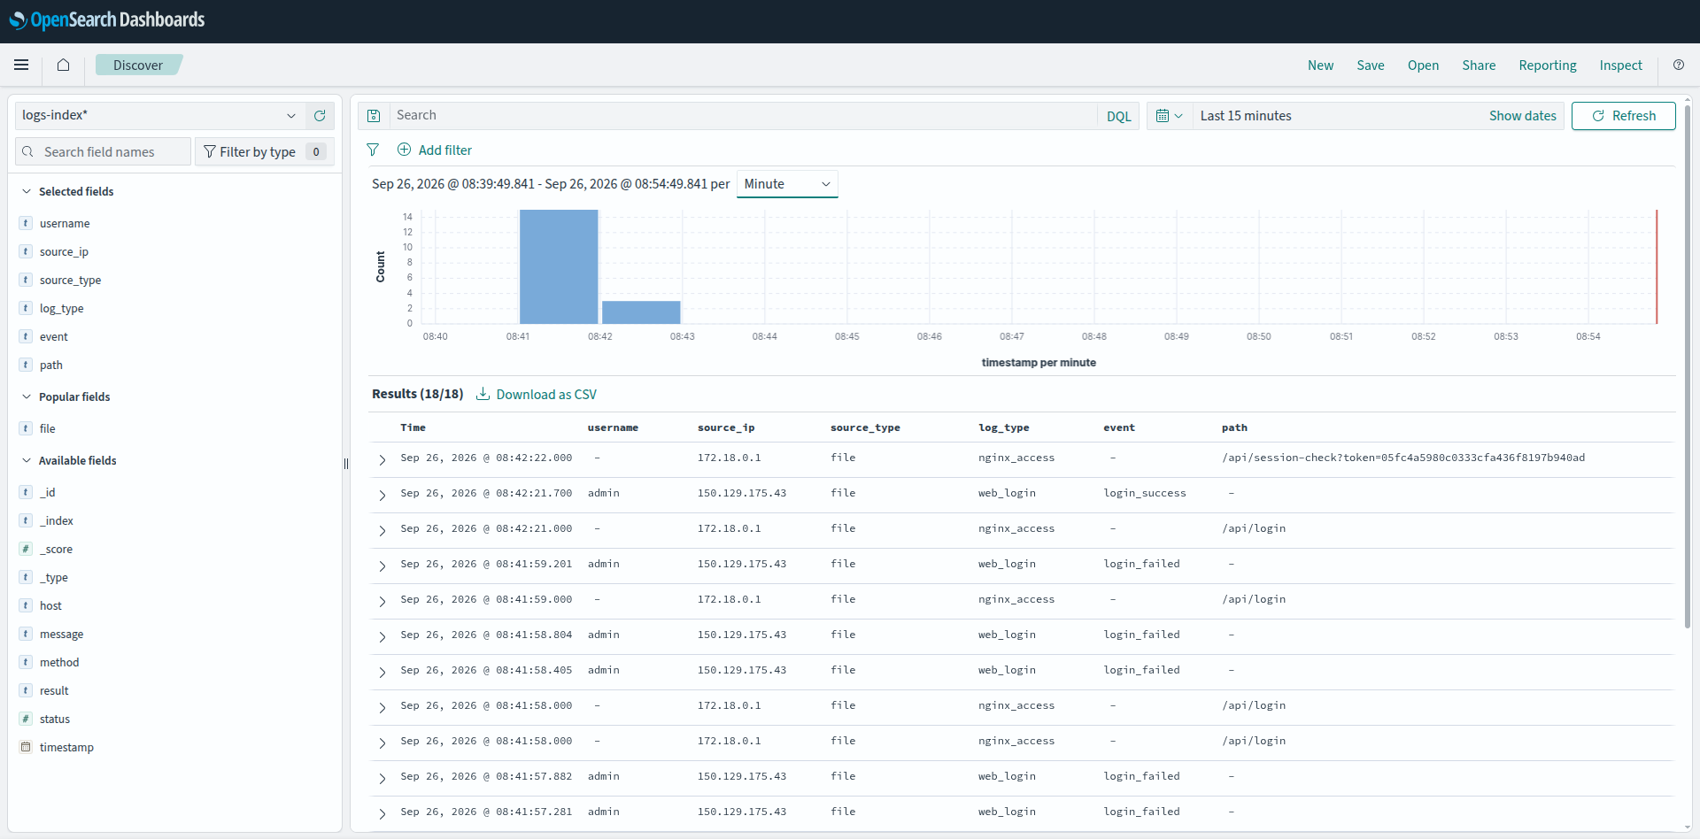
Figure 6.10: OpenSearch Dashboards – Raw Events
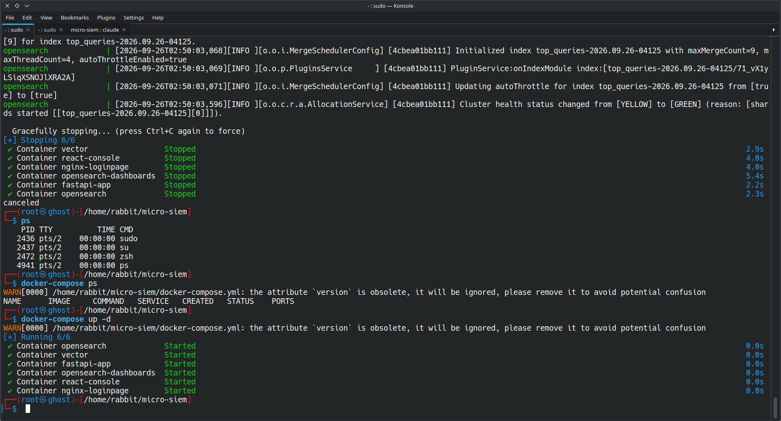
Figure 6.11: Running Containers
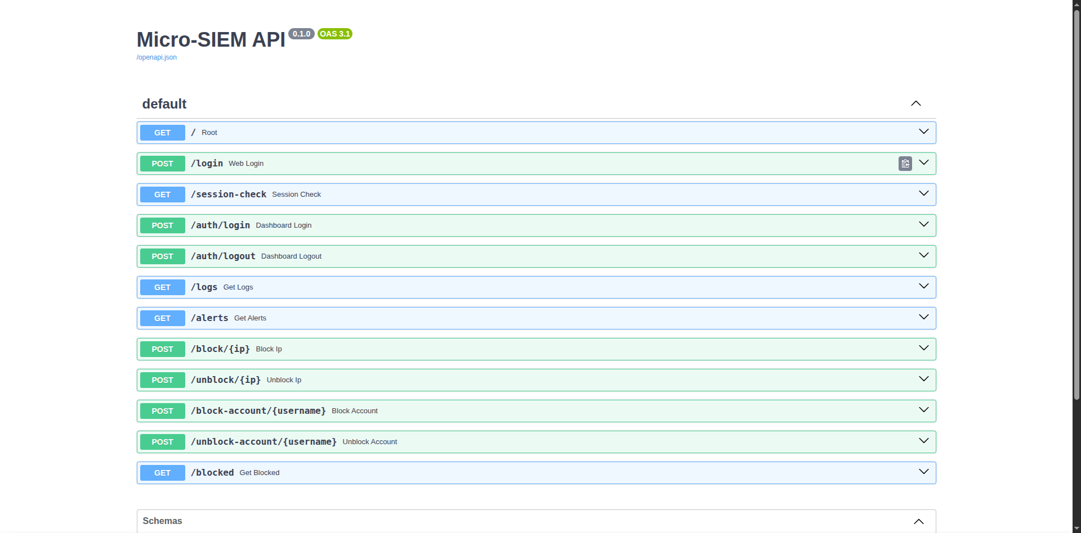
Figure 6.12: FastAPI Interactive API Documentation
7. SYSTEM TESTING
Testing verifies that each part of Micro-SIEM works on its own and that the complete pipeline — from a user action on the demo portal to an alert on the dashboard — behaves as expected. Because this is a security system, testing also included controlled attack simulations against the project's own demo portal.
Testing Strategy
Table 7.1: Levels of Testing
Level | What was tested
Unit Testing | Individual functions: IP-version detection, session expiry, rule thresholds, XSS signature matching.
Integration Testing | FastAPI → log file → Vector → OpenSearch; API ↔ OpenSearch queries; dashboard ↔ API with tokens.
System Testing | The full stack started with Docker Compose and used through the browser.
Security / Attack Simulation | Brute-force logins, fail-then-success, XSS payloads, and access-control checks for the viewer role.
Compatibility Testing | Dashboards on desktop and mobile browsers (Chrome, Firefox), local network and ngrok.

Test Environment
Tests were run on a Linux laptop (Parrot Security OS) with Docker Engine and Docker Compose, all six containers running locally. Requests were made from the same machine using a browser and the curl command-line tool, and from a second device on the same network.
Test Cases
Table 7.2: Test Cases
TC | Test Case | Input / Steps | Expected Result | Status
1 | Start system | docker-compose up -d --build | All 6 containers Up; OpenSearch healthy | Pass
2 | Demo login – wrong password | test / wrong | 'Access denied'; login_failed event stored | Pass
3 | Demo login – correct password | admin / 1234 | 'Access granted'; redirect to search page | Pass
4 | Nginx log ingestion | Open any demo page | nginx_access event visible in logs-index | Pass
5 | Dashboard login – valid admin | Admin credentials | Token issued; admin.html opens | Pass
6 | Dashboard login – invalid | Wrong password | HTTP 401 'Invalid username or password' | Pass
7 | Dashboard login – viewer | Viewer credentials | viewer.html opens, read-only | Pass
8 | API without token | GET /alerts with no token | HTTP 401; dashboard redirects to login | Pass
9 | Web brute force | 6 wrong logins from one IP within 2 min | 'Web Login Brute Force' alert, T1110 | Pass
10 | Fail-then-success | 2+ wrong logins then correct login | 'Suspicious Login' alert, T1078 | Pass
11 | XSS detection | search.html?q=<script>alert(1)</script> | 'XSS Attempt Detected', CWE-79 | Pass
12 | XSS de-duplication | Repeat XSS within 5 min | No duplicate XSS alert for same IP | Pass
13 | Alert history | Wait > 2 min after attack | Alert still visible on dashboard | Pass
14 | Viewer restriction | Viewer calls POST /block | HTTP 403 'Admin role required' | Pass
15 | Blocking disabled | Admin calls POST /block/<ip> | HTTP 503 'coming in a future version' | Pass
16 | Coming Soon pop-up | Click Block / Unblock buttons | 'Coming Soon' pop-up; nothing blocked | Pass
17 | Chart colours | Trigger all alert types | Brute force & XSS bars red; suspicious login blue | Pass
18 | Session logout | Click Logout | Token invalidated; back to sign-in page | Pass
19 | Mobile layout | Open dashboard on phone | Bottom navigation; readable single column | Pass

Attack Simulation Procedure
- Brute force: open the demo login page from a second device and enter a wrong password six times within two minutes. Within seconds the admin dashboard shows a 'Web Login Brute Force' alert with the device's IP and MITRE ID T1110.
- Credential compromise: from a device, enter two or more wrong passwords and then the correct one. The dashboard shows 'Suspicious Login: Failed Attempts Then Success' (T1078).
- XSS: log in to the demo portal and search for <script>alert(1)</script>. The reflected script runs in the page (the intentional vulnerability) and the SIEM raises 'XSS Attempt Detected' (CWE-79).
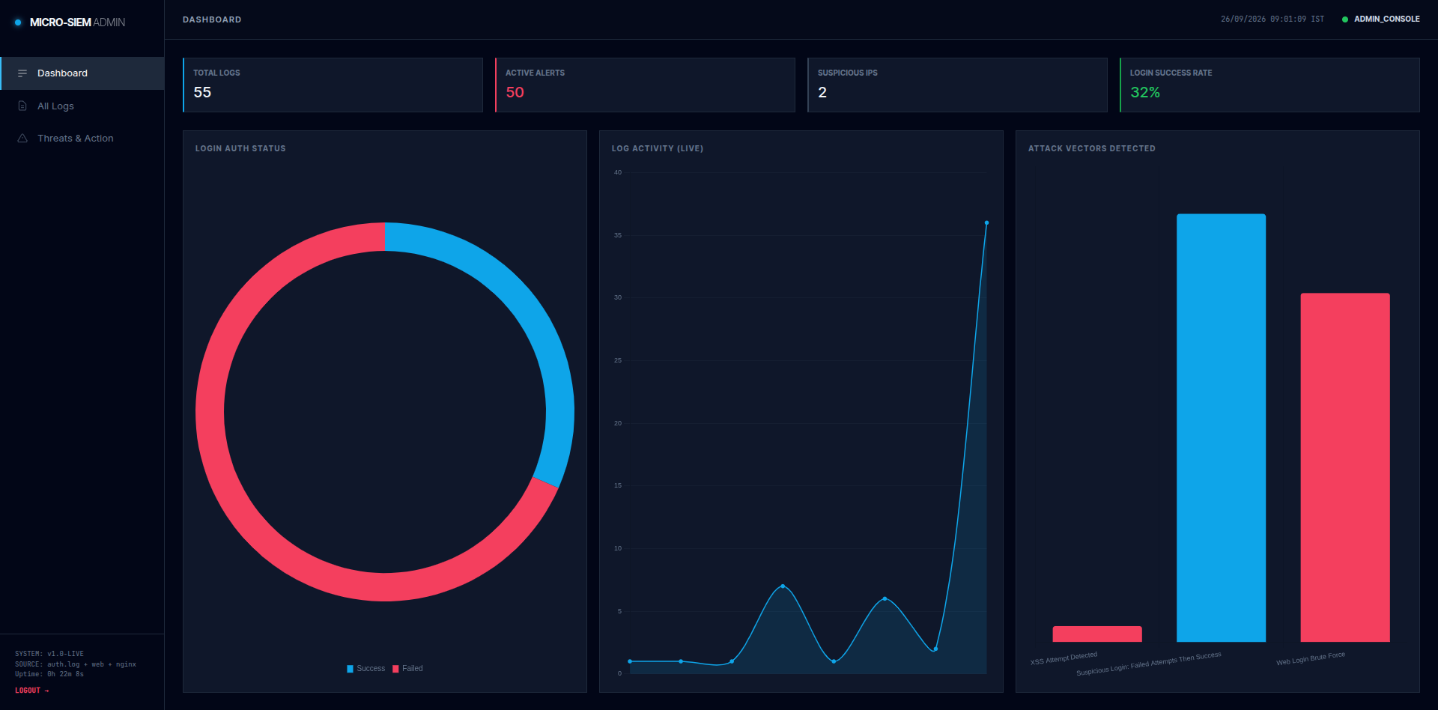
Figure 7.1: Alerts Raised During Attack Simulation
Bugs Found and Fixed During Testing
Table 7.3: Bugs Fixed
Bug | Cause | Fix
Vector → OpenSearch bulk insert returned 400 | New OpenSearch rejects the old _type field | Set api_version = "v8" in the Vector sink
API queried the wrong time field | Vector writes timestamp, not @timestamp | Queries changed to timestamp
VRL merge() compile error | Fallible function needs infallible form | Changed to merge!()
Mobile logins showed the local IP | Client IP read from the socket behind the proxy | Read X-Forwarded-For header
Chart legend showed 'undefined' | No dataset label on single-series chart | Added label, hid legend
Doughnut chart overflowed its panel | Flexbox min-height: auto | min-height: 0 and bounded canvas wrapper
IPv6 address could not be blocked | iptables handles only IPv4 | Auto-select ip6tables for IPv6
Duplicate login entries ~0.6 s apart | Double tap on submit button | Submit lock while request is in flight

8. CONCLUSION AND FUTURE SCOPE
8.1 Conclusion
Micro-SIEM successfully demonstrates the complete working of a Security Information and Event Management system on a small, understandable scale. Real log events from a web application and an Nginx web server are collected by Vector, normalized, stored in OpenSearch and analysed by a custom detection engine. The system detects password brute-force attacks, suspicious fail-then-success logins that indicate a compromised credential, and cross-site-scripting attempts, and it maps each alert honestly to MITRE ATT&CK or OWASP/CWE.
The role-based dashboards present this information live, with clear colour coding and alert history, while server-side session authentication ensures that only authorized users can see the data and that viewers cannot perform administrative actions. The whole system is containerized and starts with a single command, which makes it easy to deploy and demonstrate.
Through this project, practical knowledge was gained in log management, detection engineering, threat frameworks, REST API development, search engines, containerization and secure web development — skills that are directly relevant to a Security Operations Centre (SOC) environment.
8.2 Limitations
- Detection runs when a dashboard requests alerts; it is not yet a separate background service.
- Brute-force alerts are not de-duplicated like XSS alerts, so one ongoing attack can create several alert records.
- The client IP is taken from the X-Forwarded-For header, which a client can set; a trusted proxy header should be used.
- Response actions (IP and account blocking) are disabled in the current version.
- OpenSearch runs without its security plugin and dashboard credentials are fixed in code — acceptable for a lab, not for production.
- Dashboards load Tailwind CSS and Chart.js from a CDN, so an Internet connection is needed.
8.3 Future Scope
- Enable response actions — IP-level blocking at the host firewall (including Docker's DOCKER-USER chain) and account-level blocking.
- Password-spraying detection — many different usernames from one IP (MITRE T1110.003).
- Web scanning / enumeration detection — many different paths requested quickly by one IP.
- Background detection scheduler with de-duplication for every rule.
- More log sources — SSH on production servers, Windows Event Logs, firewall and DNS logs.
- Notifications — e-mail, Telegram or Slack alerts for high-severity events.
- Threat intelligence — enrich IPs with GeoIP and reputation data.
- Hardening — TLS, OpenSearch security plugin, hashed credentials and rate-limited dashboard login.
- Reports — daily or weekly PDF security reports and incident playbooks.
9. BIBLIOGRAPHY
[1] OpenSearch Project. OpenSearch Documentation. https://opensearch.org/docs/latest/
[2] Datadog. Vector Documentation – Sources, Transforms, Sinks and VRL. https://vector.dev/docs/
[3] S. Ramírez. FastAPI Documentation. https://fastapi.tiangolo.com/
[4] Docker Inc. Docker and Docker Compose Documentation. https://docs.docker.com/
[5] Docker Inc. Packet filtering and firewalls (DOCKER-USER chain). https://docs.docker.com/engine/network/packet-filtering-firewalls/
[6] NGINX. Module ngx_http_log_module (log_format). https://nginx.org/en/docs/http/ngx_http_log_module.html
[7] The MITRE Corporation. MITRE ATT&CK – T1110 Brute Force. https://attack.mitre.org/techniques/T1110/
[8] The MITRE Corporation. MITRE ATT&CK – T1078 Valid Accounts. https://attack.mitre.org/techniques/T1078/
[9] The MITRE Corporation. CWE-79: Improper Neutralization of Input During Web Page Generation (Cross-site Scripting). https://cwe.mitre.org/data/definitions/79.html
[10] OWASP Foundation. Cross Site Scripting (XSS). https://owasp.org/www-community/attacks/xss/
[11] K. Kent and M. Souppaya. Guide to Computer Security Log Management, NIST Special Publication 800-92, 2006.
[12] Chart.js Contributors. Chart.js Documentation. https://www.chartjs.org/docs/
[13] Tailwind Labs. Tailwind CSS Documentation. https://tailwindcss.com/docs
[14] Python Software Foundation. Python 3 Documentation – ipaddress, subprocess. https://docs.python.org/3/
[15] I. Sommerville. Software Engineering, 10th Edition, Pearson Education, 2016.

