

MIS41420 — Sports & Performance Analytics

Jayan Kokru | 25209093
Ashwinikumar Rathod | 25212300
Shivani Arora | 25218470
Shivam Bharadwaj | 25224454

MIS41420 - Sports & Performance Analytics
UCD Michael Smurfit Business School

Dead Ball
Success Predictor

User Manual
Dead-Ball Analytics for Coaches, Assistant Coaches & Analysts

TABLE OF CONTENT

S. No. | Content | Page No.
1. | Purpose of the Tool | 3
2. | Functionalities | 3-4
3. | One-time Setup | 4
4. | Launching the Tool | 4-5
5. | Using the Tool | 6-7
6. | Interpretation of Results | 7-8
7. | Working of the Tool | 9
8. | Project File Structure | 9
9. | Troubleshooting | 10
10. | Points to Remember | 10
11. | Group Member Contribution Statement | 11

What is in this submission
This project deliverable has three parts, all of which are required by the module brief.
The following table shows the same:-

 | Requirement | Location
1 | A working sports analytics tool | The application which runs in the browser (dbsp.py) - see Section 4
2 | User manual + group contribution statement | The given document. The contribution statement is in Section 11
3 | Data, code and system files | The src/ code, trained models, data file and config - see Section 8

Learning outcomes shown:
(1) the tool is a real application of analytics in sport;
(2) it applies two machine-learning models to a coaching problem;
(3) it produces engaging visuals and clear documentation.

1. Purpose of the Tool
The Dead Ball Success Predictor supports the team to plan dead-ball routines using data rather than guesswork. It works in the way in the following way:-
- Describe a routine to be used; the type of delivery, the targeted zone, the number of players in the box, and the tool is able to instantly tell:-

- How good a chance it should create : a number called Expected Goals (xG). Higher is better.
- How likely you are to keep the ball : if the first delivery is cleared. the second-ball retention percentage.

The tool is built for the whole support staff including set-piece coaches, assistant coaches and performance analysts. There is no requirement for any code to use it, only click and interaction. In case, there is experience using a data analytics tool before, Section 4 has a walk-through.

2. Functionalities
- Covers all eight dead-ball situations: corner, free kick (wide), free kick (central), penalty, throw-in, goal kick, kick-off and play restart.
- Two predictions at once: chance quality (xG) and second-ball retention probability (%).
- Detailed second-ball plan: predicting where any loose ball is likely to drop, and clear suggestions to keep possession.
- Simple, intuitive controls: drop-downs, sliders and tick-boxes.
- Explainability charts: bar charts that show which tactical factors drove each prediction up or down.
- Routine rating (0–100): a single score helps in comparing multiple routines at once.

3. One-time Setup
There are two requirements for the local system. If Python is already installed and the project folder is already there, skip straight to Section 4. Otherwise, follow Steps 3.1 and 3.2 below.

3.1 Install Python
The tool runs on Python. Go to: python.org/downloads
Download and install version 3.10 or newer.

Important — Windows users:
During installation, look for a checkbox that says, "Add Python to PATH" and tick it before clicking Install. This one step prevents the most common setup error. If you missed it, uninstall Python and reinstall with the box ticked.

3.2 Get the project folder
Once the submission file in unzipped, a folder called dead-ball-success-predictor (or similar) is found. The following are inside it :-

File/folder | What it is
dbsp.py | The main app file
src/ | The behind-the-scenes code (do not move or rename)
models/ | The trained ML models the app reads
data/ | The dataset of dead-ball routines to be used for prediction
requirements.txt | The list of Python packages to install
.streamlit/config.toml | The colour theme settings
README.md | A short quick-start guide
Keep all of these together in the same folder.

4. Launching the Tool
The tool is run from a terminal (also called Command Prompt or command line).

How to open a terminal
- Windows: press the Windows key, type cmd and press Enter.
- Mac: press Command + Space, type Terminal and press Enter.

Step 1 — Navigate to the project folder
In the terminal, type the letters cd followed by a space. Then drag the unzipped project folder onto the terminal window; this fills in the full folder path automatically. Press Enter.
It might look like the following :-
cd /Users/yourname/Downloads/dead-ball-success-predictor

Quick check:
After pressing Enter, type ls (Mac) or dir (Windows) and press Enter. The file dbsp.py is seen listed along with src, models and data. If only dbsp.py is seen, the wrong folder is wrong; try the drag step again.

Step 2 – Installation of Packages (first time only)
This downloads and installs everything the app need to run, needed to run only once.
pip install -r requirements.txt

Wait for it to finish (about 30–60 seconds depending on the internet speed).

Step 3 - Launching the Application
Type the following and press Enter:
streamlit run dbsp.py
where dbsp.py is the application name.

The web browser will open automatically at http://localhost:8501. The welcome page would be seen. Click the green “Predictor Launch” button to enter the tool.

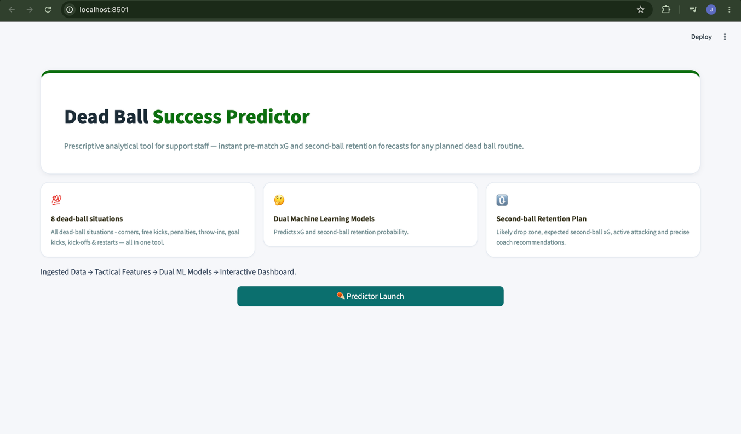

Two Important Rules
1. Always start the app with streamlit run dbsp. py, not python dbsp.py. This would prompt an error.
2. The terminal must be inside the project folder when running.

Stopping the app
Go back to the terminal and press Ctrl + C. The browser tab may stay open, but the application will be offline.

5. Using the Tool
After clicking “Predictor Launch”, the screen has three main areas:

- Console (left sidebar): This is where the routine is set up.
- Result cards (top): This is the three key numbers - KPIs which will update instantly when changes are made.
- Analysis panels (below the cards): charts, second-ball plan, and model performance.

5.1 The Console
The left sidebar is your control panel. Here, the routine is described to analyse. Changes update the results instantly, there is no need to submit.

Control | Precedent | Options
Dead Ball Routine | The planned situation a | Corner, free kick (wide), free kick (central), penalty, throw-in, goal kick, kick-off, play restart
Ball Delivery Type | Type of the ball will be delivered | Inswinger, outswinger, short, long, driven, lofted, straight
Targeted Delivery Zone | Aim location in the box | Near post, central, far post, penalty spot, edge of box, six-yard box, wide channel
Opponent Defensive Tactic | Tactical defence by opposition | High Zonal, Deep Zonal, Man-to-Man, Hybrid
Attackers (slider) | Number of attackers in the box (1–7) | Drag the slider left or right
Defenders (slider) | Number of defenders in the box (3–11) | Drag the slider left or right
Aerial Threat (slider) | Overall aerial quality of attackers (1–10) | Higher = better in the air
Second-ball Runners (slider) | Number of players stationed at the edge of box (0–4) | These win loose or cleared balls

5.2 Tactical triggers
These represents a specific tactical movement or decision within the routine which can be undertaken. Clicking on them, applies it to theplanned routine:

Trigger | Impact
Near-Post Decoy Run | A player makes a run to the near post to pull defenders out of position.
Goalkeeper Screening | A player takes a position that blocks the goalkeeper’s line of sight or movement.
Off-the-ball Blocker | A player legally blocks a defender to free up a team-mate’s run.
Foot Matches Ball Swing | The taker’s dominant foot matches the direction the ball swings.
Runner From Deep | An attacker times a late run from outside the box into the danger area.
Far-Post Overload | Multiple players attack the far-post zone to outnumber defenders there.
Designated Second-Ball Runner | A specific player is assigned to win cleared balls around the box.
Quick Delivery | The ball is played quickly before the opposition defence is set.
Dummy Run | A player makes a decoy run in one direction while the actual target moves elsewhere.

5.3 Randomise and navigation buttons
- Randomise scenario / New scenario: This loads a fresh, realistic random routine across all controls, useful for exploring multiple setups.
- Back: returns to the welcome page.

6. Interpretation of results

6.1 The three result cards
Card | Significance
Expected Goals (xG) | A score between 0 and 1 that measures the quality of the chance the routine is likely to create.
Second-ball retention (%) | The probability that the team wins the ball back if the first delivery is cleared.
Routine rating (0–100) | A combined score that blends xG and retention into a single number.

6.2 Gauge and Driver Charts
- Retention Gauge: This is the semicircular dial which shows the retention % at a glance.
Green zone is Good, Yellow is Moderate, and Red is Low.
- xG driver chart: This is a horizontal bar chart showing the top 10 factors that influenced the xG prediction. Longer bars means bigger influence on the number.
- Retention driver chart: This shows the driver behind the retention probability going up or down.

6.3 The Second-ball Plan
Below the charts you will find the Second-ball Retention Tactic section. This gives you:

Output | Impact
Estimated Drop Zone | Likely location of most cleared balls based on delivery zone
Expected 2nd phase xG | Chance quality if the team wins the second ball
Active second-ball takers | Contribution of tactical triggers to second-ball retention
Second-ball attackers list | Each selected lever can be seen
Coaching recommendations | Precise steps to improve retention based on thecurrent setup

6.4 An Example
If the routine is set to a corner, inswinger, targeting the central zone, against man-marking, with 5 attackers, aerial threat of 7 and 2 edge runners. While, the Near-Post Decoy Run, Blocker, and Designated Second-Ball Runner boxes are also selected.
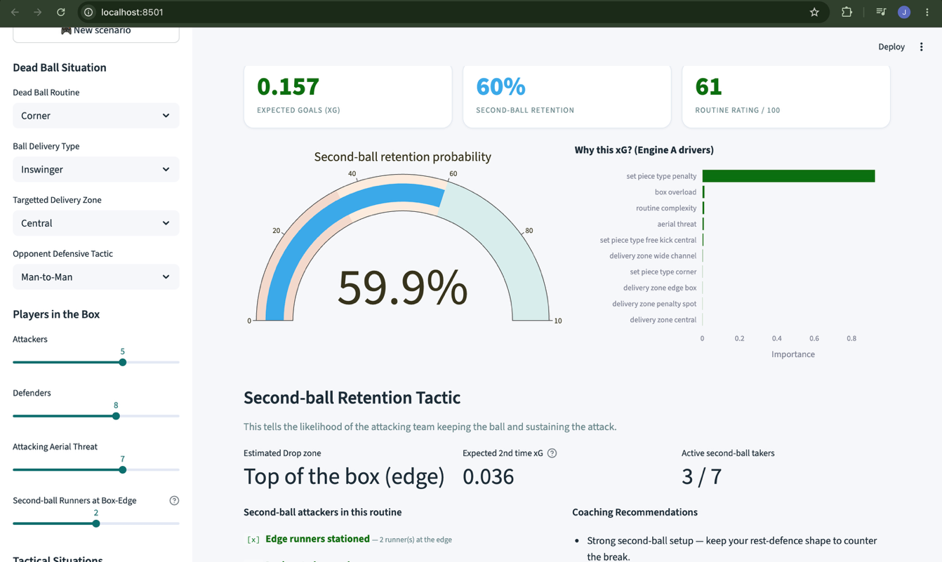
A healthy xG and a strong retention % is seen. If all the triggers are now unselected. The numbers drop noticeably, as seen in the attached dashboard screenshots. This shows the coach the exact impact of tactical triggers. This is the whole purpose of the tool. Not limited to prediction, but also a decision guide.

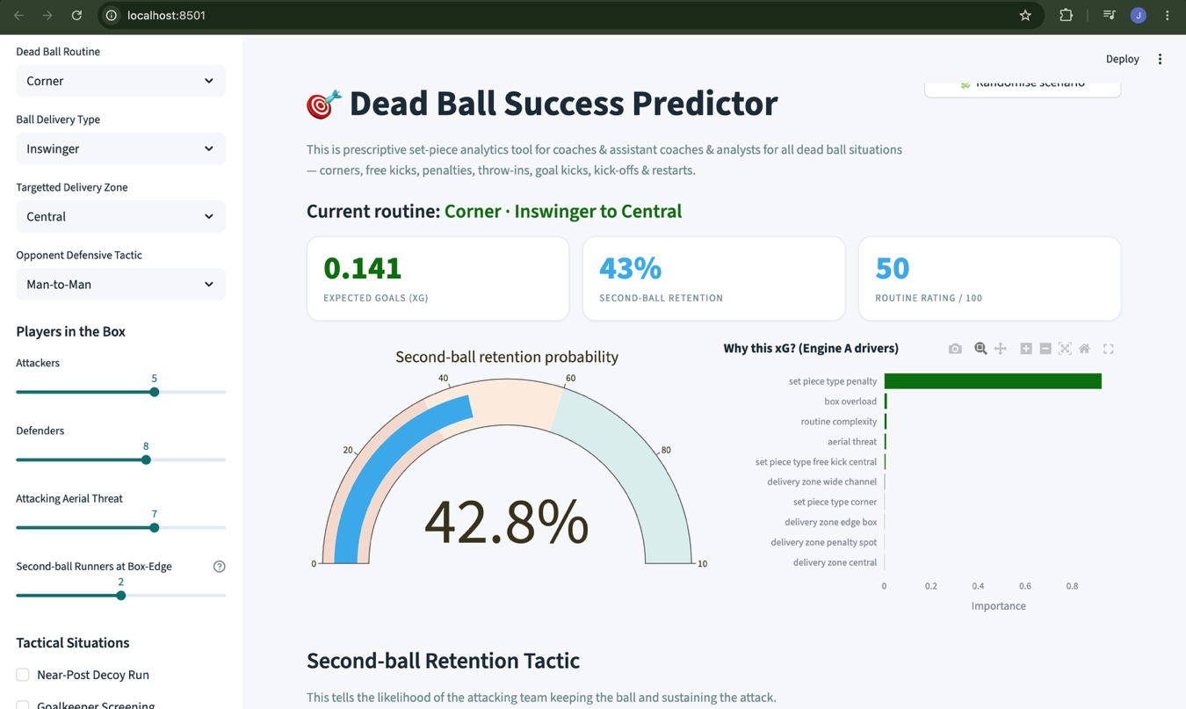

7. Working of the Tool
Not intended to understand to use the tool, but it is useful context for anyone.

7.1 Pipeline
- Data ingestion: Multitude of dead-ball routines are loaded.
- Feature engineering: Each routine is converted into a set of numeric features for the models to learn from: delivery type, zone, personnel numbers, and tactical triggers.
- Model training : Two separate machine-learning models are trained. The first engine is a regressor which learns to predict xG, and the second engine is a classifier which learns to predict retention.
- Prediction: When controls are adjusted, the chosen scenario is instantly scored by both trained models, and the results are displayed.

7.2 Model Performance Summary
Both models are genuinely predictive but are not perfect; set-piece outcomes are inherently unpredictable. The recommendation is to always combine the tool’s output with real coaching judgement.

Engine A: xG model (regressor) | Engine B: Retention model (classifier)
Typical error: ~0.025 xG | ROC-AUC: ~0.73 (good)
R²: ~0.96 across all situations* | Accuracy: ~0.72

7.3 Using Real-time StatsBomb Data
The default dataset is realistic synthetic data and works fully offline. If the team intends to use real StatsBomb data, it can be retrain the models on it by running:

pip install statsbombpy

# Mac / Linux:
PREFER_REAL=1 python src/train_models.py

# Windows PowerShell:
$env:PREFER_REAL=1 ; python src/train_models.py
If the download fails, the tool falls back to synthetic data automatically.

8. Project File Structure

File/folder | Purpose
dbsp.py | The main Streamlit web app.
src/data_ingestion.py | Defines the eight dead-ball types, tactical triggers and loads/generates the dataset.
src/feature_engineering.py | Converts a scenario dictionary into the numeric feature matrix the models read.
src/scenario.py | Random scenario generator, second-ball drop zone logic, retention levers and coaching advice.
src/train_models.py | Trains the two engines and saves them to models/
models/ | Trained model files and metrics.json.
data/set_pieces.csv | The dataset of dead-ball routines used for training.
requirements.txt | Python package list used by pip install -r requirements.txt
.streamlit/config.toml | The green and blue colour theme.

9. Troubleshooting
The following are the most common problems and how to fix them.

Error or symptom | Purpose
python is not recognised or command not found | Python is not installed or not on PATH.
No module named src | The project folder is not at the correct destination
ScriptRunContext warning, or the browser tab opens to an error | The application is started with the wrong command. With python dbsp.py instead of streamlit run dbsp.py.
The browser does not open automatically | Look at the terminal output. Copy the Local URL and paste it into the browser address bar.
“Models not found” banner in the app | The trained model files are missing. Run python src/train_models.py once in the terminal, then run streamlit run dbsp.py again.
Package install errors during pip install | Try upgrading pip first. Then, python -m pip install --upgrade pip.  Run pip install -r requirements.txt again.  On Mac, prefix with python3 / pip3.

10. Points to Remember
- Predictions are Guidance, Not Guarantees: Always combine the tool’s output with real coaching judgement and knowledge of the specific team and match context.
- Offline by Default: The tool uses realistic synthetic data and runs entirely on your local computer; no internet connection is needed after setup.
- Rate inputs Consistently: Changing ratings arbitrarily between scenarios makes comparisons meaningless.
- Retrain with real data for match-grade use: For production use, retrain the models on the club’s own data or licensed event data (see Section 7.3).
- The zip ships with pre-trained models: Step 2 of Section 4 can be skipped on subsequent runs; the models are already saved in models/.

11. Group Member Contribution Statement
Team member | Main contributions | Contribution %
Jayan Kokru | Project lead. Designed the overall system architecture, built and tuned the two engines xG regressor retention classifier, and integrated both models into the Streamlit app. | 35%
Ashwinikumar Rathod | Data pipeline development. Responsible for data ingestion, synthetic data generation, and the feature engineering module that converts tactical scenarios into model-ready numeric inputs. | 25%
Shivani Arora | Dashboard and visualisation. Built the front-end UI layout, designed the second-ball retention plan section, authored the user manual, and handled app testing across scenarios. | 20%
Shivam Bharadwaj | Scenario logic and documentation. Developed the scenario module including random scenario generation, drop zone logic, retention levers and coaching recommendations. Contributed to final report and submission packaging. | 20%

