## horizontal line

# Phase 2 Project Phase-2: Become a back-end expert

Learners Academy School Online Admin Management System version 1.0

Specification Document

----------------------------------------------------------------------------------------------------------------------------

**Document Version 1.0**

**Latest updated: 29-Nov–2020**

**Author: Jayanta Acharjee**

**Content**

**1 . About this Document………………………………........2**

**1.1 How this Document is organized ……………………………………………………….. 2**

**1.2 Contact Information..……………………………………………………………………. 3**

**2 . Introduction……………………………………………....4**

**2.1 Objectives…………………………………………………………………….………........ 4**

**3. Flow chart………………………………......................... .5**

**3.1 Flow chart diagram…….…………………………………………………………………… 5**

**4. Sprint Trello kanban board…………………………… 6**

**4.1 Sprint 1…………………………………………………………………….………...............6**

**``` 4.2 Sprint 2…………………………………………………………………….………...............7**

**5 . Solution Overview………………………………………..8**

**5.1 User Interfaces …………………………………………………………………………. … 8**

**6 . Github link……………………………………………....14**



1. **About this Document**

**This functional and integration (FIS) document will enable you to understand the proposed solution of Learners Academy School Online Admin Management**

**The content of the document will have a solution and its configuration details as it will be available for our client.**

**1.1  How this Document is organized**

**This document is organized into following chapters:**

**Chapter 2 - "Introduction" provides solution scope to be delivered to our Client.**

**Chapter 3 - "Flow chart" provides how the user is interacting with the application.**

**Chapter 4 - "Sprint Planning" provides how the application was developed in each sprint.**

**Chapter 5 - "Solution Overview" provides information on Learners Academy School Online**

**Admin Management System Components in system.**

**Chapter 6 - “Open Items” provide information about the software enhancement**

**still to be done.**

**Chapter 7- “Github link” provides the information where the project is located.**

**1.2    Contact Information**

**Learners Academy welcomes your comments and suggestions on the quality and usefulness of this document. For any questions, comments, or suggestions on the documentation, you can contact us at the following address:**

|  |
| --- |
| **For India Enquiry              .**  **Jayanta Acharjee**  **Tel: +91 9101929290**  **contact_us@Learners Academy.com** |



**2 .   Introduction**

**This document describes the implementation of *Learners Academy* School Admin online management system and how its users can interact with the application.**

**Background:**

Learner’s Academy is a school that has an online management system. The system keeps track of its classes, subjects, students, and teachers. It has a back-office application with a single administrator login.

**2.1    Objectives**

**The objective of this document is to describe how the solution of *Learners Academy* will integrate with Admin user to execute various roles.**

**This document also provides information on end to end workflow flow so that business users can understand the features and functionalities of the *Learners Academy School Online Management System***

**The workflow mainly involves the following important aspects,**

**The administrator can:**

● Set up a master list of all the subjects for all the classes  
● Set up a master list of all the teachers  
● Set up a master list of all the classes – Class V to Class X  
● Assign classes for subjects from the master list  
● Assign teachers to a class for a subject (A teacher can be assigned to different classes for different subjects)  
● Get a master list of students (Each student must be assigned to a single class)

There will be an option to view a Class Report which will show all the information about the class, such as the list of students, subjects, and teachers  
       
The goal of the company is to deliver a high-end quality product as early as possible.



**3 . Flow chart:**

Launch

***Learners Academy School Online Admin Management System***

User lands on Index Page

Admin user is provided with login option

Login page

NO

Valid login

**­­­**

Try Again

IF

1. Add/View Student
2. Add/View Subject
3. Add/View Teacher
4. View Class
5. Assign Class for Subject
6. Assign Teacher for Subject
7. View Class Report

YES

Welcome Page

**END**



**4. Sprint planning**

Learners Academy Admin Management System V1.0

1. Project needs to be completed in 3 sprints: Approx. 21 working days
2. Developer for the initial release: Jayanta Acharjee
3. We are using Git Project Dashboard for tracking. Required Work Items are created in Git Projects To Do List.
4. New Features to be marked as **NF**, Bugs are **BG**, Product Backlog as **PB** and change request are **CR**.
5. Initially all Work Items are mapped under to do list.
6. Work Items List:

1. NF001: Project set up with Database creation and config.

2. NF002: Configure index page/Launch Dashboard for Learners Academy

3. NF003: Admin Login Page Config

4. NF004: Dashboard page design after login, With Admin Welcome message.

5. NF005: Validating Classes into Database through application.

6. Nf006: Listing all the classes in application

7. NF007: Adding subjects into Database through application.

8. NF008: Listing all subjects in application.

9. NF009: Adding Teachers into Database through Application.

10. NF010: Listing all teachers in application

11. NF011: Adding students into Database through Application

12. NF012: Listing all students in application

13. NF013: Assigning subjects-class mapping

14. NF014: Assigning classes-teacher mapping

15. NF015: Assigning subjects-teacher mapping

16. NF016: Generating Class Reports

Work Distribution

Sprint 🡪 Start Date: 16th November,2020, End Date: 5th December,2020

Sprint 1: First 8 WI work Items: NF001 to NF008 needs to be completed.

Sprint 2: Last 8 WI Work Items: NF009 to NF016 needs to be completed.

Sprint 3 : Product Backlog, Change Request and Bug fixing on priority

<https://github.com/jay03101993/Datamaster/projects/1>

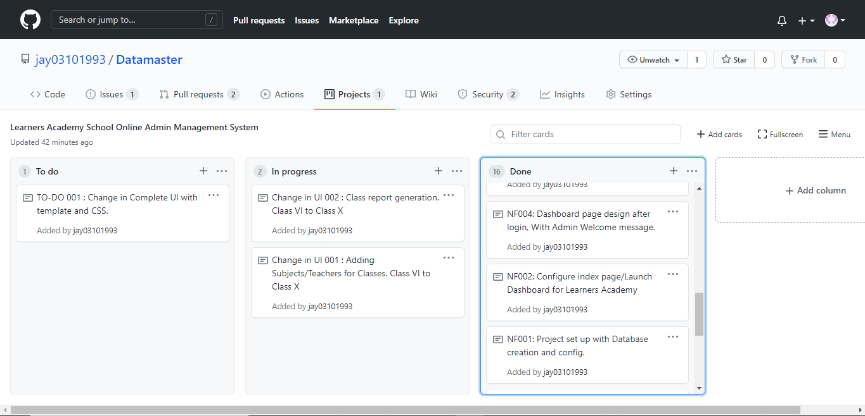



**5 Solution Overview**

**Platform requirement**

**The platform used for this project is eclipse IDE, Tomcat, XAMPP- PHPMyAdmin : MySQL database, Firefox/IE/Chrome Browser, Notepad++ or Sublime Text**

1. User Launches the Application. It has basic description and Admin Login Link. User clicks on the Admin Login link.

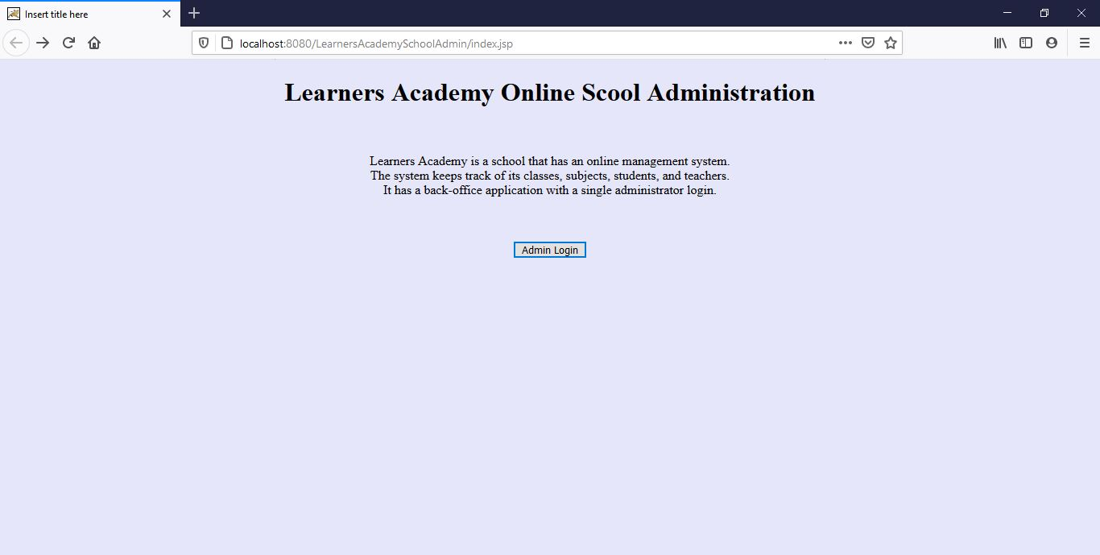

1. In Login Page User Enter valid username/password. As of now this is admin/1234.

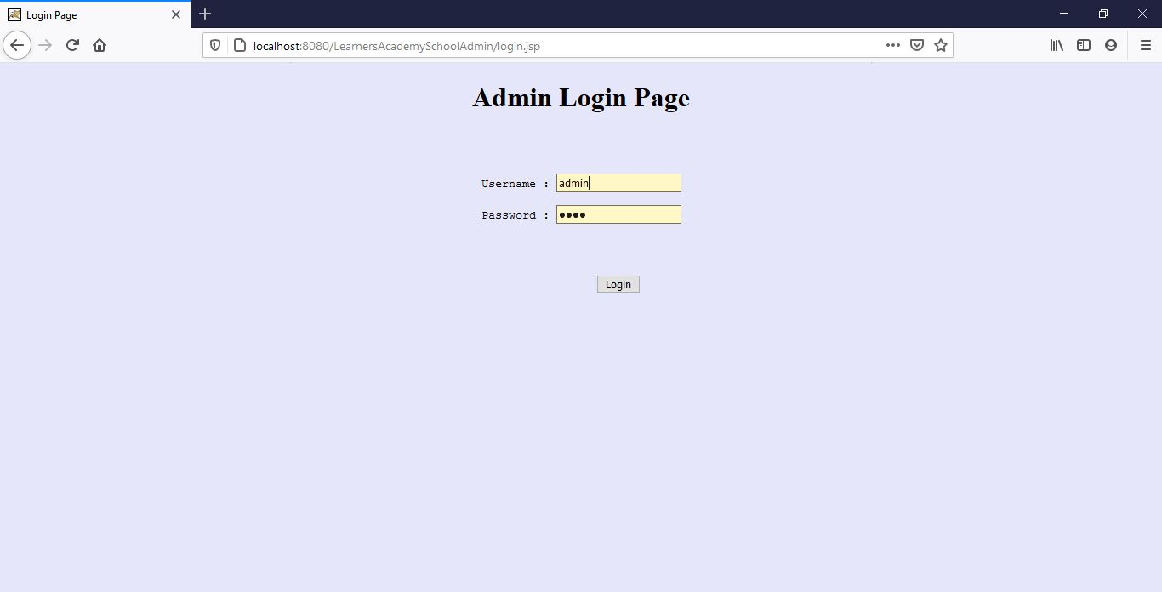

1. After Login User lands on Welcome Page. User Clicks on Add a student Button.

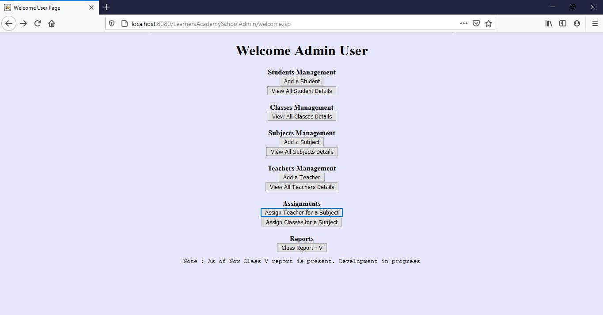

1. User Enters Student Name as Simplilearn Student and Class V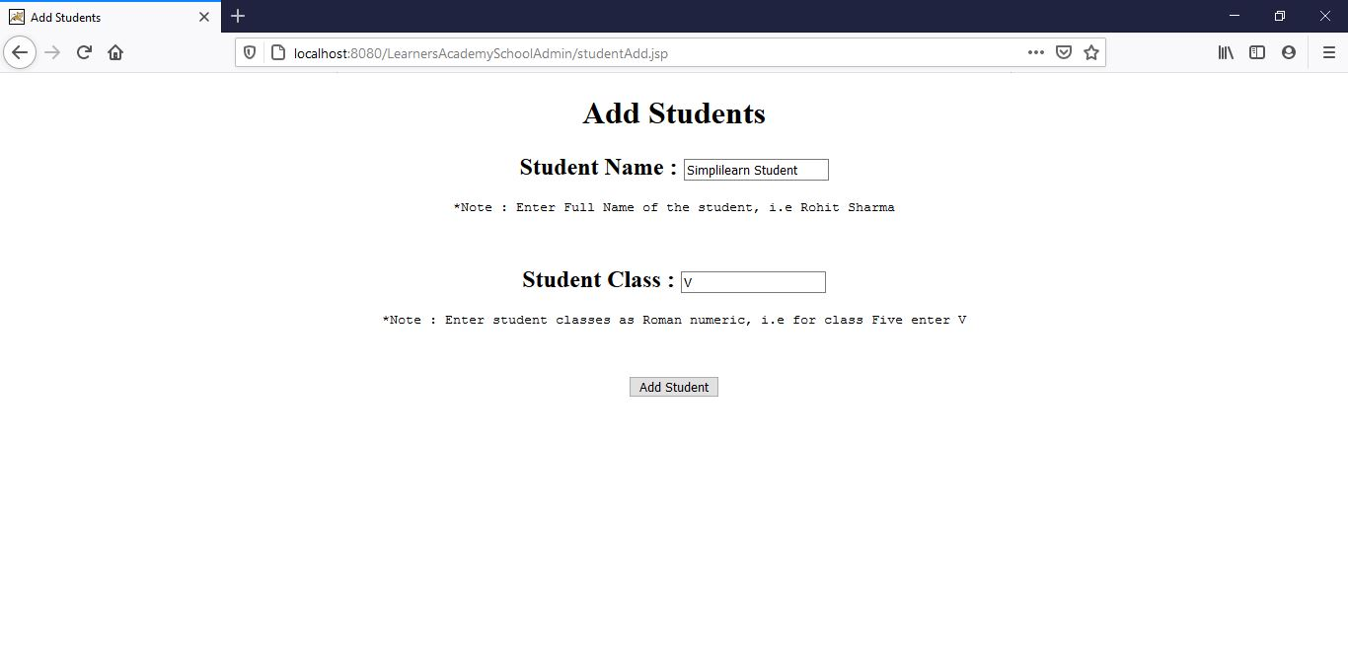
2. Student added successfully 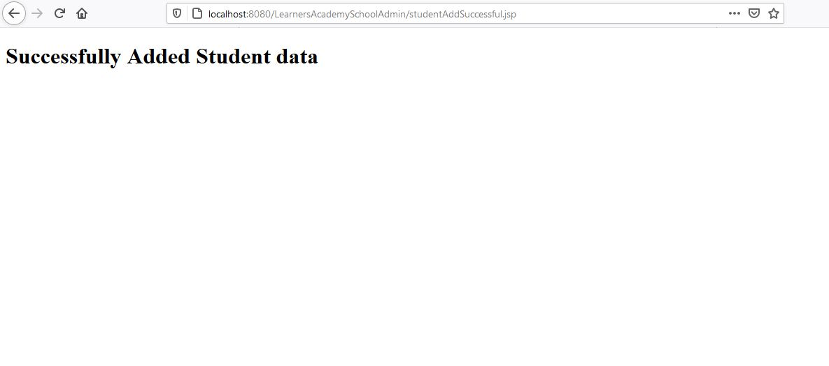
3. View Student added is listed in View, so Click on View Students list.

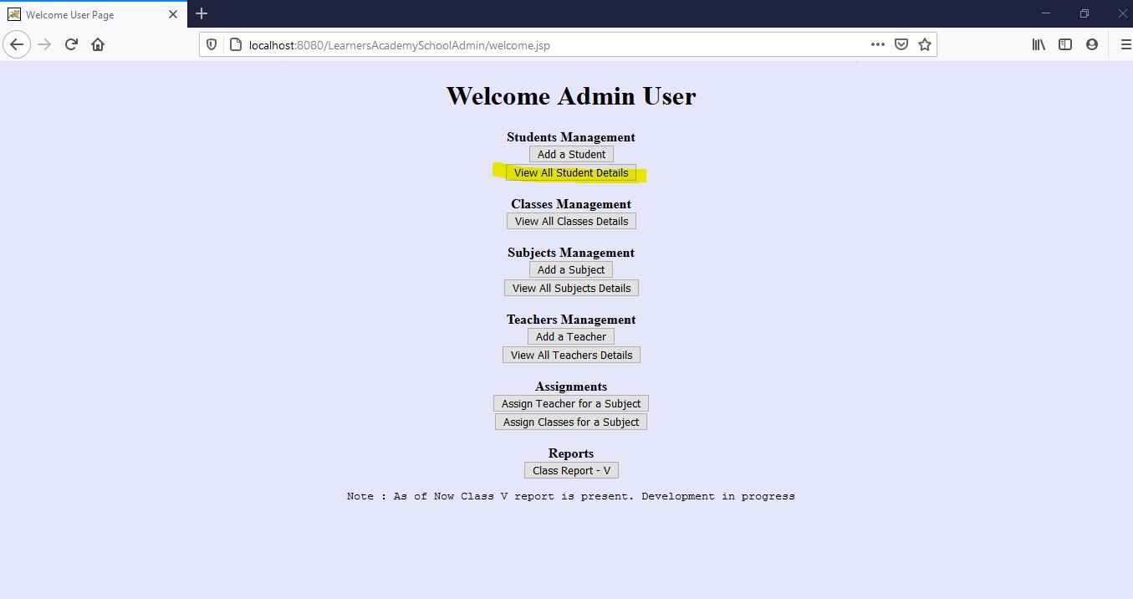

1. This displays all students’ details. It is the master list of all students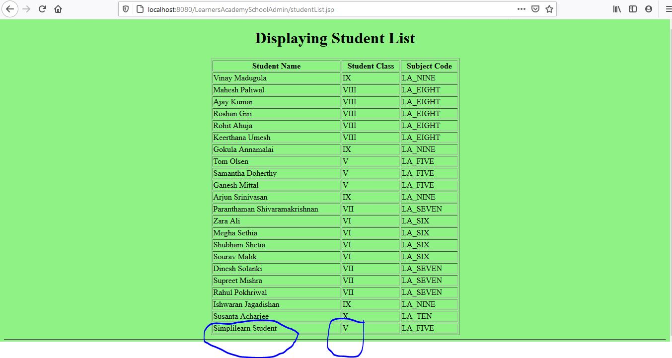
2. Now click View All Classes Details

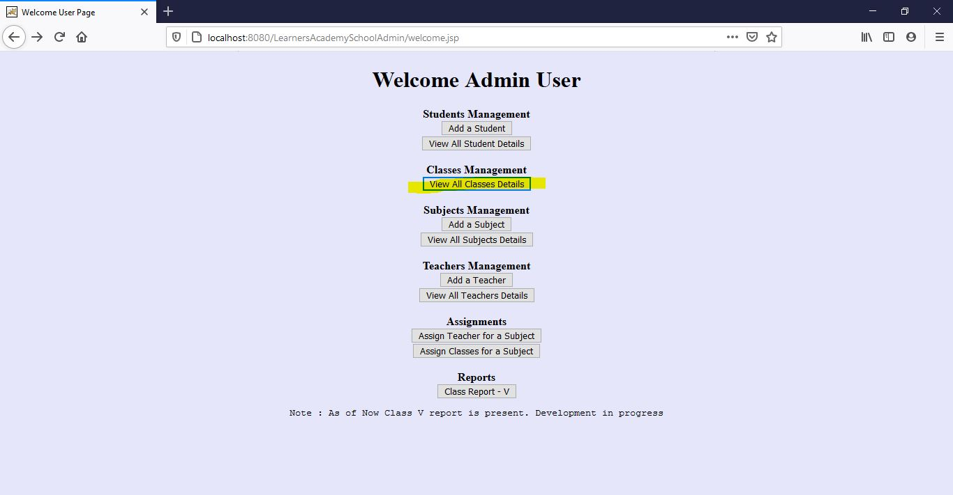

1. It will display all the classes list from Class V to Class X

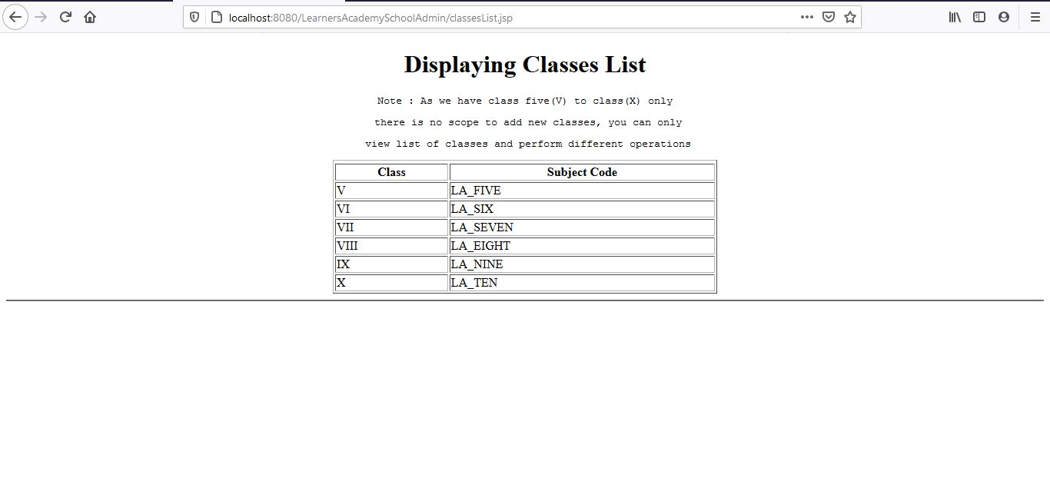

1. User clicks on Add Subjects Button

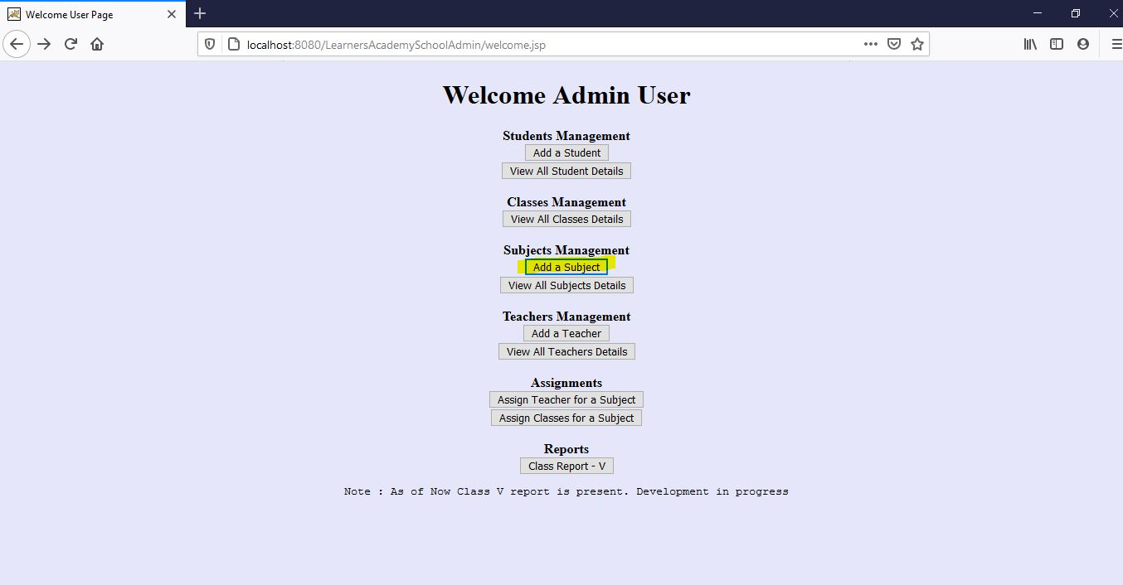

1. Now User adds a new subject i.e Drawing and description as leisure

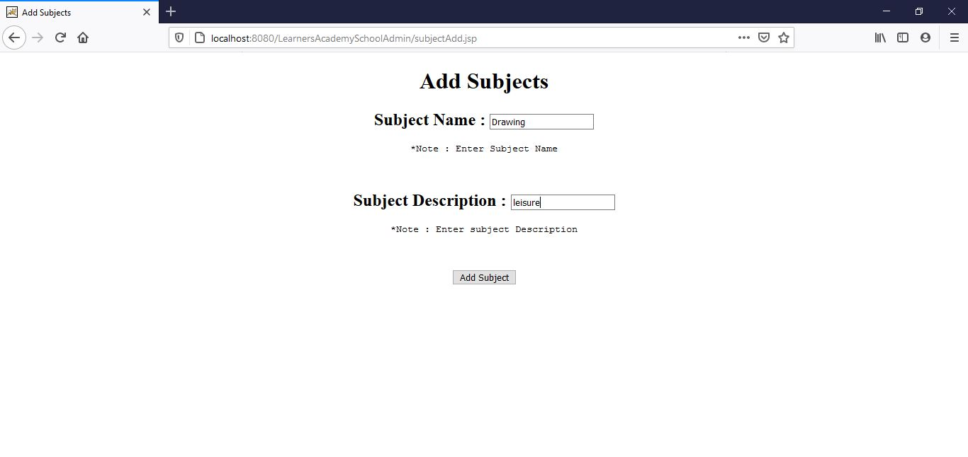

1. Subjects gets added successfully

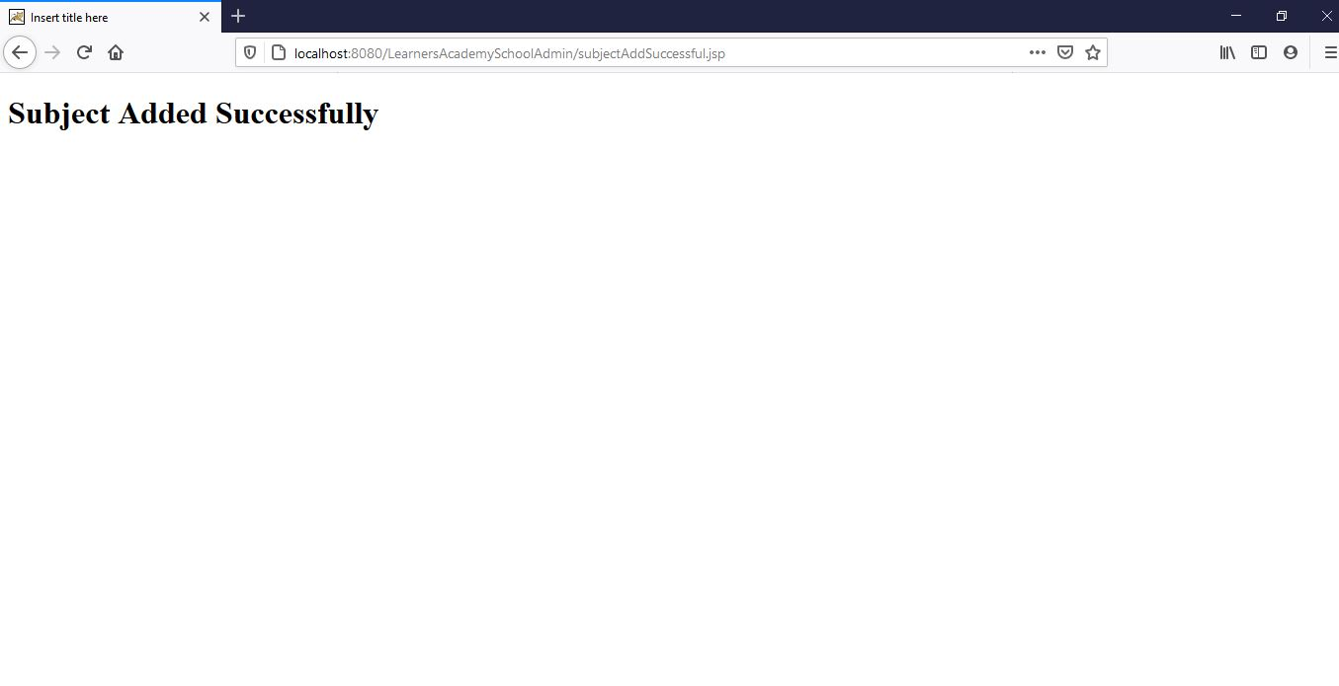

1. Now User Clicks on View All Subjects Details Button

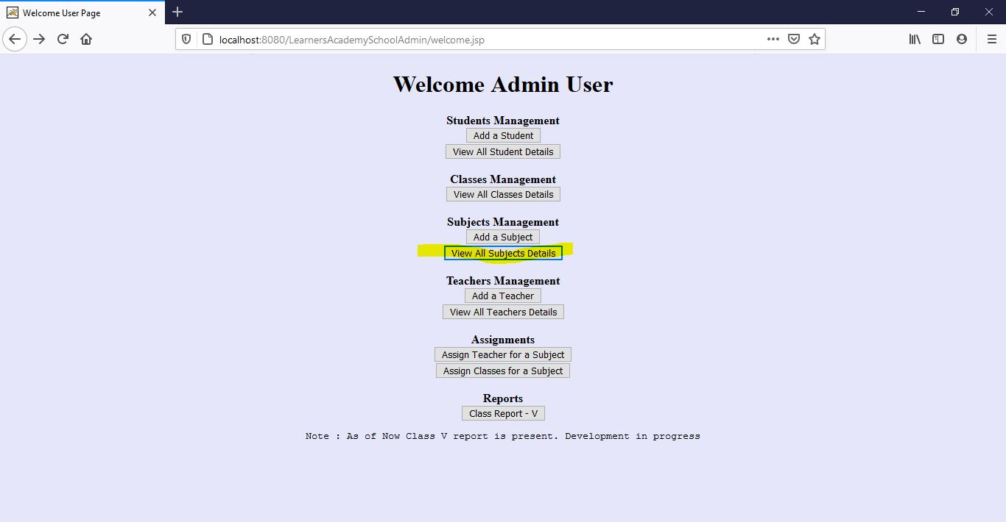

1. User is able to the newly added subject under subjects list

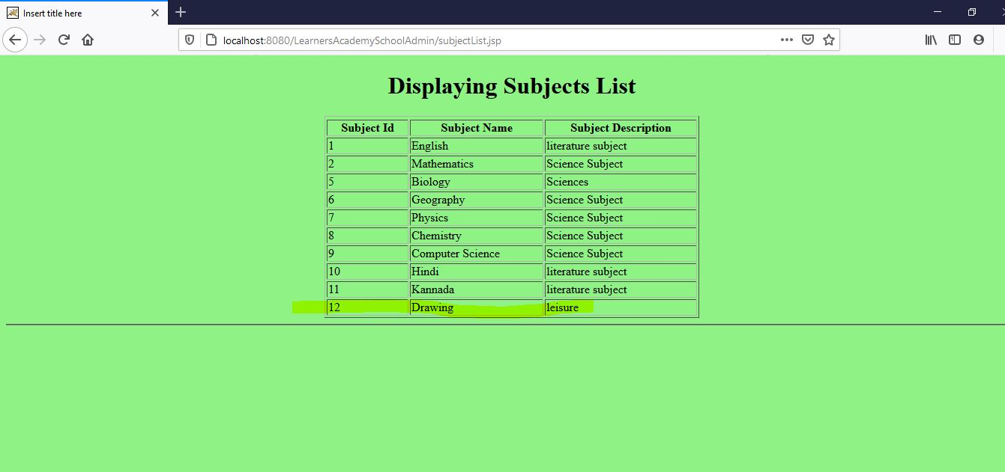

1. Now user clicks on Add a Teacher link to add to new Teacher into system

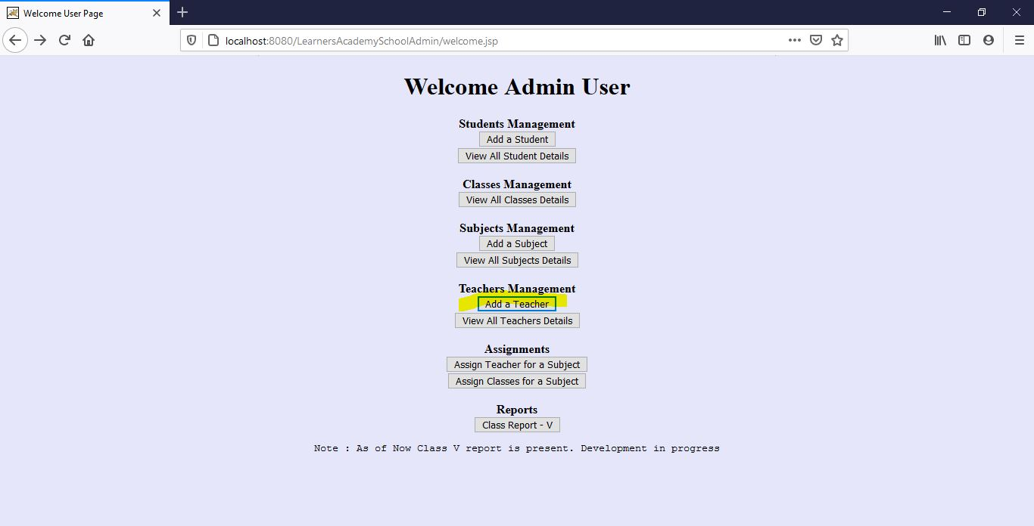

1. This time user adds a new user as Simplilearn Teacher and Qualification as Mtech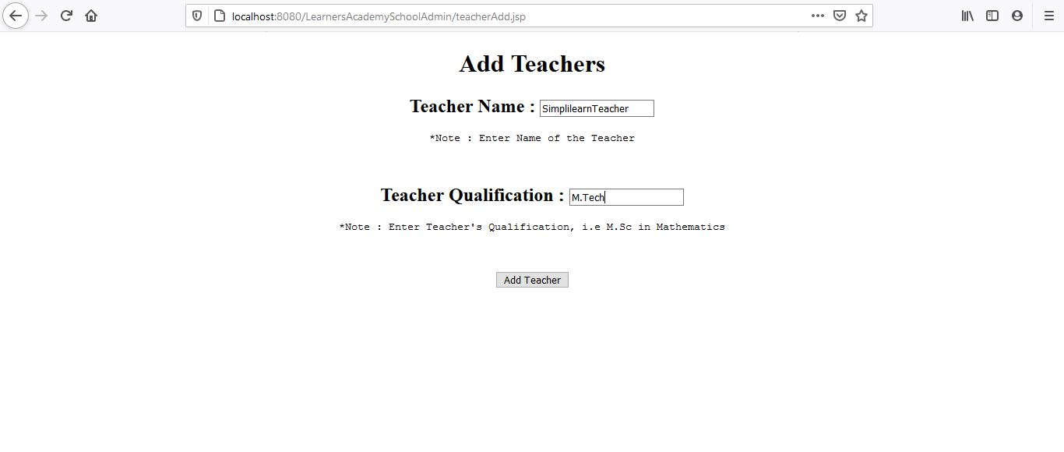
2. Teacher gets added successfully.

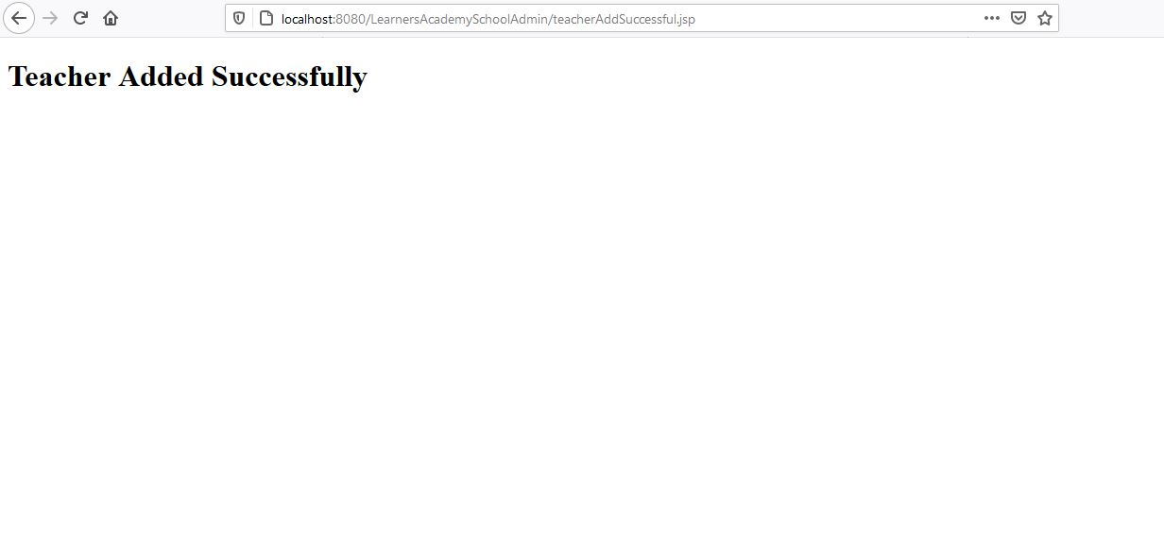

1. View Added Teachers Details Button

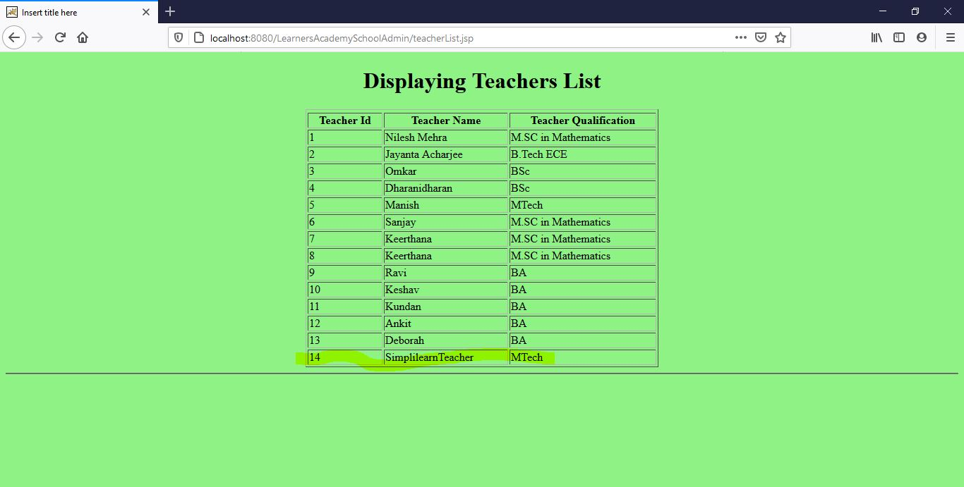

1. User can assign classes for a subject 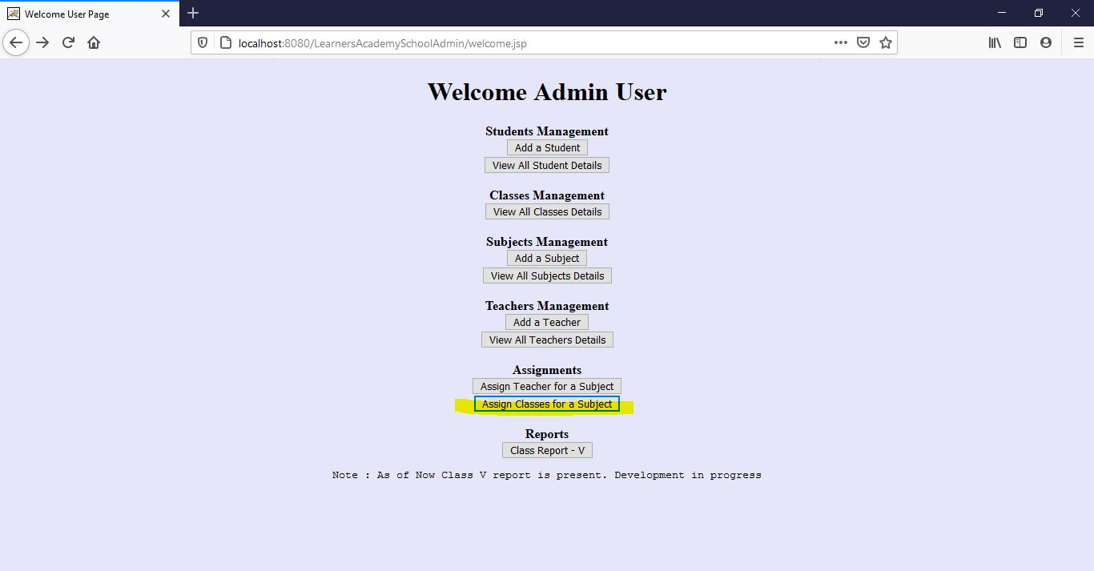
2. Assign class and subjects, data comes from master list 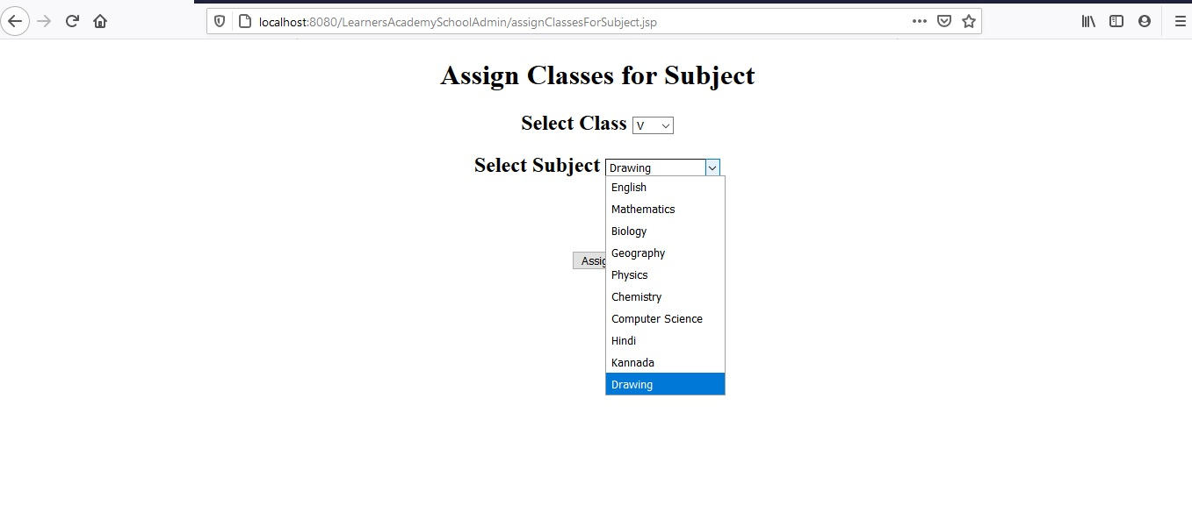
3. Similarly, user can assign teacher for a subject

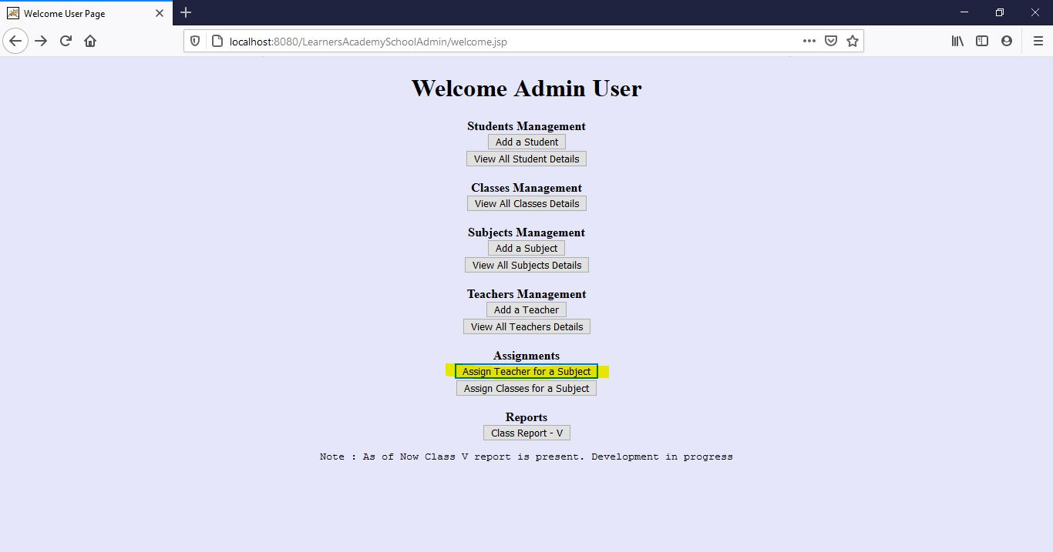

1. First to choose from a class, as demo purpose only class V assignments are available

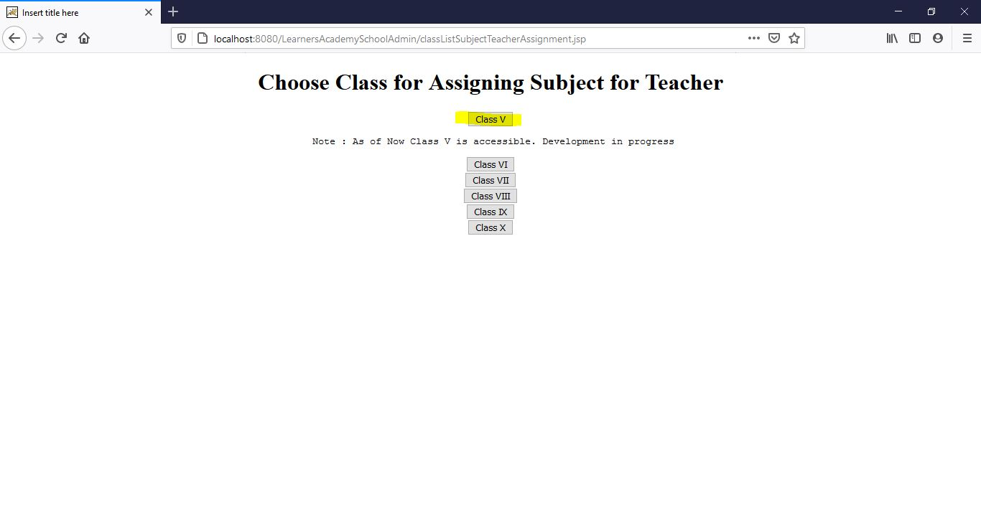

1. Then to assign subject for Teacher , from dropdown user selects Drawing Subject and SimplilearnTeacher

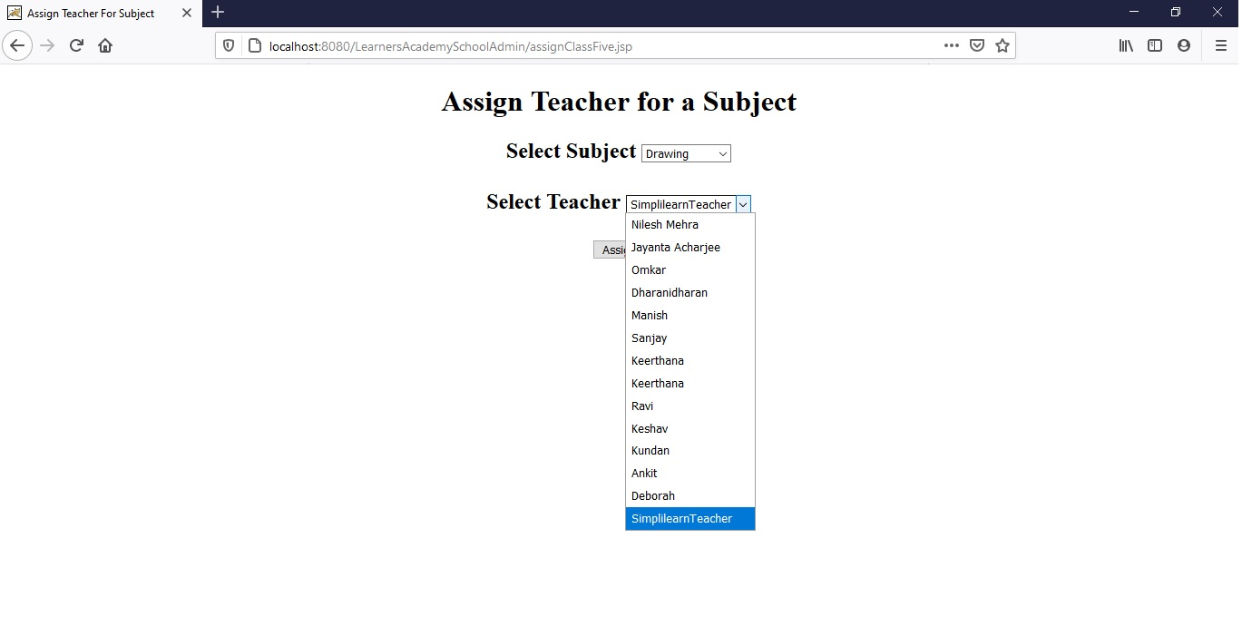

1. Lastly to View a Class Report, for Class V

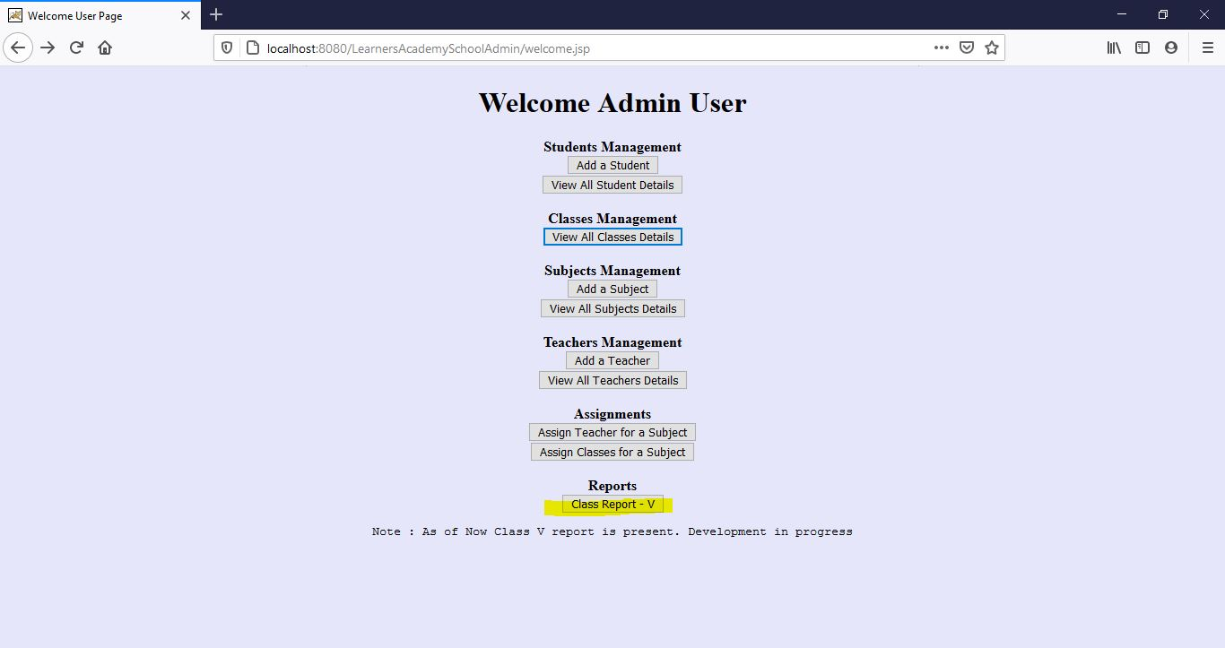

1. Clicking on the link gives user reports for the student in the class, subjects and teaches

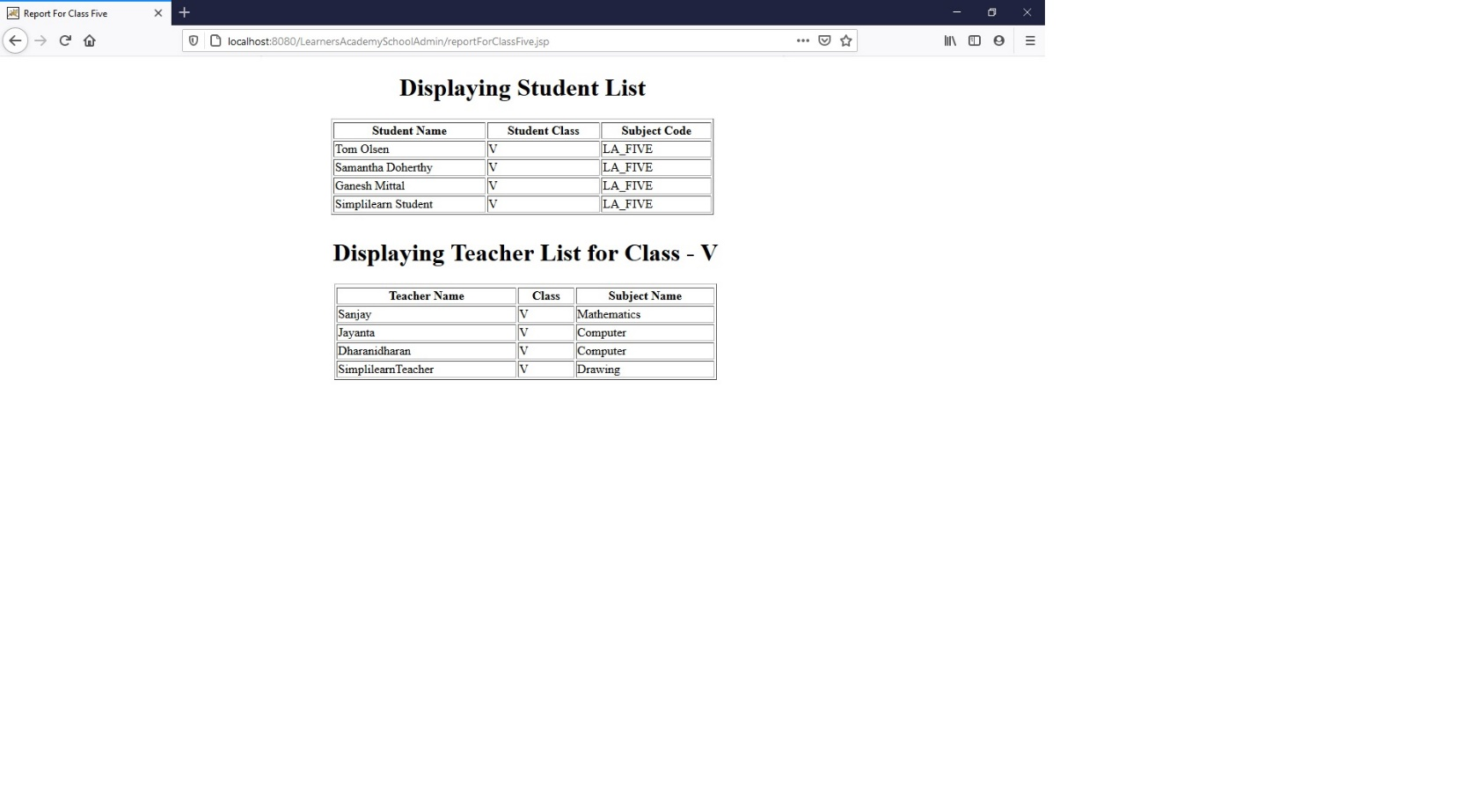



**6. Github link**

**This section lists where the source code is located and from where the user can download and use it.**

[**https://github.com/jay03101993/Datamaster**](https://github.com/jay03101993/Datamaster)