CSCE 410/611 Operating Systems Spring 2023

Homework for Week 12

(Due Date: Check Canvas)

1. [1] Consider a RAID level 5 organization consisting of five disks, with the parity for sets of four blocks stored on the fifth disk. How many blocks are accessed in order to perform the following?

(a) A WRITE of one block of data.

2 unique blocks and 4 total block accesses

1 read original party, 1 original data, 1 update data, 1 update parity

(b) A WRITE of seven continuous blocks of data.

9 blocks

7 blocks write

2 for parity check

First write is 4+1 parity, overflow second wrote 3+1 parity

2. [1] Consider a file system that uses inodes to represent files. Disk blocks are 8KB in size, and a pointer to a disk block requires 4 bytes. This file system has 12 direct disk blocks, as well as single, double, and triple indirect disk blocks. What is the maximum size of a file that can be stored in this file system?

Max file size = 96Kb + 16Mb + 32Gb + 64Tb

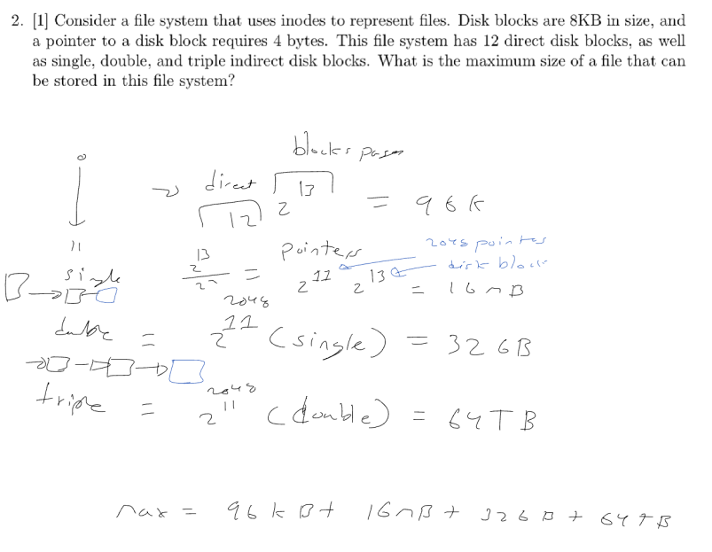

3. [4] Consider using a bitmap versus a linked list of free blocks. The disk contains a total of *B* blocks, *F* of which are free. A disk address requires *d* bits. The bitmap uses one bit for each block. The linked list is a data structure maintained in a dedicated portion of the disk. Each list element points to a single free block.

(a) State the condition under which the two methods use the same amount of disk space, assuming that the linked-list method connects all blocks individually.

A linked list holds free blocks = F\*d, the condition where the bitmap is the same is where B = F\*d.

(b) For *d* = 16 bits, determine the fraction of the disk that must be free for the above condition to hold.

1/16 must be free

Work below

(c) Repeat the two problems above, assuming that the linked-list method connects groups of adjacent blocks, rather than individual blocks. That means, each list element points to the first of block of a group, and contains a two-byte number indicating how many blocks are in the group. The average size of a group is five blocks.

5/16 must be free

Work below

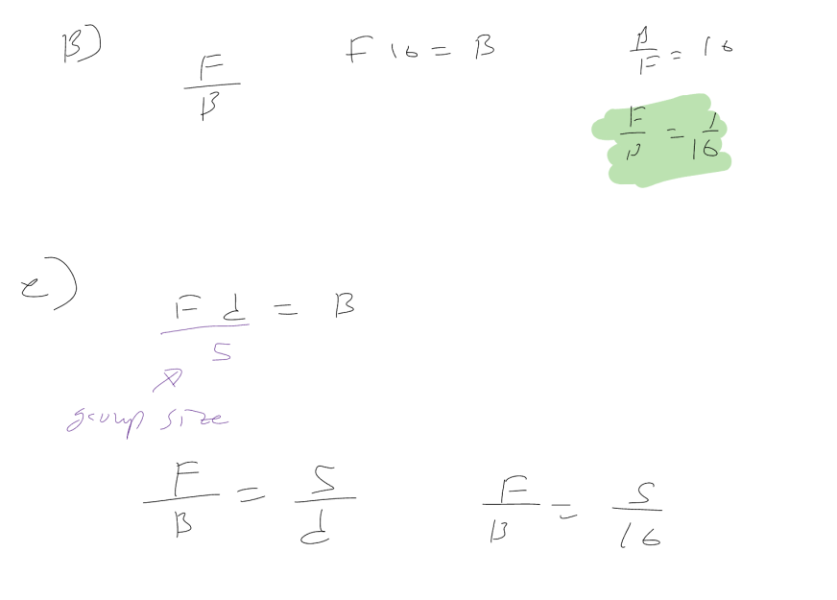

References

[1] A. Silberschatz, P. Galvin, and G. Gagne, *Applied Operating Systems Concepts*, John Wiley & Sons, Inc., New York, NY, 2000.

[2] Deitel, Deitel, and Choffnes, *Operating Systems*, Pearson / Prentice Hall, 2004. [3] A. S. Tanenbaum, *Modern Operating Systems*, Pearson / Prentice Hall, 2008. [4] L. F. Bic, A. C. Shaw, *Operating Systems Principles*, Prentice Hall 2003. [5] C. Crowley, *Operating Systems, A Design-Oriented Approach*, Irwin 1997. [6] M. Herlihy, N. Shavit, *The Art of Multiprocessor Programming*, Elsevier, 2008

1