3.1 UML Class Diagram

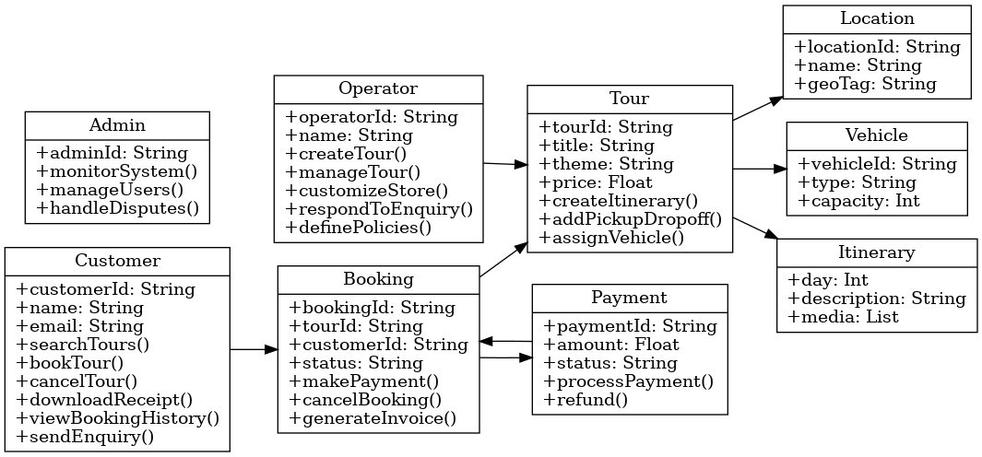

3.2 Activity Diagram

