TSLA Implied Volatility Surface Analysis
Quantitative Research Note

1. Objective
This report examines deviations from the constant volatility assumption in the Black–Scholes model by constructing an implied volatility surface for Tesla (TSLA) options using 2019–2022 end-of-day data.
2. Data and Methodology
The dataset consists of over 2.6 million option quotes, filtered to approximately 647,000 liquid observations. A hybrid Newton–Bisection method is used to invert the Black–Scholes formula and compute over 638,000 implied volatilities.
3. Key Findings
Implied volatility varies systematically across strike and maturity. Out-of-the-money puts exhibit elevated volatility, reflecting demand for downside protection. Short-dated options show higher implied volatility than long-dated ones, indicating near-term risk concentration.
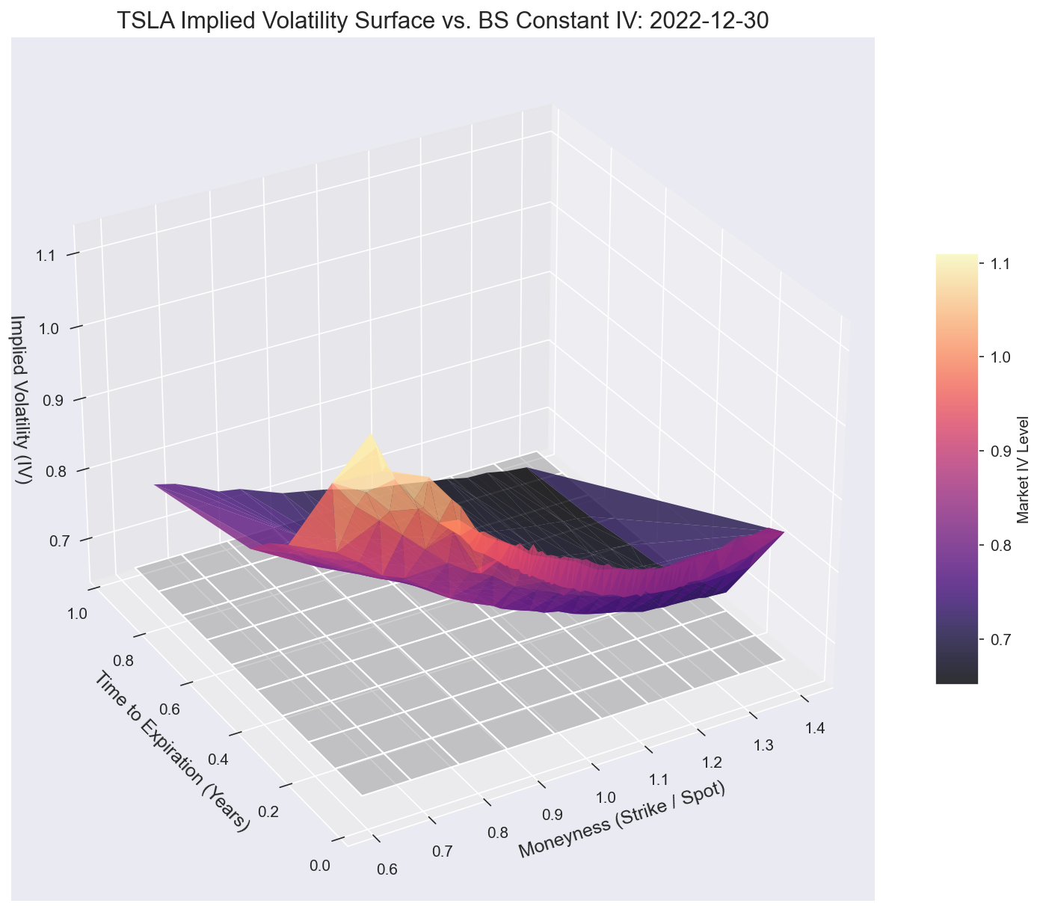
Figure 1. Implied volatility surface vs constant volatility assumption.
4. Market Interpretation
During December 2022, TSLA experienced a sharp decline, accompanied by steepened skew and inverted term structure. In contrast, the August 2020 rally saw temporary reversal of skew driven by call demand.
5. Implications
These results demonstrate that volatility is a structured surface rather than a scalar input. Accurate modeling requires capturing cross-sectional and temporal variation in implied volatility.
6. Conclusion
The implied volatility surface provides a richer framework for understanding market expectations, risk asymmetry, and regime shifts compared to constant-volatility models.

