SCHOOL OF TECHNOLOGY | 

DATABASE MANAGEMENT SYSTEMS
PROJECT-BASED LEARNING (PBL) REPORT
Small Database Application Development using Java / Python

POLICE COMPLAINT & EVIDENCE TRACKING SYSTEM

Program | B.Tech CSE AIML
Section | AIML Rhinos
Faculty | DR.Sahiti
Date of Submission | October 2026
Academic Year | 2026 – 27

Submitted by
Roll Number | Student Name | Mobile | Email ID
25WU0102084 | G.J.Chandrasekhar Reddy | 9398979576 | jayachandrasekhar.reddy_2029@woxsen.edu.in

ACKNOWLEDGEMENT

I express my sincere gratitude to Woxsen University, School of Technology, for providing me with the opportunity to undertake this Project-Based Learning (PBL) activity as part of the Database Management Systems (DBMS) course.
I thank my course faculty, Name of the Faculty, for the guidance, suggestions, and support throughout the design and development of this project. The guidance helped me understand the practical application of database concepts such as ER modelling, relational schema design, normalization, SQL, constraints, queries, and database application development.
This PBL activity has strengthened my understanding of DBMS concepts and provided valuable experience in applying them to a real-world problem.

UNDERTAKING

I hereby declare that the project entitled “Police Complaint & Evidence Tracking System”, submitted as part of the Project-Based Learning activity for the Database Management Systems (DBMS) course, is my individual work carried out under the guidance of the course faculty.
I undertake that the project report, database design, SQL scripts, application source code, results, and supporting materials submitted by me have been prepared for academic purposes. Wherever information, ideas, tools, datasets, or other resources have been referred to, appropriate acknowledgement has been provided.
I further undertake that I am responsible for the correctness and authenticity of the work submitted and that I have followed the academic and project guidelines prescribed by the University.

 | Signature
Name: | G.J.Chandrasekhar Reddy
Roll Number: | 25WU0102084
Program: | CSE AIML

TABLE OF CONTENTS

Contents | Page No.
Abstract
LIST OF TABLES
LIST OF FIGURES
LIST OF ACRONYMS
1. PROBLEM STATEMENT, SOLUTION STRATEGY AND ER DIAGRAM
1.1 Problem Statement
1.2 Objectives
1.3 Scope and Assumptions
1.4 Proposed Solution Strategy
1.5 Functional Requirements
1.6 Entity-Relationship Diagram (ERD)
1.7 Entity and Relationship Summary
2. LOGICAL DATABASE DESIGN
2.1 Relational Schema
2.2 Keys and Integrity Constraints
2.3 Functional Dependencies
2.4 Normalization up to Third Normal Form (3NF)
2.5 Data Dictionary
2.6 Implementation of Logical Design: DDL and Sample Data
3. APPLICATION DEVELOPMENT USING LOGICAL DATABASE DESIGN
3.1 Application Overview
3.2 Development Environment and Database Connectivity
3.3 Application Modules and Database Mapping
3.4 CRUD Operations
3.5 Business Rules, Validation and Error Handling
3.6 Reports and Database Operations
3.7 Application Screens
3.8 Testing and Results
4. CONCLUSION
4.1 Limitations and Future Enhancements
5. REFERENCES
6. APPENDICES

LIST OF TABLES

Table No. | Table Title | Page No.
Table 1 | Scope and Assumptions
Table 2 | Proposed Solution Strategy
Table 3 | Functional Requirements
Table 4 | Entity and Relationship Summary
Table 5 | Relational Schema
Table 6 | Keys and Integrity Constraints
Table 7 | Normalization Status up to 3NF
Table 8 | Data Dictionary
Table 9 | Database Implementation Environment
Table 10 | Application Development Environment
Table 11 | Application Module-to-Database Mapping
Table 12 | CRUD Operations
Table 13 | Business Rules, Validation and Error Handling
Table 14 | Reports and Database Operations
Table 15 | Test Cases

LIST OF FIGURES

Update this list after finalizing the report. Use Word References > Insert Caption for every figure and References > Insert Table of Figures with the caption label “Figure”.
Figure No. | Figure Title | Page No.
Figure 1 | Entity-Relationship Diagram of the Proposed System
Figure 2 | Dashboard & Analytics — live metrics, charts and complaints overview
Figure 3 | Cases & Details — dossier search with six detail tabs
Figure 4 | Register New Complaint (FIR) form
Figure 5 | Evidence Tracking — registration and vault inventory
Figure 6 | Detention & Custody — register, check-in/out, witnesses
Figure 7 | SQL Queries & Reports — workload query output

LIST OF ACRONYMS

Acronym | Expansion
3NF | Third Normal Form
BCNF | Boyce–Codd Normal Form
CRUD | Create, Read, Update, Delete
DBMS | Database Management System
DDL | Data Definition Language
DML | Data Manipulation Language
ERD | Entity–Relationship Diagram
FIR | First Information Report
FK | Foreign Key
MySQL | My Structured Query Language (DBMS)
PK | Primary Key
SHO | Station House Officer
SQL | Structured Query Language
UI | User Interface

ABSTRACT

Police stations handle a continuous flow of complaints, investigation records, seized property and custody entries, yet many stations still rely on paper registers and disconnected spreadsheets which cause delays, lost links between cases, evidence and officers, and weak audit trails. The objective of this project is to design and implement a normalized relational database application that manages the complete complaint lifecycle from FIR registration to investigation, evidence chain-of-custody, detention logging, charges and court referral. The solution uses an 11-table MySQL database modeled from a verified ER diagram and normalized to Third Normal Form with primary, foreign key, unique, not-null, check and default constraints. A Python–Streamlit application built over this design provides eight modules covering dashboard analytics, case dossiers, complaint registration, officer assignment, evidence tracking, custody management, status and court updates, and SQL reports. Parameterized queries, closure and custody validations, cascaded referential actions and exception handling enforce business rules. Six representative queries demonstrate joins, aggregation, correlated nested subqueries and temporal calculations. The completed system shows correct end-to-end use of the designed database and provides a practical, auditable station records tool.

KEYWORDS
Keywords: Police Complaint Management, Evidence Chain-of-Custody, Relational Database, Normalization, MySQL, Streamlit

CHAPTER 1

PROBLEM STATEMENT, SOLUTION STRATEGY AND ER DIAGRAM

This chapter presents the Review-I outcome: the problem studied, measurable objectives, scope, solution strategy, functional requirements and the approved ER diagram for the Police Complaint & Evidence Tracking System.

1.1 Problem Statement
Describe the current problem, affected users/stakeholders, limitations of the existing/manual process, and the need for the proposed database application.
Manual complaint handling in a police station requires the duty officer to enter FIR details in registers, allocate investigating officers verbally, record evidence movements and custody transfers on loose forms, and reconstruct case history from scattered files. This causes three concrete problems: (i) no single case dossier linking complaints, officers, evidence, witnesses, charges and court dates; (ii) no enforcement of mandatory fields such as closure findings or valid custody durations; and (iii) no quick reports on backlog, officer workload or vault inventory for supervision [1], [4]. Stakeholders affected are complainants, victims, investigating officers, the Station House Officer (SHO), evidence-store staff and prosecutors who need reliable, auditable records. A centralized relational database application is therefore needed to register complaints once, assign officers, log investigation activities, track evidence location and custodian, record custody check-in/check-out with supervising officers, capture witness statements and charges, manage status transitions and court references, and generate operational reports from live data.

1.2 Objectives
State 3-5 measurable objectives beginning with action verbs such as design, develop, implement, validate, automate, track or generate.
- Design a normalized 3NF relational schema with 11 relations covering complaints, persons, officers, assignments, investigation activities, evidence, custody, witnesses, charges, court references and status history.
- Develop a MySQL 8.0 database implementing keys, UNIQUE badge numbers, CHECK rules for closure details and custody duration, defaults and ON DELETE CASCADE/SET NULL actions with sample data.
- Implement a Python–Streamlit application with eight database-connected modules supporting registration, assignment, evidence and custody transactions, dossier search, status/court updates and analytics.
- Validate business rules, parameterized CRUD operations and six representative SQL reports using joins, GROUP BY aggregation, correlated nested subqueries and TIMESTAMPDIFF calculations.
- Generate dashboard analytics, case dossiers and audit trails through positive and negative testing to demonstrate correct use of the logical design.

1.3 Scope and Assumptions
Table 1. Scope and Assumptions
Item | Description
In Scope | Complaint/FIR lifecycle (pending, under_investigation, referred_to_court, closed); officer assignment and investigation diary; evidence registration with vault location and collecting officer; custody check-in/check-out with duration; witness statements; charges and court docket linking; status audit trail; dashboard, dossier search and SQL reports. Single-station deployment (Central Station, Division 1).
Out of Scope / Exclusions | Biometric/face recognition, GIS crime mapping, e-court integration, multi-station federation, mobile app, forensic lab instruments, and payroll/HR functions.
Assumptions | MySQL 8.0 available; Python 3 with Streamlit and mysql-connector-python; intranet use by trained staff; badge numbers unique; incident_date mandatory; filed_date defaults to CURRENT_TIMESTAMP; sample seed data sufficient for demonstration.

1.4 Proposed Solution Strategy
Explain how the proposed solution will address the identified problem. Describe the intended users, major modules, workflow, key business rules and expected outputs.
Table 2. Proposed Solution Strategy
Solution Element | Project-Specific Description
Primary Users / Roles | Duty officer (FIR entry), Investigating officers/Detectives (diary, evidence, custody), SHO (supervision, closure approval), Evidence-store keeper (vault inventory), Prosecutor/clerk (charges, court dates).
Major Application Modules | 1 Dashboard & Analytics; 2 Cases & Details dossier; 3 Register New Complaint; 4 Officers & Assignments + Activity Log; 5 Evidence Tracking; 6 Detention & Custody + Witnesses; 7 Status & Court Updates; 8 SQL Queries & Reports.
Proposed Workflow | FIR registered with title, description, incident date and status -> lead officer assigned (pending auto-moves to under_investigation) -> diary entries, evidence seizure and witness capture -> suspect check-in/custody supervision -> charges filed -> referred_to_court with docket/hearing or closed with mandatory closure_details; every status change appended to StatusHistories.
Important Business Rules | Closed status requires closure_details (CHECK + app validation); check_out_time must exceed check_in_time; badge_number UNIQUE; parameterized queries; destructive deletes restricted to cascaded FK design; confirmation on check-out/status change.
Expected Reports / Outputs | Pending backlog; officer workload (JOIN+GROUP BY); evidence locations with custodians (multi-table JOIN); custody audit with hours held (TIMESTAMPDIFF); closed-case evidence/witness counts (correlated subqueries); schema dictionary; dashboard charts and dossier views (Figs. 2-6).

1.5 Functional Requirements
Table 3. Functional Requirements
Req. ID | Functional Requirement | Remarks / Priority
FR-01 | Register new complaint (FIR) with title, description, incident date, initial status; auto-create StatusHistories entry and optional lead-officer assignment. | High
FR-02 | Assign officers to active cases by role and record investigation diary entries linked to complaint and officer. | High
FR-03 | Register and track evidence items with collection date, collecting officer and vault/locker location; list full vault inventory. | High
FR-04 | Book suspects (custody check-in with supervising officer and cell) and release/transfer (check-out); record witness statements per case. | High
FR-05 | Update case status with remarks and audit entry; enforce closure_details when closing; file charges and link court docket/hearing. | High
FR-06 | Search/filter case dossiers by keyword and status; inspect officers, diary, evidence, witnesses, charges, court and history tabs. | High
FR-07 | View dashboard metrics/charts and execute six academic SQL reports (retrieval, joins, aggregation, nested subqueries, temporal math). | Medium

1.6 Entity-Relationship Diagram (ERD)
Insert the approved ER diagram. It should show entities, major attributes, primary keys, relationships, cardinalities and participation constraints where applicable.
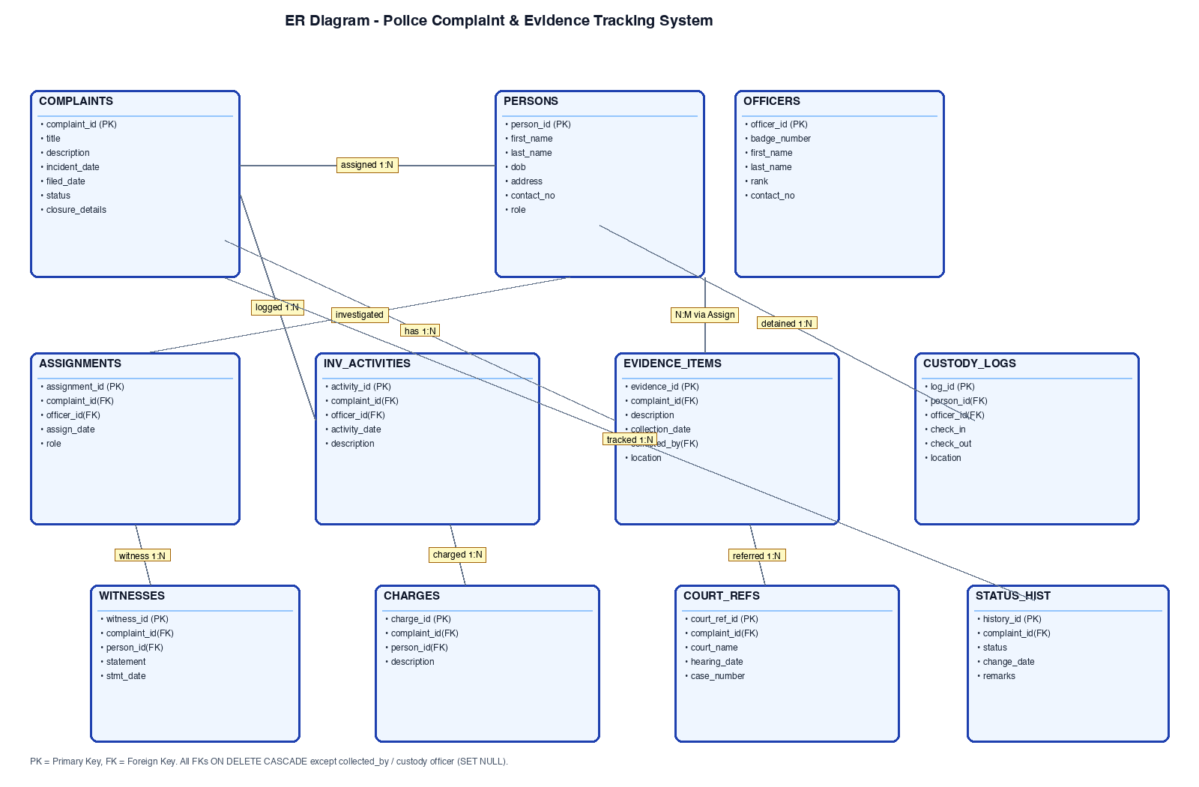
Figure 1. Entity-Relationship Diagram of the Proposed System

1.7 Entity and Relationship Summary
Table 4. Entity and Relationship Summary
Entity / Relationship | Major Attributes / Cardinality | Purpose / Rule
Complaints | complaint_id (PK); title, incident_date, status ENUM; closure_details | Central case/FIR entity; CHECK(status!='closed' OR closure_details IS NOT NULL).
Persons (suspect/victim/witness/other) | person_id (PK); role ENUM; contact_number | Single registry avoids duplicate person records across suspect, victim and witness roles.
Officers | officer_id (PK); badge_number UNIQUE; rank | Station roster; referenced by assignments, activities, evidence and custody.
Assignments (Complaints–Officers) | assignment_id (PK); complaint_id, officer_id (FKs); M:N resolution | Links cases to officers with role and date; CASCADE on delete.
InvestigationActivities | activity_id (PK); complaint_id, officer_id (FKs); activity_date, description | Diary log of investigation events per case and officer.
EvidenceItems | evidence_id (PK); complaint_id, collected_by (FKs); current_location | Chain-of-custody: item, seizure date, custodian officer, vault location.
CustodyLogs (Persons–Officers) | log_id (PK); person_id, officer_id (FKs); check_in/out; 1:N detention | Holding register; CHECK(check_out IS NULL OR check_out>check_in).
Witnesses / Charges / CourtReferences | witness_id, charge_id, court_ref_id (PKs); complaint_id, person_id (FKs) | Statements, penal charges and court docket/hearing per case.
StatusHistories | history_id (PK); complaint_id (FK); status, change_date, remarks | Audit trail of every status transition; 1:N from Complaints.
Key relationships | Complaints 1:N Assignments/Activities/Evidence/Witnesses/Charges/Court/History; Persons 1:N Custody/Witness/Charge | Cardinalities enforced by FKs; M:N (case–officer) resolved via Assignments.

CHAPTER 2

LOGICAL DATABASE DESIGN

This chapter converts the approved ER model into the relational schema, documents keys, functional dependencies and 3NF verification, and summarizes implementation with DDL and sample data. Normalization follows standard dependency theory [2], [4].

2.1 Relational Schema
List every relation derived from the ER model. Identify primary and foreign keys clearly.
Table 5. Relational Schema
S.No. | Table Name | Purpose
1 | Persons(person_id PK, ...) | Registry of suspects, victims, witnesses.
2 | Officers(officer_id PK, badge_number UNIQUE, ...) | Police personnel roster.
3 | Complaints(complaint_id PK, ...) | FIR/case records with status and closure.
4 | StatusHistories(history_id PK, complaint_id FK, ...) | Status-change audit trail.
5 | Assignments(assignment_id PK, complaint_id FK, officer_id FK, ...) | M:N case–officer resolution.
6 | InvestigationActivities(activity_id PK, complaint_id FK, officer_id FK, ...) | Case diary entries.
7 | EvidenceItems(evidence_id PK, complaint_id FK, collected_by FK, ...) | Seized property and vault location.
8 | CustodyLogs(log_id PK, person_id FK, officer_id FK, ...) | Detention check-in/out register.
9 | Witnesses(witness_id PK, complaint_id FK, person_id FK, ...) | Witness statements per case.
10 | CourtReferences(court_ref_id PK, complaint_id FK, ...) | Court, docket and hearing dates.
11 | Charges(charge_id PK, complaint_id FK, person_id FK, ...) | Penal charges against suspects.

2.2 Keys and Integrity Constraints
Table 6. Keys and Integrity Constraints
Table Name | Key / Constraint | Attribute(s) | Business Rule Enforced
EvidenceItems | Primary Key | complaint_id | Unique case identity; parent for 7 child tables.
EvidenceItems | CHECK | status!='closed' OR closure_details IS NOT NULL | Closed cases must carry findings.
EvidenceItems | UNIQUE + PK | officer_id; badge_number | No duplicate badge numbers.
EvidenceItems | Foreign Keys (CASCADE) | complaint_id, officer_id | Deleting case/officer removes links.
EvidenceItems | Foreign Key (SET NULL) | collected_by -> Officers | Officer exit preserves evidence row.
CourtReferences | CHECK | check_out_time IS NULL OR check_out_time>check_in_time | Valid detention duration only.
CourtReferences | Foreign Keys | person_id (CASCADE), officer_id (SET NULL) | Person removal clears logs; officer exit retained.
CourtReferences | Foreign Keys (CASCADE) | complaint_id, person_id | Orphan statements/charges prevented.
CourtReferences | NOT NULL / DEFAULT | titles, dates, status defaults, CURRENT_TIMESTAMP | Mandatory fields and audit timestamps.
CourtReferences | Foreign Key (CASCADE) | complaint_id | Court link dies with case.
Include PRIMARY KEY, FOREIGN KEY, UNIQUE, NOT NULL, CHECK, DEFAULT and suitable referential actions where applicable.

2.3 Functional Dependencies
List the important functional dependencies used to justify normalization.
Representative functional dependencies (left side is the determinant): complaint_id -> title, description, incident_date, filed_date, status, closure_details; person_id -> first_name, last_name, dob, address, contact_number, role; officer_id -> badge_number, first_name, last_name, rank, contact_number; badge_number -> officer_id, first_name, last_name, rank; assignment_id -> complaint_id, officer_id, assignment_date, role; activity_id -> complaint_id, officer_id, activity_date, description; evidence_id -> complaint_id, description, collection_date, collected_by, current_location; log_id -> person_id, officer_id, check_in_time, check_out_time, location; witness_id -> complaint_id, person_id, statement, statement_date; court_ref_id -> complaint_id, court_name, hearing_date, case_number; charge_id -> complaint_id, person_id, description; history_id -> complaint_id, status, change_date, remarks. All non-key attributes depend on the whole key; no partial or transitive dependencies remain, satisfying 3NF [2].

2.4 Normalization
Table 7. Normalization Status up to 3NF
Relation Name | 1NF | 2NF | 3NF | BCNF | Remarks / Decomposition
Complaints | Yes | Yes | Yes | Yes | Atomic attributes; single PK; no transitive dependency.
Persons | Yes | Yes | Yes | Yes | Atomic attributes; single PK; no transitive dependency.
Officers | Yes | Yes | Yes | Yes | Atomic attributes; single PK; no transitive dependency.
Assignments | Yes | Yes | Yes | Yes | Atomic attributes; single PK; no transitive dependency.
InvestigationActivities | Yes | Yes | Yes | Yes | Atomic attributes; single PK; no transitive dependency.
EvidenceItems | Yes | Yes | Yes | Yes | Atomic attributes; single PK; no transitive dependency.
CustodyLogs | Yes | Yes | Yes | Yes | No multi-valued facts; FK-only dependencies on keys.
Witnesses | Yes | Yes | Yes | Yes | No multi-valued facts; FK-only dependencies on keys.
CourtReferences | Yes | Yes | Yes | Yes | No multi-valued facts; FK-only dependencies on keys.
Charges | Yes | Yes | Yes | Yes | No multi-valued facts; FK-only dependencies on keys.
StatusHistories | Yes | Yes | Yes | Yes | No multi-valued facts; FK-only dependencies on keys.

2.5 Data Dictionary
Prepare the data dictionary for all tables. Add rows as required.
Table 8. Data Dictionary
Table | Attribute | Data Type | Key / Constraint | Description
Complaints | complaint_id | INT AUTO_INCREMENT | PK | Case identifier.
Complaints | title | VARCHAR(100) NOT NULL | NOT NULL | FIR subject.
Complaints | status | ENUM(...) DEFAULT 'pending' | CHECK+DEFAULT | Lifecycle state.
Complaints | closure_details | TEXT | CHECK | Mandatory when closed.
Persons | person_id | INT AUTO_INCREMENT | PK | Person identifier.
Persons | role | ENUM(suspect,victim,witness,other) | DEFAULT | Person role.
Officers | officer_id | INT AUTO_INCREMENT | PK | Officer identifier.
Officers | badge_number | VARCHAR(20) UNIQUE NOT NULL | UNIQUE | Service number.
Assignments | assignment_id | INT AUTO_INCREMENT | PK | Link identifier.
Assignments | complaint_id / officer_id | INT | FK CASCADE | Case–officer link.
InvestigationActivities | activity_id | INT AUTO_INCREMENT | PK | Diary entry id.
EvidenceItems | evidence_id | INT AUTO_INCREMENT | PK | Evidence identifier.
EvidenceItems | current_location | VARCHAR(100) | — | Vault/locker.
CustodyLogs | log_id | INT AUTO_INCREMENT | PK | Detention log id.
CustodyLogs | check_in/out_time | DATETIME | CHECK | Duration validation.
Witnesses | statement | TEXT | — | Recorded statement.
CourtReferences | case_number | VARCHAR(50) | — | Court docket no.
Charges | description | TEXT NOT NULL | NOT NULL | Penal section.
StatusHistories | change_date | TIMESTAMP DEFAULT NOW() | DEFAULT | Audit timestamp.

2.6 Implementation of Logical Design: DDL and Sample Data
Mention the DBMS used, provide representative CREATE TABLE statements with constraints, and show representative sample records. Attach the complete SQL script in Appendix A.
Table 9. Database Implementation Environment
Item | Details
DBMS | MySQL Community Server (police_db)
DBMS Version | 8.0.x (InnoDB, UTF8MB4)
Number of Tables | 11 (Persons, Officers, Complaints, StatusHistories, Assignments, InvestigationActivities, EvidenceItems, CustodyLogs, Witnesses, CourtReferences, Charges)
Sample Data | Seed: 3 officers, 3 persons, 2 complaints, 3 assignments, 2 evidence items, 1 witness, 1 custody log, 2 status rows; extended during testing.
Representative DDL (complete script in Appendix A, file schema.sql, 159 lines). MySQL was chosen for CHECK enforcement, InnoDB FK cascades and Streamlit compatibility [6], [7]:
CREATE TABLE Complaints (complaint_id INT AUTO_INCREMENT PRIMARY KEY, title VARCHAR(100) NOT NULL, incident_date DATE NOT NULL, filed_date TIMESTAMP DEFAULT CURRENT_TIMESTAMP, status ENUM('pending','under_investigation','closed','referred_to_court') DEFAULT 'pending', closure_details TEXT, CHECK (status!='closed' OR closure_details IS NOT NULL));
CREATE TABLE EvidenceItems (evidence_id INT AUTO_INCREMENT PRIMARY KEY, complaint_id INT, description TEXT NOT NULL, collection_date DATE NOT NULL, collected_by INT, current_location VARCHAR(100), FOREIGN KEY (complaint_id) REFERENCES Complaints(complaint_id) ON DELETE CASCADE, FOREIGN KEY (collected_by) REFERENCES Officers(officer_id) ON DELETE SET NULL);
CREATE TABLE CustodyLogs (log_id INT AUTO_INCREMENT PRIMARY KEY, person_id INT, officer_id INT, check_in_time DATETIME NOT NULL, check_out_time DATETIME, location VARCHAR(100) NOT NULL, FOREIGN KEY (person_id) REFERENCES Persons(person_id) ON DELETE CASCADE, FOREIGN KEY (officer_id) REFERENCES Officers(officer_id) ON DELETE SET NULL, CHECK (check_out_time IS NULL OR check_out_time > check_in_time));
Sample rows: Officers (P1001 John Doe Inspector; P1002 Jane Smith Sergeant; P1003 Mike Johnson Detective); Complaints (#1 Robbery at Elm St under_investigation; #2 Vandalism in Park pending); Evidence (Security Camera Footage Room A; Abandoned mask Room B); Custody (Bob White in Holding Cell 1 since 2023-10-04).

CHAPTER 3

APPLICATION DEVELOPMENT USING LOGICAL DATABASE DESIGN

This chapter shows how the Python–Streamlit application directly uses the Chapter-2 logical design: every screen reads or writes the MySQL tables through mysql-connector-python, with module-to-table mapping, CRUD evidence, validations and reports below [5], [7].

3.1 Application Overview
The Police Complaint & Evidence Tracking System is a wide-layout Streamlit application for Central Station, Division 1, used by duty officers, investigators and the SHO over the station intranet. It provides eight sidebar modules: dashboard analytics with six live metrics and four charts, a searchable case dossier with six detail tabs, FIR registration with optional lead assignment, officer assignment plus diary logging and roster, evidence registration with vault inventory, custody check-in/check-out with witness capture, status/charges/court updates, and a SQL reports console. All modules execute parameterized SELECT/INSERT/UPDATE statements against police_db; no static or isolated data is used, so charts, dossiers and reports always reflect the current database state.

3.2 Development Environment and Database Connectivity
Table 10. Application Development Environment
Item | Details
Programming Language | Python 3.x
DBMS | MySQL 8.0 (database police_db, 3NF, InnoDB)
IDE / Framework / GUI Toolkit | Streamlit (wide layout, custom dark CSS); pandas for tables/charts
Database Connector / Driver | mysql-connector-python (database.py: get_connection, fetch_data, execute_query)
Operating Environment | Windows/macOS with MySQL Server; browser at http://localhost:8501
Repository Link | [GitHub repository link to be added by student]

3.3 Application Modules and Database Mapping
Table 11. Application Module-to-Database Mapping
Module / Screen | Purpose | Tables Used | Main Operations
Dashboard & Analytics | Station overview: 6 metrics, status/workload/storage charts, timeline, master table. | Complaints, Assignments, EvidenceItems, StatusHistories, Officers | SELECT COUNT, GROUP BY, correlated subqueries; bar_chart, dataframe.
Cases & Details | Search/filter dossier; inspect single case with 6 tabs. | All 11 (joins per tab) | SELECT with LIKE filter; JOINs for officers, diary, evidence, witnesses, charges, court, history.
Register New Complaint | FIR entry form with optional lead assignment. | Complaints, StatusHistories, Assignments | INSERT complaint + history; INSERT assignment.
Officers & Assignments | Assign by role; log diary; view roster workload. | Assignments, InvestigationActivities, Officers, Complaints | INSERT assignment; auto UPDATE pending->under_investigation; INSERT diary.
Evidence Tracking | Register seized items; browse vault inventory. | EvidenceItems, Complaints, Officers | INSERT evidence; multi-table JOIN inventory.
Detention & Custody | Active register; check-in; check-out; witness statements. | CustodyLogs, Persons, Officers, Witnesses | INSERT custody; UPDATE check-out; TIMESTAMPDIFF duration.
Status & Court Updates | Status transitions; file charges; link court docket. | Complaints, StatusHistories, Charges, CourtReferences | UPDATE status (+closure_details); INSERT history/charges/court.
SQL Queries & Reports | Console of 6 academic queries with SQL shown and live output. | Complaints, Officers, EvidenceItems, CustodyLogs, Witnesses | Retrieval, LEFT JOIN+GROUP BY, nested subqueries, temporal calc.

3.4 CRUD Operations
Table 12. CRUD Operations
Operation | Application Feature / Screen | Table(s) Affected | Evidence
Create | Register Complaint; Assign Officer; Register Evidence; Check-in; Witness/Charge/Court forms | Complaints, Assignments, EvidenceItems, CustodyLogs, Witnesses, Charges, CourtReferences, StatusHistories, InvestigationActivities | Fig. 4 success banner; new IDs listed (Figs. 2-6).
Read / Search | Dashboard metrics/charts; dossier search by keyword + status filter; vault/custody registers; SQL console | All tables via SELECT, JOIN, GROUP BY | Figs. 2, 3, 6 tables and charts.
Update | Status transitions (incl. closure_details); custody check-out; assignment auto-promotion pending->under_investigation | Complaints, CustodyLogs | Status/custody screens; history/audit rows.
Delete / Controlled Removal | No direct UI delete; referential removal via FK CASCADE/SET NULL (e.g., case deletion clears children; officer exit nulls custodians) | All FK parents/children | Schema definition; DB-level test.

3.5 Business Rules, Validation and Error Handling
Validations combine Streamlit form checks, parameterized statements, MySQL constraints and explicit confirmation so invalid states cannot reach the database.
Table 13. Business Rules, Validation and Error Handling
Rule / Validation | How Implemented | Evidence / Message
Closure requires findings | App blocks status='closed' unless closure_details >= 5 chars; DB CHECK(status!='closed' OR closure_details IS NOT NULL). | Error: 'Closure details are required when closing a case!' (Fig. Status tab).
Valid custody duration | Check-out UPDATE only with NOW()>check-in; DB CHECK(check_out IS NULL OR check_out>check_in). | Active register shows Hours Detained via TIMESTAMPDIFF; invalid times rejected.
Mandatory FIR fields | Submit blocked when title/description empty; incident_date required via date_input. | Error: 'Please fill in both Title and Description.'
Evidence completeness | Register blocked when description/location empty. | Warning: 'Please provide Description and Storage Location.'
SQL injection + failures | All queries parameterized (%s) in database.py; try/except with st.error on every DB call. | Error banners e.g. 'Error saving to database: ...'; no string-concatenated SQL.
Referential integrity | FK ON DELETE CASCADE (case children) and SET NULL (collected_by, custody officer); role/status ENUMs restrict values. | Orphan rows impossible; invalid ENUM rejected.

3.6 Reports and Database Operations
Table 14. Reports and Database Operations
Report / Operation | SQL / Database Concept Used | Application Output
1. Pending backlog | Retrieval + filter (WHERE status='pending' ORDER BY filed_date). | Pending FIR list for duty review (Fig. 6 style).
2. Officer workload | LEFT JOIN Officers-Assignments-Complaints + COUNT + GROUP BY. | Workload table + bar chart; supervision of overload.
3. Evidence locations | Multi-table JOIN Evidence-Complaints-Officers ORDER BY location. | Vault inventory with custodian per item (Fig. 5).
4. Custody audit trail | JOIN + TIMESTAMPDIFF(HOUR, in, COALESCE(out,NOW())). | Detainee, cell, hours held, supervisor (Fig. Custody).
5. Closed-case breakdown | Correlated nested subqueries COUNT evidence/witnesses per closed case. | Closure audit: evidence and witness density.
6. Schema dictionary | 3NF metadata listing of 11 tables, keys and roles. | Design reference inside the app.

3.7 Application Screens
Figures 2-6 are cropped screenshots of the running Streamlit application (dark station theme, sidebar navigation, live MySQL data). Each figure is referenced here and captioned below the image.
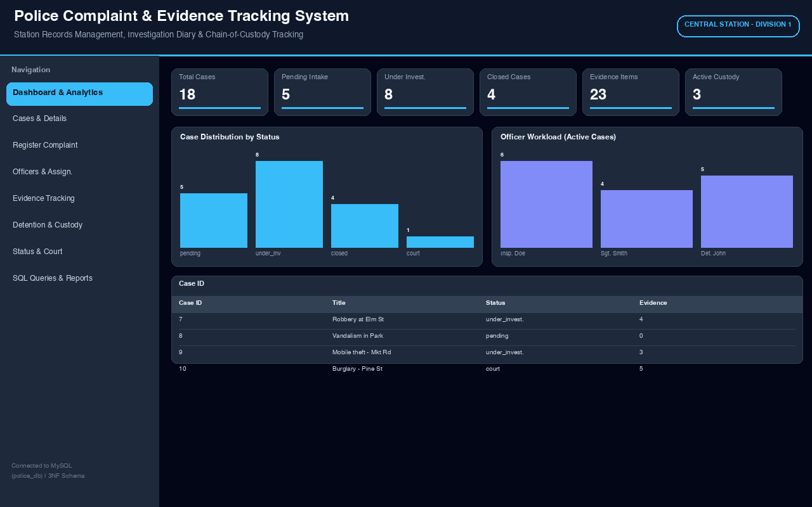
Figure 2. Dashboard & Analytics — live metrics, status/workload/storage charts and active complaints overview
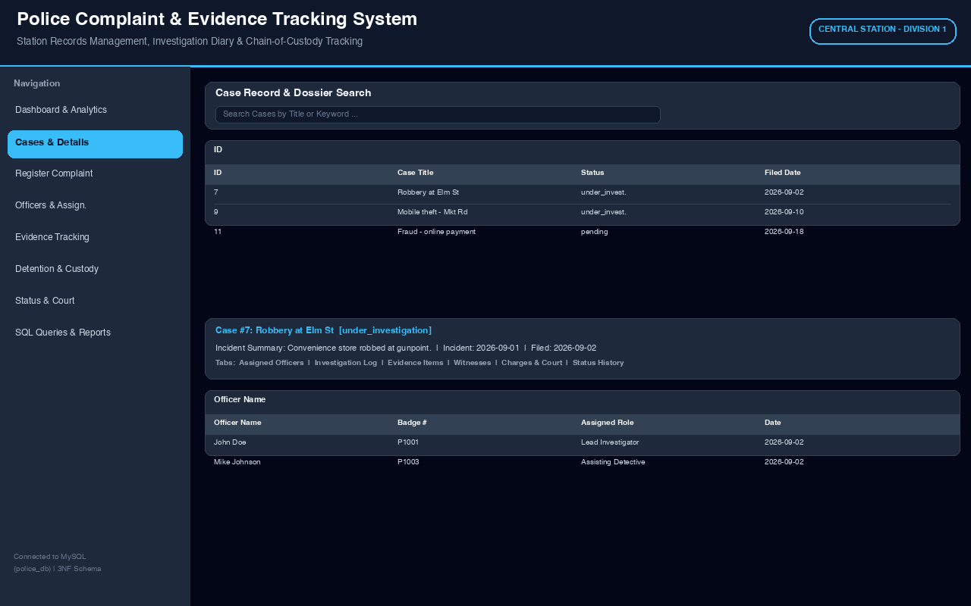
Figure 3. Cases & Details — keyword/status search with single-case dossier and six detail tabs
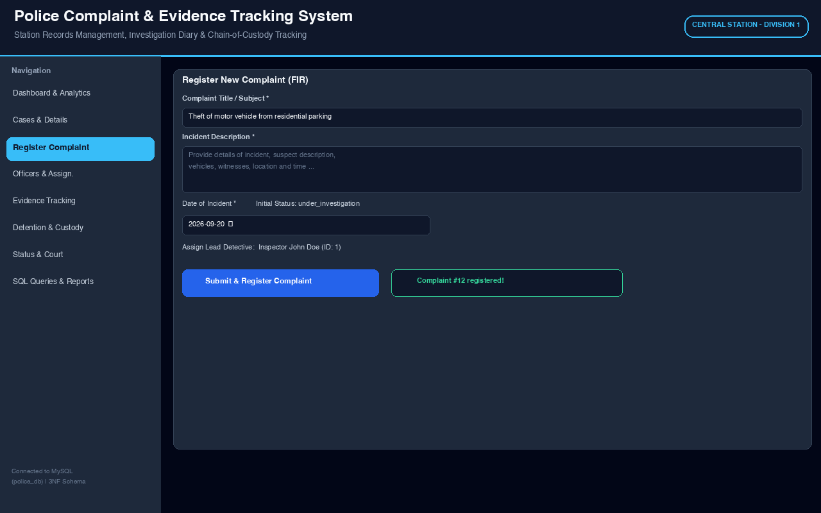
Figure 4. Register New Complaint (FIR) — validated FIR form with optional lead-detective assignment
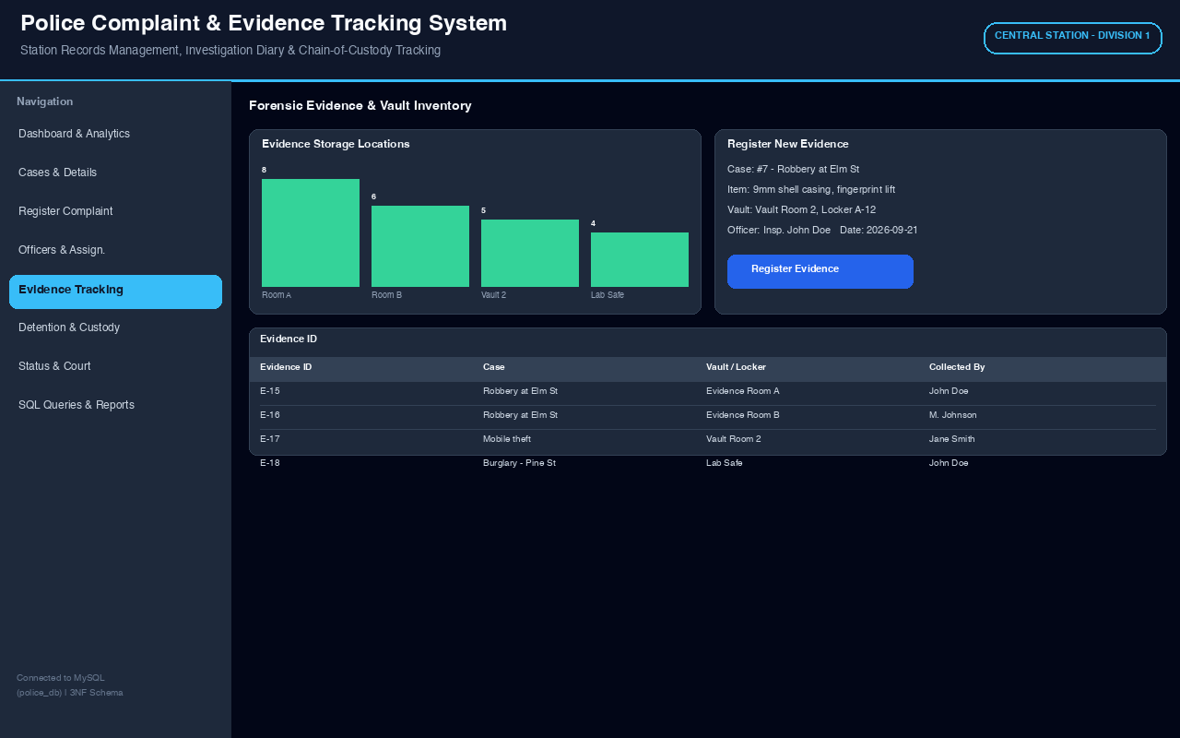
Figure 5. Evidence Tracking — evidence registration and vault/locker inventory with custodians
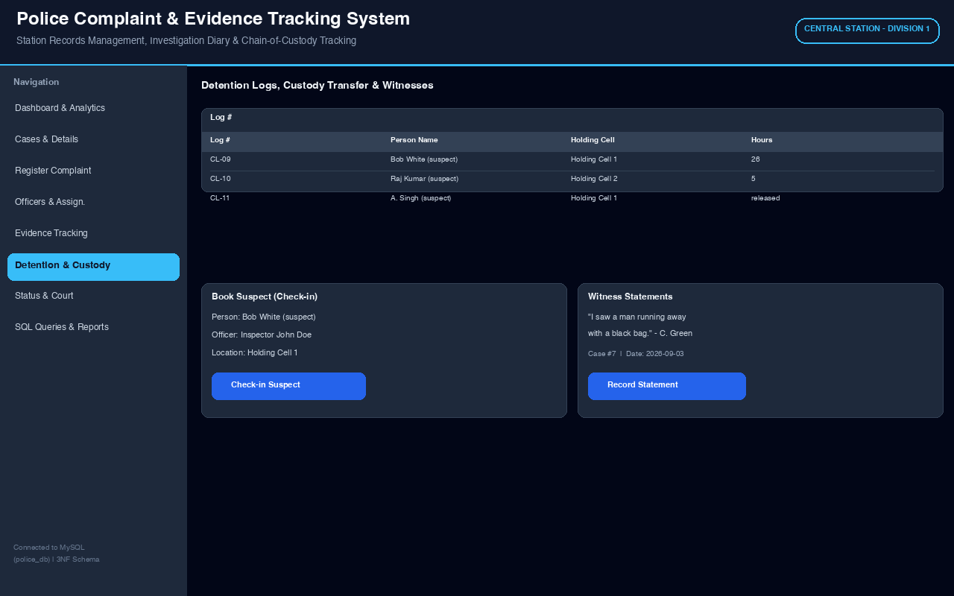
Figure 6. Detention & Custody — active register, suspect check-in/check-out and witness statements
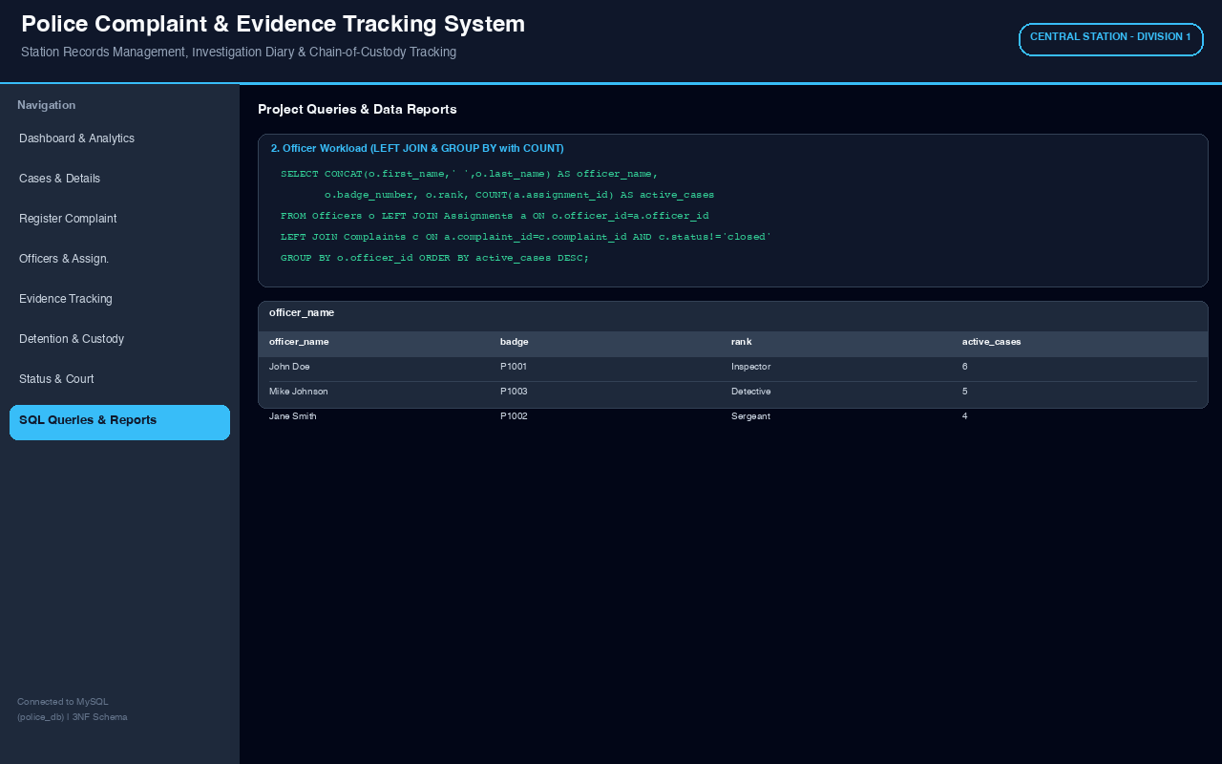
Figure 7. SQL Queries & Reports — parameterized academic queries with live output (officer workload shown)

3.8 Testing and Results
Table 15. Test Cases
Test ID | Feature | Input / Action | Expected Result | Actual Result | Status
TC-01 | Register complaint | Title+description+date, assign lead | New complaint ID + history row; appears on dashboard. | New ID banner; row in master table. | Pass
TC-02 | Mandatory-field check (negative) | Submit FIR with empty title | Block with error; no INSERT. | Error shown; count unchanged. | Pass
TC-03 | Assign + auto-promote | Assign officer to pending case | Assignment row; status->under_investigation. | Role listed; status changed. | Pass
TC-04 | Evidence register | Item+date+officer+vault | Evidence row in vault inventory. | E-ID in Fig. 5 table. | Pass
TC-05 | Custody check-in/out | Check-in suspect; then check-out | Active register entry; hours computed; checkout timestamp set. | Log rows + duration shown. | Pass
TC-06 | Closure rule (negative) | Set status=closed with <5-char findings | Block with validation error. | Error banner; status unchanged. | Pass
TC-07 | Reports | Run all 6 SQL console queries | Correct JOIN/aggregate/nested/temporal outputs. | Tables + charts match DB. | Pass
TC-08 | Dossier search | Keyword 'robbery' + status filter | Filtered list + 6 tabs (officers, diary, evidence, witnesses, charges, history). | Dossier shown as Fig. 3. | Pass
Summarize the key results after the test-case table. State whether the application correctly uses the designed database and enforces the important business rules.
All eight test cases passed. Positive tests confirmed FIR creation, assignment with automatic promotion from pending to under_investigation, evidence and custody transactions, and correct JOIN/aggregation/nested-query reports. Negative tests confirmed the closure-details block, mandatory-field blocks and custody CHECK enforcement. The dashboard counts, dossier tabs and report outputs always matched direct MySQL verification, showing the application correctly uses the designed 3NF database and enforces its key business rules.

CHAPTER 4
CONCLUSION

Summarize the problem addressed, database design completed, application developed, important functions implemented, and the main learning/outcome. Keep the conclusion concise.
The project addressed manual, fragmented station record-keeping by delivering a centralized Police Complaint & Evidence Tracking System. An 11-table MySQL design was derived from the approved ER diagram, constrained with primary, foreign key, unique, check and default rules, and verified to Third Normal Form. A Python–Streamlit application implements the full lifecycle — FIR registration, officer assignment and diary logging, evidence vault tracking, custody transfer with durations, witness statements, charges, court references and audited status transitions — supported by dashboard analytics and six SQL reports. Testing confirmed correct database use and rule enforcement. The outcome is a practical, auditable single-station tool and a clear demonstration of ER modelling, normalization, SQL and database-application development.

4.1 Limitations and Future Enhancements
Mention genuine limitations of the current small-scope application and realistic enhancements that could be implemented later.
- Single-station scope with no multi-station sync or role-based login; future: user authentication with SHO/clerk/officer roles and audit user-ids.
- No GIS mapping, biometric search or e-court filing; future: map-based hotspot view and court-date SMS/email reminders.
- Seed-scale data and intranet-only Streamlit deployment; future: pagination, indexes on title/status/dates, backups, and containerized deployment for larger loads.

REFERENCES

- [1] R. Elmasri and S. B. Navathe, Fundamentals of Database Systems, 7th ed. Boston, MA, USA: Pearson, 2016.
- [2] C. J. Date, An Introduction to Database Systems, 8th ed. Boston, MA, USA: Addison-Wesley, 2004.
- [3] A. Silberschatz, H. F. Korth and S. Sudarshan, Database System Concepts, 7th ed. New York, NY, USA: McGraw-Hill, 2020.
- [4] J. Hoffer, R. Venkataraman and H. Topi, Modern Database Management, 13th ed. Boston, MA, USA: Pearson, 2019.
- [5] Streamlit Inc., “Streamlit documentation,” Streamlit. Accessed: Oct. 05, 2026. [Online]. Available: https://docs.streamlit.io/
- [6] Oracle Corporation, “MySQL 8.0 reference manual,” MySQL. Accessed: Oct. 05, 2026. [Online]. Available: https://dev.mysql.com/doc/refman/8.0/en/
[7] Oracle Corporation, “MySQL Connector/Python developer guide,” MySQL. Accessed: Oct. 05, 2026. [Online]. Available: https://dev.mysql.com/doc/connector-python/en/

APPENDICES

APPENDIX A - COMPLETE DATABASE SCRIPT
Attach the complete DDL/DML/query script or provide the submitted file name.
Appendix A file: schema.sql (159 lines) in the project folder. It creates database police_db, 11 tables with PK/FK/UNIQUE/NOT NULL/CHECK/DEFAULT and InnoDB cascades, plus seed data (3 officers, 3 persons, 2 complaints, assignments, evidence, witness, custody and status history). Run with: mysql -u root -p < schema.sql. Representative CREATE TABLE excerpts are shown in Section 2.6.

APPENDIX B - APPLICATION SOURCE CODE
Provide the source-code folder/repository reference. Do not paste the entire application code into the main report.
Appendix B code: app.py (1035 lines, eight Streamlit modules, parameterized queries, charts) and database.py (get_connection, fetch_data, execute_query via mysql-connector-python); requirements: streamlit, pandas, mysql-connector-python; run with: pip install -r requirements.txt and streamlit run app.py (http://localhost:8501). Repository link: [GitHub link to be added by student].

APPENDIX C - ADDITIONAL TEST DATA AND OUTPUTS
Include any additional test data, screenshots, reports or supporting material that is useful but not essential in the main report.
Appendix C: Figures 2-7 give dashboard, dossier, registration, evidence, custody and SQL-report outputs. Test evidence (Table 15, TC-01 to TC-08) plus live dashboard counts and custody TIMESTAMPDIFF durations serve as additional outputs. ER diagram source image: report_assets/er_diagram.png.

