**C.B PATEL COMPUTER COLLEGE &**

**J. N. M. PATEL SCIENCE COLLEGE, SURAT**

***VEER NARMAD SOUTH GUJARAT UNIVERSITY, SURAT***

A

**PROJECT REPORT**

**ON**

***Flex Car***

AS PARTIAL REQUIREMENT FOR THE DEGREE

OF

**BACHELOR OF COMPUTER APPLICATION**

[B.C.A]

**YEAR – 2018-19**



**SUBMITTED BY: GUIDED BY:**

* **Moxil Patel Mrs. Jenish Bhavsar**
* **Mihir Rathod**
* **Jay Patel**

**ACKNOWLEDGEMENT**

Success in such a comprehensive project cannot be achieved single-handled. It is team effort that sails the ship to the coast. So we would like to express our sincere thanks to all the dignitaries who were involved in making this project a great joy and turning it into successful piece of work.

We would like to take opportunity to thank my collage **C. B. Patel Computer College & J. N. M Patel Science College**, Surat for giving us this tremendous opportunity to work in the real-time project.

**Mrs. JenishBhavsar**, our professor and project coordinator, has been very prudent to us throughout our college studies. She is the person who has been giving direction to our work and the shape to our imagination. We express our regards to her from the core of our heart.

We also like to thank our **H. O. D Dhananjay Sir** and all the professors who are always ready to give best guidance. They are the individuals who give solutions whenever required.

We would also like to acknowledge all **our friends** and colleagues, team members for their help and encouragement from time to time. The constant support and encouragement of my friend deeply appreciates. The project indeed gave challenging and exhilarating experience in designing and developing the required system.

Finally we would like to thank **our parents** for their support throughout the project. We owe a special debt to our family & friends for their supports blessing and encouragement for us.

THANKS ALL**………**

**INDEX**

|  |  |  |
| --- | --- | --- |
| Sr No. | Topic | Page No. |
| 1. | **Introduction** |  |
| 2. | **Objective of Project** |  |
| 3. | **Project Category** |  |
| 4. | **Tools/Environment Used** |  |
| 5. | **Analysis Report** |  |
|  | 5.1 Time line Chart |  |
|  | 5.2 Current System |  |
|  | 5.3 Drawback/Limitation Of Existing System |  |
|  | 5.4 Requirement Specification |  |
|  | 5.5 Proposed System |  |
|  | 5.6 Advantages of proposed system |  |
|  | 5.7 Data Flow Diagram |  |
|  | 5.8 Optional( /ERD & /UML & /STD) |  |
|  | 5.9 Process Specification |  |
|  | 5.10 Data Dictionary |  |
|  | 5.11 Table Design |  |
| 6. | **Design Report** |  |
|  | 6.1 Site Diagram/Program Flow Diagram(Map) |  |
|  | 6.2 Algorithm / Flow Chart |  |
|  | 6.3 Security issues |  |
|  | 6.4 Input Screen Layouts |  |
|  | 6.5 Output Report |  |
| 7. | **Testing Report** |  |
|  | 7.1 Test Case Design |  |
|  | 7.2 Testing Issues |  |
| 8. | **Limitation Of System** |  |
| 9. | **Future Enhancement Of The Project** |  |
| 10. | **Appendix** |  |
| 11. | **References** |  |

1. **Introduction**

This project Car Rental System is a web-based online system because it's easier for the customers to rent a car. This project Car Rental System has been provided car history details, insurance registration and expiration details, car check in and check out details, car servicing details, payment details etc. This project also have to facility to check their customers and suppliers details and their payment mode and status details along with date and time. First time customers will have to create a profile if they are taking a car on rent and select the appropriate payment mode.

However customers are taking this service by visiting the office, they will get their id and password. Customers will have the facility to select any type of car, search car by their brand name. Upon selection of particular type customers will able to get their entire details like rent type, cost for taking a particular car, mileage details in kilometer an hour. This system can also help for customers to fill the basic information details like name address , total number of family members who also travel through the car, number of days to take service, location to travel etc. The main aim of this project car rental system project is to maintain records of cars.

Basically this system help car rental shopper to make daily record and easy billing of customers and also help to keep maintain monthly revenues and help to grow business. This system work 24x7 because of it is online existence Customer can use this system from anywhere and anytime Customers can book car service from any were in the world and take service when they Visit that city.

1. **Objective of Project**

* **Project Definition:**
* To produce a web-based system that allow customer to register and reserve car online and for the company to effectively manage their car rental business.
* To ease customer’s task whenever they need to rent a car.
* **Features:**
* Project are categorized into online car booking, online car rent services
* E-mail and SMS services are provide.
* Feedback table for getting feedback from customers.
* Online renting and cash transaction with Paytm.
* Online car booking in minimum cost
* Admin panel features:
* Manage category panel to insert delete and select category.
* Login facility for admin and customer both.
* Driver details, cars details , car gallery, rent details .
* Search all types of car details.

1. **Project Category**

**FlexCar (Car rental service):**

A car rental, hire car, or car hire agency is a company that rents automobiles for short periods of time, generally ranging from a few hours to a few weeks. It is often organised with numerous local branches (which allow a user to return a vehicle to a different location), and primarily located near airports or busy city areas and often complemented by a website allowing online reservations.  
  
Car rental agencies primarily serve people who require a temporary vehicle, for example, those who do not own their own car, travelers who are out of town, or owners of damaged or destroyed vehicles who are awaiting repair or insurance compensation. Car rental agencies may also serve the self-moving industry needs, by renting vans or trucks, and in certain markets, other types of vehicles such as motorcycles or scooters may also be offered.

1. **Tools/Environment Used**

|  |  |  |
| --- | --- | --- |
|  |  |  |
| Front End | : | Visual Studio 2017 |
| Scripting Language | : | C# with ASP.NET |
| Back End | : | SQL Server |
| Operating System | : | Microsoft Windows 10 |
| Framework | : | .NET 4.5 |
| E-R Diagram / DFD | : | Draw.io |
| Additional Technologies | : | JQuery, Bootstrap, CSS3, JavaScript |

**5. Analysis Report**

* 1. **Time-Line Chart**

|  |  |  |  |  |  |  |  |  |  |  |  |  |  |  |  |  |
| --- | --- | --- | --- | --- | --- | --- | --- | --- | --- | --- | --- | --- | --- | --- | --- | --- |
| **Work Tasks** | **Jan** | | **Feb** | | | | **Mar** | | | | **Apr** | | | | **Apr** | |
| **Week** | **3** | **4** | **1** | **2** | **3** | **4** | **1** | **2** | **3** | **4** | **1** | **2** | **3** | **4** | **1** | **2** |
| **1.Requirement Gathering & Analysis** |  |  |  |  |  |  |  |  |  |  |  |  |  |  |  |  |
| 1.1 Learn C# |  |  |  |  |  |  |  |  |  |  |  |  |  |  |  |  |
| 1.2 Requirement Gathering |  |  |  |  |  |  |  |  |  |  |  |  |  |  |  |  |
| 1.3 Requirement Analysis |  |  |  |  |  |  |  |  |  |  |  |  |  |  |  |  |
| 1.4 SRS |  |  |  |  |  |  |  |  |  |  |  |  |  |  |  |  |
| 1.5 Review |  |  |  |  |  |  |  |  |  |  |  |  |  |  |  |  |
| **Milestone:** Requirements Gathered. |  |  |  |  |  |  |  |  |  |  |  |  |  |  |  |  |
| **2.Modeling** |  |  |  |  |  |  |  |  |  |  |  |  |  |  |  |  |
| 2.1 Identifying proposed project profile. |  |  |  |  |  |  |  |  |  |  |  |  |  |  |  |  |
| 2.2 Identifying Objectives. |  |  |  |  |  |  |  |  |  |  |  |  |  |  |  |  |
| 2.3 Scope definition. |  |  |  |  |  |  |  |  |  |  |  |  |  |  |  |  |
| 2.4 Review. |  |  |  |  |  |  |  |  |  |  |  |  |  |  |  |  |
| **Milestone:** Modeling Completed. |  |  |  |  |  |  |  |  |  |  |  |  |  |  |  |  |
| **3.System Design** |  |  |  |  |  |  |  |  |  |  |  |  |  |  |  |  |
| 3.1 Design system flow. |  |  |  |  |  |  |  |  |  |  |  |  |  |  |  |  |
| 3.2 Database Design. |  |  |  |  |  |  |  |  |  |  |  |  |  |  |  |  |
| 3.3 Admin Side Design. |  |  |  |  |  |  |  |  |  |  |  |  |  |  |  |  |
| 3.4 Client Side Design |  |  |  |  |  |  |  |  |  |  |  |  |  |  |  |  |
| 3.5 Review. |  |  |  |  |  |  |  |  |  |  |  |  |  |  |  |  |
| **Milestone:** System Design completed |  |  |  |  |  |  |  |  |  |  |  |  |  |  |  |  |
| **4.Coding** |  |  |  |  |  |  |  |  |  |  |  |  |  |  |  |  |
| 4.1 Admin Side Coding |  |  |  |  |  |  |  |  |  |  |  |  |  |  |  |  |
| 4.2 Client Side Coding |  |  |  |  |  |  |  |  |  |  |  |  |  |  |  |  |
| **Milestone:** Coding completed |  |  |  |  |  |  |  |  |  |  |  |  |  |  |  |  |
| **5.Testing** |  |  |  |  |  |  |  |  |  |  |  |  |  |  |  |  |
| 5.1 Unit testing |  |  |  |  |  |  |  |  |  |  |  |  |  |  |  |  |
| 5.2 Integration Testing |  |  |  |  |  |  |  |  |  |  |  |  |  |  |  |  |
| 5.3 Correction |  |  |  |  |  |  |  |  |  |  |  |  |  |  |  |  |
| **Milestone:** Testing Complete |  |  |  |  |  |  |  |  |  |  |  |  |  |  |  |  |

**5.2 Existing System**

* **Features of Existing system**
* User Registration
* Admin Login and manage category
* View and get details about cars, booking, users, drivers etc.
* **Admin**
* All Cars are managed and shown in client side.
* Also manage driver & users.
* Can edit, delete, search and add cars.
* **User**
* User can login and registered in website.
* User can also show all available car details and rents.
* User can book a car which is available in his/her city.
* **Driver**
* Driver can login his account.
* Driver Manage his profile.
* Driver show Client information and booking information.
* **Visitor**
* Visitor can only show details about car.
* Visitor can contact to admin.

**5.3 Drawback/limitation of Existing System**

* This system can’t provide client’s insurance.
* This system can’t provide car accessories.

**5.4 Requirement Specification**

* **Functionality Portioned**
* Admin
* Driver
* User
* Visitor
* **Admin**
* Login
* Client management
* Car management
* Booking management
* Payment management
* **User**
* Login
* User registration
* View car details
* Car booking
* View drivers
* Payment

**5.5 Proposed System**

* Scope
* Objectives
* Constraints

**Scope**

* Our website is bounded across the following users:-

**5.5.1 Admin**

**5.5.2 User**

**5.5.3 Visitors**

**5.5.1 Admin**

* Admin manage facility for insert, update, delete and search category.
* Admin can send registration confirmation SMS to the user.
* Admin manage feedback for system given by users.
* Admin manage comments form for different types of users.
* Admin can also manage payment for online car booking.
* Admin can manage booking details.

**5.5.2 User**

* User can login to the system.
* User can also register their information by the registration form and SMS can be received from admin.
* User can also change password.
* When the user forgot their password the forgot password facility also provide.
* User can also give feedback to the system.
* If any inquiry or details are required then the user can also contact our system.
* User can book a car for specific time prior.
* User can receive inquiry details from admin for the event booking.

**5.5.3 Visitors**

* Visitors can view all types of information about cars, drivers, .
* Visitors can also see car rent details.
* Visitors can contact to the system.
* Visitors can register on the system.

**Objectives**

* Availability of vehicle round the clock.
* Wide range of vehicles including:

Hatchback

SUVs

Sedan

* Pickup and drop-off locations according to choice.
* Online Payment option with Paytm
* Receipt and online voucher generation.

**Constraints:**

The constraints associated in the development of any software system includes those that common to all system. The common constraints may include lack of managerial participation tighter development schedule etc.

Some of the constraints listed below with which we have developed this system.

* It requires Microsoft Windows 10
* Net connection and software are requiring.
* It is a general system and hence it may require some modification of Primary Level to best fit in satisfying specific requirements.
* It requires Windows XP or higher operating system.
* It requires internet connected to the system.
* It requires SQL server.
* It requires Microsoft visual.Net 2017.

**5.6 Advantage of Proposed System**

* **Less manual work:**

Since all the work to be done from the computerized system so all the paper work will be remove and in this case it will be remove all stationary.

* **Human based activity reduce:**

The proposed system is totally based on the computer and decreased the human anomalies and all the center transactions are enter and proposed by computer so it will be take a less time and also reduce all disbursement for the employee who are working for the management and all the transactions.

* **Less Time Required:**

In our proposed system, all the processes are carried out by computer so naturally it will required less time than traditional center management system and in that sense, it will required less time to complete transactions can process data very fast.

* **High Amount of Accuracy:**

In our new proposed system there are less amount of human activities are involved in that case it will have less effect on our work. The new system will perform all calculation and manipulation automatically, in that case the data that we will received will be accurate and much more reliable that the data that is generated previously.

* **Low Expenditure:**

The stationary maintenance will be reduced in the proposed system. This automatically decreases the total expenditure of the management.

* **Help to take proper Decision:**

All Activities are computer-based activities so information provided to management is almost accurate. Right decision-making needs accurate information. So with the help of proposed system, the management can make the proper decision in most of the cases.

* **System can be implemented:**

Since all requirement are fulfilled and satisfied by our computerized system and can perform all tasks that provided by management, but in circumstances, if our management wants to improve our system and they compare to make changes in our existing system. We can improve that change according to the management requirement.

**5.7 Data Flow Diagram**

* **Context level DFD:**

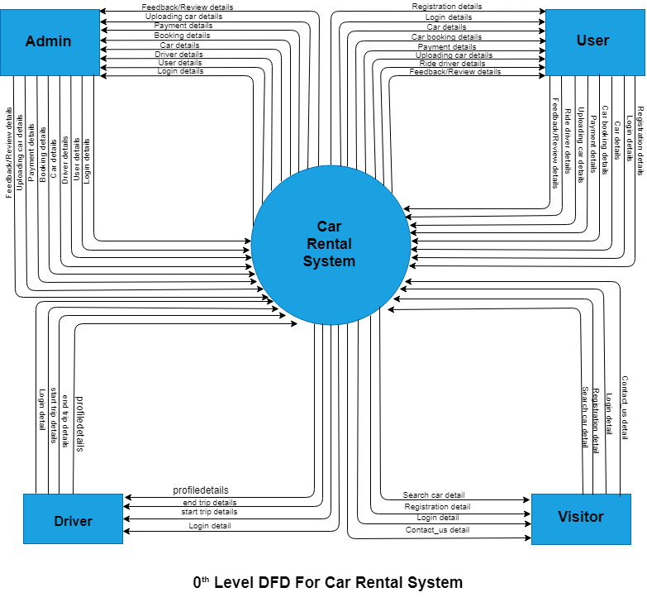

* **1St level DFD:**

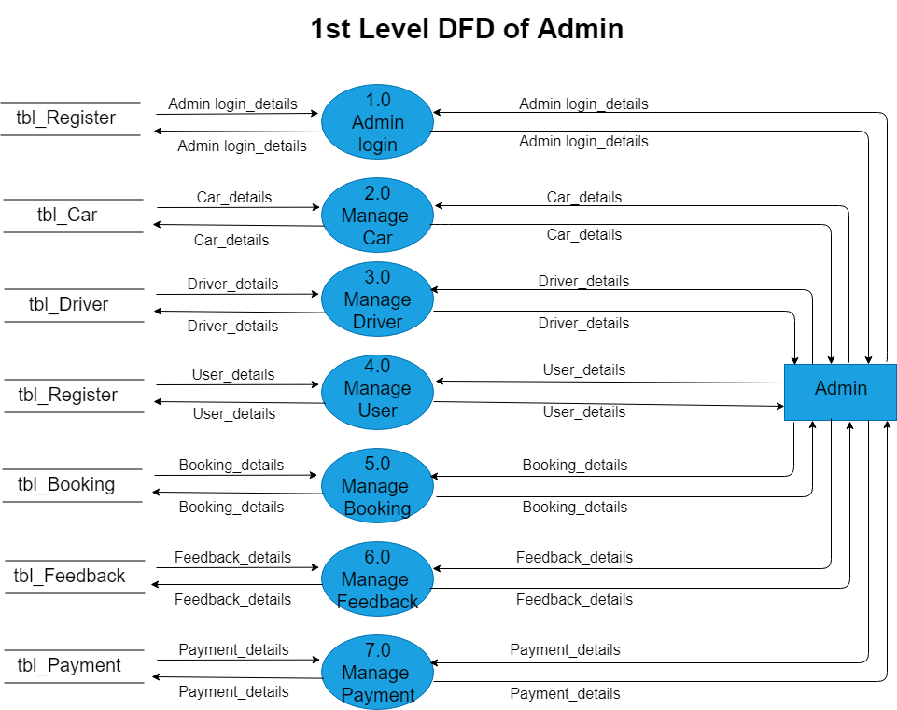

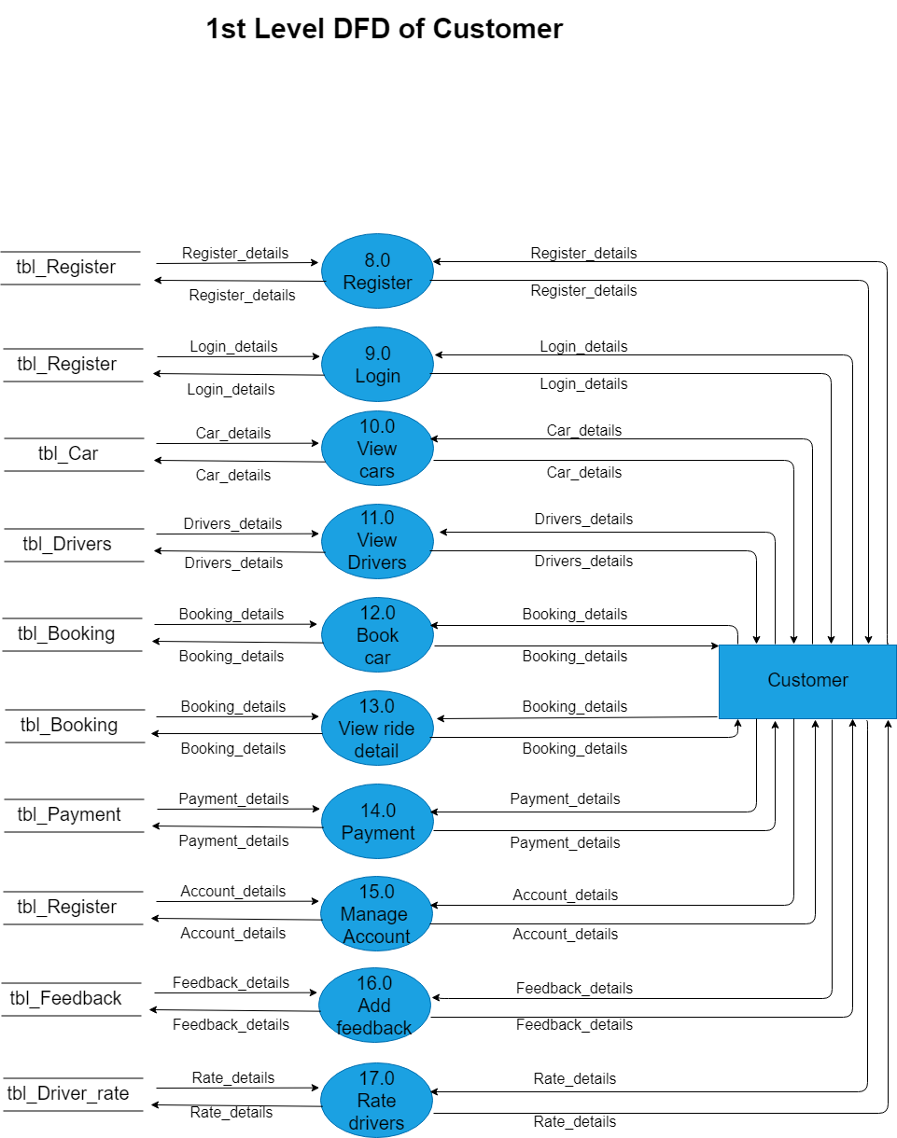

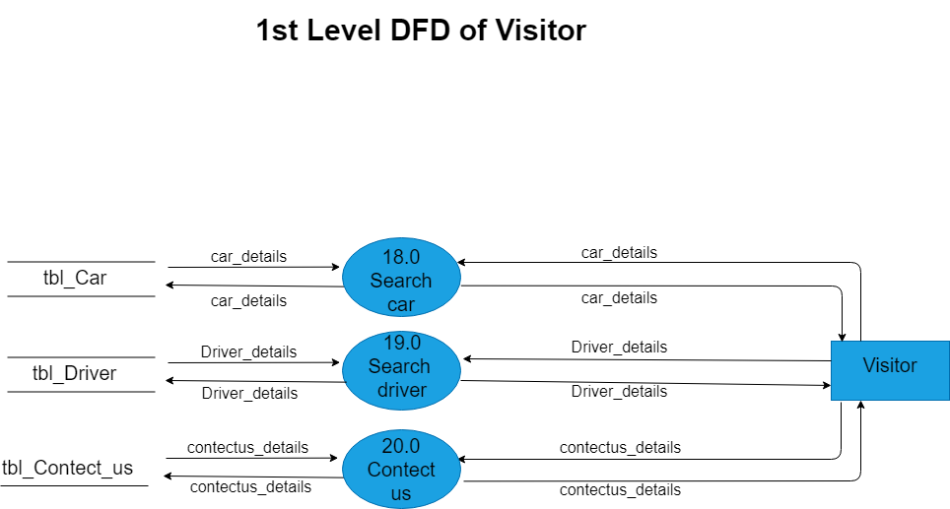

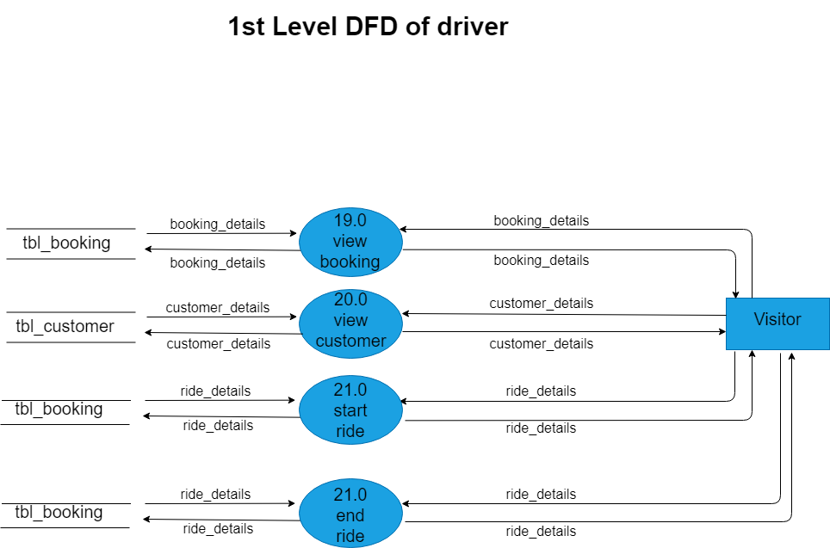

* **2nd level DFD:**

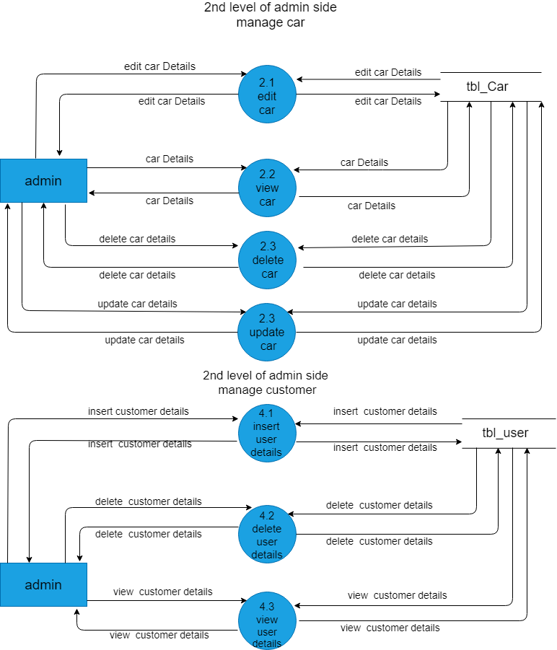

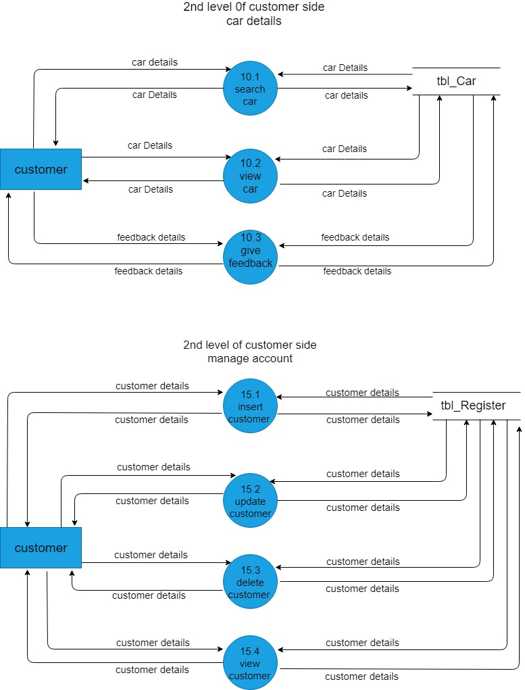

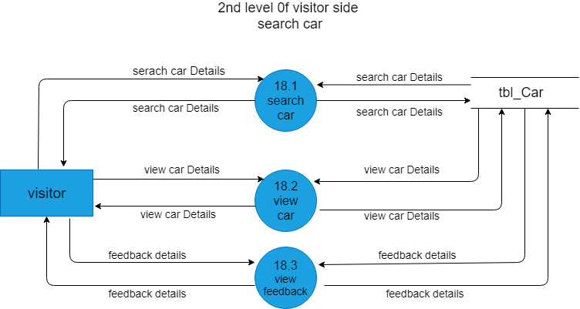

* **3rd level DFD:**

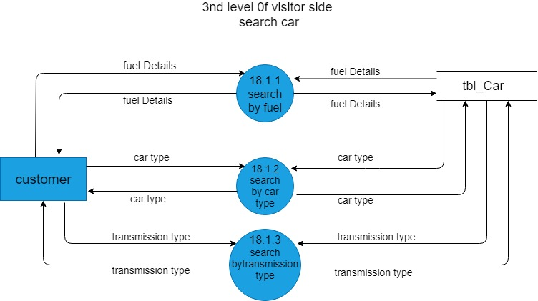

**5.9 Process Specification**

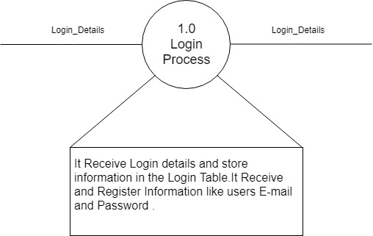

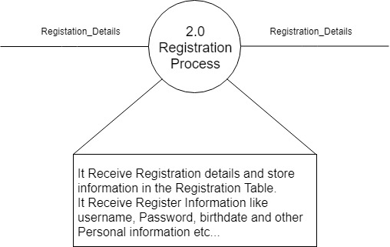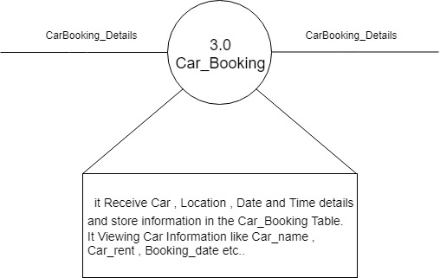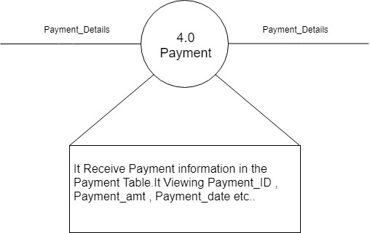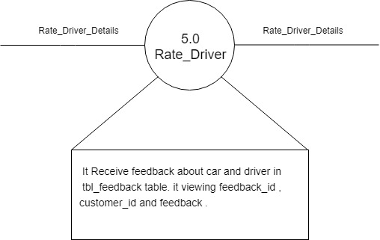

**5.10 Data Dictionary**

1. tbl_admin

|  |  |
| --- | --- |
| Name | Admin details |
| Alias Name | None |
| Where and How used? |  |
| Description | It will be describe the Details of Admin like,  admin_id(primary key) + fname + lname + phone_number + birthdate + email + password + gender + age + state_id(foreign key) + city_id(foreign key) + pic1 |

1. tbl_booking

|  |  |
| --- | --- |
| Name | booking details |
| Alias Name | None |
| Where and How used? | Manage book car  5.0 manage booking (IN/Out)  12.0 book car (IN/Out)  13.0 view ride details(IN/Out)  19.0 view booking (IN/Out) |
| Description | It will be describe the Details of booking like,  booking_id(primary key) + booking_date + ride_starting_date + ride_ending_date + customer_id(foreign key) + car_id(foreign key) + driver_id(foreign key) + total_fare + location_id(foreign key) + booking_days |

1. tbl_car

|  |  |
| --- | --- |
| Name | car details |
| Alias Name | None |
| Where and How used? | 2.0 manage car (IN/Out)  2.1 edit car (IN/Out)  2.2 view car (IN/Out)  2.3delete car (IN/Out)  2.4 update car (IN/Out)  10.0 view car (IN/Out)  18.0 search car(IN/Out) |
| Description | It will be describe the Details of car like,  car_id(primary key) + car_name_id(foreign key) + car_company_id(foreign key) + car_model_id(foreign key) + transmission_type + car_fuel_id(foreign key) + car_type_id(foreign key) + avarage_fuel_efficiency + color_id(foreign key) + registration_number + owner_name + car_menufacture_year + customer_id + car_image + car_rent + state_id(foreign key) + city_id(foreign key) + status |

1. tbl_car_color

|  |  |
| --- | --- |
| Name | car color details |
| Alias Name | None |
| Where and How used? |  |
| Description | It will be describe the Details of car color like,  color_id(primary key) + color |

1. tbl_car_company

|  |  |
| --- | --- |
| Name | car company details |
| Alias Name | None |
| Where and How used? |  |
| Description | It will be describe the Details of car company like,  car_company_id(primary key) + car_company_name |

1. tbl_car_fuel_type

|  |  |
| --- | --- |
| Name | car fuel type details |
| Alias Name | None |
| Where and How used? |  |
| Description | It will be describe the Details of car fuel type like,  car_fuel_id(primary key) + car_fuel_type |

1. tbl_car_gallery

|  |  |
| --- | --- |
| Name | car gallery details |
| Alias Name | None |
| Where and How used? |  |
| Description | It will be describe the Details of car gallery like,  id(primary key) + car_id(foreign key) + img |

1. tbl_car_model

|  |  |
| --- | --- |
| Name | car model details |
| Alias Name | None |
| Where and How used? |  |
| Description | It will be describe the Details of car model like,  car_model_id(primary key) + car_model |

1. tbl_car_name

|  |  |
| --- | --- |
| Name | car name details |
| Alias Name | None |
| Where and How used? |  |
| Description | It will be describe the Details of car name like,  car_name_id(primary key) + car_company_id(foreign key) + car_name |

10) tbl_car_type

|  |  |
| --- | --- |
| Name | car type details |
| Alias Name | None |
| Where and How used? |  |
| Description | It will be describe the Details of car type like,  car_type_id(primary key) + car_type |

11) tbl_city

|  |  |
| --- | --- |
| Name | city details |
| Alias Name | None |
| Where and How used? |  |
| Description | It will be describe the Details of city like,  city_id(primary key) + state_id(foreign key) + city_name |

12) tbl_contact

|  |  |
| --- | --- |
| Name | contact details |
| Alias Name | None |
| Where and How used? |  |
| Description | It will be describe the Details of contact like,  id(primary key) + fname + lname + email + phone + comt |

13) tbl_country

|  |  |
| --- | --- |
| Name | country details |
| Alias Name | None |
| Where and How used? |  |
| Description | It will be describe the Details of country like,  country_id(primary key) + c_name |

14) tbl_car_driver

|  |  |
| --- | --- |
| Name | car deriver details |
| Alias Name | None |
| Where and How used? |  |
| Description | It will be describe the Details of car driver like,  id(primary key) + driver_id(foreign key) + car_id(foreign key) |

15) tbl_customer

|  |  |
| --- | --- |
| Name | customer details |
| Alias Name | None |
| Where and How used? |  |
| Description | It will be describe the Details of car customer like,  customer_id(primary key) + fname + lname + phone_number + birthdate + driving_lincense_number + lincense_expire_date + email + password + gender + age + state_id(foreign key) + city_id(foreign key) |

16) tbl_driver

|  |  |
| --- | --- |
| Name | driver details |
| Alias Name | None |
| Where and How used? |  |
| Description | It will be describe the Details of car customer like,  driver_id(primary key) + fname + lname + phone_number + birthdate + driving_lincense_number + lincense_expire_date + email + password + gender + age + state_id(foreign key) + city_id(foreign key) + adharcardno + address + pic + status |

17) tbl_driver_rate

|  |  |
| --- | --- |
| Name | driver rate details |
| Alias Name | None |
| Where and How used? |  |
| Description | It will be describe the Details of car driver rate like,  rate_id(primary key) + driver_id(foreign key) + customer_id(foreign key) + rating |

18) tbl_feedback

|  |  |
| --- | --- |
| Name | customer details |
| Alias Name | None |
| Where and How used? |  |
| Description | It will be describe the Details of car customer like,  feedback_id(primary key) + customer_id(foreign key) + feedback |

19) tbl_location

|  |  |
| --- | --- |
| Name | location details |
| Alias Name | None |
| Where and How used? |  |
| Description | It will be describe the Details of location like,  location_id(primary key) + state_id(foreign key) + city_id(foreign key) + pincode + address + booking_id(foreign key) |

20) tbl_state

|  |  |
| --- | --- |
| Name | state details |
| Alias Name | None |
| Where and How used? |  |
| Description | It will be describe the Details of state like,  state_id(primary key) + country_id(foreign key) + state_name |

**5.11 Table Design**

* tbl_admin:

Admin Id - Primary Key

State_id – Reference Key

City_id – Reference Key

|  |  |  |  |  |
| --- | --- | --- | --- | --- |
| **Field Name** | **Data Type** | **Size** | **Constraint** | **Description** |
| Admin_id | int |  | Primarykey | It Contains Adminid of Admin |
| fname | varchar | 30 | NotNull | It Contains fname of Admin |
| lname | varchar | 30 | NotNull | It Contains lname of Admin |
| Phone_number | numeric | 10,0 | NotNull | It Contains phonenumber of Admin |
| Birthdate | varchar | 50 | NotNull | It Contains birthdate of Admin |
| email | Varchar | 30 | NotNull | It Contains email of Admin |
| Password | Varchar | 30 | NotNull | It Contains password of Admin |
| Gender | Varchar |  | NotNull | It Contains gender of Admin |
| Age | Int |  | NotNull | It Contains age of Admin |
| State_id | Int |  | RefernceKey | It Contains state of Admin |
| City_id | Int |  | RefernceKey | It Contains city of Admin |
| Pic1 | Varchar | 50 | NotNull | It Contains picture of Admin |

* tbl_car_color :

Color_id – Primary Key

|  |  |  |  |  |
| --- | --- | --- | --- | --- |
| **Field Name** | **Data Type** | **Size** | **Constraint** | **Description** |
| Color_id | Int |  | PrimaryKey | It Contains color_id of colour |
| Color | Varchar | 30 | Not Null | It Contains color of coluor |
|  |  |  |  |  |

* tbl_booking:

Booking id – Primary Key

Customer id - RefernceKey

Car id - RefernceKey

State id - RefernceKey

City id - RefernceKey

|  |  |  |  |  |
| --- | --- | --- | --- | --- |
| **Field Name** | **Data Type** | **Size** | **Constraint** | **Description** |
| Booking_id | Int |  | PrimaryKey | It Contains booking id of booking |
| Booking_date | Varchar | 50 | Not Null | It Contains booking date of booking |
| Ride_starting_date | Varchar | 50 | Not Null | It Contains ride starting date of booking |
| Ride_ending_date | Varchar | 50 | Not Null | It Contains ride ending date of booking |
| Customer_id | Int |  | RefernceKey | It Contains customer id of booking |
| Car_id | Int |  | RefernceKey | It Contains car id of booking |
| Total_fare | Bint |  | Not Null | It Contains total fare of booking |
| Booking_days | varchar | 50 | Not Null | It Contains booking days of booking |
| State_id | Int |  | RefernceKey | It Contains state id of booking |
| City_id | Int |  | RefernceKey | It Contains city id of booking |
| Pincode | Int |  | Not Null | It Contains pincode of booking |
| Address | Varchar | 500 | Not Null | It Contains address of booking |

* tbl_car_company :

Car_company_id– Primary Key

|  |  |  |  |  |
| --- | --- | --- | --- | --- |
| **Field Name** | **Data Type** | **Size** | **Constraint** | **Description** |
| Car_company_id | Int |  | PrimaryKey | It Contains car company_id of car company |
| Car_company_name | Varchar | 50 | Not Null | It Contains car_company_name of car company |
|  |  |  |  |  |

* tbl_car:

Car id – Primary Key

Car_name_id - RefernceKey

Car_company_id - RefernceKey

Car_model_id - RefernceKey

Car_fuel_id - RefernceKey

Car_type_id - RefernceKey

Color_id - RefernceKey

Customer_id - RefernceKey

|  |  |  |  |  |
| --- | --- | --- | --- | --- |
| **Field Name** | **Data Type** | **Size** | **Constraint** | **Description** |
| Car_id | Int |  | PrimaryKey | It Contains car idof car |
| Car_name_id | Int |  | RefernceKey | It Contains car name id of car |
| Car_company_id | Int |  | RefernceKey | It Contains car company id of car |
| Car_model_id | Int |  | RefernceKey | It Contains car model id of car |
| Transmission_type | Varchar | 30 | Not Null | It Contains transmission type of car |
| Car_fuel_id | Int |  | RefernceKey | It Contains car fuel id of car |
| Car_type_id | Int |  | RefernceKey | It Contains car type id of car |
| Average_fuel_efficiency | Varchar | 30 | Not Null | It Contains average fuel efficiency of car |
| Color_id | Int |  | RefernceKey | It Contains color id of car |
| Registration_number | Varchar | 50 | Not Null | It Contains registration number of car |
| Owner_name | Varchar | 30 | Not Null | It Contains owner name of car |
| Car_menufacture_year | Varchar | 10 | Not Null | It Contains car menufacture year of car |
| Customer_id | Int |  | RefernceKey | It Contains customer id of car |
| Car_image | Varchar | 50 | Not Null | It Contains car image of car |

* tbl_car_model:

Car_model_id– Primary Key

|  |  |  |  |  |
| --- | --- | --- | --- | --- |
| **Field Name** | **Data Type** | **Size** | **Constraint** | **Description** |
| Car_model_id | Int |  | PrimaryKey | It Contains car_model_id of car model |
| Car_model | Varchar | 30 | Not Null | It Contains car_model of car model |

* tbl_car_driver :

id– Primary Key

driver_id - RefernceKey

car_id - RefernceKey

|  |  |  |  |  |
| --- | --- | --- | --- | --- |
| **Field Name** | **Data Type** | **Size** | **Constraint** | **Description** |
| Id | Int |  | PrimaryKey | It Contains id of car driver |
| Driver_id | Int |  | RefernceKey | It Contains driver_id of car driver |
| Car_id | Int |  | RefernceKey | It Contains car_id of car driver |

* tbl_car_fuel_type:

Car_fuel_id – Primary Key

|  |  |  |  |  |
| --- | --- | --- | --- | --- |
| **Field Name** | **Data Type** | **Size** | **Constraint** | **Description** |
| Car_fuel_id | Int |  | PrimaryKey | It Contains car_ifuel_d of car fuel type |
| Car_fuel_type | Varchar | 50 | Not Null | It Contains car_fuel_type of car fuel type |
|  |  |  |  |  |

* tbl_car_gallery :

Id – Primary Key

Car_id - RefernceKey

|  |  |  |  |  |
| --- | --- | --- | --- | --- |
| **Field Name** | **Data Type** | **Size** | **Constraint** | **Description** |
| Id | Int |  | PrimaryKey | It Contains id of car gallery |
| Car_id | Int |  | RefernceKey | It Contains car_id of car gallery |
| Img | Varchar | 50 | Not Null | It Contains img of car gallery |

* tbl_car_name :

car_name_id – Primary Key

car_company_id - RefernceKey

|  |  |  |  |  |
| --- | --- | --- | --- | --- |
| **Field Name** | **Data Type** | **Size** | **Constraint** | **Description** |
| car_name_id | Int |  | PrimaryKey | It Contains car_name_id of car name |
| car_company_id | Int |  | RefernceKey | It Contains car_company_id of car name |
| car_name | Varchar | 30 | Not Null | It Contains car_name of car name |

* tbl_city :

city_id – Primary Key

state-id - RefernceKey

|  |  |  |  |  |
| --- | --- | --- | --- | --- |
| **Field Name** | **Data Type** | **Size** | **Constraint** | **Description** |
| city_id | Int |  | PrimaryKey | It Contains city_id of city |
| state_id | Int |  | RefernceKey | It Contains state_id of city |
| city_name | Varchar | 30 | Not Null | It Contains city_name of city |

* tbl_contact :

Id – Primary Key

|  |  |  |  |  |
| --- | --- | --- | --- | --- |
| **Field Name** | **Data Type** | **Size** | **Constraint** | **Description** |
| Id | Int |  | PrimaryKey | It Contains id of contact |
| fname | varchar | 50 | Null | It Contains fname of contact |
| lname | Varchar | 50 | Null | It Contains lname of contact |
| email | Varchar | 50 | Null | It Contains email of contact |
| phone | Varchar | 50 | Null | It Contains phone of contact |
| comt | Varchar | 500 | Null | It Contains comt(comment) of contact |

* tbl_country:

country_id – Primary Key

|  |  |  |  |  |
| --- | --- | --- | --- | --- |
| **Field Name** | **Data Type** | **Size** | **Constraint** | **Description** |
| country_id | int |  | PrimaryKey | It Contains country_id of country |
| C_name | Varchar | 50 | Not Null | It Contains c_name of country |
|  |  |  |  |  |

* tbl_car_type :

car_type_id – Primary Key

|  |  |  |  |  |
| --- | --- | --- | --- | --- |
| **Field Name** | **Data Type** | **Size** | **Constraint** | **Description** |
| car_type_id | Int |  | PrimaryKey | It Contains car_type_id of car type |
| car_type | Varchar | 30 | Not Null | It Contains car_type of car type |
|  |  |  |  |  |

* tbl_location:

location_id – Primary Key

state_id – RefernceKey

city_id - RefernceKey

booking_id - RefernceKey

|  |  |  |  |  |
| --- | --- | --- | --- | --- |
| **Field Name** | **Data Type** | **Size** | **Constraint** | **Description** |
| location_id | Int |  | PrimaryKey | It Contains location_id of location |
| state_id | Int |  | RefernceKey | It Contains state_id of location |
| city_id | int |  | RefernceKey | It Contains city_id of location |
| pincode | int |  | Not Null | it Contains pincode of location |
| address | varchar | 500 | Not Null | it Contains address of location |
| booking_id | int |  | RefernceKey | it Contains booking_id of location |

* tbl_customer:

customer_id – Primary Key

state_id – RefernceKey

city_id - RefernceKey

|  |  |  |  |  |
| --- | --- | --- | --- | --- |
| **Field Name** | **Data Type** | **Size** | **Constraint** | **Description** |
| customer_id | Int |  | PrimaryKey | It Contains customer_id of customer |
| Fname | Varchar | 30 | Not Null | It Contains fname of customer |
| Lname | Varchar | 30 | Not Null | It Contains lname of customer |
| phone_number | numeric | (10,0) | Not Null | It Contains phone_number of customer |
| birthdate | Varchar | 50 | Not Null | It Contains birthdate of customer |
| driving_lincense_number | Varchar | 20 | Not Null | It Contains  driving_lincense_number of customer |
| lincense_expire_date | Varchar | 50 | Not Null | It Contains lincense_expire_date of customer |
| Email | Varchar | 30 | Not Null | It Contains email of customer |
| password | Varchar | 30 | Not Null | It Contains password of customer |
| gender | Varchar | 10 | Not Null | It Contains gender of customer |
| age | Int |  | Not Null | It Contains age of customer |
| state_id | Int |  | RefernceKey | It Contains state_id of customer |
| city_id | int |  | RefernceKey | It Contains city_id of customer |

* tbl_feedback:

feedback_id – Primary Key

customer_id - RefernceKey

|  |  |  |  |  |
| --- | --- | --- | --- | --- |
| **Field Name** | **Data Type** | **Size** | **Constraint** | **Description** |
| feedback_id | Int |  | PrimaryKey | It Contains feedback_id of feedback |
| customer_id | Int |  | RefernceKey | It Contains customer_id of feedback |
| feedback | Varchar | 500 | Not Null | It Contains feedback |

* tbl_driver:

customer_id – Primary Key

state_id – RefernceKey

city_id - RefernceKey

|  |  |  |  |  |
| --- | --- | --- | --- | --- |
| **Field Name** | **Data Type** | **Size** | **Constraint** | **Description** |
| driver_id | Int |  | PrimaryKey | It Contains customer_id of driver |
| Fname | Varchar | 30 | Not Null | It Contains fname of driver |
| Lname | Varchar | 30 | Not Null | It Contains lname of driver |
| phone_number | numeric | (10,0) | Not Null | It Contains phone_number of driver |
| birthdate | Varchar | 50 | Not Null | It Contains birthdate of driver |
| driving_lincense_number | Varchar | 50 | Not Null | It Contains  driving_lincense_number of driver |
| lincense_expire_date | Varchar | 50 | Not Null | It Contains lincense_expire_date of driver |
| Email | Varchar | 50 | Not Null | It Contains email of driver |
| password | Varchar | 50 | Not Null | It Contains password of driver |
| gender | Varchar | 50 | Not Null | It Contains gender of driver |
| age | Int |  | Not Null | It Contains age of driver |
| state_id | Int |  | RefernceKey | It Contains state_id of driver |
| city_id | int |  | RefernceKey | It Contains city_id of driver |
| adharcardno | Varchar | 50 | Not Null | It Contains adharcardno of driver |
| address | Varchar | 500 | Not Null | It Contains address of driver |
| pic | Varchar | 500 | Not Null | It Contains pic of driver |
| status | int |  |  | It Contains status of driver |

* tbl_driver_rate:

driver_id – Primary Key

|  |  |  |  |  |
| --- | --- | --- | --- | --- |
| **Field Name** | **Data Type** | **Size** | **Constraint** | **Description** |
| rate_id | Int |  | PrimaryKey | It Contains rate_id of driver rate |
| driver_id | Int |  | RefernceKey | It Contains driver_id of driver rate |
| Customer_id | Int |  | RefernceKey | It Contains customer_id of driver rate |
| Rating | Numeric |  | Not Null | It Contains rating of driver rate |

* tbl_state:

state_id – Primary Key

|  |  |  |  |  |
| --- | --- | --- | --- | --- |
| **Field Name** | **Data Type** | **Size** | **Constraint** | **Description** |
| state_id | Int |  | PrimaryKey | It Contains state_id of state |
| country_id | Int |  | RefernceKey | It Contains country_id of state |
| state_name | Varchar | 30 | Not Null | It Contains state_name of state |

**6.2 Flow-Chart**

**Admin**

