Task Management To-do list
[Problem Statement]
Develop a pseudo Full Stack Web Application for Task Management To-do list.
[Ideal Behaviour]
On Front End :
— You are supposed to write a Front End for a Task Management To-do list.
— Your webapp should allow users to add Tasks in the list and also specify their ‘Due Date’, add ‘Label’ and set the ‘Status’ of the tasks.
— Your webapp should archive tasks which users specify as completed.
On Back End :
— You are supposed to write a backend in the Tech Stack mentioned below which should cater to all the requests to the frontend.
— Expose Rest API from the backend which will be consumed by the Frontend.
— All the data sent by the Frontend should be stored in the database by your Backend.
[Minimum Requirement]
On Front End :
— Implement a feature to add Tasks.
— Implement a feature to set the due date for these tasks.
On Back end :
— Implement the backend in one of the desired Tech Stack provided below.
— Your backend is supposed to store all the tasks data received from the Frontend and store it in the Database.
— You are also supposed to implement a Database in the Backend which should store all this structured data.
— The data sharing between Frontend and Backend should be in JSON format rendered over REST APIs.
— Zip all your Source Code, Screenshots, Deployment Instructions and Upload.
[Plus Point]
— Along with everything asked in Minimum Requirement :
— Implement a feature to set Labels to Tasks like ‘Personal’, ‘Work’, ‘Shopping’ and ‘Others’.
— Implement a feature to set the Status of the Tasks like ‘New’, ‘In progress’ and ‘Completed’.
— You are supposed to implement these features for an End-to-End stack, implementation will go on the Frontend as well as Backend.
— Store the relevant flags in the database.
[Extra Work]
Along with everything from the above two levels :
— Implement the Signup and Login/Logout functionality. You have to create user-auth schema in the database.
— Implement a feature to Search and Filter Tasks based on Date-time, Priority and Labels, and a combination of at least two or more.
— Implement a Token based Authentication for Login/Logout.
— Custom elegant design, fonts and icons to make web app more user-friendly.
— You may add portfolio activity comprising awesome work you have done on web Application.
— Use your imagination and add features which would make things easier for end users.
Note : If you complete any or all of the above mentioned levels please do submit.
[Ideal Stack]
Front End : ReactJS or Angular 2 or Vue or any popular javascript framework
Back End : NodeJS or Java-Spring or Python
Database : NoSQL (MongoDB) or SQL database (PostgreSQL)
— Include Content Headers in your backend :
HTTP Header
- access-control-allow-headers:Origin, X-Requested-With, Content-Type, Accept
- access-control-allow-methods:GET, POST, PUT
- access-control-allow-origin: *
- server: cloudflare-nginx
[Mockup reference]
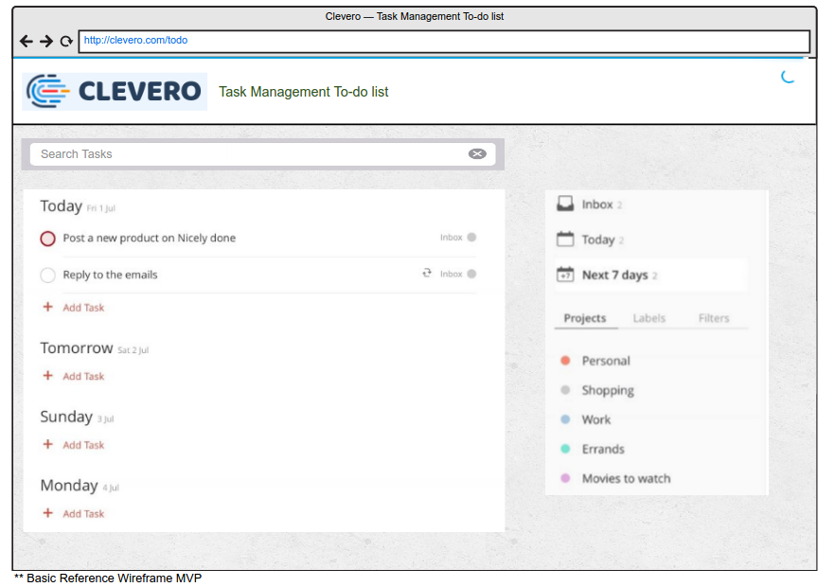
These mockup images are just for the reference, we expect a way much more beautiful and feature rich UI.

