**VB.NET**

**MAKWANA AELISHA VANISHKUMAR**

**20BCA36**

**1) Take user input in the Textbox control and print in another textbox control.**

**Output:**

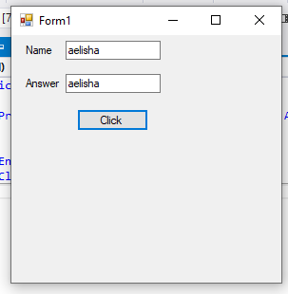

**Code:**

Public Class Form1

Private Sub btn1_Click(sender As Object, e As EventArgs) Handles btn1.Click

txt2.Text = txt1.Text

End Sub

End Class

**2) Addition of Textbox controls and print answer in label control. (Sum of two numbers)**

**Output:**

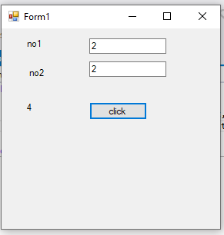

**Code:**

Public Class Form1

Private Sub btn1_Click(sender As Object, e As EventArgs) Handles btn1.Click

Label3.Text = Val(txt1.Text) + Val(txt2.Text)

End Sub

End Class

**3) Arithmetic Operators like Celsius to Fahrenheit, Rupee to dollar, pound, Euro.**

**Output:**

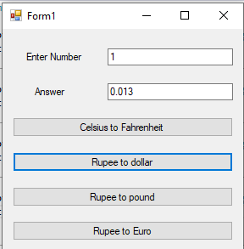

**Code:**

Public Class Form1

Private Sub btn1_Click(sender As Object, e As EventArgs) Handles btn1.Click

txt2.Text = Val((txt1.Text * 9 / 5)) + 32

End Sub

Private Sub btn2_Click(sender As Object, e As EventArgs) Handles btn2.Click

txt2.Text = Val(txt1.Text * 0.013)

End Sub

Private Sub btn3_Click(sender As Object, e As EventArgs) Handles btn3.Click

txt2.Text = Val(txt1.Text * 0.01)

End Sub

Private Sub btn4_Click(sender As Object, e As EventArgs) Handles btn4.Click

txt2.Text = Val(txt1.Text * 0.012)

End Sub

End Class

**4) Create simple calculator using 2 textboxes and 1 textboxes for answer. Take 5 buttons for perform +,-, x, / and Clear the values.**

**Output:**

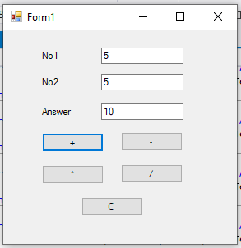

**Code:**

Public Class Form1

Private Sub btn1_Click(sender As Object, e As EventArgs) Handles btn1.Click

txt3.Text = Val(txt1.Text) + Val(txt2.Text)

End Sub

Private Sub btn2_Click(sender As Object, e As EventArgs) Handles btn2.Click

txt3.Text = Val(txt1.Text) - Val(txt2.Text)

End Sub

Private Sub btn3_Click(sender As Object, e As EventArgs) Handles btn3.Click

txt3.Text = Val(txt1.Text) * Val(txt2.Text)

End Sub

Private Sub btn4_Click(sender As Object, e As EventArgs) Handles btn4.Click

txt3.Text = Val(txt1.Text) / Val(txt2.Text)

End Sub

Private Sub btn5_Click(sender As Object, e As EventArgs) Handles btn5.Click

txt3.Text = ""

txt1.Clear()

txt2.Clear()

End Sub

End Class

**5) Assignment operator**

**Output:**

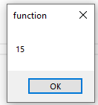

**Code:**

Public Class Form1

Private Sub Form1_Load(sender As Object, e As EventArgs) Handles MyBase.Load

'assignment operator

Dim a As Integer

a = 10

a += 5

' a -= 4

' a *= 5

' a /= 2

' a ^= 4

MsgBox(a)

End Sub

End Class

**6) Relational/Comparison operator**

**Output:**

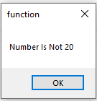

**Code:**

Public Class Form1

Private Sub Form1_Load(sender As Object, e As EventArgs) Handles MyBase.Load

'relational operator

Dim n1 As Integer = 5

If n1 = 20 Then

MsgBox("Number Is 20")

Else

MsgBox("Number Is Not 20")

End If

End Sub

End Class

**7) Concatenation Operators**

**Output:**

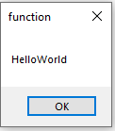

**Code:**

Public Class Form1

Private Sub Form1_Load(sender As Object, e As EventArgs) Handles MyBase.Load

'concatination operator

Dim str1 As String

Dim str2 As String

str1 = "Hello"

str2 = "World"

MsgBox(str1 & str2)

End Sub

End Class

**8) Like operator**

**Output:**

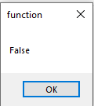

**Code:**

Public Class Form1

Private Sub Form1_Load(sender As Object, e As EventArgs) Handles MyBase.Load

'like operator

Dim a As String

a = "s" Like "S"

MsgBox(a)

End Sub

End Class

**9) The number is Numeric or not Demo. (If Else block)**

**Output:**

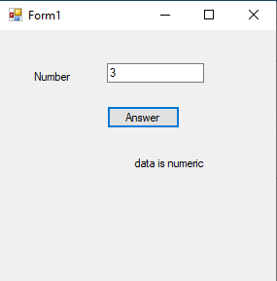

**Code:**

Public Class Form1

Private Sub btn1_Click(sender As Object, e As EventArgs) Handles btn1.Click

If IsNumeric(txt1.Text) Then

lbl2.Text = "data is numeric"

Else

lbl2.Text = "data is not numeric"

End If

End Sub

End Class

**10) Enter age and display category (Like Sr. or Gr.KG, Secondary, Primary, Higher)**

**Output:**

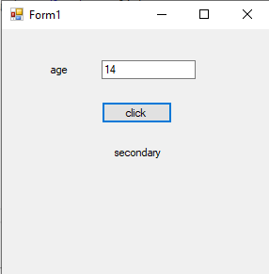

**Code:**

Public Class Form1

Private Sub btn1_Click(sender As Object, e As EventArgs) Handles btn1.Click

Dim age As Integer = txt1.Text

Select Case age

Case 1, 2

lbl2.Text = "child"

Case 3, 4

lbl2.Text = "kg"

Case 5 To 12

lbl2.Text = "primary"

Case 13 To 15

lbl2.Text = "secondary"

Case 16 To 18

lbl2.Text = "higher secondary"

Case Else

lbl2.Text = "no idea"

End Select

End Sub

End Class

**11) Write an Application of find the number is odd or even.**

**Output:**

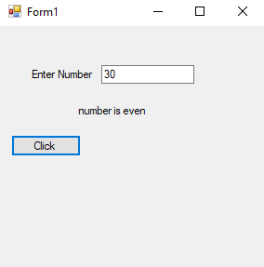

**Code:**

Public Class Form1

Private Sub btn1_Click(sender As Object, e As EventArgs) Handles btn1.Click

Dim num As Integer = txt1.Text

If num Mod 2 = 0 Then

lbl2.Text = "number is even"

Else

lbl2.Text = "number is odd"

End If

End Sub

End Class

**12) DateTimePicker and selected date should be display in label.**

**Output:**

**Code:**

**17) Example of MsgBox and MassageBox.show.**

**Output:**

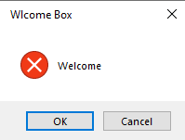

**Code:**

Public Class Form1

Private Sub Form1_Load(sender As Object, e As EventArgs) Handles MyBase.Load

MessageBox.Show("Welcome", " Wlcome Box", MessageBoxButtons.OKCancel, MessageBoxIcon.Error, MessageBoxDefaultButton.Button1

End Sub

End Class

**18) Accept the name from Input Box and Display name in the message box.**

**Output:**

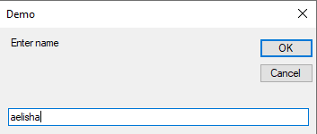

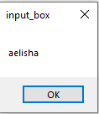

**Code:**

Public Class Form1

Private Sub Form1_Load(sender As Object, e As EventArgs) Handles MyBase.Load

Dim a As String

a = InputBox("Enter name", "Demo")

MsgBox(a)

End Sub

End Class

**20) Swapping of 2 values**

**Output:**

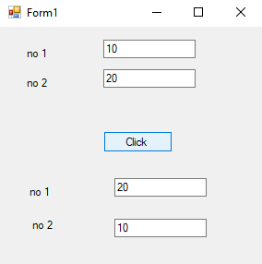

**Code:**

Public Class Form1

Private Sub btn1_Click(sender As Object, e As EventArgs) Handles btn1.Click

Dim x, y As Integer

x = txt1.Text

y = txt2.Text

swap(x, y)

txt3.Text = x

txt4.Text = y

End Sub

Sub swap(ByRef a As Integer, ByRef b As Integer)

Dim temp As Integer

temp = a

a = b

b = temp

End Sub

End Class