**Journal-1**

**1.Master Page**

* Code:

<%@ Master Language="VB" AutoEventWireup="false" CodeBehind="clgmst.master.vb" Inherits="Collage_Management.clgmst" %>

<!DOCTYPE html>

<html xmlns="http://www.w3.org/1999/xhtml">

<head runat="server">

<title></title>

<link href="Bootstrap/css/bootstrap.min.css" rel="stylesheet" /a>

<script src="Bootstrap/js/bootstrap.min.js"></script>

<asp:ContentPlaceHolder ID="head" runat="server">

</asp:ContentPlaceHolder>

<style type="text/css">

.auto-style6 {

font-size: x-large;

font-weight: 700;

}

.auto-style7 {

height: 21px;

}

</style>

</head>

<body>

<form id="form1" runat="server" class="form-check border-bottom shadow p-3 mb-5 bg-body rounded">

<table style="width: 100%; height: 443px;" class="table table-bordered">

<tr>

<td class="auto-style7" style="border: thin groove #000000;" >

<img alt="" src="bca.png" style="height: 52px; width: auto; margin-left: 0px;" /

<h1 style="height: 71px" class="auto-style6" >

<asp:Label ID="Label1" runat="server" CssClass="auto-style6" Text="VIDYABHARTI TRUST COLLEGE OF BUSINESS, COMPUTER SCIENCE &amp; RESEARCH"></asp:Label>

</h1>

</img></td>

<br />

</tr>

<tr>

<td class="auto-style3" style="bgcolor; background-color: #FFFFFF;">

<asp:Menu ID="Menu1" runat="server" BackColor="#B5C7DE" DynamicHorizontalOffset="2" Font-Names="Verdana" Font-Size="0.8em" ForeColor="#284E98" Orientation="Horizontal" StaticSubMenuIndent="10px">

<DynamicHoverStyle BackColor="#284E98" ForeColor="White" />

<DynamicMenuItemStyle HorizontalPadding="5px" VerticalPadding="2px" />

<DynamicMenuStyle BackColor="#B5C7DE" />

<DynamicSelectedStyle BackColor="#507CD1" />

<Items>

<asp:MenuItem NavigateUrl="~/Home.aspx" Text="Home" Value="Home"></asp:MenuItem>

<asp:MenuItem NavigateUrl="~/aboutus.aspx" Text="About Us" Value="About Us"></asp:MenuItem>

<asp:MenuItem NavigateUrl="~/contactus.aspx" Text="Contact Us" Value="Contact Us"></asp:MenuItem>

<asp:MenuItem NavigateUrl="~/Login.aspx" Text="Login" Value="Login"></asp:MenuItem>

<asp:MenuItem NavigateUrl="~/reg.aspx" Text="Register" Value="Register"></asp:MenuItem>

</Items>

<StaticHoverStyle BackColor="#284E98" ForeColor="White" />

<StaticMenuItemStyle HorizontalPadding="56px" VerticalPadding="2px" />

<StaticMenuStyle HorizontalPadding="280px" />

<StaticSelectedStyle BackColor="#507CD1" />

</asp:Menu>

</td>

</tr>

<tr>

<td class="auto-style2">

<asp:ContentPlaceHolder ID="ContentPlaceHolder1" runat="server">

</asp:ContentPlaceHolder>

</td>

</tr>

<tr>

<td class="auto-style1" style="border-style: inset; border-width: thin">&nbsp;&nbsp;&nbsp;&nbsp;&nbsp;&nbsp;&nbsp;&nbsp;&nbsp;&nbsp;&nbsp;&nbsp;&nbsp;&nbsp;&nbsp;&nbsp;&nbsp;&nbsp;&nbsp;&nbsp;&nbsp;&nbsp;&nbsp;&nbsp;&nbsp;&nbsp;&nbsp;&nbsp;&nbsp;&nbsp;&nbsp;&nbsp;&nbsp;&nbsp;&nbsp;&nbsp;&nbsp;&nbsp;&nbsp;&nbsp;&nbsp;&nbsp;&nbsp;&nbsp;&nbsp;&nbsp;&nbsp;&nbsp;&nbsp;&nbsp;&nbsp;&nbsp;&nbsp;&nbsp;&nbsp;&nbsp;&nbsp;&nbsp;&nbsp;&nbsp;&nbsp;&nbsp;&nbsp;&nbsp;&nbsp;&nbsp;&nbsp;&nbsp;&nbsp;&nbsp;&nbsp;&nbsp;&nbsp;&nbsp;&nbsp;&nbsp;&nbsp;&nbsp;&nbsp;&nbsp;&nbsp;&nbsp;&nbsp;&nbsp;&nbsp;&nbsp;&nbsp;&nbsp;&nbsp;&nbsp;&nbsp;&nbsp;&nbsp;&nbsp;&nbsp;&nbsp;&nbsp;&nbsp;&nbsp;&nbsp;&nbsp;&nbsp;

<asp:Label ID="Label2" runat="server" style="font-size: medium" Text="ALL RIGHTS RESERVED TO VTCBCSR © 2022"></asp:Label>

</td>

</tr>

</table>

</form>

</body>

</html>

Output:

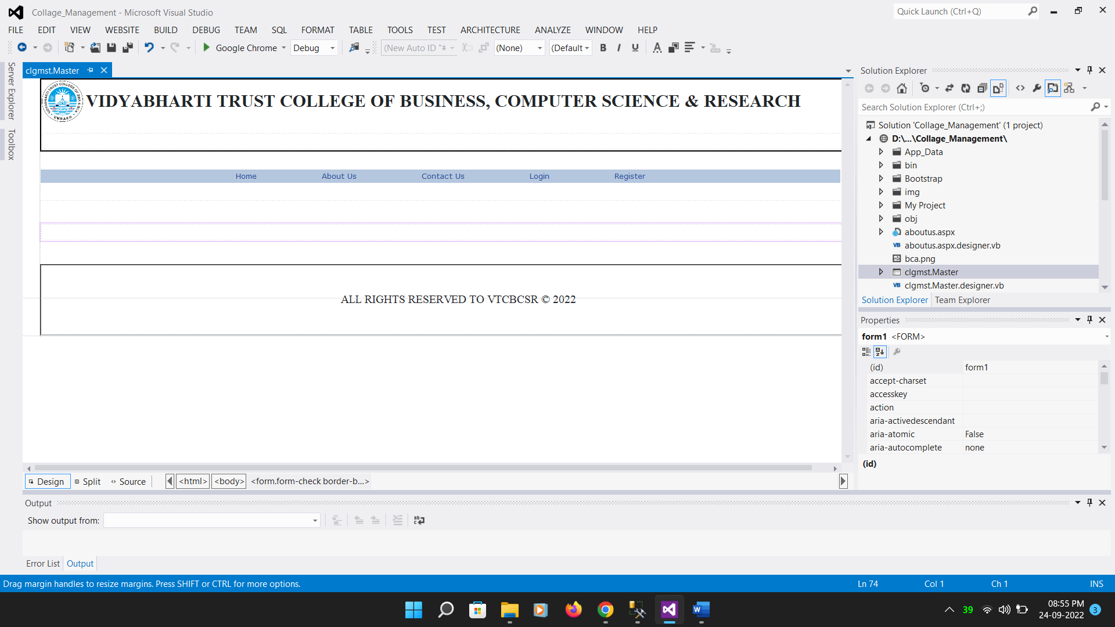

2.Login Page

* Code:

<%@ Page Title="" Language="VB" MasterPageFile="~/clgmst.Master" AutoEventWireup="false" CodeFile="Login.aspx.vb" Inherits="Login" %>

<asp:Content ID="Content1" ContentPlaceHolderID="head" Runat="Server">

</asp:Content>

<asp:Content ID="Content2" ContentPlaceHolderID="ContentPlaceHolder1" Runat="Server">

<br />

<center>

<h1>Login</h1>

</center>

<asp:Label ID="Label3" runat="server" Text="Username"></asp:Label>

&nbsp;

<asp:TextBox ID="Username" runat="server"></asp:TextBox>

<br />

<br />

<asp:Label ID="Label4" runat="server" Text="Password"></asp:Label>

&nbsp;

<asp:TextBox ID="Password" runat="server" TextMode="Password"></asp:TextBox>

<br />

<br />

<br />

<asp:Button ID="Button1" runat="server" Text="Button" />

<br />

</asp:Content>

Output:

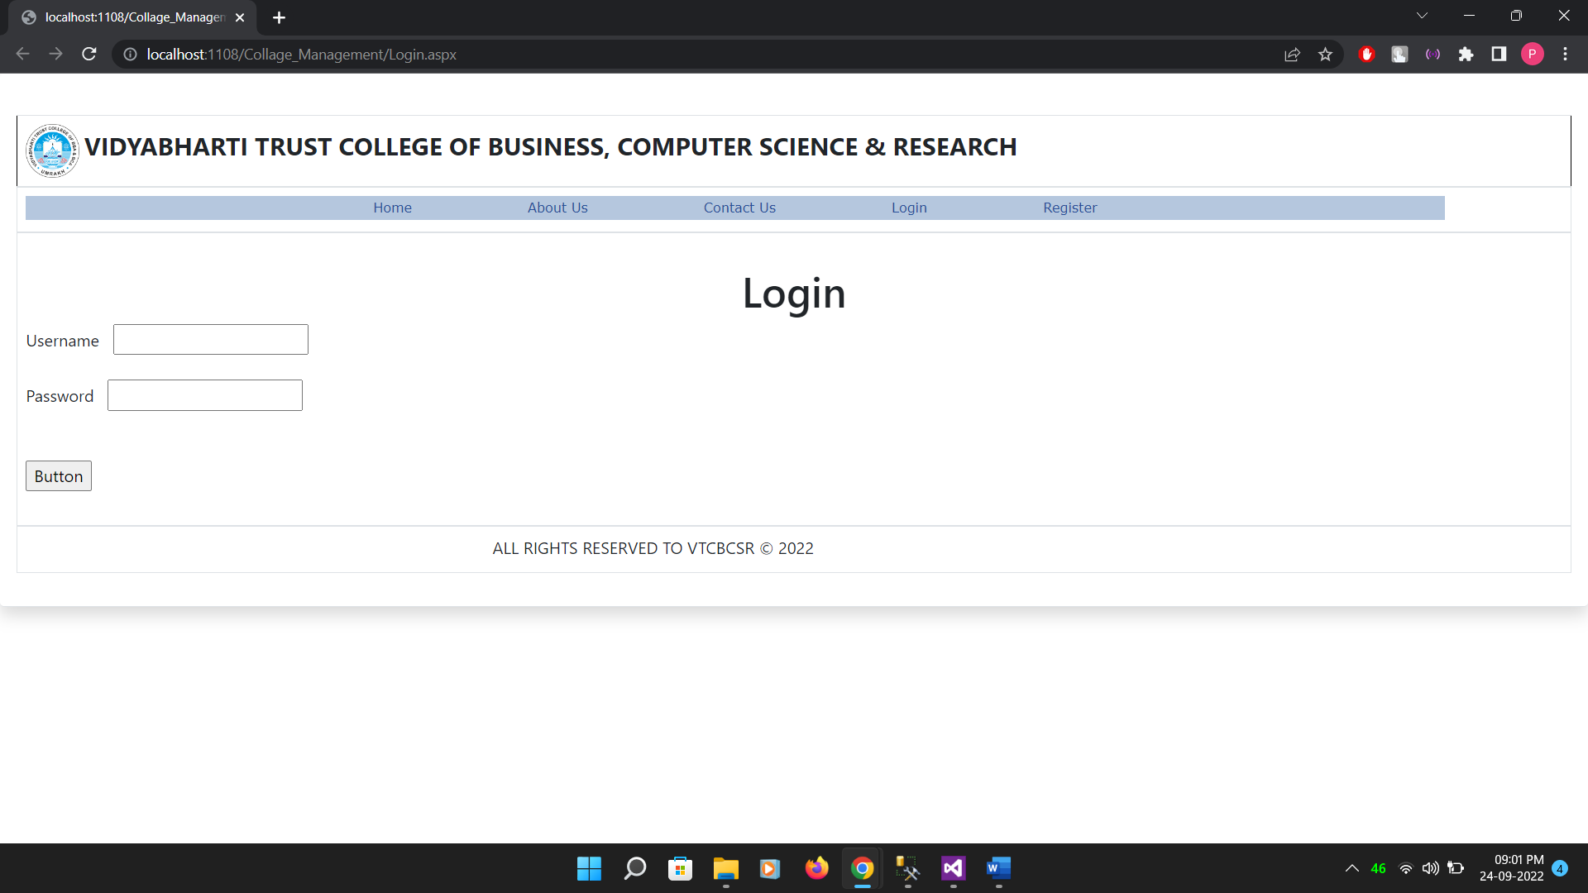

3.Homepage

* Code:

<%@ Page Title="" Language="vb" AutoEventWireup="false" MasterPageFile="~/clgmst.Master" CodeBehind="Home.aspx.vb" Inherits="Collage_Management.clgmst1" %>

<asp:Content ID="Content1" ContentPlaceHolderID="head" runat="server">

</asp:Content>

<asp:Content ID="Content2" runat="server" contentplaceholderid="ContentPlaceHolder1">

<center>

<h1 style="text-align:center"> Welcome To Vtcbcsr </h1>

<p>Vidyabharti Trust is the name associated with education for more than three decades (Est. 1980)

near Bardoli of Surat district and has now evolved as a symbol of quality education dedicated to

nurture the talent and aspirations of the right youth of our nation.

</center>

</asp:Content>

Output:

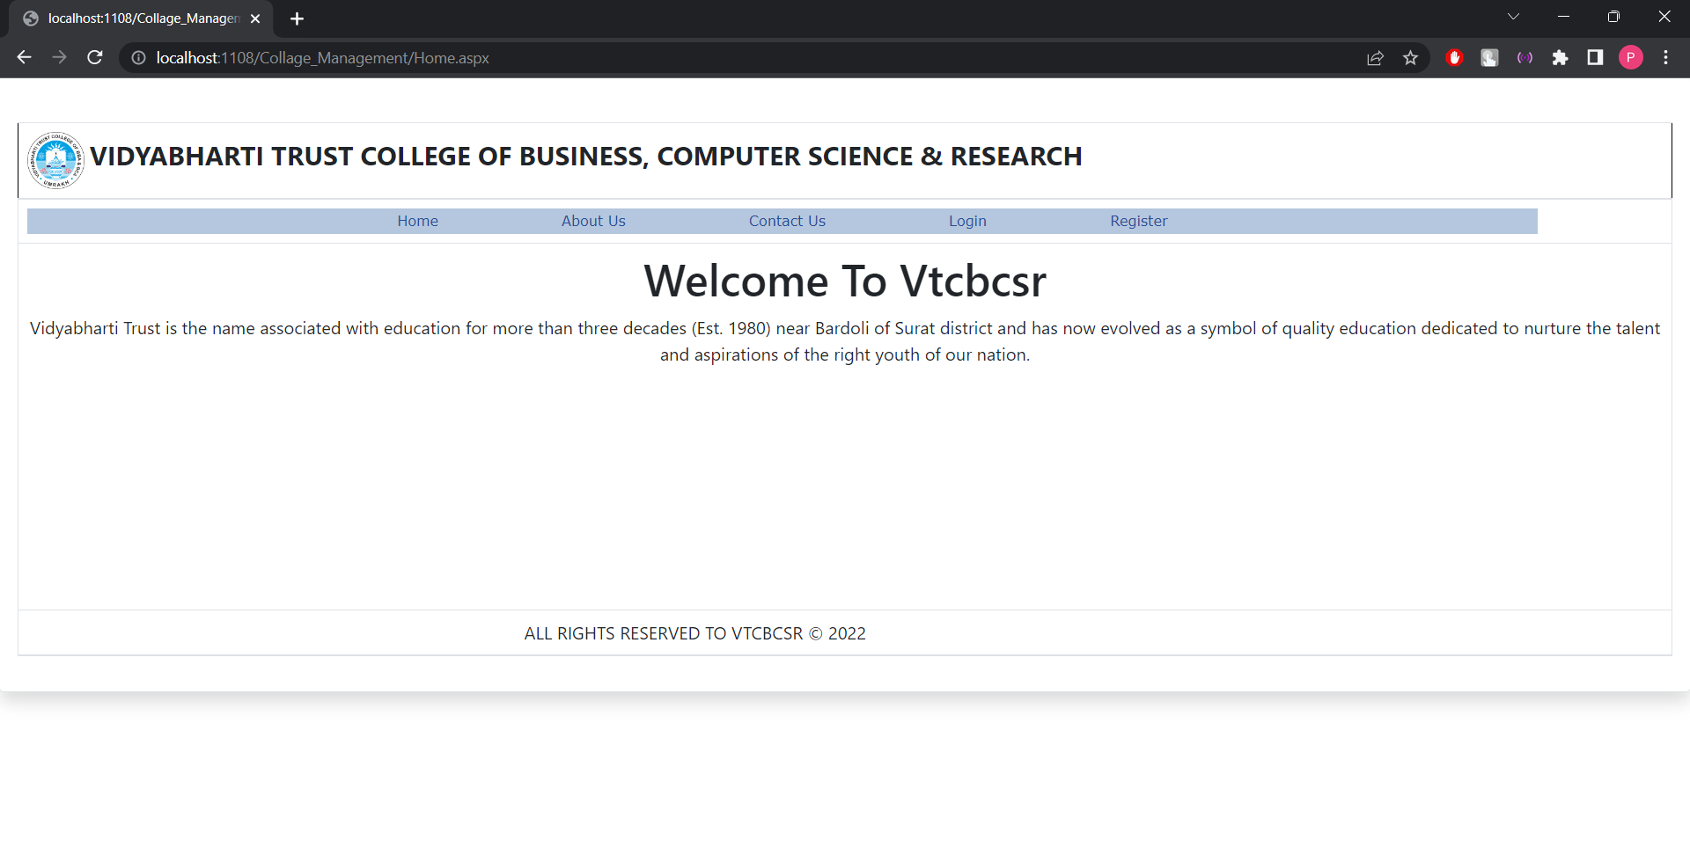

4.About Us

* Code:

<%@ Page Title="" Language="vb" AutoEventWireup="false" MasterPageFile="~/clgmst.Master" CodeBehind="aboutus.aspx.vb" Inherits="Collage_Management.aboutus" %>

<asp:Content ID="Content1" ContentPlaceHolderID="head" runat="server">

</asp:Content>

<asp:Content ID="Content2" ContentPlaceHolderID="ContentPlaceHolder1" runat="server">

<p>Hero can be anyone. Even a man knowing something as simple and reassuring as putting a coat around a young boy shoulders to let him know the world hadn’t ended.

You fight like a younger man, there’s nothing held back. It’s admirable, but mistaken.

When their enemies were at the gates the Romans would suspend democracy and appoint one man to protect the city.

It wasn’t considered an honor, it was a public service.</p>

</asp:Content>

Output:

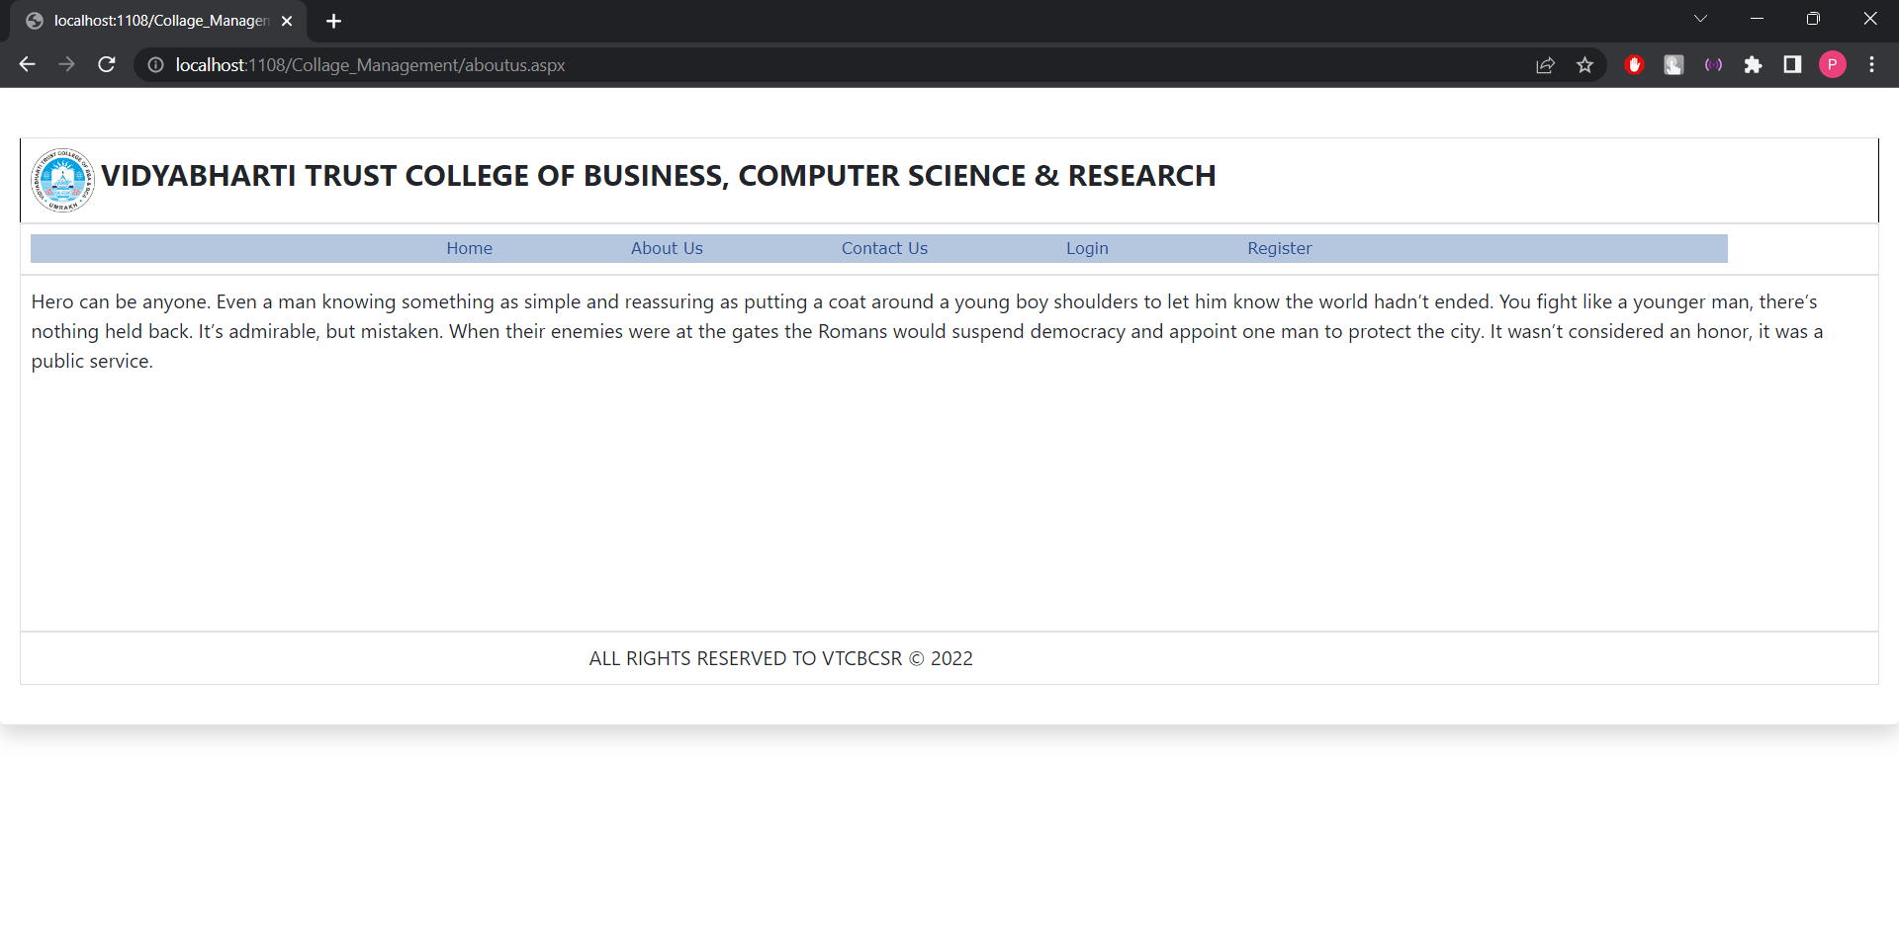

5.Contact Us

* Code:

<%@ Page Title="" Language="vb" AutoEventWireup="false" MasterPageFile="~/clgmst.Master" CodeBehind="contactus.aspx.vb" Inherits="Collage_Management.contactus" %>

<asp:Content ID="Content1" ContentPlaceHolderID="head" runat="server">

</asp:Content>

<asp:Content ID="Content2" ContentPlaceHolderID="ContentPlaceHolder1" runat="server">

<center><pre>

AT &amp; POST UMRAKH,

BABEN,

BARDOLI - 394345

</pre></h3></center>

</asp:Content>

Output:

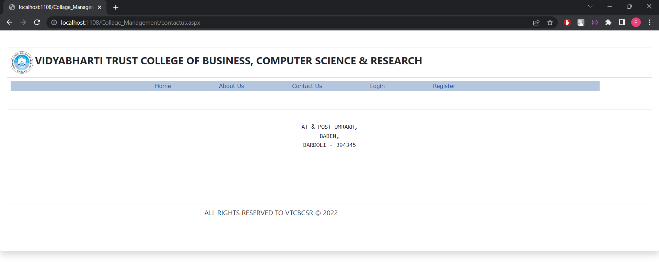

6.Register

* Code:

<%@ Page Title="" Language="VB" MasterPageFile="~/clgmst.Master" AutoEventWireup="false" CodeFile="reg.aspx.vb" Inherits="reg" %>

<asp:Content ID="Content1" ContentPlaceHolderID="head" Runat="Server">

</asp:Content>

<asp:Content ID="Content2" ContentPlaceHolderID="ContentPlaceHolder1" Runat="Server">

<div>

<br />

<br />

<asp:Label ID="Label3" runat="server" Text="Username"></asp:Label>

&nbsp;&nbsp;&nbsp;&nbsp;&nbsp;&nbsp;&nbsp;

<asp:TextBox ID="Username" runat="server"></asp:TextBox>

<br />

<br />

<asp:Label ID="Label4" runat="server" Text="Password"></asp:Label>

&nbsp;&nbsp;&nbsp;&nbsp;&nbsp;&nbsp;&nbsp;

<asp:TextBox ID="Password" runat="server" TextMode="Password"></asp:TextBox>

<br />

<br />

<asp:Label ID="Label5" runat="server" Text="Confirm Password"></asp:Label>

&nbsp;&nbsp;&nbsp;&nbsp;&nbsp;&nbsp;&nbsp;

<asp:TextBox ID="cpassword" runat="server" TextMode="Password"></asp:TextBox>

&nbsp;<asp:CompareValidator ID="CompareValidator1" runat="server" ControlToCompare="Password" ControlToValidate="cpassword" ErrorMessage="Password Not Match"></asp:CompareValidator>

&nbsp;&nbsp;&nbsp;&nbsp;&nbsp;&nbsp;&nbsp;&nbsp;&nbsp;&nbsp;&nbsp;&nbsp;&nbsp;&nbsp;&nbsp;&nbsp;&nbsp;&nbsp;&nbsp;&nbsp;&nbsp;&nbsp;&nbsp;&nbsp;&nbsp;&nbsp;&nbsp;&nbsp;&nbsp;&nbsp;&nbsp;&nbsp;&nbsp;&nbsp;&nbsp;&nbsp;&nbsp;&nbsp;&nbsp;&nbsp;&nbsp;&nbsp;&nbsp;&nbsp;&nbsp;&nbsp;&nbsp;&nbsp;&nbsp;&nbsp;&nbsp;&nbsp;&nbsp;&nbsp;

<br />

<br />

<asp:Label ID="Label6" runat="server" Text="Gender"></asp:Label>

&nbsp;&nbsp;&nbsp;&nbsp;&nbsp;&nbsp;

<asp:DropDownList ID="Gender" runat="server" Width="107px">

<asp:ListItem>Male</asp:ListItem>

<asp:ListItem>Female</asp:ListItem>

</asp:DropDownList>

<br />

<br />

<asp:Label ID="Label7" runat="server" Text="Department"></asp:Label>

&nbsp;&nbsp;&nbsp;&nbsp;&nbsp;&nbsp;

<asp:DropDownList ID="dept" runat="server">

<asp:ListItem>BCA</asp:ListItem>

<asp:ListItem>BBA</asp:ListItem>

<asp:ListItem>MCA</asp:ListItem>

<asp:ListItem>MBA</asp:ListItem>

</asp:DropDownList>

<br />

<br />

<asp:Button ID="Button1" runat="server" Text="Button" />

<br />

<br />

<br />

<br />

<br />

<br />

<br />

<br />

</div>

</asp:Content>

Output:

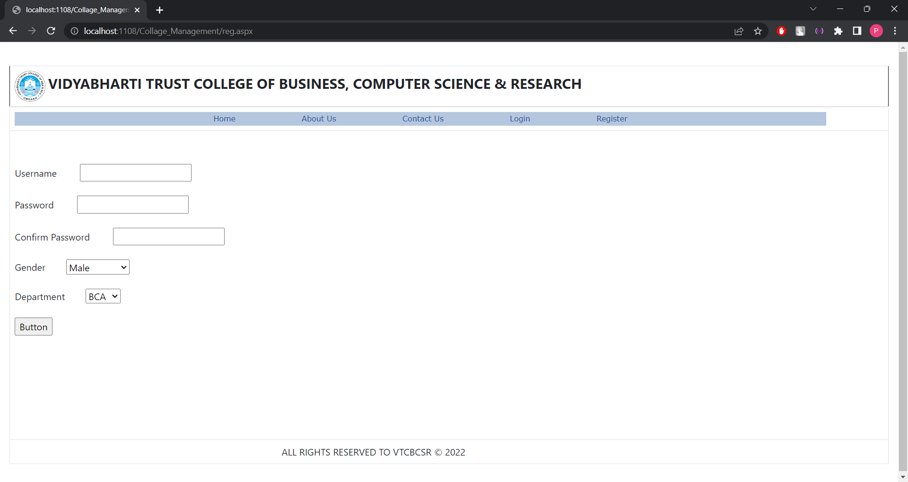

Button_Click:

Imports System.Data

Imports System.Data.SqlClient

Partial Class reg

Inherits System.Web.UI.Page

Protected Sub Button1_Click(sender As Object, e As EventArgs) Handles Button1.Click

Dim con As New SqlConnection

Dim cmd As New SqlCommand

con.ConnectionString = "Data Source=DESKTOP-VOGK8O2\SQLEXPRESS;Initial Catalog=Clg1;Integrated Security=True"

con.Open()

cmd = New SqlCommand("insert into reg values('" + Username.Text + "','" + Password.Text + "','" + Gender.SelectedValue + "','" + dept.SelectedValue + "')", con)

cmd.ExecuteNonQuery()

con.Close()

MsgBox("Record Inserted")

End Sub

End Class

7.Display

* Code:

<%@ Page Title="" Language="VB" MasterPageFile="~/clgmst.Master" AutoEventWireup="false" CodeFile="Display.aspx.vb" Inherits="Display" %>

<asp:Content ID="Content1" ContentPlaceHolderID="head" Runat="Server">

</asp:Content>

<asp:Content ID="Content2" ContentPlaceHolderID="ContentPlaceHolder1" Runat="Server">

<div>

<asp:GridView ID="GridView1" runat="server" AutoGenerateColumns="False" AutoGenerateDeleteButton="True" AutoGenerateEditButton="True" DataSourceID="SqlDataSource1" BackColor="White" BorderColor="#336666" BorderStyle="Double" BorderWidth="3px" CellPadding="4" GridLines="Horizontal" DataKeyNames="Id">

<Columns>

<asp:BoundField DataField="Id" HeaderText="Id" InsertVisible="False" ReadOnly="True" SortExpression="Id" />

<asp:BoundField DataField="Username" HeaderText="Username" SortExpression="Username" />

<asp:BoundField DataField="Password" HeaderText="Password" SortExpression="Password" />

<asp:BoundField DataField="Gender" HeaderText="Gender" SortExpression="Gender" />

<asp:BoundField DataField="Dept" HeaderText="Dept" SortExpression="Dept" />

</Columns>

<FooterStyle BackColor="White" ForeColor="#333333" />

<HeaderStyle BackColor="#336666" Font-Bold="True" ForeColor="White" />

<PagerStyle BackColor="#336666" ForeColor="White" HorizontalAlign="Center" />

<RowStyle BackColor="White" ForeColor="#333333" />

<SelectedRowStyle BackColor="#339966" Font-Bold="True" ForeColor="White" />

<SortedAscendingCellStyle BackColor="#F7F7F7" />

<SortedAscendingHeaderStyle BackColor="#487575" />

<SortedDescendingCellStyle BackColor="#E5E5E5" />

<SortedDescendingHeaderStyle BackColor="#275353" />

</asp:GridView>

<asp:SqlDataSource ID="SqlDataSource1" runat="server" ConnectionString="<%$ ConnectionStrings:Clg1ConnectionString %>" SelectCommand="SELECT * FROM [reg]"

UpdateCommand="Update reg set Username=@Username,Password=@Password,Gender=@Gender,Dept=@dept where Id=@id"

DeleteCommand="Delete [reg] where [Id]=@id">

<DeleteParameters>

<asp:Parameter Name="id" />

</DeleteParameters>

<UpdateParameters>

<asp:Parameter Name="Username" />

<asp:Parameter Name="Password" />

<asp:Parameter Name="Gender" />

<asp:Parameter Name="dept" />

<asp:Parameter Name="id" />

</UpdateParameters>

</asp:SqlDataSource>

<br />

</div>

</asp:Content>

Output:

