IS
UNIT 3 : Introduction To Various Information System

Various Information System
- Business Information System
  - Transaction Processing system
  - Workflow System
  - ERP
- Management Information System
- Decision Support System

Business Information System
- Information Systems Support for Organization Employees
  - Office automation systems
  - Functional area information systems
  - Business intelligence systems
  - Expert Systems
  - Dashboards
- Why are Information Systems Important to Organizations & Society
  - It will reduce the number of middle managers.
  - It will change the manager’s job.
  - It impacts employees at work.
  - It provides quality-of-life improvements.

Transaction Processing System
- Also known as Transaction Processing Monitor
- set of information which processes a data transaction in a database system that monitors transaction programs
- The spirit of a transaction program is that it manages data that must be left in a consistent state.

- Features of TPS
  - Rapid response
    - Fast performance with a rapid response time is critical.
    - the turnaround time from the input of the transaction to the production for the output must be a few seconds or less.
  - Reliability
    - Many organizations rely heavily on their TPS
    - a TPS to be effective its failure rate must be very low.
    - quick and accurate recovery must be possible
  - Inflexibility
    - every transaction to be processed in the same way regardless of the user
  - Controlled processing
    - All the processing must be controlled by single module or department or user

Workflow System
- consists of a sequence of connected steps
- It is a representation of a sequence of operations, declared as work of a person, a group of persons, an organization of staff, or one or more simple or complex mechanisms.
- seen as any abstraction of real work, segregated in work share, work split or other types of ordering.
- may be a view on real work under a chosen aspect
- The flow being described often refers to a document that is being transferred from one step to another.
- The term workflow is used in computer programming to capture and develop human-to-machine interaction.

- Examples of Workflow System
  - In military planning, a "concept of operations" is a workflow that defines particular mission types.
  - In machine shops, particularly job shops and flow shops, the flow of a part through the various processing stations is a work flow.
  - Insurance claims processing is an example of an information-intensive, document-driven workflow.
  - Wikipedia editing is an example of a stochastic workflow.
  - The Getting Things done system is a model of personal workflow management for information workers.
  - In global software development, the concept of follow-the-sun describes a process of passing unfinished work across time zones.
  - In Scientific experiments, the overall process (tasks and data flow) can be described as a Directed Acyclic Graph (DAG). This DAG is referred to as a workflow, e.g. Brain Imaging workflows.

Workflow improvement theories

- Six Sigma
- Total Quality Management
- Business Process Reengineering
- Lean systems
- The Helix Methodology / Helix Factor

Six Sigma
- business management strategy originally developed by Motorola, USA in 1981.
- seeks to improve the quality of process outputs by identifying and removing the causes of defects (errors) and minimizing variability in manufacturing and business processes.
- uses a set of quality management methods, including statistical methods, and creates a special infrastructure of people within the organization ("Black Belts", "Green Belts", etc.) who are experts in these methods.
- carried out within an organization follows a defined sequence of steps and has quantified financial targets (cost reduction or profit increase).
- originated from terminology associated with manufacturing, specifically terms associated with statistical modeling of manufacturing processes.

Total Quality Management
- is a management concept coined by W. Edwards Deming.
- is to reduce the errors produced during the manufacturing or service process, increase customer satisfaction, streamline supply chain management, aim for modernization of equipment and ensure workers have the highest level of training.
- is often associated with the development, deployment, and maintenance of organizational systems that are required for various business processes.
- The main difference between TQM and Six Sigma (a newer concept) is the approach. TQM tries to improve quality by ensuring conformance to internal requirements, while Six Sigma focuses on improving quality by reducing the number of defects and impurities.

Business Process Reengineering
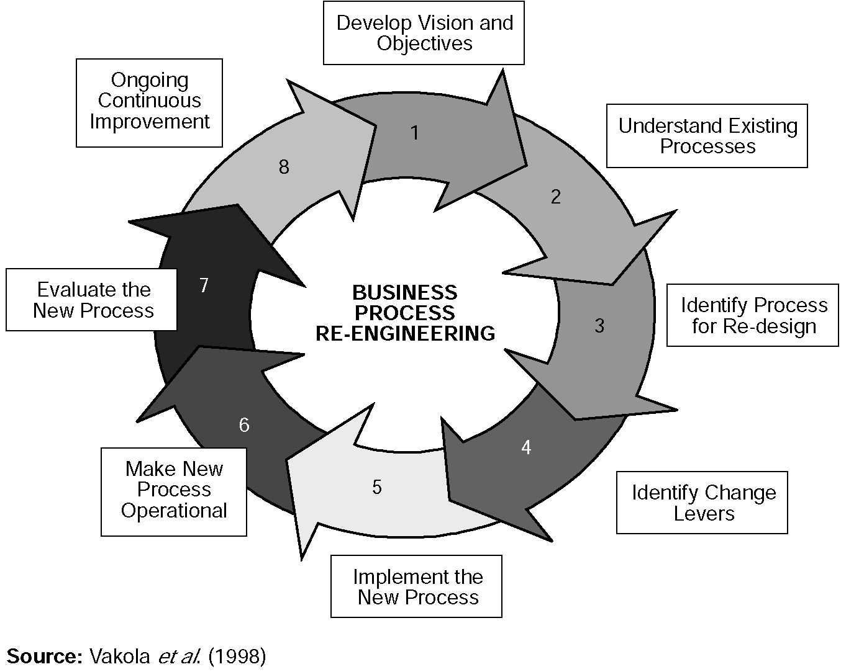

- analysis and design of workflows and processes within an organization.
- A business process is a set of logically related tasks performed to achieve a defined business outcome.
- Re-engineering is the basis for many recent developments in management.
- also known as Business Process Redesign, Business Transformation, or Business Process Change Management.

Lean systems
- "Lean," is a production practice that considers the expenditure of resources for any goal other than the creation of value for the end customer to be wasteful, and thus a target for elimination.
- is the set of "tools" that assist in the identification and steady elimination of waste.
- As waste is eliminated quality improves while production time and cost are reduced.
- As waste is eliminated quality improves while production time and cost are reduced. Lean and TPS can be seen as a loosely connected set of potentially competing principles whose goal is cost reduction by the elimination of waste.
- These principles include: Pull processing, Perfect first-time quality, Waste minimization, Continuous improvement, Flexibility, Building and maintaining a long term relationship with suppliers, Autorotation, Load leveling and Production flow and Visual control.

The Helix Methodology / Helix Factor

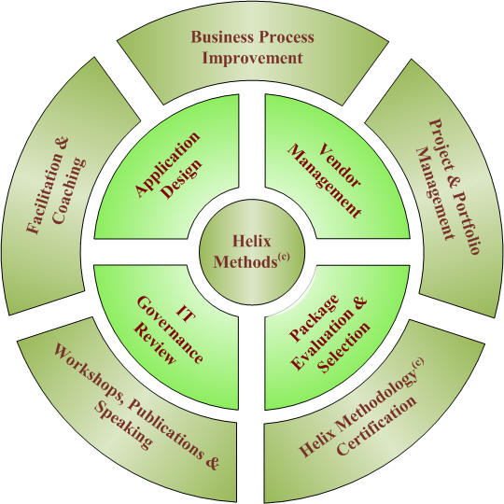

- To improve the way organizations deliver value to their stakeholders by helping them to achieve Strategically Aligned Operational Results.
- As a way of bridging the gap between the two, significant effort is being put into defining workflow patterns that can be used to compare different workflow engines across both of these domains

Customer Relationship Management

Customer relationship management (CRM)
    - Term applied to processes implemented by a company to handle its contact with its customers
    - CRM is a software-based approach to handling customer relationships
    - Store information on current and prospective customers

    - From the outside, customers interacting with a company perceive the business as a single entity, even with often interacting with a variety of employees in different roles and departments

    - CRM is a combination of policies, processes, and strategies implemented by a company that unify its customer interaction and provides a mechanism for tracking customer information
Aspects
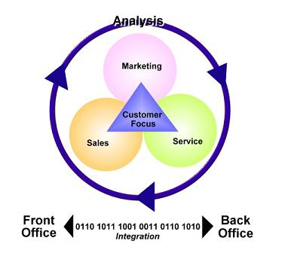

Aspect 1 – Front office
    - Direct interaction with customers
      - Face to face meetings
      - Phone calls
      - E-mail
      - Online services etc

Aspect 2 – Back office
- Operations that ultimately affect the activities of the front office
      - Billing
      - Maintenance
      - Planning
      - Marketing
      - Advertising
      - Finance
      - Manufacturing
Aspect 3 - Business relationships
- Interaction with other companies and partners

      - Suppliers/vendors
      - Retail outlets/distributors
      - Industry networks
- This external network supports front and back office activities
Aspect 4 - Analysis
- Key CRM data can be analyzed in order to plan
      - Target-marketing campaigns
      - Conceive business strategies
      - Judge the success of CRM activities (e.g., market share, number and types of customers, revenue, profitability)

Processes & Systems
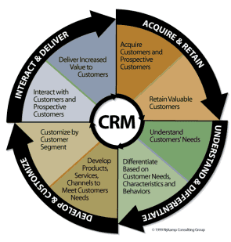

1. Understand & differentiate
- Understand
      - Demographics, purchase patterns & channels
      - Segmentation to identify logical unique groups
      - Primary research to capture needs and attitudes
      - Customer valuation to understand profitability

- Differentiate
      - Based on the value customers are expected to deliver
2. Develop & Customize
- Develop
      - Products, services, channels and media can be customized based on the needs of quantitative customer segments
- Customize
      - Based on the potential value delivered by customer segment
3. Interact & Deliver
- Interact
      - Not just through marketing, sales and media
      - Distribution, shipping, customer service & online

- Deliver
      - Delivering value is a cornerstone
      - Factors including quality, convenience, speed, ease of use, responsiveness and service excellence
4. Acquire & Retain
- Acquire
      - Learning about customers makes it easy to identify those producing the greatest value
- Retain
      - Maintain interaction
      - Deliver on value
      - Customers change as they move through differing life stages
      - Modify the service
e Commerce Overview
What is e Commerce?
e commerce is enabling or achieving your business objectives by using information technology to enhance or transform your business processes.
- Business to business (B2B)
  - automating supply
  - increasing business efficiency
- Business to Consumer (B2C)
  - Retail Sales
  - Customer Support
- Consumer to Consumer (C2C)
  - Online Auctions
- ecommerce is more then just an online shop selling goods…. Businesses make huge savings by more efficient interaction with their suppliers or buyers.
  - A local pharmacist orders 60% of his supplies from an overseas pharmaceutical suppliers website and saves 5% in his purchases - is this ecommerce?
  - A remote Fiji resort attracts guests from the USA after several exchanges of email. Is this ecommerce?
Global
- 400 million users of Internet worldwide
- 1999 US online retail sales - US$20bn. Forrester Research
- 2000 US online retail sales - US$30bn+ Forrester Research
- US Online buying will reach US$6.9 trillion 2004. Forrester Research
- electronic payment of bills and banking will cost US Postal Service $17bn over 10 years.

Interpretation ?
- Consumers are willing to spend money on online transactions.
- Despite the recent dot.com drop in investment - consumers continue to use the Internet in growing numbers.
- The US figures are only part of the global picture.

What is working?
- Travel / Tourism
- Retail - items that don’t need personal touch - objectivity in product quality and performance
  - music, books, gifts, Computers, electronic items
  - Auctions
- Real Estate - houses and investment properties.
- Customer support services
- More efficient and effective processes between businesses (B 2 B)
What is not working?
- Items which require “touch and trial”
  - Luxury goods
  - Clothes - beyond Tshirts
- Groceries - it works for some people but market is restricted
Note: Many OFF line factors determine success of Online service. Eg. Transport network, customer profiles,

e commerce and the Pacific
Traditional Barriers
- Isolation – distance from market
- Small local markets
- Limited human capacity
Opportunity
- Internet provides “instant” access to global market

ecommerce adoption in Pacific
- Tourism
  - small operators and multi nationals
  - expatriate owned businesses due to better awareness of communications possibilities.
- Online retailers - often overseas based, some Pacific based exporters.
Generally for the Pacific it has been ad hoc entry with ecommerce/

Lessons from experience
- Popular Sites Not = Revenue
  - Online Advertising Market is immature especially in the Pacific.
  - What visitors do on a website is more important then inflated “hits” figures
  - Income models based on advertising must be supported by online sales.
- Start with a strategy
  - know your market and how to reach them
- Traditional Off line issues determine profitability
  - management, product, operations and financing.

e Commerce and Pacific
- The challenge is identify market niches for products unique to the Pacific (core competencies)
  - EcoTourism, trade niches, island goods
  - Identify skill industries where local capacity can be developed and product transferred electronically. (insurance, banking, drafting etc)
- Avoid entry in IT labor market - call centers, credit card processing without an exit plan because these IT niches will be the world’s most MOBILE industries and governed by cost of labor.

Demonstrations - Tourism
Tourism: www.tongaonline.com/sailingsafaris
Sailing Safaris - Tonga
  - One boat operation in 1996 from small island base
  - Competing with 2 multinational yacht companies with global marketing network
  - Since 1997 - 80% of business from web site.
  - This statistic 60-80% of bookings from web inquiries is common to Tourism operators in the Pacific.

Example 2 - Tourism
- Pacificnavigator.com - Travel Portal
- One stop shop for travel info and bookings.
- 9 Pacific Island Countries
- Travel Information and Bookings
- Sticky Items - bring people back to site
  - message boards for comments
  - News
  - Postcards

Example 3 - Retail
Www.Fijilive.com - Portal
- Popular site and daily local news.
- immature advertising market – difficult to get local advertisers.
- Sticky Features
    - News
    - Numerous in-house websites
- sells through www.fijionsale.com
- uses credit card transactions with manual batch processing
- Kava, music, Jewelry, etc.

Example 4 - Retail
- Artifacts - Papua New Guinea
- www.niugini.com - PNG Portal
- Sticky Features
  - Forums, News, Chat, Postcards, Info pages
  - Sells PNG artifacts.
- Transactions via email and bank transfers
- Great product but management and operation issues and no online transactions.

Remember
The Internet is the best opportunity for Pacific Island business since the Jet Plane however:
- traditional business principles still matter online.
  - Value to the customer comes first.
- Be realistic about revenues and costs

Mobile Commerce (M-Commerce)
Objective
- To understanding the basic of M-commerce
- Benefit of M-commerce with small business
- Know about technology that based on M-commerce
- How to apply technology of M-commerce for business
- Know about advantage and disadvantage of M-commerce

Introduction
Mobile commerce (M-commerce) is a type of e-commerce conducted through mobile devices such as mobile phones, personal digital assistants (PDAs) and other devices with a wireless connection. It is quite different from traditional of E-commerce.

What is M-Commerce?
- M-commerce is the buying and selling of goods and services through wireless handheld devices.
- M-Commerce is the process of paying for services using a mobile phone or personal organizer.
- M-Commerce is the use of mobile devices to communicate, inform transact and entertain using text and data via a connection to public and private networks.

Messaging services and information based
m-commerce services
- Cellular phone
- Personal digital assistance(PDAs)

M-commerce benefit
- Your Internet offerings are easier and more convenient to access.
- You get considerable flexibility while conducting business.
- Transaction and personnel costs are reduced due to widespread automation of
- back-office operations.
- Field staff is more effective as they have flexible access to back-office data.

Benefit for business
For a small business could benefit from m-commerce.
- Selling a product or service
- Improving productivity

Advantage
- Offers many payment options
- Push advertising, direct marketing.
- More efficient and extensive service offered.
- The Internet is going mobile

Disadvantage
- Expensive cost
- Larger screens won’t be displayed is clear
- Slow speed
- Limited for longer message
- It hard way to fill the data.
- Security is not protected

Example
- Mobile banking
- Mobile ticketing
- Mobile marketing
- Micro-payment

Technology
- Short message service(SMS)
- Wireless application protocol (WAP)
- Bluetooth
- General Packet Radio Service(GPRS)

Conclusion
The core of m-commerce is the use of a terminal (telephone, PDA, PC device) and public mobile network to access information and conduct transactions that result in the transfer of value in exchange for information, services or goods. Mobile Commerce refers to any transaction with monetary value that is conducted via a mobile telecommunications network.

Different functionality from the operation information systems (OISs) that gather, manage and store process data in the plant.
Operation information systems are part of the layer of advanced computer applications
that lie between the instrumentation systems (DCS, PLC, laboratory instruments, etc.) and the enterprise resource planning (ERP) systems, such as SAP.

Operation Information Systems Summary

Definition | Primary Functions
Yield Accounting System  -  A system that translates process data into information suitable for  production accounting | Plant-wide material balancing  -  Relational database environment
Real-Time Database  -  An integrated information hub and a platform for on-line applications | Distributed architecture  -  Robust I/O to instrumentation systems  - Control module  -  Calculation support
Data Historian  -  A system for accurate data archiving  and its rapid recovery | Data compression  - Rapid data recovery  -  Data save-set facility

A superior operational information system puts the right information in the right hands at the right time, giving you the ability to respond to changing conditions and customer interactions in real time. The right system gives your decision makers the tools to achieve greater efficiency and mitigate risk, as well as the ability to capitalize on new business opportunities. Your operational information system should not only provide operational awareness and analysis of current business conditions but also deliver the tools to make and execute the right decisions.

