1. Write a Python Program to Convert Celsius to Fahrenheit and vice –a-versa.

Code:

cals=int(input("Tempreture in cals :"))

fahr=(cals\*1.8)+32

print("Tempreture in fahrenhit : ","%.2f"%fahr)

Output:

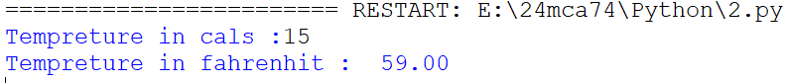

2. Write a python program to swap two variable without using third variable

Code:

a=int(input("Enter first number 1 :"))

b=int(input("Enter second number 2 :"))

print("\n")

print("Entered number 1: ",a)

print("Entered number 2: ",b)

print("\n")

print("swap numbers")

a=a+b

b=a-b

a=a-b

print("a = ",a)

print("b = ",b)

Output:

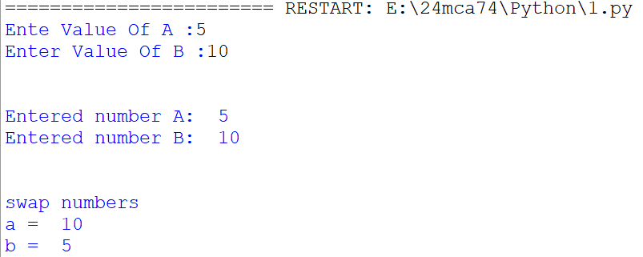

3. Write a Python Program to Convert Decimal to Binary, Octal and Hexadecimal.

Code:

num = int(input('Enter Number : '))

decimal = num

binary = bin(num)

octal = oct(num)

hexadecimal = hex(num)

print("Binary Number : " , binary)

print("Octal Number : " , octal)

print("Decimal Number : " , decimal)

print("Hexadecimal Number : " , hexadecimal)

Output:

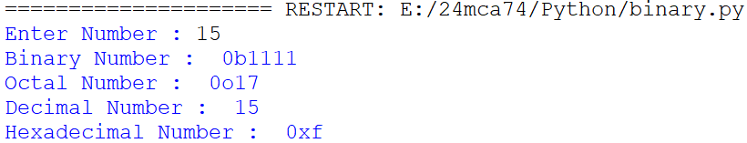

4. Write a program to make a simple calculator (using functions).

Code:

a=int(input("Enter Value Of A: "))

b=int(input("Enter Value Of B: "))

def add(a,b):

print("Addition Is ",a+b)

def sub(a,b):

print("Subtraction Is ",a-b)

def multi(a,b):

print("Multiplication Is ",a\*b)

def div(a,b):

print("Division Is ",a/b)

add(a,b)

sub(a,b)

multi(a,b)

div(a,b)

Output:

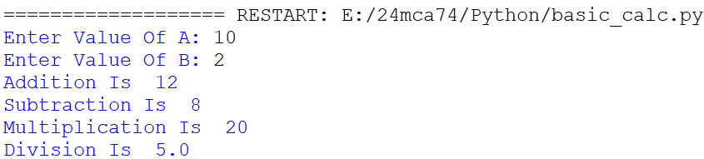

5. Write a program in python to find out maximum and minimum number out of three user entered number.

Code:

a=int(input("Enter first number A :"))

b=int(input("Enter second number B :"))

c=int(input("Enter second number C :"))

#Max

if(a>b and a>c):

print("A is maximum",a)

else:

if(b>c and b>a):

print("B is maximum",b)

else:

print("C is greater",c)

#Min

if(a<b and a<c):

print("A is minimum",a)

elif(b<c and b>a):

print("B is minimum",b)

else:

print("C is minimum",c)

Output:

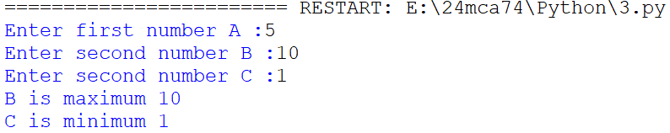

6. Write a program which will allow user to enter 10 numbers and display largest odd number from them. It will display appropriate message in case if no odd number is found.

Code:

i=0

num=0

maximum=0

n=10

while i<n:

num=int(input('Enter Number: '))

if num%2!=0:

if num>maximum:

maximum=num

i+=1

print('Largest Odd number is: ',maximum)

Output:

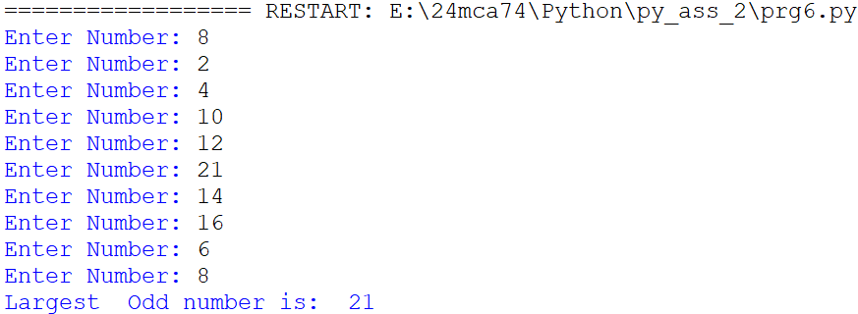

7. Write a Python program to check if the number provided by the user is an Armstrong number.

Code:

num=int(input('Enter the number: '))

sum=0

a=num

while a>0:

digit=a%10

sum += digit \*\*3

if num==sum:

print('number is armstrong',num)

else:

print('num is not armstrong',num)

Output:

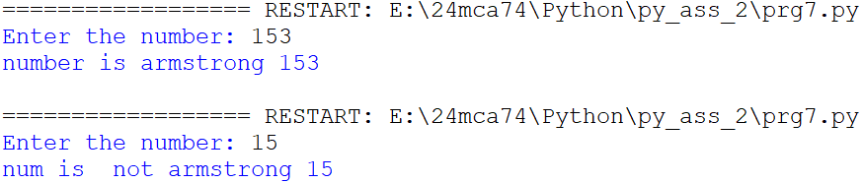

8. Write a Python program to check if the number provided by the user is a palindrome or not.

Code:

n=int(input("Enter number:"))

temp=n

rev=0

while(n>0):

dig=n%10

rev=rev\*10+dig

n=n//10

if(temp==rev):

print("The number is a palindrome!")

else:

print("The number isn't a palindrome!")

Output:

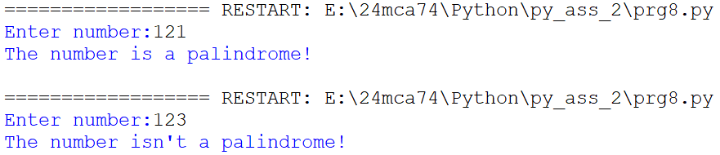

9. Write a Python program to perform following operation on given string input:

a) Count Number of Vowel in given string

Code:

String = input('Enter the string :')

count = 0

String = String.lower()

for i in String:

if i == 'a' or i == 'e' or i == 'i' or i == 'o' or i == 'u':

count+=1

if count == 0:

print('No vowels found')

else:

print('Total vowels are :' + str(count))

Output:

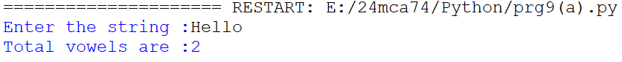

b) Count Length of string (do not use Len ())

Code:

s = input("Enter Any String: ")

l= sum(1 for i in s)

print(l)

Output:



c) Reverse string

Code:

s = input("Enter Any String: ")

rev = s[::-1]

print(rev)

Output:



d) Find and replace operation

Code:

s = input("Enter Any String: ")

select = input("Select Word To Replace: ")

repl=input("Enter Word To Replace: ")

s1 = s.replace(select,repl)

print(s1)

Output:

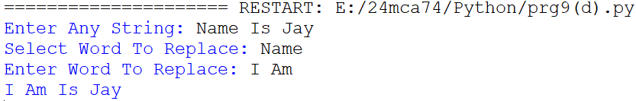

e) Check whether string entered is a palindrome or not

Code:

s = input("Enter Any String: ")

if s == s[::-1]:

print("String Is Palindrome")

else:

print("String Is't Palindrome")

Output:

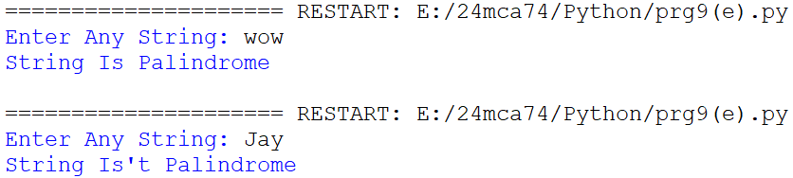

10. Define a procedure histogram () that takes a list of integers and prints a histogram to the screen.

For example, histogram ([4, 9, 7]) should print the following:

\*\*\*\*

\*\*\*\*\*\*\*\*\*

\*\*\*\*\*\*\*

Code:

def histogram(inputList):

for i in range(len(inputList)):

print (inputList[i]\*'\*')

List = [5,10,3]

histogram(List)

Output:

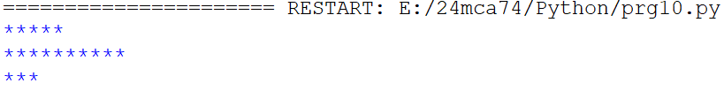

11. Write a program in python to implement Fibonacci series up to user entered number.(Use recursive Function)

Code:

def fibonacci(n):

if n <= 1:

return n

else:

return fibonacci(n - 1) + fibonacci(n - 2)

num = int(input("Enter the number: "))

print("Fibonacci series: ")

for i in range(num):

print(fibonacci(i))

Output:

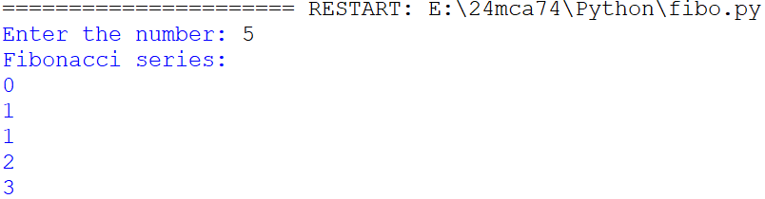

12. Write a program in python to implement Factorial series up to user

entered number. (Use recursive Function)

Code:

def factorial(n):

if n==0 or n==1:

return 1

else:

return(n\*factorial(n-1))

number=int(input("ENTER A NUMBER: "))

print("THE FACTORIAL OF ",number," IS ",factorial(number))

output:

